The Wise Group
Evaluation of the CashBack Connections Programme
Final Report

Contents
1. Executive summary 2
2. Introduction and context 7
3. Participation in CashBack Connections 12
4. Programme referrals and the role of Wise Group staff 16
5. Programme impacts and qualifications gained 21
6. Changes to the programme, challenges and transitions 30
7. Conclusions and recommendations 39

Executive summary
This chapter introduces the programme, summarising the context, programme elements, participant numbers and demographics, together with our key findings and recommendations.

Context
Rocket Science UK Ltd was commissioned by the Wise Group in March 2018 to conduct an independent evaluation of the CashBack Connections programme. This programme ran from April 2017 and finished in June 2019. It aimed to support the development of employability and skills for young people in Glasgow, East Ayrshire and Inverclyde aged 16-24 who are not in education, training or employment. Area-specific Youth Coaches have supported young people into employment through a three-to four-week Sector Based Work Academy (SBWA) approach.

Two evaluation reports have been produced. In September 2018, a Year 1 report was published. This looked at programme outcomes, delivery and impact, staff roles and support provided, programme pathways and challenges to securing employment. In June 2019, a Year 2 and 3 report was produced, building on Year 1 through findings gathered from interviews with young people, follow up interviews with Wise Group staff, and an analysis of programme data.

This Final Report reflects on all three years of the programme, combining key findings, comparing each year, and providing an overview of outcomes and demographics.

Key findings
The infographic (Figure 1) summarises the key findings from Rocket Science’s evaluation activities:
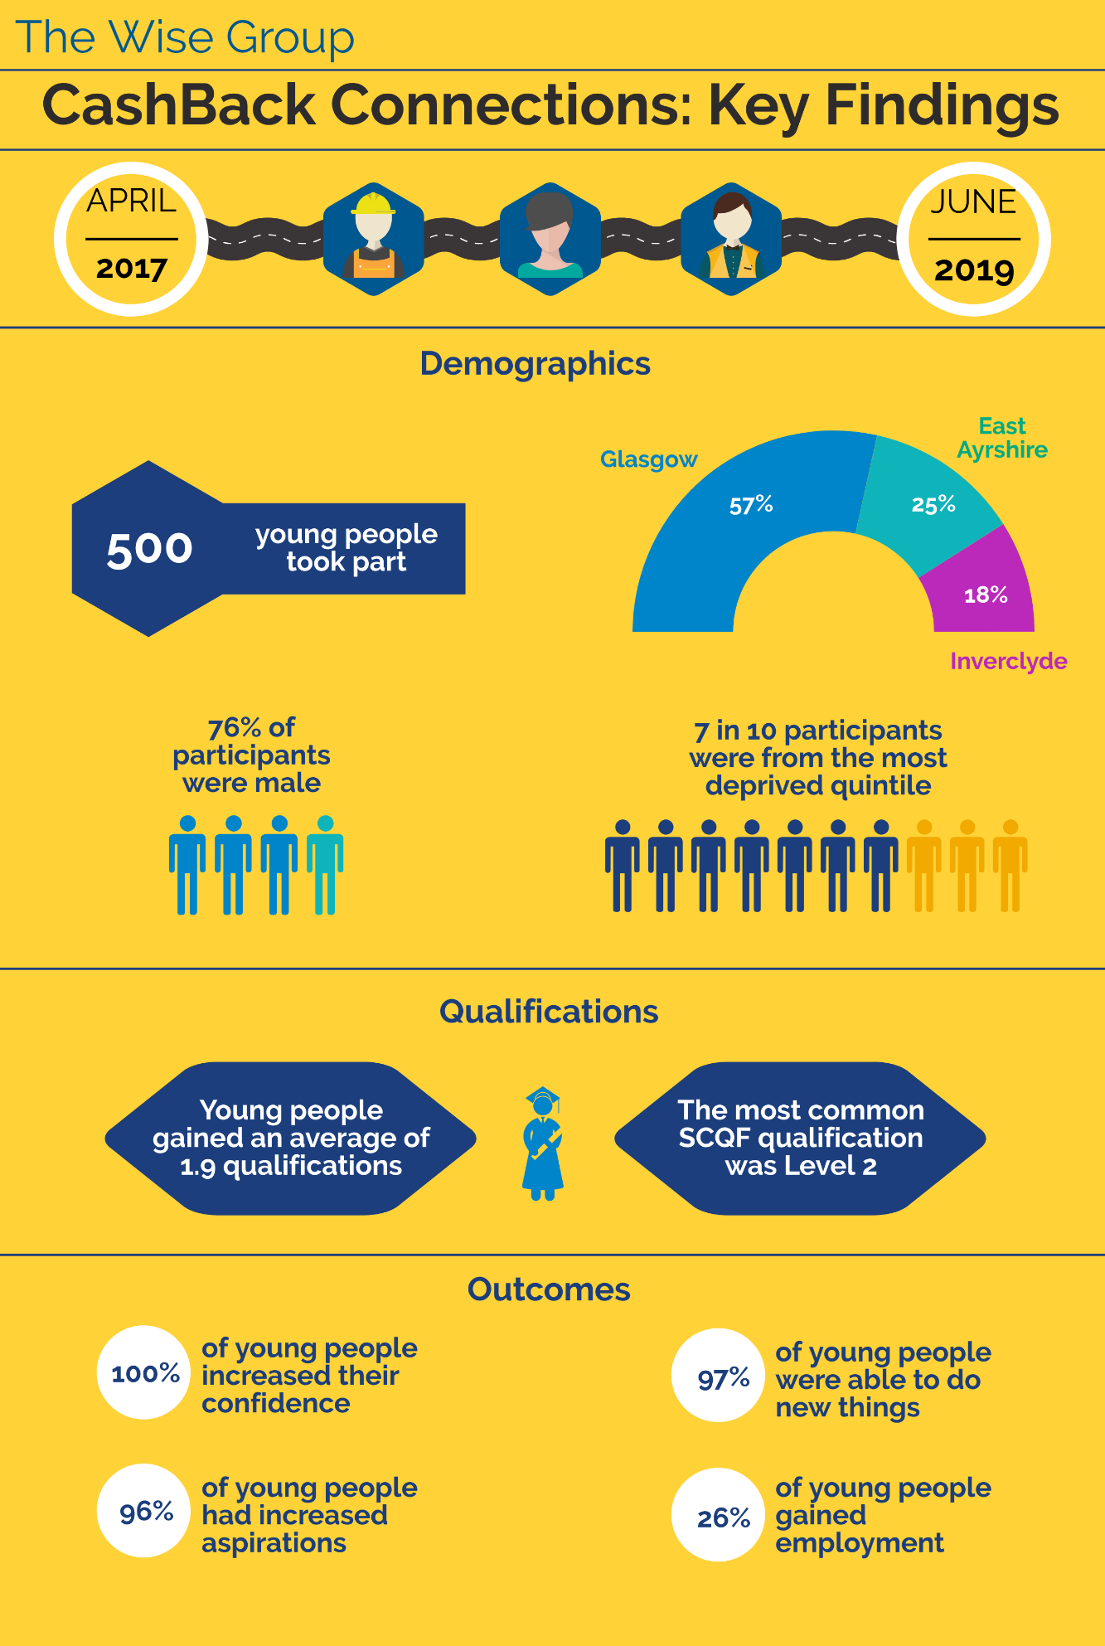
Figure 1 Key findings [Infographic created by Rocket Science, using Wise Group data on Wise Steps participants]

CashBack Connections aimed to reach 500 young people: 300 in Glasgow (60%), 100 in East Ayrshire (20%) and 100 in Inverclyde (20%). The programme achieved its overall target, with actual numbers of participants being similar to the originally planned numbers across the different locations.

Since the programme’s inception, the most frequent Sector Based Work Academies (SBWAs) have been in Construction and Customer Service. In Years 2 and 3, three new types of SBWA were added in Warehousing, Administration, and Security.

Youth Coaches have offered holistic support to engaged young people, depending on their specific needs. This has included helping young people with induction; improving their mindset; developing skills; and finding and sustaining work.

Youth Coaches also played a fundamental relationship-building role in Year 1, increasing awareness of the programme in Years 2 and 3 amongst referring organisations such as Jobcentre Plus. This led to an increase in the quantity and suitability of referrals of young people to the programme.

Skills Development Scotland’s Individual Training Accounts, which were launched in October 2017, had provided funding to support employability for those actively seeking employment and those in low paid work looking to progress. However, access to this funding ceased in early 2019. This meant that in Years 2 and 3 the provision of training through CashBack Connections became increasingly sought after. This is one reason for higher numbers of participants in the second year (and in Year 3, but this only ran for one quarter).

The programme has been successful in achieving positive outcomes for young people, such as improved confidence, skills, wellbeing and employability. Interviewed young people described enjoying the social aspects of participating in group activities while undertaking the classroom-based elements of the programme. They were positive about the support that they had received from Youth Coaches and other Wise Group staff, both during and after the programme. Following their completion of training, participants generally described feeling ready for work.

Despite these positive elements of the programme, concern was expressed about the rate at which young people were progressing from the classroom-based element of the course to work placements (and ongoing employment). This was particularly apparent in Year 2, in which around one in five participants went on to complete a work placement. This compares with almost two in three in Year 1, and just under half in Year 3. This was related to concerns about the numbers of those who made progress into work. A fifth of young people gained employment in Year 2, compared to just under half in Year 1. In Year 3 just 5% went on to employment.

Wise Group staff reflected on some of the challenges faced in sourcing work placements, particularly when trying to engage new employers with the programme, and the area of employer engagement in a crowded employability market – specifically alongside programmes that offered wage subsidies – was identified as an important issue.

Recommendations
Based on our evaluation, we have developed 12 recommendations. These are detailed in Chapter 7 and summarised below:
Theme | Recommendations
The provision of holistic support | - The Wise Group should carry out an assessment at the beginning of each programme to determine the support needs of each cohort (eg reading and writing; or English as a second language). This could inform the sourcing of additional support staff (either from within the Wise Group or external staff), as well as signposting to wraparound services. The risk of drop out could be reduced by a thorough assessment of suitability for the programme.  - The Wise Group could increase work readiness amongst participants by ensuring that young people attend classroom-based training for the full two-week period.  - A two-track model of support should be implemented with young people either undertaking a work placement or being referred to additional support at the end of the two-week classroom-based training part of the programme. This model is detailed in Section 5.5.

Training and qualifications using a SBWA approach | - The Wise Group should continue to involve Youth Coaches in the planning and design of programmes. Youth Coaches have close contact with participants and referring organisations and therefore have invaluable insight about the sectors which have both vacancies and an interest in employing young people.  - The offer of a diverse range of training opportunities should continue to be prioritised, whilst ensuring that this aligns to local labour market opportunities.  - Practical forms of training could help to smooth the transition between the CashBack Connections programme and employment.
Work placements and employment | - The Wise Group should ensure that there is clarity about the programme’s offer in terms of access to work placements. This would avoid disappointment if a placement is not possible.  - When recruiting young people to SBWAs, more detail should be provided about the nature of work and range of potential roles in that sector. This would help to better inform potential participants and motivate them to take part.  - Programme staff should continue to work closely with employers to ensure that their needs are met.
Partnership working with referrers, employers and other employability programmes | - Future programmes should have a planning phase which maps related service provision and ensures that there is limited overlap in the support provided. Mapping the employability landscape could facilitate partnership working, with different programmes signposting to one another based on an individual’s needs.  - Wise Steps could improve the sustainability of outcomes by asking for regular feedback from employers and conducting short ‘exit’ interview with young people. This would improve understanding of why some young people are not being kept on as employees following their placement.  - When implementing future programmes, The Wise Group should plan for a set-up period at the outset of programmes, where resources are devoted to relationship-building and awareness-raising with referral organisations. This should include a social media strategy.

Introduction and context
This chapter explores the background and evolution of the programme, explaining the key features of the Sector Based Work Academy (SBWA) approach; the outcomes that the programme set out to achieve; and the evaluation activities carried out by Rocket Science.

The programme
Figure 2, below, summarises the CashBack Connections model:
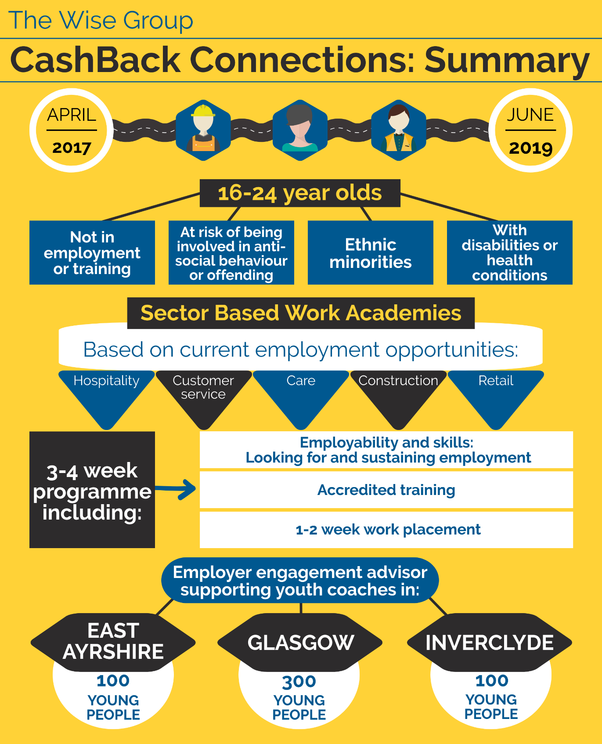
Figure 2 The Cashback Connections model
The Wise Group CashBack Connections programme ran from April 2017 to June 2019 and aimed to support the development of employability and skills for young people aged 16-24 who are not in education, training or employment in Glasgow, Inverclyde and East Ayrshire. The programme was funded by the Scottish Government through the CashBack for Communities Scheme, which has committed £92 million, recovered under the Proceeds of Crime Act, to community initiatives, since 2008.

Young people attended Sector Based Work Academies (SBWAs) which consisted of one- to two-weeks of classroom-based learning delivered by the Wise Group or external trainers. Sessions covered both practical employability skills (eg travel and developing CVs) and sector-specific skills (eg customer service).

Sector Based Work Academies have been designed around the needs of local employers. For example, a SBWA in Inverclyde on customer service was focused on call centre work as this was identified as an area with potential for youth employment. The tailoring of academies around current employer needs was described as helping the CashBack Connections programme to stay “proactive and dynamic” by one Youth Coach. In 2019, three new types of SBWA were run in security, warehousing and administration.

Following the classroom-based learning element of the programme, some young people completed a work placement. This was designed to offer a taste of real working life, and the potential of employment post-placement.

The programme was staffed by three area-specific Youth Coaches who:

- Promoted the programme through Jobcentre Plus and other referring organisations
- Recruited and registered young people on the programme
- Provided support during the programme, including help with practical tasks such as paying participants’ expenses
- Followed up with young people after the programme to offer additional support.

Target outcomes
The programme aimed to achieve the following outcomes for young people (Figure 3), including four which are mandatory for Phase 4 CashBack for Communities projects, plus an additional two outcomes:
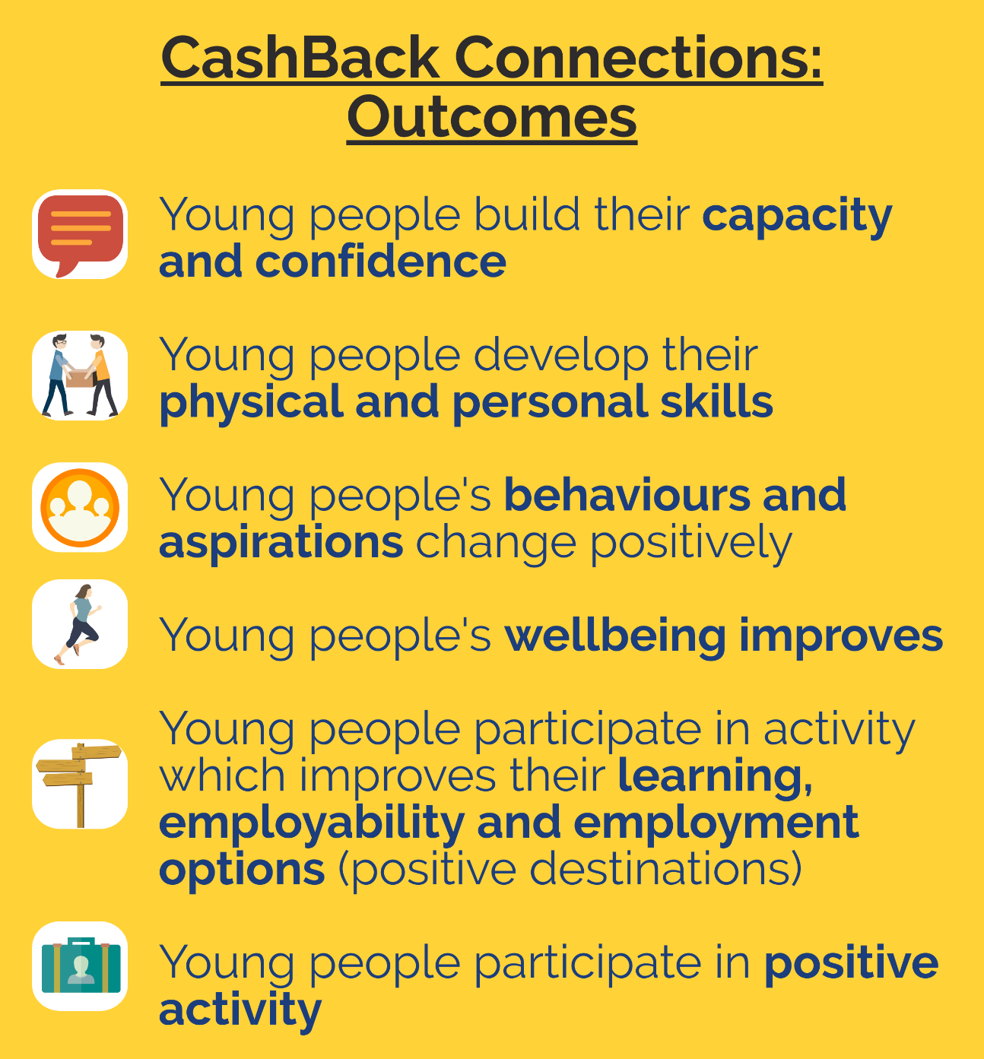
Figure 3 Phase 4 outcomes [Rocket Science presentation of Wise Group information]

Evaluation activity
Rocket Science was commissioned in March 2018 by the Wise Group to conduct an independent evaluation of the CashBack Connections programme. A Year 1 evaluation report was published in September 2018 and looked at:

- Programme outcomes
- Programme delivery and impact
- Staff roles and support provided
- Training, qualifications and placements
- Programme promotion and referral pathways
- Work readiness and challenges to securing employment.

A Year 2 and 3 report was published in June 2019, building on Year 1. In Year 2, Rocket Science carried out additional interviews with young people, follow up interviews with Wise Group staff, and an analysis of programme data gathered by the Wise Group:

Activity | Detail
Interviews with CashBack Connections participants | Year 1: Four interviews with young people involved in the programme  Year 2: 13 interviews with young people involved in the programme
Interviews with Youth Coaches | Year 1: Three interviews with Youth Coaches  Year 2: Four interviews with Youth Coaches (two follow up interviews with Coaches who were involved in Year 1, and two interviews with new Youth Coaches)
Interviews with other Wise Group staff | Year 1 and 2: Regular catch up discussions with the Wise Group’s CashBack Coordinator  Year 2: One interview with the programme’s Employer Engagement Advisor
Workshop | Year 2: One half-day workshop with various Wise Group staff to reflect on Rocket Science’s Year 1 CashBack Connections report and its recommendations
Area Development Plans | Year 1: Development/action plans for Glasgow, East Ayrshire and Inverclyde. Development/action plans for employer engagement
Outcomes and outputs data | Years 1, 2 and 3: Analysis of outcomes and outputs data which is gathered by the Wise Group for all CashBack Connections participants
Data on Sector-Based Work Academies | Years 1, 2 and 3: Analysis of the full list of SBWAs which were run since the programme’s inception until the present to examine sectors covered in each of the locations

To assess the impact of CashBack Connections, the following data was collected and analysed as part of the evaluation:

- Monitoring and performance data collected by the Wise Group and analysed by Rocket Science including:
- The number of young people participating in the programme
- Qualifications gained
- Placements completed
- Number moving onto positive destinations
- Impact data related to skills development (eg confidence).

- Telephone interviews with young people:
- Three and six months after their completion of the programme
- Telephone interviews with Youth Coaches and other relevant stakeholders
- Survey sent to employers every six months
- Area Development Plans – gathered quarterly.

Participation in CashBack Connections

Participant engagement
A total of 500 young people participated in CashBack Connections between April 2017 and June 2019. Most of the participation occurred in Year 2. Due to delivery delays, a Year 3 was added to the programme which ran from April to June 2019.

The Wise Group set a target that 60% of all participants would attend the programme in Glasgow, 20% in East Ayrshire and 20% in Inverclyde. Actual participation was close to this target:

There were some differences in participation across the three areas between Years 1, 2 and 3:

Between 2017 and 2019, a total of 60 CashBack Connections academies have been run across the three locations. Local job vacancies informed the sector focus of academies in the three areas. Based on programme data, the most frequent sector-specific academy was construction, followed by customer service/call centre. A summary of the Academies is provided overleaf.
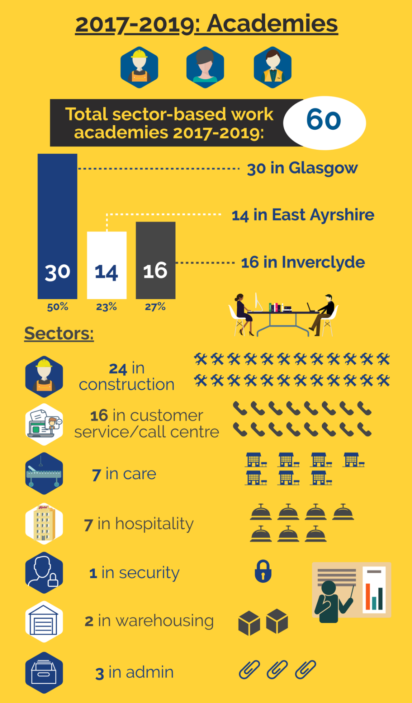
Figure 4 Pattern of academy delivery [Rocket Science infographic, based on Wise Steps Academy data]
Overall, around three in four CashBack Connections participants (~76%) were male. Only ~24% of participants were female, with one participant choosing ‘prefer not to say’.

The Scottish Index of Multiple Deprivation (SIMD) ranks areas from most deprived to least deprived (where 0-20 is the most deprived quintile). Overall, 7 in 10 young people who participated were in the most deprived quintile. A higher proportion of Year 2 and 3 participants were in the most deprived group than in Year 1.

Programme referrals and the role of Wise Group staff

Routes into the programme
Interviewed participants most commonly heard about CashBack Connections through Jobcentre Plus, but a number of other routes were identified, such as through:

- A Careers Advisor at their school
- Skills Development Scotland
- The Prince’s Trust
- A Wise Group staff member who had provided support in prison
- Street League
- A local authority
- Centrestage on the Road – Kilmarnock
- An employability programme running in a local church
- A parent
- A friend
- An online search
- A course with Community Justice Scotland.

The diversity of referral routes into CashBack Connections demonstrates the programme’s success in establishing multiple ways of engaging young people with employability support.

Youth Coaches described the importance of developing relationships and building trust with organisations to encourage a steady stream of referrals into CashBack Connections. Coaches were involved in delivering presentations about the programme to relevant audiences to increase levels of engagement, for example in the local Jobcentre Plus. In addition, recruitment involved emailing stakeholders about upcoming academies.

It was emphasised that Youth Coaches needed to continue to think creatively about how to encourage young people to join CashBack Connections, beyond those already engaged with another employability services or programmes. This included going into local schools, leaving leaflets in I Youth Zones (Inverclyde) or speaking to those involved with a dignified food provision scheme (East Ayrshire). The potential for the use of social media to help in recruiting ‘the hidden unemployed’ to CashBack Connections was stressed, and it was felt that the Wise Group was aware of this.

Youth Coaches continued to strengthen relationships with referring organisations in Years 2 and 3, however, it was felt that Year 1 was particularly important for establishing those relationships with referrers:

“This was the first time we delivered CashBack. For the first year we were building relationships with agencies to get referrals. In the second year, the relationships were already established. It took lots of time to develop those relationships in the beginning. Going forward, we have built a really good network of referral agencies.”
– Wise Group staff member

“The big challenge was the referrals, but now I’m good at it, I have the contacts and maintain the relationships.”
– Youth Coach

In the future, Wise Group employability programmes will be able to draw on these established relationships for referrals.

It was felt that the Sector Based Work Academy approach was helpful for encouraging referral organisations to “buy-in” to the programme, as CashBack Connections was operating in a crowded employability market:

“Referral organisations needed to know what they were referring into. The accredited training was a tangible aspect of the programme for the young person and the referring organisation to see.”
– Youth Coach

The role of Wise Group staff
Youth Coaches described a positive and collaborative working relationship with the Employer Engagement Officer operating across the three areas. While there were some shared aspects in the types of support provided by the Youth Coaches and the Employer Engagement Advisor (eg in matching young people to placements and raising the profile of the programme), the functions of these two roles differed which is presented below:

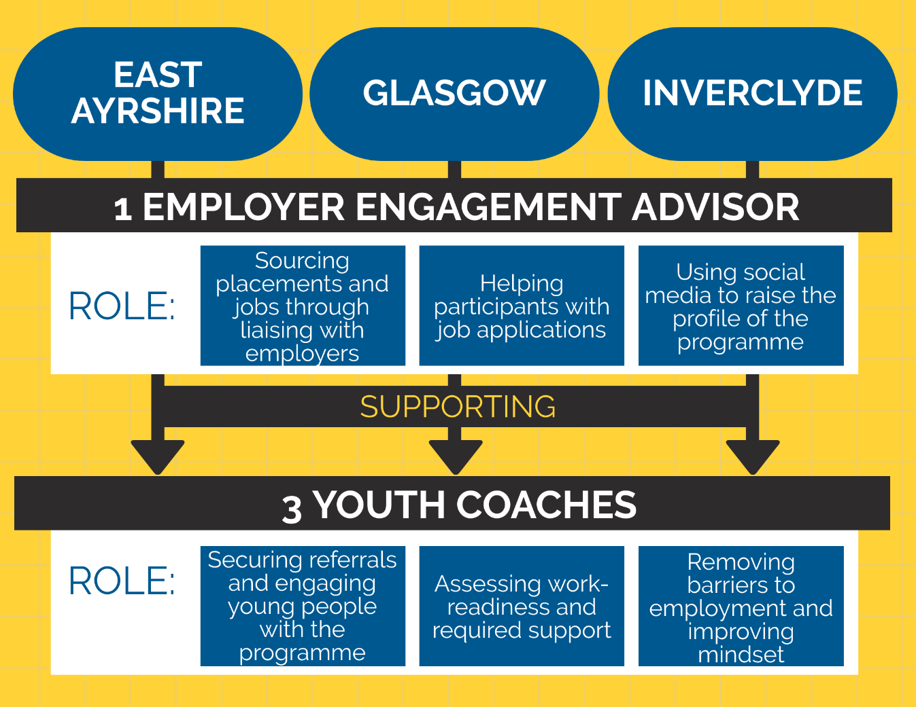
Figure 5 Respective roles of Employer Engagement Adviser and Youth Coaches [Rocket Science infographic]

Youth Coaches provided practical support directly to programme participants, but also played a role in shaping the direction and content of programmes, for example, by suggesting new types of SBWA and sourcing work placements for young people.

When asked in detail about their role, Youth Coaches highlighted the following elements as most important:

- Recruiting young people for the programme, including providing information to prospective participants through Jobcentres and developing relationships with referring organisations
- Identifying any additional support needs at the beginning of the programme, such as problems with reading and writing
- Motivating young people:

“[There is a need to] be positive, try your best to inspire them and motivate them…I try to make the good things about working real, talking to them about being able to go out to a restaurant. I tell them that they will get used to getting up every day.”
– Wise Group staff member

“We try to give them the belief that they can be the first person that breaks the cycle of unemployment.”
– Youth Coach

- Being the “go-to person” for practical support eg paying travel expenses, keeping a note of participants’ test dates and answering general queries:

“Support is specific to the person: you can be a mentor, coach, facilitator or teacher. It depends on what the young person needs from you. It is about adapting.”
– Youth Coach

- Signposting to additional support if needed eg financial help:

“I will apply to the Prince’s Trust for financial support. These are small grants of up to £500 that could be for clothing, tools, travel – anything that will ease entry into work.”
– Youth Coach

- Employability support including helping with CVs, job searches and interview techniques:

“It’s not just about getting the job; it’s about staying in employment. I will correct bad language and emphasise the importance of how they conduct themselves.”
– Youth Coach

- Following up with participants after the programme and offering any additional support.

Programme participants were overwhelmingly positive about the support provided to them by Youth Coaches during the programme. Participants described Youth Coaches as supporting them in various ways:

- Directing them to job vacancies and helping with CV writing
- Sourcing grants and paying expenses
- Keeping in contact with them during and after placements:

“The people who run it were brilliant and helpful – they still are helpful… they kept in contact throughout the placement and after, they would give us a hand and help with our CVs.”
– Wise Group participant

- Sharing their experiences of work:

“[The Youth Coach] is from the same area and was in a similar position when he was my age. He is a passionate individual and is good at inspiring people… they [Wise Group staff] were giving me life experiences, what they went through and information about sectors they have worked in.”
– Wise Group participant

Despite the range of support provided, there were examples of additional support needs which were not always met, for example, providing a scribe for a participant with dyslexia.

Programme impacts and qualifications gained
This chapter provides an analysis of outcomes data, as well as qualitative findings from interviews conducted by Rocket Science.

Achievement of outcomes
As detailed in Section 2.2, CashBack Connections set out to achieve outcomes against six targets:

Quantitative outcomes data
Outcomes data is gathered through assessment forms which are completed by all participants at the end of academies and again once they have moved into positive destinations. Wise Group outcomes data suggests that the programme has made good progress towards most of its targets:

Outcome | Progress overall
Capacity and confidence | 100% of those who took part in a CashBack Connections programme across the three areas reported an increase in their confidence and/or capacity. A similarly high proportion (97%) reported being able to do new things as a result of attending a SBWA. All five Youth Coaches interviewed felt that an increase in confidence was one of the main outcomes of the programme.
Physical and personal skills | 66% of those who attended a SBWA achieved accredited learning and 90% reported an increase in their skills. This shows that accredited learning is not the only path to skills development on the programme. All five Youth Coaches interviewed felt that qualifications and skills of participants increases as a result of the programme.
Behaviours and aspirations | 96% of programme participants reported positive change to behaviours and increased aspirations. All five Youth Coaches interviewed highlighted behaviour and aspiration changes in programme participants, which varied from person to person. For example, one Youth Coach mentioned character development, another mentioned greater motivation, while another felt that their young people had a greater sense of purpose.
Wellbeing | 96% of young people reported improved wellbeing (using SHANNARI indicators). While several Youth Coaches mentioned mental health issues as a barrier for programme participants, only one specifically mentioned wellbeing improving. However, changes to wellbeing did seem to occur but more indirectly, for example through a boost in confidence, having more friends and through positive lifestyle changes.
Learning, employability and employment | 24% of young people gained employment upon completion of CashBack Connections. Eight young people went on to training or education. Three young people went on to volunteer after the programme ended. Youth Coaches interviewed highlighted difficulties in achieving positive destinations for their young people, for example, work placements, and employment, training and education outcomes appeared to be less strong than other outcomes, with three out of five Youth Coaches feeling this was achieved.
Positive activity | 96% of programme participants took part in positive activity (only measured in Year 2). In the context of CashBack Connections, positive activity includes forming social connections, developing employability skills, taking part in training and completing work placements. Overall, four out of five Youth Coaches interviewed mentioned young people taking part in positive activity of some kind.

Rocket Science interview data
Rocket Science conducted interviews with CashBack staff and participants. This section outlines the key findings from these, including successful elements of the programme, how the programme achieved outcomes for young people and the impacts on their lives.

Capacity and confidence
It was felt that the programme helped participants to feel more confident in a work setting and when speaking to new people. Specifically, the Mindset element of the course was described as therapeutic and useful for improving confidence when talking in a group.

“I used to be dead shy, since I’ve been working, I can talk to people better. It came from taking part in the programme.”
– Wise Group participant

“I have got a lot more confidence since going to Wise Group.”
– Wise Group participant

One Youth Coach explained that increases in confidence were especially visible amongst those who began the programme with very low confidence, whilst those who were reasonably confident to begin with seemed to sustain this level of confidence throughout their engagement with the Wise Group. Despite this, it was noted that, while the course helped to build participants’ skills and experience, some could benefit from a longer intervention:

“I think it builds skills and experience, for the most part it did – some would require more time, they aren’t so fast at learning. Some improve really fast, others don’t.”
– Wise Group staff member

Physical and personal skills
Young people described gaining a wide range of skills eg:

- Software (Excel)
- First Aid
- Customer service skills
- People and communication skills
- Public speaking
- Team working
- Restraint (security SBWA).

“With security we learnt a lot of legislation – we went over a lot of the difference between legislation, laws and bills. I went to uni and that, I didn’t know half of it.”
– Wise Group participant

“[CashBack Connections] gave me the tools I needed to achieve goals, it got me my CSCS card which you need to be able to do anything on site.”
– Wise Group participant

“Qualifications helped me get feet on the ground.”
– Wise Group participant

Youth Coaches also reflected on the importance of young people being given the opportunity to gain qualifications to help them enter employment and to have something to feel proud of:

“Some have not got qualifications; they may have not done well in school… or have struggled to find work. We show them that they can do it and they realise they can do it with no issues.”
- Wise Group staff member

Behaviours and aspirations
Young people described feeling more positive about achieving their goals. It was felt to be reassuring to meet other participants and learn that others are in the same position (ie looking to gain experience and employment).

“There were a lot of people in the same spot as me.”
– Wise Group participant

It was felt that being given the opportunity to learn new things through employment increased motivation and independence, with one young person stating that, since participating, they were more willing to take on additional hours at work.

“Taught you that you can accomplish a lot on your own.”
– Wise Group participant

“I know what I’m doing, if someone tells me what to do at work, I can get right on with it.”
– Wise Group participant

One Youth Coach noted that some participants had previously never left their local area and that feeling able to go on public transport was thus a big achievement. It was felt that this could positively change aspirations.

Wellbeing
The main impact of the programme on participants’ wellbeing was around encouraging a better routine and sleeping pattern. Other impacts included exercising more, being out and about more and eating healthily.

“[CashBack Connections] increased motivation, I think it was because we were going out in the morning to the course, out most of the day rather than sitting in the house.”
– Wise Group participant

[When discussing increases to participants’ wellbeing]: “It is about mental stimulation, they need to get up and have a purpose.”
- Youth Coach

Despite reported increases in wellbeing, it was described that some young people could “fall by the wayside” due to circumstances external to the programme. It was felt that Youth Coaches could reduce the likelihood of this happening by either personally helping or seeking additional assistance for issues such as mental health or housing.

Learning, employability and employment
Young people described Youth Coaches as being friendly and supportive. Youth Coaches encouraged young people to take up opportunities, provided help with CVs and helped participants to “get in the mood” for working life.

“They [the youth coaches] have a wealth of life experience.”
– Wise Group participant

“It gave me the courage that going for an interview wasn’t as daunting as it seems.”
– Wise Group participant

It was seen as useful that young people were provided with the opportunity to ask Youth Coaches work-related questions during and after classroom-based training:

“Anyone who has moved into work, I keep in touch, they know I’m here if they need me. Someone with no work experience, they can call me and say I know this is a silly question but… and I can help.”
- Wise Group staff member

Wise Group staff reflected on the benefits of offering young people a range of courses and qualifications. Following the end of ITA, there was an increased availability of external trainers. This meant that CashBack Connections could provide additional types of training to young people, which was viewed positively:

“I don’t think you could have too many options of training.”
- Wise Group staff member

Within each academy, young people were typically provided with various types of training that would be useful for work in a variety of industries eg learning around managing aggression, first aid and manual handling:

“They teach us everything, they teach us health and safety, all the stuff you need to know on site. Once you go onto site you aren’t clueless. Smooth process from placement to work.”
– Wise Group participant

The employability week of the programme was felt by Youth Coaches to help break cycles of unemployment, providing young people with everything they would need to know in order to gain and sustain employment.

“You are trying to end second or third generation unemployment through showing young people that there is a different way. We try and nurture a view that work, education and training is about adding meaning to your life.”
- Youth Coach

“I have been working in the same place since involvement with Wise Group. It’s great, I love it [the job].”
– Wise Group participant

Positive activity
Young people took part in a range of positive activities such as completing training and gaining qualifications. Youth Coaches emphasised the importance of making friends and having a positive routine on wellbeing.

“I got on well with everyone else, there was about eight of us, it was close knit.”
– Wise Group participant

While some young people described the benefits of forming social connections and making new friends on the programme, its relatively short duration was felt to limit other participants’ abilities to form lasting connections.

Qualifications gained
A total of 958 qualifications were gained by CashBack Connections participants. As well as achieving SCQF qualifications, young people undertook a number of non-SCQF sector-specific qualifications, for example forklift truck operation, ‘Construction Skills Certification Scheme Cards’ and ‘Security Industry Authority Badge’ qualifications. Other non-SCQF qualifications included personal development courses such as ‘Mindset’.

Overall, participants gained an average of 1.9 qualifications. More qualifications were gained per person in Year 1 (3.6) and in Year 3 (3.1) than in Year 2 (1.5). A wide range of qualifications and non-accredited courses were offered, detailed below.

Qualification or course
SQA Unit Level 1: Health and Safety in a Construction Environment
Construction Industry Training Board (CITB): Construction Skills Certification Scheme (CSCS) card
Novice Counterbalance Forklift Operation course
SCQF Level 2: Health and Safety
SCQF Level 5 and 6: Customer Service
Level 5 and 6: Door Supervision
Highfields Level 2: Managing Conflict in the Workplace
Highfields Level 2: Manual Handling
Highfields Level 2 and 6: 3-day First Aid
Highfields Level 2: Customer Service
REHIS Level 2 and 5: Emergency First Aid
REHIS Level 5: Elementary Health & Safety
REHIS Level 5: Food Hygiene
Bar License Level 6 course
Security Industry Authority (SIA) Badge Qualification
Dementia Awareness course
SSSC Awareness course
Protection of Vulnerable Adults course
Mindset – personal development course
3-day Digital Inclusion course

Changes to the programme, challenges and transitions
This chapter examines the project’s evolution over time, the main challenges in delivery and in transitioning from classroom-based learning to placements to employment. It also sets out a potential new two-track model, designed to cater to differing levels of need amongst young people.

Changes to the programme
The CashBack Connections programme has been focused since its inception on helping young people aged 16-24 who are not in employment, education or training to develop skills and increase their readiness for employment. However, the programme has evolved over time to use a three to four-week Sector Based Work Academy approach (SBWA) to employability.

One Youth Coach described a shift in the programme from an initial focus on the provision of a one-to-one type of employability support to support within a group setting. This was beneficial for young people because being part of a group during the Academy was seen to be similar to what would be experienced in a work environment. The opportunity to see how a young person operates in a group setting was seen as useful by Youth Coaches as they gained better understanding of the work-readiness of that young person.

Across all three years, the programme provided one- or two-week Sector-Based Work Academies (SBWA), ideally followed by one- or two-week work placements. Despite this continuity in approach, the following three changes occurred between Years 1 and 2:

- New academies and training offered: New SBWAs were offered to participants in Security, Administration and Warehousing. New forms of training offered included Bar Licensing with the Tennent’s Academy and Forklift Licensing. Updating the offer of academies and training was the result of Jobcentres providing information about vacancies (eg administration vacancies in Glasgow) and increased availability of external training providers following the closing down of Individual Training Accounts (ITA). This meant that the young people that would have applied for ITA looked to CashBack Connections to access training.

- Developed relationships with referring organisations: Following efforts in Year 1 to develop relationships with referring organisations such as Street League and Jobcentre Plus, awareness of CashBack Connections increased in Year 2. One Youth Coach described that the local Jobcentre had “really come on board” and were increasingly familiar with exactly what the programme provided for young people. There was a decreasing need to do a “sales pitch” to get the Jobcentres to refer to the programme, and Jobcentre staff started “picking out people in their caseloads” who were well-suited to the programme.

- Provision of general (rather than sector-specific) employability support: Towards the end of Year 2, individuals who had previously completed a SWBA but had not moved into work or training were invited back to gain general employability support from Wise Group staff, such as CV writing and job applications. In addition, generalised work academies (without a sector-focus) were offered in Inverclyde in 2019.

Challenges in programme delivery
When asked about challenges faced in delivering CashBack Connections, Youth Coaches described the following:

- Getting the word out about what the programme was and how young people could be supported by CashBack Connections
- Reaching the range of young people who could benefit from participation, eg those who are not engaged with the Jobcentre or other services
- Getting in contact with young people if they do not have access to a mobile phone
- Sourcing work placements (detailed in Section 6.2.3)
- Challenging behaviour amongst participants eg conflict between those coming from different areas
- Having the time to fulfil the various aspects of their role, ie providing one-to-one support, following up with participants who had completed previous SBWAs, recruiting for upcoming SBWAs, visiting participants while they are completing placements and general administration
- Limits to staff capacity for providing support to young people with literacy or numeracy issues, particularly in large groups
- Encouraging young people to undertake placements which are unpaid
- Variation in work-readiness and need (detailed in Section 6.2.2)
- Operating in a saturated employability market (detailed in Section 6.2.1).
Interviewed participants were asked to comment on any aspects of the programme that they did not enjoy or would want to improve. Many of the interviewed participants did not provide any suggested areas of improvement. Those that did described the following improvements:

- A shorter waiting time for their accreditation to come through to them once they had passed their training programme

“We had an issue with getting our SIA badge even though we passed.”
– Wise Group participant

- More challenging course content

“If anything, maybe compacting some of the courses, the six day course, we could have covered it in a shorter period of time.”
– Wise Group participant

- A longer classroom-based training period covering an increased number of topics:

“They did a pretty good job, the only thing I could say is maybe if the course was a bit longer, another week with more subjects.”
– Wise Group participant

- Improved support for individuals with dyslexia during classroom-based sessions.

Operating in a crowded employability market
Youth Coaches described a “saturated” employability market in their local areas. A crowded market was seen to have negative implications for referrals into CashBack Connections, particularly where other programmes were able to offer young people wage subsidies:

“It is a saturated employability market. It makes it harder to secure referrals, some programmes do what we do and also offer subsidised wages, and this is more attractive [for young people].”
- Youth Coach

“Glasgow is saturated with employability programmes. In construction a lot of the programmes are wage subsidised and for 16-18 year olds this is a massive incentive.”
- Youth Coach
Despite potential challenges to securing referrals in circumstances where other organisations offer similar types of support, Youth Coaches emphasised the positives of multiple programmes seeking to help young people in their local areas:

“We can work together, we are all working to help youth. It doesn’t matter who gets the young person. For too long it has been each to their own. I try to be open and just say, ‘What can we do?”.
- Youth Coach

“It is an absolutely saturated market but that is a positive in that it means there are lots of groups working to support young people.”
- Youth Coach

Work readiness and outlook of participants
Wise Group staff noted the variation in programme participants in terms of their outlook, level of independence, work preferences and readiness for full time work. This was seen as primarily related to age:

“The 20- to 24-year olds have a more mature outlook and variation in experience. The 16 to 18 year olds have no experience and [often] want to work in construction, they don’t know what else to consider.”
– Wise Group staff member

“The biggest issue I have found with the younger group, they are doing a one- to two-week classroom based thing, I am then putting them out onto a placement, [for example] in a construction environment - it is just a step too far for them….Because they are so young, their parents are helping with a lot of stuff.”
– Wise Group staff member

“The care academy that we ran – numbers were very low in the lower age group. Care work for me is a 30+ [career], kids are not interested in doing that.”
– Wise Group staff member

When asked whether it would be useful to separate younger and older participants, Youth Coaches reflected that the mix of ages is useful, but that younger participants could potentially benefit from a longer classroom-based intervention:

“I think the age group is right, it works well if the 16-17 year olds are mixed with the 23-24 year olds, the vast percentage are 16-20. The older ones are happy enough to help the younger ones.”
– Wise Group staff member

“I think it does strike a good balance to have mix of ages, the only bit that would be good about separation, some require a longer intervention. If you only had 16-18 year olds, it could be too much, it’s good to balance it out.”
– Wise Group staff member

A short project duration was also felt to limit the ability of Youth Coaches to help some young people with barriers to work, such as mental health or housing issues:

“My passion is working with young people, they should be nurtured and helped. The programme needs to be longer to help them into sustainable employment.”
- Youth Coach

In addition, one Youth Coach described growing up in a workless household as a potential barrier to sustaining employment:

“We work in deprived area postcodes – young people may have not grown up in a working household. They don’t know any different, so it can be hard to get them to engage well with an employer.”
- Youth Coach

Interviewed programme participants were asked about the extent to which they knew what they wanted to do before starting CashBack Connections. Responses ranged from those who had a clear idea of the career they wanted to pursue, to those who did not know which sector or job they would want to work in:

“I knew I wanted to get my security licence.”
– Wise Group participant

“I didn’t really have a clear sense before the programme, I have a clearer sense now, I feel like I could do admin.”
– Wise Group participant

Therefore, CashBack Connections and future Wise Group programmes can usefully provide programme participants with information about the range of jobs and sectors that individuals could work in. The provision of information about potential opportunities would allow young people to make more informed career choices.

CashBack Connections participants were also asked about the extent to which they felt ready for work, and whether taking part in the programme had helped with this. Most interviewed young people described feeling ready for work in the period following their participation in CashBack Connections:

“We were definitely ready to get out there, there were five or six of us on the course, we seemed quite excited.”
– Wise Group participant

“Yeah definitely [ready for work] – it gives you confidence and motivation to get into a work environment.”
– Wise Group participant

“They give you the boost, they say: you can do it, you know you can, if you have any problems let us talk you through it.”
– Wise Group participant

Transitions into work placements and employment
The placement element of the programme was designed to act as a trial period for a young person to gain an interview or ongoing employment with the same organisation. Of the 500 young people who took part in CashBack Connections, 153 completed a work placement (31%). A higher proportion of young people accessed placements in Year 1 (63%) and Year 3 (44%) than in Year 2 (19%). Similarly, almost half of all young people gained employment in Year 1, compared to around a fifth in Year 2. In Year 3, 5% of people gained employment.
Securing placements for all participants was seen to be challenging amongst Wise Group staff for several reasons:
- There were a limited number of employers in specific sectors in the local area with the ability to take on multiple young people at once, eg construction in East Ayrshire in Year 2
- Delays in a young person gaining the qualification that they need to complete a placement eg gaining their CSCS card (needed to work in a construction environment). This can be due to administrative delays or waiting for availability with external examiners
- Giving the limited number placements to the “most suitable” candidates ie those perceived to be most likely to gain ongoing employment
- A mismatch between the vacancies that are available and the types of work that interests and excites young people (eg care vacancies that young people are not keen to pursue)
- A reluctance from new organisations to take on young people for placements when approached – this has led to certain employers becoming “go-to” providers of placements eg:

“I have been surprised at how difficult it is to get good placements. I thought if you were phoning [employers] and saying, ‘I will give you three young people for free’, but organisations don’t want to take young people. Some have become go-to [providers of placements].”
- Wise Group staff member

One Youth Coach described that there was room for improvement in terms of the number of young people progressing onto placements after the classroom-based training. There was concern about the programme being marketed as offering work placements which in some cases it could not provide.

This was mitigated by Youth Coaches being open with young people at the programme’s outset that it may not be possible for them to gain a placement:

“Placements and opportunities could have been better throughout… there wasn’t nearly the number of outcomes in terms of placements and jobs compared to referrals…. I would have liked to have seen them moving onto a job or placement.”
- Wise Group staff member

I’m recruiting people based on saying ‘we offer a two-week placement’, it says that on the form/poster. I tell them it’s not guaranteed but we try our best.”
- Wise Group staff member

Given the variation in the extent to which young people are seen to be ready to undertake work placements and ongoing employment, we recommend that the Wise Group considers a two-track model of support where at the end of the classroom-based training young people either:

- Progress directly into a work placement
- Gain access to additional forms of support or services.

This suggested model would help to prevent those who are not able to undertake a placement from disengaging with the Wise Group without any further assistance.

To date, Wise Group staff have encouraged young people to stay in touch and reach out if they need additional help from Youth Coaches after the end of the programme. However, the extent to which this has been taken up by young people, and the degree to which Youth Coaches have had the time to provide extensive ongoing support, is limited. In 2019, previous CashBack Connections participants were invited back to the Wise Group for additional employability support, but the uptake has been minimal.

The current programme (based on Rocket Science’s understanding) and suggested two-track model of support is illustrated overleaf:
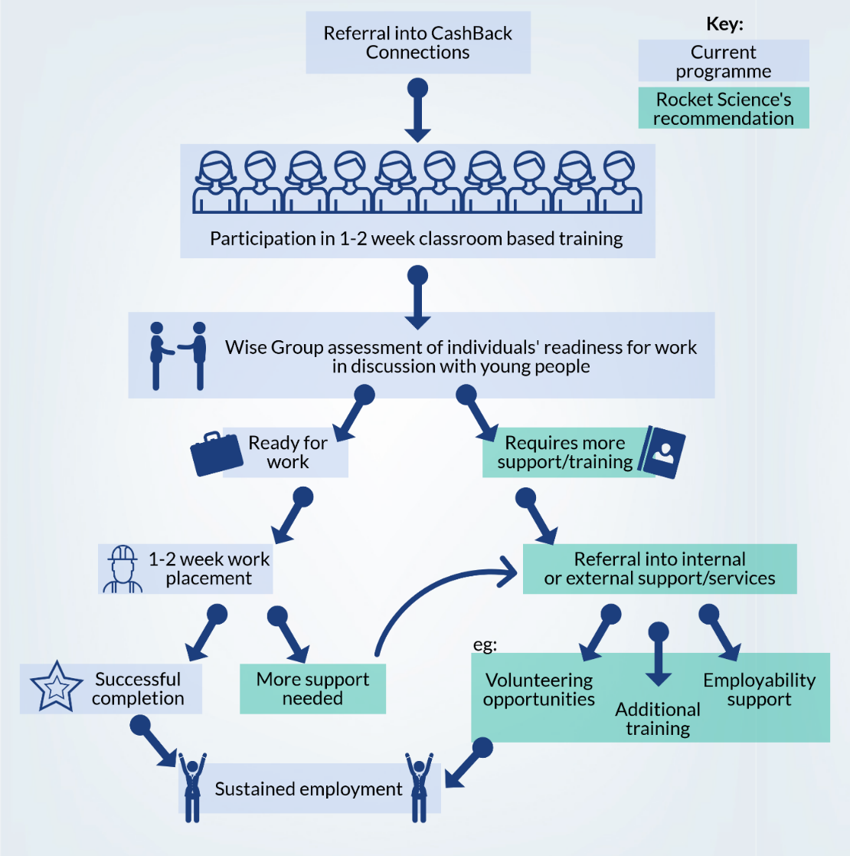
Figure 6: Proposed two track model of support for participants

Conclusions and recommendations
This section outlines the main conclusions from Rocket Science’s evaluation of the Wise Group’s CashBack Connections programme. Alongside these conclusions are recommendations about the ways in which this programme (or similar future employability programmes) can be delivered successfully to maximise their reach and impact for participants.

- The provision of holistic support
Conclusions:  Participants have varied in their level of prior work experience and in the extent to which they are ready to begin working following completion of the programme.  Youth Coaches and other Wise Group staff (eg the CashBack Coordinator and Employer Engagement Advisor) have been flexible in their approach to providing support and have been willing to do additional work beyond their roles to support positive outcomes for young people.  Despite this, staff have been somewhat limited in their capacity to provide support:  - During programmes for those with additional support needs  - At the end of the classroom-based training for those who are not ready to undertake a placement. | Recommendations:  - The Wise Group should carry out an assessment at the beginning of each programme to determine the support needs of each cohort (eg reading and writing, or English as a second language). This could inform the sourcing of additional support staff (either from within the Wise Group or external staff). The risk of drop out could be reduced by thorough assessment of suitability for the programme.  - The Wise Group could increase work readiness amongst participants by ensuring that young people complete classroom-based training for the full two-week period.  - A two-track model of support should be implemented whereby young people either undertake a work placement or are referred to additional support at the end of the two-week classroom-based training part of the programme. This model is detailed in Section 5.5.

2. Training and qualifications using a SBWA approach
Conclusions:  The programme has been responsive to local job markets. It has sought to provide young people with the skills and qualifications that will help them to access local job opportunities. Youth Coaches have been proactive in shaping the content and direction of SBWAs.  CashBack Connections offered new types of SBWAs and training in Year 2 and this was seen positively amongst staff who felt that providing a wider variety of training options was beneficial. | Recommendations:  - The Wise Group should continue to involve Youth Coaches in the planning and design of programmes. Youth Coaches have close contact with participants and referring organisations and therefore have invaluable insight about the sectors which both have vacancies and interest young people.  - The offer of a diverse range of training opportunities should continue to be prioritised, whilst ensuring that this aligns to local labour market opportunities.  - Practical forms of training could help to smooth the transition between the CashBack Connections programme and employment.

3. Work placements and employment
Conclusions:  Despite efforts by Wise Group staff to engage new employers, there have been various challenges to securing placements for participants (detailed in Section 5.5).  While providing academies in sectors which have vacancies is beneficial for helping young people into employment, there can be a reluctance for young people to participate in some academies (eg in care) as a result of:  - Low awareness about the range of job opportunities within that sector  - Low levels of enthusiasm from the young people about work in that sector. | Recommendations:  - The Wise Group should ensure that there is clarity about the programme’s offer in terms of access to work placements. This would avoid disappointment if undertaking a placement is not possible.  - When recruiting young people to SBWAs, a greater level of detail should be provided about the nature of work and range of potential roles in that sector. This would motivate and inform potential participants.  - Programme staff should continue to work closely with employers to ensure that their needs are met.

4. Partnership working with referrers, employers and other employability programmes
Conclusions:  CashBack Connections has operated alongside various other types of employability and training provision for young people in Glasgow, East Ayrshire and Inverclyde.  Some young people have not progressed from their placement during Cashback Connections to become an employee. More understanding is needed to identify the key issues and find solutions.  Wise Group staff have invested time and effort in developing relationships with referring organisations and employers throughout Year 1 of the programme. In Year 2, the benefits of this investment were evident through an increase in the number and suitability of referrals to CashBack Connections; and the range of ‘go-to’ employers for placements. | Recommendations:  - Future programmes should have a planning phase which maps related service provision and ensures that there is limited overlap in support provided. Mapping the employability landscape could facilitate partnership working whereby various programmes mutually signpost to one another based on an individual’s needs.  - Wise Steps could improve the sustainability of outcomes by asking for regular feedback from employers and conducting short ‘exit’ interview with young people. This would improve understanding of why some young people are not being kept on as employees following their placement.  - When implementing future programmes, The Wise Group should plan for a set-up period at the outset of programmes where resources are devoted to relationship-building and awareness-raising with referral organisations. This should include a social media strategy.

Rocket Science Project team
Dina Papamichael, Consultant
Shannon Anderson, Senior Consultant
Cristiana Orlando, Consultant
Richard Scothorne, Managing Director – richard.scothorne@rocketsciencelab.co.uk

Offices:

Edinburgh
T: 0131 226 4949 2 Melville Street, Edinburgh EH3 7NS
Newcastle
T: 07887 673 407 The Beacon, Westgate Rd, Newcastle upon Tyne NE4 9PQ
London
T: 0207 253 6289 Fleet House, 8-12 New Bridge Street, London EC4V 6AL
www.rocketsciencelab.co.uk
Rocket Science UK Limited 2020

