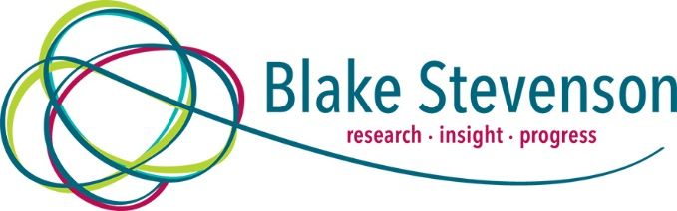

Evaluation of Way2Work#Cashback: Final Report

Bridges Project

August 2020

CONTENTS

Chapter Page
1. Introduction and context 1
2. Programme delivery 5
3. Impact of Way2Work 9
4. Summary and learning points 25

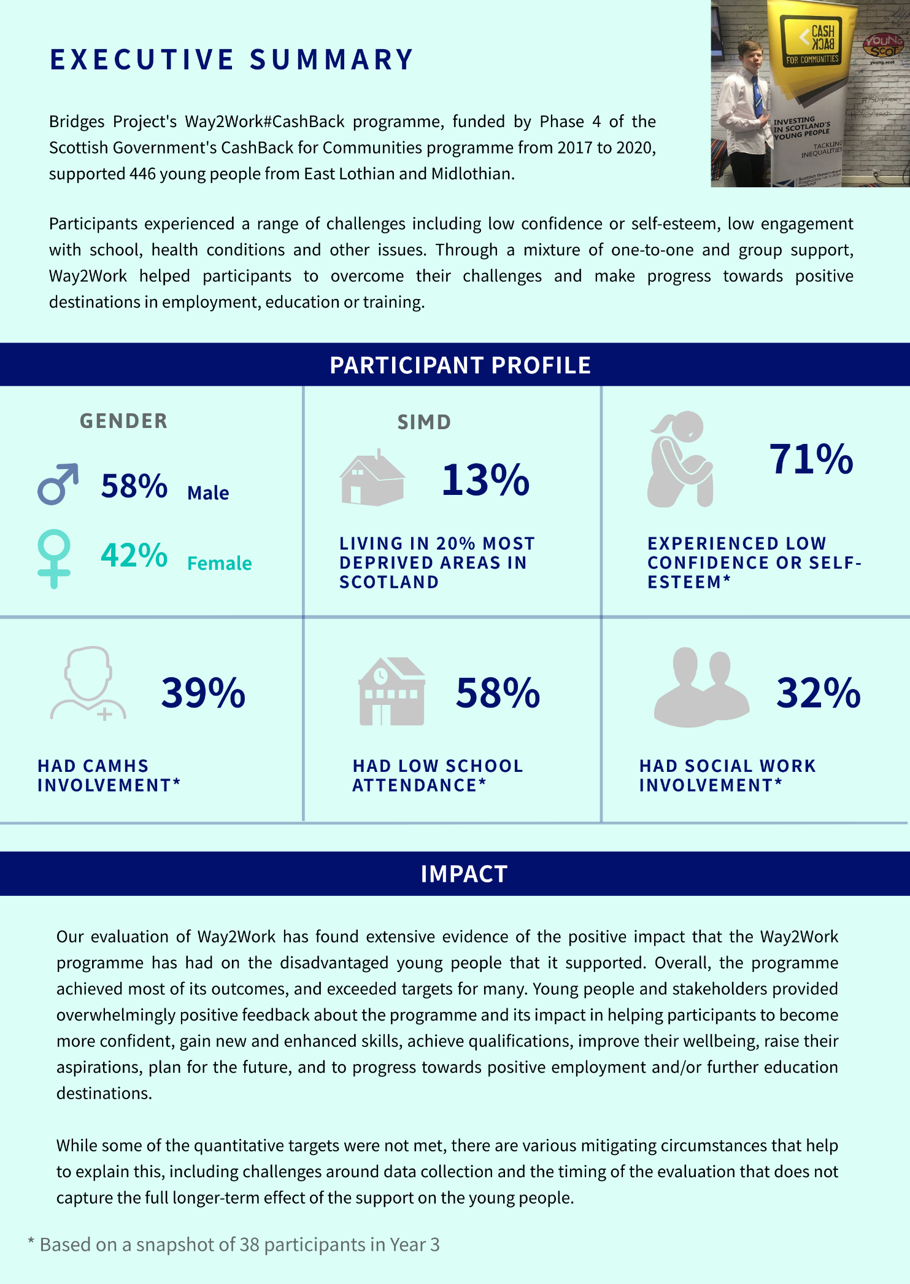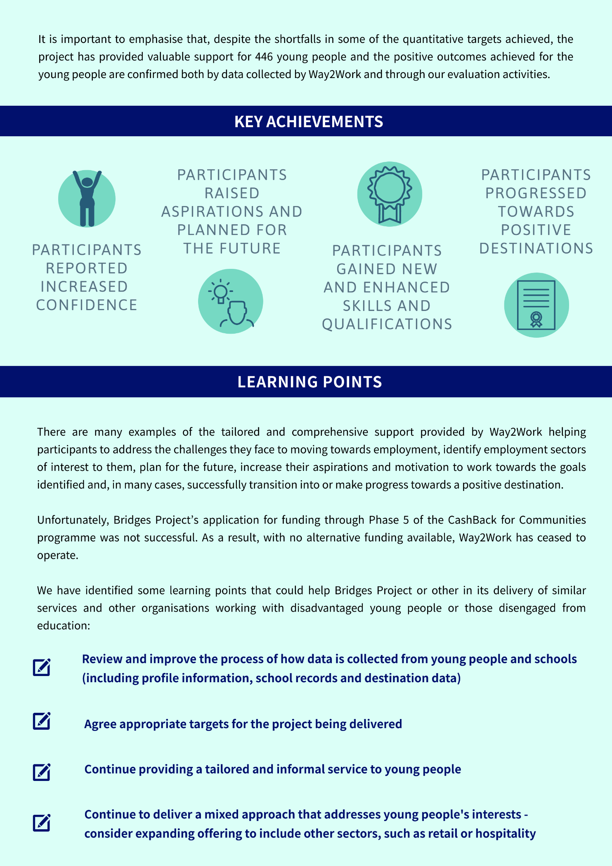

- Introduction and context
- In July 2017, Bridges Project commissioned Blake Stevenson Ltd to evaluate its Way2Work#CashBack programme (referred to as ‘Way2Work’ in this report), which was funded by Phase 4 of the Scottish Government’s CashBack for Communities programme between 2017 and 2020.
- This report builds on our reports from Years 1 and 2. We explore the delivery and impact of Way2Work in the third and final year of Phase 4, and across the Phase as a whole, with reference to the six core CashBack outcomes that the programme aimed to deliver:
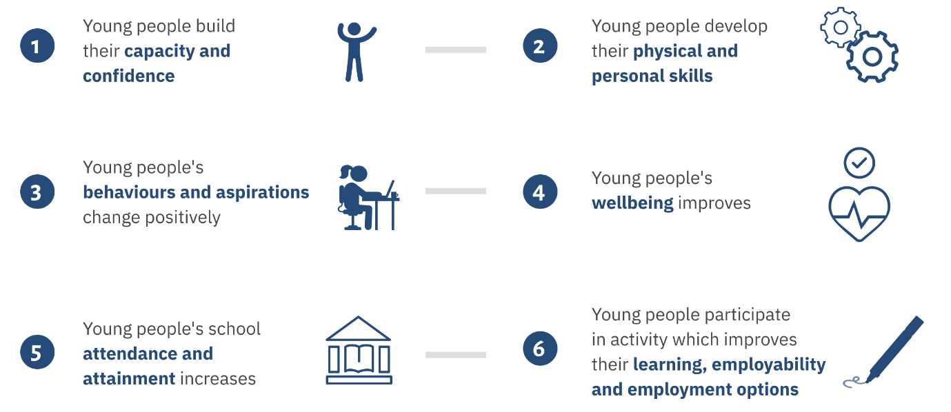
Overview of Way2Work
- As part of Phase 4 of the CashBack for Communities programme, Bridges Project received £393,183 to deliver the Way2Work programme. Way2Work was designed to support vulnerable young people from Midlothian and East Lothian to transition from school or unemployment into positive destinations, such as employment, further education or training.
- The programme targeted young people aged 14-21 who are disadvantaged or marginalised due to various circumstances. These included young people who were:
- looked after or care-experienced;
- young carers;
- experiencing mental health issues;
- living in areas of deprivation or households living in poverty;
- disengaged in education; and/or
- affected by Adverse Childhood Experiences (ACEs).
- Way2Work supported 446 young people over the three years of Phase 4, exceeding its target of 360. Table 1.1 includes a breakdown of the total participants and new referrals by year.
Table 1.1: Participants and new referrals by year
 | Year 1  (2017-18) |  | Year 2  (2018-19) |  |  | Year 3  (2019-20)
Participants | 173 |  |  | 282 |  |  | 446
New referrals |  | 109 |  |  | 164

Approach and methodology
Evaluation aims
- In designing Way2Work, the Bridges Project identified targets related to outcomes and indicators, drawn from the CashBack logic model, which it intended Way2Work to deliver over the three-year funding period. Like other CashBack partners, monitoring and evaluating the delivery of Way2Work was a key requirement.
- Blake Stevenson’s role was to independently evaluate the progress of Way2Workin delivering the funded outcomes and to add value to the self-evaluation activity. Our evaluation methodology is summarised below.
Methodology
- We used a mixed-methods methodology over the three-year evaluation period. Our evaluation activities included interviews and focus groups with young people involved in the programme; interviews with Bridges Project staff and parents/carers of participants; and consultation with external stakeholders such as school staff and training providers.
- We also analysed quantitative and qualitative data collected by Way2Work including case files and results of baseline and follow-up Employment Skills Assessment (ESA) and SHANARRI surveys conducted with young people.
- The SHANARRI questionnaire involves young people rating themselves on a scale of one (low) to five (high) on eight different aspects of wellbeing:
S | Safe | A | Active
H | Healthy | R | Respected
A | Achieving | R | Responsible
N | Nurtured | I | Included
- The questionnaire is used to track any changes in a young person’s attitude toward their wellbeing.
- The ESA requires young people to assess, on a four-point scale from ‘I need lots of help’ to ‘I am good at this’, their competency in 22 different areas including confidence, self-esteem, communication and career decisions. The ESA was completed on more than one occasion, which enabled the young person and their Support Worker to measure progress over time.
- Table 1.2 provides a summary of our evaluation activity by year.
Table 1.2: Evaluation activity by year
Evaluation activity | Year 1 | Year 2 | Year 3
Interviews with young people | 7 | 15 | 8
Focus groups with young people | 1 | 0 | 1
Stakeholder survey responses | 20 | N/A | 10
Stakeholder interviews | 4 | 5 | N/A
Parent/carer interviews | 0 | 3 | 2
Bridges staff interviews | 2 | 2 | 3
SHANARRI survey responses (administered by Way2Work) | 74 | 57 | 70
Employability Skills Assessment (ESA) survey responses (administered by Way2Work) | 107 | 62 | 73

Challenges for the delivery and evaluation of Way2Work
- In November 2019, the Bridges Project and staff were heavily impacted by the death of Jim Boyle, the then Chief Executive who had led the organisation for more than 30 years. He helped build the charity since it was established in 1985 and he led the team, was a key advocate for disadvantaged young people and his work and commitment in the sector helped secure financial backing for the Bridges Project.
- As noted above, Way2Work collected quantitative data from participants through ESAs and SHANARRI surveys. It also carried out questionnaires with stakeholders and requested data from schools to evidence achievement of the targets. However, there were challenges throughout Phase 4, particularly in Years 1 and 2, in collecting some of this data.
- For example, ESA and SHANARRI data was not available for a significant number of young people. For example, ESA scores were available for 62 of the 175 young people who engaged with the programme in Year 2, and similarly SHANARRI scores were available for 57 of the 142 young people who engaged in group activities. While the number of responses increased in Year 3, and the evaluation activity that we undertook supplements this, the shortfall in data submitted impacts on the extent to which progress against the targets can be accurately measured.
- Similarly, there were some issues in collecting data from schools about young people that could be used to evidence progress towards targets, in particular those related to school attendance and attainment. While in Year 2 programme staff finalised a data-sharing agreement with Midlothian Council, issues in receiving school-related data continued throughout Phase 4, both in Midlothian and East Lothian, and again this limits the extent to which progress towards the targets can be accurately measured.
- There were also some challenges around the stakeholder questionnaires administered by Way2Work, with no questionnaires completed in the first quarter of Year 3.
- Although the Phase 4 delivery effectively supported 446 young people, the Phase 5 application for CashBack funding was unsuccessful and with the time-limited resources, and the COVID-19 pandemic, the three staff delivering Way2Work work were placed on furlough leave through the Government’s Job Retention Scheme at the end of April 2020 and their posts made redundant at the end of June. Before they were furloughed, the staff ensured that the young people who required continued support were referred to other programmes delivered by the Bridges Project or to other local support organisations.
- Finally, the COVID-19 pandemic has limited some elements of our Year 3 evaluation activities. While we had completed most interviews and groupwork observation before lockdown commenced, we had to cancel our plans to observe another group taking place at a school, and instead carried out telephone interviews with four of the participants. We were also unable to carry out a final visit to the Bridges Project office to undertake outstanding reviews of data held there such as case files and profile information.
Structure of the report
- The remainder of the report is structured as follows:
- In Chapter 2, we provide an overview of Way2Work’s programme delivery model
- In Chapter 3, we explore the impact of the programme on the young people involved
- In Chapter 4, we summarise the key findings from the evaluation over the three-year evaluation period.
- Programme delivery
Bridges Project management and team
- Bridges Project is a charity that aims to help young people in East Lothian and Midlothian to manage the transition from adolescence to young adulthood and life beyond school. In addition to Way2Work, the Bridges Project delivers other services related to education and helping young people reach positive destinations. The organisational structure is summarised in Figure 2.1.
Figure 2.1: Bridges Project organisational structure
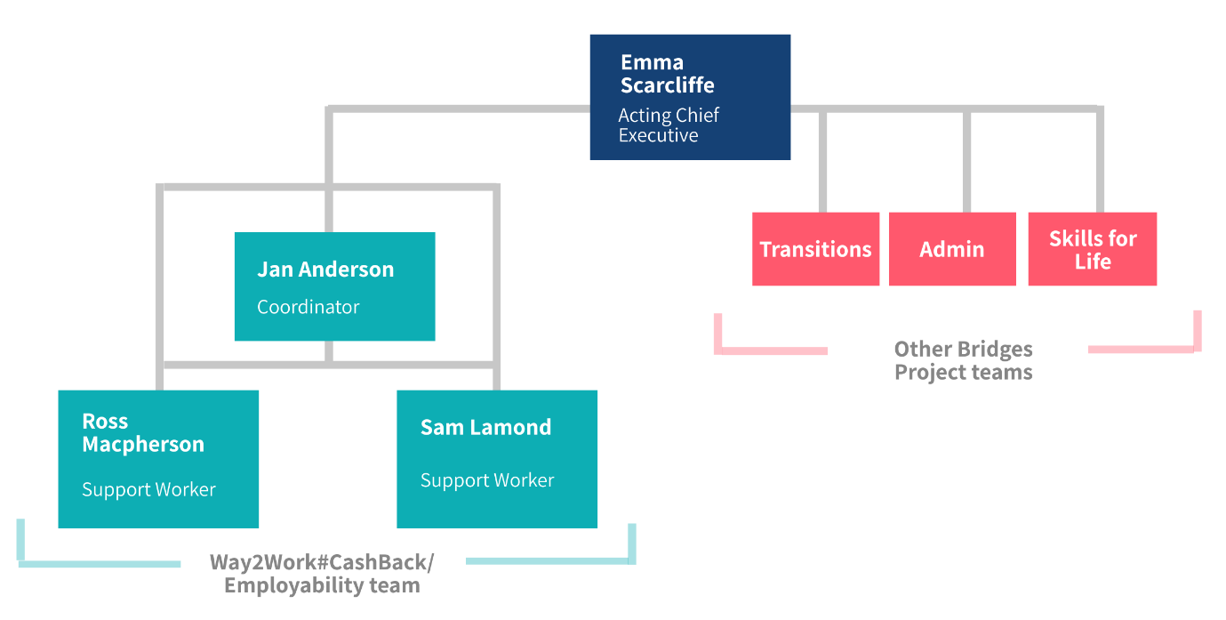
Funding
- Bridges Project was awarded £409,000 to deliver Way2Work over three years from 2017 to 2020. Table 2.1 shows that the programme cost £408,966 across the three-year period.
Table 2.1: Way2Work expenditure 2017-20
Expense | Expenditure (£)
Year 1 programme activity | 111,477
Year 1 other costs | 18,818
Year 1 Sub total | 130,295
Year 2 programme activity | 103,313
Year 2 other costs | 19,032
Year 2 Sub total | 122,345
Year 3 programme activity | 130,977
Year 3 other costs | 25,349
Year 3 Sub total | 156,326
TOTAL | 408,966

Programme content
- Way2Work supported young people through individual one-to-one support and group sessions.
One-to-one support
- Many young people referred to Way2Work received one-to-one support from the programme’s Support Workers. The Workers worked closely with the young people to learn about their personal circumstances, abilities and needs, and used a tailored approach to help identify employment sectors of interest to them and to build the employability skills and confidence required to work in those sectors.
- One-to-one appointments provided the young person and their Support Worker an opportunity to reflect on the young person’s progress, achievements and issues since the previous appointment. They also involved a discussion of any actions to be taken forward into the future and/or the next meeting. Between meetings, the young person and their Support Worker kept in touch, typically via text but also through phone calls and emails.
Group work
- Way2Work also delivered group activities and courses aimed at supporting the young people to develop new skills and improve their employment prospects. Descriptions of these groups are provided below:
- PX2 and Mindbuzz – both of these courses focused on building confidence and self-esteem and setting goals for the future. They also helped participants to enhance other important life skills such as communication, effective thinking and resilience.
- Preparation for Employment and Developing Confidence for Employment - both groups offered employability support to young people, including CV writing and interview skills, while they worked towards an SCQF Level 4 qualification, with Developing Confidence for Employment being tailored towards those young people who were most distant from the labour market. –
- Build You Up - formerly known as the Morrison Construction group in Year 1, this was enhanced and re-introduced for Year 3. It involved a tailored, six-week programme which helped young people to build an understanding of the construction industry and the qualities and skills required to work in the industry.
- Animal Care – involved weekly group activities aimed at young people interested in working with animals and enabled them to work towards an SQA-recognised qualification.
- Tenancy Award – a weekly group aimed at young people with issues around housing and homelessness. Delivered in partnership with Borders College, young people received support with housing and worked towards an SQA-accredited award.
- Construction Skills Certification Scheme – sessions which enabled young people to work towards obtaining a CSCS card, which provides certification for a range of construction jobs.
- First Aid at Work – a course that explored several aspects of first aid, including the recovery position, CPR for adults, children and babies, choking, bleeding and shock.
- Royal Environmental Health Institute of Scotland (REHIS) Health & Safety course - sessions for young people interested in learning about health and safety in the workplace (introduced in Year 2).
- While these were the core groups on offer in Year 3, in some cases, Support Workers helped participants to access other courses specific to their aspirations. For example, a social enterprise called Heavy Sound delivered a course focused on sound production at Bridges Project for young people interested in working in that industry.
Profile of participants
- Due to the COVID-19 pandemic, we were unable to visit Bridges Project’s office at the end of Year 3 to access the paper files required to collate participant profile data related to ethnicity, age or disability. However, Way2Work was able to provide data related to gender and SIMD profile, which we have presented in Figure 2.2.
Figure 2.2: Gender and SIMD profile of all participants (Year 1 to Year 3) (n=446)
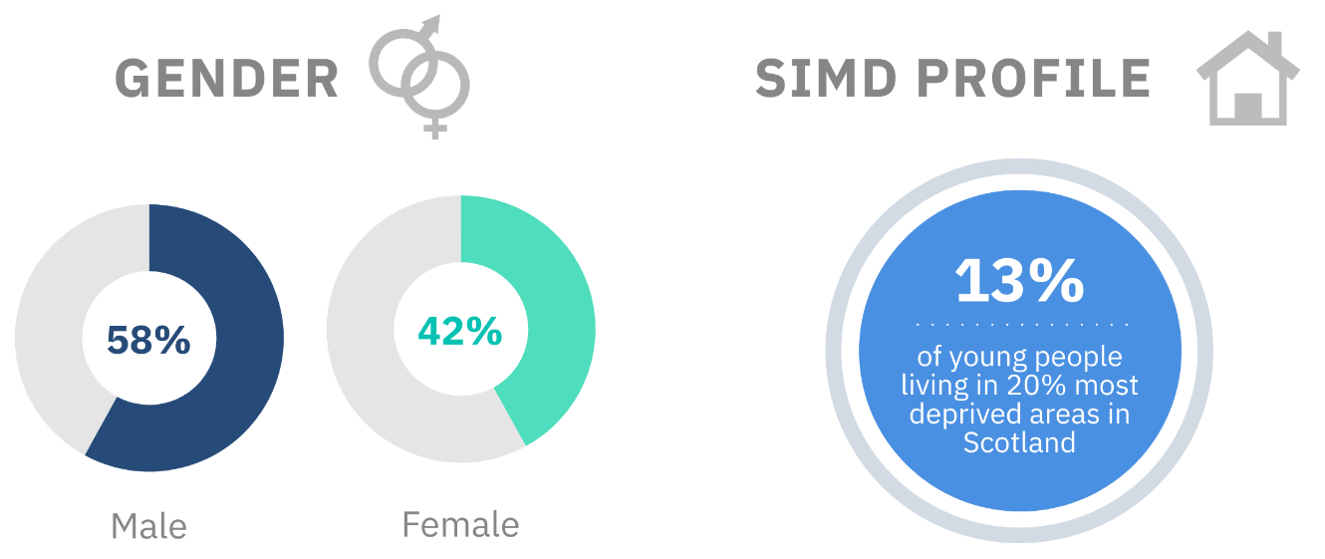
- Figure 2.2 shows that 58% of participants in Way2Work were male and 42% were female. The young people involved represent the full range of SIMD classifications, with 13% living in neighbourhoods classified as among the most deprived quintile in Scotland.
- The Way2Work team supported young people who are disadvantaged by many indicators of vulnerability, such as mental and physical health conditions, chaotic home lives and social isolation. Way2Work collected data about these indicators from a snapshot of 38 young people supported by the programme. We analysed this data and found that:
- 71% of participants experienced confidence issues or low self-esteem;
- 58% had low school attendance;
- 47% had been bullied at school;
- 39% had CAMHS involvement; and
- 32% had social work involvement.
- This shows that Way2Work supported young people with a range of challenges that they required support with to help them move towards positive destinations. We discuss the impact of the programme on the young people in the following chapter.

- Impact of Way2Work
- This chapter considers whether Way2Work met its intended outcomes, and discusses the overall impact of the programme in Year 3 and across Phase 4.
- The analysis is based on a range of evidence collected by Way2Work and Blake Stevenson during the evaluation. This includes data gathered through interviews, focus groups, surveys and analysis of ESA and SHANARRI scores.
- This chapter also includes three case studies of young people supported in Year 3. The names of the young people in the case studies have been changed in order to preserve their anonymity.
- The data presented in this chapter indicates that Way2Work has not met some of the targets it had identified for Phase 4. This, however, does not detract from the value of the support it delivered to young people nor the positive outcomes it achieved. Various factors have contributed to some of the targets being missed, in addition to the data collection issues highlighted in Chapter 1, and we outline these where relevant throughout this chapter.
- We present data related to the outcomes and indicators set for Phase 4 in Figures 3.1 to 3.7. This data is based on evidence collected by Way2Work, and data related to feedback from stakeholders is taken from a stakeholder questionnaire conducted by Way2Work. However, it is important to note that no stakeholder questionnaires were collected in the first quarter of Year 3, and this has affected the overall total.
- It is also important to note that Blake Stevenson carried out a separate survey of stakeholders. We refer to results from this survey throughout this chapter, but it is important to note that this is separate to the questionnaires conducted by Way2Work and has not been included as evidence related to indicators achieved in Figures 3.1 to 3.7.
Outcome 1: Young people build their capacity and confidence
- Way2Work continued to have a positive effect on participants’ capacity and confidence in Year 3. As in Year 1 and Year 2, all targets related to young people (YP) building their capacity and confidence were achieved in Year 3.
Figure 3.1: Capacity and confidence 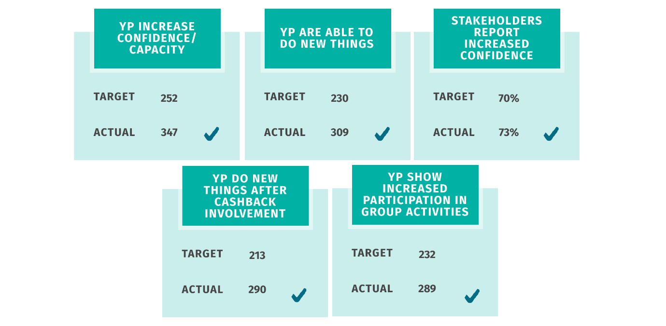
- Throughout the three years of Phase 4, the young people who took part in Way2Work described how the programme enhanced their confidence and capacity to try new things. Participants praised Way2Work for its “supportive, kind, caring and helpful” approach, which they said pushed them out of their comfort zone without being too intimidating, and this helped to improve their confidence.
- Stakeholders and parents/carers agreed with this. Parents/carers who took part in the evaluation reported that they observed improvements in their child’s confidence as a result of Way2Work, and all stakeholders who took part in our survey in Year 3 (10) agreed that Way2Work helped young people to improve their confidence and made them more able to try new things.
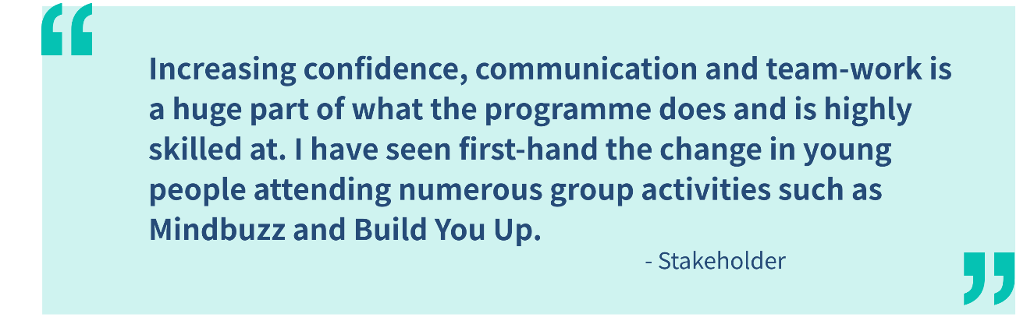
- Young people throughout Phase 4 described examples of how the increased confidence they gained through taking part in Way2Work enabled them to do things that they were unable or reluctant to do before. Interviewees gave examples such as applying for jobs, attending job interviews, using public transport independently to attend meetings with Way2Work, attending meetings at school and becoming more involved with the community through activities such as volunteering, drama, gardening and sports.
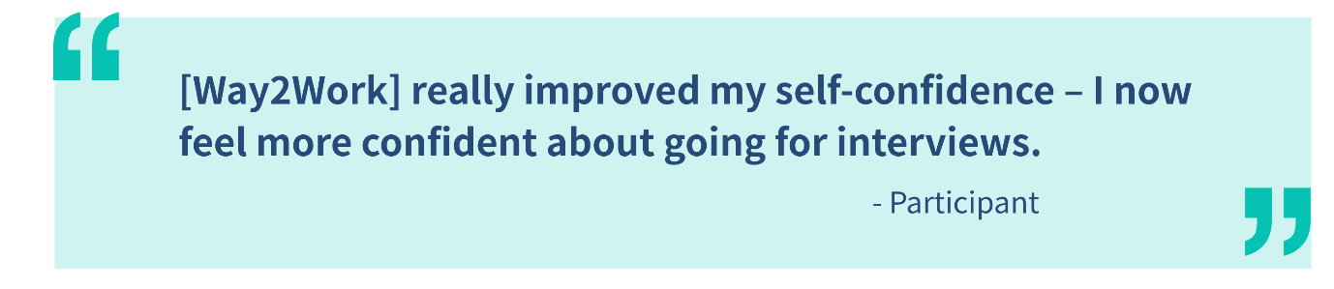
- Young people and stakeholders also reported that Way2Work enhanced participants’ confidence in social situations. Interviewees said working with the programme, and in particular groupwork sessions, had helped them to feel more comfortable when meeting and interacting with new people and working in a group. One said, for example, that “[Way2Work] has drastically improved my confidence with social interactions” and another said “I have a lot more confidence speaking to people”.
- One parent/carer gave an example that working in a group had helped her son to increase his confidence. She said he was very quiet and nervous when he first joined the programme and reluctant to open up but, as time went on, he became more confident speaking in the group. She also said that the programme “helped him to gain some independence” by giving him experience of travelling to and attending sessions on his own.
- The case study overleaf provides a detailed example of Way2Work’s impact on one participant’s confidence and capacity.

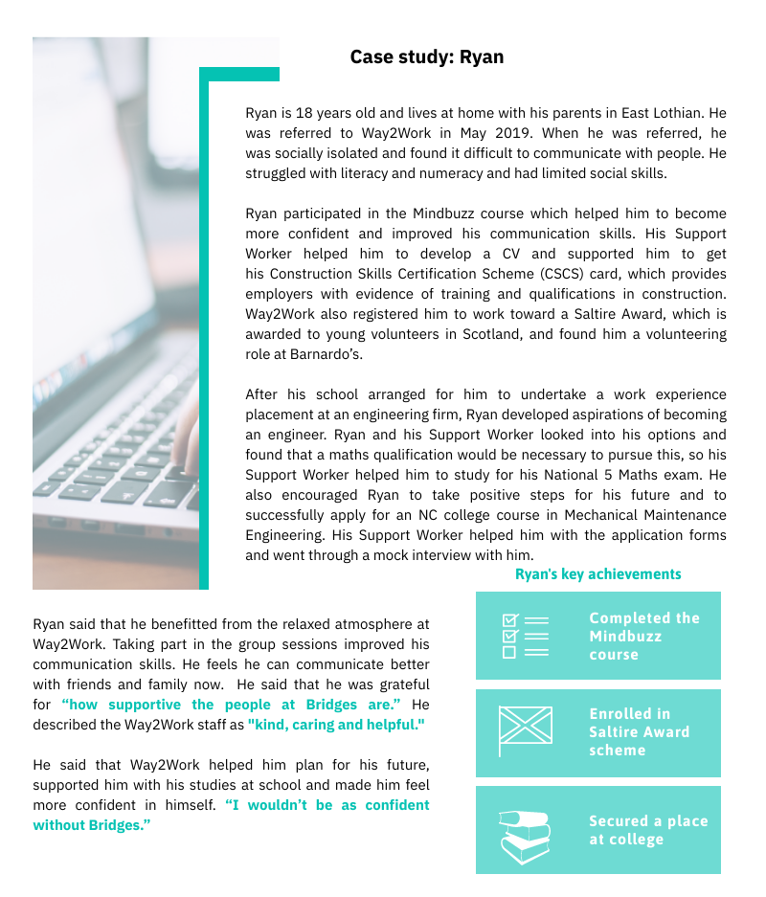

Outcome 2: Young people develop their personal and/or physical skills
- For the third year running, Way2Work met all targets related to young people developing their personal and physical skills.
Figure 3.2: Personal and physical skills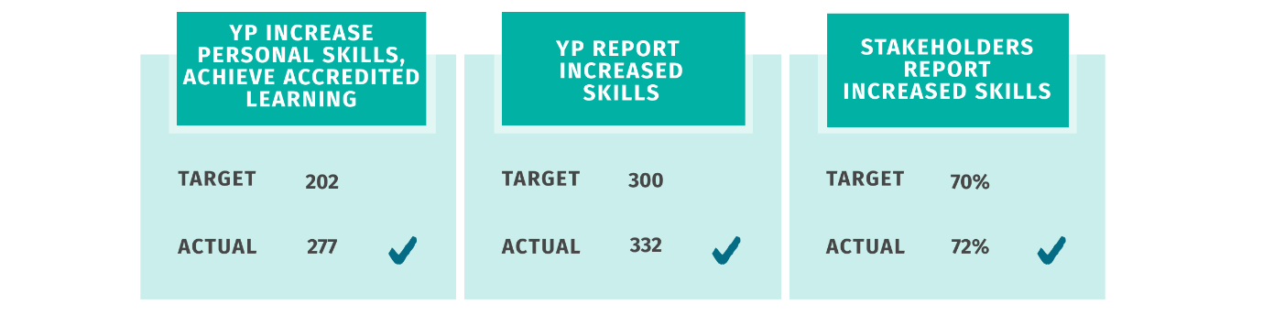
- Throughout Phase 4, participants and stakeholders reported that Way2Work supported young people to build a range of hard and soft skills. Participants praised Way2Work for the “relaxed environment” where they were “treated as an adult” but where they were also given a taste of “the real world”. They felt this approach suited them better than school and helped them to achieve learning goals that they might not otherwise have done.
- Data collected by Way2Work shows that 332 young people involved in Way2Work increased their skills and 277 achieved a recognised SCQF qualification or accreditation, which exceeded the target by 75 young people.
- The qualifications that young people achieved included school-based qualifications such as Maths, English and ICT, as well as others related to food hygiene, fire safety and construction. The majority of the accreditations achieved by young people across Phase 4 were SCQF Level 4 (232), which is equivalent to a National 4 exam, and young people achieved 65 qualifications at SCQF Level 5.
- Way2Work’s impact on participants’ skills is further evidenced by the responses to the Employment Skills Assessment survey received from 73 participants in Year 3. This shows that 90 % showed an improvement and, for those that improved, the average increase between April 2019 and March 2020 was 10 points.
- Feedback from young people and stakeholders shows that the programme helped participants to develop a range of skills including the following:
- Skills related to looking for work, including job search, CV preparation and interview skills.
- Sector-specific skills and knowledge gained through group work and one-to-one support that will help young people to pursue a career in an industry that interests them. For instance, those who took part in the Build You Up programme reported improved understanding of the construction industry and improved relevant skills, and those who took part in the animal care group enhanced their skills in working with animals.
- Soft skills, relevant for all employment sectors, such as improved communication, teamwork, organisational skills, time management, self-awareness and an enhanced understanding of how their behaviour affects others.
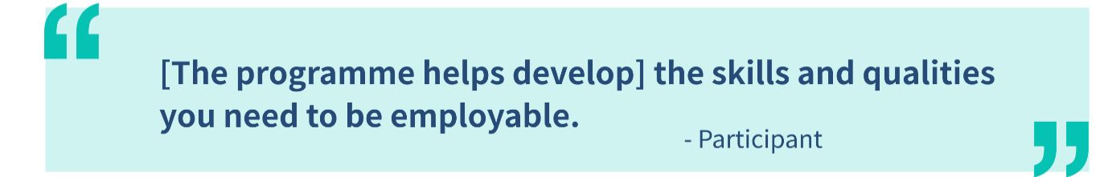
Outcome 3: Young people’s behaviours and aspirations change positively
- Way2Work achieved all of its targets related to changing young people’s behaviours and aspirations in Year 1 of Phase 4, but limitations in the number of ESA and SHANARRI assessments collected in Year 2 meant that the programme could not fully evidence the targets in Year 2 or Year 3. Figure 3.3 indicates that the programme has achieved five of the seven targets related to this outcome across Phase 4.
Figure 3.3: Behaviours and aspirations
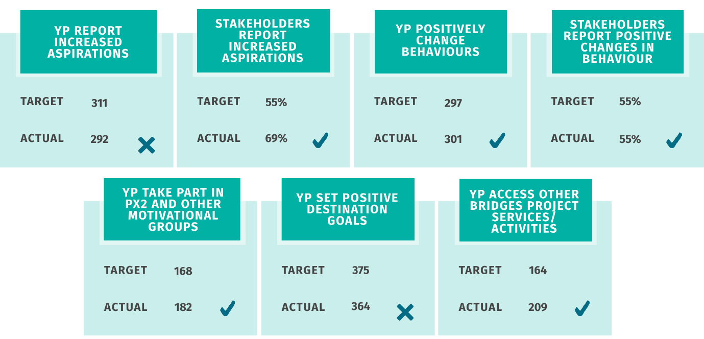
Improvements in behaviour
- The programme exceeded its target for Phase 4 in terms of young people positively changing their behaviour, with 301 noting improvements in this respect against a target of 297.
- Throughout Phase 4, during our interviews, young people and parents/carers identified a range of positive changes in behaviour through their involvement in Way2Work. For a few young people, these related to changes in their overall outlook on life, leading to a more positive attitude towards work and learning. Others reported reductions in risk-taking behaviour. For example, one interviewee in Year 3 said that they reduced their cannabis use as a result of engaging with Way2Work.
- Stakeholders agreed that the programme helped participants to improve their behaviour, with nine out of ten respondents to our survey in Year 3 (90%) reporting positive changes in this respect. Throughout Phase 4, stakeholders have provided various examples of positive changes in young people’s behaviour, such as showing more maturity, engaging more or getting on better with others in the group, and interacting better with adults.
Raised aspirations
- Although the data suggests the programme has not met its targets related to young people’s aspirations and destination goals, we received very positive feedback from young people, parents/carers and stakeholders about the impact of Way2Work on young people’s plans and aspirations for the future.
- A common theme among many participants was that they had low aspirations and lacked motivation to look and apply for jobs before engaging with Way2Work, but the programme helped to change this. Many noted that the programme helped them to identify employment sectors and opportunities of interest to them, and supported them to gain skills and experience necessary to work in that sector. This helped them to raise their aspirations, and increased their motivation to achieve the goals they had identified. One of our case studies presented later in this chapter (James) provides an example of a young person who was lacking motivation and was unsure what he wanted to do, but Way2Work helped him to identify and work towards positive destination goals.
- Others noted that they felt more motivated to apply for jobs because Way2Work had helped them to enhance their self-confidence and self-belief by helping them to gain new skills and qualifications. One participant, for example, said the programme “made me feel I have more potential” and a stakeholder noted that “Way2Work “has helped with regards wider recognition of achievements and in instilling a sense of belief and purpose to our pupils”.
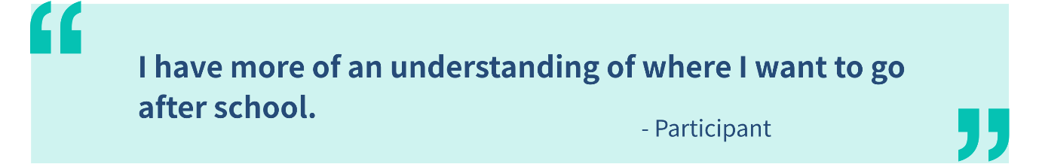
Outcome 4: Young people’s wellbeing improves
- Based on the available data, Way2Work met three out of four targets related to improving young people’s wellbeing in Phase 4.

Figure 3.4: Wellbeing
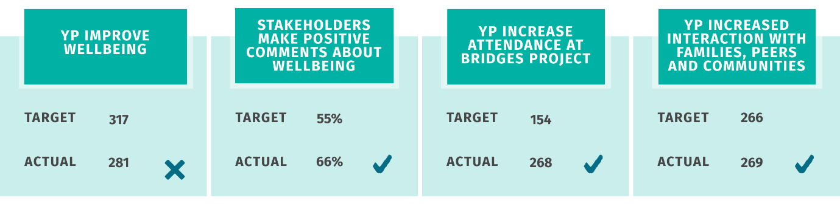
Young people improve wellbeing
- The target related to young people improving their wellbeing was not met but, again, this can be explained, at least in part, by the shortfall in SHANARRI surveys available for young people.
- Despite this, and as in Years 1 and 2, the data available from the 70 participants in Year 3 where SHANNARI data was available, indicates an improvement in young people’s wellbeing across all eight SHANARRI indicators.
- Figure 3.5 shows the average scores for each indicator and how these changed over time.
Figure 3.5: Average SHANARRI scores

- We discuss in more detail below the impact of Way2Work on participants’ wellbeing.

Managing personal issues
- Way2Work supported many young people who face a range of personal challenges including physical and mental health issues. In some cases, these were quite severe and posed serious challenges for the young people in moving towards positive destinations. For some, it was difficult just to leave their house.
- Throughout Phase 4, young people who took part in interviews reported that, by receiving tailored support from the staff to address their personal issues and being made to “feel welcome the minute you walk in the door”, they were able to address their challenges and make significant progress towards a positive destination. The case studies presented throughout this chapter provide examples of Way2Work supporting young people to address their challenges, improve their wellbeing and progress towards employment or further education.
- Some young people reported that their wellbeing had improved because Way2Work had helped them to become more aware of their own mindset and the consequences of negative thought. For example, in Year 2, a stakeholder commented that a young person’s “wellbeing has massively improved due to the PX2 course because he is now aware of how he thinks and it gives him a greater understanding of his negative thought process. [The group leader] always gives great real life examples to make this relatable”.
Improved social skills and relationships with others
- As noted above, in our discussion about the impact of the programme on participants’ confidence, we noted that participants enhanced their skills and confidence in interacting with other people. All stakeholders who responded to our survey in Year 3 (10) agreed that the programme helped young people to improve their relationships with peers and family members, and stakeholder interviewees in previous years of the evaluation felt that young people’s improved ability to socialise with others was evidence of an improvement in overall wellbeing now that they were “less socially isolated”.
- Earlier in Phase 4, a few young people reported that the programme improved their relationships with family. Examples of those positive changes include:
- reconnecting with a parent where contact had stopped;
- improved communication between young people and parents/carers; and
- spending more time with grandparents
- The following case study shows how Way2Work helped improve James’ mental and physical wellbeing.

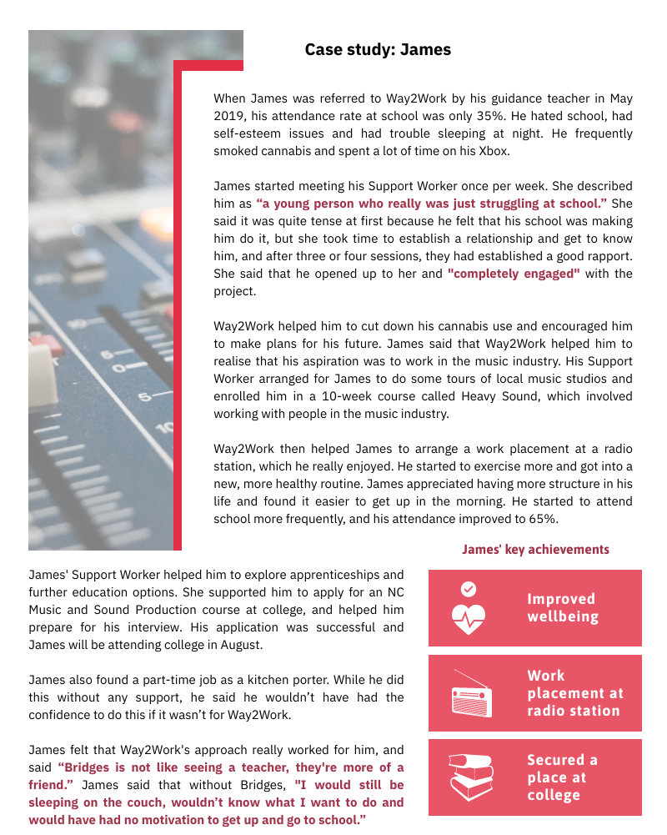

Outcome 5: School attendance and attainment increases
- Way2Work did not meet the targets related to young people’s attendance and attainment at school in Phase 4. However, there are various mitigating factors for this:
- As noted in Chapter 1, the programme had issues throughout Phase 4 in collecting data from schools that could be used to evidence progress towards targets, and this has affected the ability to hit targets.
- The timing of receiving information from the schools has also had an effect on the amount of data that can be reported. For example, most young people who engaged with the programme in Year 3 will not receive confirmation of the qualifications they have achieved until August 2020 so the target for young people leaving with more qualifications than expected cannot be accurately reported at this point.
- Also, the figures provided below represent progress towards cumulative targets over the full Phase 4 period, but no information was collected on progress during Year 1 of the programme. Therefore, the data presented here relates to a two-year period but with a three-year target.
- Additionally, the target related to Staged Assessment Intervention (SAI) meetings was redundant. SAIs are no longer used consistently across schools to plan a young person’s care and support so there is no data on this target. Young people can be involved in a variety of alternative meetings, such as Multi-Agency Meetings, Child Protection Meetings and Involved Professional Meetings – and not all of these will involve the young person and/or their parents or carers.
- Finally, but importantly, Support Workers pointed out that, because many of the young people they supported were already disengaged from school, using school-based indicators was not the most appropriate way to measure their progress. They noted that, for these young people, while they might not have improved their attendance or attainment at school, they often made significant progress in other ways through, for example, securing employment or a place at college.

Figure 3.6: Attendance and attainment
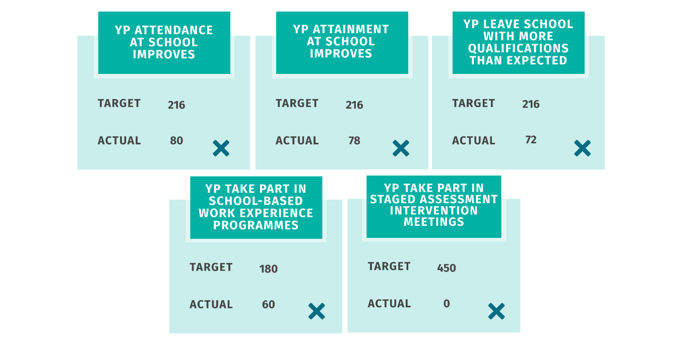
- Despite the issues around data collection, the evidence collected by the programme shows that 80 young people improved attendance at school and 78 improved their attainment across Phase 4.
- Some interviewees explained that their participation in the programme was an incentive to attend school. In some cases, this was because young people knew they had to attend school to be granted permission to attend Way2Work. For example, a stakeholder in Year 2 reported that many of the young people’s attendance at school increased by taking part in PX2 because they enjoyed the group and “they don’t want to blow it”.
- In other cases, the programme provided an incentive for participants to improve both their attendance and attainment. Way2Work helped participants to formulate career plans, and some interviewees explained this made them more motivated to attend school and to work hard to achieve the qualifications required to pursue that career.
- Some stakeholders reported that some young people engaged more with their learning and/or became more confident learners, while others communicated better and worked more effectively with their peers at school. One stakeholder gave an example of a participant who had “wanted to leave school but decided to stay on and get more qualifications”.
- Further evidence of the positive impact of the programme on young people’s attainment at school can be found in data provided by schools in Midlothian and East Lothian. Data was not available for each young person, but the information provided showed that, across Phase 4, 72 young people left school with more qualifications than expected. Information provided about 27 young people in Year 3 showed that they achieved 152 passes at various levels, and most qualifications achieved by these young people (86, 57%) were at National 4 level.
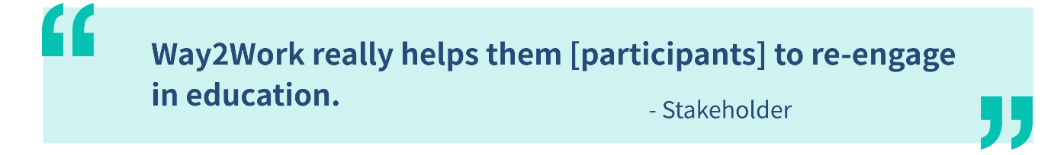
- In some cases, Way2Work provided important support that allowed participants to remain engaged with education even where they were unwilling or unable to attend school. For example, one parent/carer explained that although her son had not been attending school, his support worker acted as a “go-between” and was regularly in touch with his school to report on his progress. He also provided maths tuition and collected exam papers from the school for her son to sit under exam conditions. Some stakeholders gave similar examples. One said that Way2Work “provides an alternative educational package for young people with complex needs, providing essential partner support for schools.”
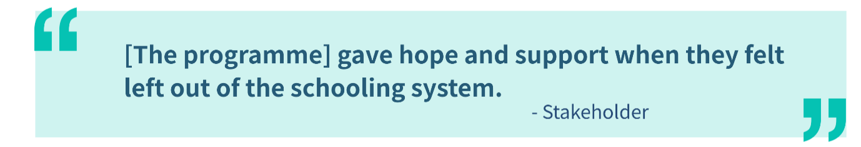
Outcome 6: Young people participate in activity which improves their learning, employability and employment options (positive destinations)
- Way2Work met two out of seven targets related to Outcome 6. However, again, there are mitigating circumstances for the shortfall. The gaps in data collected outlined above meant that there was incomplete evidence of the extent to which the programme improved participants’ learning, employability and employment options.
- Additionally, there has been a time lag in gathering data on positive destinations - destination data for young people leaving school at the end of the 2019/20 academic year was not available at the time of writing this report.

Figure 3.7: Learning and employability
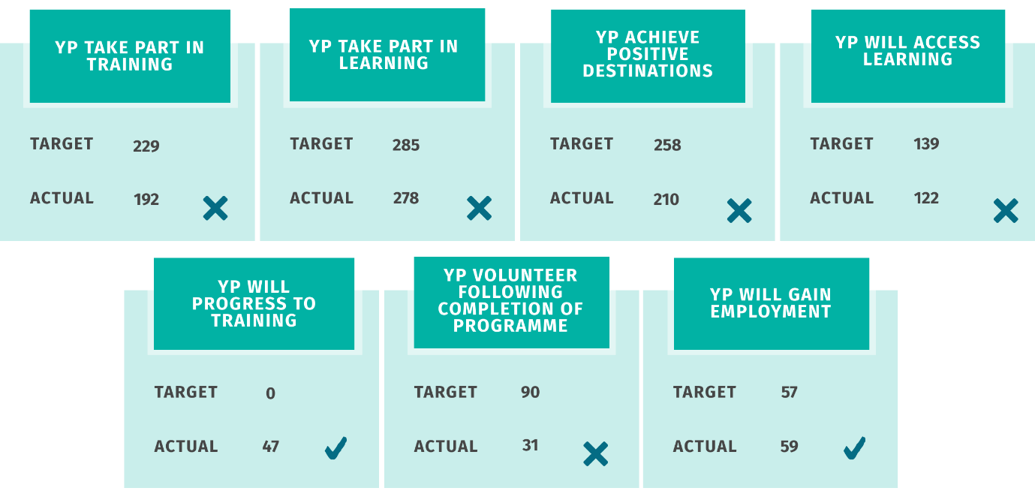
- Although not all targets were met, the data shows that Way2Work supported significant numbers of young people to make progress towards positive learning, employability and employment destinations. For instance, at least 210 young people achieved positive destinations, which is 81% of the target of 258, and 59 participants gained employment, in excess of the target of 57.
- Young people highly valued the support that Way2Work provided in planning their future. Many said that their Support Worker spent one-to-one time with them helping them to look into different options for the future and helped them to make steps toward positive destinations. Support Workers helped by organising work placements, volunteering opportunities and supporting college applications.
- Many young people described how the Way2Work programme had provided them with new opportunities to learn and explore future careers. Young people generally agreed that the programme had opened up new doors for them, and support with identifying job opportunities, developing CVs, making applications and preparing for interviews helped them to “think about what I want to do”, “made me focus on what I wanted to do”, “plan my future” and “to prepare for the real world”.
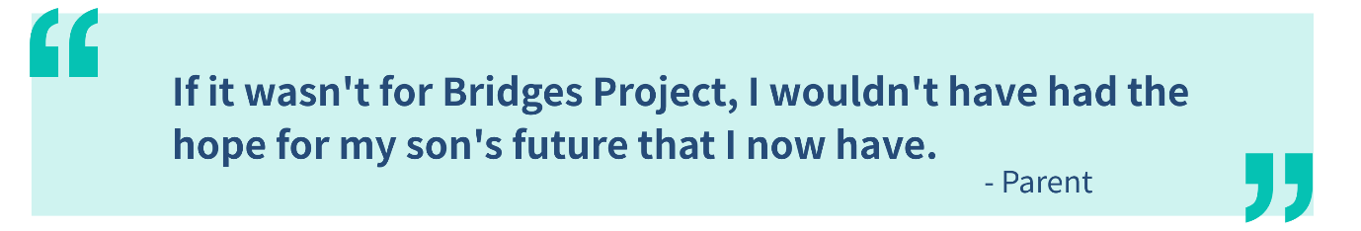
- Figure 3.8 illustrates the types of destinations achieved by young people in Year 3.

Figure 3.8: Positive destinations achieved by Year 3 participants
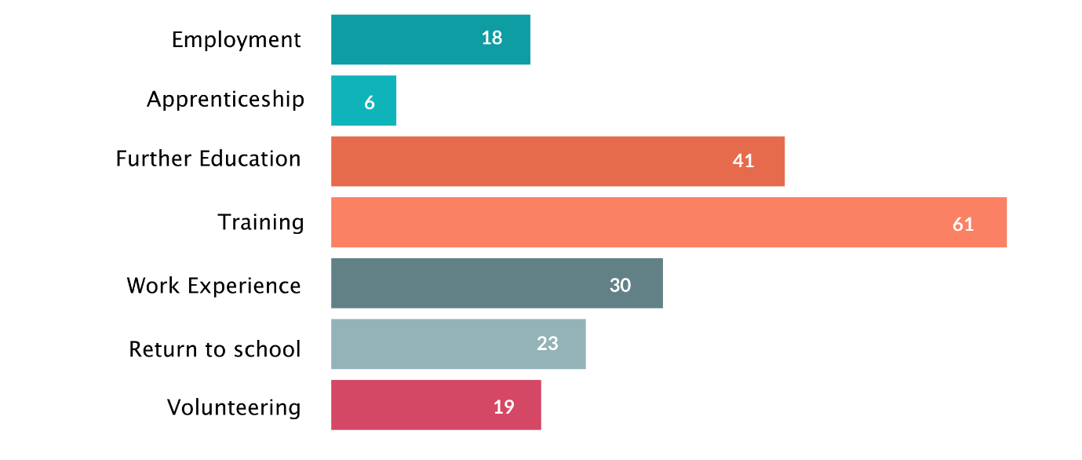
- Some of the examples of the types of destinations that young people have moved into throughout Phase 4 include:
- making a successful application to college to study music and sound production;
- taking part in volunteering opportunities in the community;
- moving into employment in the construction industry;
- securing a part-time job in a supermarket;
- starting an HGV mechanic apprenticeship; and
- moving on to a retail course at Fort Kinnaird (shopping complex).
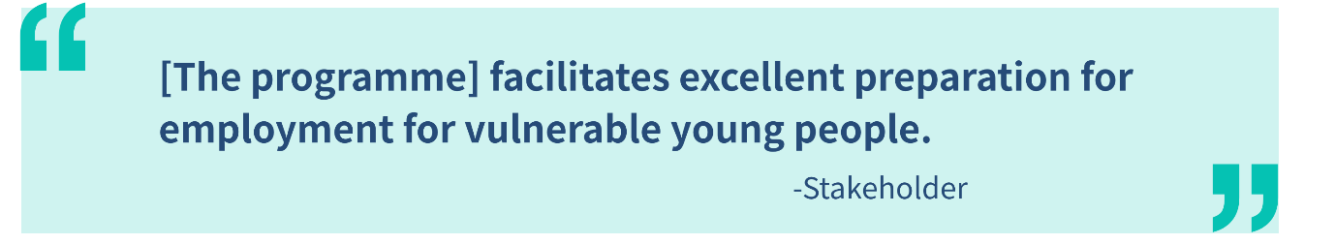
- The case studies presented earlier in this chapter provide examples of young people that Way2Work supported into a positive destination – both Ryan and James obtained a place at college with Way2Work’s support. The following case study provides another example, where Way2Work helped Oliver to plan his next steps toward a positive destination after sustaining a serious injury.
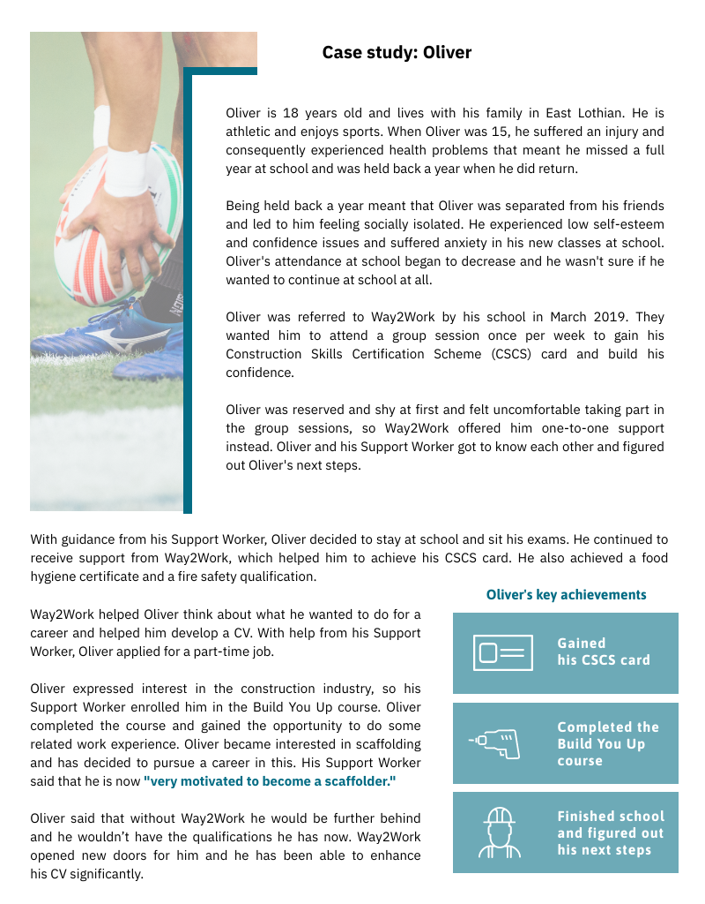
- Summary and learning points
Summary of activity
- Our evaluation of Way2Work has found extensive evidence of the positive impact that the Way2Work programme has had on the disadvantaged young people that it supported. Overall, the programme achieved most of its outcomes, and exceeded targets for many. Young people and stakeholders provided overwhelmingly positive feedback about the programme and its impact in helping participants to become more confident, gain new and enhanced skills, achieve qualifications, improve their wellbeing, raise their aspirations, plan for the future, and to progress towards positive employment and/or further education destinations.
- While some of the quantitative targets were not met, there are various mitigating circumstances that help to explain this, including challenges around data collection and the timing of the evaluation that does not capture the full longer-term effect of the support on the young people. Challenges around collecting data from schools and young people mean that the quantitative outcomes data presented in this report perhaps under-estimates the full extent of the impact of Way2Work on young people.
- It is important to emphasise that, despite the shortfalls in some of the quantitative targets achieved, the project has provided valuable support for 446 young people and the positive outcomes achieved for the young people are confirmed both by data collected by Way2Work and through our evaluation activities.
- Participants reported that they responded well to the supportive and caring approach of Way2Work staff. Young people said that Way2Work enabled them to learn new skills, gain new experiences and helped them to prepare for the real world in a supportive environment. A common theme among participants was that the relaxed, informal environment and the fact they felt they were “treated like an adult” was in contrast to their experience of school and helped them to achieve learning and qualifications that they feel they would have been unable to at school. This indicates that the programme was particularly beneficial for young people who were disengaged from school and whose learning styles were not best suited to academic school-based approaches.
- There are many examples of the tailored and comprehensive support provided by Way2Work helping participants to address the challenges they face to moving towards employment, identify employment sectors of interest to them, plan for the future, increase their aspirations and motivation to work towards the goals identified and, in many cases, successfully transition into or make progress towards a positive destination.
- Unfortunately, Bridges Project’s application for funding through Phase 5 of the CashBack for Communities programme was not successful. As a result, with no alternative funding available, Way2Work has ceased to operate. The Support Workers have been made redundant and participants who still required support referred on to other local support organisations.
- However, the programme leaves a positive legacy in terms of the impact it had on the young people it supported and the positive destinations they have achieved or are yet to achieve as a result of the support delivered.
- We have identified some learning points below that could help Bridges Project or other in its delivery of similar services and other organisations working with disadvantaged young people or those disengaged from education.
Learning points
Collecting data from young people: Way2Work encountered challenges throughout Phase 4 in collecting quantitative impact data from young people. Large numbers did not complete the ESA and SHANARRI assessments, and this limits the evidence available about the impact of the programme and meant that some targets were not achieved. In future, it would be beneficial for services delivered by Bridges Project to consider approaches that will encourage more young people to provide evidence by considering the most engaging and effective methods for collection, the timing of the evidence collection and ways to incentivise completion.

Collecting destination data: There were challenges around collecting data about young people’s destinations after leaving Way2Work. This can be difficult for many projects when their engagement ends and it would be beneficial for Bridges Project to explore ways to systematically collect data about the destinations achieved by the young people it supports through the services that routinely collect this data within the local authority and/or from the young people themselves, e.g. a telephone call or text message six months after the young person has been discharged from the service.

Collecting data from schools: A further challenge around data collection related to data from schools about the young people supported by Way2Work. The project worked hard to secure data sharing protocols with the relevant local authorities, but this did not translate into receiving regular data from the relevant schools. It would be beneficial to have a frank discussion with schools about what data can be provided and the timing of access to that information so that data like attainment and attendance can be accurately reported.

Capturing the complex profiles of young people: Often the programme collected information on participants’ ethnicity, disabilities, care experience, young carer status, mental health issues, and other indicators of vulnerability and recorded it in the paper case files but did not collate or analyse it for this project. Ensuring that this data is used to provide a richer understanding of the diversity of young people supported by Bridges Project is an important consideration for the future.

Agreeing appropriate targets for the project being delivered: Way2Work did not meet its targets around attendance and attainment at school. However, programme staff noted that school-based measures were not appropriate indicators of progress among this group of young people, who were often disengaged from school. While services will always need to tailor their intended outcomes and indicators to the priorities set by funders, it would be beneficial, as far as possible, for Bridges Project to minimise the extent to which it commits to achieving school-based outcomes.

Importance of a tailored and informal service: Participants responded well to the comprehensive, tailored, informal and relaxed support provided by the Way2Work Support Workers, and this reinforces the importance of services delivered across Bridges Project continuing to take this approach.

Value of a mixed approach to delivering the service and one that addresses young people’s interests: Participants valued the combination of groupwork and one-to-one support, especially those tailored to specific sectors including construction and animal care. Continuing this approach and expanding this offering to include other sectors, such as retail or hospitality in line with young people’s interests and in sectors with job opportunities could be another possibility for Bridges Project.

This included observation of a session of groupwork activity with four young people before we held a focus group with the four young people.
We carried out an online survey of stakeholders in Year 3 instead of interviews.
One Way2Work staff member has since started a new position within the Bridges Project.

