CashBack Change Cycle Programme
Year 3 Report

2020

Programme Overview

CashBack Change Cycle is an employability programme for young people aged 16-24, who are not in work, education or training, facing long term unemployment and disadvantage as well as potentially at risk of (re-)offending or anti-social behaviour. It is designed to equip participants with the core skills needed to build longer term stability, the support to enter into learning or work and the space to reflect on and change harmful behaviours. These can in turn help to avert repeat or potential episodes of homelessness, involvement in criminal justice or other damaging activity.

Following referral, potential participants are contacted by a designated Employability Support Worker, and are met for assessment and if appropriate, preparation for the three-week course. The course then starts with two weeks of workshop training, where days are split between bike building/maintenance (delivered by our partners Bike Station and Bike for Good, and working towards either Velotech Bronze: Cycle Maintenance or City and Guilds level one: Bike Maintenance Awards), and employability skills training: CV writing; interview techniques; and building a working routine. Participants can also complete SQA Award in Employability to demonstrate to future employers the skills and commitment young people have gained.

Week three is a five-day residential. Group based activities (hill-climbing, abseiling, biking) and problem-solving challenges introduce personal development concepts such as establishing trust/safe spaces; responsibility/accountability; emotion management; goal setting; confidence and resilience building and giving/receiving feedback, as well as the obligations of communal living and healthy eating. Participants lead activities, taking on group roles (navigator, session leader, energizer) with staff acting as facilitators. Mentoring is also encouraged, with participants supported to coach each other through shared experience and group-based problem solving. Every activity is front-loaded with discussion about skills individuals hope to develop and interspersed with reflection upon what they have learnt and how this can be applied at home. One-to-one support sessions use Kolb’s Learning Cycle- ‘Plan-Do-Review-Transfer’ to embed and individualise this learning. Participants prepare action plans, designed to set personalised goals for the weeks and months following their return, and direct ongoing support. These skills can also help participants maintain the relationships and tenant responsibilities that ensure stable living situation.

Sessions in the wilderness include:
- First Aid course.
- Conservation volunteering delivered by range of partners: demonstrating the principles of caring for local spaces, with signposting offered towards relevant community projects.
- Mountain Biking: introduction to activities/areas participants can access post-course to encourage outdoor usage and improve physical/mental health.
- Graduates keep their bikes for improved acess to employment/training, services and leisure opportunities.

During the final debrief there is an emphasis on celebrating achievement, to reinforce what participants have overcome and recognise successes, with certificate and photo slideshow of their journey.

Following the journey sessions are led by the individual’s needs and goals. Their dedicated Employability Worker works with the participant in one-to-ones through the Action Plan they created, coaching and brokering access to opportunities that match their skills and wants.

Workshop skills training and bike building qualifications, led by partners Bike Station Edinburgh, and Bike for Good Glasgow.
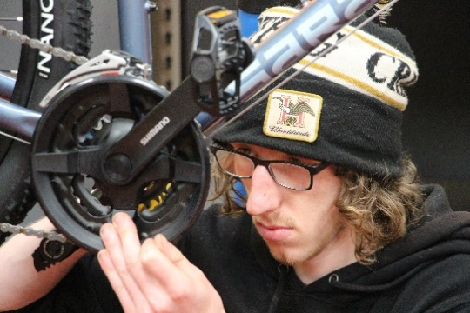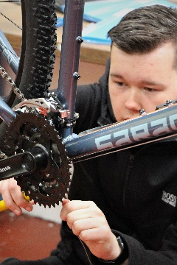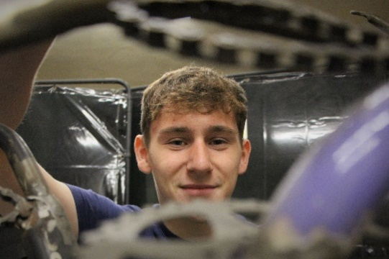
Introduction to off-road cycling and new areas for leisure and fitness.
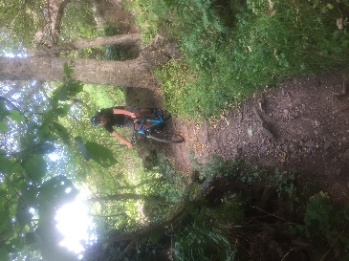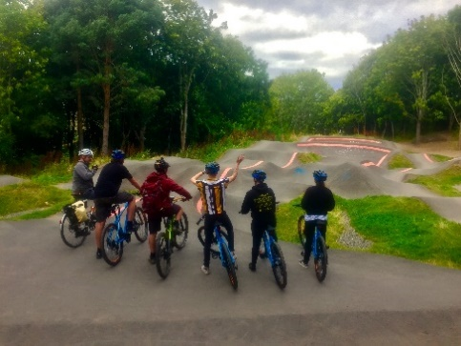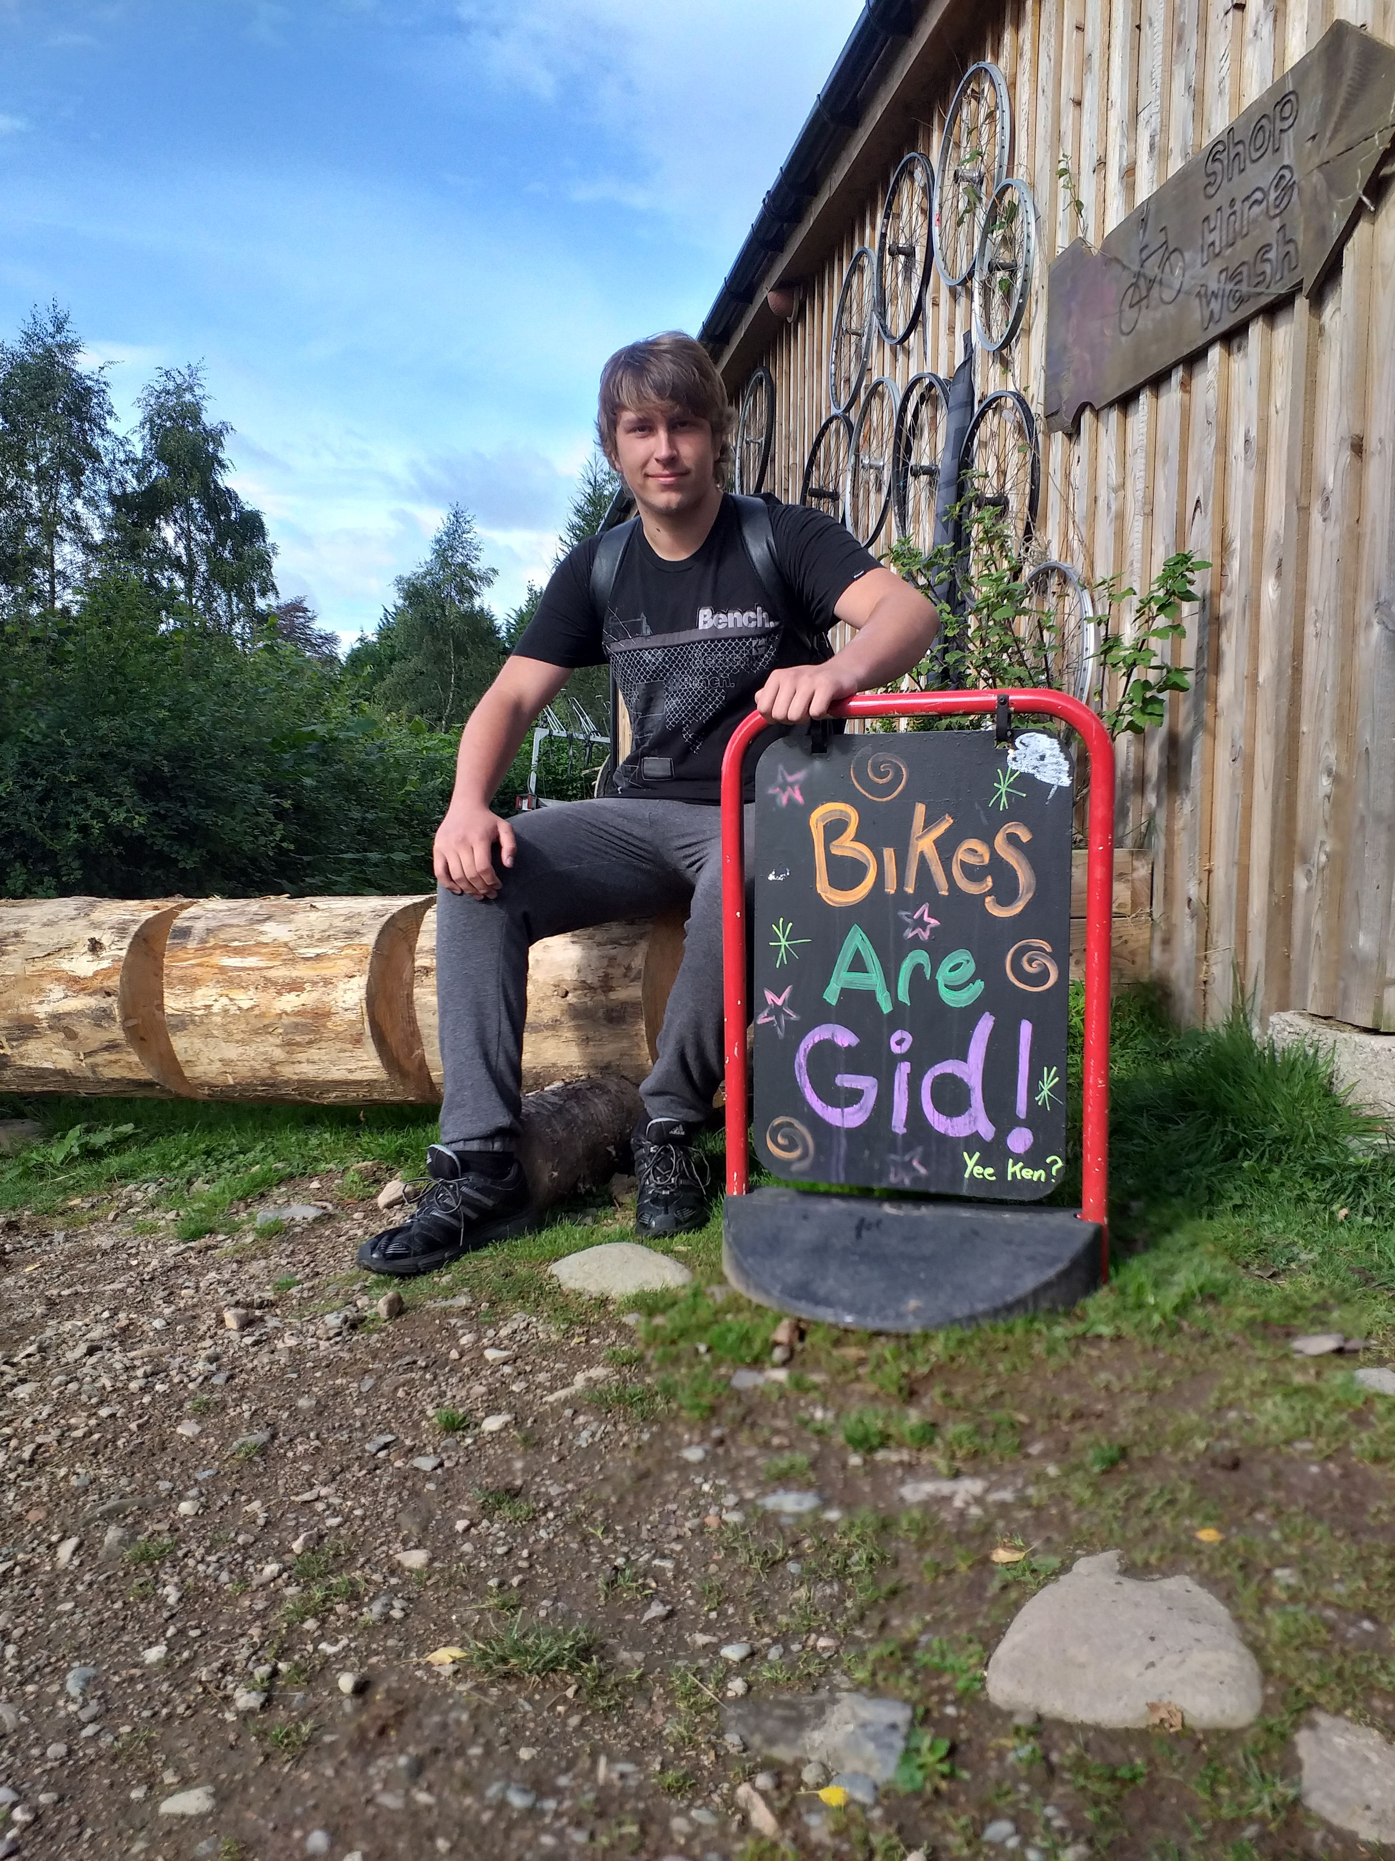
But it’s not all about the bikes…
Employability training and skills development.
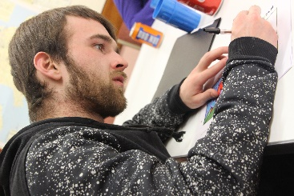
First Aid Training and Conservation Volunteering.
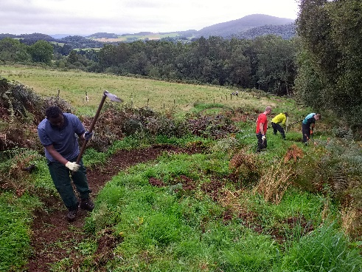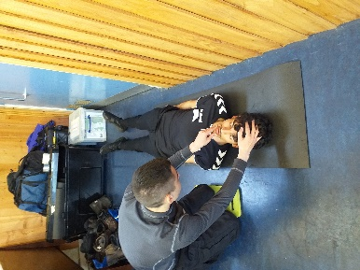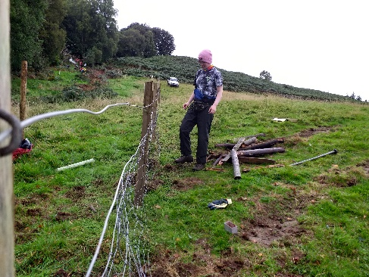

Developing wellbeing in the outdoors

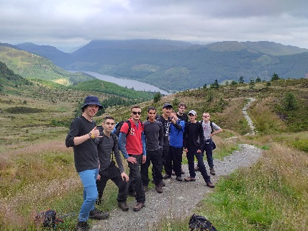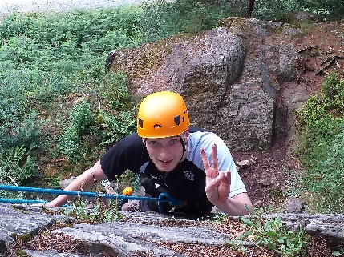

Community outreach support and action planning.
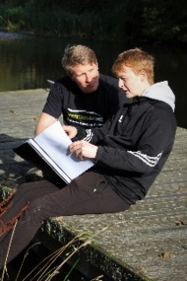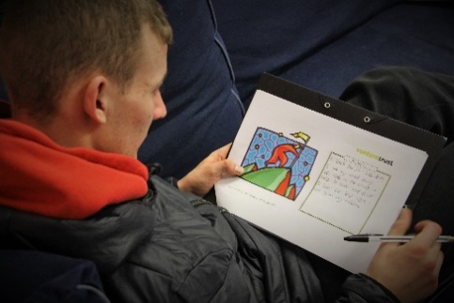
- CashBack Change Cycle Participants
The programme is for those who are disadvantaged by:
- living in areas of deprivation and/or
- being unemployed, not in education or training; and/or
- being at risk of being involved in anti-social behaviour, offending/re-offending
This year 106 young people from 9 local authorities engaged with the initial assessment and course preparation. 62 took part in the Community Phase of the 3-week training courses and 54 progressed to the wilderness residential phase.
Venture Trust data shows the numbers in each SIMD datazone for each participant in Year 3, as well as the first two years of the programme. See the table below:
 | SIMD quintile 1 | SIMD quintile 2 | SIMD quintile 3 | SIMD quintile 4 | SIMD quintile 5
Year 1 | 20 | 6 | 4 | 0 | 1
Year 2 | 24 | 16 | 10 | 6 | 5
Year 3 | 50 | 19 | 17 | 9 | 9

*NB SIMD data not available for 16 participants across the three years.
The table above not only demonstrates a marked increase in the number of referrals across the three years, but also that the percentage of those coming from the top SIMD Quintile between years two and three has increased by almost 10%. This can be attributed to the hard work of the Employability Team, in building strong referral partnerships and marketing the course appropriately, ensuring participants are at the right stage in their personal-development and most in need.
While some participants are not from the top 20% SIMD datazone, all are facing a range of challenges to getting a job as the table below demonstrates.
Presenting Issue | % of referrals
Not in education employment or training (16 - 19 yrs) | 52
Mental health issues | 43
Homeless (or occupying unsettled or temporary accommodation) | 42
No experience of paid work | 34
Literacy or numeracy problems | 25
Criminal Justice background | 23
History of substance abuse | 14
Young person leaving care or is currently in care | 12
History of alcohol abuse | 10
Learning Disability | 10
Long Term Physical Illness/Condition | 9
Caring responsibilities | 9
No qualifications | 8
Registered Disabled | 4
Refugee | 4
Non-EU migrant worker | 3
Armed Forces Veteran/Currently Serving | 3
Lone parent | 2
Asylum seeker | 2

CashBack Change Cycle supports participants to build aspiration, motivation and self-confidence while developing meta-employability skills that will help participants achieve the goals they want to achieve in life. This means that we can help individuals with a variety of complex traumas and barriers, to improve their quality of life now and in the future.

- Programme Development in Year 3
Our Year 2 report highlighted areas of potential improvement in Year 3, some of which were underway at the time of the report. The below table summarises actions taken and outcomes against each of these:
Recommendation in Year 2 Report | Actions taken in Year 3 and Outcome | Ongoing Plans
Reviewing performance and identifying appropriate responses. | The performance management process for CashBack Change Cycle has continued in Year 3, with quarterly Programme Management Groups to help identify best practise, issues and solutions.  We have also updated both our database and Monitoring and Evaluation Framework, to better quantify the efficacy of the programme in the future. | We intend to continue quarterly PMG meetings ongoing and are due to do a formal review the success of the new systems for monitoring.
Increase the number of young people the CBCC programmes engages with through strengthening the programme’s referral system: | Throughout Year 3, the Employability Team have attended a number of meetings with key referral partners, including local job centres, SDS offices and third sector agencies. As demonstrated above this has greatly benefited referral numbers. The increased capacity of the team in Year 2 has also fostered closer working with Venture Trust’s Outreach Workers, ensuring that appropriate internal referrals have also increased in Year 3.  The Comms and Marketing team have also worked hard in Year 3 to increase the profile of the programme. This has been particularly successful in terms of new video content created, a celebrity visit which elicited a number of print and online media outlet stories and an increased social media presence which as stated above has led directly to an increase in the number of self-referrals. | With the new contract for the programme there will be an increased focus on working with SDS offices and approved EF providers to ensure smooth referral routes into the programme.  Change Cycle and Employability more generally remains a key focus for the organisation and the Marketing and Communications team. In addition to the Referral marketing established through the CashBack programme, we have several campaigns scheduled to continue to promote the programme more widely.
Minimise the risk of young people not attending and/or dropping out of the course: | Visits to Bike for Good and Bike Station partner workshops, have become an integral part of our early engagement process. This gives participants the opportunity to meet delivery agents from our partner organisations, each other and see the workshop environment prior to committing to the course. This early involvement has led to an increased understanding and improved cohesion of the two elements (mechanical and employability) of the first two weeks of the programme leading to fewer dropouts. | Early engagement remains a priority for the programme, to increase participants understanding of and commitment to all phases of support.  The addition of Employability Workshops and increased post-journey support, means that even those who do not fully engage in week 3 will have an ongoing support offer available to them. The Employability Fund also provides a financial incentive for continued engagement, so we expect to see this improve within the programme.
Devise a clear strategy for continuous support after the completion of the course. | The division of support for participants has been more formally established in Year 3.  The launch of the Employability Workshops has provided a clear route for ongoing work-related support, including CV writing, job matching and assistance with training and job applications. This has given other Venture Trust staff more confidence in how continuous support of CashBack Change Cycle participants is managed and provided an additional route for participants of our other programmes. | The organisation is committed to continuing to enhance our employability support offer, with the Employability Workshops being open to all Venture Trust participants.  4-week work placements are due to become a formal offer for the majority of Change Cycle participants ongoing, and conversations with providers across various industries are well underway.  Additional options for other programmes/offers are also being explored, which would enhance the provision available to all our participants.
Attention to gender balance at the stage of recruiting for the course: | The Employability Team have continued to re-enforce to referrers that the programme is for everybody. This has included meeting with women’s organisations specifically to promote the programme. This had led to there being on average at least one female participant on each course.  There has also been a focus on marketing and case studies which highlight female participants, to help address this imbalance. | Whilst the gender balance has been improving across all 3 years, we are aware that further work needs to be done.  Plans to further involve the Venture Trust ambassador Lee Craigie, who is herself a former British mountain bike champion, in the promotion of the programme are already in place.
Increased cooperation between staff members of the first two weeks and the third week of the course: | The early-engagement visits to Bike for Good and Bike Station partner workshops detailed above, have also helped to establish smoother working relationships between staff members.  Formal course reports and catch-up calls with the wilderness delivery team, have also allowed the Employability Team greater agency over the participant’s whole journey through the programme. | We are intending to include a partner’s report as part of the case notes for each participant, to give participant’s and staff a greater understanding of the individual’s engagement with each aspect of the course.  As part of our Covid-19 response we have also been running post-course meetups which have been well received. These are run by the wilderness delivery team and it is hoped that we can extend this offer for Change Cycle groups in the coming months, to encourage a sense of continuity and re-establish some of the personal-development work of week three of the course.

- Financial performance
Our spending against budget was as follows:
Dashboard: Measure | Metric | 2019/2020
 |  | Actual | Target | Variance
Project Activity (no less than 85% of CashBack funding)
CashBack Project Co-ordinator | £ | 23,460 | 23,680 | (220)
Phase 1: Referral, Assessment, Engagement | £ | 13,320 | 13,320 | 0
Phase 2: Course Delivery Community Phase | £ | 109,694 | 88,424 | 21,270
Phase 2: Course Delivery Residential Phase | £ | 58,426 | 62,724 | (4,298)
Phase 3: Post Course Progression Support | £ | 13,076 | 13,076 | 0
PROJECT DIRECT DELIVERY COSTS | £
Total Project Activity | £ | 217,976 | 201,224 | 16,752
Other Project Costs
Management and Marketing (up to 10% of CashBack funding) | £ | 5,776 | 5,776 | 0
External Evaluation (up to 5% of CashBack funding) | £ | 8,000 | 8,000 | 0
Total Other Project Costs | £ | 13,776 | 13,776 | 0
Total Expenditure | £ | 231,752 | 215,000 | 16,752

*NB The additional expenditure shown above was covered by match funding secured.

We worked across 9 local authorities. Our spend per local authority, based on the number of clients from each, was as follows:
Local Authority | No. participants | £ cost by local authority
Edinburgh City | 24 | £49,143
West Lothian | 23 | £47,095
Glasgow City | 19 | £38,905
Midlothian | 17 | £34,810
South Lanarkshire | 7 | £14,333
Inverclyde | 6 | £12,286
Renfrewshire | 6 | £12,286
West Dunbartonshire | 2 | £4,095
North Lanarkshire | 1 | £2,048
Total | 105 | £ 215,000

Outcomes Achieved

With the exception of a couple of anomalies, our retention of participants has continued to improve in year three. Course 1902 had a particularly stark drop-off during the residential phase, due to an incident which required a number of participants to be sent home early. The table below shows the course starters and completers for both phases across the three years of the programme.

 | Year 3 Result | Total 3 years Result | Total 3 years Target | % of course starters  (3 years) | % of target  (3 years) | % Stakeholders report this outcome  (3 years) | Target % Stakeholders report this outcome  (3 years)
Increased Confidence | 56 | 130 | 162 | 82% | 80% | 81% | 75%
Increased personal skills, achieving accredited learning | 58 | 140 | 174 | 88% | 80% | N/A | N/A
Report an increase in their skills | 63 | 141 | 174 | 89% | 81% | 69% | 75%
Report increased aspirations and behaviours | 50 | 115 | 174 | 72% | 66% | 75% | 75%
Improve wellbeing | 49 | 111 | 138 | 70% | 80% | 81% | 60%
Reduction in antisocial or criminal behaviour | 12 | 79 | 111 | 50% | 71% | N/A | N/A
Achieve positive destinations (Total No. positive destinations achieved) | 38 | 109 | 111 | 69% | 98% | N/A | N/A
Will access learning (VT community phase course) | 62 | 158 | 210 | N/A | 75% | N/A | N/A
Will progress to training (VT residential course) | 52 | 129 | 182 | 81% | 70% | N/A | N/A

The table above also shows performance against core life skill indicators and as a percentage of course starters across the three years. Despite not hitting our engagement targets in Year one due to capacity issues, we have managed to catch up significantly in years two and three, allowing us to perform well against our initial targets. This is particularly true of our Positive Destinations results, which despite having none in quarter four of year three (due to Covid 19 lockdown restrictions), we have still achieved a very good result.

Monitoring and Evaluation

self-evaluation
Participants in the course fill out a self-evaluation outcome star at the beginning and end of the three-week course. This is used to track progress on key SHANARRI indicators. Venture Trust also uses its own longer-term monitoring system to track participants’ personal development over the course of their full involvement with the programme. This monitoring continues for 6 months after our final contact with participants. Involvement in Education, Training, Employment and Volunteering is also recorded as part of the monitoring process.

External evaluation
External evaluation of the CashBack Change Cycle programme is conducted by Rocket Science. Rocket Science have conducted research among stakeholders, referrers, partners, participants and Venture Trust staff to build up a picture of how effectively the programme has worked across the three-year funding cycle. They have in all of their reports made a number of recommendations based on their findings and their final report reflects the overall development of the programme over the last 3 years.

Key findings
The key findings from the Rocket Science Year 3 report are:

Relationships with referrers/ referral activities
- CashBack Change Cycle has diverse referral routes, and formed part of a participant’s wider journey towards employment, supporting existing services rather than acting in isolation.
- “Efforts to promote the CashBack Change Cycle programme appeared to pay off, as referrers had a good understanding of the programme and who it was for”

“I gave her guidance around what the young person would like, and she came and met us, she showed us a PowerPoint and explained what would happen and what they could expect”. Referrer

- The use of a variety social media platforms has helped to improve recruitment, particually using Facebook leading to a number of self-referrals.
- CashBack Change Cycle staff were able to build relationships with the young people before the course had started, and Venture Trust staff and referrers agreed that this pre-programme support was crucial to ensuring buy-in to the programme and engagement from participants during Year 3. Pre-programme support included visits to the Bike Station/Bike for Good workshops – allowing participants to meet each other and get a taste of what was to come, as well as 1to1 community sessions with the Employability team.
- Referrers felt that more feedback could be provided.

Effect on participants
- Interviews with participants showed how the course helps them make positvie changes to their behaviour and attitudes and those who had referred into the programme reported positive changes in the referred client such as:

“The young person I referred has definitely benefited… [They are] living in sheltered accommodation and didn’t really have a routine before. [They] got that from the programme. [They’ll] be able to use that now as a steppingstone to go onto further training.” Referrer

Confidence and relationships
- Participants highlighted how group work helped to build confidence.

“Speaking out in front of people. I used to be more shy. Ever since [CBCC] I have been more confident.”
Participant

- Participants also noted that building peer groups helped improve their confidence.

“It was brilliant. The boys were pretty decent. Some had got into trouble - others not. So, there was a mixture. So, seeing other people’s backgrounds… and speaking to them - that made me think. If that boy can do it, I can do it. So, the best thing about the course was the mixture of people. We were having heart to heart conversations.”
Participant

- In addition, success in new challenges including the physical activities of the programme, such as rock climbing and mountain biking, helped to better participants sense of self-belief.

“When we did mountain biking, I fell off my bike and I had to get up and show a bit of resilience… and after I did that my confidence levels shot right up because it made me feel like I could conquer certain fears.”
Participant

Physical and Mental Health

- Both participants and referrers reported improvements in both their physical health and mental wellbeing. Often this included longer-term interest in cycling and the outdoors.

“The programme helped me be more active, get out as just sitting at home and watching TV. The more you get up, the more successful you can get.”
Participant

“My wellbeing is better. I am always out cycling. I also go to the gym. I am very active. The CashBack programme helped me get into this active mode.”
Participant

“It’s seeing all the new places and it’s good to get out of the city and it’s relaxing.”
Participant

Practical Skills and qualifications
- Participants also acknowledged the work-based skills and qualifications they gained, and the use that these would be in their ongoing search for employment.

“The qualifications will help me to get onto the building site… that’s saved me a bunch of hassle getting those qualifications myself.”
Participant

Aspirations
- Many participants reported improved aspirations and a broadening of both their life and employment horizons.

“I worked in things like restaurants, but I wasn’t really into that – so I was a bit nervous about what to do before the programme. The CashBack Change Cycle course then helped me realise that I would like to work with my hands and maybe with bikes and outdoors.”
Participant

“Doing the course, it shows you how much you can accomplish in one day.”
Participant

Improved programme delivery
The report details Venture Trust’s progress in improving programme delivery through the 3 years on which Rocket Science has been evaluating the programme:

Since our initial report in May of 2018, the Venture Trust has invested in and improved the delivery of the CashBack Change Cycle programme each year, following recommendations. The most crucial change made appeared to be increasing staff capacity and consistency in Years 2 and 3 of the programmes. In Year 1, a single worker was responsible for all delivery, while in Years 2 and 3 there was a delivery worker for each area (East and West). This enabled several key changes, which improved referrals and support for participants:
- Increased capacity and consistency enabled better relationships with referrers
- Increased capacity meant pre-programme support could be offered, reducing disengagement
- Increased capacity and consistency meant aftercare support could be offered, and better links into other programmes could be made
- Staff consistency meant continual learning could occur, ensuring a smooth-running programme

In Year 3, staff found that the earlier someone was able to engage with a young person, and the greater the intensity and frequency of support, the greater the likelihood that they would go on to take part in the community phase.

Recommendations
The report makes the following recommendations

- Our findings confirmed the importance of pre-course support, particularly in sustaining engagement with participants throughout all stages of the programme. We recommend that Venture Trust should continue to provide this, refining the offer and exploring reasons for continued disengagement. Venture Trust could increase the value of pre-course support by expanding it for particular individuals - for instance, offering different types of more flexible support for those who cannot attend the three-week course.

- Our findings suggest that young people are engaging with the CashBack Change Cycle programme as part of a longer journey to employment. As the programme operates at Stage 2 to 3 of the Employability Pipeline, participants may already have had some support from other organisations prior to starting, and may continue to need further support after the programme’s finish. Venture Trust have already built good relationships with referrers, however, there is an opportunity to increase these connections further, creating clear and consistent pathways of support between a network of trusted organisations. We recommend that Venture Trust pursue this opportunity. This would mean improving signposting for young people to the most appropriate organisations for aftercare support, including introducing them to new staff and preparing them for this change. This would increase the likelihood of positive outcomes for young people, and would help ensure there is no duplication of effort, creating ‘employability programme fatigue’.

- Our findings suggest that the use of social media increased awareness of the CashBack Change Cycle programme, leading to an increased number of external and self-referrals. We recommend an enhanced use of social media, especially Facebook, to promote the programme. The use of short eligibility surveys on social media platforms could act as a quick and effective way to assess whether self-referrals are likely to be appropriate. It may be possible to conduct social media research to explore its reach and impact on young people and referrer organisations. This would provide Venture Trust with examples of best practice in social media use to increase referrals.

- A number of participants struggled with not being able to get in contact with family or friends during the residential. This led to some anxiety and worry among some participants. This suggests improvements could be made in identifying participants who may need to keep in contact with a support network while away from home. We recommend that Venture Trust explore a range of methods to do this, including providing these participants with limited and carefully managed mobile phone access while on the residential week.

- While referrers were very positive about the difference that the programme had made for participants, they felt that more formal feedback would be helpful. We recommend that Venture Trust establishes a system of providing feedback to referrers about how the young person has progressed during and after the CashBack Change Cycle programme. This could be linked to the ongoing effort to build close relationships with referrers and encourage repeat referrals. This can be seen both as a benefit to this programme and as a contribution to strengthening relationships for other work in the future.

- Our findings show a lack of engagement of female participants across all three years, suggesting an opportunity for Venture Trust to explore different and creative ways of engaging with females, including the potential for a female-only course. We recommend that future communication with Edinburgh- and Glasgow-based organisations that work with young women and girls should highlight CashBack Change Cycle’s relevance to increasing positive outcomes for young people. This work could help establish more partnerships with other relevant organisations where benefits are twofold: increasing the number of female referrals and increasing signposting opportunities for support after female participants have completed the CashBack Change Cycle programme.

- Venture Trust has collected useful outcomes data through Outcomes Stars and video interviews. However, we recommend that Venture Trust further enhance this data offer, for example, ensuring that demographic data is available for programme engagements, rather than for referrals on to the programme.

Partnerships

Delivery partners
The programme is delivered through partnerships with Bike Station Edinburgh and Bike for Good Glasgow. A shared ethos, commitment and expertise in working with young people facing multiple disadvantages has meant a positive partnership experience with a firm focus on ensuring an enhanced learning experience for the participants. Over the last year, we have seen these partnerships flourish, with a continued commitment to work together following the period of Cash Back funding.

Referral partners
CashBack Change Cycle provides progression opportunities for those coming through other Venture Trust courses, as well as from our wide referral networks. Participants have come via: the courts, social work (Criminal Justice, Children and Families, Drug Treatment and Testing), Skills Development Scotland, Housing Associations (such as the Wheatley Group) and third sector partners such as Enable Scotland, Barnardo’s and Action for Children. In the last year we have also formalised our referral pathways with Third Sector partner The Prince’s Trust, and we are looking forward to see this progress in the near future.

Progression partners
We have built up meaningful and long-lasting relationships with multiple employment and placement partners over the three years of the programme. These particularly in sectors such as retail, hospitality, catering, building and infrastructure. We hope to continue to grow this portfolio, so we can integrate work-placement opportunities as part of the CashBack Change Cycle offer.

- Organisational update

Funding for the future

This year we were successful in our application for continuation funding of the CashBack Change Cycle programme through the Employability Fund. We are excited to be able to continue the fantastic legacy of the CashBack 3-year project, in supporting some of Scotland’s most vulnerable to gain the skills to work and thrive.

Staffing the Project

The project draws on expertise and experience from all partners:
During year 3 staffing levels have remained consistent, with an employability worker dedicated to each Edinburgh and Glasgow. The improved staffing has been the main driver behind the significant improvement in performance identified by Rocket Science in their reports for year 2 and 3.
As before, workshop based vocational skills training is delivered by Bike Station and Bike for Good experienced staff and freelancers. The residential week is delivered by Venture Trust field staff and as well as conservation partners and Accredited First Aid trainers.
The partnerships with Bike for Good and Bike Station have worked smoothly and positively with all partners demonstrating a willingness to take on lessons from our regular reviews to improve delivery. A project steering group comprises lead contacts from both partners and Venture Trust managers.

Comms and marketing

- Monitoring and Evaluation: Rocket Science have finished their report, the full version of which has been included with this report. The data gathered included: video evidence including peer interviews; written logs from the Bike Station and Bike for Good; Outcomes star before and after self-evaluation tools; and follow-up interviews with participants.

- Comms and Marketing: We were lucky enough to have a celebrity visit, in the form of the Scottish Olympic athlete, Laura Muir. Following interviews and a chat with some of the CashBack Change Cycle participants, the story featured in both the Edinburgh Evening News and the Sunday Post.

Plans and priorities for the future

Maintaining and building on improved performance:
- Continuing the flow of internal referrals from other Venture Trust programmes.
- Building and improving relationships with referral partners to ensure a flow of high-quality potential participants.
- Working directly with Job Centres in Edinburgh and Glasgow to gain access and presence and publicity such as desk space and virtual space on Job Centre information screens.
- Strengthening the referral and assessment processes with the aim of minimising the number of participants who drop out during a course.
Strengthening post course support:
- Encouraging participants to access the range of support services in their community.
- Negotiating and offering a series of 4-week work placements with a variety of partners.
- Working with partner agencies to place participants in volunteering, employment and training opportunities as quickly as possible.
- Building relationships with new and existing onward referral partners/training providers/employers to enable us to offer more opportunities to participants.
Monitoring and Evaluation:
- Implementing the Year 3 evaluation recommendations through the Venture Trust management and outreach hub structures and with our partners Bike for Good and the Bike Station.
- Reviewing the evaluation methodology and planning longitudinal case studies.
Comms and Marketing:
- Maintaining our email referral marketing programme and reviewing performance regularly.
- Developing new case studies and placing these internally and externally through social media posts, internal and external newsletters, websites and other media.
- Involving our Venture Trust ambassador in social media promotion of cycling and the CashBack Change Cycle programme.
- Further sharing the short film and photo essay covering of the CashBack Change Cycle programme.

Appendix 1: Case Study

CASHBACK CHANGE CYCLE Case Study

Alan’s Story
CashBack Change Cycle is a 3-week employability course that supports young people aged 16-24 into employment, education or further training. All participants who attend the programme have the opportunity to complete various employment focused qualifications and employability skills training, as well as learning practical bicycle maintenance/mechanical skills. The third week is a 5-day residential, focused on personal development and goal setting.

Alan had been discharged from Army early with a knee injury and didn’t feel ready to leave. He struggled when he moved back to his community, started drinking on a daily basis and eventually found himself in a young offenders’ institute for 18 months. This was a wake-up call. A social enterprise which supports people into work referred Alan to Venture Trust. Alan joined CashBack Change Cycle after successfully completing previous Venture Trust courses targeted at supporting veterans. At the time of the referral to CashBack Change Cycle, Alan had therefore already made positive changes to his life, but still had many challenges to face. He was struggling with his mental health which made him more prone to stress and anger. Alan and his dedicated Venture Trust Employability Support Worker discussed what he wanted for his future, and he said he would like to find work but was unsure of what type of work he would like to do. Alan also had some financial issues, so he was keen to find a job where he could start focusing on paying off his debts.

Alan began the CashBack Change Cycle course in October of 2019. On course Alan was an immediately positive influence in the group and was often looked to as a leader. He was always on time and rarely if ever missed a day within the community phase of CashBack Change Cycle. Alan enjoyed the bike mechanics element of the course, particularly working with his hands. He was praised by Bike for Good mechanics for his teamwork. Alan was always keen to discuss topics in the employability workshops, and would often steer conversations and help get the rest of the group involved.
After this fantastic start, Alan had a rocky time at the end of Week 1. He found the employability workshop easy and would often rush ahead, asking if he could leave early. He found this frustrating and at one point let this get to him. His Venture Trust Employability Support Worker had a discussion with Alan regarding this incident, discussing the previous leadership qualities he had shown and how this had resonated with the rest of the group. Alan took this discussion to heart, and from then continued to show great leadership.
Alan enjoyed his experience on the CashBack Change Cycle residential journey, following on from his positive feedback from the community phase. He maintained a high level of motivation, accepting every challenge, reviewing his performance and transferring learnings on to the next challenge. This was particularly true when it came to leading morning meetings and reviews, where there were huge improvements in his delivery and management of discussions, with his confidence being built by each new achievement. He also demonstrated a high level of commitment to his learning by setting and re-setting SMART goals, to find new ways to challenge himself. By the end of the course Alan was relaxed and smiling.
On returning from his residential, Alan immediately set up follow-up one to one meetings with his Venture Trust Employability Support Worker in the community, to get to work on setting clear job goals. Alan’s focus was on finding work to help make positive changes towards his financial issues. With support he completed ‘better off’ calculations and started looking at jobs that fit the financial criteria he needed. Over the Christmas period Alan struggled to find work, so support focused on his employability skills; updating his CV and applying for suitable jobs online. Alan decided he wanted to upskill himself, so he completed a hospitality course with the Princes Trust, as well as a 3-week work experience within a Hotel. Unfortunately, due to the COVID19 outbreak his time with the Hotel was cut short and his hope for employment after his placement was no longer possible.
At this time Alan connected in with Venture Trust’s digital ‘Be Connected’ service, initially working with the Employability Hub. During digital hub appointments, Alan expressed how not working was affecting his mental health and that he was really struggling without a routine. Alan’s CV was again updated, and he expressed interest in a Work-from-Home vacancy with a customer service company. He was supported to apply for the role and the next day Alan had an offer of employment. The only concern was that the start date was so soon, and Alan worried he wouldn’t have the laptop he needed on time.
After this discussion, his Venture Trust Employability Worker reached out to our Princes Trust Development Award Administrator Linsey Rusk who quickly applied for a Princes Trust Development Award for Alan. This application was successful, and Alan has now received a laptop, USB headset and 4GB USB to be able to complete this new role.

