Cashback Change Cycle Programme
Year 2 Report

May 2019
Table of contents
Table of Contents
1. Programme Overview 3
2. Outcomes Achieved 7
3. Monitoring and Evaluation 8
4. Partnerships 10
5. Organisational update 10
6. Plans and priorities for 2019-20 11
Appendix 1: Case Study 1

Programme Overview

Change Cycle is for young people aged 16-24 who are not in work, education or training, facing long term unemployment and disadvantage as well as potentially at risk of (re-)offending or anti-social behaviour.
Following outreach assessment and preparation, the three-week course starts with two weeks of classroom-based employability training and workshop-based vocational skills development focused on bike building and maintenance. Participants then take the bike they have built on a 1-week wilderness residential which includes a volunteering conservation project and mountain biking training. Following the course, support is provided by Venture Trust's outreach workers guided by the participants' individual goals and personal action plans.
Participants achieve accredited certificates in cycle maintenance, health and safety and first aid training as well as producing their own action plan and preparing their CV.
A self-constructed bike and equipment to take home and use for travel in job search, accessing services or training, getting to work and leisure.

Change Cycle Participants
The programme is for those who are disadvantaged by:
- living in areas of deprivation and/or
- being unemployed, not in education or training; and/or
- being at risk of being involved in anti-social behaviour, offending/re-offending
75 young people from 10 local authorities engaged with the initial assessment and preparation. 67 took part in one of the 3-week training courses and 53 progressed to the wilderness residential phase.
Venture Trust data shows the numbers in each SIMD datazone for each participant in Year 2. See the table below:
Data Zone | 1 to 1395 | 1 to 2092 | 1 to 2790 | 1 to 3488 | 3,489 to 6976 | Total
Year 2 | 25 | 46 | 59 | 65 | 7 | 72*
*NB SIMD data not available for 3 participants

Hands-on skills training in bike building led by partners Bike Station Edinburgh, and Bike for Good Glasgow
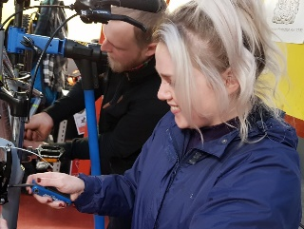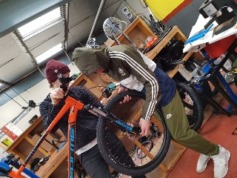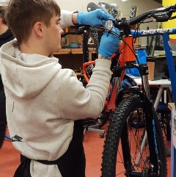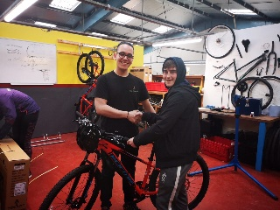

Safe cycling/mountain bike training in the city and in the wilderness
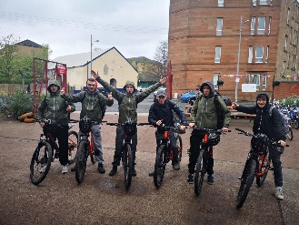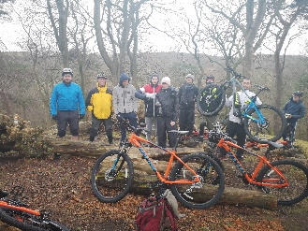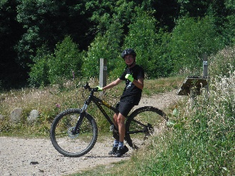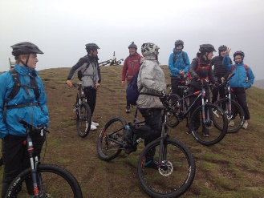

Employability training and skills development including on-line health and safety training
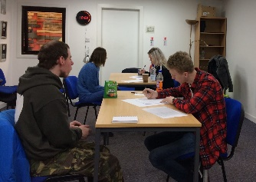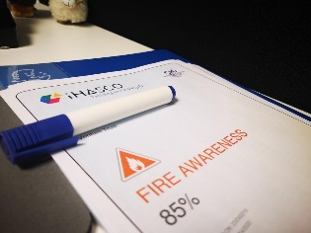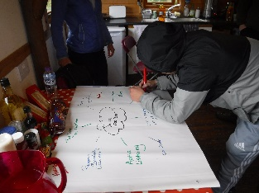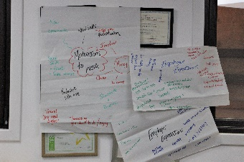

First Aid Training
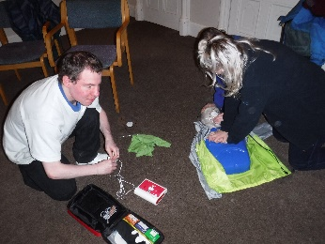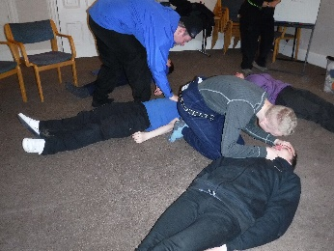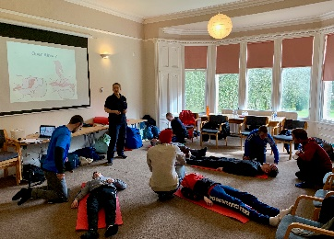

Conservation volunteering: developing work skills in the outdoors
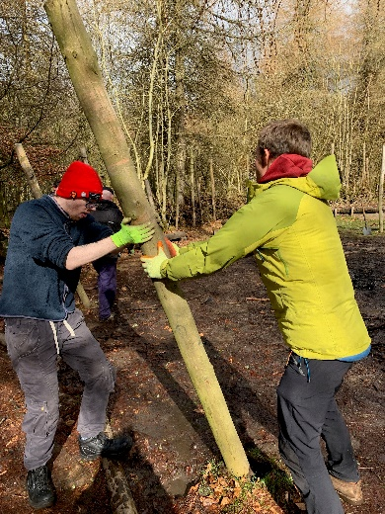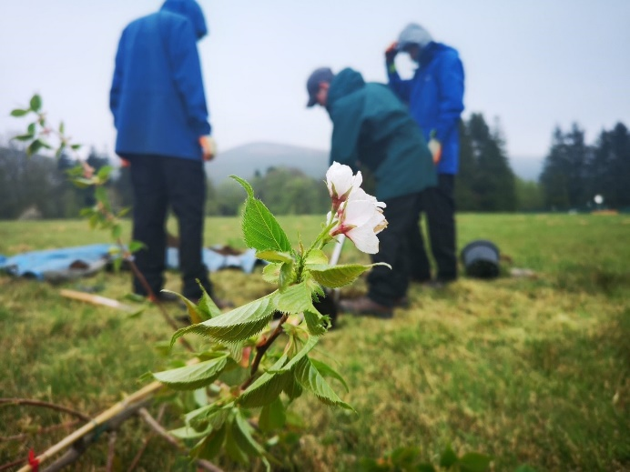
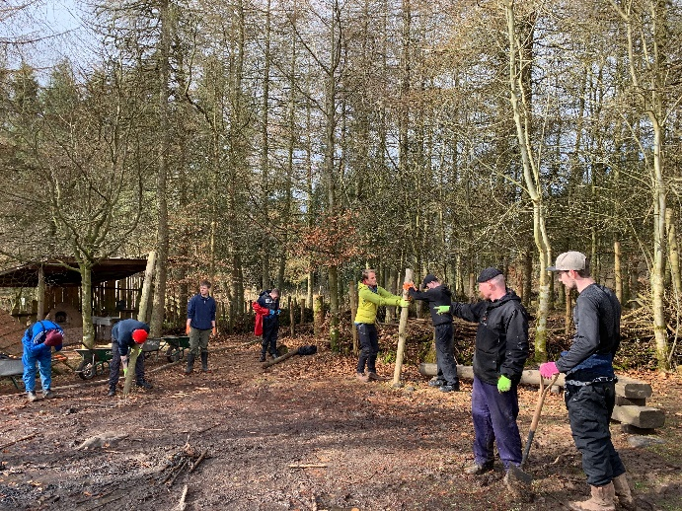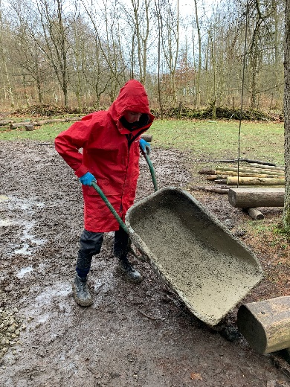
Developing wellbeing in the outdoors
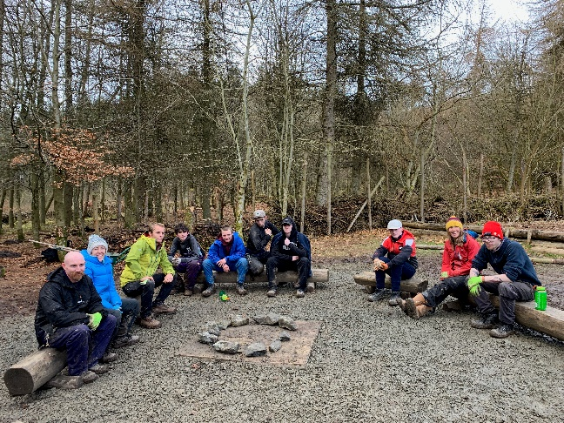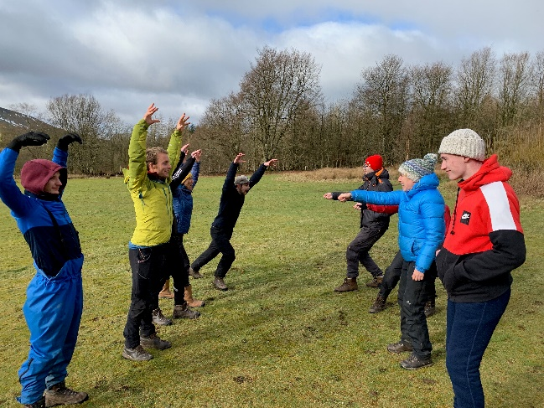

While some participants are not from the top 20% SIMD datazone all are facing a range of challenges to getting a job.
Presenting Issues | % of participants
Low Skilled | 48%
Not in education, employment or training, and aged 16 - 19 yrs. | 42%
Mental health issues | 38%
Literacy or numeracy problems | 34%
History of substance abuse | 24%
No experience of paid work | 24%
Criminal Record | 22%
Homeless | 22%
In need of education / employment training | 22%
Living in a jobless household | 20%
Young person leaving care or is currently in care | 18%
Learning Disability | 16%
History of alcohol abuse | 12%

Participants from the following local authorities accessed the programme. Places are allocated according to need and demand and are available to those who can access the delivery centres in Edinburgh and Glasgow.

Programme Development in Year 2
Our Year 1 report highlighted areas of potential improvement in Year 2. The below table summarises actions taken and outcomes against each of these:

Improvement Area | Suggested improvements in Year 1 Report | Action taken in Year 2 | Outcomes from actions taken
Increasing Referral and engagement numbers | Working with Venture Trust colleagues to increase internal referrals to the Change Cycle programme and with partners to increase external referrals from key partners including third sector agencies, CashBack Portfolio partners and Job Centres. | New internal processes set up; increased networking and education of external partners | Referral numbers increased internally and externally
 | Ongoing marketing and recruitment drive including: email marketing, increased social media presence and working to gain access, presence and publicity such as desk space and virtual space on Job Centre information screens. | Regular email marketing; more staff using social media; conversations with Job centres | Response from email marketing; social media engagement; work still to be done with access to Job Centres
 | Reviewing our approach to pre-course preparation and engagement with the aim of increasing the % of referrals starting the programme.
 | Working across all referral activities to address the gender imbalance on the programme. | Re-enforcing to referrers that the programme is for everybody | Limited impact – vast majority of referrals are still male

Improvement Area | Planned improvements | Action | Outcome
Strengthening Course Delivery including Post-course support | Working with our delivery partners in Bike for Good and the Bike Station and our Venture Trust staff teams to create stronger links between all phases of the programme to ensure a greater % of referrals engage with all stages of the programme. | More staff time spent with delivery partners; clients told more about the full programme from the beginning | Increased completion rates from 37% of starters to 63%.
 | Working within Venture Trust to develop a clearer programme of post course support including encouraging uptake of the ongoing 1:to:1 support services within Venture Trust. | Greater focus by Employability Officers on providing direct post-course support with view to positive destination | Significant increase in positive destinations achieved
 | Encouraging participants to access the range of support services in their community. | See above | See above
 | Working with partner agencies to place participants in volunteering, work placement and training opportunities. | New employability staff used and developed their existing links with partners agencies | See above
Monitoring and evaluation | Reviewing the evaluation methodology and evaluation tools and planning longitudinal case studies. | Two review meetings with Rocket Science. | New process for engaging with clients. Longitudinal methodology to be further discussed
 | Working with our external evaluator to explore ways to improve measuring the impact of the course on participant ‘wellbeing’. | Discussed in reviews with Rocket Science | No better measure available, given time and resource constraints

Improvement Area | Planned improvements | Action | Outcome
Comms and Marketing | Expanding the on-line and targeted mailshots to ensure the widest exposure for the programme. | New systematic e-marketing campaign launched, tied specifically to course dates | Increased referrals and numbers engaged in courses
 | Developing new case studies and placing these internally and externally through social media posts, internal and external newsletters, websites and other media.
 | Planning for and utilising publicity from a ministerial visit. | Liaison with SG | Ministerial visit by Hamza Yousuf on 14/03/2019. Publicised through social media
 | Involving our new Venture Trust ambassador in social media promotion of cycling and the Change Cycle programme. | Ongoing conversations with ambassador | Some social media activity – more to be done
 | Exploring ways to involve recent participants in publicising the Change Cycle programme and contributing to wider CashBack Phase IV publicity. | Development of videos for online use | Delivered June 2019

Financial performance
Our spending against budget was as follows:
Dashboard: Measure | Metric | 2018/19
 |  | Actual | Target | Variance
Project Activity (no less than 85% of CashBack funding)
CashBack Project Co-ordinator | £ | 22,394 | 21,198 | 1,196
Phase 1: Referral, Assessment, Engagement | £ | 13,403 | 13,512 | (109)
Phase 2: Course Delivery Community Phase | £ | 95,317 | 111,638 | (16,321)
Phase 2: Course Delivery Residential Phase | £ | 67,253 | 52,019 | 15,234
Phase 3: Post Course Progression Support | £ | 13,076 | 13,076 | 0
PROJECT DIRECT DELIVERY COSTS | £
Total Project Activity | £ | 211,443 | 211,443 | 0
Other Project Costs
Management and Marketing (up to 10% of CashBack funding) | £ | 19,617 | 19,617 | 0
External Evaluation (up to 5% of CashBack funding) | £ | 6,000 | 6,000 | 0
Total Other Project Costs | £ | 25,617 | 25,617 | 0
Total Expenditure | £ | 237,060 | 237,060 | 0

We worked across 15 local authorities. Our spend per local authority, based on the number of clients from each, was as follows:

Local Authority | No. participants | £ cost by local authority
Glasgow City | 21 | £ 61,880
Edinburgh City | 18 | £ 53,040
Midlothian | 8 | £ 23,573
West Lothian | 5 | £ 14,733
North Lanarkshire | 4 | £ 11,787
East Lothian | 3 | £ 8,840
South Lanarkshire | 2 | £ 5,893
Falkirk | 2 | £ 5,893
Stirling | 2 | £ 5,893
West Dunbartonshire | 2 | £ 5,893
Clackmannanshire | 2 | £ 5,893
Scottish Borders | 2 | £ 5,893
Renfrewshire | 2 | £ 5,893
Perth & Kinross | 1 | £ 2,947
East Renfrewshire | 1 | £ 2,947
Total | 75 | £ 221,000

Outcomes Achieved

As indicated above, over the course of the year our recruitment and retention of participants improved significantly, as the below chart shows. (Courses are numbered sequentially throughout the year – later courses show a clear increase in both recruitment and retention).

The below table shows performance against targets and as a percentage of course starters (n=67). Unfortunately, as we achieved only 75% of our course starter target this has had an impact on our ability to hit targets. We would note that in terms of percentage of those who started the course our performance was generally strong.
The area in which the programme overachieved against targets was in positive destinations. In terms of significant outcomes
 | Result | Target | Percentage of course starters | Percent of target
Increased Confidence | 54 | 69 | 81% | 78%
YP increased personal skills, achieving accredited learning | 53 | 69 | 79% | 77%
YP report an increase in their skills | 52 | 69 | 78% | 75%
YP report increased aspirations and behaviours | 51 | 69 | 76% | 74%
YP improve wellbeing | 51 | 55 | 76% | 93%
YP achieve positive destinations (Total No. positive destinations achieved) | 77 | 55 | 115% | 140%
YP will access learning (VT community phase course) | 67 | 92 | 100% | 73%
YP will progress to training (VT residential course) | 52 | 92 | 78% | 57%
YP volunteer following completion of programme | 11 | 11 | 16% | 100%
YP will gain employment | 30 | 13 | 45% | 231%

Monitoring and Evaluation

self-evaluation
Participants in the course fill out a self-evaluation outcome star at the beginning and end of the three-week course. This is used to track progress on key SHANARRI indicators. Venture Trust also uses its own longer-term monitoring system to track participants’ personal development over the course of their full involvement with the programme. This monitoring continues for 6 months after our final contact with participants. Involvement in Education, Training, Employment and Volunteering is also recorded as part of the monitoring process.

External evaluation

External evaluation of the CashBack Change Cycle programme is conducted by Rocket Science. Rocket Science conduct research among stakeholders, referrers, partners, participants and Venture Trust staff to build up a picture of how effectively the programme is working. They also make recommendations based on their findings. This programme of evaluation will last for the full three years of the programme, with annual reports deliverable at the end of each financial year.

Key findings
The key findings from the Rocket Science Year 2 report are:
Relationships with referrers:
- Referrers found out about the Venture Trust in different ways.
- Referrers had a good understanding of the course
- CBCC staff were able to build relationships with the young people before the course had started.
- Referrers understood the programme’s target client group
- All of those who had referred into the programme reported a positive change in the referred client
- Referrers felt that clients had to be ready for the course
- Referrers felt that more feedback could be provided
“[Venture Trust] are not looking for every single person to go and work in bike maintenance, however this person liked it so much that that’s now what he wants to do”. [Referrer]

Effect on participants
Interviews with participants showed how the course helps them make positvie changes totheir behaviour and attitudes:
Confidence and relationships:
“It was brilliant. The boys were pretty decent. Some had got into trouble - others not. So, there was a mixture. So, seeing other people’s backgrounds… and speaking to them - that made me think. If that boy can do it, I can do it. So, the best thing about the course was the mixture of people. We were having heart to heart conversations.”
“It was really good to work with others on the programme.”
“I feel like I am more open guy, I can chat to people.”

“Meeting other people, coming in a new environment. Now I would be more comfortable joining groups.”

“Yes, it has really helped build confidence to talk in groups. These guys in the group talked to each other, they involved everyone in the conversation, so I learnt from that.”

“I am more confident, I do more socialising, I am more outgoing. I’m now more confident in groups.”

Health
“I have lost a lot of weight since the course. Because I got more active and got up early. I go on my bike a lot – the bike of the bike station.”
“The programme helped me be more active, get out as just sitting at home and watching TV. The more you get up, the more successful you can get.”
“My wellbeing is better. I am always out cycling. I also go to the gym. I am very active. The CashBack programme helped me get into this active mode.”
“I couldn’t even ride a bike before the course, so for me I learnt how to ride a bike and build a bike, it was really helpful.”

Aspirations
“Now I know how to fix a bike and got my manual handling. Something to do with construction and engineering and mechanics is what I want to do.”
“I worked in things like restaurants, but I wasn’t really into that – so I was a bit nervous about what to do before the programme. The CBCC course then helped me realise that I would like to work with my hands and maybe with bikes and outdoors.”
Wellbeing and self-care

“The programme also got me waking up early, have a good breakfast, just general habits that I have been using.”

“My routine before the programme - I would sleep all day. It is really different now. The programme helped me to get a normal routine – get up in the morning and get stuff done.”
“Before the course I used to get up late and now I am up early. I feel more motivated now to apply for jobs.”

Improved programme delivery
The report details Venture Trust’s progress in improving programme delivery:
“Since our initial report in May of 2018, Venture Trust has invested in and improved the delivery of the CBCC programme. An additional employability worker was hired, and the programme now has two full-time employability workers that are focused on delivering CBCC courses in Edinburgh and Glasgow respectively. This increased capacity allowed Venture Trust staff to dedicate more time into recruitment and pre-programme support.”
“The more intensive pre-programme support does lead to more suitable young people taking part in the course and more consistent engagement, as demonstrated by the lower rate of client disengagement.”
“There were considerable improvements between Year 1 and Year 2 in the extent to which the participation target was met.”
“We consider the participant numbers for the recent courses (1805-1807) not only an improvement to Year 1, but a realistic indication of the number of young people that can be expected to participate in a single CBCC course”
“Only the drop between the average number of young people who started and completed the residential - a drop from an average of 7 young people starting the residential to 5 completing it – is an area where we believe Venture Trust can improve”

Recommendations
The report makes the following recommendations
“We recommend that Venture Trust establishes a system of providing feedback to the referrers of the programme about how the young person has progressed during and after the CBCC programme. This can be linked to the ongoing effort to build close relationships with referrers and encourage repeat referrals. This can be seen both as a benefit to this programme and as a contribution to strengthening relationships for other work in the future.”
“We recommend that Venture Trust continues its approach of providing intensive pre-programme support to individuals. We recommend that identifying and supporting suitable candidates should be prioritised over increasing participant numbers, especially if the latter comes with the risk of taking on unsuitable candidates that are more likely to disengage throughout the programme.”
“We recommend that Venture Trust continues to encourage referrers to identify suitable female candidates for the programme. In order to substantiate these efforts, we suggest that Venture Trust establishes partnerships with Edinburgh- and Glasgow-based organisations that work with young women.”
“We recommend that Venture Trust continues to invest in the aftercare support provided to participants. We suggest that this could involve building up a network of employers and volunteering organisations (particularly those focused on outdoors, manual handling, construction) and to increasingly act as job brokers for the young people finishing the course. Again, this could be seen by Venture Trust as an investment in future relationships as well as providing benefits to CBCC participants.”

Partnerships

Delivery partners
The programme is delivered through partnerships with Bike Station Edinburgh and Bike for Good Glasgow. A shared ethos, commitment and expertise in working with young people facing multiple disadvantages has meant a positive partnership experience with a firm focus on ensuring an enhanced learning experience for the participants. Following Year One recommendations we have worked with our partners to improve the experience of delivery for participants and to increase efficiencies.

Referral partners
Change Cycle provides progression opportunities for those coming through other Venture Trust courses from our wide referral networks. Participants have come via: the courts, social work (Criminal Justice, Children and Families, MCMC), Skills Development Scotland, Housing Associations and third sector partners such as Enable Scotland, Barnardo’s and Who Cares? Scotland. 7 participants were self-referrals. We continue to work with Job Centres to encourage direct referrals; 5 participants came from this route this year.

Cashback portfolio partners
Interaction with CashBack portfolio partners has largely been through social media and participating in media events such as cinema screenings. We continue to be interested in developing more involved and direct partnerships with other CashBack stakeholders.

Organisational update

Staffing the Project

The project draws on expertise and experience from all partners:
Over Year Two there have been significant changes to the staffing levels on CashBack Change Cycle. Initially the programme was run by Venture Trust’s Employability Manager and a full-time Venture Trust Employability Development Worker co-ordinating the delivery of all employability content. We have now expanded to include a full-time Co-ordinator and have replaced the single full-time Development Worker with two part-time Development Workers, each covering one of our regional hubs (Glasgow and Edinburgh). This has allowed us to build deeper networks of referrers and of potential providers of positive destinations. The improved staffing has been the main driver behind the significant improvement in performance identified by Rocket Science.
As before, workshop based vocational skills training is delivered by Bike Station and Bike for Good experienced staff and freelancers. The residential week is delivered by Venture Trust field staff and as well as conservation partners and Accredited First Aid trainers.
The partnerships with Bike for Good and Bike Station have worked smoothly and positively with all partners demonstrating a willingness to take on lessons from our regular reviews to improve delivery. A project steering group comprises lead contacts from both partners and Venture Trust managers.

Comms and marketing

- Monitoring and Evaluation: Rocket Science have been continuing with Field work, as detailed above. The data being gathered includes: video evidence including peer interviews which we experimenting with as a source of direct feedback; written logs from the Bike Station; Outcomes star before and after self-evaluation tools; and follow-up interviews with participants.

- Comms and Marketing: We have revisited our referral marketing for all programmes this year, and there is now a regular cycle of email marketing aimed at potential referrers. These mailings are scheduled in advance of each course with enough time to allow for recruitment and preparation lead times. We have seen a steady improvement in responses from referrers throughout this year. Other Comms and Marketing activity includes a ministerial visit, social media engagement for every course, an article in the Scotsman promoting the programme, and regular news updates to our website. We were also nominated for a Herald Society Award.

Plans and priorities for 2019-20

Maintaining and building on improved performance:
- Continuing the flow of internal referrals from other Venture Trust programmes
- Building and improving relationships with referral partners to ensure a flow of high-quality potential participants
- Working with Job Centres in Edinburgh and Glasgow to gain access and presence and publicity such as desk space and virtual space on Job Centre information screens.
- Strengthening the referral and assessment processes with the aim of minimising the number of participants who drop out during a course
Strengthening post course support:
- Encouraging participants to access the range of support services in their community.
- Working with partner agencies to place participants in volunteering, work placement and training opportunities as quickly as possible.
- Building relationships with new and existing onward referral partners/trainig providers/employers to enable us to offer more opportunities to participants.
Monitoring and Evaluation:
- Implementing the Year 2 evaluation recommendations through the Venture Trust management and outreach hub structures and with our partners Bike for Good and the Bike Station.
- Reviewing the evaluation methodology and planning longitudinal case studies.
Comms and Marketing:
- Maintaining our email referral marketing programme and reviewing performance regularly
- Developing new case studies and placing these internally and externally through social media posts, internal and external newsletters, websites and other media.
- Involving our Venture Trust ambassador in social media promotion of cycling and the Change Cycle programme.
- Planning for a further ministerial visit
- Developing a short film and photo essay covering the CBCC programme

Appendix 1: Case Study

CBCC Case Study
23rd May 2019

Cashback Change Cycle is a 3-week employability course that supports young people aged 16-24 into employment, education or further training through group work focusing on employability skills and bicycle maintenance. All participants who attend the programme have the opportunity to complete various employment focused qualifications as well as learning practical bicycle maintenance/mechanical skills.
Joe joined the programme in January 2019 as a self-referral, at the time he was homeless and living with a friend. Joe was receiving no support from any other organisations and found out about the programme through his friend (who he was staying with) and decided to join the course based on that recommendation.
We met with Joe and identified that he required additional support for his accommodation as soon as possible and began supporting Joe by speaking to local authorities about this current living situation. Joe had a tough time at home with his mum and step-dad and felt he couldn’t return to live with them as the relationship had become so strained. He wanted support to find a job so he could better support himself and gain his own tenancy through work.
Joe also struggled with drug use, using recreational drugs on a daily basis and felt he was becoming dependent on these, we recommended Joe speak to local drugs charity Crew 2000 who supported him through harm reducing measures and gave him more information on how to manage his use.
In February 2019 Joe began the community phase of the cashback change cycle course, he started the course with 2 of his friends but was happy to make connections with other young people within the group. He done very well in bicycle maintenance and gained his VELOTEC Award through this, as well as his Employability Award through our employability skills workshops.
Within the community phase Joe’s housing situation fell into crisis and we again contacted local authorities and set up an emergency housing meeting with the Customer Hub in Edinburgh City Chambers. At this point Joe did not access this service as he had managed to organise to stay with friends.
Joe worked well with other young people in the group and enjoyed coming along, he done well on the bike rides and really enjoyed being out and about on the bikes. He was excited to be able to use his bike full time as this would allow him to apply for jobs that he could cycle too. We began looking at work and identified warehouses that he might not have been able to get to before he had his bike and made applications on that basis.
Joe completed the residential phase of Cashback Change Cycle; his 2 friends left the residential, but this did not have a detrimental effect on his experience as he had already bonded well with other people in the group. Joe’s course report shows that during this time he managed to overcome obstacles/fears such as climbing by actively engaging and gaining support from others in the group. Improvement in his confidence was also noted and he was eager to complete group goals often being the first person to put himself forward for tasks. He showed excellent leadership skills, having the ability to command the groups attention during morning/evening meetings. Joe also noted that during his time with the programme his drug use had dramatically decreased, and he had no desire to use drugs on a daily basis but worried about going back into his peer group where drugs were a day to day occurrence. He noted that he wanted further support within this area.
When Joe returned from the residential phase we met with him soon after to discuss his next steps, within this meeting Joe mentioned that his housing situation had become an issue again as he no longer wished to stay with his friend due to their daily drug use and he felt there was a pressure to join his friend in drug use as they stayed in the same home. During this meeting we took Joe again to the Customer Hub in City Chambers and met with Conor from the throughcare after care team, at this meeting emergency accommodation was offered to Joe and he was placed on the waiting list for 2 supported accommodations in his area. Conor and the throughcare after care team have continued their support of Joe through telephone/1-1 appointments since applying for housing.
Joe was also at this time struggling with mental health issues due to the crisis of housing and the breakdown of his relationship with his family. We referred Joe to the NHS cool2talk programme, they have been in regular contact with Joe providing telephone-based appointments/check-ins.
At further appointments support was provided to Joe focused more on employment. We made an application to DWP for Universal Credit payments so Joe would be able to claim housing benefit when he was offered accommodation. We also focused on finding work for Joe as this was his main goal after securing accommodation, we focused on finding work where he could use his bike to travel to and from as we were unsure of cost of housing etc. We worked with Joe to build his CV and apply for various roles that were suitable for him.
Whilst applying for different roles, Joe received notification that he was being offered a room in supported accommodation in his local area, Joe is still waiting on his own secure flat but is happy with his currently living situation as he feels more secure in his supported accommodation.
After securing housing we made a connection with “All Cleaned Up Scotland”, a local employer who had recently secured Community Jobs Fund Scotland funding for 2 new Cleaner/Stair Cleaner positions. We spoke with All Cleaned Up about Joe’s current living situation and told him how successful his time on the change cycle course, Joe really wanted to apply for the role but was unsure how this would affect his current housing situation. We set up a meeting between Joe and All Cleaned Up to discuss the role as well as any concerns Joe had. Joe appeared very smart on the day of the meeting and answered questions professionally, using interview skills/techniques he had used on the course such as the STAR method. He asked All Cleaned Up what support they could provide for him in his current situation and they agreed to provide him with any support he needed, looking into housing grants and additional support they may be able to offer him.
Joe was offered and accepted the role with All Cleaned Up Scotland as is currently working 25 hours per week in a community jobs fund Scotland post, he is being supported with his accommodation through his employer. Joe enjoys the role and is still actively engaging with Venture Trust.

Scottish Index of Multiple Deprivation

