Evaluation of Bridges Project Way2Work#Cashback: Year 2 report

Bridges Project

June 2019

CONTENTS

Chapter Page
Executive Summary i
1. Introduction 1
2. Programme delivery 4
3. Impact of the programme 12
4. Conclusions and recommendations 32

Executive Summary

Introduction and context
Funded through the CashBack for Communities Programme, Bridges Project’s Way2Work #CashBack programme supports vulnerable young people aged 14-21 across Midlothian and East Lothian who are disadvantaged or marginalised for a wide variety of reasons. Through group-based and one-to-one support, the programme aims to equip young people with the skills required to transition from school or unemployment into positive destinations including work, training or further education.
In 2017, Blake Stevenson was commissioned to conduct a three-year evaluation of the programme. Building on the previous Year 1 evaluation, in Year 2 the research team conducted interviews and focus groups with young people, and interviews with parents and stakeholders. As part of the evaluation, the team also analysed secondary data gathered by Bridges Project and local schools.
Delivery of Way2Work#CashBack in Year 2
One hundred and seventy-five young people engaged with the programme in Year 2, 109 of whom were new referrals.
Many of the young people supported during the year faced a wide variety of challenges and the programme has increasingly targeted young people at an earlier stage of their employability journey.
In Year 2 the programme provided young people with opportunities to engage in tailored one-to-one support and a variety of group activities, including groups relating to employability, animal care, confidence-building and social group work.
The programme has increasingly supported young people through group-based activities due to high demand for school and community-based group provision. Of the group activities delivered, confidence-building and accredited employability activities were most popular.
Impact of the programme
The extent to which progress could be measured against the six key outcomes for CashBack-funded programmes was limited by incomplete data from ESAs, SHANARRIs and schools, as well as the lack of cumulative figures from stakeholder questionnaires.
Outcome 1: Building capacity and confidence
The programme continued to positively impact young people’s capacity and confidence in Year 2, achieving its targets for all indicators where cumulative data was available. Despite an incomplete set of scores, the ESAs demonstrated an improved level of capacity and confidence for all participants. Participant and stakeholder feedback also reinforced that the programme had helped young people to become more confident, move out of their comfort zone and try new things.
Outcome 2: Developing personal and physical skills
Young people developed a range of skills, gained a variety of accreditations in Year 2, and the programme met all of its targets around the development of physical and personal skills. Young people gained a range of new skills including employability-related skills, core academic skills and soft skills such as self-awareness and organisation.
Outcome 3: Changing behaviour and aspirations
Limited data from ESAs and SHANARRIs meant that targets around changing young people’s behaviours and attitudes were not met. However, young people, parents and stakeholders nevertheless identified a range of positive changes in behaviour as a result of the programme, such as an improved overall outlook on life, increased maturity and being more settled.
At the same time, there was a strong sense that engagement in the programme had raised young people’s aspirations and positively influenced their future.
Outcome 4: Improving wellbeing
Again, limited data collection suggests that the programme did not meet the majority of indicators relating to young people’s wellbeing. However, young people, stakeholders and parents provided clear evidence that the programme positively impacted on their wellbeing – mainly around managing personal issues and improving social skills and relationships with others.
Outcome 5: Increasing school attendance and attainment
Mixed and incomplete data sets suggest that the programme has not reached its targets for attendance and attainment and again, the real extent of progress could not be accurately measured.
However, there was some clear evidence of the programme’s positive impact on young people’s attendance and attainment at school. For example, stakeholders felt that some young people’s attendance improved because they enjoyed the group sessions, while others were engaging more with their learning, communicating better or working more effectively with others.
Outcome 6: Improving learning, employability and employment options
The available quantitative data does not accurately portray the programme’s success in encouraging young people to participate in activities designed to improve their learning, employability and employment options.
The programme has helped many young people plan towards, or progress into, a variety of positive destinations, such as working at a local golf club, being accepted into college, starting a mechanical apprenticeship or gaining employment as a general labourer.
There were some changes in the types of destinations that young people achieved in Year 2, with employment and apprenticeships becoming the most popular destination compared to college, the most popular destination in Year 1.
Conclusion and recommendations
The programme remains on track to support 360 young people over the three-year delivery period. Although ongoing issues with data and incomplete returns limited the extent to which progress towards the six key outcomes could be effectively measured, this should not deflect from the overwhelmingly positive feedback received from young people, parents and stakeholders.
Recommendation 1: In Year 3, the programme should capture, a more comprehensive profile of the young people. Often this information, for example, care experienced, young carers, mental health issues is recorded in the case files but not collated and reported. This would provide a richer understanding of the diversity of backgrounds of those in the Way2Work cohort.
Recommendation 2: In our Year 1 evaluation we recommended the use of ESAs with all participants to measure young people’s progress in a range of areas. The use of the ESAs, Ryff Scales and SHANARRI wellbeing tool was inconsistent in Year 2 and the number of completions has prevented a robust assessment of delivery of the project targets. In Year 3 the measurement tools should be used more widely and consistently with the relevant young people.
Recommendation 3: Although school data returns will likely improve in Year 3 as the data-sharing agreement with Midlothian Council is further embedded, programme staff would benefit from providing schools with further guidance around their requirements and expectations for schools data ahead of the next academic year. This would lead to more consistent datasets that in turn enables more accurate reporting.

- Introduction

- In July 2017, Bridges Project commissioned Blake Stevenson Ltd to undertake a three-year evaluation of its Way2Work#CashBack programme, funded through the CashBack for Communities Programme.
- In this report, we outline the progress of the programme in Year 2, exploring its delivery against the six core CashBack outcomes for programme delivery:

Overview of Way2Work#CashBack
- As part of Phase 4 (2017-2020) of the CashBack for Communities programme, Bridges Project received £393,183 to deliver its Way2Work programme. The programme is designed to support vulnerable young people from Midlothian and East Lothian to transition from school or unemployment into positive destinations, such as employment, further education or training.
- The programme targets young people who are disadvantaged or marginalised due to various circumstances. These include:
- being looked after or care-experienced;
- young carers;
- those experiencing mental health issues;
- those who are disengaged in education; and
- those affected by Adverse Childhood Experiences (ACEs).

- The programme is also targeted at young people living in areas of deprivation or households living in poverty.
Year 2 evaluation activity
- In conducting this evaluation, we have gathered evidence from a range of sources. As in Year 1, we conducted interviews and focus groups with young people, interviews with stakeholders and a review of the secondary data provided by programme staff. For the Year 2 evaluation, we also obtained data from new sources including parent interviews and data from schools.
- We undertook three new case studies with young people involved in the programme in Year 2 and revisited one of our case studies from the Year 1 evaluation.
- In the diagram overleaf, we summarise the main data sources used for the Year 2 evaluation.

Figure 1.1: Data sources used for Year 2 evaluation

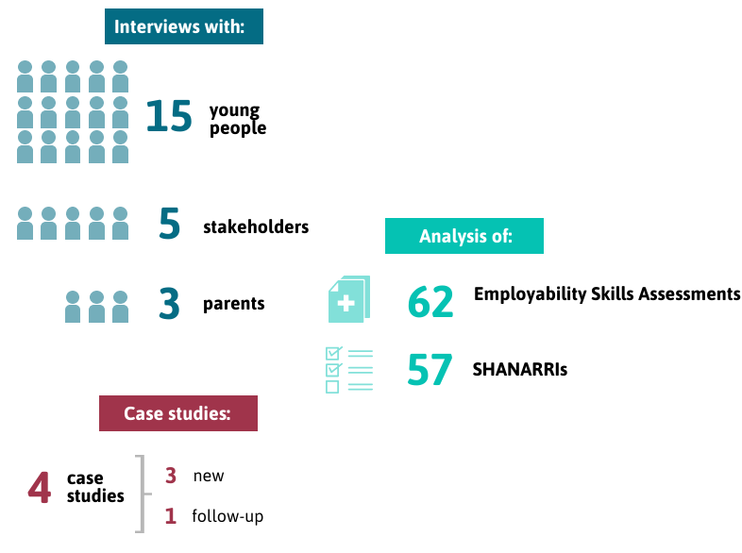
Outline of report
- In Chapter 2, we provide an overview of the Way2Work programme and its delivery in Year 2. In Chapter 3, we explore the impact of the programme in relation to the six core outcomes. In Chapter 4, we summarise the key findings from the evaluation and provide recommendations to enhance programme delivery in Year 3.

- Programme delivery

- In this chapter, we provide an overview of the delivery of the Way2Work programme in Year 2, focusing on key changes in programme delivery since Year 1.
- We also explore the profile of new referrals on to the programme in Year 2 and describe the support provided to participants during the year.
Funding agreement
- Way2Work staff continue to deliver the programme to budget. Over the first two years, staff have spent £252,640 out of an allocated £271,369 - a surplus of £18,729, which is mainly accounted for by salary savings while a post was vacant and reduced travel costs.
Changes in programme delivery
- There were a few changes around the delivery of Way2Work in Year 2. These are described overleaf.

Changes in group activities and delivery partnerships
- Following Year 1, there were some changes to the range of groups offered through the programme. The partnership with Morrison Construction Ltd ended for a brief period in Year 2 due to funding cuts and so the Morrison Construction group was not delivered. The First Aid at Work and Tenancy Award groups also did not run - the Tenancy Award group was instead delivered by Midlothian Council Housing Department.
- Some new group activities were introduced, others were modified, and new partnerships were formed. These changes included:
- a new social group work programme – a softer group activity which, although not accredited, is designed to build young people’s life skills and provides them with a social platform; and
- an Employability Skills course, involving a new partnership with the Construction Academy at Musselburgh Grammar School and, later in the year, a reformed partnership with Morrison Construction;
- a new Developing Confidence for Employment programme, delivered in partnership with Penicuik High School; and
- the Royal Environmental Health Institute of Scotland (REHIS) Health & Safety course, involving full-day sessions delivered in partnership with Bruce Robertson Training.
- In Year 2, Way2Work also expanded its range of partnerships with schools, taking referrals from new schools including North Berwick High School and Knox Academy.
Improvements to the programme database
- In Year 1, we reported that programme staff experienced some issues in reporting against the six outcomes and their indicators – for example, young people being double-counted, referral agencies’ use of both proper names and ‘known as’ names, and confusion among staff about how young people are counted against each indicator.
- Programme staff resolved these issues in Year 2 by making improvements to the Way2Work internal monitoring database. All additions to the database are now validated internally by one member of staff and all referral agencies are required to provide proper names only.
The Ryff Scale of Psychological Wellbeing
- In Year 1, we identified a validated tool for measuring an individual’s wellbeing and agreed with Way2Work staff that this would capture a more detailed account of the wellbeing changes amongst young people supported through the programme. Early in Year 2, we delivered a workshop to programme staff to refresh their understanding of the use and value of the Ryff Scale of Psychological Wellbeing. The Ryff Scale enables us to understand how a young person is doing across six aspects of their wellbeing:
- Autonomy – for example, their opinions and personal values;
- Personal Growth – such as how important they feel it is to have new experiences and to learn, change and grow;
- Purpose in Life – for example, whether they think about the future;
- Environmental Mastery – for example, if they feel in control of their own life situation;
- Positive Relations with Others – such as whether they can enter and maintain close relationships with others; and
- Self-Acceptance – for example how content they are with their life.
- The young person responds to a series of statements, indicating how much they agree or disagree with each statement on a six-point scale. There are 18 statements in total – three for each of the six dimensions above.
- The Ryff Scale is designed to be completed with the young person when they first begin the programme, every 12 weeks while they are being supported, then once after they have left the programme.
- Following the workshop, Way2Work staff implemented the use of the Ryff Scale with participants receiving one-to-one support.
- Although 46 young people were supported on a one-to-one basis during Year 2, only three Ryff Scales were completed during the year. As a result, we have not included these in our analysis.
Data-sharing agreement with Midlothian Council
- In our Year 1 evaluation, we recommended that Way2Work staff work with Midlothian Council to resolve the issues around the data-sharing agreement and facilitate access to data around school attendance and attainment. These issues have been successfully resolved in Year 2, and staff received attendance and attainment data from a number of partnering schools.
- However, despite the data-sharing agreement now being in place, challenges in obtaining schools data have continued in Year 2, due to the timing of availability of data and the relevance and/or fit of the CashBack indicators to the programme. We expand on these issues further in Chapter 3.

Profile of Year 2 participants
- Staff remain on track to meet the target of engaging 360 young people over three years. Since Year 1, 282 young people have engaged with the programme – 42 above the two-year target.
- In Year 2, Way2Work staff worked with 175 young people, 109 of which were new referrals. One hundred and thirty-three young people exited the programme during the year, 12 (9%) due to non-engagement.
Figure 2.1: Summary of Year 2 participant profiles
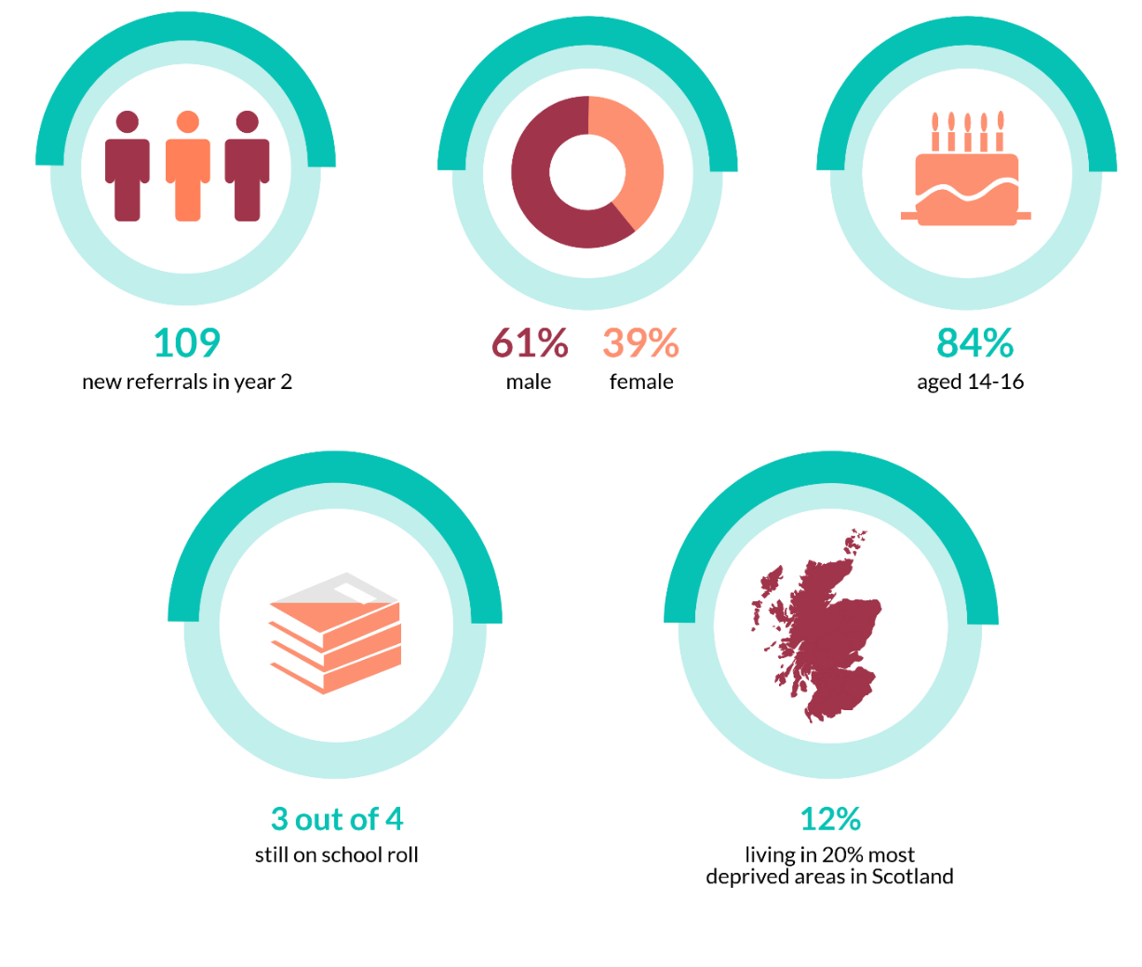
Gender of participants
- The gender split of participants has changed. While in Year 1, 52% of participants were male and 48% were female, referrals to the programme in Year 2 are 61% male and 39% female.
Age of participants
- As the programme progressed into Year 2, programme staff have increasingly engaged younger people at an earlier stage of their employability journey in response to the demand from schools and organisations.

Figure 2.2: Age of new referrals in Year 2 (n=109)

- As shown above, the largest proportion of new referrals in Year 2 were aged 15 (54, 50%). This is a change from Year 1 when the largest proportion were aged 16.
- As a result, more young people compared to Year 1 are still at school at the point of referral (75% in Year 1 and 40% in Year 1).
Referral sources
- In Year 2, Way2Work staff worked with a range of referral organisations and partnerships with local schools were key. As shown below, the majority of new referrals in the year were made through partnerships with local schools (71, 65%).
Figure 2.3: Referral sources for new Year 2 participants (n=109)

SIMD breakdown of participants
- Over the first two years of the programme, staff have increasingly supported young people living in a range of areas classed between SIMD1 and SIMD10. As mentioned previously, the programme targets young people who are disadvantaged or marginalised due to a range of circumstances, and SIMD classification does not capture the diverse situations facing many of the young people, for example young people who are care-experienced or in kinship care.
- In Figure 2.4, we provide a breakdown of new Year 2 participants by SIMD decile.
Figure 2.4: Breakdown of new Year 2 participants by SIMD decile (n=105)

- As shown above, 13 young people (12%) referred to the programme in Year 2 were from the 20% most deprived areas of Scotland. This is proportionately less than Year 1 when 17% of young people were from these areas.
- Building on the fact that disadvantage can be measured in multiple ways other than SIMD classification, the figures above also do not take account of the fact that many young people involved in the programme are looked after by foster carers or kinship carers, and that few, if any, of the cared-for addresses provided were in the most deprived areas.
- The reduction in the proportion of young people from the most deprived areas of Scotland is further explained when considering the schools involved in the programme. For example, learning and training groups were delivered at Musselburgh Grammar School targeted for young people with Additional Support Needs and/or acute social anxiety.

Support delivered in Year 2
- The programme has supported more young people through group-based activities and less so on a one-to-one basis. This is due to the levels of resources available and a high demand for school and community-based group provision, which can deliver to more young people in a shorter timeframe compared to 6-12 months on a one-to-one basis.
- Of all 175 young people who engaged in the programme in Year 2, including 66 young people who initially joined in Year 1:
- 129 (73%) young people took part in group activities;
- 33 (19%) received individual support; and
- 13 (7%) received a combination of group and individual support.
- Among the 109 young people who were referred in Year 2:
- 89 (82%) participated in group activities;
- 16 (15%) received individual support; and
- four (4%) received both group-based and individual support.
- During Year 2, 1400 hours of support were delivered to young people.
Summary of group activities delivered
- In Year 2, programme staff delivered a range of group activities. These included:
- Animal Care – this involved weekly group activities for young people interested in working with animals, enabling them to work towards an SQA-recognised qualification in Animal Care;
- the rolling CSCS group – this involved young people working towards obtaining a CSCS card, certifying them for a range of roles in the construction industry;
- Employability Skills – this group activity, which is distinguished from the accredited employability groups, involved motivational group work and vocational training in construction skills;
- Preparation for Employment/Developing Confidence for Employment – both groups offered employability support to young people while they worked towards an SCQF Level 4 qualification, with Developing Confidence for Employment being tailored towards those young people who were most distant from the labour market;
- PX2/Mindbuzz – these groups focused on confidence-building while also building important life skills and improving self-esteem;
- REHIS Health & Safety – originally delivered as part of the Morrison Construction group in Year 1, in Year 2 these were standalone sessions for young people interested in learning about health and safety in the workplace;
- Social group work – a non-accredited activity focusing on building young people’s life skills and enabling young people to work together.
- In Table 2.1, we show the number of sessions delivered for each group and the number of participants involved.
Table 2.1: Summary of group activities delivered in Year 2
Activity | No. of sessions delivered | No. of participants
Animal Care (accredited) | 29 | 23
CSCS (accredited)* | 50 | 36
Employability Skills | 12 | 12
Preparation for Employment/Developing Confidence for Employment (accredited) | 49 | 56
PX2/Mindbuzz | 78 | 55
REHIS Health & Safety | 3 | 17
Social group work | 14 | 11
Total | 235 | 210
- In Year 2, most of the group-based activity focused on confidence-building and employability, often through accredited learning groups. Although the largest number of sessions were delivered through the PX2/Mindbuzz groups (78), the accredited Preparation for Employment/Developing Confidence for Employment groups were most popular in terms of participant numbers (56).
- Since Year 1, there has been an increase in the delivery of some groups. For example, 36 young people attended the rolling CSCS group this year compared to 19 last year. Twenty-three young people attended the Animal Care group in Year 2, compared to 10 in Year 1.
Chapter 2 summary
- As this chapter has shown, in Year 2 the programme team has supported 109 new referrals, expanded its range of referral and delivery partnerships and delivered an increasing amount of school- and group-based activity, due partly to growing demand for Way2Work intervention. As such, the programme has supported young people facing a variety of challenges at an earlier stage of their employability journey.

- Impact of the programme

- In this chapter, we explore the impact of Way2Work in Year 2, measured against each of the six outcomes for CashBack-funded programmes. In doing so, we draw on qualitative data gathered by the evaluation team and secondary data received from programme staff.
- The quantitative data from the ESAs, SHANARRI scores, stakeholder responses and schools data is used to evidence the targets. However, all four have incomplete returns and this impacts on the extent to which progress against the targets can be accurately measured. We received:
- 62 ESA scores out of a possible 175 young people who engaged with the programme during the year;
- 57 SHANARRI scores out of 142 young people engaging in group activities;
- figures from stakeholder returns for Year 2 only; and
- partial returns of schools data for Year 2 participants.
- Building on the above, issues with the quarterly reporting scorecards meant that there are currently no cumulative figures from stakeholder questionnaires for Years 1 and 2. In this report, indicators relating to stakeholder questionnaires are presented separately in each of the relevant sections and relate to Year 2 only.

Outcome 1: Young people build their capacity and confidence
- As in Year 1, the success of the Way2Work programme in positively impacting young people’s capacity and confidence remained a key strength of the programme in Year 2. As shown below, the programme has successfully achieved its targets for all indicators (where cumulative data was available) and with two indicators these targets were far-exceeded.
Figure 3.1: Building capacity and confidence
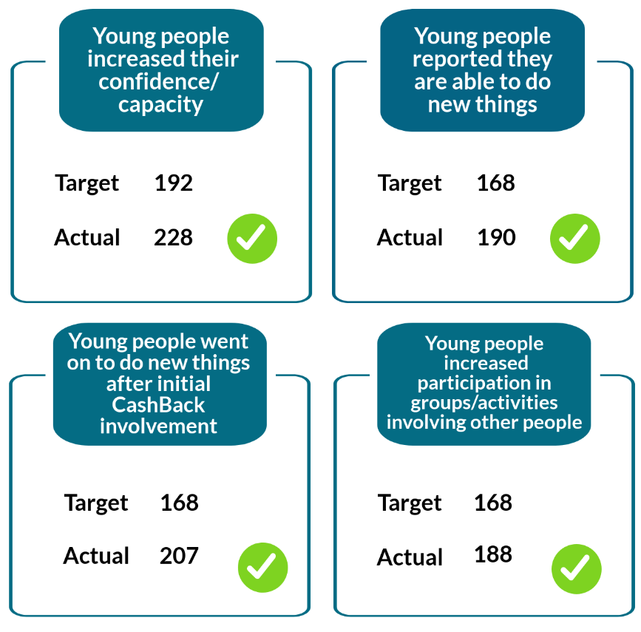
- The programme targets young people who are disadvantaged or marginalised due to various circumstances, such as mental health issues. To measure the impact of the programme on young people building their capacity and confidence, Employability Skills Assessments (ESA) were conducted throughout Year 2.
- The ESA requires the young people to assess, on a 4 point scale from ‘I need lots of help’ to ‘I am good at this’, their competency in 22 different areas including confidence, self-esteem, communication and career decisions. The ESA is completed on more than one occasion, enabling the young person and their ESW to measure progress over time.
- As mentioned previously, we only received a proportion of EA scores for Year 2 participants (62) compared to the number of young people engaging in the programme during the year (175). These scores provide evidence of improved capacity and confidence amongst the young people that completed the assessment.

Figure 3.2 Average ESA scores for Way2Work participants during Year 2 (n=62)

- Even with an incomplete set of data, the ESAs demonstrate an improvement in capacity and confidence amongst the young people being supported – in particular, those supported through the PX2/Mindbuzz groups, reflecting the focus of these groups’ work. As shown in Figure 3.2, these groups experienced a continual increase in average ESA scores.
- Scores for one-to-one support also increased gradually although participants involved in Preparation for Employment/Confidence for Employment experienced a dip in their scores before increasing again. Overall, compared to when they started the programme, levels of confidence and capacity improved for all participants.
- The young people themselves also reflected on the success of the programme in building their capacity and confidence and attributed this change to the groups and one-to-one support. For example, one young person described how the small groups in particular helped them grow in confidence as it pushed them out of their comfort zone without being too intimidating.
- Feedback from both the young people and stakeholders also reflected the success of the PX2 groups in developing young people’s confidence. For example, one stakeholder interviewee described one young person who benefited from PX2 notably because it “pushed him that bit forward”. They emphasised that impact builds up over time, with young people changing from initially being quiet to gradually engaging more and more in group discussions.
- As mentioned previously, there are currently no cumulative figures from stakeholder questionnaires to evidence progress against the relevant indicators in the first two years of the programme. However, in the Year 2 stakeholder questionnaires, stakeholders provided evidence of the programme’s impact on young people’s confidence and capacity through the stakeholder questionnaires. They identified that the young people showed increased active participation in groups, improved social skills and ability to apply for jobs independently.
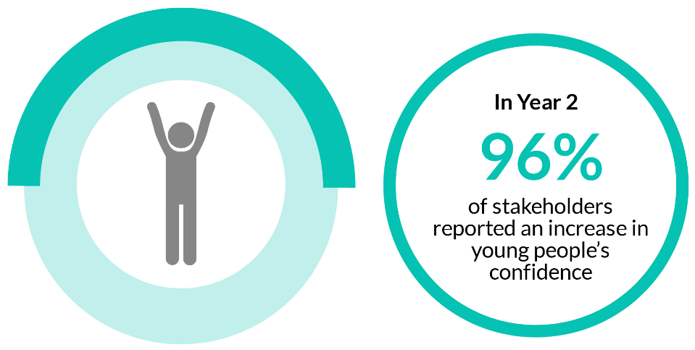
- Some stakeholders also gave examples of how the programme has encouraged young people to try new things. For example, one young person decided to join a local group:
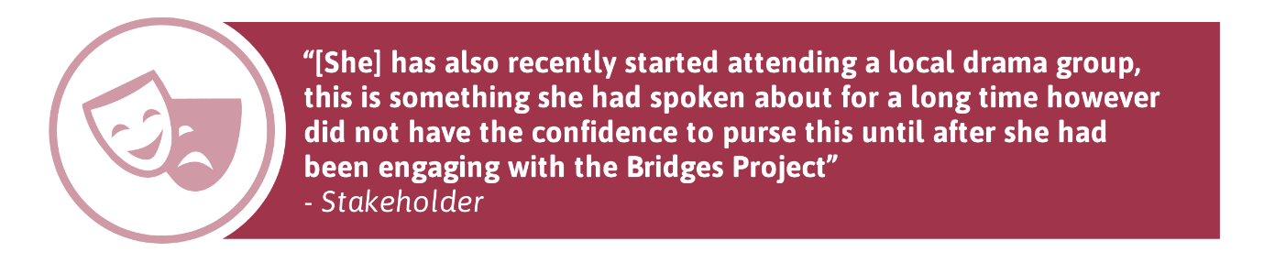
- Overleaf, we provide a follow-up case study of Stuart, a Year 1 participant who remained on the programme in Year 2. In this case study, we illustrate the impact of Way2Work on improving young people’s confidence.

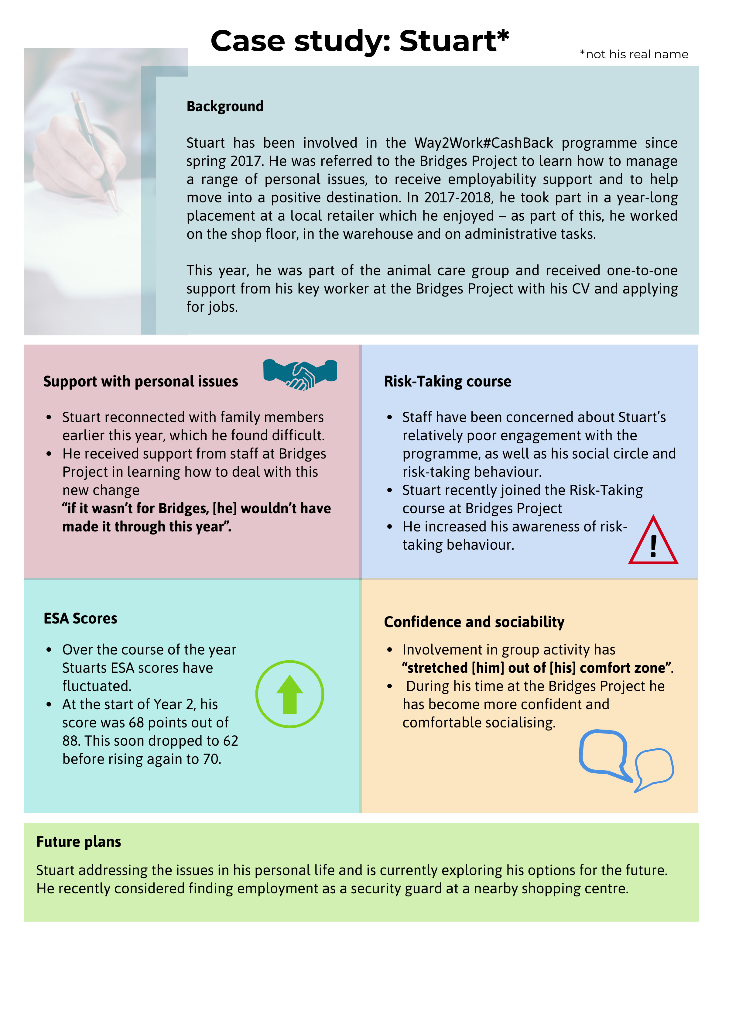
Outcome 2: Young people develop their physical and personal skills
- Way2Work has continued to enable young people to develop a range of skills and gain a range of accreditations in Year 2.
Figure 3.3: Developing physical and personal skills
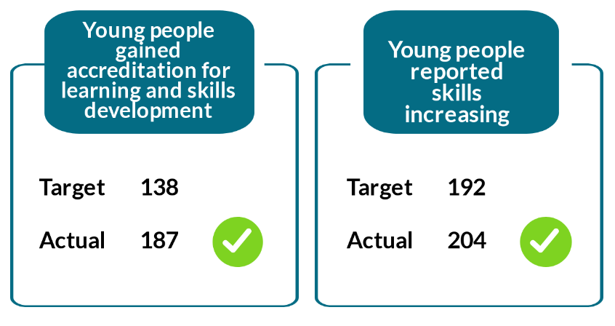
- In Year 2, the programme again succeeded in meeting all of its targets around the development of physical and personal skills. There has been an increase in the number of young people gaining accreditation for learning and skills development since Year 1. By the end of Year 1, 84 young people had gained accreditation for this and then 187 young people by the end of Year 2 – an increase of 122%.
- One hundred and three young people gained accreditation for learning and skills development for the first time in Year 2 and 215 accredited qualifications were attained in total. Over half of these accreditations (118, 55%) were SCQF Level 4 qualifications.
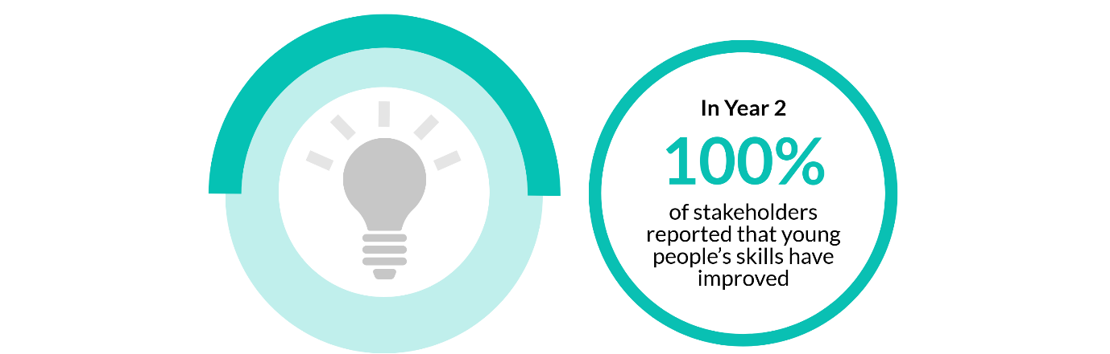
- As in Year 1, the second year of the programme enabled young people to build a range of hard and soft skills. During the interviews, many young people gave examples of the skills they had gained through the programme. Those who had engaged in accredited learning often emphasised new employability-related skills such as how to write a CV or job application, or skills relating to working with animals. As well as further developing on core academic subjects including maths, English and ICT. For example, as one stakeholder commented in their questionnaire:

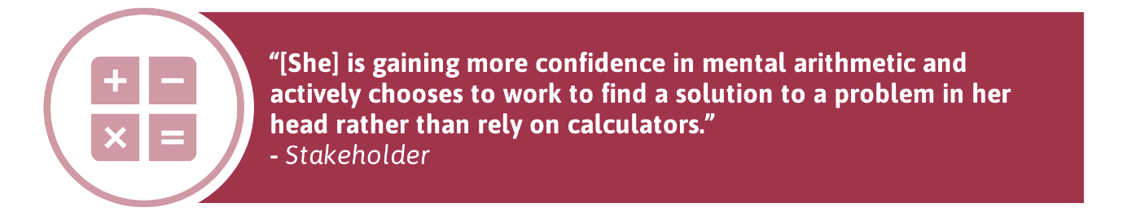
- Reflecting the programme’s impact in building soft skills, some young people described how they now have increased their own self-awareness, understanding of their behaviour and how it can impact others. This increased self-awareness was also reflected in some of the stakeholder questionnaires:
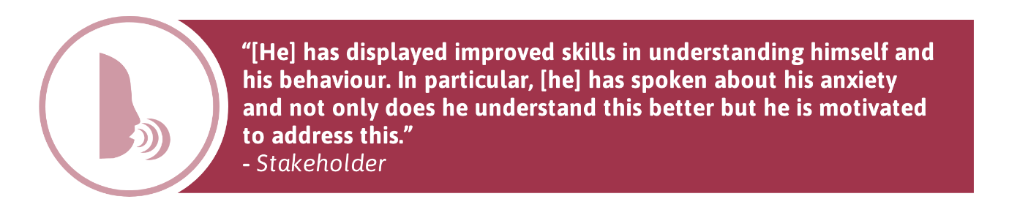
- Other young people improved their organisational and time management skills. For example, at one of the employability sessions, one young person created a plan of what to do if they were invited to an interview, what buses to get and when to leave home. This was particularly helpful to them when attending a college interview and they were later accepted on to a college course.
Outcome 3: Young people’s behaviours and aspirations change positively
- Despite the successes achieved in meeting all of its targets around changing young people’s behaviours and attitudes in Year 1, the limited data from the ESAs and SHANARRIs means that the Year 2 targets have not been met.
Figure 3.4: Changing behaviours and aspirations
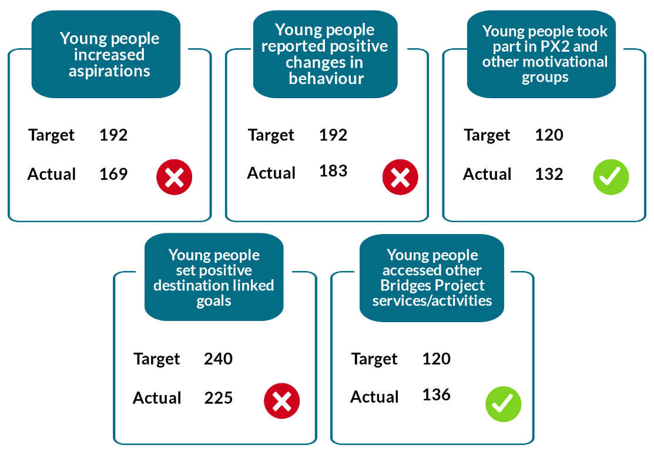
Improvements in behaviour
- As already discussed, the project uses a combination of quantitative tools, including SHANARRI and ESAs, to capture data on these indicators. However, despite the data shortage, our field research highlights that young people reported positive behavioural changes.
- Through our interviews, both young people and parents identified a range of positive changes in behaviour through their involvement in Way2Work. For a few young people, these related to changes in their overall outlook on life.
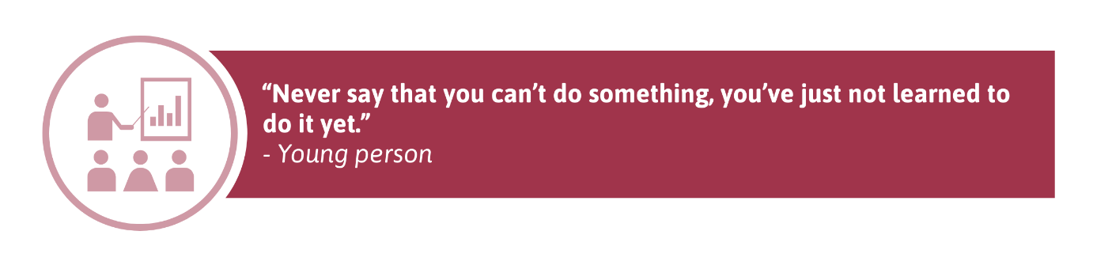
- Likewise, while several stakeholders mentioned in their questionnaires that behaviour was not an issue for the young people they worked with, others gave various examples of positive changes in young people’s behaviour, such as showing more maturity, engaging more or getting on better with others in the group, and being more settled.
- Some young people engaged with other services and activities offered at Bridges Project. For one young person, this was to further develop their behaviour by taking part in the risk-taking course to learn more about risk-taking behaviour.
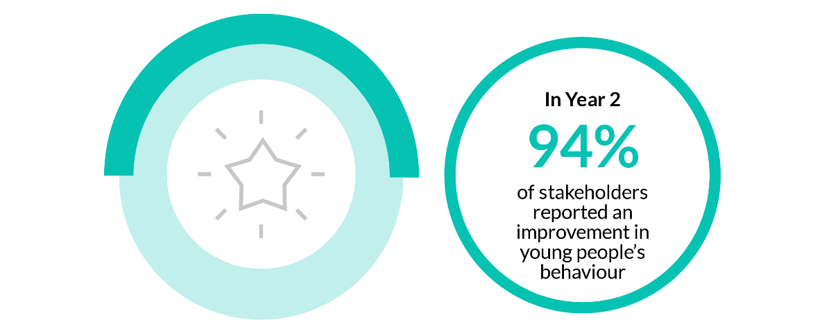
- Our case study of Lucy, at the end of this section on Outcome 3, reflects the positive changes in young people’s behaviour and aspirations through their participation in Year 2 of the programme.
Raised aspirations
- Although looking at the data suggests the programme’s impact in raising aspirations has been limited, almost all of the young people and parents that we spoke to felt that the young person’s engagement in Way2Work had positively influenced their future.
- As in Year 1, the support and encouragement during the programme helped young people to consider their future and what might suit them. This was also reflected in the stakeholder questionnaires.
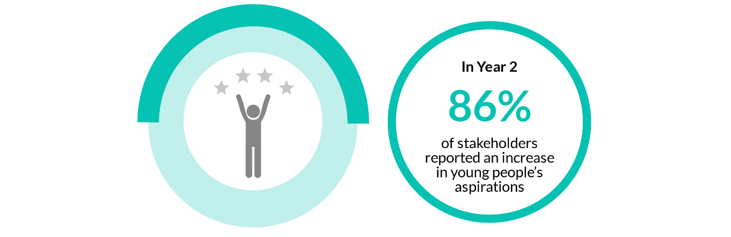
- We provide more details about young people’s plans for the future later in this chapter.

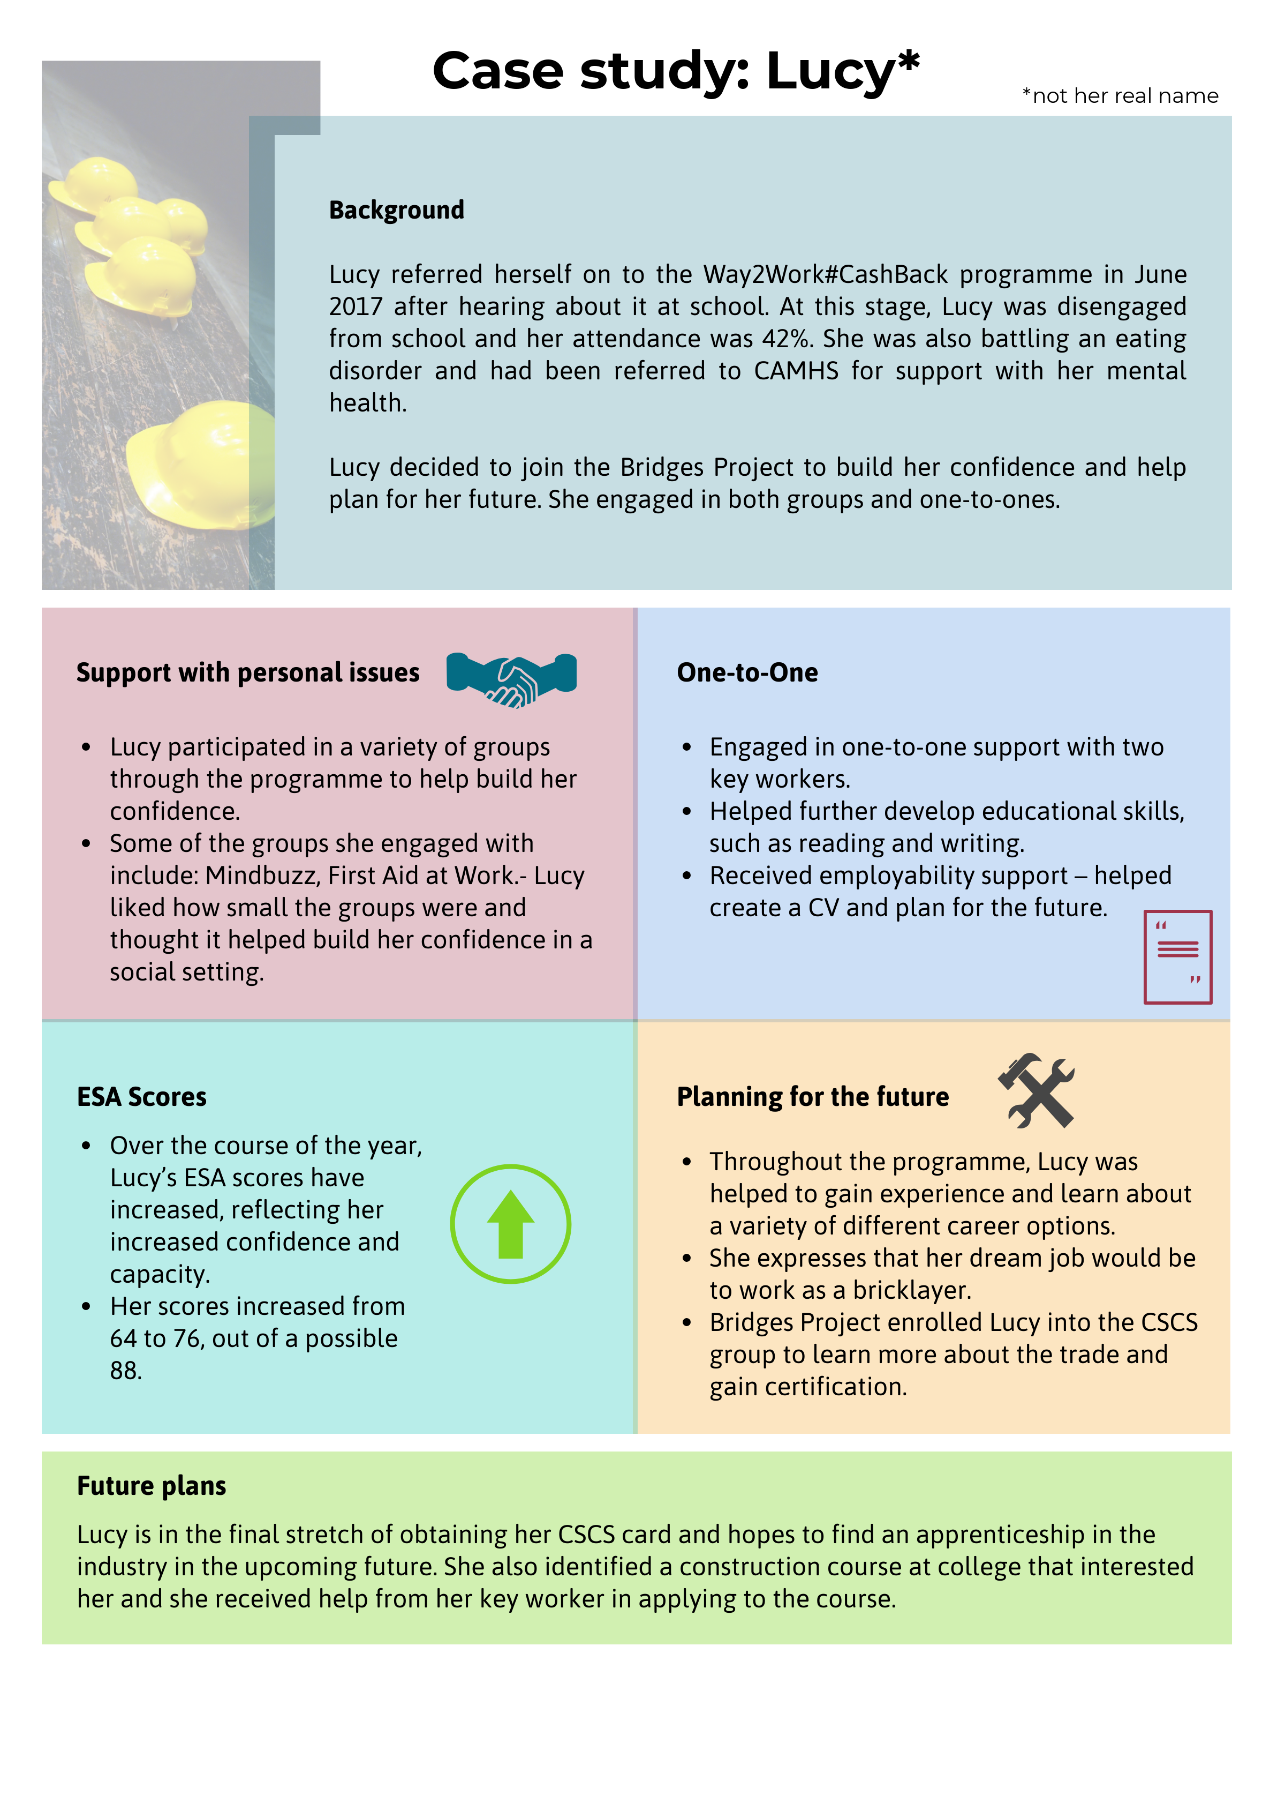
Outcome 4: Young people’s wellbeing improves
- By the end of Year 2, again the limited data collected about young people’s improved wellbeing would suggest that the programme has fallen short of two indicators, in contrast to the data collected in Year 1 when all three targets were met.
Figure 3.5: Improvements in wellbeing
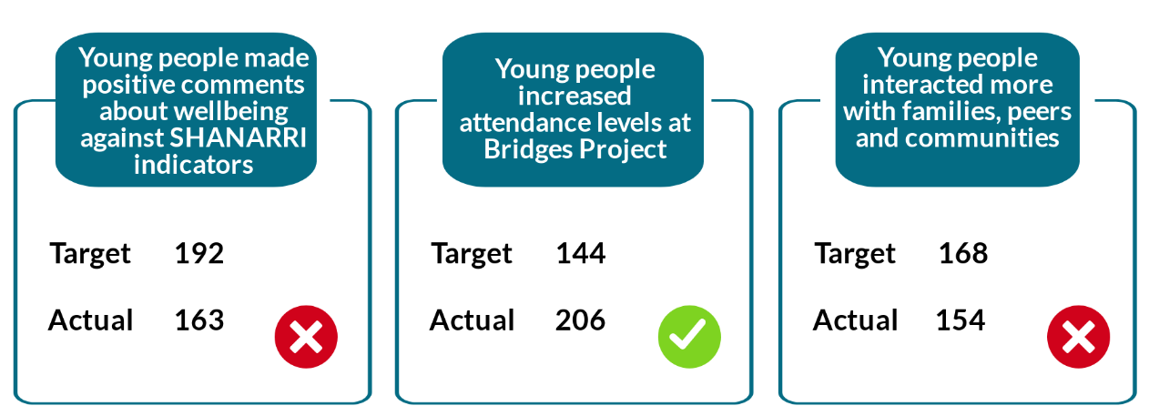
- We received SHANARRI scores for 57 young people who participated in Way2Work in Year 2. This is 40% of the 142 young people who participated in group activities during the year and this is likely to be the main reason why Way2Work has not met its target for the number of young people making positive comments about their wellbeing against the SHANARRI indicators.
- In Figure 3.6 below, we illustrate changes in the SHANARRI scores obtained for these 57 young people.
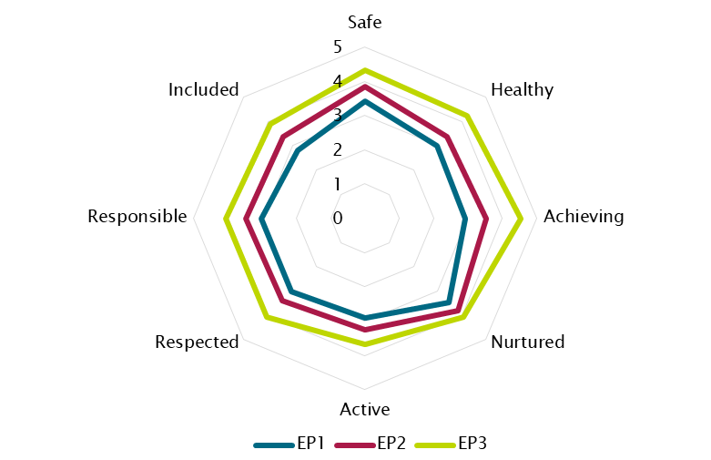
Figure 3.6: Average SHANARRI scores for participants in Year 2 (n=57)
- As in Year 1, the average SHANARRI scores for our sample of Year 2 participants increased across the year.
- The young people that attended the Preparation for Employment/Developing Confidence for Employment groups displayed the most improved SHANARRI scores in Year 2 compared to Year 1 where CSCS displayed the most improved scores.
- Since Year 1, there has been a substantial rise in the number of young people with increased attendance levels at Bridges Project and by the end of Year 2 this target was exceeded by 62.
- Despite the quantitative data, there is clear evidence that the programme has positively impacted on young people’s wellbeing. Similar to Year 1, this applied particularly to managing personal issues and improving their social skills and relationships with others.
Managing personal issues
- Bridges Project works with many young people who face a range of personal challenges like health issues who come to receive support to address them. During the interviews, a few young people said that the Bridges Project has helped them become more aware of their own mindset and the consequences of negative thought.
- Young people’s increased ability to manage their mental health and emotions was also reflected in some of the stakeholder questionnaires.
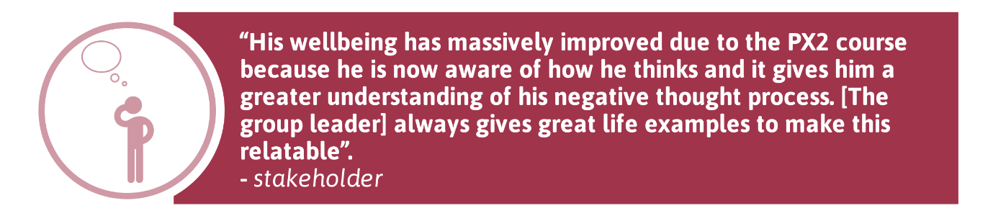
- Another young person learned to write a blog which they used to express their feelings and perspectives on the world. Their parent felt that the young person had made more progress at Bridges Project compared to school and commented that “the small things they do to suit her make a big difference”.
- A few young people had initially found it difficult to leave the house but this changed through their participation in the programme. By receiving support from the staff to address server personal issues and being made to “feel welcome the minute you walk in the door”, they managed their feelings better and could engage with others outside their home.
Improved social skills and relationships with others
- In many stakeholder questionnaires, young people’s improved ability to socialise with others was given as evidence of an improvement in overall wellbeing now that they were “less socially isolated”.
- For a few young people, the programme has also improved their relationships with family. Examples of those positive changes include:
- reconnecting with a parent where contact had stopped;
- improved communication between young people and parents; and
- spending more time with grandparents
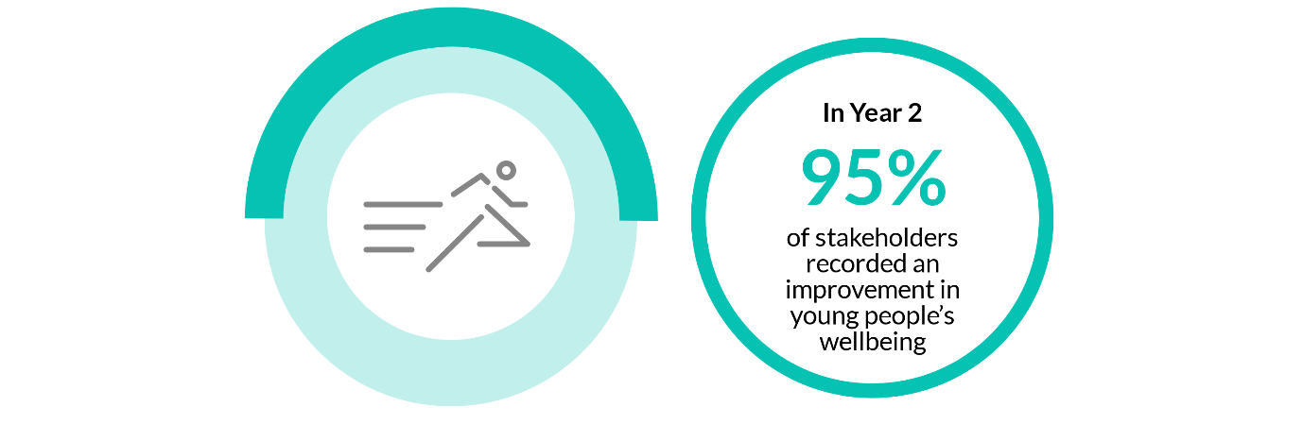
- Overleaf, we provide a case study of Amber, who experienced positive changes in her wellbeing and outlook on life through her participation in the programme.

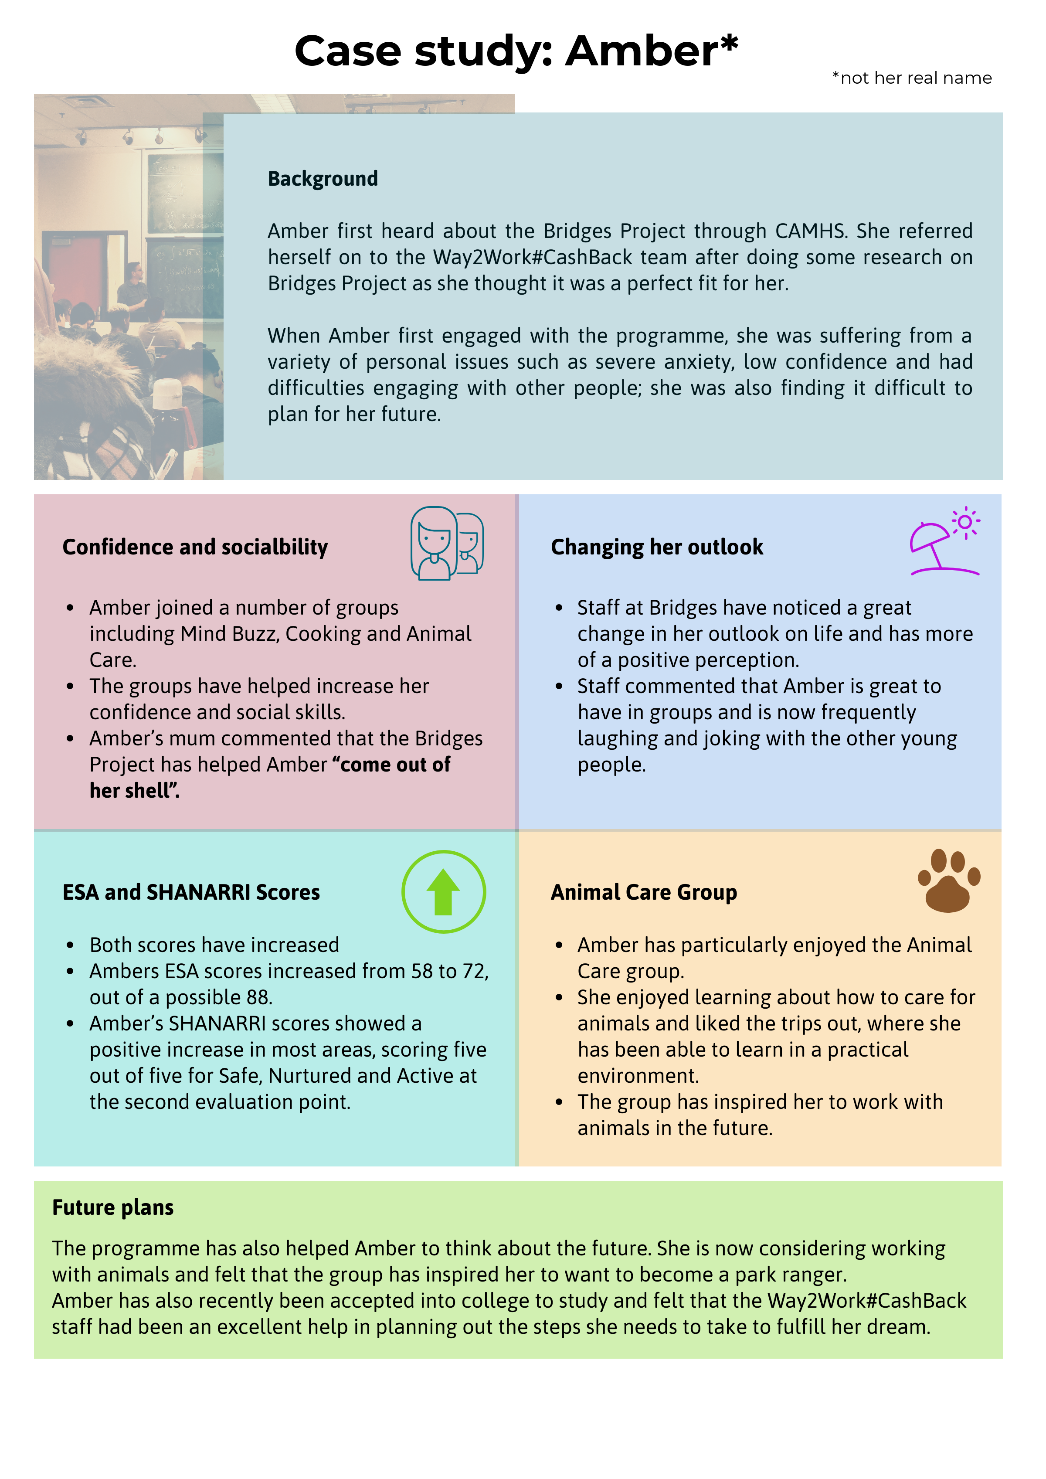

Outcome 5: Young people’s school attendance and attainment increases
- If we consider the data, the figures provided in Figure 3.7 suggest that the programme has yet to reach its attendance and attainment targets. As mentioned previously, in Year 2 programme staff resolved the data-sharing agreement with Midlothian Council but issues in receiving school-related data have continued. Issues in receiving data from East Lothian are also ongoing - as half of the young people still on the school roll in Year 2 are from East Lothian, this has impacted on the target results.
- The timing of receiving information from the schools has had an effect on the amount of data that could be collected. For example, most young people will not be receiving their qualifications until August 2019 and the target for young people leaving with more qualifications than expected cannot be accurately reported at this point.
- Also, the figures provided below represent progress towards cumulative targets over the full two-year period to date, and no information was collected on progress during Year 1 of the programme. Therefore, the data is for a one-year period but with a two-year target.
Figure 3.7: Attendance and attainment at school
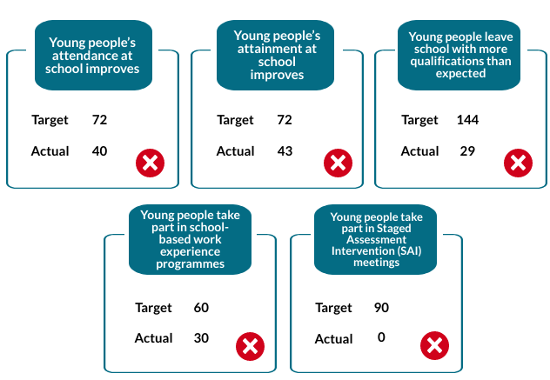
- Additionally, some of the targets listed above are redundant. For example, Staged Assessment Intervention (SAI) meetings are no longer used consistently across schools to plan a young person’s care and support so there is no data on this target. Young people can be involved in a variety of alternative meetings, such as Multi-Agency Meetings, Child Protection Meetings and Involved Professional Meetings – and not all of these will involve the young person and/or their parents or carers.
Attendance at school
- Despite these issues around data collection, when analysing the data that was collected for 30 young people it showed that the programme had positively impacted on their attendance at school.
- Most of our young people interviewees had already left school, therefore, there was limited qualitative data around the impact of the programme on their attendance and attainment at school. However, for some young people their participation in the programme was an incentive to attend school - one stakeholder interviewee from a local school felt that many of the young people’s attendance at school increased by taking part in PX2 because they enjoyed the group and “they don’t want to blow it”.
Attainment at school
- Again, despite the data limitations, there is some evidence of the positive impact of the programme on young people’s attainment at school.
- Data from schools in Midlothian and East Lothian showed that:
- 24 young people sat exams during the 2018 exam period, achieving 95 passes at various levels;
- 21 young people achieved better results than expected; and
- the largest proportion of passes achieved (47, 49%) were at National 4 level.
- More evidence of the positive impact of Way2Work on young people’s attainment at school can be found in a small number of stakeholder questionnaires – their responses showed that some young people were engaging more with their learning or had become more confident learners. Others were communicating better or working more effectively with peers.

Outcome 6: Young people participate in activity which improves their learning, employability and employment options
- Again, the incomplete data does not reflect an accurate picture of how the programme has encouraged young people to participate in activity that improves their learning, employability and employment options.
- The same challenges apply for measuring progress towards each of the targets listed in Figure 3.8 for Outcome 6. In our Year 1 report, we recommended that the programme should obtain access to destination data for larger numbers of young people exiting the programme. These difficulties in obtaining destination data have continued in Year 2.
Figure 3.8: Participation in activity improving learning, employability and employment options
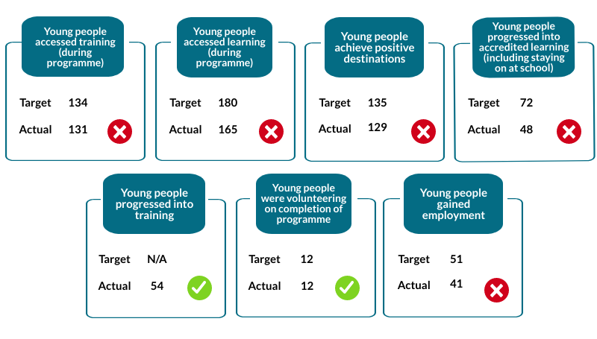
- Additionally, there has also been a time lag in gathering data on positive destinations - destination data for young people leaving school at the end of the 2018/19 academic year was not available at the time of writing this report.
- Also, as with Outcome 5, not all of the indicators for Outcome 6 are relevant to all of the young people supported on the Way2Work programme. For example, Figure 3.8 suggests that 48 out of a target of 72 young people progressed into accredited learning, such as staying on at school. However, 25% of participants were not on the school roll at the point of referral.
- As shown in Figure 3.8, at least 129 young people have progressed into a positive destination over the first two years of the programme. Of these, at least 60 (47%) achieved a positive destination in Year 2.

Positive destinations achieved
- Since Year 1, there were some changes around the types of destinations that young people have achieved. In the diagram below, we illustrate the destinations achieved by the 60 young people achieving a positive destination in Year 2.
Figure 3.9: Positive destinations achieved by Year 2 participants (n=60)

- The largest proportion (20, 33%) of young people moving into a positive destination in Year 2 progressed to employment or an apprenticeship. This is a change from Year 1, when college was the most popular destination (21 of 26 young people, 30%).
- Some of the examples of the types of destinations that young people have moved into include:
- gaining full-time employment at a local golf club;
- being accepted into college to study social sciences;
- working as a catering trainer;
- starting an HGV mechanic apprenticeship;
- gaining employment as a general labourer; and
- moving on to a retail course at Fort Kinnaird.
Planning towards achieving a positive destination
- For those young people who were yet to move into a positive destination, the programme helped them plan towards achieving this. Many of the participants we spoke to had plans to go to college to study a variety of subjects – childcare, bricklaying, music, animal care, film, and media, and communities work.
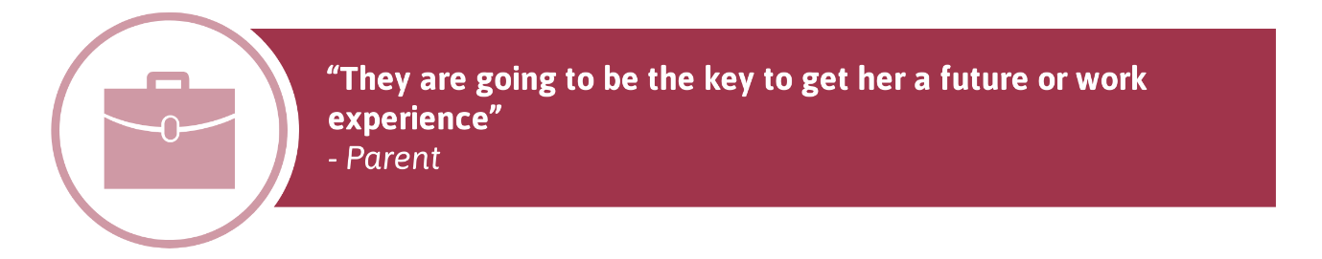
- Parents also reflected on the positive impact of the programme in providing young people with a sense of direction and helping them to consider their future options:
- For the few young people who already had an idea of what they wanted to do before they engaged in the programme, the programme reaffirmed these. For example, one participant said that while they had already identified a particular career path of interest to them, the support and encouragement of the Way2Work staff reinforced their decision and gave them the confidence to do the college course.
- In our case study of Martin, overleaf, we demonstrate the impact of the programme in helping young people to move into positive destinations.
Chapter 3 summary
- As this chapter has shown, the data does not accurately reflect the success of the programme in meetings its end of Year 2 targets due to the ongoing issues around data collection and the timing of the receipt of this data. However, the available quantitative and qualitative evidence indicates that the programme has helped many young people to build a range of skills, boosted confidence and aspirations and led to improvements in overall wellbeing. At the same time, there have been improvements in some young people’s performance at school, while many have also been supported to move into or plan towards a range of positive destinations.

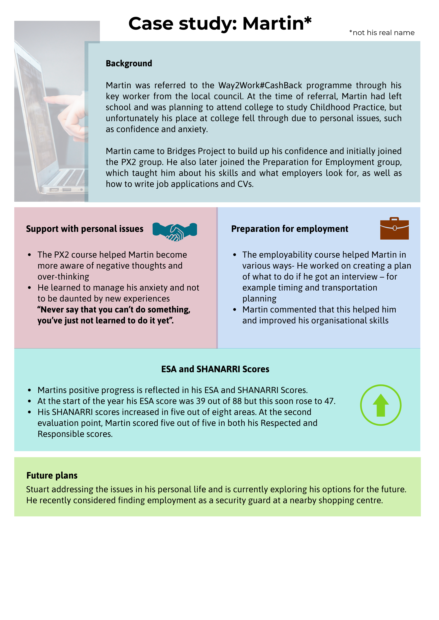

- Conclusions and recommendations

Conclusions
- Overall, Way2Work remains on track to support 360 young people over the three-year delivery period, with 282 young people engaging with the programme during the first two years.
- Following Year 1, there were some changes in how the programme is delivered through the formation of new partnerships and changes in the group activities offered. Group activities increased in Year 2 in response to the demand for this element of the programme.
- New processes for collecting and sharing data were also implemented, with key improvements being made to the internal programme database and the data-sharing agreement with Midlothian Council being resolved.
- As we have shown, in Year 2 the success of the Way2Work programme has continued in supporting many young people to prepare for and/or enter a positive destination has continued.
- However, the data does not tell the whole story. It does not fully reflect the complexity, on several fronts, of the lives of the young people who are referred on to the programme for a wide variety of reasons.
- Ongoing issues around data collection have made it challenging to accurately measure progress towards some of the key outcomes for CashBack funding. This was due to incomplete returns of ESAs, SHANARRIs, Ryff Scales and the lack of cumulative figures from stakeholder questionnaires, combined with incomplete data returns from schools.
- Despite these issues with the data, feedback from young people, parents and stakeholders was hugely positive and the programme has succeeded in tackling some of the key barriers that young people face, such as low confidence, a lack of employment-related skills and low aspirations. At the same time, the programme has contributed to improvements in young people’s general wellbeing.
- There is also evidence to suggest that the programme has had a tangible impact on the attendance and attainment of young people at school. Likewise, although some data on positive destinations was missing, the programme has continued to help young people progress into a variety of high-quality positive destinations or plan towards achieving this.
- There have also been important changes in the types of destinations achieved, with more young people entering employment or starting apprenticeships than progressing to further education.
Recommendations
- The recommendations for future delivery relate to the evidence-gathering aspects of the programme.
- Recommendation 1: In Year 3, the programme should capture, a more comprehensive profile of the young people. Often this information, for example, care experienced, young carers, mental health issues is recorded in the case files but not collated and reported. This would provide a richer understanding of the diversity of backgrounds of those in the Way2Work cohort.
- Recommendation 2: In our Year 1 evaluation we recommended the use of ESAs with all participants to measure young people’s progress in a range of areas. The use of the ESAs, Ryff Scales and SHANARRI wellbeing tool was inconsistent in Year 2 and the number of completions has prevented a robust assessment of delivery of the project targets. In Year 3 the measurement tools should be used more widely and consistently with the relevant young people.
- Recommendation 3: Although school data returns will likely improve in Year 3 as the data-sharing agreement with Midlothian Council is further embedded, programme staff would benefit from providing schools with further guidance around their requirements and expectations for schools data ahead of the next academic year. This would lead to more consistent datasets that in turn enables more accurate reporting.

The Academy was also involved in delivering the rolling CSCS activities.
In Year 1, Health & Safety sessions were delivered through the Morrison Construction group, but this changed in Year 2 after the Morrison Construction group was disbanded.
Postcode data was not available for four young people referred to the programme in Year 2.
Note that the average scores at EP3 and EP4 represented only two young people.
Although the SHANARRI tool is aimed at young people participating in group activities, two young people from the Year 2 sample received one-to-one support.
The figures provided were gathered from data from schools in both local authority areas combined with other data sources, such as stakeholder feedback.

