Evaluation of basketballscotland’s Phase 3 CashBack for Communities programme

Final Evaluation Report

June 2017

CONTENTS

Chapter Page
Executive Summary i
1. Introduction and context 1
2. Growing the Game 6
3. Developing Young People – the Education Programme 16
4. Developing Young People - Schools of Basketball 24
5. Developing Young People – Modern Apprentices, Youth Leadership & Youth Achievement Awards 30
6. Summary of observations from Phase 3 37

Appendices:
Appendix 1: basketballscotland – activities and related CashBack for Communities outcomes

Executive Summary

Introduction and context
basketballscotland is the national governing body for basketball in Scotland, aiming to provide players of all ages with the opportunity to play at the level of their ability. basketballscotland has ambitions to embed basketball in Scotland’s sporting landscape, enabling both mass participation and achievements at an elite level.
The Scottish Government started the CashBack for Communities programme in 2007. The programme takes funds raised through the confiscation of assets from those involved in crime and invests them in community programmes, facilities and activities. These activities are aimed largely, but not exclusively, at young people at risk of turning to crime and anti-social behaviour. They ask that activities are positive, open to all, developmental and sustainable.
The story so far
In 2008, basketballscotland embarked on a programme of activities funded by CashBack for Communities. So far CashBack has funded three phases of development, outlined below. This report looks at the progress made in Phase 3 of the programme and shares the impact of the programme and learnings to take forward into Phase 4.
Phase 1, 2008 – 2011
£343,000 funded four Regional Development Coordinators and led to the development of playing and coaching opportunities for young people across Scotland.
Phase 2, 2011 – 2014
£700,000 funded the continued development of opportunities for children to play basketball at primary school, helped create links between schools and clubs, increased the teams playing competitively and upped the support for volunteers and professionals in clubs.
Phase 3, 2014 – 2017
£600,000 funded the development of the game, particularly for under-represented groups of people. The conditions of the funding specified that this should be achieved under the ‘Growing the Game’ and ‘Developing Young People’ strands of the programme.

The focus for Phase 3
This latest phase of development has focused on two key strands: ‘Growing the Game’ and ‘Developing Young People’.
Growing the Game consists of four programmes: Club Champions, Competition and Club Development, Equalities and School Champions. Each of these four programmes develops and delivers initiatives to grow the game and increase participation.
Developing Young People consists of five programmes: Education, Youth Leadership, Modern Apprentice, School of Basketball and Youth Achievement Awards. Each of these programmes help young people learn to play and coach the sport, as well as developing new skills and accessing employment opportunities.
Delivering the Growing the Game strand
Club Champions
Club Champions offer taster sessions and other activities at schools to encourage greater participation in basketball and foster links between schools and clubs. 13 Club Champions were appointed in Phase 3. The intention is that these roles are filled by young people, but only half were under 25. Evidence shows that Club Champions have increased participation of women, youth membership and the establishment of new teams.
The Club Champions themselves noted that the programme brought additional benefits beyond those of access to and playing a sport. Young people gained life skills, increased confidence and built new relationships. Those who were not necessarily academic found an outlet at which they could excel. The Champions observed a change in culture at basketball clubs to a more community-focused, family atmosphere.
The programme has also enabled the Club Champions to develop as people, acquiring new interpersonal and employment skills, allowing for self-reflection and gaining in confidence.
Competition and Club Development
Regional Development Leagues, a key strand of Competition and Club Development, give entry level teams opportunities to compete. They far exceeded their targets for establishing new teams and increasing new youth members. The Leagues also continued to provide an ideal learning environment for young referees and officials to gain regular experience.

Equalities Programme
This saw real progress in attracting participation from excluded communities. A 29% increase in registered players with a disability was attributed to the work of the Wheelchair Development Officer, while a wide range of targeted activity pushed the number of girls and women participating in the game up significantly, which has been sustained over the three year phase, although not quite to the ambitious target of 60:40 male to female set by the national body.
School Champions
The School Champion strand was not implemented as intended and there was no independent evaluation of the strand on which to base any reporting. Despite this, basketballscotland still delivered targets in relation to this strand.
Delivering the Developing Young People strand
Education Programme
The Education Programme offers young people opportunities to gain accreditation for basketball learning and achievements. It offers courses that range from entry level to advance training. An online survey issued to young people who had recently completing training found that they had increased their learning and skills, and the subsequent opportunities this had provided, had made them more confident individuals, committed to pursuing healthy lifestyles.
Youth Leadership
In this programme, clubs are offered a financial incentive to select and support young people in leadership roles. Those who are selected coach, organise events, and act as mentors. There were 92 people on the programme in this phase, just short of the 100 target. Youth Leaders are also offered the opportunity to take part in the Young People’s Panel, giving them a say in the decision-making and policies of basketballscotland. Interviews with participants of the programme said that it had increased their confidence, allowed them to make contacts with people who worked in sport and confirmed their ambition to work in sports development.
Modern Apprentice
Two people took up six-month apprenticeships with basketballscotland. They supported clubs in their work to increase participation and provide opportunities for competitive basketball. Both reported improvements in their confidence and skills and appreciated the access it gave them to possible further employment. One found a permanent role within basketballscotland following her apprenticeship.

School of Basketball
This is a flagship strand of CashBack-funded activity. Schools who might benefit from additional support (for example, according to SIMD) are offered a tailored programme of positive activity, skill development, and progression towards a positive destination. The programme exceeded the target number of participants by almost 300 across Phase 3 and was delivered in 12 schools.
Case studies found the extensive impact that the programme is having on both young people and communities involved. Schools of Basketball often provided young people with their first opportunity to experience basketball, increased physical activity, and encouraged positive behaviour and personal development; those that took part showed better attendance rates at school than those who didn’t. Some young people have tried further basketball activities, such as club membership, after attending the School.
However, the way the Schools are set up and delivered varies from school to school. Whilst this means they can cater for local circumstances, it does mean an inconsistent experience for participants. basketballscotland have recognised this and developed a 40-week curriculum that will be delivered in a refocused programme in Phase 4.
Youth Achievement Awards
The SQA-accredited Youth Achievement Award was designed to recognise young people who have developed leadership, responsibility and confidence, or volunteering experiences. During Phase 3 this was changed and Future Starz Dynamic Youth Award was introduced to reward similar achievements among the younger age groups. Future Starz disbanded during Phase 3. The main barrier to delivering an awards scheme was a lack of administrative support and appropriate structure at club level, something that needs to be addressed before another award scheme is proposed.
Key impacts
Evidence gathered about the activities during Phase Three continues the trend of positive impacts started by CashBack-funded activities in the first two phases. The key areas of progress are:
- Increased participation in basketball, particularly by girls, women and people with disabilities;
- Further development of young people and promotion of progression pathways;
- Significant development of transferable skills, both for participants and coaches, using those acquired by playing basketball to achieve better behaviour, improve confidence and progress future careers;

Key learnings
Phase 3 saw considerable changes to local and national personnel, the incomplete delivery of the School Champions programme and the Youth Achievement Awards coming to an end. An absence of robust monitoring tools and procedures mean it has not always been possible to measure the direct impact of CashBack-funded activities. Other key observations that basketballscotland is aware of and addressing are:
- Club Champion roles were aimed at young people, but less than half of those employed in Phase 3 were under 25;
- The RDLs need to be reframed to cater for both experienced teams and new players just starting out in the game.
- The ratio of male:female participants in the sport still falls short of its ambitious 60:40 target.
- Award schemes flounder because of a lack of administrative support at club level.
- Schools of Basketball vary in how they deliver the programme meaning participants’ experiences are very different.
However, basketballscotland has already taken significant steps to eliminate similar challenges in Phase 4, as follows:
- A change of leadership to re-focus on the resourcing and direction of the programme;
- A move to focus on what really works by condensing programme activity to Schools of Basketball only;
- Implementation of a 40-week curriculum for Schools of Basketball to encourage a consistent experience for participants regardless of location
- Introduction of an array of new data-gathering procedures (such as Upshot) to allow more robust evidence of the impact of the programme to be collected.
- Establishment of a Female Strategy Working group to review the ratio of male to female participants and set out a plan to achieve the 60:40 target by 2022.

- Introduction and context

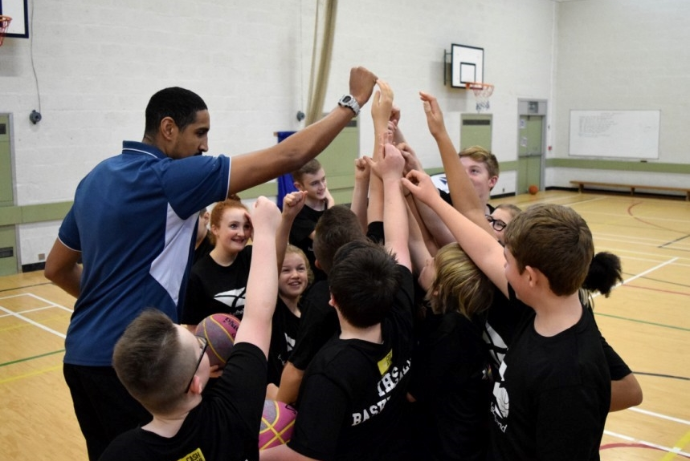
Keiran Achara visits a School of Basketball in Inverness
CashBack for Communities
- The Scottish Government started the CashBack for Communities programme in 2007. The programme takes funds raised through the confiscation of assets from those involved in crime and invests them in community programmes, facilities and activities. These activities are aimed largely, but not exclusively, at young people at risk of turning to crime and anti-social behaviour. There are key principles underpinning all activities:
- positive: wholesome, healthy, fun, active, engaging;
- open to all: accessible, well-advertised, free of charge, of interest to all ages and to both boys and girls, ethnic minorities, and young people with disabilities;
- developmental: changing behaviours and attitudes, developing personal and physical skills; and
- sustainable: providing medium and long-term benefits, in addition to short-term benefits.

basketballscotland’s CashBack for Communities programme
- basketballscotland is the national governing body for basketball in Scotland, aiming to provide players of all ages with the opportunity to play at the level of their ability. basketballscotland has ambitions to embed basketball at a high level in Scotland’s sporting landscape, particularly since similar smaller countries have been able to establish basketball at both mass participation and elite performance levels. CashBack for Communities has enabled basketballscotland to further progress these ambitions while benefiting young people across Scotland.
- Phase 1 of CashBack for Communities activity was launched in 2008, when basketballscotland received £343,000 to deliver a three year programme. This funded four new Regional Development Coordinators across Scotland, and led to the development of basketball playing and coaching opportunities for young people. Following a successful application for Phase 2 (2011-14) funding this activity continued. £700,000 was spent on increasing opportunities for primary school pupils, creating formal links between clubs and local schools, increasing the number of teams playing at a competitive level, and increasing support opportunities for volunteers and professionals at a club level.
Phase 3 CashBack for Communities
- The next three-year phase began in 2014, when basketballscotland was awarded £600,000 of CashBack funds to continue developing the game, particularly among under-represented groups of young people. It was specified that this would be achieved through ‘Growing the Game’ and ‘Developing Young People’. This phase also saw particular focus on monitoring and reporting systems. Observations from these have helped the strand develop and progress.
Phase 3 expenditure
- The strands of activity are delivered in partnership across basketball clubs and schools, engaging players, staff and volunteers. The investments for each area of activity funded through CashBack for Communities 2014-17 are outlined in Table 1.1.
Table 1.1: Investment in each strand of activity
Area of expenditure | CashBack funding over 3 years
Delivery staff | £360,461
Competitions | £39,000
Education | £10,500
School of Basketball | £24,000
Youth employability | £15,000
Club employment | £60,000
School Champions | £4,500
Management fee | £57,868
Monitoring and evaluation | £28,671
TOTAL | £600,000

Evaluation methods and aims
- Alongside the key principles underpinning all CashBack-funded activity, each programme has identified short-, intermediate-, and long-term outcomes. These are articulated through the CashBack logic model and specified in the Grant Offer Letter (GOL).
- As well as detailing the funded outcomes and anticipated indicators, the GOL specifies the frequency and type of monitoring activity required of basketballscotland. The national body committed to delivering on many outcomes and indicators within Phase 3 and over the three years has worked closely with Inspiring Scotland to capture the achievements and reflect on lessons learnt.
- The desired outcomes of the two funded strands, Growing the Game and Developing Young People, are summarised in Tables 1.2 and 1.3.
Table 1.2. Growing the Game
Growing the Game
Competition and Club Development Programme | Continue to deliver and grow the game through the Regional Development Leagues.
Equalities Programme | Provide opportunities for under-represented groups to engage in the sport.
School Champions | Increase basketball delivery in schools by recognising and rewarding those involved in school basketball.
Club Champions | A part-funded club position, for a young person, designed to support clubs to increase participation with schools.

- Since the Phase 2 evaluation activity primarily focused on ‘Growing the Game’ it was agreed that Phase 3 activity would focus on ‘Developing Young People’, particularly since this was a new emphasis within the planned set of activities. This focus informed the evaluation methods and approaches undertaken, which have been adjusted, at times, to reflect the changing circumstances in delivery of funded activities.
Table 1.3: Developing Young People
Developing Young People
Education Programme | Provide opportunities for young people to gain accredited learning and develop new skills.
Youth Leadership | Designed to develop a large group of young leaders to work with their club to support basketball development at a local level.
Modern Apprentice | Employment of a young person to achieve a modern apprenticeship.
School of Basketball | Work with targeted schools to deliver curriculum and extra-curricular basketball programme for S1 and S2 pupils and links to clubs.
Youth Achievement Awards | Deliver these awards for young people through a volunteer accreditation scheme in partnership with affiliated clubs.
Evaluation activity
- In addition to the findings from the mid-phase evaluation report, this final report has been informed by the following sources:

Changes during Phase 3
- Since the submission of the mid-phase evaluation report in March 2016, there have been key personnel changes in the basketballscotland team. The Head of Communities left the organisation and responsibility for delivering CashBack activities was taken on by the newly appointed Head of Education and Development. The new postholder has revisited some activity to strengthen or refocus efforts and this has resulted in some changes to the programme delivery.
- The mid-phase evaluation report proposed that the second half of the Phase 3 evaluation should focus on the following strands: Modern Apprentice, School Champions, Youth Achievement Awards (or alternative), and revisit the experiences of young people involved in the Young People’s Panel and in Schools of Basketball. Since then, amendments have been made to the evaluation approach in light of changes to the implementation of some strands of activity, in particular, the School Champions strand.
- The mid-phase evaluation report described how internal issues meant that the School Champions programme had not received sufficient administrative resource. This was reinforced when attempts to issue online surveys to those involved in this strand of the programme gathered only one response. Whilst schools remained engaged in basketball through other strands of activity, basketballscotland’s intention was to relaunch the programme in the first quarter of 2016. However, the School Champion strand was not fully implemented as intended due to a combination of factors that are discussed in Chapter 2, but despite this basketballscotland still delivered targets in relation to this strand.
- Similarly, the Youth Achievement Award has not been covered by this report. Through discussion with basketballscotland, we understand that no awards have been offered in 2016-17.
The report
- The rest of the report is structured as follows:
- Chapter 2 focuses on the strands delivered under ‘Growing the Game’;
- Chapter 3 through to Chapter 5 explores the evidence gathered against outcomes and indicators for the ‘Developing Young People’ programmes (the Education Programme in Chapter 3 and Schools of Basketball Chapter 4); and,
- Chapter 6 outlines a summary of observations from Phase 3 and learning for Phase 4 of funding.

- Growing the Game

Club Champions
- The Club Champions programme is integral to the ‘Growing the Game’ focus of Phase 3. The young person, based in a club, encourages greater participation in positive activities by increasing opportunities for young people to develop interests and skills, particularly among difficult to engage and equalities groups. The outcomes and indicators of the programme are shown below.
Table 2.1: Club Champions outcomes and indicators
Outcomes | Indicators | Achieved
Short-term outcomes – participation
Increased participation by difficult to engage and equalities groups | - 40% female players ratio  - 50% of Clubs delivering female basketball | - 32% (2,230)  - 75% (75) of basketball clubs deliver female basketball.
Increased participation in positive activity | - Increase in youth memberships with clubs who deploy a club champion  - 66 new teams established  - Minimum of 60% (3,500) youth memberships out of total | - 214 more youth club members (a 28% increase from 769 to 983)  - 95 new teams established  - 61% (4,543) youth members from total
Increased opportunities to develop interests and skills | - Number of schools/taster sessions delivered by clubs with club champions | - 111 schools visited/taster sessions delivered
Increased opportunities for continued participation by linking up and signposting to other provision | - Increase in club membership and attendance due to school / taster session links | - 214 more youth club members (a 28% increase from 769 to 983)
Intermediate outcomes
Sustained participation in positive activities | - 70% retention rate of youth members  - Minimum of 60% youth memberships | - 71% retention rate  - 61% (4,543) youth membership
More participants progress into a positive destination | - 10 young coaches in sustainable employment through club champions | - 13 young coaches employed in Club Champions programme

The role of Club Champions
- CashBack funding has enabled a number of clubs to part fund Club Champion roles in partnership with the local club or local authority. Primarily, the purpose of the Champions is to encourage greater participation in basketball across the community and to develop links between schools and local clubs. This is usually achieved by offering taster sessions and other activities at local schools or after-school coaching sessions. The intention is that the Club Champion is a young person and so this also provides opportunities for them to develop their coaching and other necessary skills to plan and promote the sessions, and be paid to do so. Line management and day to day support is the responsibility of the club committees while basketballscotland provides learning opportunities through coach and volunteer development.
- During Phase 3 there were 13 Club Champions were appointed, in excess of the target of 10. Whilst the original intention was for young people to fill these posts, only five of the 13 Club Champions were 25 or under when they were appointed. Based on the target of ten, this means that only 50% were 25 or under. The interviews with the Club Champions identified the impact of their role on participation in the sport, on the players and on the Club Champions themselves.
Impact of Club Champions on participation
- Table 2.2 highlights the current roles in clubs by local authority, the impact this has had on club membership, and the proportion of male/female young people enrolled at the club. This suggests that Club Champions have positively affected club membership, most noticeably in Edinburgh, Aberdeenshire and North Ayrshire. Growth since Club Champion involvement, relative to the number of schools visited and taster days delivered, is particularly high although in Dunfermline there is negative growth, despite the high number of taster sessions. This contrasts with zero or negative growth in club membership in Glasgow Rens and Glasgow Storm, where there were no Club Champions.
- Overall, basketballscotland male/female membership ratios are almost at the target level (67.5%/32.5%). On the whole, the difference is greater among clubs with a Club Champion (71%/29% on average) but the split is narrower in some clubs in Edinburgh and Glasgow.
- For two clubs, Glasgow City and City of Edinburgh, the male to female ratios of 61:39 almost reach the ambitious 60:40 target set by basketballscotland and one other, Glasgow Fever has achieved a higher ratio than the national average. It is mainly the history and original establishment of these clubs which have helped to achieve this higher level of female participation. Glasgow City and City of Edinburgh basketball clubs have always offered a pathway for boys, girls, men and women rather than having the tradition of being a male only club that has introduced a female section, like most of the other clubs. At Glasgow Fever they were a female club with a male section added. In all these cases it is likely that the culture, traditions and infrastructure help to support and reinforce the participation of female players which possibly accounts for the high ratio of male to female players.
Table 2.2: Club Champions activity
Basketball Club | Local Authority | # of Schools visited / Taster Sessions | Growth in youth membership since club champion | Male / Female ratio %
Glasgow Fever | Glasgow | 7 | -21 | 66% / 34%
Glasgow  City | Glasgow | 18 | -9 | 61% / 39%
Glasgow  Rens* | Glasgow | 1 | -6 (position vacant since Nov 2015)* | 96% / 4%
Glasgow Storm | Glasgow | 0 | -14 (position re-commenced in Jan 2016) | 95% / 5%
Ayrshire Tornadoes | North Ayrshire | 14 | 12 | 79% / 21%
City of Edinburgh BC | Edinburgh | 13 | -6 | 61% / 39%
Dunfermline Reign | Fife | 45 | -31 | 87% / 13%
South West Edinburgh | Edinburgh | 3 | 37 | 91% / 9%
Portlethen Panthers | Aberdeenshire | 10 | 53 | 75% / 25%
Boroughmuir Blaze | Edinburgh | Data not available | 199 | 68% / 32%
Total |  | 111 | 214 | 71% / 29%

- The Phase 3 evaluation has also been informed by interviews conducted with five Club Champions. These discussions build on conversations held with eight of the Club Champions during the mid-project evaluation.
- Each Club Champion we spoke with is affiliated to a different club across Scotland. All these interviewees had significant involvement in basketball in school, gradually transitioning into formal education/training. They saw the Club Champion position as an opportunity to become more involved in the game and, “give something back”.
- The Club Champions we spoke with were primarily involved in working with local schools (mainly primary but some secondary), offering taster sessions, lunchtime clubs, and summer camps. Their aim was to familiarise young people with the game, build rapport, and thus encourage them to attend local clubs. Increasingly, Club Champions are using alternative means to make this process both successful and sustainable. For example, one Champion described encouraging teacher involvement and teaching them drills in order to ensure lasting impact at the school. However, they acknowledged that this was reliant on having a good relationship with teachers and the school, “you can’t start anything in a high school without support from teachers”.
- Club Champions remarked that increasing involvement in basketball is having a lasting impact on both young people and the clubs they are affiliated with. Specifically, giving young people access to a “familiar face” at the clubs through the taster sessions meant that young people were both more aware of the opportunities that clubs provided and also “felt more relaxed coming to them”. Club Champions’ activity has resulted in clubs becoming “more visible” in the local community, and consequently has led to “a lot more young players in the club”. This activity has also led to a change in club culture. One interviewee remarked that their club has “much more of a family feel”. For example, one club described having an awards night recently, which had the biggest turnout in the history of the club (nearly twice as many as before). This has had a lasting impact on the club as “some people who came to the awards event with friends then got in touch – they want to join”.
Impact on young people
- In terms of the effects on young people, interviewees pointed out that, without their role, many young people would not have access to basketball in the same way; “it’s not the same thing getting it as a game at PE. It’s a sport and we are coaching it”. Club Champions also remarked on the difference it has made to young people’s attitudes to sport, health and wellbeing more generally:
“It’s making them realise that sport has a big importance… but also that sport is not everything, it’s about staying healthy as well – in all our sessions we are doing five minutes [about] why nutrition is good, why it's good to be active for an hour a day”.
- One Club Champion also remarked on the ability of sport to teach young people specific life skills, “it’s not just basketball, it’s teaching them loads of things: how to work together, how to win, how to lose, social skills”; and that this could be particularly beneficial to young people who might not be traditionally academic: “if you’re not good at school, then in sport you can really shine through”.
Impact on Club Champions
- Interviews with Club Champions revealed the impact that the role has had on the Club Champions themselves, and the personal learning opportunities that the role has entailed. One commented it led to “understanding that every kid’s got different needs”, and more generally: “[when] I used to play basketball I wanted to win – now I know for a lot of kids it’s doing something they enjoy”. This has made the Club Champions: “a lot more confident and able to deal with things”, able to “do[ing] a lot of things that I wouldn’t have done”, and conquer nerves and confidence issues - “I used to get nervous and stutter – not any more”, indicating the wider impact of the programme. Interviewees suggested that this impact will influence their future career prospects. For example, one interviewee remarked:
“I’ve always been pretty confident but if I was going for a job, it’s more of a boost – if I was going for a job or a presentation or speaking in front of a few people”.
- Furthermore, the role has given young people the opportunity to self-reflect on potential areas for improvement:
“One thing I’m looking at is working on time management – as you get into the job you need that more, there are deadlines for replies to things; that’s one thing I’ve improved but still need to get better at”.
- We also asked Club Champions about the support that they receive in their role. Interviewees were positive about the accredited learning provided by basketballscotland and valued the opportunities to develop their coaching and officiating skills. Day-to-day support of the Club Champions was the responsibility of the clubs that employed them. Most felt well-supported although two interviewees appeared to work relatively independently. This highlights the variation in the experiences of Club Champions.
- There was some evidence that work is being undertaken by Club Champions to improve the inclusivity of the game. For example, one interviewee described working with a child who attended a session with a walker, and how she used her Inclusion Training in order to adapt the session to his needs. A number of the interviewees referred to the value of similar training, and the adaptations that they have made as a result.
- Overall, there was a variety of evidence to suggest that “being able to have somebody in this [Club Champion] role is really important – you couldn’t always rely on volunteers the way it works”, and that they were “not sure what engagement we’d get from schools without going into [schools]”. However, one interviewee remarked that this approach could have the unintended consequence of keeping young people away from clubs, if parents and young people are happier to engage in free, after-school basketball on school premises rather than attending club sessions.
Competition and Club Development
- The Regional Development Leagues (RDLs) support the development and growth of the game. There is a particular focus on boys and girls in the under 10s, under 12s and under 14 age groups. The RDLs give entry level teams opportunities for competition. As a result there has been significant growth in the number of players and teams during Phase 3 (Table 2.3).

Table 2.3: Competition and club development outcomes
Outcomes | Indicators | Achieved
Short-term outcomes – participation
Increased participation in positive activity | - 66 new teams established  - Minimum of 60% (3,500) youth memberships | - 95 new teams  - 61% (4,543)
Increased participation by difficult to engage and equalities groups | - 40% female players ratio  - 50% of Clubs delivering female basketball | - 32% (2,230)  - 100% of clubs with youth sections deliver female basketball
Intermediate outcomes
Sustained participation in positive activities | - Retention of Youth Players at 70% | - 71%
Improved perception of the community as a place to live |  | - Data not available

Impact of the competition and club development programme
- Whilst, in this third year, this increase has slowed in the under 10s and under 12s categories, overall the number of new teams established (95) has exceeded the target for the phase (66). Similarly, the number of new youth members (4,543) far exceeded the target (3,500) by nearly a third, even though the proportion of members who are young people was only just over the 60% target. Following a review of the programme, basketballscotland is looking to reframe the RDLs to cater for the changing needs and demands of the more established teams and the newer players looking to experience the game.
- The RDLs provide opportunities for young referees and table officials to gain regular experience in their officiating roles in an ideal learning environment.
Equalities programme
- Throughout Phase 3, basketballscotland has continued to try to improve opportunities for under-represented groups to engage in the sport and to work with clubs to break down barriers to participation. Table 2.4 summarises the CashBack-funded outcomes and indicators for this phase.

Table 2.4: Equalities programme outcomes
Outcomes | Indicators | Achieved
Short-term outcomes – participation
Increased participation of difficult to engage and equalities groups | - 40% female players ratio  - 120 wheelchair memberships  - 50% of clubs delivering female basketball  - Clubs/SOBs delivering in SIMD index area  - Protected Characteristics statistics from Equalities surveys | - 32% (2,230)  - 155 (increase from 31)  - 100% of clubs with youth sections deliver female basketball  - Five SOBs have more than 20% of pupils living in 20% most deprived datazones No data available on clubs  - basketballscotland survey (300 members) - 6% describe themselves as having a disability, 3% as LGBTI, 22% from an ethnic minority, and 9% have a caring responsibility
Intermediate outcomes
Sustained participation in community based activity |  | - Data not available
Sustained participation in positive activities |  | - Data not available

- Whilst there has been some real progress in championing the equalities agenda, there is not a consistent collection of equalities data. Therefore, it is difficult to present a clear and detailed picture of the profile of those engaged with and benefitting from CashBack-funded strands.
Achievements and impact of the equalities programme
- A key success of basketballscotland’s equalities approach has been the achievements of the Wheelchair Development Officer. Overall, there has been a 29% increase in the number of registered players with a disability and increased opportunities for participation. The Officer introduced the programme ‘Inclusive Zone Basketball’ (IZB) and has now launched a Wheelchair Championship with a five team league. The league gives disabled people a chance to play competitive basketball regularly, with league matches held monthly at a central venue and a final play-off held at the end of the season.
- There are clear signs that improving opportunities to access basketball is having great impact on those young people involved. For instance, we spoke with one disabled young person who has played at a national level in a number of competitive matches, as well as being involved in a number of coaching and volunteering opportunities in the sport. She described how her involvement has not only developed her confidence in the game, but given her a number of transferable skills. For example, playing wheelchair basketball has developed her skills in using her wheelchair and this helps to facilitate better mobility outside of the game. She has also observed improvements in self-esteem, independence and people skills among disabled people who she plays basketball with.
- Another success of the equalities programme is the growth of female participation in the sport. The national body set an ambitious target of 60:40 male to female ratio for its membership. To meet this goal, a wide range of activities across Phase 3 focused on increasing the number of girls and women involved in the game. They included female-only courses, leagues and competitions. We spoke to a Development Officer about his role in promoting basketball among girls and women at his club. This DO works with Active Schools and basketballscotland to deliver girls-only basketball tasters, sessions and competitions, often with female coaches. This activity has led to increased participation among girls and women and the club now has under 10, 12 and 14 girls’ teams.
- Of the 100 registered clubs, 75% of all clubs have a female section and all clubs with a youth section offer basketball for girls. Nearly a third of basketballscotland members (32.5%) and players (31.7%) are female. Although the high 40% target was not met, the proportion of female members has remained consistent across the phase even with such a strong period of growth in participation of the sport. basketballscotland has established a Female Strategy Working Group, comprised of basketballscotland staff. They are carrying out interviews and focus groups with other staff, members of the community and basketball clubs to explore why the 60:40 ratio has not been achieved and to set out a plan to achieve this target by 2022.
- In terms of participation among other protected characteristics and minority groups, a members’ survey carried out by basketballscotland with 300 responses, showed that:
- nearly a quarter (22%) of members described themselves as being from an ethnic minority (2% Asian, 4% Caribbean or Black and 16% other)
- 6% identified that they had a disability;
- 3% identified as LGBTI; and,
- nearly one in ten (9%) of members have a caring responsibility.

- To further progress its equalities work, basketballscotland, having met the foundation and preliminary levels, has commenced on progressing to the intermediate level of the Equality Standard for Sport. This standard provides a framework for assisting sports organisations to widen access and reduce inequalities in sport from under-represented individuals, groups and communities by developing their organisation and service. At this level basketballscotland will be reviewing its policies and procedures to consider their impact on people who share protected characteristics and work towards increasing the diversity of people participating and using its services.
School Champions
- This strand aimed to increase basketball delivery in schools by recognising and rewarding those involved in school basketball, while incentivising them to deliver the sport and link their school to clubs.
Table 2.5: School Champions outcomes
Outcomes | Indicators | Achieved
Short-term outcomes – participation
Increased participation in positive activity | - 3,500 youth registered (60/40 ratio) | - 61% youth membership (4,543 total) - 67.5%/32.5% male/female split
Increased opportunities for continued participation by linking up and signposting to other provision | - 1,000 school pupils registered as school basketball players | - 1,362
Short-term outcomes - progression pathways
Participants demonstrate new skills and positive changes in behaviour |  | - Data not available
More participants have achieved accreditation for their learning | - 600 school pupils qualified as basketball coaches co-ordinated through school champions  - 300 school pupils qualified as basketball officials co-ordinated through school champions | - 966 coaching  - 410 officiating
Intermediate outcomes
More participants progress into a positive destination | - 600 school pupils qualified as basketball coaches co-ordinated through school champions  - 300 school pupils qualified as basketball officials co-ordinated through school champions | - 966 coaching  - 410 officiating

- As noted above, basketballscotland has been able to engage schools in basketball through various strands of activity. It has exceeded targets for the number of school pupils registered as school basketball players and qualifying as basketball coaches and officials (as illustrated by the figures in Table 2.5).
- However, the Schools Champion strand was not fully implemented as intended. This was due initially to a lack of resourcing and promotion of the programme to support schools to deliver it. Although a relaunch of the programme was planned, the management changes at basketballscotland resulted in a further delay to the programme. As such, there was no independent evaluation of this strand and therefore it is not discussed in this report.
Observations and considerations (for all the Growing the Game strands)
- Successful activity in Phase 3 has led to an increase in participation in basketball, the establishment of a significant number of new teams and new opportunities for young people to take part in competitive basketball.
- Phase 3 saw the establishment of the wheelchair basketball league and a real development in the participation and opportunities for disabled people to play basketball.
- Whilst basketballscotland has not met its ambitious target of the 60:40 male to female ratio of members, there has been consistent and sustained growth in participation among women and girls. Three quarters of clubs have a female section and all clubs with a youth section deliver female basketball. The protected characteristics of gender and disability is captured for players and whilst the national body does have some equalities data on members from the equalities survey, there is scope for more systematic collection of equalities data for members and players. However, now that basketballscotland is working towards the intermediate level of the Equality Standard it will review systems and data collection about who delivers and accesses the sport and this will help to bridge the gap in the data currently held. The introduction of the Upshot performance management system will further support more effective collection of monitoring data.
- The Club Champions strand has helped support this growth by making connections with the schools, engaging young people and facilitating access to basketball and pathways into clubs. As individuals they have also benefited from their role and developed new skills. However, the support from clubs varied significantly and more consistency and structured support would maximise the impact of their role at a local level and collectively as a group. The aim of the programme was to provide this opportunity to ten young people. During the last three years, 13 Club Champions (the target was ten) have been employed but only five of these postholders have been aged over 25 years old.

- Developing Young People – the Education Programme

- The Education Programme underpins the principles of ‘Developing Young People’, offering opportunities for young people to achieve accreditation for on-going learning and achievement in basketball. Specifically, this programme aims to increase opportunities for young people to develop their interests and skills, encourage positive changes in behaviour, and enable young people to achieve accreditation for their learning.
Table 3.1: Education Programme outcomes
Outcomes | Indicators | Achieved
Short-term outcomes – participation
Increased participation in positive activity | - Number of young people (<25) attending Education Programme events | - 673 people aged under 25 (67% of 999 in total) took part an Education Programme course in 2016-17  - Across Phase 3, 966 school pupils under 18 completed a coaching qualification (46%) and 410 achieved an officiating qualification (27%)
Increased opportunities to develop interests and skills | - Increase in number of courses run in coaching and officiating | - 42 coaching courses run in 2016-17, down by 32% from 62 in 2015-16. Total for Phase 3: 163  - 25 officiating courses run in 2016-17, down by 53% from 53 in 2015-16. Total for Phase 3: 126
Short-term outcomes– progression pathways
Participants demonstrate new skills and positive changes in behaviour | - 2,300 coaching qualifications achieved  - 1,500 officiating qualifications achieved  - 100 well trained, confident YP on Youth Leadership Programme  - 10 young people serving on National YP Panel | - 2,123 coaching qualifications including 966 school pupils under 18 (46%)  - 1,528 officiating qualifications including 410 school pupils under 18 (27%)  - 92 young people on Youth Leadership Programme  - 10 young people serving on National YP Panel
More participants have achieved accreditation for their learning | - 2,300 coaching qualifications  - 1,500 officiating qualifications  - 100 well trained, confident YP on Youth Leadership Programme  - 10 young people serving on National YP Panel | - 2,123 coaching qualifications  - 1,528 officiating qualifications  - 92 young people on Youth Leadership Programme  - 10 young people serving on National YP Panel
Participants develop confidence in their skills and develop aspirations of further learning and development | - Positive results from survey / evaluation | - Blake Stevenson survey - 72% of respondents (28) reported improved confidence, 74% (29) said the Education Programme helped them to decide to do FE/training, 85% (33) more interested in volunteering in their community
Intermediate outcomes
Sustained improvements in awareness of the benefits of play, interactive, physical and social activities | - Positive results from survey / evaluation | - Blake Stevenson survey - 28% of respondents (11) exercise more frequently and 13% (5) eat more healthily as a result of taking part in the Education Programme
More participants progress into a positive destination | - 2,300 coaching qualifications achieved  - 1,500 officiating qualifications achieved  - 300 young people achieving youth achievement awards | - 2,123 coaching qualifications  - 1,528 officiating qualifications  - 277 young people achieving youth achievement awards

- The Education Programme encompasses an array of courses in both coaching and officiating, ranging from entry level (Level 1), to more advanced training. Table 3.2 details the 67 courses delivered in Year 3.
Table 3.2: Courses delivered in 2016-17
Qualification | Courses Delivered | Candidates
 |  | Male | Female | Total
Getting Started | 23 | 248 | 111 | 359
UKCC Level 1 Coach | 17 | 144 | 54 | 198
UKCC Level 2 Coach | 2 | 18 | 6 | 24
Getting Started in Refereeing | 5 | 37 | 26 | 63
Level 1 Referee | 6 | 55 | 15 | 70
Level 1 Table Official (Classroom) | 5 | 33 | 25 | 58
Level 1 Table Official (Online) | N/A | 87 | 62 | 149
Level 2 Table Official (Classroom) | 9 | 41 | 37 | 78
Total | 67 | 663 | 336 | 999

- Of those that have been involved in the Education Programme in year 3, 673 (67%) are aged under 25. A significant proportion of these participants would have received a qualification to recognise their learning and development. Across Phase 3, 46% of those who completed a coaching qualification were aged under 18 (966) and 27% of officiating course completers (410) were school pupils aged under 18 years.
- In Year 3 there was a review of the Education Programme to realign delivery with development priorities. This led to a reduction in the number of courses delivered and impacted on the number of accreditations.

Table 3.3: Number of coaching and officiating courses per year
 | Year 1  2014-15 | Year 2  2015-16 | % change years 1& 2 | Year 3  2016-17 | % change years 2 & 3 | Total
Coaching | 59 | 62 | +5.1% | 42 | -32.3% | 163
Officiating | 48 | 53 | +10.5% | 25 | -52.8% | 126

- Table 3.3 shows the lower number of courses in the third year. Despite this reduction, across Phase 3 the education courses have provided opportunities for learning and delivered the funded outcomes and set targets. In total, candidates achieved a total of 2,123 coaching qualifications (92% of the 2,300 target) and 1,528 officiating qualifications (in excess of the 1,500 target) in Phase 3. Although there was a lower number of coaching and officiating courses in 2016-17, there appears to be more coaching and officiating qualifications achieved by completers, compared to the previous year (536 coaching and 404 officiating qualifications in year 2). We do not have the data for the total number of young people who took part in the Education Programme across the three year phase or the actual percentage that received qualifications.
Impact of the Education Programme
- In order to better gauge the lasting impact of the programme in March 2017, an online survey was issued to 300 young people who had recently completed basketballscotland coaching or officiated training events and were CashBack-funded. We received 39 responses, representing a response rate of 13%. All the respondents were aged under 25 years old, the majority of respondents were male (69%, 27), and most respondents were aged 16-18 (67%, 26). 87% (34) considered themselves to be White, 8% (3) African, 3% (1) of mixed or multiple ethnic groups, and 3% (1) Asian, Asian Scottish, or Asian British.
Involvement in basketball
- Participants were asked how they first got involved in basketball: nearly a quarter started playing during PE activities at secondary school (23%, 9), a fifth through involvement in a local basketball club outside of school (21%, 8), and 15% through after school activities at secondary school (6). A further breakdown of responses is shown in Figure 3.1.

Figure 3.1: How did you first get involved in basketball? (n=39)
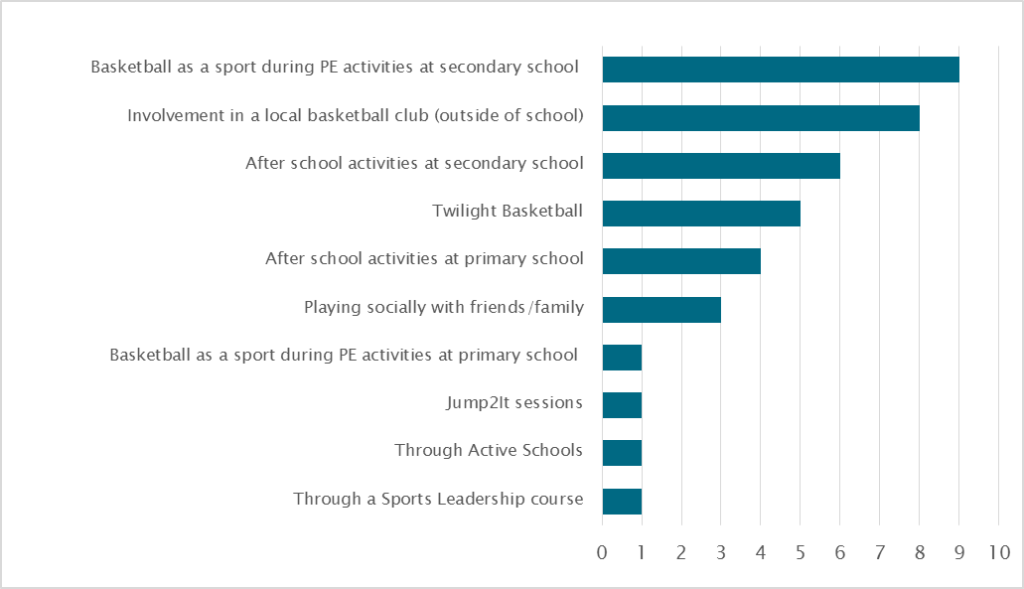
Figure 3.2: Which of the following types of education, coaching or training have you received from basketballscotland? (n=39)
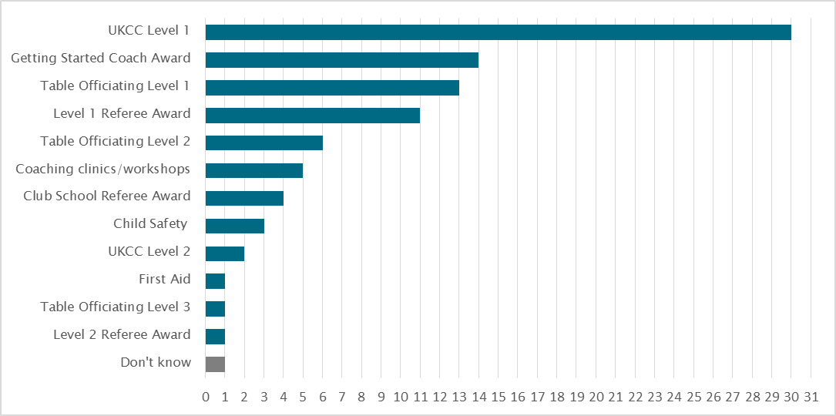
- Figure 3.2 illustrates the wide range of education, coaching or training opportunities that respondents have completed. Of the 92 completions, one third (33%, 30) were the UKCC Level 1, 14 (15%) were the Getting Started Coach Award, 13 (14%) were Table Officiating Level 1, and 11 (12%) were the Level 1 Referee Award. This suggests that Cashback funding has enabled these young people to begin their coaching and officiating journey but not necessarily to progress. There may be an increasing need, as they become more experienced, to access more advanced programmes to enable progression along the relevant pathways. If this need is reflective of the larger education programme, it is worth considering in the planning of future learning initiatives.
Impact on participants
- Responses suggest that involvement in basketballscotland coaching or officiating courses has significantly improved participants’ health and wellbeing (see Figure 3.3). Almost three quarters of respondents (72%, 28) felt their involvement had made them more confident and they also felt their participation had encouraged them to eat more healthily, feel more motivated, and exercise more frequently.
Figure 3.3: Because of my involvement in basketballscotland courses I… (n=39)
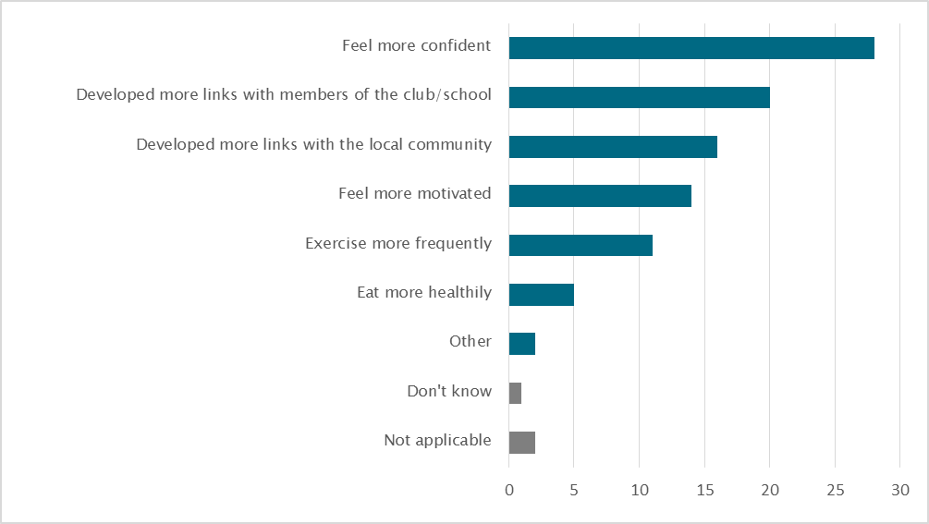

- When asked for the reasons for their responses, Education Programme participants spoke of the enhanced opportunities that course participation had provided, “I have been able to get to see the game at all sorts of levels, creating an opportunity to see and speak to people of all ages/abilities”. Respondents referred to their confidence being improved “on and off the court, as it has developed certain skills that I can use outside of basketball and sport”; and one respondent spoke about how completion of the course has encouraged them to create long-term changes in their approach: “after attending coaching courses, I came up with short-term and long-term goals which gave me targets to achieve as a coach and now I feel motivated to do so”. For some, their participation has led to the development of informal relationship building and networking, while for others this has already led to employment.
Figure 3.4: Because of my involvement in basketballscotland coaching or officiating courses I… (n=39)
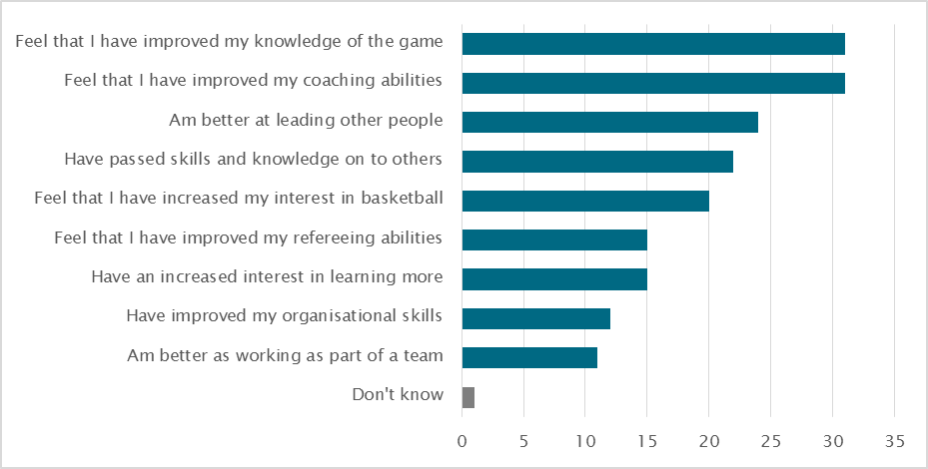
- When asked about the skills and personal development they had gained from their participation in the education programme, 79% (31) said that it had improved their knowledge of the game and an equal number felt it had improved their coaching abilities, as shown in Figure 3.4. Furthermore, 62% (24) said they are better at leading other people, while 56% (22) said they have passed their skills and knowledge onto others. No-one said they had not noticed any changes in their interests or skills. Respondents were asked to detail reasons for the responses they gave. In addition to the practical opportunities that the courses have provided, respondents spoke about wider shifts in their attitudes and approaches: “I want to step outside my comfort zone sometimes and develop new skills that will help in other aspects of my life and in the future”.
Figure 3.5: To what extent do you agree or disagree with each of the following statements? (n=39) 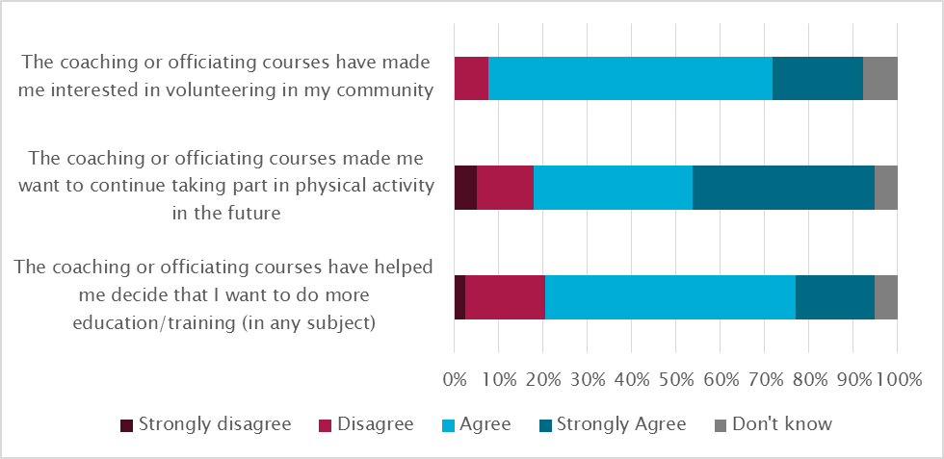
- Over half (51%, 20) felt that the programme had enabled them to develop more links with members of the club/school, and 41% (16) said they had developed more links with the local community. In order to gauge the long-term and wider impact of the Education Programme, the survey also asked respondents about the impact of their course completion. Responses to this were positive: as Figure 3.5 shows, 85% (33) of respondents strongly agreed or agreed that their participation has made them interested in volunteering in their community. When probed further, respondents said they wanted to “inspire the future generations”, “be able to give back to the community”, and were “very motivated to stay active within a team”. Furthermore, respondents described volunteering opportunities that they have already engaged with, which included coaching and officiating/tabling local team games, assisting at Twilight sessions and with former high school teams, and [soon to be] leading a basketball development centre.
- Overall, the courses that respondents had been involved in were considered to provide positive experiences, with opportunity to engage in coaching post-course completion. For some, this has mainly come from the impact of course participation on their confidence in their skills as it has “convinced me that I can ACTUALLY coach”, and:
“they have made me a better and more confident individual who can proudly show off his skills on the court and who can also communicate with team mates to create good team working relationships”.
- In terms of their future, 77% (30) of respondents strongly agreed or agreed that course completion made them want to continue taking part in physical activity and 74% (29) said it had helped them decide that they want to do further education or training.
Observations and considerations
- During Phase 3, 163 coaching courses and 126 officiating courses were delivered as part of the education programme. This resulted in the achievement of 2,123 coaching and 1,528 officiating qualifications.
- Whilst the complete age profile of participants on the Education Programme across the three years is not clear, sizeable proportions of coaching (46%) and officiating (27%) education participants are aged under 18 years, and it is likely that the majority is aged under 25. The survey with a small cohort portrays a clear picture of how the education opportunities helped to:
- develop personal and social skills;
- encourage interest in further learning;
- inspire involvement in their local community; and,
- use and apply their new coaching and officiating abilities.
- Again, improved data collection and monitoring processes would provide a more detailed profile of education programme participants and greater clarity of the reach and impact of this strand.
- Developing Young People - Schools of Basketball

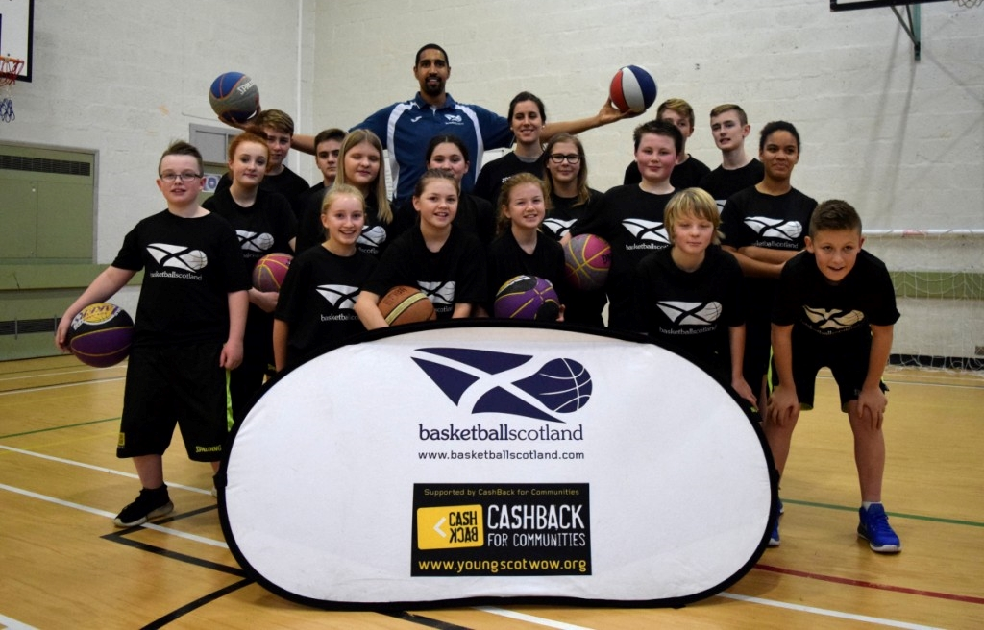
Inverness School of Basketball launch
The purpose of the School of Basketball programme
- The School of Basketball programme is one of the flagship strands of CashBack-funded activity. The programme aims to encourage greater participation in positive activities, skill development, and progression towards positive destinations among the young people taking part.
- Schools are targeted to take part in the School of Basketball programme based on criteria that includes suitable SIMD areas that could benefit from the programme, and local authority buy-in. Programme delivery is supported by external coaches, sourced by basketballscotland, in addition to teaching modules and skills guides to inform teaching and session plans. Table 4.1 displays the outcomes achieved by the School of Basketball programme in this phase.
Table 4.1: School of Basketball outcomes
Outcomes | Indicators | Achieved
Short-term outcomes – participation
Increased participation in positive activity | - Data from enrolments in SOB teams /programmes - target of 12 Schools of Basketball with 480 young people participating  - Survey of young people involved using questions from the CB Question bank | - 772 young people participating across 12 SOBs  - Interviews by Blake Stevenson found SOBs have increased participation in basketball among young people
Increased participation by difficult to engage and equalities groups | - Diversity figures from SOB teams  - Aim for 50/50 male/female ratio  - SIMD index | - Data not available  - 450 boys (58%), 322 girls (42%)  - 5 of 12 schools have more than 20% of pupils living in 20% most deprived datazones based on SIMD 2016
Increased opportunities for continued participation by linking up and signposting to other provision | - Schools of Basketball with formal links to local clubs | - 12 Schools of Basketball have a formal link to a local club
Short-term outcomes - progression pathways
Participants demonstrate new skills and positive changes in behaviour | - Longitudinal Case Studies | - Interviews that Blake Stevenson carried out with SOB participants, teachers & coaches revealed improvements in pupils’ behaviour, confidence & skills
Intermediate outcomes
Sustained participation in positive activities | - Survey of SOB pupils from CashBack question bank | - Survey data not available. Blake Stevenson interviews found SOB provided an opportunity for young people to take part in basketball.
Sustained improvements in awareness of the benefits of play, interactive, physical and social activities | - Surveys | - Survey data not available. Blake Stevenson interviewees referred to the positive impact of SOB on participants’ physical fitness.
More participants progress ito a positive destination | - 12 Schools of Basketball, with 480 young people participating  - Schools of Basketball specific attendance statistics in comparison to school specific/national attendance statistics | - 12 Schools of Basketball delivered with 772 young people participating  - In 8 schools where data available, attendance is higher among SOB participants than the whole school average and/or the national average for secondary schools.
- Since the completion of initial piloting at Ardrossan Academy, the programme has expanded to include 12 schools across Scotland. However, delivery is focused on ten schools (listed in Table 4.2 overleaf). Despite the reduction in the number of Schools of Basketball, the number of participants across Phase 3 (772) has exceeded the target (480) by 61%.
- Four of the 12 Schools of Basketball have contributed towards the final year of the Phase 3 evaluation. Two of these schools – Hillhead High School and Inverness Royal Academy - were case study schools in the mid-phase evaluation report, that have been followed-up by telephone in order to gauge the ongoing impact of the programme. We also carried out a telephone interview with a teacher responsible for the School of Basketball at Perth Grammar, and we visited Larbert High School to speak with both those delivering and taking part in the programme.

Impact of Schools of Basketball
Table 4.2: Details of Schools of Basketball
Years | School | Local Authority | Link to Club | SIMD** | Ethnic minorities# | Total participants (Phase 3) | SOB  Average Attendance | School  Average Attendance
4 | Ardrossan Academy | North Ayrshire | Ayrshire Tornadoes | 50 - <55% | 0 - <5% | 72 | 95% | 92%
3 | Shawlands Academy | Glasgow City | Glasgow Rens | 30 - <35% | >20% | 48 | 92% | 91.8%~
3 | Calderglen High School* | South Lanarkshire | South Lanarkshire Colliers | 0 - <5% | 0 - <5% | 48 | Data not available | 91.8%~
3 | Wallace High School | Stirling | Stirling Knights | 30 - <35% | 5 - <10% | 94 | 96.4% | 92.0%
3 | Larbert High School | Falkirk | Falkirk Fury | 5 - <10% | 0 - <5% | 116 | 98% | 95.8%
2 | Hillhead High School | Glasgow | Glasgow Fever | 35 - <40% | >20% | 51 | 97% | 93%
2 | Perth Grammar School | Perth & Kinross | Perth Phoenix | 10 - <15% | 5 - <10% | 59 | 94.5% | 91.8%~
2 | Inverness Royal Academy | Highland | Inverness City Lions | 5 - <10% | 5 - <10% | 82 | 98% | 88.6%
2 | St Maurice’s RC HS | North Lanarkshire | Lady Rocks | 15 - <20% | 5 - <10% | 24 | 94% | 91.8%~
1 | Portobello High School* | Edinburgh | City of Edinburgh BC | 15 - <20% | 10 - <20% | 107 | Data not available | 91.8%~
1 | Queen Anne High School | Fife | Dunfermline Reign | 10 - <15% | 0 - <5% | 47 | Data not available | 91.8%~
1 | Inverness High School | Highland | Highland Bears | 40 - <45% | 10 - <20% | 24 | Data not available | 91.8%~
* Calderglen and Portobello are no longer taking part in the School of Basketball programme
** Proportion of pupils who live in 20% most deprived datazones in Scotland based on SIMD 2016
# Proportion of pupils who are from an ethnic minority group
~ Data is not available at school level but 91.8%, the average attendance at Scottish secondary schools, has been used
- Table 4.2 highlights further details about each of the 12 Schools of Basketball that have operated in Phase 3 (ten of which are still in operation). This shows that, in general, School of Basketball participants have a higher average school attendance than the average school roll. While there is a good geographical distribution of the Schools of Basketball, the table also highlights that a few of the schools are located in the most deprived datazones of Scotland. At most of the schools (7), less than 20% of pupils live in the 20% most deprived neighbourhoods in Scotland. Ardrossan Academy has the highest proportion of pupils from neighbourhoods in the 20% most deprived in Scotland (50% - <55%).

Case Study: School of Basketball, Larbert High School
With a school roll of 1,669 students, Larbert High School is located in Stenhousemuir, directly to the east of Larbert and northwest of Falkirk. The School of Basketball is delivered in S1 to S3 and there are 58 pupils currently involved: 19 girls and 39 boys. The school is based in a relatively affluent area, with less than 5% of pupils living in areas categorised as among the 20% most deprived neighbourhoods in Scotland.
Delivery
The programme is delivered across five hours a week through three periods of Physical Education (PE) class time, and two hours out of school time (also open to non-School of Basketball pupils). The school employs a Head of School of Basketball who works 16 hours a week delivering the programme and is supported by a PE teacher. Delivery mainly involves practical sessions and includes games against other schools several times a month, as well as weekend tournaments. Classwork is a small component of the overall programme. Teams from Larbert also take part in basketballscotland’s festival for Schools of Basketball held at the Oriam National Performance Centre for Sport in Edinburgh.
School of Basketball staff were kept informed of participants’ behaviour in school. It meant they could raise any personal issues with the students and encourage them to improve their behaviour.
Participation
Discussion with young people found that most had limited exposure to basketball prior to joining the School of Basketball, mainly consisting of playing socially in primary school. Although basketball had been offered at Larbert prior to the School of Basketball starting, staff believed that without the programme there would not be as many opportunities, such as weekend tournaments. According to staff, the programme is popular and attracts a lot of interest through information sessions at local primary schools. There are no specific selection criteria but all new School of Basketball students attend two trials and an interview for selection.
The School of Basketball has developed links with nearby basketball clubs including Falkirk Fury, however, some staff said that more links with clubs that offered social rather than competitive activities were needed. To this end, the school is developing a partnership with a club in North Lanarkshire that plays at a lower level than Fury and offers more recreational opportunities.

Impact
Students described feeling more confident, having better communication skills and being more disciplined as a result of being involved in the programme. In one example, a School of Basketball participant started playing for a club in the National Scottish Championship and is now a member of the Scottish national squad. The student noted that this “wouldn’t have happened without the School of Basketball.” Others expressed an interest in coaching primary school students.
Participants also spoke about making new friends and improving their confidence through the School of Basketball. From the perspective of teachers, School of Basketball participants have an incentive to behave well in other classes because if they misbehave, they may be excluded from basketball activity. Teachers in other subjects approach School of Basketball staff for help in addressing any behavioural issues that have arisen in other classes. Staff involved in delivering the School of Basketball also told us about the importance of the programme in providing pastoral care to participants. They gave an example of when a participant was being bullied, they approached School of Basketball staff for help rather than guidance staff.
- The findings from the mid-phase report, in addition to the case study above, show that School of Basketball programme has been able to impact positively on the volume of young people participating in basketball, as well as increasing confidence and other valuable social skills of young people. In some cases, teachers reported increased fitness levels, better attitudes and improved relationships between pupils.
- These observations have been reinforced by the findings from follow-up telephone interviews with schools. In general, programme delivery has remained fairly consistent since previous contact. The exception was a change of coach in one school, resulting in a pause in programme delivery. Similarly to previous interviews, Schools of Basketball try to identify those individuals who would most benefit from the programme; and as a result, were all able to cite examples of young people who have particularly benefited from the programme. For example, one interviewee remarked on a participant who had “real anger management issues…used to fly off the handle, lash out”; but who is now a “completely different child”, and is able to control himself more. Another interviewee spoke of young carers who are involved in the programme, providing them with an opportunity to engage in physical activity, among friends.
- More generally, interview findings suggest that participation in School of Basketball has been able to positively impact young people, not only physically but also by emphasising the importance of teaching them life-skills that are transferable to other areas of their life. One interviewee commented that the confidence and self-esteem of participants had “come on leaps and bounds”, and that their physical literacy is “miles above” other pupils in the school. Within the school, it has given young people an avenue for conversation and connection with peers and teachers, benefiting relationships and school culture.
- As discussed in earlier interviews, School of Basketball staff again commented that timetabling the sessions is, at times, difficult; particularly since the sessions inherently require specific facilities. Specifically, one of the younger Schools of Basketball has also encountered some challenges in creating a sustainable system of catch-up sessions for missed lessons, which is something that they are continuously working to improve.
Observations and considerations
- This programme has provided 772 pupils across 12 schools the opportunity to participate in the sport and develop their basketball abilities and knowledge of the game, alongside the development of personal and social skills. The flagship programme has benefited the schools and the local clubs by strengthened links, social connections and overall engagement.
- The mid-phase evaluation report highlighted that there were variations in the delivery of the programme, given that coaches have the opportunity to develop their own School of Basketball model. While this was seen as beneficial in some ways, as it ensures the programme adapts to the needs of individuals, interviewees remarked that the learning experiences of pupils across different Schools of Basketball could be more consistent. There would be a real benefit if certain standard elements were delivered as part of the programme at each school.
- basketballscotland has taken the opportunity to improve the delivery of the School of Basketball programme for the next phase of CashBack for Communities funding. In Phase 4, a 40 week curriculum for School of Basketball has been developed to ensure a standardised and consistent approach to delivery across all the schools involved.
- In terms of continued development of the programme, interviewees remarked that their ability to grow interest and develop players required a competitive structure that was often limited in their local communities, “there’s definitely not enough interest in other schools”, which meant a restricted number of teams that they could play. This highlights the impact of Schools of Basketball, but also the importance of continuing to grow and promote participation of basketball amongst younger people in order to ensure progression pathways are developed across all areas of Scotland.
- Again, as mentioned with the other funding strands, a more robust data set about participants and their progress is required so that a more comprehensive picture of their improvements and the achievements of this successful programme can be provided.

- Developing Young People – Modern Apprentices, Youth Leadership & Youth Achievement Awards

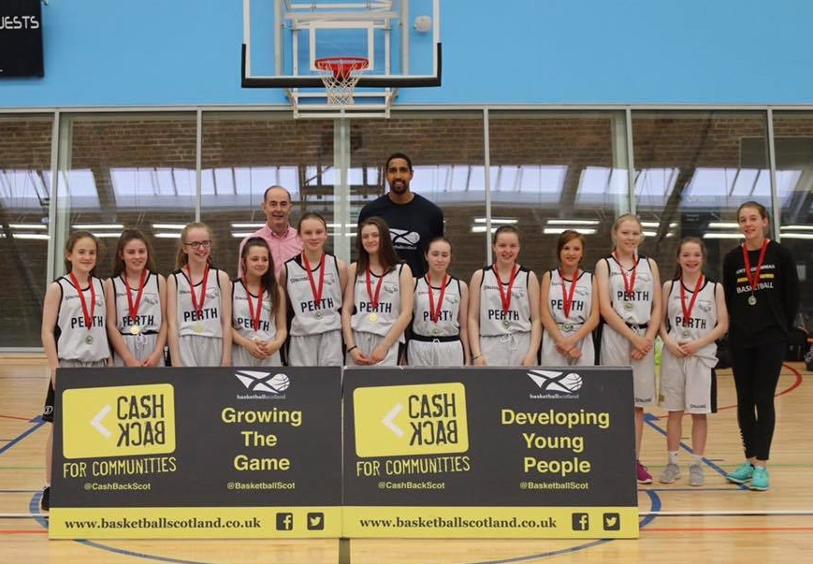
S1 players from Perth Grammar who competed in the School of Basketball festival at the Oriam National Performance Centre for Sport
Modern Apprentices
- As part of Phase 3, providing a placement for a modern apprentice (MA) was an identified strand. The delay in recruiting to the post provided the cumulative resource to offer two six month placements within basketballscotland. One MA was based in Aberdeen and another in Edinburgh. The posts were advertised and successful applicants took up their post in August 2016.
- Both successful candidates for the MA had an established interest in basketball and were involved in coaching and supporting their local basketball clubs.
Table 5.1: Modern Apprenticeship programme outcomes
Outcomes | Indicators | Achieved
Short-term outcomes – progression pathways
Participants develop confidence in their skills and develop aspirations of further learning and development | - Not in annual report | - Case study in annual report
Intermediate outcomes
More participants progress into a positive destination | - One Modern Apprentice employed and deployed. | - Two MAs employed and deployed, with one now in full time employment with basketballscotland

The role of Modern Apprentices
- One MA was based in the regional office in Aberdeen and the other in Head Office in Edinburgh. The Modern Apprentices have undertaken various roles to support the development of basketball, including:
- the co-ordination of competitions, other basketball sessions for schools and clubs including Regional Development League fixtures and finals;
- organising coach education and officiating courses;
- logistics of registering players and membership services;
- supporting the marketing and social media accounts; and
- general promotion of the sport.

Impact of the Modern Apprentices programme
- As a result of the wide range of involvement in the delivery and organisation of basketball activities, the MA programme has had a positive impact on basketball clubs, basketballscotland and the MAs themselves.
- The MAs offered valuable support for clubs and schools in providing opportunities for young people to play basketball. They have supported basketballscotland in their work to increase participation in basketball and in providing opportunities for competitive basketball.
- For the two MAs, whilst their different placements resulted in a variety in their experiences, they both described improvements in confidence and skills in organisation and communication, as a result of their role. They both had greater opportunities for networking across the basketball community and improved understanding of the range of employment options within the sport. This gave them clarity about future plans as well as having a positive impact on their career prospects.
- As described in the case study below, the programme helped one MA to achieve her aim of finding a permanent position in basketball when, after seven months in the programme, she was appointed as basketballscotland’s Regional Development Officer in North East Scotland. basketballscotland is exploring opportunities to create a position for the other MA in Edinburgh on completion of the MA, dependent upon funding.

Case Study: Zanè Bricite, basketballscotland Modern Apprentice
Zanè, 25, was a Modern Apprentice (MA) with basketballscotland between August 2016 and March 2017. The MA was delivered by basketballscotland in partnership with Aberdeen and Grampian Chamber of Commerce. Zanè, who grew up in Latvia, moved to Aberdeen in October 2012 via spells in Wolverhampton and Cyprus. She has a passion for basketball, describing it as a “massive part of my life since a very young age”, and having played the game since she was seven years old.
Her time in Cyprus included an internship with an organisation promoting basketball, where she was given the chance to deliver coaching sessions. This helped her to decide to pursue a career in basketball - she realised “I don’t want to do anything else other than basketball”.
Route into the Modern Apprenticeship
When Zanè first arrived in Aberdeen, she contacted basketballscotland for advice but was not able to find a job working full time in basketball or sports development more generally. However, she did find some relevant employment, working part time as a sports coach with Sport Aberdeen’s Active Schools team. At the same time, she formed her own basketball club, the Granite City Flames, on a voluntary basis, to help provide more opportunities for young children to take part in basketball.
Her work at Sport Aberdeen and at the Flames led to greater involvement with basketballscotland and she became a coach with the national under-12 girls’ team. When she heard about the Modern Apprenticeship opportunity through her contacts at basketballscotland, she “jumped at the chance” to apply.
The Modern Apprentice’s role
Zanè’s role as an MA included co-ordinatingcompetitions and other basketball sessions for schools and clubs including RDL fixtures, coach education and officiating courses.
Views of the Modern Apprenticeship programme
Zanè enjoyed her MA experience. She was happy with the support provided by basketballscotland and the Aberdeen and Grampian Chamber of Commerce, which she described as “awesome”. She said she is “really grateful for all the support from basketballscotland”, whose staff made sure that she had enough time to complete the practical and desk-based components of the Modern Apprenticeship.
Impact of the Modern Apprenticeship on the community
Zanè felt the role came “at the right time” for local basketball clubs and schools who needed help with providing opportunities for young people to play basketball.
basketballscotland noted that her role provided “robust and reliable” support for clubs and schools and led to “a rapid increase in the number of people playing basketball on a weekly basis”.

Impact of the Modern Apprenticeship on the MA
Zanè grew in confidence throughout the MA. She felt her confidence improved with every event she organised and basketballscotland also observed that “within the first six months of being in the MA programme, Zanè’s confidence and ability to deliver soared”.
She also noticed improvements in skills including organisation and communication.
Most importantly from Zanè’s point of view, the post helped her to “get a foot in the door” and was an important stepping stone to being appointed as basketballscotland’s North East Regional Development Officer when the post was created in March 2017.
Summary
This MA was beneficial for the local community, basketballscotland, and the apprentice herself. The role provided valuable support for clubs and schools in providing opportunities for young people to play basketball. basketballscotland was able to recruit a passionate and dedicated member of staff who has helped to increase participation in the North East. Zanè herself developed confidence, organisation and communication skills, and ultimately the experience helped her to secure a permanent job in the sport she loves.

Youth Leadership
- The Youth Leadership Programme aims to address a series of CashBack outcomes relating to participation and progression pathways. Clubs are offered a financial incentive to select and support young people in leadership roles. Young people gain opportunities through taking leadership roles for different activities (such as coaching young players or organising events), while gaining opportunities for training and for support from a club-based mentor. In Phase 3, 92 young people were on the youth leadership programme, just short of the 100 target.
Table 5.2: Youth Leadership outcomes
Outcomes | Indicators | Achieved
Short-term outcomes – participation
Increased opportunities to develop interests and skills |  | - 92 young people on Youth Leadership Programme  - 10 young people serving on National YP Panel
Short-term outcomes– progression pathways
Greater confidence and self-esteem amongst participants |  | - Data not available but participants interviewed by Blake Stevenson referred to improvements in confidence
Participants demonstrate new skills and positive changes in behaviour | - 100 well trained, confident YP on Youth Leadership Programme  - 10 young people serving on National YP Panel | - 92 young people on Youth Leadership Programme  - 10
More participants have achieved accreditation for their learning |  | - Data not available but interviewees referred to some accredited learning such as First Aid courses
Participants develop confidence in their skills and aspire to further learning and development |  | - Data not available
Intermediate outcomes
More participants progress into a positive destination | - 100 well trained, confident YP on Youth Leadership Programme  - 10 young people serving on National YP Panel | - 92 young people on Youth Leadership Programme  - 10

The Young People’s Panel
- Some Youth Leaders are invited to take part in a Young People’s Panel, which gives young people a voice at the highest level within the decision making structures of basketballscotland. The Young People’s Panel, which has ten members and meets approximately quarterly, gathers views of other young people about basketball and how it can be improved. The panel feeds these views back to basketballscotland to ensure that the governing body’s policies and plans take account of young people’s views.
- Eight of the ten Young People’s Panel members are female, which positively reflects on the involvement of girls and women in basketball.
Impact of the Youth Leadership programme
- We interviewed two Youth Leaders in the final year of the evaluation, both of whom are members of the Young People’s Panel.
- The interviewees described the various benefits of taking part in the Youth Leaders programme. They reported improvements in confidence – “[I have] been so much more confident” - , soft skills such as communication and working with other people, and more specific skills such as coaching, first aid and media skills. They enjoy their role and have found satisfaction in promoting basketball among other young people.
- For some members, the experience has confirmed that they want to work in sports development. One said that involvement in the Youth Leaders programme has made her “a lot more happy, contented” because it has cemented her interest in sport development as a career, particularly since basketballscotland has facilitated her participation in of a number of courses to help her develop and achieve more. Another said that her role as a Youth Leader was invaluable experience and helped her to make contacts with people who work in sport and at basketballscotland in particular.

Youth Achievement Award
- The original aim of the programme was to work with Youth Scotland to deliver awards for young people involved in basketball. The awards would help to recognise and reward young volunteers who have developed their leadership, responsibility and confidence and who have undertaken a volunteering placement.
- This SQA accredited and levelled award is designed for those aged 14 years or over and comes at four different levels: Bronze, Silver, Gold and Platinum. Each level takes on a different level of responsibility and an increasing number of hours. It was to be delivered through a volunteer accreditation scheme in partnership with affiliated clubs. However, in Year 1 not many clubs took part in the awards scheme as it involved a lot of extra administration – for example, logging the activity of volunteers and supporting the young people pursuing the award.
- As an alternative, participants in basketballscotland’s Future Starz programme had the opportunity to take part in Dynamic Youth Awards. The awards, designed for young people aged between 10-14, require the participants to commit to a minimum five hours and have five levels of star rating based on the young person’s cumulative hours. This means they are easy to use and incorporate into existing or planned activities and still recognise a young person’s achievements.
- In the final year of Phase 3, it was not possible to offer any awards, Future Starz was disbanded and there was a review and change in the player pathway structure.
- However, as shown in Table 5.3, during Phase 3, awards were achieved by 277 young people. This falls only slightly short of the 300 target. We do not have the breakdown of the type or level of these awards.
Table 5.3: Youth Achievement Award outcomes
Outcomes | Indicators | Achieved
Short-term outcomes – participation
Increased opportunities to develop interests and skills | - 300 young people achieving Youth Achievement Awards | - 277 achieved an award
Short-term outcomes - progression pathways
Greater confidence and self-esteem amongst participants |  | - Data not available
More participants have achieved accreditation for their learning | - 300 young people achieving Youth Achievement Awards | - 277 achieved an award
Participants develop confidence in their skills and develop aspirations for further learning and development |  | - Data not available
Intermediate outcomes
More participants progress into positive destinations |  | - Data not available

- This evaluation report does not provide any further information about the impact of the Youth Achievement Awards. In discussion with basketballscotland it was agreed that development of this award to date made it difficult to consider the impact with a sample of young people.
Observations and considerations
Modern Apprenticeship
- Our interviews with the two MAs found that the programme had a very positive impact on basketball clubs, basketballscotland and the MAs themselves, with one of them securing a permanent RDO role with the national body.
- However, these two MAs were engaged young people with notable experience in basketball and who were likely to achieve a positive destination even if they had not taken part in the programme. While the programme has been really worthwhile, it could have a greater impact if MA roles were filled by people who are more disengaged from education, employment or training and have a greater risk of not achieving a positive destination.
Youth Leadership
- Participation in the Youth Leaders programme, and the Young People’s Panel, has helped to increase participants’ confidence, skills and aspirations for a future career in sport. The role of the youth leaders has supported local delivery of basketball and the Young People’s Panel has influenced decision making at a national level within the sport.
Youth Achievement Awards
- The Youth Achievement Awards required a level of activity and support for young people that was too onerous for local clubs to administer. The move to the Dynamic Youth Award through Future Starz had more success. Any adoption of an accredited award scheme needs the appropriate infrastructure to support and deliver it and this should be a key consideration if basketballscotland plans to introduce other award schemes in the future.

- Summary of observations from Phase 3

- The final evaluation activity for Phase 3 has continued to find evidence of the positive impact of CashBack-funded activities that have supported the growth of the game and developed young people. As the data has shown, there has been increased participation in the sport, opportunities for structured progression in the game or to be involved in coaching or officiating and this has all been extended to wider sections of the community. In particular, the growth of participation amongst girls and women and people with disabilities has been successfully championed in the last few years.
- Individuals involved in the sport, through the range of strands, like the Education Programme, have not only developed their basketball skills and knowledge but also skills for life, learning and work. They have been given opportunities which have informed their future choices about learning and career development and strengthened social connections both in school and the local community.
- Clubs and schools have seen real benefits from the different strands - Club Champions, Youth Leaders and Schools of Basketball - that have increased their capacity and resources to offer basketball, strengthened links between them and individuals and engaged and encouraged young people to participate in the sport.
- With all the strands there are opportunities for some improvement in the structure, focus or resourcing of the work and the School Champions and the Youth Achievement Awards did not progress as intended. Despite this, the basketballscotland programme has had an impact on thousands of young people.
- Phase 3 has seen key changes to basketballscotland and club personnel which have led to changes in the delivery of the programme both at a local and national level. In addition, the programme of work, for the funding provided and the basketball infrastructure, was ambitious and meant that some strands needed to be adjusted or have not been fully delivered. This was often due to issues related to capacity and resources at basketballscotland and local clubs. basketballscotland has learned from its experience in Phase 3 and the Phase 4 CashBack programme will focus on delivering Schools of Basketball as one carefully-designed, resourced and targeted programme.
- CashBack funding is aimed at programmes targeting young people and whilst most of the delivery and engagement has been with the under 25 age group, in the absence of robust monitoring data it has not always been possible to clearly identify the profile of individuals engaged with each strand. This has reduced the opportunity to evidence the full impact of the CashBack-funded programme. basketballscotland is aware of this shortcoming and have taken account of this in future delivery. They are introducing a new performance management system, Upshot, and this will mean that the data can be systematically captured and limit any future gaps in information.
- By the end of Phase 3, and under new leadership, the delivery of CashBack-funded activities appears to be more focused and realistic which has led to a slight shortfall in some targets but has resulted in the sport being in a stronger position as it progresses into its Phase 4 CashBack for Communities programme.

Appendix 1 –basketballscotland activities and related CashBack for Communities outcomes
(revised by basketballscotland October 2015)

SHORT TERM OUTCOMES | Growing the Game |  |  |  | Developing Young People
Outcome | Competition & Club Development Programme | Equalities Programme | School Champions | Club Champions | Education programme | Youth Leadership | Modern Apprentice | School of Basketball | Youth Achievement Awards
Participation
1 Increased participation in positive activity
2 Increased participation by difficult to engage and equalities groups
3 Increased opportunities for new experiences or activities for participants
4 Increased opportunities to develop interests and skills
5 Increased opportunities for continued participation by linking up and signposting to other provision
Diversion/Protection
6 Increased involvement in structured pro-social and healthy activities
7 Participants have places to go where they feel safe and comfortable
Progression pathways
8 Greater confidence and self-esteem amongst participants
9 Participants demonstrate new skills and positive changes in behaviour
10 More participants have achieved accreditation for their learning
11 Participants develop confidence in their skills and develop aspirations of further learning and development
Engagement
12 Participants are more involved in community based activities
13 Participants develop positive peer networks and relationships
14 There is increased community based interaction

INTERMEDIATE OUTCOMES | Growing the Game |  |  |  | Developing Young People
Outcome | Competition & Club Development Programme | Equalities Programme | School Champions | Club Champions | Education programme | Youth Leadership | Modern Apprentice |  | School of Basketball | Youth Achievement Awards
Confident communities
15 Sustained participation in positive activities
16 Sustained improvements in health and well-being
17 Sustained improvements in self-esteem and confidence
18 Sustained improvements in awareness of the benefits of play, interactive, physical and social activities
19 Increased supportive social networks and feelings of belonging

20 More participants progress into a positive destination: such as learning in a non-school environment, further and higher education, pre-employment training, volunteering, personal development and employment
21 Increased horizons and improved outlook amongst participants
22 Participants have influenced the opportunities available to them in their community
23 Sustained participation in community based activity
24 Reduced levels of crime and anti-social behaviour
25 Improved perception of the community as a place to live
26 Increased community esteem and capacity to shape local development
27 Better community integration and cohesion

LONG -TERM AND NATIONAL OUTCOMES | Growing the Game |  |  |  | Developing Young People
Outcome | Competition & Club Development Programme | Equalities Programme | School Champions | Club Champions | Education programme | Youth Leadership | Modern Apprentice | School of Basketball | Youth Achievement Awards
1 Our young people are successful learners, confident individuals, effective contributors and responsible citizens
2 We live longer, healthier lives
3 We have improved the life chances for children, young people and families at risk
4 We live our lives free from crime, disorder and danger
5 We have strong resilient communities where people take responsibility for their own actions
6 We live in well-designed, sustainable places where we are able to access the amenities and services we need

Includes £19,443 for Modern Apprentice
Participation in the Education Programme reflects a similar gender ratio. In 2016-17, two-thirds (66%) of the candidates were male (663), compared to 336 (34%) female participants.
Scottish Government (2016), School contact details, http://www.gov.scot/Topics/Statistics/Browse/School-Education/Datasets/contactdetails (accessed 23 May 2017)
Ibid
Scottish Government (2015), Summary statistics for Schools in Scotland (as at December 2015) No. 6, http://www.gov.scot/Resource/0049/00494569.pdf (accessed 17 May 2017)

