Evaluation of the Scottish Football Association’s
Phase 3 CashBack for Communities programme

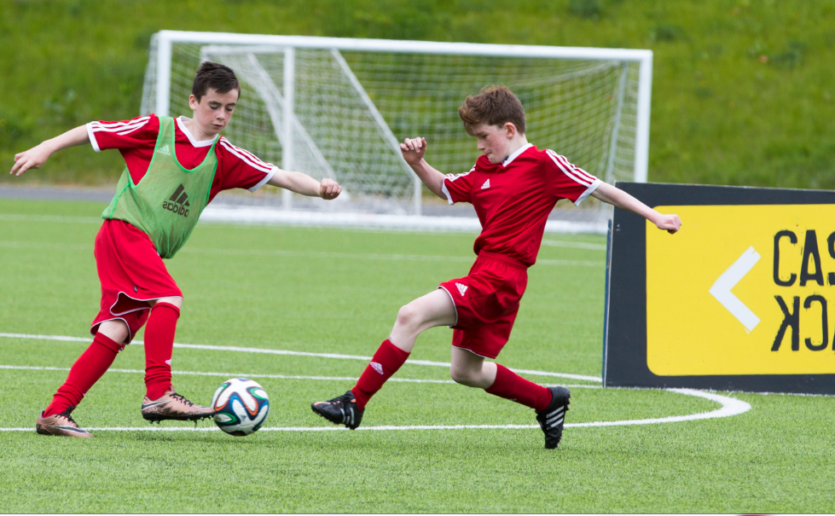

Draft Final Evaluation Report - Year 3

June 2017

CONTENTS

Chapter Page
Executive Summary i
1. Introduction and context 1
2. Midnight Leagues 6
3. Volunteer Development 11
4. The Equalities programmes 19
5. Schools of Football 34
6. Summary of observations and considerations 49

Appendices:
Appendix 1: Intended outcomes
Appendix 2: Grant Offer Letter: outcomes, indicators, and evidence
Appendix 3: School of Football case study
Appendix 4: School of Football fitness and skills testing

Executive Summary

Introduction and context
The Scottish Football Association (Scottish FA) commissioned Blake Stevenson to evaluate Phase 3 of its CashBack for Communities programme, running 2014-17. CashBack for Communities uses funds raised through confiscated proceeds of criminal activity, and invests them in community programmes, facilities and activities; largely directed towards young people at risk of turning to crime and anti-social behaviour. The programme hopes to impact positively on young people’s lives by increasing their confidence, skills, community participation and future career prospects.
The Scottish FA is Scotland’s governing body of football, endeavouring to promote, foster and develop the game at all levels. Following their initial funding award in 2008, Phase 3 saw £2.25 million of CashBack funds awarded to the Scottish FA, invested across five strands: equalities programme, CashBack 7s, the Midnight League, Volunteer Development and Schools of Football. Each strand is designed to meet specific outcomes outlined in the Grant Offer Letter (GOL), which is evidenced by various qualitative and quantitative data collected throughout the evaluation. This report evaluates the final year of Phase 3 activity, as well as findings across the phase, in order to inform learning for Phase 4 beginning later this year.
Midnight Leagues
Midnight leagues, also sponsored by Bank of Scotland, operate in all 32 local authorities to provide free football for young people aged 12-16 years in areas of social deprivation. In terms of volume, delivery of the Leagues has remained broadly consistent across the three years. In order to assess impact, the final year evaluation involved speaking with parents of young people involved, to support the findings from interviews with young people completed in the first two years of the evaluation. These, along with supporting data, found participation in Midnight Leagues has positively impacted young people’s confidence and self-esteem, organisational skills, and informed future plans. Furthermore, providing opportunities to stay off the streets helps to avoid anti-social behaviour in the wider community. Making better care to ensure Midnight Leagues are located in particular areas of deprivation, along with more consistent data gathering, should help ensure the programme is impacting those individuals with most propensity to benefit from involvement.
Volunteer development
The Volunteer Development strand enables young people to develop themselves as coaches and/or referees in order to support the grassroots game. The Coach Education programme mainly supports those aged 16-25 to access free CashBack-funded coach education courses in return for delivering coaching sessions on a voluntary basis. The majority of participants complete courses at level 1.1 ‘Early Touches’, but have opportunity to complete courses through to level 2 Children’s Award. While the volume of participants has fallen across the three years of the Phase, this might reflect a degree of saturation in the entry level courses as young people progress onto more advanced levels of training. This will be reflected in Phase 4, which will have more intensive focus on the progression on a smaller number of individual volunteers.
Pre- and post-course surveys were used to gauge the impact of the programme, exploring the motivation and outcomes for the young people participating in the course. This found that the courses not only improved football- and coaching-specific skills, but also the personal confidence and transferable leadership and organisational abilities. Many hoped that this would translate into involvement in more coaching in future, in turn, benefiting local clubs and communities.
The Referee Development strand funds school pupils’ access to the SQA Referee Personal Development Award. An online survey and interviews with two teachers from schools delivering the Referee Development Award informed the findings of Year 3, albeit their low response rates meant it was difficult to draw definite conclusions. In accordance with earlier years of Phase 3, evidence indicated that the award has positively impacted participants’ knowledge of the law of football, understanding of the role of the referee in football, and skills, confidence and interest in refereeing. Additionally, it was promising to see that the volunteer development strand has benefited from the implementation of an online candidate application process in order to better capture the progress of individual through the training offered.
The Equalities programme
The Scottish FA use a portion of CashBack funding to improve equality in football, remove barrier, and increase participation among under-represented groups. Across football equity, disability football, and girls and women’s football development programmes, it was positive to see a large volume of young people, clubs and communities benefiting from the programme according to secondary data. This was supported by findings from visits to two participation centres, and the analysis of several surveys.
For Football Equity, activity remains successful, albeit at a dramatically reduced rate compared to earlier years. The programme continues to work towards overcoming barriers to participation, for example through Development Inclusion Officers (DIOs) delivery of workshops, or working in partnership with local organisations. This led to greater participation from young people in these communities, subsequent participation in accredited learning, and increased social cohesion.
Girls’ and women’s involvement in football involved a far higher number of players than the target originally set in the Grant Offer Letter. This also translated into a high number of new girls’ and women’s teams and clubs, and a growing demand for volunteers in the sport. While there remain ongoing challenges to girls’ involvement in the game, the increased participation has translated to improved social skills, physical fitness, and learning for those involved; and highlights the impact of the Girls’ and Women’s Club Development Officers (GWCDOs) to this strand of activity.
The Scottish FA continues to support the involvement of people with disabilities in the sport, primarily through its strategic framework for disability football and flagship programme, the National PAN Disability League. The League informs 36 clubs across Scotland, bringing teams together centrally six times across the football season. A survey of coaches of PAN Disability League teams found the League has dramatically increased opportunities for young disabled individuals to engage in sport, and for engagement in competitive activities. In turn, this has positively affected participants’ confidence and friendships, and even daily living skills. In future year of funding, the programme can build on these success, refining delivery and perhaps shifting focus to other equalities groups.
Schools of Football
The Schools of Football programme aims to develop social and academic skills of primarily S1 and S2 secondary school pupils by delivering a programme of activity, including that related to the Curriculum for Excellence. Some schools also deliver the SQA Accredited Dynamic Youth Award, which provides formal recognition of the learning in School of Football. Visits with Schools of Football in addition to surveys and interviews, first found that the programme continues to engage pupils from areas of deprivation. In general, attendance is higher among School of Football pupils compared to the school average attendance rates. Not only does the programme benefit young people’s confidence, attitudes and skills in football, but there were reports of wider benefits to their engagement with other subjects at school. Consistent with earlier years, participation in the programme was seen to incentivise good behaviour among the young people taking part.
Due to increased data collection, the final year report was also able to focus more closely on the benefits to health and wellbeing resulting from participation in the programme. Schools use a variety of tests to measure this, so while it was not possible to aggregate results, trends in the findings suggest that the test results tend to improve between the beginning and the end of the programme. Furthermore, there were reports of involvement leading to progression into positive destinations, such as volunteering opportunities in local football clubs, or aspiring to careers in sport. In part, this was reliant on developing successful links with local football clubs to facilitate these additional opportunities. Challenges encountered by parents, pupils and teachers mainly centred around frustration from parents about the amount of information they receive from the school about the programme, which might be easily addressed in future years.

- Introduction and context

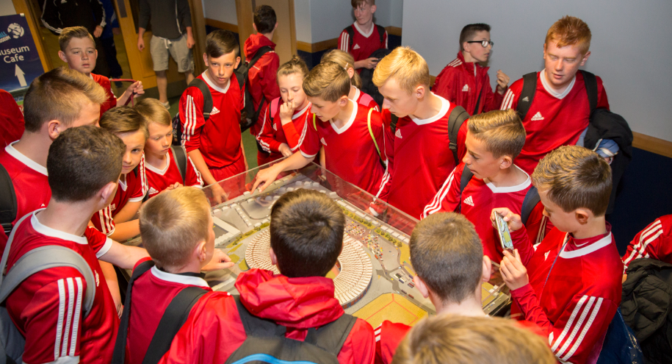

In December 2014, the Scottish Football Association (Scottish FA) commissioned Blake Stevenson Ltd to evaluate Phase 3 of its CashBack for Communities programme. This report evaluates the impact of the third year of funded activities covering April 2016 to March 2017, draws conclusions about the impact of Phase 3 as a whole, and proposes issues for consideration in Phase 4 of the CashBack for Communities Programme.
CashBack for Communities
The Scottish Government started the CashBack for Communities programme in 2007. The programme takes funds raised through the confiscation of assets from those involved in crime and invests them in community programmes, facilities and activities. These activities are aimed largely, but not exclusively, at young people at risk of turning to crime and anti-social behaviour.
The programme aims to provide diversionary activities, increase engagement and participation and improve progression pathways, producing long-term positive impacts for those involved. The outcomes for these participants, articulated through a CashBack logic model, are identified for each funded programme.
Inspiring Scotland is the Scottish Government’s delivery partner for the CashBack for Communities programme and the Scottish Football Association works with their Performance Advisor to monitor the delivery of its CashBack-funded activities.

The Scottish FA’s CashBack for Communities programme
The Scottish FA is Scotland’s governing body of football, existing to promote, foster and develop the game at all levels. In 2008, the Scottish FA was awarded CashBack for Communities funding to deliver a three-year programme of coaching and playing opportunities across Scotland, free of cost and concentrated in areas of particular deprivation. Following this first phase of funding, the Scottish FA were awarded £3 million of CashBack funding in Phase 2, which ran from 2011 to 2014 and was designed to continue to develop the work and successes to date.
Phase 3 began in 2014, in which £2.25 million of CashBack funds were awarded to the Scottish FA. This funding was invested across five specific programme strands of activity:
- the three equalities programmes - football equity, girls' & women's football development and disability football;
- CashBack 7s;
- the Midnight Leagues;
- volunteer development (coach education and referee development); and
- Schools of Football.
Interim evaluation reports have marked the successes and considerations at the end of each year of Phase 3 activity to date. The interim reports described successful delivery of CashBack-funded strands of activity to over 20,000 children and young people across Scotland. These young people had been able to engage in positive activity and there were early indications that this was having a beneficial impact on their lives. Evidence of particular successes included the equalities strand for the development of the girls’ and women’s game, engaging individuals from ethnic minority backgrounds and also players with disabilities to play football. The impact of the Schools of Football programme was also extensively described, highlighting the positive outcomes for participants, their schools and local community.
Within the reports there were some suggestions about key improvements to evidence gathering and more consistent data collection and collation. A number of changes to programme delivery and organisation, alongside recommendations for potential areas for improvement, have taken place throughout Phase 3 in order to maximise the benefit to the young people involved. For example, the first year of Phase 3 funding saw the introduction of the SQA-accredited Dynamic Youth Award to the Schools of Football programme, which reinforced the impact of this programme to both skills and educational outcomes by facilitating accredited recognition of participants’ learning.
Meanwhile, the second interim report highlighted the need to better evidence the use of Midnight League as a tool to divert young people away from anti-social behaviour, in light of the change in profiles of Midnight League participants. The report also suggested that greater attention, and appropriate planning, take place to ensure that suitable evidence was gathered to meet the proposed indicators against their associated outcome. Specifically, this was recommended to allow more consistent data collection and collation across all strands of activity.
This final evaluation report builds on the interim reports throughout Phase 3 by drawing on further qualitative and quantitative evidence gathered from funded activities across Scotland. It profiles the substantive successes of the programme, in addition to highlighting potential challenges and learning points that could be implemented as the programme enters Phase 4.
Phase 3 funding was allocated across the five strands as outlined in Table 1.1. Expenditure completed at the end of March 2017.
Table 1.1: Phase 3 funding allocation
Investment area | Phase 3 investment
Equalities programmes (including football equity, girls’ and women’s football development and disability football) | £863,296.36
Volunteer Development (coach education & referee development) | £113,517.00
Midnight League | £96,000.00
School of Football | £334,383.44
Cashback 7s | £24,000.00
Total | £1,431,196.70

Each strand of activity is designed to address outcomes relating to participation, diversion or progression. These were specified in the Grant Offer Letter (GOL) and are detailed in Appendix 1. They were agreed to ensure maximum benefit of CashBack-funded activity to young people across Scotland, and better direct each strand of activity. In addition to the specific outcomes, the strands deliver four key Scottish FA outcome areas for young people, namely:
- playing football and improving their football skills;
- experiencing health improvements and growing in physical competency;
- developing positive behaviours and life skills; and
- improving educational outcomes.
The qualitative and quantitative secondary evidence gathered for the final report is drawn from various sources of information provided by the Scottish FA, schools, and local authorities. This includes the Scottish FA’s Balanced Scorecard, detailed data about each strand of activity and individual school monitoring data.
Additionally, the evaluation team has gathered various sources of primary evidence. Across the strands of activity, this includes interviews with 48 participants, 19 adults assisting in the delivery or organisation of the programme (i.e. coaches, teaching staff, DIOs), and 20 parents who described the impact of their child’s involvement in activity. This was further informed by 173 survey responses across six surveys, concerning girls’ and women’s football, coach education courses, referee development award, Schools of Football, equalities, and the PAN Disability League. The following diagram details specific sources of evidence.

In line with previous reports, this final report draws on evidence to address the success and challenges of the programme in relation to the CashBack outcomes and indicators outlined in the GOL.
The report
The rest of the report is structured as follows:
- Chapter 2 looks at the Midnight League strand of activity;
- Chapter 3 covers Volunteer Development, which includes coach education and referee development;
- Chapter 4 discusses the equalities work to widen participation in football and develop pathways for people with disabilities, girls and women and people from ethnic minority communities;
- Chapter 5 reviews the impact of Schools of Football activity; and
- In the final chapter the observations are summarised, and recommendations are made for the next phase of activity.
- Midnight Leagues

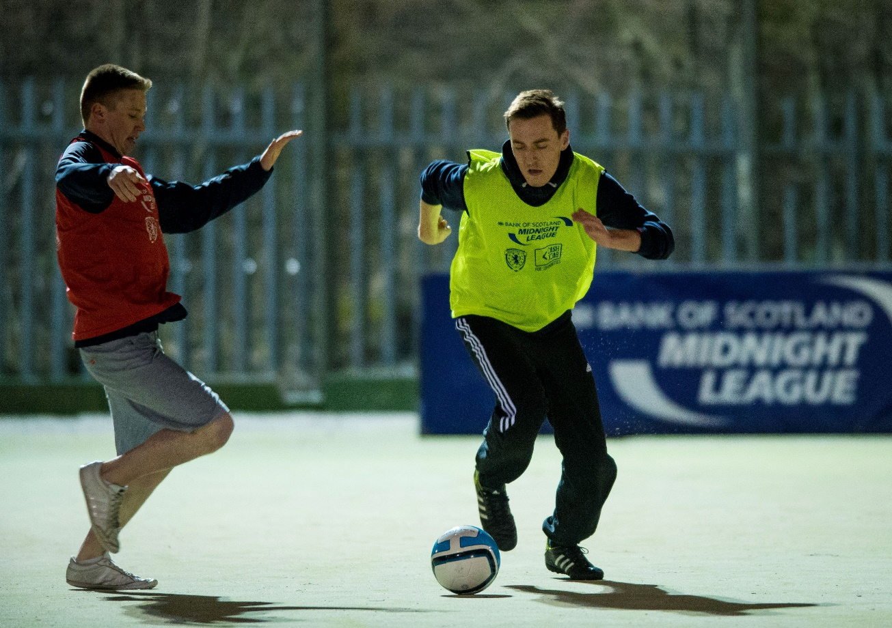

Now in its 14th year, the Bank of Scotland-sponsored Midnight League programme operates in all 32 local authorities. It provides free football for people aged 12-16 years in areas of social deprivation. The programme encourages them to take part in positive activity while diverting them away from anti-social behaviour.
Each local authority holds a minimum of ten weeks of activity per year; normally on a Friday or Saturday night. In some areas the programme has been extended to include 17 and 18 year olds; in others the activity runs for a longer period with additional funding from the local authority. The programme includes finals and player of the year events.
In total, there were 123 Midnight League groups across 117 different venues in Year 3, running across the six Scottish FA regions. Together they saw an estimated weekly attendance of 4,537 people. This is similar to Year 2, when there were 123 groups across 118 venues and an estimated weekly attendance of 4,759.
The Scottish FA aims to deliver Midnight League activity in areas of deprivation but the extent to which this can be achieved largely depends on factors such as venue suitability and availability. Based on the 106 locations where we could identify a postcode, 17 are in areas categorised as belonging to the 15% most deprived areas of Scotland (according to the Scottish Index of Multiple Deprivation (SIMD) 2016. This compares with 18 venues in 2015-16. We should acknowledge, though, that participants are drawn from a variety of neighbourhoods near the venue, so the venue location is not necessarily a reflection of the socio-economic backgrounds of participants.
Figure 2.1 shows the spread of activity across each of the Scottish FA regions, by the number of the Midnight League sessions offered and the estimated number of attendances. In many areas, the attendance figures are based on estimations made by the organisers or coaches delivering the sessions. Like last year, there is a higher programme offering in the West Region, yet Midnight Leagues are better attended relative to the number of sessions on offer in the South West, East and the North.
Figure 2.1: Total estimated weekly attendances and Midnight League sessions by Scottish FA Region

The drop-in nature of the programme continues to prove a challenge to consistent collection of registers, meaning that some leagues rely on estimated head counts; while other leagues take detailed registers and gather information like the name of their school establishment, home addresses, and dates of birth.
In previous years, the focus of our fieldwork was interviews with young people who took part in Midnight Leagues. This year, to gain a different perspective on the programme, we interviewed participants’ parents. To reach the parents, we attended an event at Hampden Park organised for young people nominated as their League’s player of the year. We interviewed 12 parents and three participants at the event.
These interviews and secondary data provided by the Scottish FA informed the evaluation of this diversionary programme.
The impact on young people participating in Midnight Leagues
Increased participation
All 12 parents told us that their children were already involved in football before joining the Midnight League, but the Midnight League offers a more sociable and less structured form of football than participants experience at other clubs. Participants enjoy the opportunity to play with their friends in a well organised setting, but with the formality of coaching input and instruction. One said his son “enjoys playing with his chums rather than the more structured team - they can please themselves, choose who goes in goals and make substitutions. They’re having fun”.
If participants were not playing at the Midnight League, parents thought they would be probably be at home playing on Playstation, “sat in their rooms or hanging round a car park”. One parent said he encouraged his son to go to the Midnight League because the x-box was “taking over”.
Improved organisational skills
Some participants take a more active role in the Midnight League, helping to publicise the League among their peers and working with the coaches to organise sessions. Those who take on roles such as these gain benefits including organisational skills and a sense of achievement. As one father said, “they get to organise it themselves and do it with their friends. He adored it, having a bit of responsibility and getting his pals together… I think he enjoyed that responsibility of not having his mum or dad doing it for him”.
Confidence and self-esteem
Some parents observed a change in their children’s self-esteem after attending the Midnight League. One said his son “has become more confident… more outgoing”. Another parent, whose son helps with coaching at the Midnight League, said he is “a quiet lad so it’s made him more confident and assertive”.
Influencing their future plans
We were told about one participant who has been helping a local Development Officer to coach at his Midnight League. The experience has led him to consider a career as a football coach. His father said that this experience has “shown him the career he can have with coaching” and “he probably wouldn’t have got into coaching without the Midnight League”.
Impact on the wider community and anti-social behaviour
Interviewees noted that the Midnight League helps to keep young people occupied on those evenings where they might be tempted to be out and causing some disruption. One participant said he had learned “to stay off the streets” through the Midnight League. Comments from parents include:
“They all want to hang about the streets and drink so it stops them doing that”.
“There’s a lot of kids out there causing trouble, it gives them something more constructive to do with their time”.
“I think it’s a great thing, especially at night time as it keeps them off the street”.
Some parents noted that the Midnight League gives participants a sense of collective responsibility about the facilities used for the League. As one said, “the kids police it [the 3G pitch] themselves, if it’s wrecked they won’t be allowed to use it”. Another pointed out that “the community is happy with how it is working. I think there’s an impact on anti-social behaviour. The kids look after the stadium rather than going round on their skateboards”.
Impact on parents
A few parents told us that they liked the Midnight League because it was reassuring to know that their children are off the street and taking part in pro-social activity: “on a dark night we know where our kids are. We know he’s safe and enjoying himself”. Another said his son is “a sensible boy but it’s good that he’s out there (playing football) and I know what he’s doing”.
Observations and considerations
The Midnight League continues to be a successful and popular programme. Our fieldwork over Phase 3 has illustrated the positive impact of the Midnight League on young people in terms of diverting them from anti-social activities, improving confidence, providing educational inputs and outreach work, as well as pathways into further participation and further involvement in football, especially coaching opportunities.
Interviewees were overwhelmingly positive about the Midnight League and the impact it has had on participants and the wider community. They did highlight that in some areas there was a lack of awareness of the Midnight League, and a suggestion that the leagues could be better promoted locally so that more young people knew about it.
Parents value the programme because they can see that their children enjoy it, that it has a positive impact it has on their children, and because it provides reassurance that their child is involved in a pro-social fun activity. This also has benefits for the wider community more young people are off the street and involved in pro-social activity, there are less likely to be involved in anti-social behaviour. Parents also noted that young people take pride in the community facilities used by the Midnight League, and self-police these to limit potential damage by them or their peers.
As identified in the interim reports, many participants are already involved in football. So, the Midnight League does not seem to act as an entry into football. However, it does give participants a chance to enjoy playing football in a setting less formal than their clubs, without the pressure to perform well and with the freedom to enjoy themselves with their peers.
Analysis of the location of Midnight Leagues suggests that more could be done to target this diversionary activity at areas of deprivation. As we commented in Year 2, the original intention was that the Midnight Leagues would be delivered in areas of social deprivation, attracting boys and girls from the local area. However, in Year 3, only 16% of the Midnight League venues with available postcodes are located in the 15% most deprived areas of Scotland. While it is inevitable that the location of facilities determines where a league can be held, the use of other venues and building links in other communities could be considered to target areas where anti-social behaviour may be a greater issue.
The programme has expanded over the years and, as well as the local sessions, there are opportunities for young people to play in regional and national competitions. However, there are ways the programme could be further refreshed, having been in operation for over a decade. It is worth considering ways in which it can continue to have an impact on individuals and local communities in the most deprived areas.
The lack of data collected about Midnight League participants has continued to be an issue in Year 3. The drop-in nature of the league means it can be challenging to collect a register of attendees but some leagues do gather registration data. As in Year 2, we would suggest introducing a suitable system that collects information at each Midnight League session, for example the actual numbers of attendees, the name and postcode of the venue, profile data about the players as well as emergency contact details. This would help the Scottish FA to develop a more comprehensive picture of this diversionary strand.

- Volunteer Development

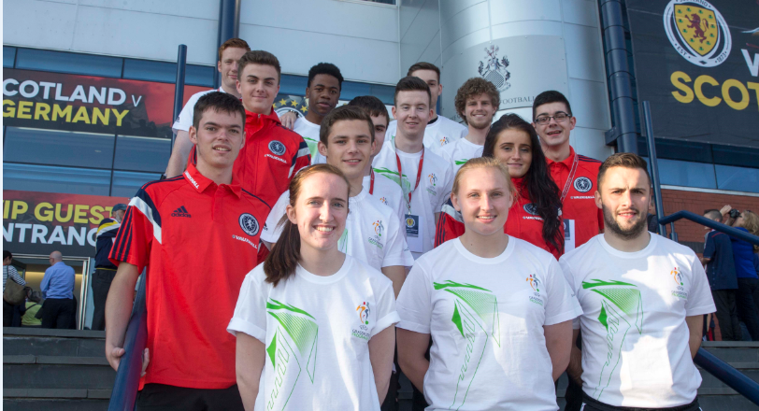

This strand provides young people with opportunities to develop as coaches and/or referees. The drive behind this initiative is to produce volunteers to support grassroots football in schools and community clubs.
The coach education and referee development course start by teaching football-related skills and offer a qualification, but they end up giving so much more. The transferable skills that participants pick up along the way enable participants to progress into other volunteering or employment opportunities.
Coach education
This programme gives16-25 year olds access to free CashBack-funded coach education in return for delivering coaching sessions on a voluntary basis.
The coach education programme is promoted in various ways. These include inviting selected former School of Football participants to take part, Development Officers making the specific groups they work with, such as girls and women, aware of what they can access, and targeting students at further education institutions such as City of Glasgow College and Edinburgh College.
Most of the participants who undertake CashBack-funded courses complete level 1.1 and level 1.2 courses on the Children’s Pathway.

Figure 3.1: Level 1 & 2 of the Children’s coach education pathway

In Year 3, 1,043 people completed a coach education course funded by CashBack. During Year 3 of this phase of funding, 273 individuals (26% against a target of 20%) returned to undertake further courses which amounted to 374 coach places.
On an annual basis, there are challenges with the time period for reporting the number of young people completing the courses because delivery falls into the next reporting year. However, as Figure 3.2 highlights, the 2016-17 number of participants across all levels was far higher in Year 1 than in Years 2 or 3.
Figure 3.2: Distribution of coach education courses across Phase 3

The Scottish FA believes that the reasons for this reduction are linked to the long period that the programme has been operating. Coach education has been offered since 2008 and so demand for the entry level coaching has fallen. There are three key areas to consider as coach education continues: how it is promoted, how people access the courses, and the needs of those wishing to take part. The Scottish FA has revised the use of CashBack funding for coach education in Phase 4. This phase will see an intensive and direct focus on progressing a smaller number of individual volunteers further, in contrast to Phase 3 when the emphasis was on the volume of young people taking up these opportunities.
Of those that have been involved in coach education in year 3, 858 (82%) were aged under 25 and 184 (18%) were 25 or over.
To gather primary evidence for this evaluation period, two Scottish FA Player and Coach Development Managers (PCDM) distributed a pre- and post-course course survey to participants of three groups undertaking the Children’s Pathway Level 1.1 (Early Touches) in Aberdeen (November 2016), Renfrewshire and Glasgow (both March 2017). We received 40 responses to the pre-course survey and 34 participants completed the post-course survey. Nineteen respondents completed both the pre- and post-course surveys.
Motives for participation
As in Year 2, the most popular reasons among participants for taking part in coach education were a desire to improve their football coaching skills (28, 70%), gain a qualification (27, 68%) and to improve their confidence in delivering coaching sessions (22, 55%).
Outcomes for participants of the coach education courses
Impact on participants’ skills, confidence and interest in delivering coaching sessions
Participants gained confidence, skills and interest in football after taking the course. They were all better at delivering football coaching sessions. All post-course survey respondents (34, 100%) confirmed that the course had improved their football coaching skills (Figure 3.3). All but one respondent (33, 97%) said that their confidence when delivering football coaching sessions had improved, 91% (31) feel more able to start or continue delivering football coaching sessions, and 85% (29) feel more interested in delivering football coaching.
Figure 3.3: By completing the course, I:

Of the 19 respondents who completed both the pre-course and post-course surveys, there was a 26 percentage point increase in the number who felt confident in their ability to deliver a coaching session (from 74% (14) to 100% (19)). There was a less pronounced increase in respondents’ ratings of their knowledge of football, from 89% (17) to 95% (18). This is illustrated in Figure 3.4.
Figure 3.4: Pre- and post-course changes among respondents who completed both surveys (n=19)

Respondents to the post-course survey reported learning a range of skills and knowledge on the course. Most (25, 76%) said they learnt new drills, activities and exercises that they could use during coaching sessions, while others said they learnt about how to deliver sessions, particularly how to make sessions appropriate for children (Figure 3.5).

Figure 3.5: What are the two main things you learnt on the course (coded, n=33)

Impact on participants’ life skills
Figure 3.6: By completing this course, I:

Like our findings in Year 2, participants reported that the coach education course had a beneficial impact on various life skills, including self-confidence, leadership, working with other people and organisational skills, as shown in Figure 3.6. A large proportion (30, 88%) also said that having the coach education qualification would improve their CV.
As the PCDMs said, coach education courses have a positive impact on participants’ leadership and communication skills “learning life skills… projecting your voice, being organised”.
Impact on participants’ plans for the future
Most post-course survey respondents (25, 74%) reported they would use what they learned on the course when delivering coaching to local teams and/or in schools. Another four (12%) said that they planned to use what they had learnt on the course in college placements.
The coach education programme has increased participants’ interest in getting more involved in sport and in their community. One respondent highlighted that the course “has swayed me to do more voluntary coaching”.
As Figure 3.7 shows, taking part in the course has:
- increased interest in taking part in sport and physical activity in general (30, 88%);
- increased interest in delivering football coaching (29, 85%);
- resulted in wanting to do more education or training linked to football or other sports, (27, 79%); and,
- increased interest in volunteering in their community (26, 76%).

Figure 3.7: By completing this course, I:

Most respondents seemed to be focused on coaching football on a voluntary basis but one, who is studying a sports course at college, noted that they would be interested in pursuing football coaching as a career: “it has shown me that the more coaching I get involved with, the more likely I am to become a coach full time”. As a PCDM said, for those who are interested in pursuing a future in coaching, the programme “creates opportunities… a pathway for people to have a career in football, in sport”.
Impact on football clubs and schools
The two PCDMs we interviewed both identified the value of the coach education programme in increasing the pool of volunteer coaches available for grassroots football clubs and schools. Both PCDMs emphasised the importance of selecting candidates who want to go on and use what they learn through the course, rather than those who are just attending because it is free or because they want to add something to their CV. As one PCDM put it, this course is most effective when it reaches participants who “want to go and deliver and make a difference in their communities”, which is reflected in the high percentage of survey participants who said they are more interested in volunteering in their communities. This in turn has a positive effect on schools and football clubs by making “more young coaches available for local teams in their area” and creating “good volunteers for schools”.
Referee development
CashBack funding, along with commercial sponsorship from Specsavers, enables secondary school pupils to access the 13-week SQA Referee Personal Development Award (Level 7 on the Scottish Credit and Qualifications Framework). The course teaches the laws of the game and the role of the referee. Encouraging and increasing participation in the refereeing of games is a core element of the Scottish FA’s Referee Development Strategy. On completion of the award, pupils are qualified to referee school games.
In 2016-17, there were 447 participants on the course, but the number of young people who completed the course will not be known until the end of 2017. Twenty-nine (6%) of these participants have moved on to the next level (Category 7) on the referee pathway, compared with 69 (15%) in Year 2. The reasons for this decline are not clear.
The primary research activity in this year is based on an online survey and interviews with two teachers from schools delivering the Referee Development Award. We distributed the survey to two schools with a request for all Referee Development participants to complete the survey. One of these schools provided responses from three participants who completed the Referee Development Award in April 2017.
The small sample sizes involved mean it is not possible to draw definitive conclusions about the operation and impact of the programme in Year 3, but our findings give some indication of the effect it is having on the young people involved.
Outcomes for young people undertaking the Referee Development Award
Interviews with teachers and the three survey responses indicate that, as in Year 2, the Referee Development Award has had a positive impact on participants’:
- knowledge of the laws of the football;
- understanding of the role of the referee in football; and
- skills, confidence and interest in refereeing.
Participants plan to use their new qualification to referee local games, providing a valuable source of referees for local teams. For some participants, refereeing is a way to supplement their income while studying at university or college: “I may not need to get a part-time job at university”.
As well as referee-specific skills, the course has helped participants to develop other personal and social skills. Participants told us “I feel that I am more confident and decisive”. Teachers identified other skills that the course helps participants to improve including leadership, team working and the “ability to deal with situations under pressure”.
Teachers also identified the importance of the course in helping schools offer extra options and experiences for pupils in their senior years at school. However, the pressures of Highers led to some pupils not completing the course and, of the teachers questioned, one group had some misgivings about the high proportion of pupils who started, but did not finish, the course. It is not clear whether this relates to only one school or if the attrition rate is high for this course.
One of the teachers interviewed also identified a lack of opportunities for practical experience of refereeing matches. He felt that his pupils would have benefited from “more in-game experience as part of the course” and that refereeing matches organised during PE lessons is not the same as refereeing a competitive match with pressure from players and spectators.
Observations and considerations
Across Phase 3, the volunteer development programme has supported participants to build confidence in their skills, pursue opportunities to further learning and develop their football skills.
The coach education courses and the referee development award provide opportunities for young people to achieve recognised qualifications, develop transferrable skills that can support their progression into further education, training or employment, and encourage participation in volunteering opportunities within the game or the wider community.
Year 3 has seen an increase in the proportion of candidates returning to complete coach education courses beyond Level 1.1, which is a positive sign that candidates are staying engaged in coaching activity and enhancing their coaching skills over time.
However, there has been a noticeable reduction in the uptake of CashBack coach education courses in Years 2 and 3 compared with Year 1. Nearly a fifth of coach education candidates were aged 25 or over, despite the intended focus of CashBack being young people 25 and under. The Scottish FA are aware that the coaching pathway needs to be reviewed and broadened to support participants to progress to higher levels.
In referee development, there was a marked decrease in the number of participants who moved on to the next level (Category 7) on the referee pathway (from 69 (15%) in Year 2 to 29 (7%) in Year 3. It would be useful to understand the reasons for the decrease in candidates’ progression in order to develop and enhance this programme in the future. The Scottish FA could review the timing and length of the programme if attrition rates are high and explore whether including greater practical experience would further support participants’ development.
We reported last year that the Scottish FA’s introduction of an online candidate application process to Scottish FA courses, in which participants are assigned a unique identification number for use in all future courses, was likely to prove a useful tool to help assess the impact of the programme in coming years. This is already making a difference, enabling analysis of the number and proportion of candidates who moved on to further courses to be completed more easily. Going forward it will help the Scottish FA to better understand the long term impact on participants’ further education and destinations.
- The Equalities programmes

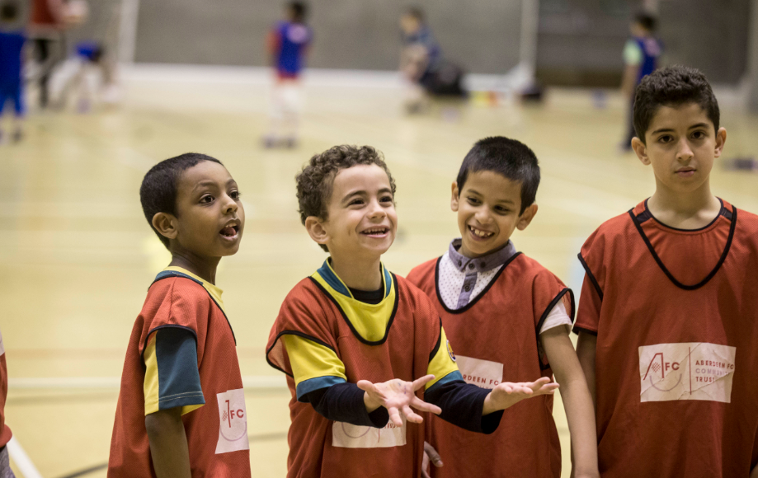

The Scottish FA has committed CashBack funding to improve equality in football, remove barriers and increase participation in football among people from ethnic minority communities, girls and women and disabled people. This, the final year of Phase three, continued the successes of the first two years. The table below summarises the number of participants that have been supported or engaged with to increase their involvement in football.
Table 4.1: Programmes and support offered in Year 3 compared to Year 2
Programme | Support offered in Year 3 | Support offered in Year 2
Football equity | 197 new individuals  22 new clubs/teams  224 volunteers  1 coach education course  1,127 total players  102 total groups | 989 new individuals  55 new clubs/team  426 volunteers  5 coach educations courses  2,050 total players  86 total groups
Girls’ and women’s football development | 115 new clubs/teams  266 volunteers  8 female-only coach education courses  10,776 total players | 141 new clubs/teams  231 volunteers  5 female-only coach education courses  10,666 total players
Disability football | 370 new individuals  1,430 contacts  40 clubs/teams  51 volunteers | 400 new individuals  2,160 contacts  40 clubs/teams  50 volunteers
Our fieldwork in Year 3 has included: visits to two participation centres for people from ethnic minorities in Edinburgh and Aberdeen (interviews with 18 young people, five representatives of partner organisations and two Scottish FA staff); analysis of a survey of clubs and players conducted by the Scottish FA; survey of Scottish FA staff working with equalities groups (with ten responses); a survey of coaches and volunteers in the girls’ and women’s game (62 responses); and a survey of coaches of teams in the PAN Disability League (15 responses).
Football Equity
The five Diversity and Inclusion Officers (DIOs) continue to deliver a programme of opportunities for individuals and groups from ethnic minority communities to engage with the game through coaching, playing, volunteering, refereeing or as club officials.
Much of this activity is delivered through participation centres, where Scottish FA staff work in partnership with local organisations to deliver opportunities for people from ethnic minority communities to take part in organised football activities.
Increased participation among difficult to engage and equalities groups
This year has continued to be successful in terms of promoting participation in football among people from ethnic minority communities, but with a dramatic reduction in activity compared to Year 2. For example, 197 new individuals from ethnic minority backgrounds got involved in football through CashBack activities in Year 3, narrowly missing the target of 200, but this is a huge decrease compared to Year 2’s figure of 989. Similarly, 22 new clubs or teams were supported in 2016-17, comfortably exceeding the target of 12, but this is substantially fewer than the 55 clubs or teams supported in 2015-16, as shown in Figure 4.1.
Figure 4.1: Support offered through the Equity programme across Phase 3

* In 2014-15 this was all individuals supported, but in 2015-16 and 2016-17 refers to new individuals supported only.
Overcoming barriers to participation
A survey by the Scottish FA indicated that more than one in ten respondents (17, 11%) said that fear of racism meant they did not play football at all or as much as they would like to. Other barriers identified included cultural differences (14, 9%) and religious beliefs (12, 8%).
Our research has found numerous examples of where CashBack-funded activity has helped to overcome these barriers and increase participation in football among ethnic minority communities. For example, the Scottish FA has delivered workshops to help community grassroots clubs become more open to and understanding of the needs of people from an ethnic minority background. Over the course of Phase 3, 39 clubs have had workshops delivered, beating the target of 36.
The DIOs, in response to a survey, described a number of other activities aimed at increasing participation among ethnic minority communities. One example was a partnership with a local mosque that resulted in around 50 Muslim boys and girls playing football on a weekly basis.
Staff and volunteers involved with delivering the two participation centres that we visited reported that these centres are important in giving children from ethnic minority communities their first taste of organised football, in making contacts with coaches from grassroots clubs and in creating pathways into clubs. For example, 19 children from ethnic minority communities recently joined a grassroots club after taking part in activity at a participation centre in Edinburgh. In one group, children from ethnic minorities are buddied-up with other children in order to ease their transition into the club.
The UEFA Captains of Change project, which links community groups with professional clubs, was cited by several DIOs as a significant programme that had resulted in football clubs becoming more representative of local communities. As one DIO noted, “this has meant that that the club’s make-up has become much more aligned with that of the area’s demographics.”
Through the survey, DIOs reported greater confidence in engaging diverse community groups which, according to one, has resulted in “better pathways and sustained participation from individuals from an ethnic minority background”. In one example of this, a DIO described assisting two physically inactive parents—who were concerned that they were not good role models for their children—by encouraging them to become involved in local football.
Impact on participants
Our research has found that the Scottish FA’s work to increase participation among individuals from ethnic minority communities has had a positive impact.
Opportunities for accredited learning
Many survey respondents indicated that the number of participants from ethnic minority communities taking part in coach education and becoming volunteer coaches had been a significant achievement.
Respondents reported an increase in the number of participants from ethnic minority communities receiving coaching accreditation from basic qualifications to UEFA licences. 217 individuals from an ethnic minority community completed a coach education course in 2016-17 (32 funded by CashBack). In one example, a respondent described a participant who has progressed through the Scottish FA Coach Education Pathway, passed the Children’s Award and is currently taking part in an internship with the Scottish FA’s North region.
Community-based interaction
Participants described a rise in community-based interaction and social cohesion as a result of increased participation in football among ethnic minority groups. For instance, a survey respondent believed the increase in football pathways gave people from ethnic minority communities a sense of belonging: “the biggest impact the programme has made has been to provide a sense of belonging to those from diverse backgrounds in the region”. A staff member at a participation centre added that football is “key to integrating socially” for children from ethnic minorities who had previously felt left out. Another participation centre, described in detail (see below) how the centre helped to bring together children and families from different ethnic backgrounds.
Case study: Hilton Participation Centre, Aberdeen

In Aberdeen, the Scottish FA’s Diversity and Inclusion Officer worked in partnership with the Jesus House Church in the Hilton area of the city, along with Active Schools, to establish a participation centre in the Hilton area of Aberdeen. Thirty children from various ethnic minorities, including European, African and Asian backgrounds, attend a weekly football session led by a coach from the Church. The DIO and representatives of the Church feel that the centre has had a positive impact on community integration. They reported that the centre involves children from different backgrounds “who normally wouldn’t interact with each other”. The Church Pastor said the centre “connects children and families together in a new platform… across the social divide”.

It has also had a positive impact on participation in football. For many children, it is the first opportunity to play football and a few have now moved on to play for a club and/or school team.
The DIO described the participation centre as “a safe environment” for children from ethnic minority backgrounds to participate in football and overcome any potential barriers linked to culture or religion and any fears of racism.

Church representatives involved in delivering the centre reported that the children gain other benefits including making new friends and learning about the benefits of exercise and healthy living.

The DIO acknowledged that this centre could be improved through closer liaison with local clubs. Having a coach from a local club attend the sessions would help to create a link between the club and the centre, and make children more likely to join the club. This is an approach that works well at a participation centre in another area of Aberdeen.

Coaches and participants at the Hilton Participation Centre

Girls’ and Women’s football development
The Scottish FA’s CashBack-funded work in girls’ and women’s football aims to build capacity in clubs to support and increase opportunities for girls and women to play and coach football. A network of Girls’ and Women’s Club Development Officers (GWCDOs), one in each of the six Scottish FA regions, co-ordinate work in this strand.
Targets have been surpassed in all elements of the girls’ and women’s development programme in Year 3.
Increased participation
There has been a small 1% growth in participation in football among girls and women between 2016 and 2017, from 10,666 to 10,776 (Figure 4.2).The high number of players has been retained through the year and far exceeds the Phase 3 target of 8,000.

Figure 4.2: Number of female players across years of funding

Similarly, there has been an increase in the number of new girls’ and women’s teams and clubs: 115 were established in Year 3, and 407 in total across Phase 3. This, again, far exceeds the Phase 3 target of 177.
GWCDOs continue to promote opportunities for participation across all age groups. Figure 4.3 shows that, of the 5,833 girls and women registered as players with Scottish Women’s Football, the largest proportion are under 13 (2,700, 46%).
Figure 4.3: Age profile of registered players (n=5,833)

Some respondents to our survey of coaches and volunteers reported greater participation among girls - “our annual football festival is now made up (of) school children of all ages and girls participate way more than before” - and this has led to “a lot more opportunity for girls to play in friendlies and tournaments/festivals”.
The trend of increased opportunities for girls and women to get involved in non-playing opportunities in football continues. Nearly 200 girls and women (194) took part in CashBack-funded coach education opportunities in 2016-17, including participants in eight female-only courses.
266 new volunteers were recruited in 2016-17, helping to meet the growing demand for volunteers to support the greater number of participants and teams in girls’ and women’s football.
Coaches and volunteers surveyed have noticed the increased participation of girls and women. Over two-thirds of respondents (44, 69%) agreed or strongly agreed that it was easy for girls and women to get involved in football in their local area. Most survey respondents commented that they had observed an increase in both the number of clubs in their area that offer opportunities for girls and women and in the number of girls and women participating in football. For example, one respondent reported that, “there has been a huge increase in girls and women taking up the game in either a player or coaching capacity”.
Respondents to our surveys of Scottish FA staff and coaches and volunteers in girls’ and women’s football identified several examples of increased participation. For instance:
- A GWCDO described the establishment of four new clubs for girls and women, 14 new teams, and 200 new players in their region.
- A respondent to our survey of coaches and volunteers gave an example of large clubs that had previously only catered for boys now offering a range of girls and women’s activities.
- Another respondent indicated that the expansion of football activities into rural areas had provided new opportunities for girls who had previously had to travel to larger towns.

However, increased participation is perhaps not universal. In the South East region, a respondent reported that “there are excellent facilities and coaches with great support but this still doesn’t seem to attract sufficient numbers”.
Greater confidence and self-esteem among participants
Many coaches and volunteers who took part in our survey reported that taking part in football helped to improve the confidence of girls and women. This was accompanied by greater social, communication and team working skills, as well as improvements in self-esteem. One respondent described “seeing the progression of girls who have never kicked a ball to now feeling confident enough to play in games”. Respondents described this increase in confidence both in terms of participants’ technical capabilities, and more broadly in their overall behaviour.
Physical fitness
GWCDOs indicated that taking part in football promoted improvements in physical fitness among girls and women. For example, one respondent believed that the increase in football pathways for girls “gives them a sense of belonging and a safe environment in which they can become fit and active”.
Skills and learning
As noted above, a significant number (194) of girls and women took part in coach education activity in 2016-17. A number of survey respondents acknowledged an increase in females coaching at all levels of football. This has resulted in increased demand for female-only coaching courses in some areas.
The increase in volunteer coaches has been accompanied by an increase in accreditation. Survey respondents reported an increase in the number of female participants receiving coaching accreditation from basic qualifications to UEFA licences.
Impact of the GWCDO role
Coaches and volunteers who responded to our survey indicated that the GWCDO role has been instrumental in increasing participation in football among girls and women.
The vast majority (44, 80%) of respondents to our survey of coaches and volunteers in girls’ and women’s football indicated that they had worked closely with their local GWCDO.
Respondents were positive about the impact of this joint working: 90% of respondents (50) agreed or strongly agreed that support from the GWCDO has strengthened opportunities for female players at their club. Several respondents attributed the growth in participation to the work of the GWCDOs. One respondent reported that “there is now a complete pathway in place and opportunities to take part in school and club football from age 6”.
Four-fifths of respondents (44, 80%) agreed or strongly agreed that the opportunities for young girls to participate in football would decline in their area if there was no GWCDO in post.
More generally, respondents expressed satisfaction with the work of the GWCDO progressing football for girls and women. Comments included:
- “I have found the GWCDO to be of great help improving sustainability and bringing innovative ideas to girls’ and women’s football” and that the work of the GWCDO has “really raised the profile of the girls’ game” ;
- “without this help I think a lot of girls would have stopped playing”; and,
- “this role is absolutely essential to the development of the female game”.

Although feedback about the GWCDOs was overwhelmingly positive, one respondent indicated that although their GWCDO was very good, they never saw her or any of her coaches in the local area, as their efforts were concentrated in a larger urban centre. This meant regional squads had more players from the GWCDO’s main area of focus.
Challenges
Despite the significant progress made across Phase 3 in promoting girls’ and women’s participation in football, there remain significant challenges to girls and women getting involved in football. A number of respondents to our survey of coaches and volunteers raised concerns about the attitudes of a small number of parents and the public towards girls and women playing football. Some indicated that they had encountered a few people with views about football not being a suitable sport for girls and women. There was also a view among some respondents that girls’ football was treated as being inferior to boys’ football.
In addition, several respondents indicated that girl’s football did not attract sufficient publicity, and the game needed to be promoted more in primary schools. This resulted in a lack of awareness of the opportunities available in some areas. A GWCDO who responded to our survey also reiterated some of these challenges, in particular, a “lack of visibility of female game” and the need for greater media coverage of women’s football.
There were several other issues that were identified as barriers to girls’ and women’s involvement in football:
- Funding - buying strips and training equipment was not financially viable given the small number of participants and this then fell to individuals so the cost could be high.
- Facilities - as numbers of participants increase it is more difficult to find and then access affordable facilities with the capacity and appropriate facilities to support training.
- Coaching staff – there was a perceived shortage of coaches both generally and at a higher level for participants wishing to become more competitive.
- Recreational football – limited opportunities for recreational football (e.g. 5-a-side) so for those players that “cannot commit to training matches etc for any reason” access to football is far more difficult for a female.
- Progression - limited opportunities for girls to keep playing football as they moved into their teens, particularly at the over 13-year-old age group.

Disability football
The Scottish FA has committed to encourage and support participation in football among people with disabilities through its strategic framework for disability football. CashBack funding is used to take forward key elements of this commitment and promote opportunities for disabled people to play football. The National PAN Disability League is the flagship element of this programme. This began in August 2014 and in this, the third year of CashBack funding, the league continues to build on the success of the first two seasons.
The PAN Disability League allows opportunities for adults, females and youths to play in competitive seven-a-side matches. It involves 36 clubs from across Scotland with teams classified into four divisions (Premiership, Championship, League 1 and League 2) according to participants’ type and level of disability. The teams in each division come together and play in a central venue (either Toryglen in Glasgow or Sighthill in Edinburgh) six times over the course of the football season. These fixture days provide regular opportunities for players and coaches supporting their teams to develop their skills and engagement in the sport.
In 2016-17, 370 disabled people attended clubs for the first time. Thirty-six teams and 400 players competed in the PAN Disability League.

The fixture list for matchday 6 of the 2016-17 PAN Disability League, Championship division
Increased opportunities for competitive football
The establishment of the PAN Disability League has increased opportunities for disabled people to take part in competitive football. Coaches of PAN Disability League teams who responded to our survey reported that, before the League was established, teams played organised matches against other teams or clubs fairly infrequently or never. Four (27%) said they never played organised matches, six (40%) said they took place every few months and three (20%) once or twice a year. Only two (13%) reported playing matches once a month, and none more frequently than that. Where teams did play organised fixtures, these were friendly fixtures arranged with other clubs or tournaments organised by their own or another club.
The introduction of the PAN Disability League has had a positive impact on young disabled people’s opportunities to play competitive matches against other teams, according to all 15 survey respondents (100%). Figure 4.4 shows that nearly all (13, 87%) respondents reported that their team has played more organised matches since the League was established.
Figure 4.4: Since the PAN Disability National League was established, has your team(s) played more or fewer organised matches against other teams/clubs? (n=15)

The League has facilitated opportunities for more competitive football in two ways. Firstly, the regular matchdays organised by the League provide fixtures for teams to take part in. Secondly, attendance at the League has enabled coaches to build relationships with other clubs, as reported by all survey respondents (15), thereby making it easier for clubs to arrange their own matches or tournaments outwith the League (14, 93%).
Comments about the fixtures organised by the League include the following:
“We are now able to give the group games to look forward to on a regular basis”.
“It gives players a platform to play competitively in a league setting at an appropriate level when, historically, they wouldn't have had the chance to”.
“The league was something that was required as there are so many teams out there who were always looking for games, as I am sure you can see by the way the league is supported”.
“The whole event through the year is well structured in the way it gives players regular football”.
Comments about the League’s impact on the ease with which fixtures can be organised outwith the League include the following:
“It is easier to arrange matches as we see each other more often”.
“The other part of the league is that it has opened a lot of the club’s eyes to organising their own tournament and that's a big step forward as well so much so that we cannot make all the different tournaments that are on”.
“We now organise friendlies against other teams as well as attending other teams’ tournaments. We also now have our own tournament that teams from our league attend”.
“It's a great way for clubs to form stronger partnerships”.

Increased participation in football
The increased opportunities for competitive football have, in turn, helped to attract more disabled young people to get involved with football teams. All but one respondent (14, 93%) agreed that the League had increased participation in football among disabled young people. One coach told us that his squad increased from eight players to 21 as a result of taking part in the League.
“The League has also helped attract more players to our team as they know they can play in competitive games once a month”.
For some players, the League has led to increased involvement in football. There are some examples of players being invited to join the Scotland PAN Disability squad, and instances where players are getting involved in coaching in the community:
“Some of our players are now keen to take up a role in coaching due to increased confidence and motivation for the sport”.
“Lots of the players are developed through the club through coaching and move on to either volunteer coach or use it as an aid when working in a support environment”.

Impact on participants’ confidence and friendships
The PAN Disability League has also had a positive impact on participants more widely, especially in terms of increased confidence, self-esteem and social networks, as displayed in Figure 4.5.

Figure 4.5: Impact on participants’ confidence and friendships (n=15)

All respondents (15, 100%) reported that the League encouraged young people to develop friendships with their peers.
“The group do enjoy the games and [it] gives them the chance to meet new friends and meet up with friends not seen in months”.
“It's a fantastic platform for players with disabilities/ASN to feel a part of a community and mix with each other/make new friends”.
“All of the men that are in the team consider themselves as friends and meet outwith the football”.
“Social impact is amazing, I love taking the group along and how they get to meet friends not seen in years and get to meet new friends, a joy to watch that side of things”.
A very high proportion of survey respondents (13, 87%) felt that the experience of the League boosted young people’s confidence and self-esteem, and 93% (14) agreed that the League increased disabled young people’s confidence to participate in sport.
“The opportunity for players to play meaningful matches is fantastic for them, the confidence is immeasurable, the ‘playing for the badge’ emotion/feeling is unbelievable, the difference we've seen in players over the past few years is tremendous”.
“The PAN Disability League has provided a platform for our players to form strong bonds with each other and develop confidence and self-esteem”.
“Meeting other players at League games has enabled my players to make new friends… and given them confidence to travel to other competitions”.
Some respondents commented that taking part in the League had a positive impact on participants’ daily living skills. For example, one commented that “you just have to talk to the players and see their confidence in travel, independence, communications, personal hygiene, budgeting and there is so much more. Sport plays a part in their daily life skills”.
Coaches felt that the League provides a focus for players and is important in providing regular competitive football, which gives players a focus and something to train for: “the league has been very important to the athletes, giving them a purpose to train for. It is important to have regular competitive matches to give them the feeling that they are not just training for nothing. They are very proud to play in the league”.
Increased participation in other community-based activities
Two-thirds of survey respondents (10, 66%) felt that taking part in the League has helped disabled young people to take part in other opportunities in their local community. These include getting involved with football coaching, as noted above, as well as other, non-football related activities:
“The players now want to ‘hang out’ more with each other and do other recreational based activities that they would never have dreamed of doing before the introduction of the league”.
“[The] Self-confidence they now have allows them to be a part of the community which they were excluded [from] before”.
“Many players undertake voluntary positions within the club and community”.
A few respondents gave examples of participation in the League having a positive impact on participants’ involvement in education, volunteering or employment:
“We have players on the employability programme, Street League”.
“Some boys moving into sporting education, college courses etc”.

Challenges
Survey respondents were overwhelmingly positive about the PAN Disability League but some identified a few challenges, including:
- The overly-competitive attitude of some coaches and players, which can be off-putting for some less competitive participants: “I don’t like the fact that so many coaches have such a big aspect on winning and for us being fairly new I think it puts a lot of our guys off. On our last two sets of fixtures we have had boys sit out (claiming to be injured but fine) because [they] don’t like the pressured atmosphere which comes from other coaches/players”.
- There could be scope for the organisation of the matchdays to be slightly enhanced: “Maybe more organisation on the day would help coaches”.
- Challenges around classifying players: “Some of the divisioning is out and needs addressed, a couple of guys in a team who might have slightly better skills than the rest of the team is not too bad but some of the teams have got five or six players who are playing far too good for the league and that's far too many and that's not right”.
- The timing of the matchdays: “The timing of the league days could be better, more evenly spread throughout the year and avoiding the winter months. Standing around between matches at the current facilities where there is not a lot of shelter in winter is not good for the players”.
- Some clubs from outside the central belt identified the distance they have to travel as a challenge: “Difficult for us as we travel the furthest and long days”.
- Some respondents, including some from the central belt, told us that the associated cost of participating in the League is challenging: “Finance is always an issue - hiring a coach/bus at £400 a time”.

Observations and considerations
The Football Equity programme has been highly successful across Phase 3. The programme provides opportunities for people from ethnic minority communities to play football in a safe environment. It can act as a stepping stone to joining a mainstream local club and can help improve community integration and, where local clubs are involved, it is helping them to consider their approaches to engage and connect with their local community.
Participation in football has also increased dramatically among girls and women across Phase 3. The role of the GWCDOs has been crucial in building clubs’ capacity to support and promote increased opportunities for girls and women to get involved in playing and coaching football. The growth of female participation in the game is highlighting that in many places the football infrastructure, facilities and coaching pathways are not sufficient to meet the growing demand.
The PAN Disability League is another success story, with more and more disabled young people getting involved with teams, because of competitive games. This has led to increased opportunities to play football, positive impacts on confidence and friendships and greater participation in other community activities. Coaches of teams in the League identified potential areas of improvement, such as organisation and facilities, which the Scottish FA could look at when building on the success of the League so far.

- Schools of Football

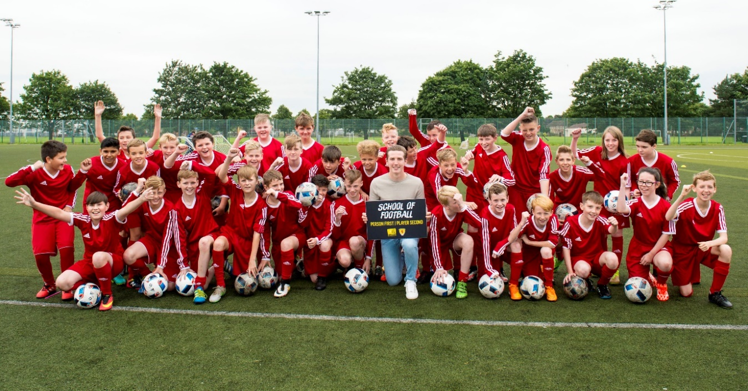
Schools of Football
The Schools of Football (SoF) programme aims to develop the social and academic skills of secondary school pupils through a football programme that includes theory-based content linked to the Curriculum for Excellence (CfE). The programme is aimed primarily at S1 and S2 pupils and the aim is to use football to help participants develop skills for learning and skills for life.
The initiative provides a Curriculum for Excellence-focused programme of football coaching during the school timetable at schools whose roll consist of at least 50% of young people living in socially deprived communities. Each person receives over 190hrs of additional coaching aimed at developing cognitive and social skills as well as completing an SQA accredited Dynamic Youth Award.
We visited two Schools of Football in Year 3 to provide insight into the programme: Lornshill Academy in Clackmannanshire and Craigroyston Community High School in Edinburgh, which we also visited in Year 2. Our research took the form of interviews and focus groups with four staff involved in delivering the Schools of Football, five current participants and four former participants. In addition, we:
- examined data collected by the Scottish FA;
- carried out a survey of School of Football head teachers, which received nine responses;
- carried out follow-up interviews with seven parents and five participants who took part in interviews in Year 2; and,
- interviewed a PCDM.
We have included the findings of these interviews in this chapter, and Appendix 3 contains a case study about Lornshill Academy.
Profile of Schools of Football and participants
There are 27 schools benefiting from the Schools of Football programme and these are recorded as 25 CashBack-funded Schools of Football. This compares to 27 in Year 2. The data available shows that there were 431 new participants in Schools of Football in 2016/17, and 863 in total. This is slightly lower than 2015/16 (when there were 465 new participants and 903 in total) but the proportion of female participants has increased slightly - from 10% (92) in 2015-16 to 12% (106) in 2016-17.
Table 5.1: Schools of Football 2016-17
School and local authority | Proportion of pupils from minority ethnic groups | Proportion of pupils who live in 20% most deprived datazones in Scotland | Participants
 |  |  | Total | Male | Female
Auchenharvie Academy, North Ayrshire | 5 - <10% | 65 - <70% | 25 | 22 | 3
Braidhurst High School, North Lanarkshire | 5 - <10% | 55 - <60% | 40 | 40 | 0
Calderglen High School, South Lanarkshire | 0 - <5% | 0 - <5% | 33 | 32 | 1
Carluke High School, South Lanarkshire | 0 - <5% | 20 - <25% | 38 | 38 | 0
Castlehead High School, Renfrewshire | 5 - <10% | 35 - <40% | 36 | 35 | 1
Charleston Academy, Highland | 5 - <10% | 5 - <10% | 28 | 27 | 1
Craigie High School, Dundee | 5 - <10% | 60 - <65% | 28 | 22 | 6
Craigroyston Community High School, Edinburgh | 10 - <20% | 65 - <70% | 31 | 26 | 5
Cumnock Academy, East Ayrshire | 0 - <5% | 35 - <40% | 36 | 33 | 3
St Augustine's High School, Edinburgh (shared campus) | >20% | 40 - <45% | 31 | 30 | 1
Forrester High School, Edinburgh (shared campus) | 10 - <20% | 20 - <25%
Govan High School, Glasgow | 10 - <20% | 85 - <90% | 28 | 27 | 1
Gracemount High School, Edinburgh | >20% | 50 - <55% | 39 | 37 | 2
Grange Academy, East Ayrshire | 5 - <10% | 25 - <30% | 36 | 33 | 3
Inveralmond Community High School, West Lothian | 5 - <10% | 25 - <30% | 27 | 27 | 0
Larbert High School, Falkirk | 0 - <5% | 5 - <10% | 36 | 30 | 6
Levenmouth Academy, Fife | 0 - <5% | 50 - <55% | 38 | 34 | 4
Lornshill Academy, Clackmannanshire | 0 - <5% | 30 - <35% | 44 | 0 | 44
Newbattle High School, Midlothian | 0 - <5% | 25 - <30% | 35 | 33 | 2
Port Glasgow High School, Inverclyde (shared campus) | 0 - <5% | 50 - <55% | 36 | 32 | 4
St Stephen's High School, Inverclyde (shared campus) | 0 - <5% | 65 - <70%
Prestwick Academy, South Ayrshire | 0 - <5% | 5 - <10% | 39 | 38 | 1
Renfrew High School, Renfrewshire | 5 - <10% | 15 - <20% | 39 | 35 | 4
St Machar Academy, Aberdeen City | >20% | 25 - <30% | 29 | 26 | 3
St Mungo's Academy, Glasgow | >20% | 85 - <90% | 41 | 40 | 1
Vale Of Leven Academy, West Dunbartonshire | 0 - <5% | 40 - <45% | 38 | 34 | 4
Wallace High School, Stirling | 5 - <10% | 30 - <35% | 32 | 26 | 6
Total |  |  | 863 | 757 | 106

As shown in Table 5.1, the 25 Schools of Football:
- involve 27 schools (including two lots of two schools on a shared campus);
- are located across the six Scottish FA regions;
- are delivered in 19 of the 32 local authorities (the same as in 2015/16);
- involve 14 schools where more than a third (35% or more) of the school population live in the 20% most deprived datazones in Scotland; and,
- include 16 schools (as Table 5.2 shows) who have a higher proportion of pupils from minority ethnic groups than the average across the population (4% according to the 2011 census).

Table 5.2: Proportion of pupils from minority ethnic groups
Proportion of pupils from minority ethnic groups | Number of schools
0 - <5% | 11
5 - <10% | 9
10 - <20% | 3
>20% | 4

The School of Football programme has been successful in reaching people from areas of deprivation. Analysis of postcode data (Figure 5.1) shows that a third of participants (180, 33%) live in an area categorised as among the most deprived 15% in Scotland (according to the Scottish Index of Multiple Deprivation (SIMD) 2016). The number of participants that fall into this category varies dramatically with just over 50% in the west region compared to 7% in the north region.
Figure 5.1: Proportion of SoF participants who live in neighbourhoods among the most deprived 15% in Scotland (SIMD 2016)

Delivery of the programme
The SQA-accredited Dynamic Youth Award, introduced in 2014-15, has enhanced the formal recognition of the learning that takes place in Schools of Football. Seventeen schools delivered the Award to 491 pupils in 2016-17, compared to 473 pupils at 19 schools in 2015-16. Youth Scotland is currently accrediting the participants’ work for 2016-17 and the results will not be available until after the summer. However, assuming that all 491 participants receive a two or three star award, participants will each achieve between two or seven SCQF credits, equivalent to a cumulative achievement of between 982 and 3,437 SCQF credits.
Currently the School of Football programme is designed for S1 and S2 year groups. The opportunity to extend the programme beyond S3 is a development that several schools would welcome and which some have managed to achieve, as highlighted in responses to our head teacher survey.
Schools we spoke to emphasised the importance of providing an opportunity for participants to gain more advanced qualifications from their participation in the programme, if it is to be extended beyond S2. To this end, the Schools of Football in the South East region are working with the Player and Coach Development Manager to develop a qualification accredited by the SQA that is suitable for senior phase pupils. As a head teacher said, “we are aiming to ensure the programme leads to some form of accreditation”.
School interviewees also emphasised the importance of being able to provide data about the quantifiable benefits for participants in order for senior management teams to sanction devoting time and resources to the programme, particularly if funding from a school’s budget is required to supplement the cost of delivery. While the programme can provide largely anecdotal evidence of its impact on young people, there is a need to gather more data about the relationship between participation and attainment. A head teacher who responded to our survey said “there is a need for School of Football to collect and provide evidence” of its impact on young people.
Some schools have taken on more responsibility for running elements of the programme themselves. In one school, for example, which has extended the programme to S3 and S4, the Scottish FA funded a member of PE staff to complete the UEFA C Licence coaching qualification, and this teacher now leads the S3 and S4 SoF programme at his school. This arrangement is being repeated at another School of Football.
The outcomes for young people in the Schools of Football
Engagement with learning
The School of Football programme has resulted in improved engagement with school.
Table 5.3: Attendance data in Schools of Football compared with the rest of the school year
School Name | Attendance data
 | S1 |  | S2
 | SoF | School | SoF | School
Alva Academy | No longer in programme
Auchenharvie Academy | 94.1 | 92 | 93 | 91.5
Bo'ness Academy | Not available
Braidhurst High School | 94.7 | 91.33 | 95 | 91.3
Calderglen High School | 95 | 91 | 93 | 90
Carluke High School | 97 | 93 | 93 | 92
Castlehead High School | 95 | 94 | 92 | 92
Charleston Academy | 92 | 92 | 93 | 90
Craigie High School | 94.1 | 88.1 | 93.5 | 87.3
Craigroyston Community High School | 90 | 92 | 94 | 91.3
Cumnock Academy | 94 | 92 | 93 | 93
Duncanrig Secondary School | No longer in programme
Govan High School | 94 | 92 | 90 | 94
Gracemount High School | 91.37 | 89.12 | 91.11 | 88.67
Grange Academy | 96.1 | 94.4 | 95.8 | 92.3
Inveralmond Community High School | 95.01 | 93.67 | 95.92 | 93.38
Port Glasgow High School (shared campus) | 95 | 92 | 91 | 92
St Stephen's High School (shared campus)
Larbert High School | 95.3 | 94.8 | 94.1 | 95.2
Levenmouth Academy | 91 | 89 | 93 | 92
Lornshill Academy | 93 | 93 | 92 | 93
Newbattle High School | 94.7 | 91.02 | 90.37 | 90.92
Prestwick Academy | 97 | 95 | 94 | 93
Renfrew High School | 95 | 94 | 92 | 90
St Augustine's High School (shared campus) | 93 | 90 | 95 | 92
Forrester High School (shared campus)
St Machar Academy | 96 | 91 | 92 | 89
St Mungo's Academy | 94 | 91 | 93 | 89
Vale Of Leven Academy | 95.9 | 93.4 | 97.1 | 93.5
Wallace High School | 96.9 | 93.9 | 95 | 92.4
Attendance, broadly speaking, is higher among SoF participants than the school average in 22 S1 groups (88% of the 25 SoFs where data is available) and 18 S2 groups (72%). School staff we spoke to felt that the programme provided “a positive reason for attending school” and former participants who we interviewed acknowledged that the programme increased their motivation for attending school. One even said “School of Football is the only reason I came to school, especially on a Friday”.
Many evaluation participants told us that the programme has improved pupils’ engagement with other subjects. One head teacher said, “for many of the youngsters involved being part of the School of Football has… resulted in increased engagement with learning across many spheres”. Other comments from teachers include:
“(The programme has led to) improved motivation, attendance and general behaviour across the school”.
“(SoF is) a tool to engage pupils in S1 and S2 to achieve in other curricular areas”.
“(The School of Football is) a bespoke programme for pupils who may become disengaged during transition to secondary”.
“We have been better able to engage vulnerable young people and have now implemented a School of Dance programme to replicate this model and support more pupils”.
“Support for the School of Football (among other teachers) is huge because it genuinely is impacting on the pupils’ engagement”.

Feedback from other teachers
We were shown a collection of feedback about School of Football participants submitted by teachers of other classes at one school. This provided many examples of SoF participants who had shown improved behaviour and engagement in other classes. Comments included:

“Jamie was a handful… (but) seems to have matured a lot and is responsible and is able to work independently and quietly. He was able to persevere and work without distractions”.

“Kyle has matured a great deal over this school year”.

“Gavin’s behaviour has really improved and he is working much harder in class”.

“Alfie is like a different pupil to the person I met in August. He is so able and enthusiastic in class, he gets work done and is very respectful to myself and other class members”.

Behaviour
Participants also told us that the programme had led to improvements in their behaviour, particularly because they knew they could be excluded from SoF activity if they misbehave in other classes. One former participant, who is now in S5, agreed that the programme helped him to behave at school and parents also recognised the value of the programme as an incentive for good behaviour and maintaining focus in other classes. One said the programme “is encouraging him (her son) to do things like homework” because he knows he will not be allowed to do SoF if he does not.
There appear to be benefits of extending the programme beyond S2 in terms of maintaining positive behaviour. Teachers at one school where the programme has been extended into S3 and S4 had observed changes in behaviour among School of Football participants towards the end of S2 and for many this deteriorated after leaving the SoF, in some cases leading to exclusion from the school. However, staff had noticed a difference now that the programme has been extended into S3 and S4. A teacher involved in delivering the SoF said that extending the programme keeps “the good behaviour going longer” into S3 and S4 - SoF is “enough to keep them coming, keep them engaged, keep them focused”. Another said “we’ve noticed a massive difference in the past year”. A member of the school’s senior leadership team agreed that extending the programme had a positive impact on behaviour: “boys who could quite easily have gone off the rails” are still in school and performing well.
In another school where the SoF is not available beyond S2 just now, a parent expressed concern that her son, who is now in S3, is not doing as well now as he was when he was in the SoF: “he was doing much better before when he was doing the School of Football”. The pupil himself acknowledged that he “felt more confident” when he was in the School of Football.
Skills and confidence
The programme also has a positive impact on participants’ skills, both in terms of football-related skills as well as skills for learning, life and work such as leadership, responsibility, communication and team working. Nearly 90% (8, 89%) of head teachers in our survey felt that the programme made a positive contribution to skills for life, learning and work and one said the programme is a good opportunity to “offer targeted support and mentoring to individuals”. Some participants also recognised that the programme helps them to develop skills that can be helpful in the workplace or further education: “I enjoy looking at learning, life and work”.
Participants who have taken up opportunities to get involved with coaching younger children reported that they had learned valuable new skills through this experience. As one said, he has learned “how to stand up and speak in front of younger kids”.
Taking part in the School of Football has a positive impact on participants’ confidence. Many reported feeling “more confident in general” and “made me feel better (about myself)”. Some said that, although they had been shy before, the SoF had helped them feel more confident in mixing and working with other people.
Social networks
The School of Football programme also has a positive impact on participants’ social networks. Taking part in the School of Football enables participants to make friends with their peers in the group. A parent gave an example of her son who had recently moved to the area and for whom SoF helped him to make new friends and settle into the area. Another parent observed that her son used to hang around with children he knew from his primary school, but being part of the SoF had helped to widen his friendship circle. Participants also spoke about the social benefits of participation and head teachers noted that taking part leads to “a sense of belonging within the peer group” and “positive relationships with cohort”.
Health and wellbeing
Taking part in the School of Football seems to have a positive impact on football skills and levels of physical fitness. In Year 3 additional data was recorded about participants’ height, weight, fitness and skill level. Many schools measure participants’ fitness when they start the School of Football and then repeat these tests later in the year to identify any improvement, using a variety of measures as shown in Figure 5.3.

Figure 5.2: Types of skills and fitness tests used across schools

As shown in Figure 5.2, tests of fitness included:
- Bleep test, continuous running between two points that are 20 metres apart, in order to test aerobic fitness;
- T-test, a test of agility that includes forward, background and lateral running; and
- Cooper Run; a 12 minute run to test maximal running capability and aerobic fitness.

Figure 5.2 also shows that skills tests included:
- Keepy-ups, juggling with a football using knees, legs, chest, and head without letting the ball fall to the ground;
- Dribbling, travelling with the ball;
- Shooting, the ability to shoot the ball into the opponent’s goal net;
- Drag-backs and push-pull (sole-drag), popular football tricks used to quickly change direction or avoid an opponent;
- Kaka challenge, named after the famous football player; and
- Passing the ball between other players.

Since the schools use a variety of tests, it was not possible to analyse the data collected consistently, although an approximate average of the means of each group indicates an improvement of 2% in fitness across all the schools where data was available. However, Figure 5.3 provides evidence of some improvements in fitness. For example, of the 25 year groups where data is available, 16 showed improvements in the average test scores, although there were decreases in eight cases and no change in one.
Figure 5.3: Change in average fitness test scores in schools where data is available

Some interviewees spoke about improvements in physical fitness. For instance, a parent observed that her son’s fitness level seems higher than other boys in the team he plays with outside school, and a participant said she is more active now and is “less likely to sit down and watch TV after school”. Teachers also identified the benefits of the programme for physical fitness - as one said, it provides “increased coaching opportunities which will increase their physical literacy”.
Schools take a similar approach to testing participants in football skills, using tests of skills like dribbling, shooting, keepy-ups, passing, drag backs and sole drags (Figure 5.2). Again, different schools use different tests, but an approximate average of the means of each group indicates an improvement of 10%. These are possibly determined by information needed to inform coaching sessions but we cannot analyse the data across or all schools. However, the data that is available (Figure 5.4) shows that, similar to the fitness tests, there were improvements in 24 of the 37 tests carried out, but decreases in 12, and one stayed constant.
Appendix 4 provides further details of the fitness and skills testing completed in 2016-17.

Figure 5.4: Change in average skills test scores in schools where data is available

Relationship between School of Football staff and participants
Another element of the programme is the positive relationship between coaching and teaching staff involved in delivering the programme and participants. Interviews with participants and parents revealed very positive attitudes towards the staff involved and some talked about the pastoral care that staff can offer. A participant described staff as being like friends and easy to talk to, unlike other teachers, and a parent said, “I think he’d rather go to a coach than a teacher if he had a problem”.
Progression into positive destinations
Although there is no data on attainment available, interviewees identified the School of Football as helping participants to move towards a positive destination. As a teacher said, “the School of Football programme… has inspired our pupils to work towards a positive destination”. Another said that, “by acknowledging and building on the youngsters’ talent in football and building on general fitness those involved experience increased self-esteem, improved health, remain at school for longer, increase attainment and enter a positive destination on leaving school”.
We found several examples of participants who had been inspired to take up volunteering opportunities at local football clubs. One participant, who now wants to work as a PE teacher and to coach football voluntarily, said that he “looks up to people like [the coach] - he is such a role model. You aspire to be something more than you would have been if you hadn’t had that experience”. Another participant reported that School of Football in S4 became more focused on qualifications and the pathway into National 5 PE.
As reported in Year 2, analysis of data collected by the Scottish FA about the destinations of 132 pupils who participated across eight Schools of Football in 2010-11 and who left school in 2015-16 showed that the proportion of participants moving on to positive destinations is lower than the overall school population. We know that School of Football participants are not reflective of the school population and that a proportion of the pupils are living in the most deprived areas of Scotland. The data showed that former School of Football pupils progressed to positive destinations including full-time employment, apprenticeships, college courses, or professional contracts with football clubs. In the absence of progression data we do not know if the number who moved into positive destinations exceeds expectations.

Impact on schools
Figure 5.5: Becoming a School of Football has (n=9):

Taking part in the School of Football programme has a positive impact on the schools involved.
Figure 5.5 shows that survey respondents identified various benefits for the schools involved, including:
- enhancement of the overall sports offering (8, 89%), “The School of Football has inspired other staff to offer other sporting opportunities”;
- improved reputation of the school in the community (7, 77%);
- increased participation in football and other sports among pupils (6, 67%), “The School of Football programme has helped encourage more pupils to play football outwith school. This has had an impact on the school as it has allowed us to be more competitive with other schools with a similar school roll”; and,
- fits in well with schools’ ethos and values: “Fits well with our vision and values. We are also a rights respecting school so I believe the programme promotes this well”.
Comments from respondents included:
“SoF pupils participate in other sports representing the school e.g. cross country road races due to increased fitness levels”.
“We have always had a strong extra-curricular sporting tradition in the school. The School of Football has assisted in continuing that tradition”.
“It fits in with our desire to improve the health and wellbeing of pupils and in giving them greater opportunities to develop a range of skills”.
“We have a strong ethos of engaging young people with education and the programme supports this”.
Developing links
Some interviewees and survey respondents told us about the importance of developing links with Scottish FA staff, local football clubs and/or other schools through the SoF programme. The development of links with local football clubs was seen as particularly important in creating additional opportunities for pupils, including the chance to gain experience of delivering coaching sessions with younger children, as well as work experience and training courses. As one said:
“The School of Football has enabled the school to offer many opportunities through our partnership with the Scottish FA and [a football club]. Pupils have had the opportunity to take part in regional tournaments, a development tour to Spain and learning visits to Hampden and [a football club]. Pupils have been able to utilise these partnerships as they go through the school by accessing work experience and training courses”.
Curriculum for Excellence
Teachers who responded to our survey reinforced the participants’ and parents’ views and recognised that School of Football makes a positive contribution to several approaches that are embedded in CfE. Most evident was the effect on skills for learning, life and work, co-operative learning and active engagement, as shown in Figure 5.6.
Figure 5.6: School of Football has made a positive contribution to (n=9):

Challenges
The programme is viewed very favourably by participants, teachers and parents, but there were challenges highlighted by a small number of parents. These related to frustration about the amount of information from the school about their child’s progress and concerns over the classes missed, particularly in core subjects like maths. There is merit in ensuring that learning from across Schools of Football is shared – especially with parents -and that the programme is delivered without disruption to the school timetable.
Observations and considerations
Again, as in Year 2, we have found that the School of Football is a very successful programme highly valued by participants, parents and schools. The classroom-based and practical elements of the programme help to support the emotional, social, personal and physical development of participants, echoing the programme’s slogan: person first, player second. The programme has seen particular success in promoting good behaviour and engagement in school, as well as encouraging participation in positive physical activity.
Although there was a slight decrease in participants in Year 3 compared with Year 2, the proportion of female participants has increased slightly, from 10% to 12%the programme appears to be reaching a diverse group of young people including 33% from areas listed as among the 15% most deprived communities in Scotland.
The Dynamic Youth Award offers the opportunity for participants to gain recognition for their learning in the programme. However, if the programme is to be extended beyond S2, as many schools aspire to do, there is a need to consider how the programme can offer accredited learning opportunities for more senior pupils.
Some schools have already begun to extend the programme beyond S2. This is a positive independent development. The Scottish FA has supported this by providing school staff with advanced coach education, enabling them to lead parts of the programme and helping ensure these additional activities are sustained. This is a worthwhile approach; training school staff to a high standard has positive outcomes for both the school and the Scottish FA. It ensures continued quality of delivery and allows school staff to deliver the programme as part of their role at the school, while at the same time reducing the burden of delivery for Scottish FA-employed or funded staff.
We recognise that the Scottish FA has continued to enhance its data collection processes over the course of Phase 3 and it has been useful to analyse the proportion of participants who live in areas of deprivation, as well as the results of skills and fitness tests, in this report. However, further development in this regard would be beneficial, particularly in terms of evidencing the impact of the programme. Further useful changes include:
- completing the postcode data collected about participants;
- encouraging standardisation of fitness and skills tests across schools. This would be useful for coaching purposes and allow comparative analysis between participating schools;
- gathering data on attainment of pupils; and
- repeating height and weight measurements among participants towards the end of the year to measure any changes.
- Summary of observations and considerations

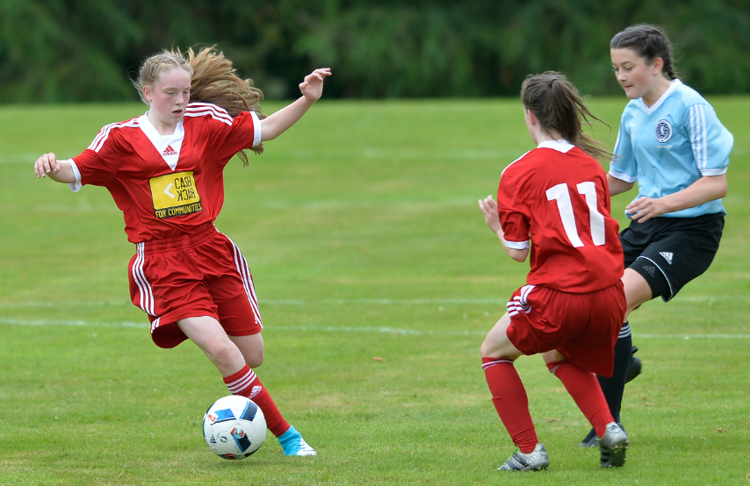

Phase 3 of the Scottish FA’s CashBack-funded programme has continued to build and develop the work of earlier phases and has, once again, provided opportunities for a wide range of young people to benefit from their participation in the sport.
The Midnight League
The Midnight League continues to be a successful programme with a visible impact on participants and the wider community. Everyone we interviewed was overwhelmingly positive about the league. Its key benefits were outlined as:
- diverting young people from anti-social activities;
- improving their confidence;
- the provision of educational inputs and outreach work;
- the creation of clear pathways into further participation and involvement in football, especially coaching opportunities;
- providing parents with reassurance their children were involved in a positive activity;
- instilling pride and ownership into participants leading to self-policing of community facilities; and,
- giving participants a chance to take part in fun and sociable football without the pressure to perfom.
The challenges for the Scottish FA in Phase 4 are to:
- find ways to raise awareness and better promote the Midnight League to local communities;
- ensure that the league reaches its intended audience by seeking venues and infrastructure in areas of deprivation;
- review its strategies and relevance as it approaches its tenth year of operation; and,
- develop a standardised system of collecting information about the participants and their behaviour to better measure the diversionary impact of the programme.
Volunteer Development Programme
The coach education courses and the referee development award provide opportunities for young people to achieve recognised qualifications, develop transferrable skills that can support their progression into further education, training or employment, and encourage participation in volunteering opportunities within the game or the wider community.
Year 3 has seen an increase in the proportion of candidates returning to complete coach education courses beyond Level 1.1, which is a positive sign that candidates are staying engaged in coaching activity and enhancing their coaching skills over time. The introduction of unique identification numbers for each participant has made it easier to track their progress and trace the impact of training on their future choices.
However, there are some challenges to be aware of for Phase 4. The Scottish FA needs to consider:
- how to sustain the uptake of coach education courses, unless they have reached saturation point, in which a change of focus is required, encouraging more people to progress to higher levels;
- how best to recruit younger participants in coach education and steer the programme back to its intended focus audience of people aged 25 and under;
- why participants in the referee training courses choose not to take training beyond the entry levels – and how they can engage them in further progression; and,
- whether including more practical experience in the courses would make them more attractive.

Football Equity Programme
The Football Equity programme is the stand out success of Phase 3, providing opportunities for people from ethnic minority communities, girls and women and disabled people to play and coach football. Highlights include:
- improvements in community integration and approaches to engagement with ethnic minority groups;
- the outstanding work of GWCDOs, who have proved crucial in increasing opportunities for girls and women to play football; and,
- the successful use of competition by the PAN Disability League to get more young disabled people involved with teams.
The key area of focus for the Scottish FA in Phase 4 is looking at how to improve the football infrastructure, facilities and coaching pathways to meet the growing demand from girls and women.
School of Football
The School of Football continues to be a very successful programme highly valued by participants, parents and schools. The programme has: promoted good behaviour and engagement in school; expanded the physical, social and academic skills of participants; and allowed young people to access positive physical activity.
The programme has seen an increase in the proportion of female participants and continues to reach a significant proportion of young people from areas of deprivation.
The Dynamic Youth Award offers the opportunity for participants to gain recognition for their learning in the programme. Some schools have already expanded this programme beyond S2, supported with training from the Scottish FA.
Recommended development areas for Phase 4 are as follows:
- a review of how to expand the Dynamic Youth Award beyond S2, especially how best to support schools who want to take ownership for this development; and,
- a closer look at data collection and how it could be enhanced to provide further evidence of impact.
Over the three year phase, the Scottish FA have used the learning from their own and the external evaluation to refine and reinforce the delivery of the CashBack-funded strands. Whilst there is still more to achieve, they have made great efforts to improve their monitoring and data gathering which has provided more detailed evidence of the impact of the work and introducing such changes should be commended.

Appendix 1 – INTENDED OUTCOMES
 | Eq | G&W | MLs | SoF | Vol | Ref | Dis | C7s
Short term outcomes - participation
- Increased participation in positive activity.
- Increased participation by difficult to engage and equalities groups.
- Increased opportunities for new experiences or activities for participants.
- Increased opportunities for continued participation by linking up and signposting to other provision.
Short term outcomes - diversion/protection
- Increased involvement in structured pro-social and healthy activities.
Short term outcomes - progression pathways
- Greater confidence and self-esteem among participants.
- Participants demonstrate new skills and positive changes in behaviours.
- More participants have achieved accreditation for their learning.
- Participants develop confidence in their skills and develop aspirations for further learning and development.
- Participants are more involved in community-based activities.
14. There is increased community-based interaction.

Intermediate outcomes
15. Sustained participation in positive activities.

16. Sustained improvements in health and well-being.
17. Sustained improvements in self-esteem and confidence
18. Sustained improvements in awareness of the benefits of play, interactive, physical and social activities
19. Increased supportive social networks and feelings of belonging.
20. More participants progress into a positive destination: such as learning in a non-school setting, further and higher education, pre-employment training, volunteering, personal development opportunities and employment.
22. Participants have influenced the opportunities available to them in their community.
23. Sustained participation in community-based activity.
24. Reduced levels of crime and anti-social behaviour.
27. Better community integration and cohesion.

Long term and national outcomes
1. Our young people are successful learners, confident individuals, effective contributors and responsible citizens.
2. We live longer, healthier lives.

3. We have improved the life chances for children, young people and families at risk.
4 We live our lives free from crime, disorder and danger.
5. We have strong resilient communities where people take responsibility for their own actions.

APPENDIX 2 – Grant Offer Letter: Outcomes, indicators and evidence
Grant Offer Letter: Midnight Leagues outcomes and indicators
Outcomes | Indicators* | Evidence in 2016-17 | Evidence in phase 3 overall
Increased participation in positive activity | 4800 young people involved | Estimated no. of weekly attendances is 4,537 | Estimated of weekly attendances: 2014-15: 3,747; 2015-16: 4,759; and 2016-17: 4,537
Increased opportunities for new experiences or activities for new participants | 100 venues offering the MLs over 32 Local Authorities | 123 leagues offered across all 32 local authorities | 123 leagues offered across all 32 local authorities in 2015-16 and 2016-17
Increased involvement in pro-social and healthy activities | 55% of participants will demonstrate an increase in physical activity  70% will make new friends as a result of the MLs | Interviews indicate young people have made friends and have increased levels of physical activity | Interviews across the phase suggest increased social networks and participation in healthy activities
Increased opportunity for continued activity by sign posting to other provision | 30 young people from the project will complete coach education qualifications  75% of young people will take part in football beyond the project | Not available  Most interviewees play for a team outside the Midnight League | Not available  Most interviewees play for a team outside the Midnight League
Greater confidence and self-esteem among participants | 79% of young people will show improvement as a result of the scheme | Interviews with parents and young people described increased confidence levels among participants. | 73% of participants who took part in University of Stirling research in 2015 reported improved confidence and 68% said they felt better about themselves. This concurs with interviews completed throughout the phase
Sustained participation in positive activities | 60% of annual retention rate of young people in the scheme | Interviews suggest participants are likely to continue attending the Midnight League | 89% of participants who took part in University of Stirling research in 2015 said they were likely or very likely to continue, concurring with interviews completed throughout the phase
Sustained improvements in self-esteem and confidence | 74% of young people will feel more responsible  89% of young people will make new friends  66% of young people will be more physically active | Interviews with parents and young people described increased confidence levels, social networks and participation in physical activity | Interviews completed across the phase, with parents and young people, described increased confidence levels, social networks and participation in physical activity
More participants progress into positive destinations | 30 young people from the project will complete coach education  20 young people who played in the league will be involved in its delivery as a coach | Not available  45 ML coaches were former participants in 2016-17 | Not available  22 ML coaches were former participants in 2015-16 and 45 in 2016-17
*Target at end of project in 2017

Grant Offer Letter: Volunteer Development outcomes and indicators
Outcomes | Indicators* | Evidence in 2016-17 | Evidence in phase 3 overall
More volunteers will achieve accreditation for their learning | 5,604 young people will complete a coach education course | 1,043 new course completions in 2016-17 | 4,512 (2014-15: 2,163; 2015-16: 1,306; 2016-17, 1,043)
Volunteers will develop confidence in their skills and develop aspirations for further learning and development | 1,404 young people will complete courses beyond that of the ‘1.1’ entry level course  40 young people will move to the next level of the Referee development ladder | 273 completed coach education courses at 1.2, 1.3 or another level  29 | 490 completed coach education courses at 1.2, 1.3 or another level in (217 in 2015-16 (217) and 2016-17 (273)  98 newly qualified referees moved onto the next level of the referee development pathway in 2015-16 (69) and 2016-17 (29)
Volunteers will sustain their participation in positive activities | 20% of CB funded coaches will return to do another course beyond that of level 1.1 (new measurement –targets to be evaluated after each year) | 26% (273 individuals) returned to undertake further courses which amounted to 374 coach places | 8% of 2014-15 participants returned to undertake courses beyond level 1.1 in 2015-16, rising to 26% in 2016-17
Volunteers will have sustained improvements in confidence and self-esteem | 60% of participants involved in the scheme will report improvement in confidence | 97% in 2016-17 said participation in the course increased their self-confidence in delivering sessions  Survey with small sample of participants of the referee development course reported increased confidence | Coach education survey: 92% of respondents in 2015-16 strongly agreed or agreed that their self-confidence in delivering sessions has improved by completing the course, and 97% in 2016-17 said their confidence had improved  In 2015-16 referee development survey: 82% strongly agreed or agreed that their involvement in the award has improved their confidence. In 2016-17 survey respondents reported increase confidence
*Target at end of project in 2017

Grant Offer Letter: Football equity outcomes and indicators
Outcomes | Indicators* | Evidence in 2016-17 | Evidence in phase 3 overall
Increased participation by difficult to engage and equality groups | 600 new participants identified and directed into new activity | 197 new individuals supported | 2,587 (1,401 new individuals supported in 2014-15, 989 in 2015-16, 197 in 2016-17)
Greater confidence and self-esteem amongst participants | 75% of current participants will show an improvement in confidence as a result of their involvement in the project | Anecdotal evidence of improved confidence and self-esteem | Anecdotal evidence of improved confidence and self-esteem
Participants will demonstrate new skills and positive changes in behaviour | 330 young people from an EM background complete a coach education course | 224 young people from an EM background completed a coach education course | 650 young people from an EM background completed a coach education course in 2015-16 (426) and 2016-17 (224)
Increased community based interaction | 36 clubs will have completed workshops in equality | 1 course delivered | 39 clubs/groups took part in workshops across Phase 3
Sustained participation in community based activities | 36 newly established clubs/groups will retain their delivery of football after 3 years | Data not available at time of writing | 86 clubs/groups have been retained in some capacity since 2014-15
Increased supportive social networks and feelings of belonging | 75% of participants will show an improvement as a result of their involvement in the scheme | Anecdotal evidence of improved social networks and feelings of belonging | Anecdotal evidence of improved social networks and feelings of belonging
Participants have influenced the opportunities available in their community | 6 Regional EM Football Development Forums will be created | Regional forums have been replaced by the Captains of Change project | Regional forums have been replaced by the Captains of Change project
Better community integration and cohesion | 75% of participants will show an improvement as a result of their participation in the scheme | Anecdotal evidence of improved community integration and cohesion | Anecdotal evidence of improved community integration and cohesion
*Target at end of project in 2017

Grant Offer Letter: Girls’ and women’s outcomes and indicators
Outcomes | Indicators* | Evidence in 2016-17 | Evidence in phase 3 overall
Increased participation by difficult to engage and equality groups | Increase of 3,030 individual female players  Increase of 360 new coaches in the game | 10,776 total players  266 new volunteers | 10,776 total players in 2016-17 (increase of 3,201 since 2015)  1,142 new volunteers (645 in 2014-15; 231 in 2015-16 and 266 in 2016-17)
Increased opportunities for new experiences or activities for participants | Increase in new clubs by 48  Increase in new teams by 177 | 115 new clubs/teams supported | 407 new clubs/teams supported (151 in 2014-15; 141 in 2015-16, 115 in 2016-17
Greater confidence and self-esteem amongst participants | 60% improvement in confidence from participants involved in the scheme | Coaches and volunteers surveyed commented that they saw improved confidence and self-esteem among players | Female players’ survey: 56% of respondents feel more confident as a person as a result of playing football (2015-16). Qualitative responses across Phase 3 support this.
More participants achieve accreditation for learning | Increase of 360 new coaches | 194 female coaches funded by CashBack | 472 female coaches funded by CashBack across 2015-16 (278) and 2016-17 (194)
Participants have influenced the opportunities available to them in their community | Case studies from positive work achieved as a result of club led regional forums | Case studies of positive work developed as a result of club-led regional forums across the phase | Case studies of positive work developed as a result of club-led regional forums across the phase
Sustained participation in community based activities | 80% of players will be retained as registered players at a club from season to season | 2,821 of 5,833 SWF-registered players retained (48%) | 2016-17: 2,821 of 5,833 SWF-registered players retained (48%)
*Target at end of project in 2017

Grant Offer Letter: Disability football outcomes and indicators
Outcomes | Indicators* | Evidence in 2016-17 | Evidence in phase 3 overall
Increase participation by difficult to engage and equality groups | 1,200 attendances will be achieved at the festivals | 1,430 | 3,590 attendances in 2015-16 (2,160) and 2016-17 (1,430)
Participants are more active in community based activities | 500 young people will be involved in regular club activity | 400 people competed in the PAN Disability League (370 new individuals) | Pan league stats suggest there are 395 players in teams in 2015/16 and 400 in 2016-17
Participants develop positive peer networks and relationships | 75% of participants will show an improvement since their involvement in the project | Anecdotal evidence shows improvement and 100% of coaches who responded to survey (15) reported that PAN Disability League encouraged disabled young people to develop friendships with their peers | Anecdotal evidence shows improvement and 100% of coaches who responded to survey (15) reported that PAN Disability League encouraged disabled young people to develop friendships with their peers
Sustained participation in positive activities | 90% retention rate at the events | No data currently to evidence this indicator | No data currently to evidence this indicator
Sustained participation in community based activities | 9,400 total number of attendance at club based activity after 3 years | 1,430 | 3,590 attendances in 2015-16 (2,160) and 2016-17 (1,430)
*Target at end of project in 2017
Grant Offer Letter: Schools of Football outcomes and indicators
Outcomes | Indicators* | Evidence in 2016-17 | Evidence in phase 3 overall
SoF pupils will have greater confidence and self-esteem | 90% of data gathered from questionnaires will show improved performance and relationships with peers | Head teacher survey and interviews with participants and parents report improvements in confidence and self-esteem | Teacher surveys and interviews with participants and parents have consistently reported positively on the confidence of participants across the phase
SoF pupils will demonstrate new skills and positive changes in behaviour | 84% of data gathered from questionnaires will show improved behaviour and relationships with peers  94% positive perceptions of key people in schools such as Guidance and Head Teachers | Interviews and surveys indicate improved behaviour, relationships and positive perceptions of key people in schools  Attendance was higher among 22 S1 groups and 22 S2 groups compared to the school average | Interviews and surveys indicate improved behaviour, relationships and positive perceptions of key people in schools  Data across Phase 3 has indicated that attendance is greater among SoF participants than the school average
SoF pupils will achieve accreditation for learning | 90% of SoF achieve accreditation from Youth Scotland for Dynamic Youth Award | 491 pupils across 17 schools | 1,540 across Phase 3 (2014-15: 576 pupils, 2015-16: 473; 2016-17: 491 pupils) (58%)
The SoF pupils will have a sustained participation in community based activity | 75% of data gathered from questionnaires will show pupils involved in at least 5hrs of physical activity per week  86% of players in SoF will be registered at a football club | Interviews show positive impact on physical activity  Where data is available, 84% (459 of 584 participants) are members of a football club outside School of Football | Interviews show positive impact on physical activity. In 2014-15:  - 60% were involved in six or more hours of physical activity per week; 36% three to five hours  - 80% registered at a club  2016-17: Where data is available, 84% (459 of 584 participants) are members of a football club outside School of Football
More SoF pupils will progress into positive destinations | A higher average attendance in the SoF class versus the rest of the school year  Analysis of the current destinations of ex SoF pupils in S4/5/6 | Attendance was higher among 22 S1 groups and 22 S2 groups compared to the school average  Analysis conducted for the SoF that we have available showing promising results | Attendance was higher among 22 S1 groups and 22 S2 groups compared to the school average  Analysis conducted for the SoFs available show promising results
*Target at end of project in 2017

Appendix 3 – School of Football Case study: LORNSHILL ACADEMY
Background
Lornshill Academy is a 6-year comprehensive school located in Alloa, Clackmannanshire. There are currently 1,006 pupils enrolled at the school, with 91% (compared to 92% in the virtual comparator) of school leavers entering positive destinations¹. The school also has a higher percentage of unauthorised absences across every year group compared to both Clackmannanshire and Scotland overall. Lornshill Academy serves the surrounding area of Alloa, of which large portions fall into the most deprived decile areas of Scotland according to 2016 SIMD data.
The Schools of Football programme was introduced at the school in 2012 (albeit initially not funded by CashBack), starting with 14 girls. Since then, the programme has grown to deliver a number of other ‘Schools of’ including dance, rugby, and science; testament to the successful adoption and model delivered at the school. The case study visit involved speaking with the PE teacher involved with setting up the initial programme, the local Development Officer and four S2 girls currently involved in the programme; in order to understand the delivery and impact of the programme.
Delivery
The School of Football is delivered through 3 curriculum periods, 1 extra-curricular period, and the remaining time allocated in 10-minute tutorial times each day. While the School of Football started with an extraction model, this has been reconfigured into grouping all School of Football pupils into one class, to benefit continuity for participants. In addition to the practical sessions, the content of the classroom sessions include sex education and equality/equity issues.
The Lornshill Academy School of Football endeavours to positively affect individuals who are exposed to particular risk factors, particularly since 56% of pupils are in the lowest 30% SIMD (according to the PE teacher); and recruitment takes place on this basis. For example, teachers involved in the programme receive recommendations from primary school teachers. This also means the programme has particular focus on ensuring attendance rates are maintained.
Impact
Pupils remarked that they found it easier to engage in a football programme that was “just for girls”; and enjoyed the encouraging atmosphere, “if you miss a goal, they cheer you one”, which one pupil felt was unique to a girls-only setting. Pupils acknowledged that you had to behave well in order to take part in the programme, as they saw it as a “privilege to be let out of classes”. The pupils also suggested that the programme has encouraged them to make new friends, become more confident, and be “less shy about talking”; and some have become involved in Tullibody Football Club as a result. Involvement in the programme has had lasting impact on their lifestyles in other ways: one pupil remarked that she was far more active now and, “less likely to sit down and watch TV after school”. This same pupil remarked that she hoped to become a PE teacher or work in sports development in future.
The teacher and development officer provided further evidence to reinforce the impact described by participants. They particularly remarked on positive behaviour, as School of Football participants have experienced reductions in exclusions and demerits, and have the lowest behaviour sanctions of any other group in the school (perhaps in part due to the rigorous approach that the School of Football adopts to informing parents in instances of a child receiving a demerit; more so than the wider school). Furthermore, the PE teacher noted that attendance is 96% in School of Football compared to 92% school average and 90% first year average; thus helping to close the attainment gap.
According to a recent internal survey, 100% of participants would recommend the programme to others, and 96% said it eased the transition between primary and secondary education. There is a high succession rate (>50%) of pupils going from into club environments – for example Falkirk, performance teams. The girls team also recently played their first 11-side-match, which the PE teacher felt was quite momentous.
Challenges
The success of the ‘Schools of’ model – now encompassing other sports and subjects – means that the school now faces the challenge of how to support those pupils not in any ‘Schools of’ programme. Attempts to overcome this include developing special sport events exclusively for these pupils.

APPENDIX 4: SCHOOLS OF FOOTBALL FITNESS AND SKILLS TESTING DATA
West
Tests to measure fitness and skills are taken at the beginning and end of the year to see whether improvements were made by individuals that might be attributable to their involvement in School of Football. The specific tests used at each school are:
- In Renfrew, the Bleep Test was used as a measure of fitness and Keepy ups was used to gauge skills;
- In Castlehead, the Bleep Test was used as a measure of fitness and Passing was used to gauge skills;
- In Govan, the Bleep Test was used as a measure of fitness and Dribbling was used to gauge skills;
- In St Mungo’s, the T-Test was used as a measure of fitness and 20m dribbling was used to gauge skills; and
- In Port Glasgow/St Stephen’s, the Bleep Test was used as a measure of fitness and shooting was used to gauge skills.
 |  | Fitness |  |  | Skills
School | Year group | Start (mean) | End (mean) | % change between means | Start (mean) | End (mean) | % change between means
Renfrew | S1 (n=16) | 7.3 | 7.6 | 5% | 35.3 | 39.9 | 13%
 | S2 (n=19) | 8.5 | 9.2 | 8% | 72.3 | 80.9 | 12%
Castlehead | S1 (n=16) | 8.5 | 9.2 | 9% | 11.7 | 13.0 | 11%
 | S2 (n=19) | 7.6 | 8.8 | 16% | 10.7 | 12.6 | 18%
Govan | S1 (n=13) | 79.1 | 58.3 | -26% | 13.8 | 16.2 | 17%
 | S2 (n=14) | 73.4 | 78.2 | 7% | 14.0 | 18.0 | 29%
St Mungo’s | S1 (n=20) | 31.5 | 30.9 | -2% | 13.9 | 13.7 | -1%
 | S2 (n=20) | 29.0 | 26.9 | -7% | 12.5 | 12.1 | -4%
 | S3 (n=8)* | 28.2 | 24.1 | -14% | 12.0 | 10.5 | -13%
Port Glasgow/ St Stephen’s | S1 (n=18) | 6.7 | 7.1 | 6.% | 3.2 | 3.9 | +21%
 | S2 (n=16) | 7.0 | 7.3 | 3% | 4.6 | 4.1 | -11%
*note that only 7 cases were analysed as the data for 1 pupil was incomplete

Note: all change positive except those in red (% decreases)
South East
Tests to measure fitness and skills are taken in term 1 and term 2 (or term 3 for Inveralmond), in order to see whether improvements were made within individuals, which might be attributable to their involvement in School of Football. The specific tests used at each school are the Kaka challenge for skill and the Cooper test for fitness.
 |  | Fitness |  |  | Skills
School | Year group | Term 1 (mean) | Term 2§ (mean) | % change between means | Term 1 (mean) | Term 2§ (mean) | % change between means
Inveralmond | S1 (n=15)¹ | 1491.1 | 1687.5 | 13% | 33.1 | 41.1 | 24%
 | S2 (n=13) ² | 1759.6 | 1951.9 | 11% | 46.6 | 49.8 | 7%
Newbattle | S1 (n=16) ³ | 2084.1 | 2020.8 | -3% | 35.2 | 49.1 | 40%
 | S2 (n=19) ⁴ | 2246.1 | 2160.0 | -4% | 49.1 | 57.7 | 18%
Gracemount | S1 (n=16) ⁵ | 1941.7 | 2031.3 | 5% | 34.3 | 34.6 | 1%
 | S2 (n=16) ⁶ | 2463.6 | 2727.3 | 11% | 59.5 | 67.1 | 13%
Craigroyston | S1 (n=14) ⁷ | 2369.2 | 2471.4 | 4% | 36.5 | 39.8 | 9%
 | S2 (n=13) ⁸ | 2340.0 | 2510.0 | 7% | 50.9 | 56.4 | 11%
Forrester | S1 (n=15) ⁹ | 2624.9 | 2420.0 | -8% | 45.3 | 49.6 | 10%
 | S2 (n=17) ¹⁰ | 2816.2 | 2810.8 | 0% | 49.1 | 48.3 | -2%

¹ there were only 14 entries in fitness
² there were only 13 entries in fitness, and 12 in skills, due to injury
³ there were only 13 entries in fitness and 12 in skills due to injury/missing data
⁴ there were only 9 entries in fitness and 15 in skills due to injury/missing data
⁵ there were only 12 entries in fitness and 12 in skills due to injury/missing data
⁶ there were only 11 entries in fitness and 14 in skills due to injury/missing data
⁷ there were only 13 entries in fitness and 13 in skills due to injury/missing data
⁸ there were only 10 entries in fitness and 11 in skills due to injury/missing data
⁹ there were only 12 entries in fitness and 12 in skills due to injury/missing data
¹⁰ there were only 13 entries in fitness and 16 in skills due to injury/missing data
§ Term 3 for Inveralmond

East

 |  | Skills – Shooting (right foot) |  |  | Skills – Shooting (left foot)
School | Year group | Test 1 (mean) | Test 2 (mean) | % change between means | Test 1 (mean) | Test 2 (mean) | % change between means
Craigie High School | S1 (n=17) | 5.41 | 5.41 | 0% | 1.65 | 2.29 | 39%
 | S2 (n=11) | 4.36 | 5.18 | 19% | 2.36 | 2.73 | 15%
Levenmouth Academy | S1 (n=14) | 3.00 | 3.93 | 31% | 1.36 | 1.57 | 16%
 | S2 (n=14) | 2.21 | 2.71 | 23% | 1.86 | 2.50 | 35%

Note Craigie High School also performed the 10 yard dash, 30 yard dash and T-test, but it was unclear in the files when these tests were taken, so a change over time could not be assumed. Similarly, dates of when the tests above were conducted were not provided.

North

Tests to measure fitness and skills are taken four times throughout the academic year; the first three were available for analysis, so the first and last tests have been compared here. Three tests are used to measure skills and fitness: drag back, pull push, and Cooper run.

School | Year group | Drag back |  |  |  | Pull push (sole drag) |  |  |  | Cooper run
 |  | Oct-16 (mean) | Feb-17 (mean) | May-17 (mean) | % change between means | Oct-16 (mean) | Feb-17 (mean) | May-17 (mean) | % change between means | Oct-16 (mean) | Feb-17 (mean) | May-17 (mean) | % change between means
Charleston | S1 (n=14)¹ | 6.9 | 6.8 | 6.8 | -2% | 8.7 | 8.8 | 9.3 | 6% | 15.4 | 14.3 | 14.7 | -5%
 | S2 (n=14)¹ | 7.0 | 6.9 | 6.9 | -2% | 9.4 | 8.4 | 9.0 | -5% | 14.2 | 15.2 | 15.6 | 10%
St Machar | S1 (n=15)² | 5.1 | 4.9 | 4.8 | -6% | 3.9 | 3.8 | 3.6 | -6% | 22.3 | 23.2 | 23.6 | 6%
 | S2 (n=13) ³ | 5.4 | 5.2 | 5.1 | -6% | 3.8 | 3.5 | 3.4 | -9% | 21.2 | 21.9 | 22.5 | 6%

¹ there were only 8 entries available across the tests
² there were only 12 entries available across the tests
³ there were only 7 entries available across the tests

Note: all changes positive except those in red (% decreases)

The remainder of the £2.25 million is accounted for by staffing, management, marketing and evaluation costs.
We have analysed the 2015-16 data using the SIMD 2012 dataset because that was the current version of the SIMD at the time of delivery. We have used SIMD 2016 to analyse the 2016-17 data.
Scottish FA, Scotland United: A 2020 Vision, http://www.scottishfa.co.uk/resources/documents/SFAPublications/ScottishFApublications2011-12/Scotland%20United%202011.pdf (accessed 15 June 2017)
Another school, Bo’ness Academy, operates a School of Football but does not receive CashBack funding.
Two schools left the programme at the end of 2015-16.
Scottish Government (2017), Schools Contact Details, http://www.gov.scot/Topics/Statistics/Browse/School-Education/Datasets/contactdetails (accessed 17 June 2017)
Based on data from the SIMD 2016, sourced from link above
There is at least one School of Football operating in each of the ten local authorities ranked as the most deprived based on the proportion of areas in the local authority categorised as among the 20% most deprived in Scotland.
Valid postcodes were available for 539 participants from 2016-17.
The data from Central region was not available at the time of writing.
Names have been changed to protect anonymity.
These are eight of the nine Schools of Football which have been established long enough to have former participant now leaving school.
Available at: https://education.gov.scot/ParentZone/find-a-school/Clackmannanshire/5702631 (Accessed 22 June 2017)
Available at: http://www.gov.scot/Topics/Statistics/SIMD (accessed 22 June 2017)

