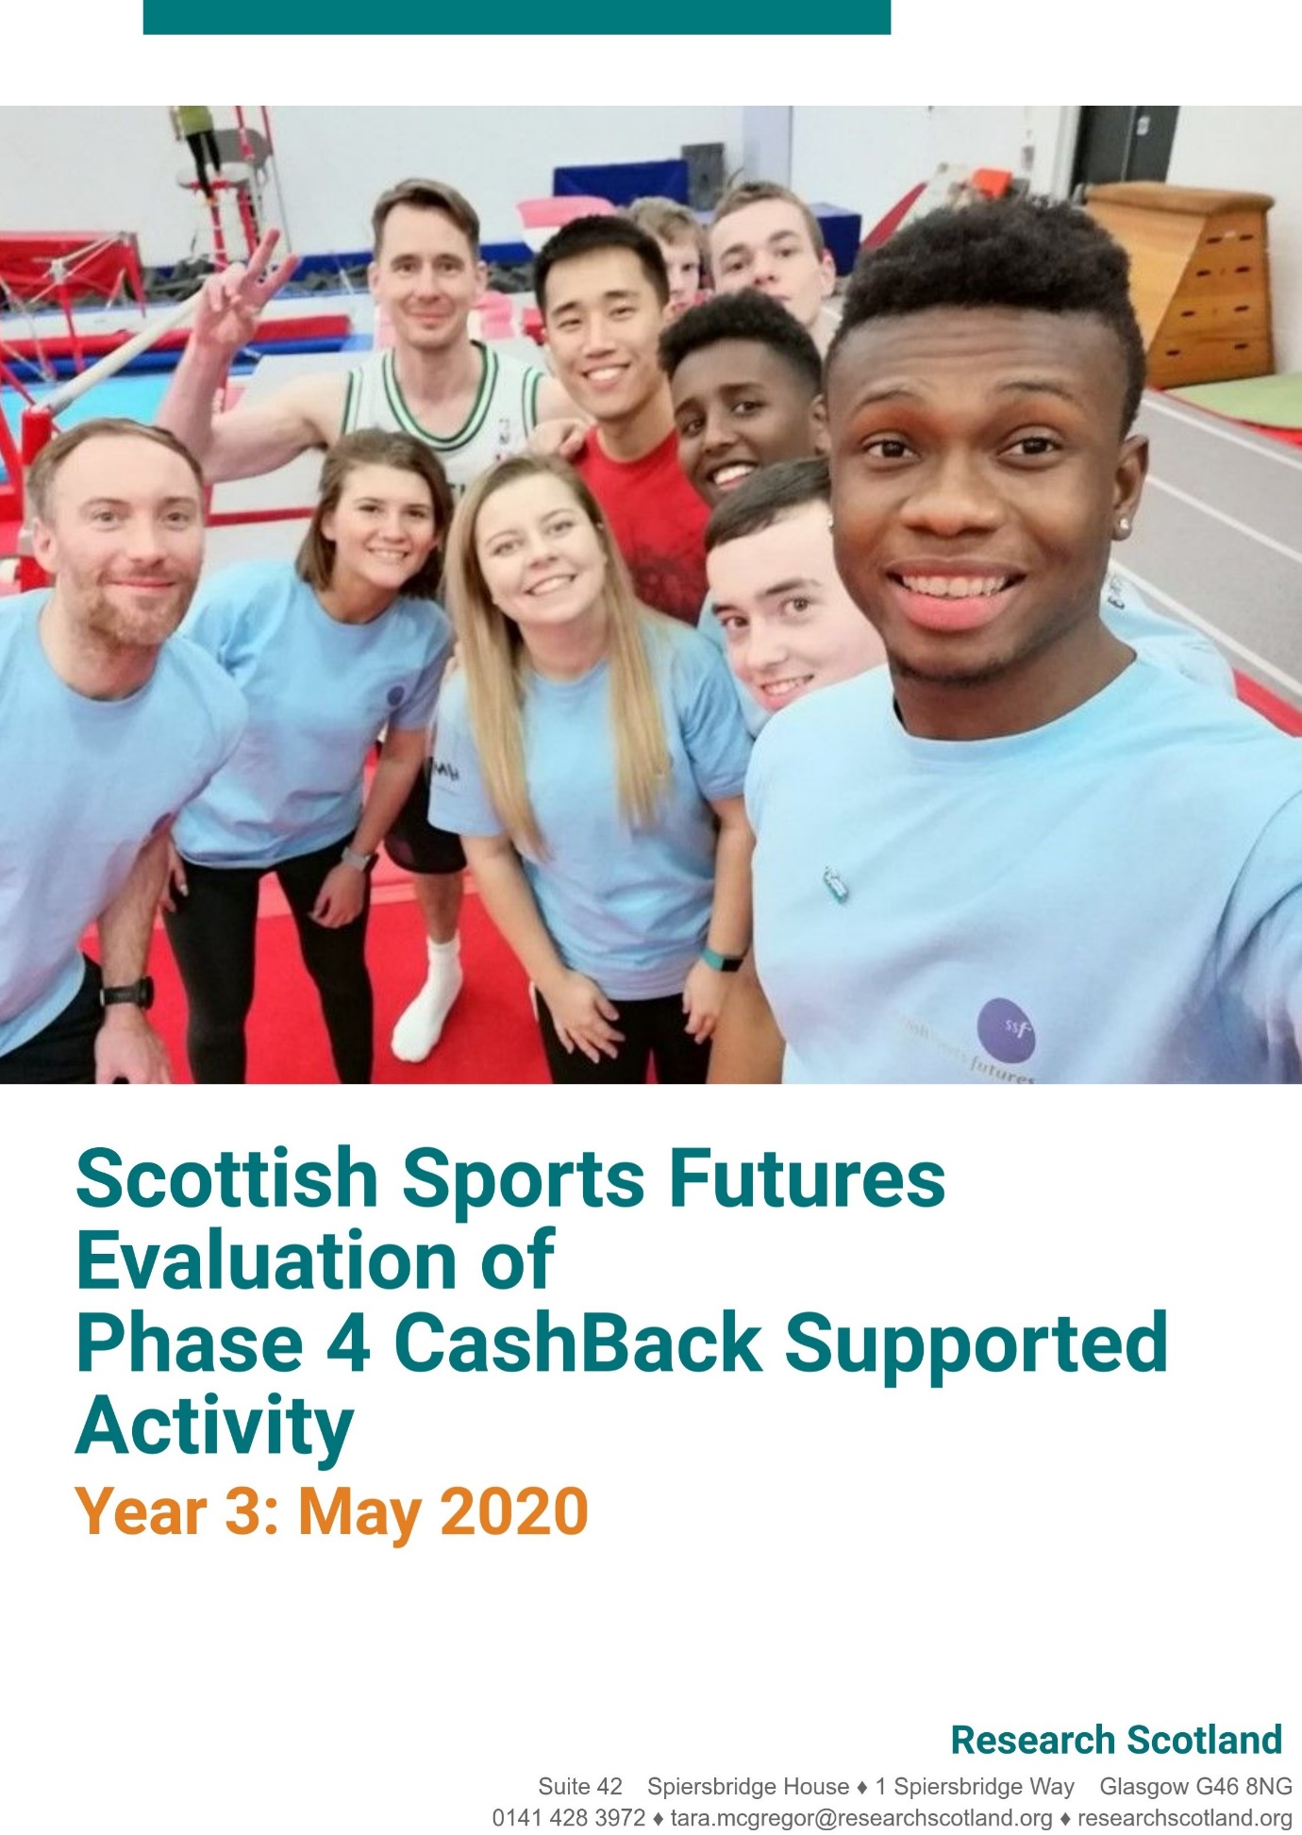
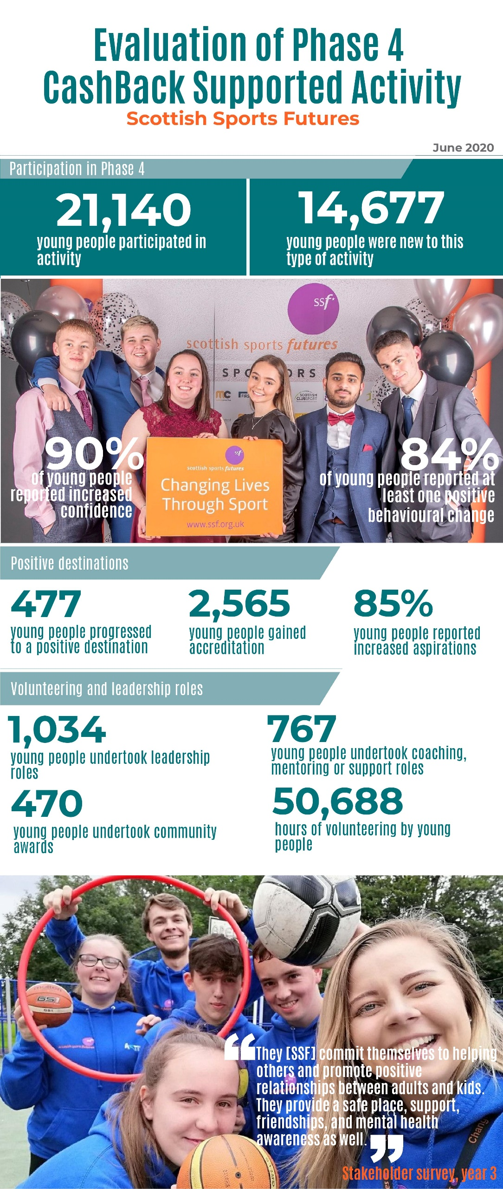
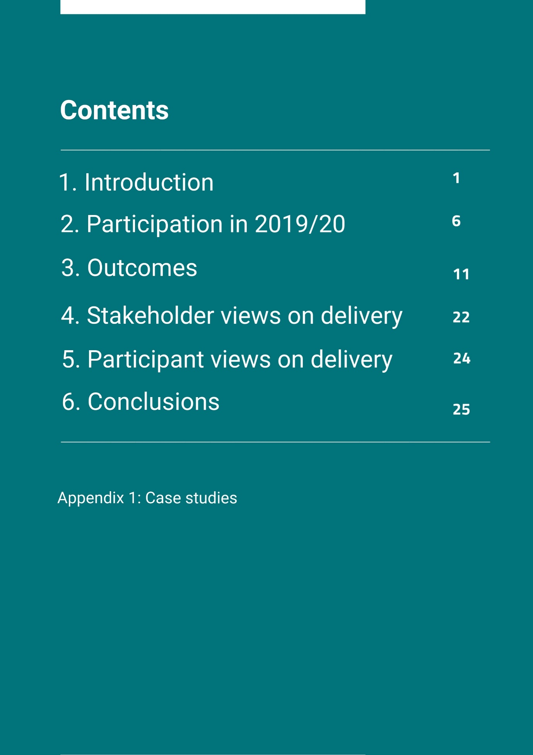

Introduction

About this report

  - Scottish Sports Futures (SSF) commissioned us (Research Scotland) to evaluate the impact of its Phase 4 CashBack funded activities. This report reviews the impact of the programmes at the end of the third and final year of Phase 4, April 2019 to March 2020. It reviews the reach of the programme in its last year of delivery, the outcomes it has delivered during the three year delivery phase, and includes an analysis of the most recent surveys with participants and stakeholders.

  - This report will:
- explore the reach of SSF’s CashBack funded activity;
- consider developments and progress; and
- explore the impact of SSF programmes, during the funded period.

SSF

  - SSF is a Glasgow based charity which delivers ‘Sport for Change’ activities across Scotland. It uses inclusive sport and physical activity as a tool to engage with young people, and support them to learn about physical and mental wellbeing, goal setting, teamwork and active citizenship.

  - SSF programmes are focused at different stages of development and target communities that are vulnerable or at-risk.

  - CashBack funding supports the delivery of the following SSF programmes:

- Shell Twilight Basketball – This is an evening basketball programme for young people which includes weekly sessions incorporating “Educational Timeouts”. Running across Scotland, sessions, tournaments and an Ambassador programme encourage leadership and development among young people.
- Jump2it – This programme is targeted at primary school pupils. It involves educational roadshows in primary schools delivered by professional athletes as role models and associated tournaments with pupils. It includes a network of community-based clubs (Rocks Community Clubs, or RCCs) designed to widen access to, and encourage regular participation in, basketball for primary school children.
- Education through CashBack (ETC) – This training and development programme is specifically designed for staff and volunteers who work with young people.
- Active East– A partnership and volunteering based approach to supporting young people in the East End of Glasgow, including a range of development programmes for young people.

CashBack for Communities

  - CashBack for Communities is a Scottish Government funding programme which takes money seized from criminals under the proceeds of crime legislation and invests it into community programmes, facilities and activities largely with young people.

  - Phase 4 of the CashBack programme ran from 1 April 2017 to 31 March 2020. It had a stronger focus on helping tackle Scotland’s inequalities than previous phases and emphasised the importance of raising the attainment, ambition and aspirations of those young people across Scotland who are disadvantaged by:

- living in areas of deprivation;
- being unemployed, not in education or training;
- being excluded, or at risk of exclusion from school; or
- being at risk of being involved in antisocial behaviour, offending or re-offending.

  - In 2019-20 SSF’s CashBack expenditure was £422,272.

Year three programme delivery

  - Here we discuss key developments and achievements identified by SSF staff at the end of the phase.

  - Staff highlighted the following areas of significant change:

- Organisational focus and structure – Staff spoke of the significance of SSF’s strategic planning review undertaken during year three of delivery. This has culminated in the recent publication of a new strategy and a staff restructuring programme. Staff felt this had allowed the organisation to re-focus on: young people and communities who are most in need; offering a full range of SSF programmes, with relevant pathways; diversifying the types of sport being offered. The phase has seen increasing collaboration between programmes, which has been viewed positively by staff. This approach is reflected in the new structure which is not divided on a programme by programme basis, but regionally and thematically. This process has also taken SSF ‘back to its roots’ in some ways, with a return to more diversionary activity and street-work. It is changing the content of some programmes – such as ETC, which is developing new modules on topics such as adverse childhood experiences and mental health to add to its existing suite of training.

- Strengthening youth involvement – There has been an increasing focus on youth involvement in decision making throughout the phase. This can now be seen at all levels within the organisation – from delivery of programme activities, right through to the new Youth Advisory Panel, and the appointment of a young person to the Board.

- Sustainability – The new SSF structure and recently secured funding means that SSF is able to plan activities effectively for the next few years. One staff member highlighted that the stability of a funding programme like CashBack has allowed the organisation to focus effectively, and have greater impact.

- Equality – Staff emphasised that the Phase 5 CashBack programme, and its wider activities, are more focused than ever before on young people experiencing inequality. There has also been recent work with Scottish Disability Sport and with young carers. There has continued to be a strong emphasis on engaging more women, particularly in Twilight and ETC, during Phase 4.

- Partnership working – SSF has continued to build new partnerships during this phase. Staff highlighted the strategic importance of working closely with sportscotland on the Sport for Change agenda. Staff highlighted positive relationships with a diverse range of stakeholders, including the Police, Celtic Foundation and Scottish Rugby Union. Some relationships, such as the relationship with SAMH, has led to significant new areas of work. There have been more targeted discussions with schools and community programmes in areas of deprivation. For example, SSF has been working with the Glasgow Community Planning Partnership as part of the Thriving Places approach, to deliver change in the Barrowfield area of the city. Other recent discussions have taken place with housing associations to support diversionary activities for young people in some areas. Throughout the phase SSF has consciously moved towards working with local partners in a more sustainable way – particularly on the Twilight programme, where local ownership of delivery has been key to the long term sustainability of projects.

Evaluation method

Review of SSF data
  - In developing this report, Research Scotland reviewed the following information provided by SSF:

- monitoring data for 2019/2020 – key data collected by SSF and reported to Inspiring Scotland (who administer CashBack funding on behalf of the Scottish Government); and
- data on participants registered during 2019/2020 – a spreadsheet provided by SSF which includes equalities data on new participants from year three; and
- case studies – which explore examples of successes from year three.

Year three surveys with participants and stakeholders
  - Research Scotland designed a core set of participant survey questions, and a stakeholder survey, based on workshop discussions with SSF at the beginning of year one. SSF then transferred the surveys onto its online survey tool, Survey Monkey.

  - The table below provides an overview of how many people completed the participant and stakeholder surveys during 2019/20. The numbers of TBB and Jump2it surveys completed were significantly lower than hoped, due in part to the impact of Covid-19 on survey administration. There was a slightly higher number of ETC and Active East surveys completed than in the previous year. The stakeholder survey response was lower than last year, when 91 surveys were returned.

Table 1.1: Number of survey responses to surveys by programme, 2019/2020
Programme | TBB | Active East | Jump2It | ETC | Total survey responses
Main participant surveys | 167 | 50 | 98 | 518 | 833
Stakeholder survey | 21 |  |  | 20 | 41

  - This report uses survey results from all three years. In total, 2,547 participant surveys and 193 stakeholder surveys were completed and have been analysed here.

  - It is important to recognise that the survey evidence is based on perceptions, and that the sample may not reflect the views of wider participants. While the percentage figures used in this report provide a helpful indication of progress in relation to agreed outcomes, they are not perfect measures.

  - During year three SSF experienced a slight issue with recording ‘no responses’ for some Twilight and ETC survey responses. When a respondent had left a survey blank these were sometimes recorded as ‘not sure’. For this reason, the ‘not sure’ category has not been included in some calculations for year three. In these cases, percentages have been worked out based on the sample of respondents who answered the question with the other options.

Interviews with SSF staff
  - In April 2020 Research Scotland interviewed a lead from each of the programmes. The interviews explored key developments during 2019/20, and offered a chance to reflect back on the Phase overall. A short summary of the key points from these discussions is provided earlier in this Chapter.

Case study interviews with young people
  - Two zoom interviews were conducted with young people alongside the main SSF staff who support them. The interviews explored the young peoples’ experience of SSF’s CashBack funded programmes. The interviews explored their situation before becoming involved, how SSF had supported them, and the outcomes they experienced as a result of being involved. SSF staff were asked to reflect on the young person’s progress. Two case studies based on these interviews are included in Appendix 1.
2. Participation in 2019/20

Introduction

  - SSF reported that it engaged with 5,320 young people in its CashBack funded activities during 2019-20. This chapter provides an overview of the number and profile of new participants in SSF programmes during the third and final year of Phase 4, based on available data.

Gender profile of participants

  - Data was available on the gender of 5,320 new participants in 2019-20. At an overall level, there was a broadly equal proportion of males (52%) and females (47%), with 1% preferring not to say

  - The overall programme data includes large variations in response levels between programmes, so it is useful to look at the profile of the individual elements of SSF’s CashBack funded work, as shown in the chart below. From this we can see that the profile of Shell Twilight Basketball, ETC, and Active East is predominantly male.

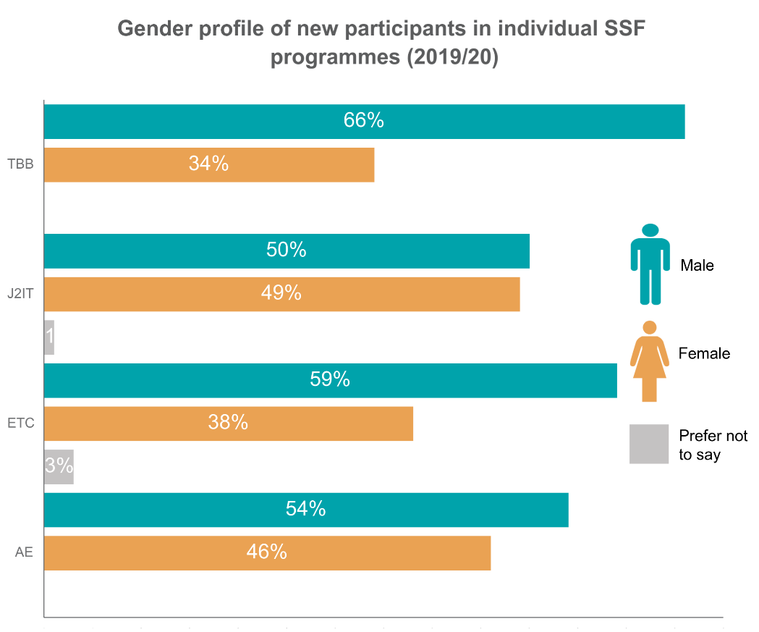
SIMD profile of participants

  - SSF recorded postcode data on all 5,320 participants during the delivery period. Where individual data could not be gathered, for example in relation to Jump2It participants, the school or club location postcode was used as a proxy. The postcode data allows an analysis of deprivation based on the Scottish Index of Multiple deprivation (SIMD). Most participants (90%) came from the 20% most deprived communities (SIMD vigintiles 1-4) in Scotland during year three. The data suggests SSF has continued to increase the proportion of participants coming from these areas during the phase.

  - The chart below shows the profile of participants based on the areas they came from (or attended activities in) during year three.

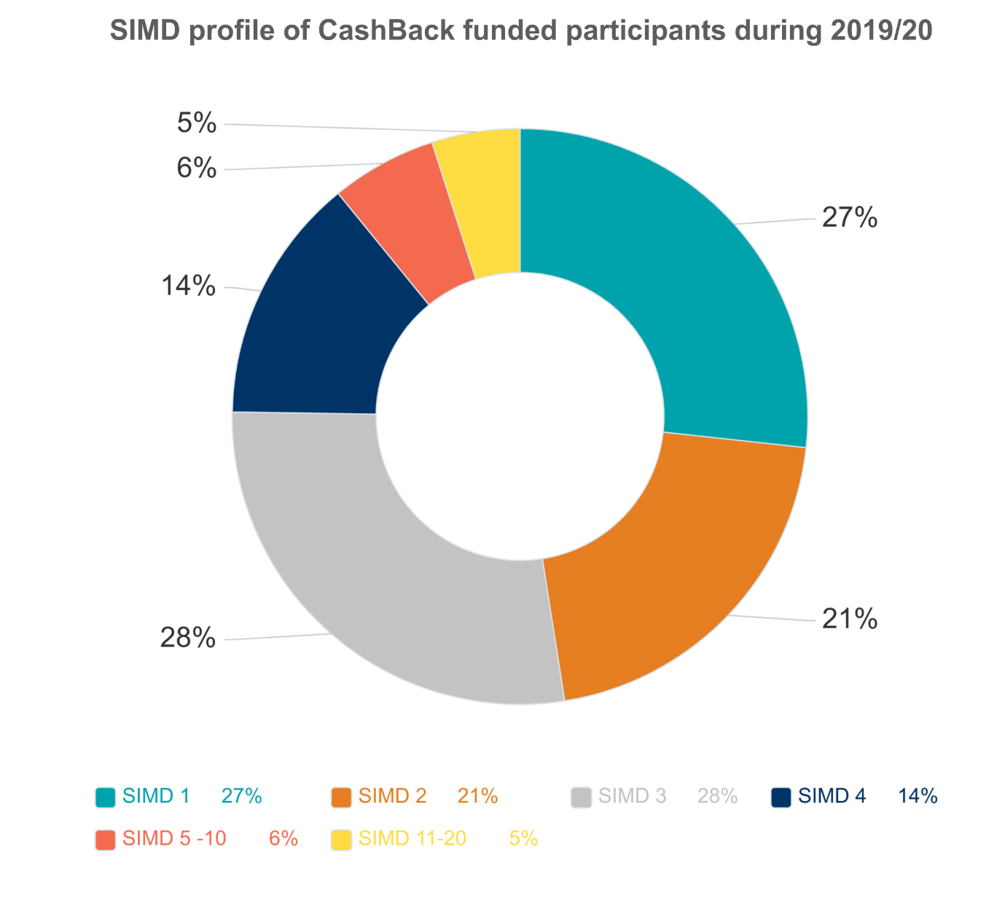

Disability profile of participants

  - The available data on disability suggests that 9% of participants identified as having a disability, impairment or mental health condition, during year three.

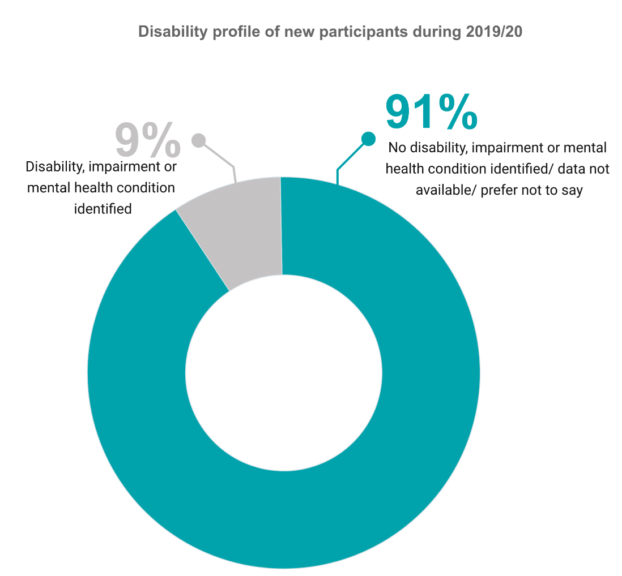

Ethnic profile of participants

  - Data was gathered on the ethnicity of 4,135 new participants. As shown on the chart below, 19% identified as being part of a minority ethnic group. This suggests the programmes are reaching relatively high proportions of people from ethnic minorities, based on the most recent available data which suggests approximately 4% of the Scottish population is from a minority ethnic group.

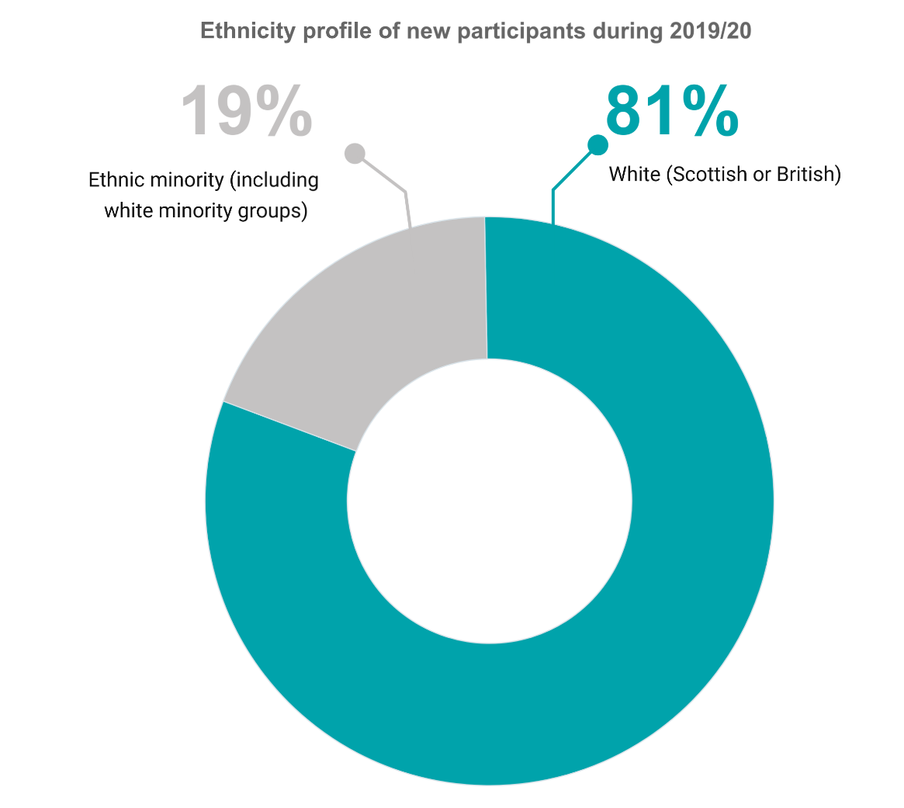

  - Similarly to last year, Active East had the lowest proportion of minority ethnic people at 8%.

Geographic reach

  - During 2019-20, SSF reports delivering sessions in the following twenty local authority areas of Scotland: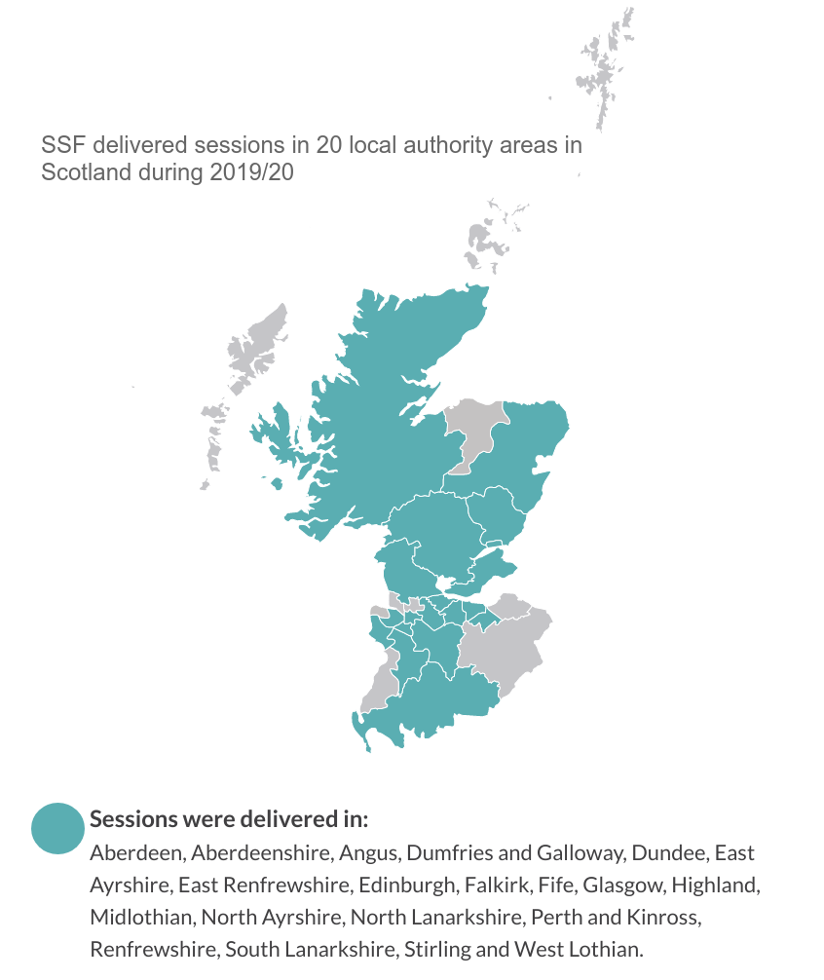

3. Outcomes

Introduction

- This chapter explores the extent to which SSF has delivered its identified outcome focused targets. Because this is the final year of delivery, we have mainly focused on the total impact over the three years of the phase.

- SSF worked with Inspiring Scotland at the beginning of Phase 4 to agree annual targets for the three years (usually based on a third of the three year total target numbers). These were reviewed and adjusted annually. Here we compare indicators with the original targets set out in the Grant Offer Letter issued to SSF by the Scottish Government.

- This chapter uses data from surveys with participants and wider stakeholders (as percentages of survey respondents), as well as other information gathered by SSF, to report on agreed indicators.

Outcome 1
Young people build their capacity and confidence

- There is very strong evidence that during Phase 4 SSF has had a very positive impact on the capacity and confidence of the young people it supports. Annual survey results across programmes, and for both participants and stakeholders, consistently highlighted the difference made in relation to participant capacity and confidence. This was reinforced by qualitative evidence from interviews with participants and stakeholders each year.

- To understand progress in relation to this outcome, SSF primarily used the following specific indicators:

- young people report their confidence increasing;
- young people feel able to do new things;
- other stakeholders report perceived increases in confidence and ability to do new things among young people; and
- young people go on to do new things after their initial involvement in CashBack.

- During Phase 4 SSF consistently exceeded its targets in relation to outcome one.

- When asked to rate their confidence, most participants (90%) surveyed over the three year period said the programme or programmes they were involved in had improved their confidence a little or a lot. This far exceeded its aim to improve the confidence of 60% of young people.
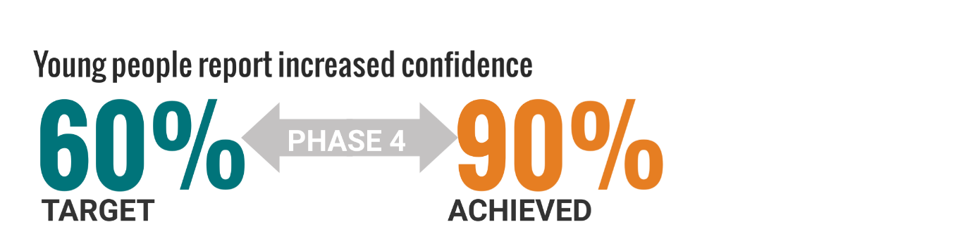

- Each year young people were also asked if their capacity to do new things had improved as a result of the programme(s) they participated in. Across the phase SSF consistently exceeded its targets in relation to this indicator, with most participants surveyed (88%) feeling they were more able to do new things as a result of their involvement with SSF.

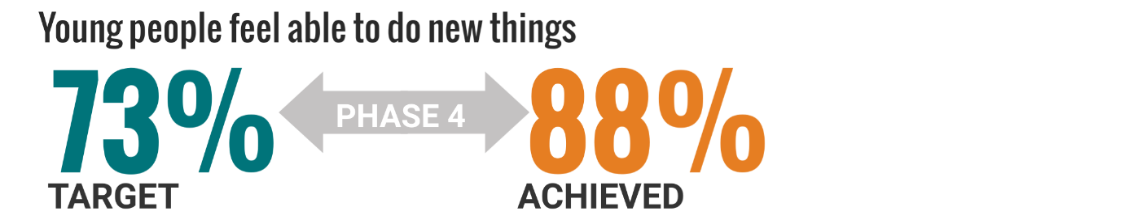

- Stakeholders agreed. During the phase, 92% of stakeholder responses said that young people’s confidence had increased, and 93% felt their ability to do new things had improved.

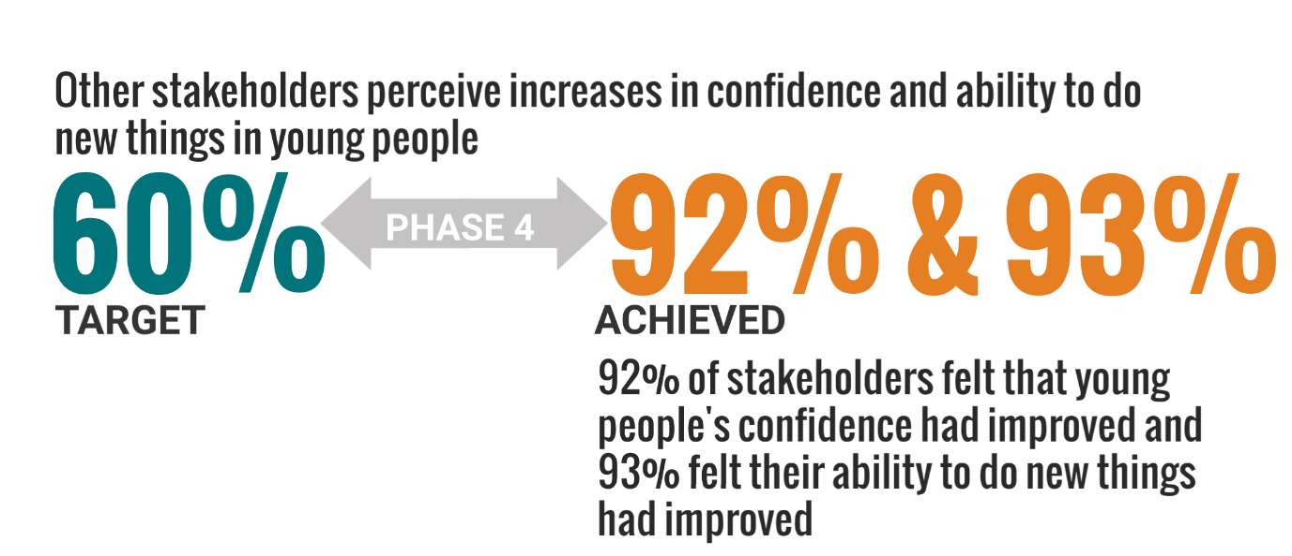

- During the three years of delivery, 79% of young people surveyed identified at least one new thing they had become involved with as a result of participating in SSF. The types of activities young people identified varied but included training and learning, school activities, and volunteering.

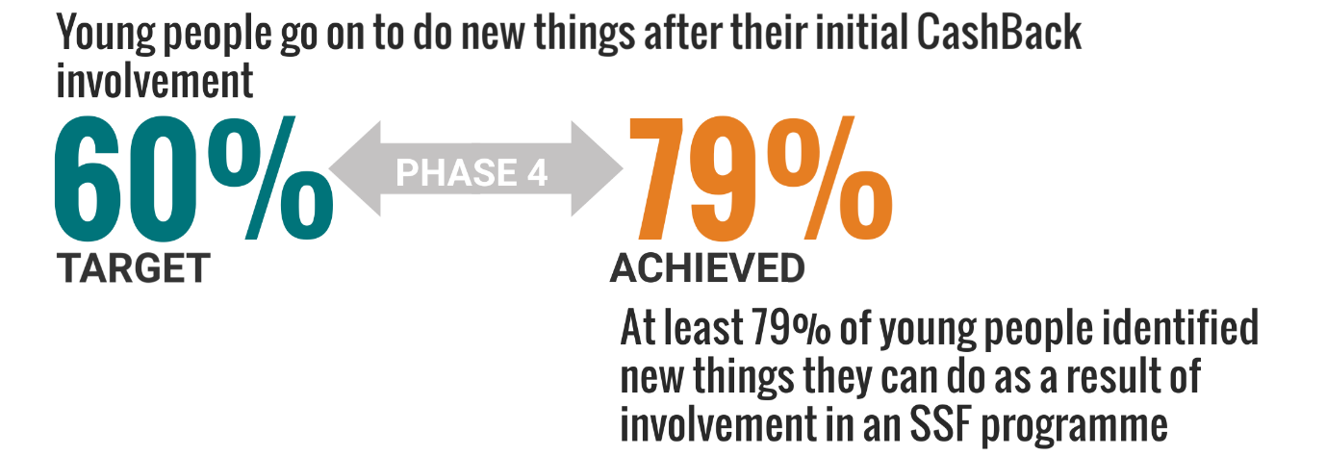

Outcome 2
Young people develop their physical and personal skills

- The evidence collected throughout Phase 4 suggests SSF has had a very significant impact on the physical and personal skills of young people. Survey data gathered over three years, and qualitative evidence from young people and stakeholders, both support this.

- SSF used the following indicators to understand progress in relation to outcome 2:
- young people gain accreditation for learning and skills development;
- young people report their skills are increasing; and
- other stakeholders report skills are increasing.

- Progress in relation to accreditation was slow in the first year of delivery, as programmes were being designed and set up, and young people had often not had the chance to complete programmes of learning. SSF focused strongly on this area during its second year of delivery. By the end of the phase they had far exceeded their goal, delivering accreditation for 2,565 young people.

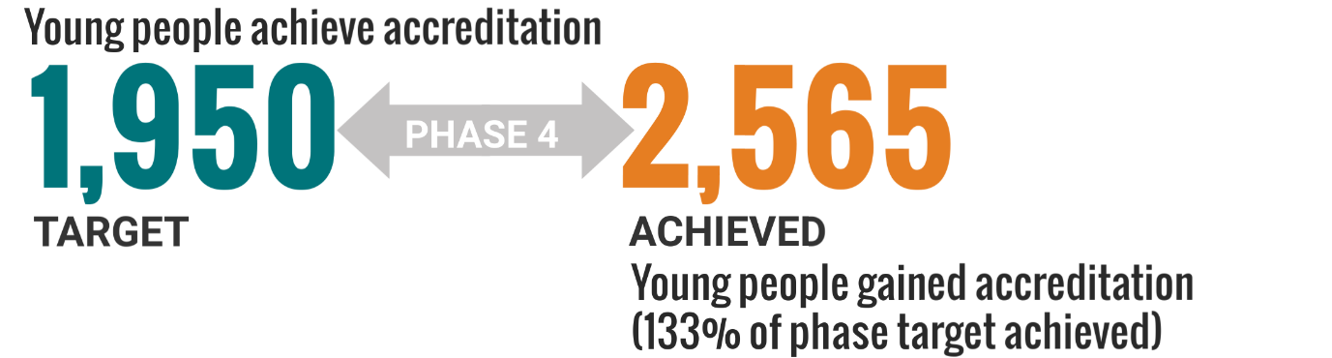

- Many young people achieved more than one accreditation, so the number of accreditations is much higher than this.

- Staff felt that their structured approach, the introduction of Hi-5 awards at Rocks Community Clubs, and the SCQF accreditation of six ETC modules, have had a significant impact on the high number of accreditations achieved. Most of the accreditations were at levels 4 and 5 on the Scottish Credit and Qualifications Framework (SCQF).

- The annual participant surveys asked young people to select specific skills they felt that SSF programmes had helped them improve. These included team work, communication skills, sports skills, leadership skills, concentration and commitment, and respect for others. During Phase 4 the vast majority of young people surveyed identified at least one new skill they had developed as a result of being involved with SSF. Again, this suggests SSF was achieving a much higher level of impact than it originally anticipated.
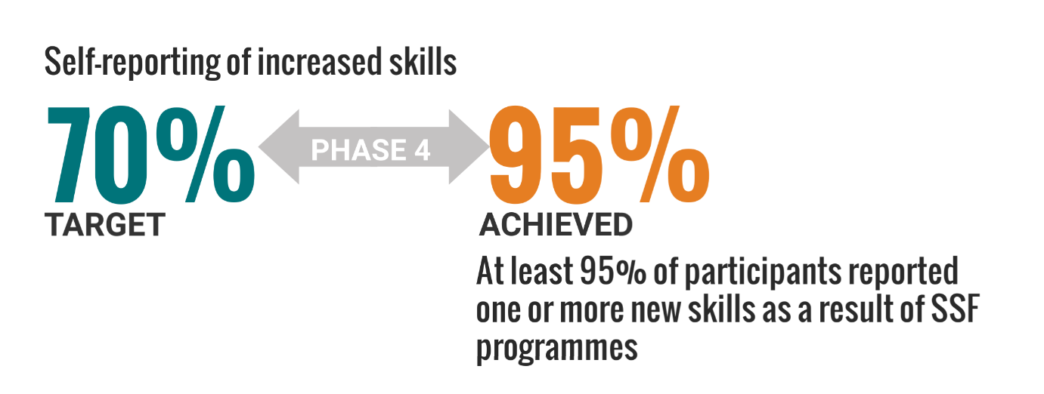

- In their survey responses, other stakeholders further supported the experiences of young people in relation to new skills. During the phase, almost all stakeholder responses identified at least one skill area young people had improved in.
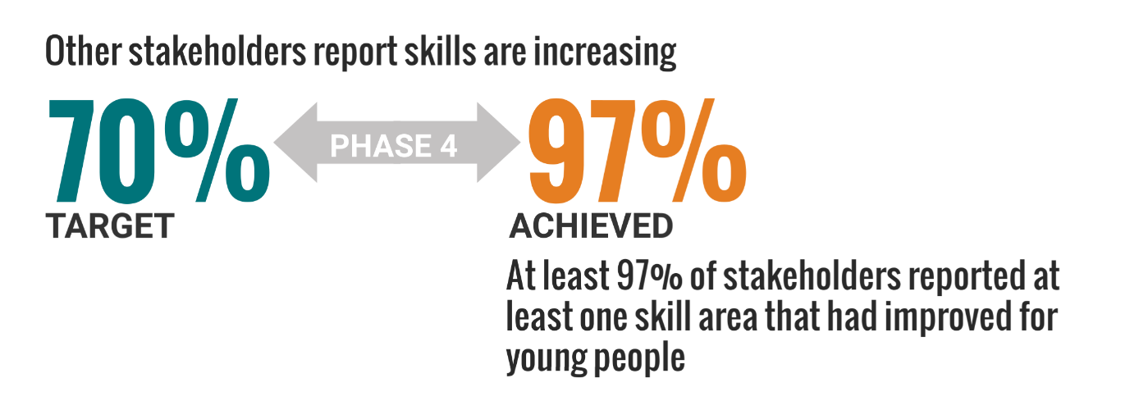

- Interviews with participants and stakeholders across the three years of delivery further emphasised the skills development impact of SSF’s CashBack programmes. This was a real and tangible difference young people pointed towards. They spoke of how transferable the skills often were, and how they provided the basis of job, further and higher education applications.

Outcome 3
Young people’s behaviours and aspirations change positively

- A range of evidence gathered across the phase points towards a positive change in behaviours and aspirations for a large number of young people participating in SSF’s CashBack funded programmes.

- SSF tracked progress for this outcome with the following specific indicators, based on evidence gathered from its annual surveys:

- young people report increased aspirations;
- other stakeholders report perceived increased aspirations in young people;
- young people report positive changes in behaviour; and
- other stakeholders report perceived positive changes in behaviour.

- When asked about how SSF programmes had changed their aspirations, survey data over the three year delivery period suggests that SSF has had a much more significant impact than it expected, with 85% of participants identifying increased aspirations as a result of being involved with SSF.
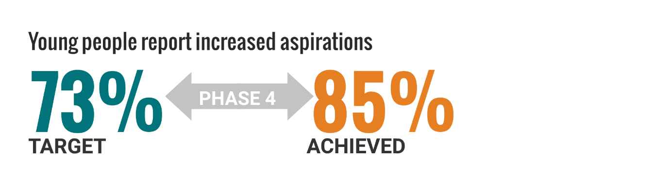

- Stakeholders surveyed were similarly positive, with 91% of them saying SSF programmes had positively impacted on how people felt about themselves, their lives or their futures.

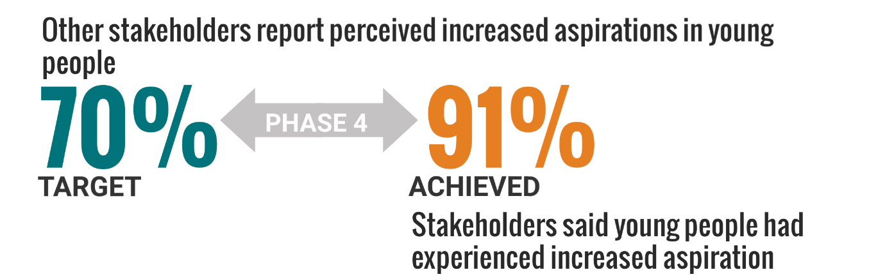

- The annual surveys with participants and stakeholders also asked whether a range of behaviours had changed for the better. These included: getting on better with other people; making healthier choices; taking on more responsibility or helping out more; being more active in school activities; and being involved in supporting other young people or setting up SSF sessions.

- Survey data suggests that most young people’s behaviours had changed positively, with SSF exceeding its targets in relation to this indicator for both young people (84%) and stakeholders (87%).

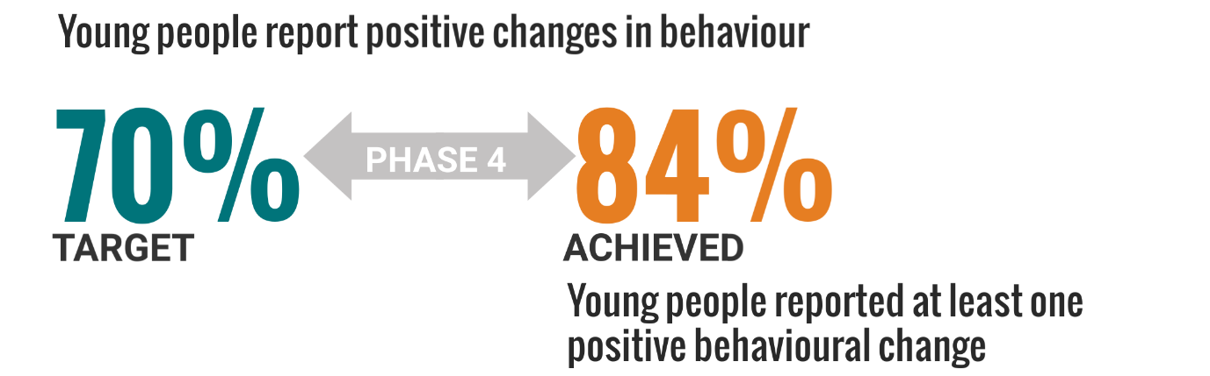

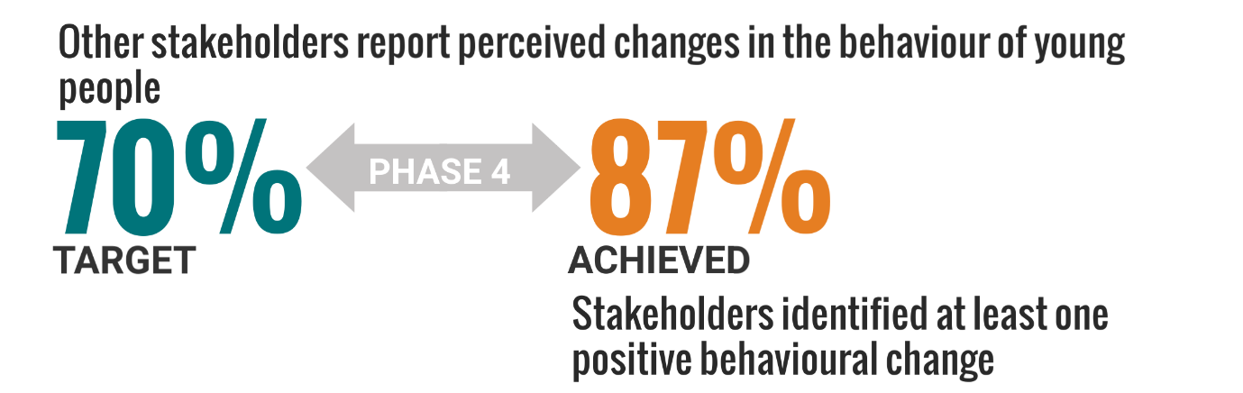

Outcome 4
Young people’s wellbeing improves

- SSF set out to measure its impact in relation to participant wellbeing. SSF used the following indicators to understand progress in relation to this outcome:

- young people report increases in feelings against SHANARRI indicators; and
- other stakeholders report perceived increase in SHANARRI indicators among young people.

- Surveys with participants and stakeholders listed SHANARRI indicators, and asked about SSF’s activities and impact in relation to these.

- Survey responses show that the vast majority of surveyed participants (92%) and stakeholders (95%) over the three year period felt that SSF activities had led to improvements in at least one SHANARRI indicator. This represents a significantly higher proportion than SSF aimed to achieve.

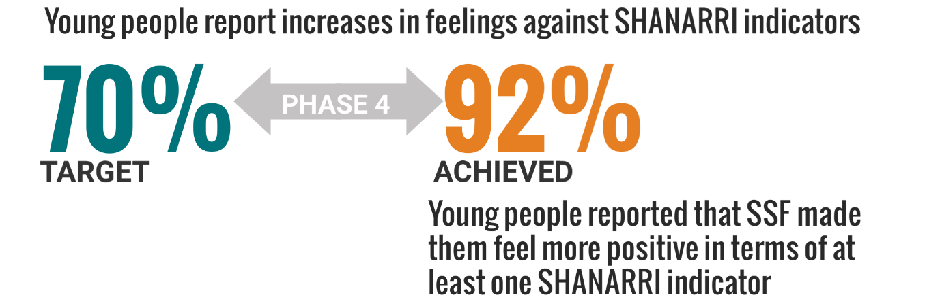

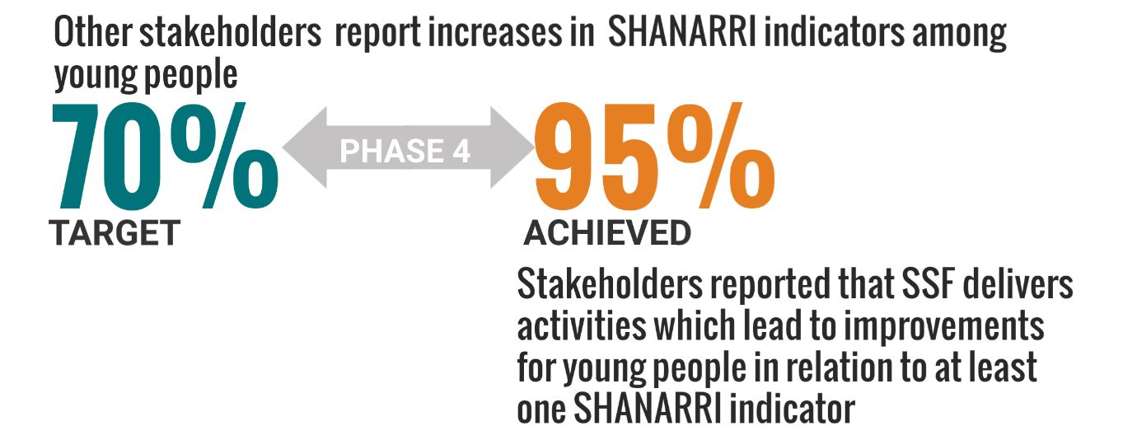

Outcome 6
Young people participate in activity which improves their learning, employability and employment options

- SSF used the following indicators to understand progress in relation to this outcome:

- as part of the programme, the number of young participants taking part in training; learning; employment; and volunteering (SSF to record and report quarterly); and
- progression outcomes after completion of the programme, the number of participants: remaining at or returning to school; taking a course of further or higher education; undertaking a training programme funded by Skills Development Scotland; engagement in an activity agreement; participating in learning or training offered by identified providers; volunteering; work experience; where it is part of a recognised course or programme; Community Jobs Scotland; being employed or a Modern Apprenticeship (SSF to record and report quarterly.)

- The table below provides an analysis of available data for this outcome. It shows that SSF has exceeded its target numbers for the whole phase.

Phase 4 targets | Number achieved in Phase | Performance
2790 YP take part in training | 3,007 | +217 YP (108% of target no.)
2670 YP taking part in learning | 3,187 | +517 YP (119% of target no.)
180 taking part in employment | 186 | +6 YP (103% of target no.)
870 taking part in volunteering | 1,050 | +180 YP (121% of target no.)

- Finally in relation to this outcome, SSF reports 477 young people have moved onto a positive destination following engagement in Phase 4. This exceeds its progression target by 27 young people.

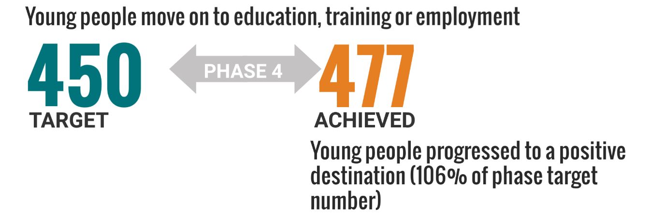

Outcome 7
Young people participate in positive activity

- This outcome is measured through:

- the number of young people participating in SSF activities; and
- the number of young people who are new to this type of activity.

- SSF made great strides with its participation levels in the first year of delivery, delivering more than half of its phase target in its first year. By the end of the phase it has engaged with 21,140 young people, exceeding its target reach by 3,140. Of these, SSF estimates 14,677 were new to this type of activity.

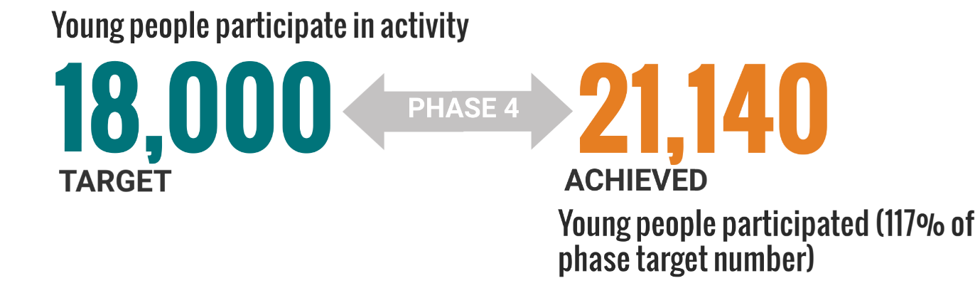

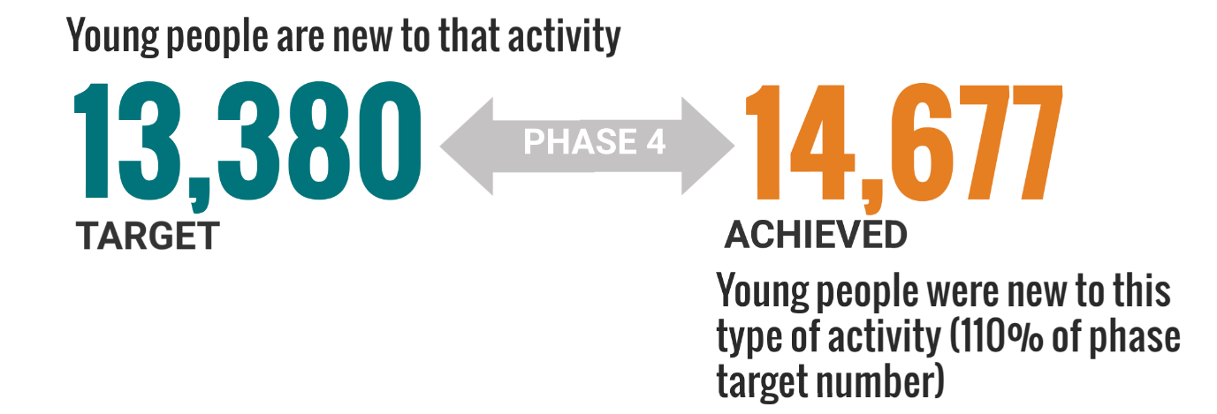

Outcome 9
Young people contribute positively to their communities

- SSF used the following indicators to understand progress in relation to this outcome:

- the number of participants going on to volunteer or take a leadership role in community organisations (SSF records and reports on this directly on a quarterly basis);
- the number of hours of volunteering contributed by participants (quarterly reporting);
- the number of community focused awards gained by participants (quarterly reporting);
- young people feel their contribution and links with communities are improving;
- other stakeholders perceive that young people’s contribution and links are improving; and
- young people are undertaking coaching, mentoring or supporting roles (quarterly reporting).

- The table below provides an overview of three year data on volunteering, leadership, and other community based roles. The data shows that SSF has exceeded its target numbers for the Phase across all indicators. The number of volunteering hours is striking. This is equivalent to the time input of around 36 full-time staff members.

Phase 4 targets | Number achieved | Performance
840 young people undertake volunteering or leadership roles | 1034 | +194 YP (123% of target no.)
48,000 hours of volunteering | 50,688 | +2,688 hours (106% of target no.)
435 undertake community awards | 470 | +35 YP (108% of target no.)
690 young people undertake coaching, mentoring or supporting roles | 767 | +77 YP (111% of target no.)

- The annual surveys asked young people and stakeholders if they felt SSF activities had led to them or the young people they work with making a difference in their local community. Most participants (70%) and stakeholders (65%) felt programmes had, at least a little.

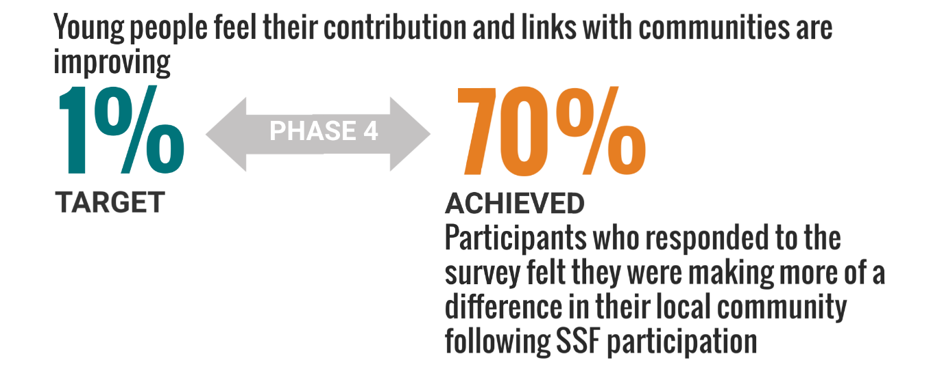
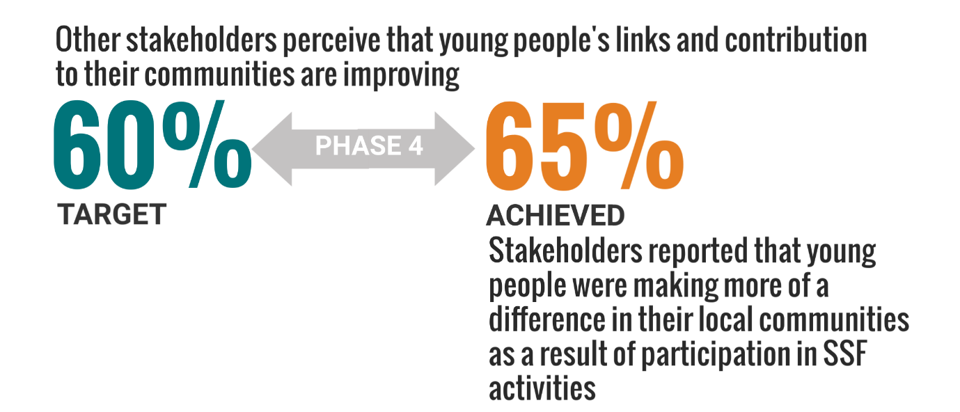
- Qualitative data from interviews and surveys has regularly highlighted the specific contributions individual young people are making as volunteers in their local communities. Often young people identified a strong desire to make a difference in the future, with some speaking of pursuing careers that will allow them to do this, as a direct result of working with SSF.
4. Stakeholder views on delivery

Introduction

- This chapter provides an analysis of qualitative evidence from the year three stakeholder survey.

What works well

- The stakeholder survey asked “What do you think SSF do well? Eighteen respondents offered comments, which are analysed here.

Inclusive approach
- Stakeholders emphasised that SSF are often focused on bringing about change for young people facing significant challenges. They spoke of their participative approach, and engagement of young people at all levels of decision making.

“SSF work with the toughest cohort of young people. The engagement you have had from our young people has been astounding.”
Stakeholder survey, year 3

“Involve young people in decision making.”
Stakeholder survey, year 3

“I like that everybody is included in the activities.”
Stakeholder survey, year 3

Approach
- Stakeholders talked about different aspects of SSF’s approach to delivery in a positive way. They emphasised the value of SSF staff’s commitment, care, encouraging approach and the motivational nature of SSF activities. They also highlighted how enjoyable SSF activities are for young people. As in previous years, stakeholders drew attention to the important role of staff attitudes in delivering positive outcomes.

“The care. They go over and above to make sure that young people feel included and listened to. More than any other partner I work with.”
Stakeholder survey, year 3

“Provides encouragement and support to help kids achieve goals.”
Stakeholder survey, year 3

“Everything. They commit themselves to helping others and promote positive relationships between adults and kids, they provide a safe place, support, friendships, and mental health awareness as well.”
Stakeholder survey, year 3

Staff are amazing, well organised and extremely supportive.”
Stakeholder survey, year 3

They are inclusive and enthusiastic in their outlook and a real ‘can do’ attitude oozes from the coaches / players and cascades through the young people!”
Stakeholder survey, year 3

Working with other stakeholders
- In previous years, stakeholders have spoken of their positive relationship with SSF, and its credibility as a partner. This year, a few stakeholders further emphasised the benefits of working with SSF.

“Engages well with existing youth providers and provides excellent service for clients.”
Stakeholder survey, year 3

“. . . giving other organisations with the community and further afield to work with them too.”
Stakeholder survey, year 3

“Supportive links established showing possible pathways to pupils and raising aspirations.”
Stakeholder survey, year 3

What could be better

- The survey also asked stakeholders “What is the main thing you would like SSF to change or improve?”. Fourteen stakeholders answered this question in year three. Most of them (10) had no suggestions for improvements. Others suggested ‘more of you’, variation on the sports being offered, more and timely publicity on opportunities available to schools, and to continue working with schools.
5. Participant views on delivery

Introduction

- This chapter provides an overview analysis of views expressed by participants in year 3 surveys. The survey questions varied across programmes, so this chapter mainly focuses on the common themes emerging.

What works well

- Participants were asked a variety of questions about what they enjoyed, what they remembered most and what worked well about the programmes they had participated in. They emphasised similar themes to those identified by stakeholders and in previous years.

Impact of staff and volunteers
- A consistent theme was SSF staff and volunteers - their approach and impact. Clearly this is a critical success factor in delivery, and has been reinforced during Phase 4 fieldwork. Again, in this year’s participant survey it was seen as a key strength.

Specific activities and training
- Participants identified a wide range of different activities that had been important to them, or had worked well. This varied depending on their involvement and individual experiences. Residentials and awards were highlights, but people also spoke of simply enjoying basketball or engaging in a specific ETC training course. They often identified specific areas of learning or training they had learned from or found beneficial.

Areas for development

- Generally, young people were positive about their involvement. Many respondents didn’t have significant suggestions, or took the opportunity to say that nothing could be better. There were also a range of specific ideas. Across programmes, participants sometimes asked for more or more diverse delivery – more activities, or more days a week, on more topics or including more sports. A lot was dependent on the session or activity they attended – so comments related to specific training courses, or the venue for their Twilight session, equipment and so on.

6. Conclusions

Reach and engagement

- During the three-year Phase 4 Cashback delivery period SSF engaged with 21,140 young people across its different programmes. Of these, 14,677 were identified as ‘new’ to this type of activity.

- Monitoring data on participants in the final year suggests that SSF successfully engaged with a mix of young people in terms of gender, although there was a higher proportion of young men than young women, particularly on some programmes. While there were small numbers of young people from ethnic minority groups and with disabilities, this reflects the relatively low levels of these characteristics within the wider population.

- Socio-economic data suggests SSF has continued to strongly engage with young people living in, or going to school in, areas of very high levels of deprivation. In fact, nine out of ten SSF CashBack participants in 2019/20 live or go to school in the 20% most deprived communities in Scotland, according to the Scottish Index of Multiple Deprivation.

- SSF has strengthened its reach across Scotland as well, operating in 20 of Scotland’s 32 local authorities during 2019/20.

Impact

- SSF identified the main CashBack outcomes it aimed to deliver, and related targets, before beginning delivery. Data shows SSF has consistently exceeded most of its outcome targets annually, and by the end of the Phase has exceeded all of them.

- Progress in relation to some outcomes is tracked using the views of young people and stakeholders participating in annual surveys. While it is important to note that the survey sample may not be representative, this data does act as useful proxies for performance. Survey data collated over the three-year delivery period shows that the majority of young people and stakeholders feel that SSF involvement has led to improvements in young people’s confidence, ability to do new things, skills, aspirations, behaviour and wellbeing.

- SSF had specific targets relating to learning, employability and employment for Phase 4. It exceeded all its targets in this area. Data gathered by SSF shows it has directly supported 2,565 young people to achieve accreditation of some kind, with many achieving more than one qualification, over the three-year period. While working with SSF, young people took part in training (3,007 young people), learning (3,187), employment (186) and volunteering (1,050). A total of 477 young people moved on to a positive destination following their engagement with SSF. Qualitative data, from surveys, case studies and focus groups suggests that SSF’s strong relationships between staff and young people have supported young people to aspire for more, and engage in education and training.

- Data recorded by SSF suggests that the programme has had a very significant impact on volunteering and leadership development. Over the three-year delivery period 1,034 young people undertook volunteering or leadership roles and 767 undertook coaching, mentoring or supporting roles. Young people contributed a huge number of volunteering hours (50,688) which is equivalent to around 36 full time staff members, in terms of time input.

Future delivery

- As an organisation, SSF has undertaken an in-depth review of its role and focus towards the end of this phase. This has shaped its successful Phase 5 CashBack programme. During Phase 5, SSF plans to focus on activities which engage with smaller numbers of young people intensively, in order to maximise its impact as an organisation.

Appendix 1: Case Studies

CASE STUDY: Katie

About Katie
Katie is 16 years old, and lives in Glasgow.

Involvement in SSF
Katie first heard about SSF through a friend who was already involved. She liked the idea of being involved in volunteering, but hadn’t expected to enjoy it so much. Katie started actively working with SSF in July 2017.

“I didn't think it would be so fun … I thought it would be a lot more serious.”

Katie has been an Active Champ within the Active East project, and more recently has become an active member of SSF’s new Youth Advisory Panel. Within SSF she has been involved with organising and running lots of different events and activities with young people. SSF encouraged Katie to take part in a range of volunteering placements with local organisations. She has volunteered as a Health Champ with YOMO and with PEEK. She has also volunteered to support disabled children attending swimming sessions with Glasgow Life.

Youth Advisory Panel
SSF recently established a new Youth Advisory Panel to steer the work of the organisation. There are currently seven members. Young people involved in the panel play an important role in decision making. They report directly to the Board of Trustees, and are involved in planning activities for the organisation.

The group first met in August 2019. The group has played a valuable role in the development and launch of SSF’s new Strategic Plan. At the start of lockdown, the panel was taking an active role in planning how best to engage young people over the next few months, with a focus on staying active and well. They planned to send out letters to participants with ideas for activities at home, postcards to young people, and pairing young people up with others for peer support.

Outcomes
When Katie was asked about the positive impact SSF has had on her, she identified a number of different areas.

Increased confidence
Katie feels being involved with SSF has really increased her confidence. This has been a significant change for her. At school Katie previously found speaking in front of her class or just a small group of pupils impossible. But now, she is much more confident, and recently spoke at the SSF Awards night.

“Definitely my confidence. . . before I couldn't speak in front of people at all . ..”

“She seems a lot more sure of herself.”
(SSF staff member)

Working with a range of people
Katie pointed out the broader impacts of this improved confidence. It has helped her build stronger relationships, and talk to new people. She now runs sessions with young people, and delivers training to other volunteers.

“. . . now when I am talking to people I don't know, I'm able to start up a conversation.”

Improved knowledge and skills
Katie feels her knowledge and skills of health and wellbeing have really improved since becoming involved with SSF, and volunteering in other organisations. She feels she has learned a lot about mental health in particular.

She has developed planning skills she didn’t expect to. For example, Katie was involved with a group within SSF who applied for funding, organised and ran an event for more than 100 young people.

Katie has been developing her leadership skills, and has taken on further roles which demonstrate this, including as a Sports Leader in her school.

Benefiting her community
Katie is now actively involved in a range of volunteering roles which support other young people, and make a difference.

“She is taking on new opportunities. She’s fearless now. It is great to see how she wants to get involved and benefit her local community.”
(SSF staff member)

Work and aspirations
Her increased confidence and skills have helped Katie secure a job in a sports shop. Working with disabled children during swimming lessons has led to an interest in a career as a special needs teacher. She feels confident about her skills and abilities.

“I am much more confident going for a job having all this on my CV.”

SSF is working with Katie to identify a disability focused group to volunteer with. SSF staff have been impressed with the amount of time Katie is investing in volunteering, and her commitment.

“How much Katie is doing is completely amazing. At one point she was working with four organisations each week, and volunteering as an Active Champ for SSF on the weekends, and doing lots of training.”
(SSF staff member)

SSF’s role

Katie feels that SSF staff have played a crucial role in helping her achieve so much. She spoke about how supportive they have been, but also how they challenged her.

She feels that SSF’s focus on young people and families who are struggling is really positive.

CASE STUDY: Kodie

About Kodie
Kodie is 13 and lives in Glasgow.
.
Involvement in SSF
Kodie first became involved with SSF when she was seven. She met SSF staff at her local park. They spoke with her about playing basketball, and she became involved with Twilight. From early on, Kodie really wanted to become involved in Active East but the normal starting age was 12. She started attending when she was 10, and was the youngest participant on the programme.

Kodie volunteers at Active East sessions – she works directly with small groups of young people during breakout activities. Kodie is also actively involved in the Twilight sessions at Wellhouse.

Outcomes
When Kodie was asked about the positive impact SSF involvement has had on her she talked about a range of different outcomes.

A better attitude
Kodie feels working with SSF really helped her improve her attitude and approach. SSF staff are able to see a real change in her and now describe Kodie as one of the young people they will go to for help.

“[SSF activities have helped me] mature. I was always carrying on, and getting in trouble. . . now I am helping young people in trouble.”

“I used to go to sessions and Kodie was the one climbing the walls. . . now she is so helpful. . . she has matured so much . . . you can forget she’s only 13.”
(SSF staff member)

Supporting others
Kodie spoke about how working with SSF has helped her understand how to get support, and how to support others. She describes how she is directly helping young people with their problems.

“I never thought I would be doing that.”

SSF staff point to the role that Kodie plays in sessions, leading and supporting others.

“She can really handle responsibility.”
(SSF staff member)

Building new relationships
SSF staff feel Kodie has been able to build strong working and social relationships with lots of new people since joining SSF. She has a strong support network, and actively supports others.

“She has widened her circle. . . she is working well with SSF staff . . . and she has really good friends at Wellhouse, and in Active East.”
(SSF staff member)

Aspirations
In the next few years Kodie is keen to volunteer with PEEK, another local organisation. Kodie is keen to follow a career where she helps others and is currently considering becoming a Fire Fighter.

SSF’s role
Kodie is very positive about the role SSF has played in her life. She feels they have made a life changing difference. She didn’t have any suggested improvements to the way the organisation supports young people like her.

“I think everything about [SSF] is perfect. The staff are amazing . . . and so good to talk to. . . and it’s fun.”

The Active Champions element of this programme is funded by CashBack.
For Shell Twilight Basketball, ETC and Active East, this data was gathered directly from participants as part of the registration process. Because of the nature of Jump2It delivery, and the age of pupils, data was collected on some equalities aspects during delivery, with further data collected from teachers. In relation to SIMD, the postcode of the school was used for all pupils participating, as a proxy for individual postcodes.
Participants were asked to identify as one of the following categories during registration: White (Scottish); White (British); White (gypsy/traveller); White (Polish); White (Other); Ethnic Minority; Asian Indian; Asian Bangladeshi; Asian Chinese; Asian Pakistani; Black Caribbean; Black African; Chinese; Filipino; Arab; Kurdish; Other mixed background; Prefer not to say. For analysis purposes we have grouped all categories other than “White (British)” and “White (Scottish)” as ethnic minority. Data on “Prefer not to say” has been excluded from this analysis.
http://www.gov.scot/Topics/People/Equality/Equalities/DataGrid/Ethnicity/EthPopMig
http://www.gov.scot/Topics/People/Young-People/gettingitright/wellbeing
Assuming 7 hours per day for a year, less weekends and 40 additional days off.
This question wasn’t asked of Jump2it participants

