Prince’s Trust Scotland Development Awards Programme

Evaluation of Phase 4 of CashBack supported activity

Year Two

June 2019

Research Scotland
Suite 42, Spiersbridge House
Spiersbridge Business Park
Glasgow, G46 8NG
0141 428 3972
nadia.hyder@researchscotland.org

Contents

- Introduction 1

- Programme development 6

- Participation in 2018/19 11

- Outcomes 16

- Conclusions and Recommendations 30

Appendix 1 – Table of targets and indicative performance

Introduction

About this report

  - The Prince’s Trust Scotland commissioned Research Scotland to evaluate the impact of Phase 4 of its CashBack funded Development Awards Programme. This report covers programme delivery during 2018/19, the second year of Phase 4 of CashBack delivery.

  - This report:

- explores the reach of Development Award activity;
- considers developments and progress; and
- explores the impact of the Development Awards programme.

The Prince’s Trust Scotland

  - The Prince’s Trust Scotland is a UK wide charity which works with disadvantaged young people aged 11 to 30, to build their confidence, increase their motivation and improve their employability. It achieves these goals by providing practical and financial support to help young people develop key workplace skills such as confidence and motivation. It targets its support at 13 to 30 year olds who have struggled at school, have been in care, are long-term unemployed, have criminal convictions or are at risk of offending.

  - The Prince’s Trust Scotland delivers a range of education, training and development, as well as employment and enterprise programmes. Beginning as a small grants programme, the Development Awards programme was one of the founding elements of the Prince’s Trust Scotland. The programme was introduced in its current form in 1999, initially as a pilot which was reviewed and expanded across the UK.

Development Awards

  - Development Awards offer cash awards up to £500, and support for young people aged 13-24 who are struggling to access education, work or training due to a lack of funds. The programme often works with young people that are unemployed, leaving care, in trouble with the police or with no qualifications.

  - The Development Awards are targeted at:

“...young people who are ready for work or education but cannot access education, employment or training because of a financial barrier that prevents them from having the resources or skills they need.”

  - The programme specifically aims to:

“Remove financial barriers that prevent young people entering education, employment or training and help them into these outcomes.”

  - The Prince’s Trust Scotland has a clear target group for the Development Awards programme. To be eligible for an award a young person must be:

- aged 13 to 24;
- living in an area of deprivation;
- unemployed, not in education or training;
- excluded or at risk of exclusion from school; or
- at risk of being involved in antisocial behaviour, offending or re-offending.

  - Across three years of delivery in Phase 4, the programme aims to engage 3,431 young people across all 32 local authorities in Scotland. This will be delivered as:
  - Year 1 – 950 Awards;
  - Year 2 – 1,140 Awards; and
  - Year 3 – 1,341 Awards.

CashBack for Communities

  - The Prince’s Trust Scotland has been allocated £1,070,000 of Phase 4 CashBack funding to deliver the programme during 2017- 2020.

  - Funding was allocated over three years as follows:
  - Year 1 2017/18 - £297,000
  - Year 2 2018/19 - £353,000
  - Year 3 2019/20 - £420,000.

  - Over the three year funding period, 88 per cent of CashBack funding is allocated to Awards for young people. The remaining 12 per cent is allocated towards management, marketing and evaluation of the programme.

  - In year one, the programme had an underspend of £30,000. This was transferred to year two, giving the programme £383,000 to deliver Awards in year two.

  - In year two, the programme has spent a total of £384,309, with £341,309 spent on Development Awards for young people. Development Awards can be up to £500. The budget allocation over three years allowed for an average Award value of £275. The average Award value has risen from £240 in year one to £293 in year two, which may account for the increased expenditure.

  - The Development Award programme and its eligibility criteria has remained largely the same in Phase 4 as it was in previous years. The maximum Award amount remains at £500. As there was an additional £30,000 carried over from the previous year, the programme has been able offer more Awards at a higher amount.

Evaluation method

  - In April 2018 we met with the Development Award Programme Manager to agree an evaluation plan. We developed an evaluation logic model, outlining outcomes, indicators, targets and responsibilities for data collection. This helped to ensure that evidence was gathered in relation to all outcomes and targets. We also developed discussion guides and surveys to use with young people and partners.

  - During the 2018/19, our evaluation work involved:

- analysis of 19 completed surveys from partners;
- one focus group with five Development Award recipients;
- 15 telephone interviews with Development Award recipients;
- two individual case studies;
- a discussion with programme staff; and
- analysis of programme data collected by Prince’s Trust Scotland.

  - Most partners completing a survey were mentors/assessors who support young people to apply for a Development Award. A few were from organisations which support young people to use their Development Awards to progress into positive destinations and one was from an organisation that refers young people to Development Awards.

  - We conducted telephone interviews with young people at least three months after they had received their Development Award. Reaching young people was challenging at times due the limited interaction that some young people had with the Prince’s Trust Scotland and because Prince’s Trust Scotland staff were also conducting telephone interviews with young people. In order to gather rich feedback from young people Prince’s Trust Scotland arranged a focus group with young people that had received an Award and were still in contact with the organisation. Where young people agreed to be involved in the evaluation but were unable to attend the focus group, we collected contact details and are continuing to conduct further telephone interviews through May 2019. These will be analysed and included in our final report in June 2019.

  - Prince’s Trust Scotland staff conducted a telephone survey with young people to obtain outcomes focused data. Staff contacted young people aged over 16, and who had not accessed their Award through a school partnership. In total there were 125 responses to the telephone survey.

  - Prince’s Trust Scotland provided information on demographics of Award recipients from the national ‘DASH’ monitoring system.

  - Data reported by Prince’s Trust Scotland in the reporting scorecard was based on the 125 survey responses and extrapolated to report against CashBack targets. Ideally, with a population of 1166, the sample size should be at least 268, to ensure an accurate representation and to allow for extrapolation. Throughout this report we have used a percentage, to indicate the extent to which the outcome has been achieved. The extrapolated figures are available in Appendix 1.

Agreed targets and intended outcomes

  - CashBack funding is granted on the understanding that the programme will work towards agreed outcomes and outputs.

  - The Prince’s Trust Scotland has agreed to deliver the following CashBack outcomes, and will measure progress towards these outcomes through set targets.

CashBack outcomes and targets for Phase 4
Outcome 1: Young people build their capacity and confidence
- 2,882 (84%) of participants will increase their confidence/capacity
- 2,744 (80%) of young people will report they are able to do new things
- 80% of other stakeholders report increases in confidence and ability to do new things
Outcome 2: Young people develop their physical and personal skills
- 1,372 (40%) of young people will gain accreditation for learning and skills development
- 3,053 (89%) of young people will demonstrate increased skills

Outcome 3: Young people’s behaviours and aspirations change positively
- 2,882 (84%) of young people report increased aspirations
- 2,401 (70%) of young people report positive changes in behaviour
- 70% of other stakeholders report perceived positive changes in behaviour

Outcome 4: Young people’s wellbeing improves
- 2,744 (80%) of young people will make positive comments about wellbeing against one of the relevant SHANARRI indicators
- 80% of partners will make positive comments about wellbeing against one of the relevant SHANARRI indicators
Outcome 6: Young people participate in activity which improves their learning, employability and employment options
- 2,744 (80%) of young people will achieve positive destinations
- 1,509 (44%) of young people will move into employment
- 892 (26%) of young people will progress to further education or training
- 343 (10%) of young people will be involved in volunteering
Outcome 7: Young people participate in positive activity
- 2,744 (80%) of young people will participate in positive activity
- 2,744 (80%) of young people are new to the activity

Programme development

Programme and organisational development

  - During year two the Prince’s Trust Scotland underwent a significant organisational restructure. The restructure has changed how Development Awards are managed and delivered. Where previously Development Awards were managed and delivered by one central team based in Glasgow, they will now be delivered across all of the Prince’s Trust Scotland delivery regions (or ‘Hubs’), and managed regionally. Staff hoped that this would help them to improve the geographic spread of Awards.

  - The national level programme manager meets with the hub managers monthly. There are also monthly meetings of the strategic group which manages all aspects of the Development Awards.

  - The national level programme manager meets monthly with the programme leads in each of our four geographical hubs: Clyde Valley; South West Scotland; Central and South East Scotland; and North East, Highlands and Islands. There is also a CashBack Development Awards Strategy Group which meets monthly with representatives from the following functions:

- Partnerships/Fundraising;
- Operations/Delivery;
- Operations Support;
- Contract Management; and
- Marketing & Communications.

  - Representatives on this Strategy Group operate at manager level as a minimum. The purpose of the group is to monitor progress of the funded delivery across Scotland, address any issues as they arise and share ideas on how to continually improve our offer.

  - The new staff demonstrated a lot of enthusiasm for the new delivery model and hoped to maximise the potential of Development Awards for young people. They felt that it would help them use the organisation’s resource efficiently and avoid duplication of support.

“The restructure is great because now staff have an overview of all programmes.”
Prince’s Trust Scotland staff

  - The restructure of the organisation posed some challenges in terms of staff turnover, vacancies and continuation of organisational memory. Despite these challenges staff have successfully continued delivery throughout the year.

  - Key areas that staff hoped to focus on were:

- increased direct contact between Award recipients and Prince’s Trust Scotland;
- increased awareness of wider Prince’s Trust Scotland programmes amongst Award recipients;
- increased oversight of batch applications – to ensure that Awards are individualised and utilised appropriately;
- improved gender balance;
- understanding the long term impact of celebration events; and
- wider geographical spread of Awards.

“We want to have meaningful connection with all the young people.”
Prince’s Trust Scotland staff

  - Prince’s Trust staff felt that a key area which has continued to develop is the partnership with schools in Ayrshire. This partnership has worked well for all partners – the schools, Developing the Young Workforce and Prince’s Trust Scotland. Where possible, the Development Award is integrated with other Prince’s Trust Scotland programmes such as the Achieve programme or the personal development and employability qualification to maximise outcomes for young people. This work has now been shared across the regions and it is hoped that the model may be adopted in other local authority areas.

  - Another important change has been the focus on ensuring that any group awards to cohorts of young people are young person led and routed in genuine partnership. Feedback had been received that a small number of young people were unaware that they had received a Development Award from The Prince’s Trust. While The Trust remains very happy to support appropriate ‘group’ awards for eligible young people, all partners will have to better evidence the need, reporting process and potential impacts before the award is approved. All young people will now be case managed by a Prince’s Trust Executive and will have a more joined up journey with The Trust.

Events

  - During year two, the Prince’s Trust Scotland hosted a CashBack celebration event in Glasgow. The event was attended by young people, partners and the Cabinet Secretary for Justice. The event provided a useful opportunity for Development Award staff to build relationships with partners, and also provided a networking opportunity for partners more generally. The event helped to showcase how the Development Awards support young people and highlighted the progress that young people had made, using Development Awards to start their own businesses. The event also showcased some of the work done in schools, with pupils from South Ayrshire and South Lanarkshire attending.

  - The Trust also delivered open days in Dundee, Edinburgh and Glasgow to promote Development Awards and to support young people to apply for them.

  - Staff felt that, in the short term, the events and marketing had helped to raise awareness of Development Awards. They were also keen to understand if there was any wider or longer term impact of the events.

Addressing equality and diversity

  - In terms of gender balance, the programme has worked closely with the communications and marketing teams to reiterate the message that Awards are suitable for young women. Prince’s Trust Scotland launched ads through social media to try and target young women. Staff have also worked to develop new partnerships with organisations working with women, or with targeted programmes for women, such as SportEd. During the delivery period the proportion of young women accessing awards increased from 33% in quarter one to 41% in quarter four.

  - Similarly the programme has worked developing partnerships with organisations that support disabled young people, in particular with the National Autistic Society, which is also a CashBack funded organisation.

  - In order to continue reaching young people most in need of a Development Award, programme staff have further developed relationships with prisons in Scotland and maintained the relationship with the community safety team in Glasgow.

  - Staff have also worked to develop new partnerships or re-engage partners from Impact Arts, Bridges, Access to Industry and LGBT Youth. It is hoped that partnership work with these agencies will help improve equality and diversity amongst Award recipients.

“There’s so much potential to recalibrate partnerships.”
Prince’s Trust Scotland staff

Monitoring and evaluation

  - In February 2018, the Prince’s Trust Scotland moved to a new monitoring system. Due to ongoing challenges migrating information across systems, not all data relating to Development Awards has been available throughout the monitoring period. Development Award staff have prioritised monitoring. By working regionally and maintaining manual records staff have collected all relevant data. Staff noted that the process of updating and accessing manual records regularly had given them better insight into the trends in data, and allowed them to see where they needed to focus their efforts.

  - Staff are also considering the most appropriate way to robustly evaluate Development Awards delivered in schools, as young people under 16 are not surveyed through the telephone survey. Looking closely at individual schools projects this year has helped them understand that most young people participated in different types of volunteering within the community.

What has worked well

  - The new approach to delivering and managing Development Awards was felt to be working well, and a key success of the programme this year. Staff felt that Development Awards had a lot of potential and that the new regional model would help more young people to not only access an Awards, but also to access a wraparound service from the Prince’s Trust Scotland.

  - During year two, the Development Award have become more integrated with wider Prince’s Trust Scotland programmes and this has resulted in increased awareness of the range of Prince’s Trust Scotland support amongst Award recipients.

“There are amazing opportunities now because we’re not working in silos anymore.” Prince’s Trust Scotland staff

  - Staff reported that anecdotally, they have received good feedback from young people. They felt that the Awards were useful for young people and were helping them to move forward in their careers.

  - Most young people we spoke with said that they found the application process straightforward and had no significant issues. A few noted that they felt particularly well supported. One young person said that their assessor checked up with them after they had received the Award and one young person said that their assessor was “brilliant” and that they did not feel “judged.” Another young person we spoke with said that she was visually impaired and had help from staff at Prince’s Trust Scotland to complete her application form. One young person said she appreciated how simple the application process was, and that she was not required to provide a detailed business plan in order to access the Award.

  - A number of young people we spoke with referred to the support they had received through the Enterprise programme, or the support that they planned to access in the future. And many spoke positively of the overall support that they had received from staff at the Trust.

“It felt like they were treating everybody with a lot of compassion and you wouldn’t feel silly sharing your idea.”
Young person

“For me it felt really friendly, they had an interest in what I was doing.”
Young person

  - Both staff and stakeholders commented that although Awards were often for small amounts of money, this could still make a significant impact for a young person.

“A relatively small amount of money can make a huge difference, it can unlock a career.” Prince’s Trust Scotland staff

“Sometimes the award is for a small amount but that is all that’s needed to help the young person on that important road to achieve their goals.”
Stakeholder

  - A few stakeholders said that they understood the main aim of the Awards were to remove financial barriers preventing young people from achieving their goals. They felt that the programme was successfully achieving this aim.

“The Development Awards programme is an excellent part of what the Trust does for young people. It provides young people with easy access to funding to enable them to achieve their chosen goal - usually work or work related training.”
Stakeholder

  - Similarly, young people told us that the Awards removed relatively small, but significant financial barriers that prevented them from moving forward.

“Being in care there are always barriers.”
Young person

“If I hadn’t received the Award there would have been no way that I could have taken the job.”
Young person

Challenges

  - The key challenges identified by staff were primarily operational challenges and were not directly to do with the programme itself. For example, there has been an ongoing challenge around accessing data from the centralised national monitoring database. As would be expected, the restructuring of Prince’s Trust Scotland presented challenges, however staff approached these changes with a positive attitude.

  - Overall, staff felt that they were able to overcome challenges in a way that did not have a negative impact on young people.

  - For stakeholders and some young people we spoke with, the key challenges were around the time taken for Awards to be processed. Prince’s Trust Scotland staff were aware of this challenge, and noted that the new regional model of delivery meant that each region had a relatively small pot of funds to work with each quarter. The increasing popularity of Awards has meant that sometimes the fund ran out before the end of the delivery period.

“The Development Awards are great the only negative thing can be the time that they take to get processed.”
Stakeholder

  - One stakeholder suggested that it would help if the assessment form could be completed electronically, as paper forms were a barrier for some young people.

  - One young person noted that she was limited in how she could use the Award, as she had to use specific suppliers to purchase equipment. She noted that she would have bought different equipment if she had been able to use the Award to purchase equipment through third party websites, such as eBay or Gumtree.

  - A few stakeholders also commented that they would like some way to maintain an ongoing relationship with young people, in order for them to better understand how the Award had supported them.

“It would be satisfying for us and them to have a slightly longer relationship so we could assess whether the Prince’s Trust is helping.”
Stakeholder

Participation in 2018/19

Introduction

- This section outlines programme participation in year two of CashBack funded activity. It is based on data provided by the Prince’s Trust Scotland.

Overall activity
- In year two, the programme has delivered 1,166 Development Awards, achieving 26 more than the target of 1,140. The average award value was £293.

- Of the Awards, 516 were delivered through the partnership with schools and Developing the Young Workforce in Ayrshire. This involved 75 funded projects across 26 schools, including one primary school and one special school. All of the Awards delivered through this partnership were used for training course fees.

- Overall, most Development Awards were used for training course fees. The chart below outlines how awards were used, as categorised by the Prince’s Trust Scotland. This data does not include the 516 Awards delivered through the school partnership programme in Ayrshire.
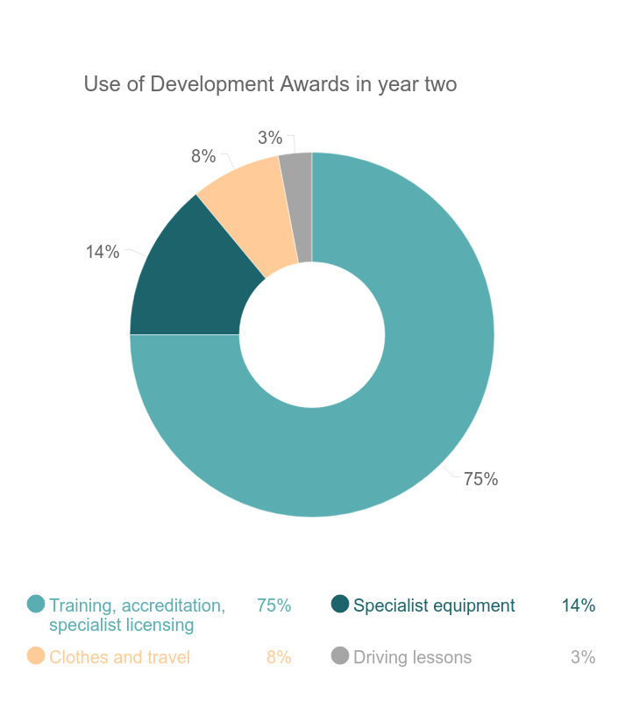

Gender
- Of the 1,166 Development Award recipients, just under two thirds were male (740), just over one third (419) were female and a small proportion (7) preferred not to say.

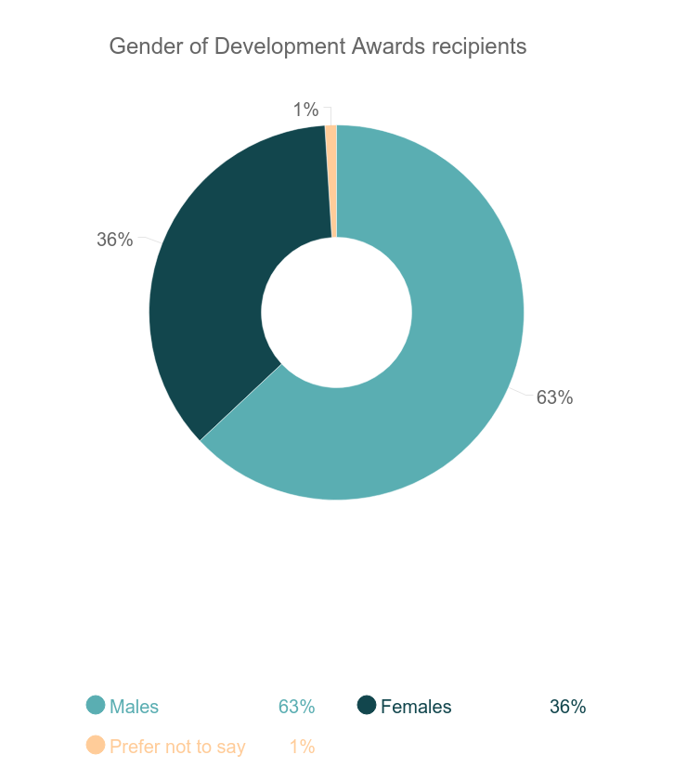

- The current staff team hopes to address the balance and increase the proportion of young women accessing Awards. They have worked proactively to promote the Awards and to reach young women through relevant organisations.

Age
- Information on age of Development Award recipients was available for 1,156 young people. Most award recipients were aged between 14 and 17. The high proportion of young people aged 14 and 15 may be to the large number of young people accessing Awards through Ayrshire schools.

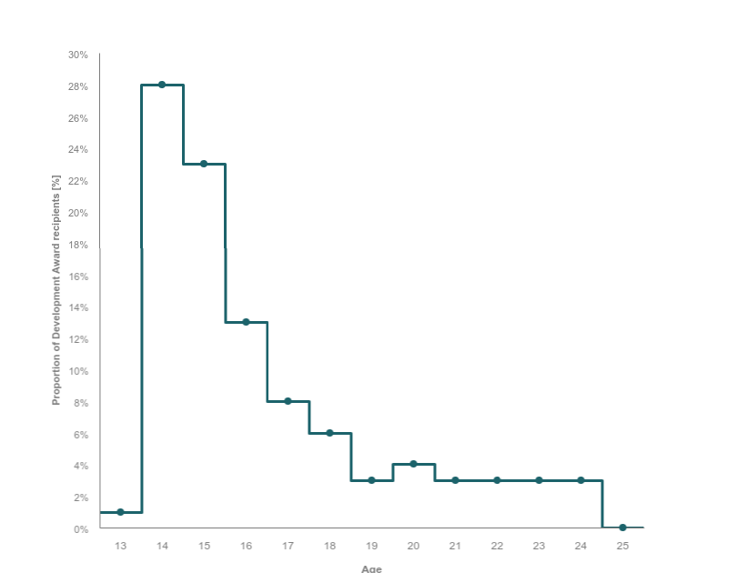

Disability
- Data recorded by Prince’s Trust Scotland indicates that 25 per cent of young people receiving Development Awards identified as disabled, of which 18 per cent had mental health needs. This is higher than the known national proportion of disabled people in Scotland (20%) and indicates that the targeting of Awards at specific demographics is helping the Prince’s Trust Scotland to reach those most in need of an Award. To continue supporting disabled young people, the Trust has worked on developing partnerships with relevant organisations, including CashBack partner National Autistic Society.

Sexual orientation and identity
- Data recorded by Prince’s Trust Scotland indicates that less than one per cent of young people receiving Awards identified as something other than heterosexual. To reach more LGBTQI young people the Trust has been developing relationships with relevant organisations, such as LGBT Youth.

Ethnicity
- Data recorded by Prince’s Trust Scotland indicates that five per cent of young people accessing Awards identified as minority ethnic. This is broadly in line with the national statistics (4%) and indicates that Awards are reaching young people from a range of backgrounds.

Disadvantage
- Of 1,123 valid postcodes, 502 (45%) were in the 20% most deprived areas in Scotland. The chart below shows the proportion of Award recipients in the least and most deprived parts of Scotland.

- Data from Prince’s Trust Scotland also indicated that the programme has supported young people that had criminal convictions (6%) and young people experiencing homelessness (6%).

Geographic spread
- Information on local authority area was available for 1,156 award recipients. During year two, the programme supported young people from 27 local authorities across Scotland. As in year one, most award recipients were from Glasgow and Ayrshire. The programme was able to deliver large numbers of awards in these areas through established referral routes and partnerships.

- The chart below shows the spread of awards delivered across local authorities. Most awards were delivered in the central belt. This year has seen a significant increase in awards delivered in Ayrshire, due to a new partnership developed in the area. The proportion of Awards delivered in other local authorities remains largely unchanged, with the exception of a significant increase from 37 to 78 Awards in South Lanarkshire.

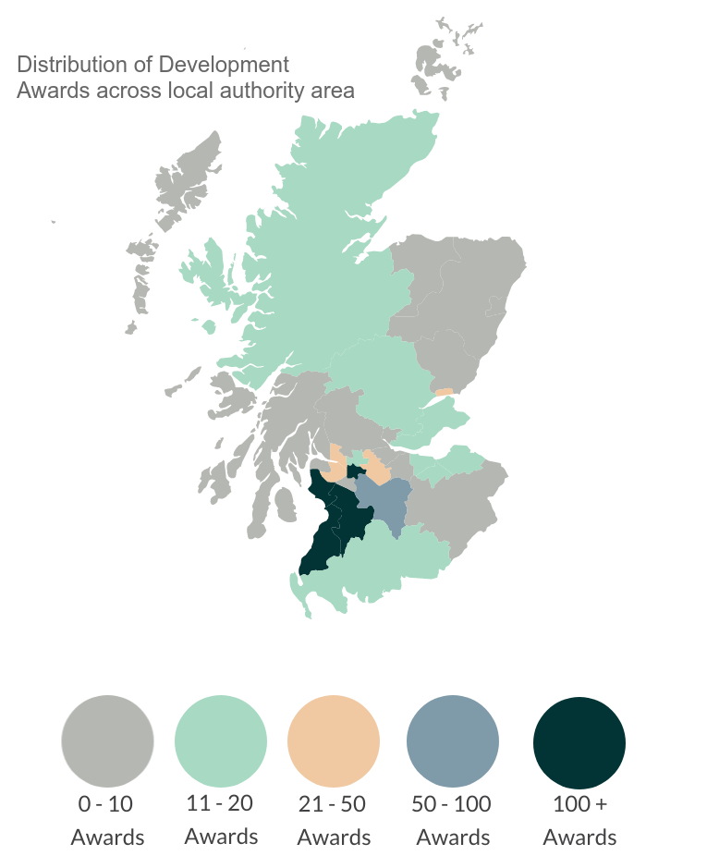

- There were no Awards delivered in Argyll and Bute, Clackmannanshire, Orkney Islands, Scottish Borders or Shetland Islands.

- Outcomes

Introduction

- This chapter explores how the Development Awards programme has progressed in relation to its intended outcomes. The information in this chapter is based on:

- surveys with 19 stakeholders;
- Research Scotland interviews with young people;
- Research Scotland focus group with five young people;
- a staff discussion group; and
- data collected by the Prince’s Trust Scotland relating to outputs and outcomes.

Outcome 1: Young people build their capacity and confidence

Target: 84% of participants will increase their confidence/capacity.

Achieved: 91% of young people reported an increase in confidence or capacity.

Target: 80% of young people will report they are able to do new things.

Achieved: 88% of young people reported that they are able to do new things.

- The programme has met and exceeded its target for young people building confidence and capacity and reporting that they are able to do new things.

- Young people that we spoke with said the Award had allowed them to do new things, and that being able to do new things gave them more confidence. Young people said that receiving an Award gave them the confidence to pursue education or employment, which they could not have done without the Award. A few young people also mentioned that it gave them a focus to build structure into their life.

“It definitely improved my confidence ‘cos at that point I was totally skint.”
Young person

Beforehand I didn’t feel I could go into the world. I now feel more capable – I’m more capable than I thought.”
Young person

“It’s definitely helped my confidence and enabled me to get an education.”
Young person

“Yes it helped me to put myself back out there – to get a job.”
Young person

- A few young people felt that receiving a Development Award gave them confidence in themselves and their ability, because someone had entrusted them with the grant.

“It definitely improved my confidence because getting the award made me feel that people care.”
Young person

Target: 80% of other stakeholders report increases in confidence and ability to do new things.

Achieved: 88% of stakeholders responding to the survey said that they had noticed an increase in confidence amongst young people since they received their Development Award, and that they were able to do new things. 71% of stakeholders felt that confidence had increased ‘a lot’.

- Stakeholders responding to the survey said that they felt young people demonstrated increased confidence after receiving an Award. They felt that receiving an Award in itself gave young people a boost in self-esteem. They also noted that the use of the Award for clothing or equipment or upskilling gave young people confidence as they felt on a more equal footing with their peers.

“The Award often helps them to purchase clothing/equipment they otherwise wouldn't be able to and this has a huge impact on their sense of self-worth and confidence and helps them to be able to attend job interviews or work placements just like their peers.” Stakeholder

“After they have received their Award, the young people seem to have a new found purpose or "goal" that they can strive towards too, which ultimately leads to an increase in confidence and overall increase in general wellbeing.”
Stakeholder

- One stakeholder worked closely with the Ayrshire schools and conducted a survey with pupils who had received a Development Award. The survey found that over 70% of young people reported an increase in confidence and over 95% said that they were able to do new things. This stakeholder said that they had also witnessed improved confidence in how pupils interacted with school staff and visitors, and how they engaged in public speaking.

“They would engage in discussions with visiting dignitaries including politicians, educationalists, business people and so on. A number of them felt confident to answer questions on stage at events.”
Stakeholder

- Predominantly, stakeholders felt that Awards helped young people to move forward with their plans, and gave them the confidence to try new things.

“I have found that clients who utilise the Development Award are eager and more ready to try out new learning experiences, without being afraid of failure. I believe the Development Award and the guidance and support in preparing for training gives them something to work towards.”
Stakeholder

- For some, they felt that Development Awards allowed young people to develop tangible skills that they could use to apply for work or to access higher education.

“For many young people it’s the lifeline they’ve been waiting for and the first step to a brighter future.”
Stakeholder

“Development Awards are often the catalyst to bringing about positive change in a young person’s life.”
Stakeholder

- A small number of stakeholders responding to the survey who were mentors/assessors said that they have minimal contact with young people post-Award, and did not feel that they could comment.

Outcome 2: Young people develop their physical and personal skills

Target: 40% of young people will gain accreditation for learning and skills development.

Achieved: At least 44% of young people receiving a Development Award gained accreditation.

Annual target: 425 young people will gain accreditation for learning and skills development.

Achieved: 517 young people receiving a Development Award gained accreditation.

- Prince’s Trust Scotland data indicates that 44% receiving a Development Award were able to gain accreditation for their learning. Data gathered by The Trust also indicates that 75% of Awards were used for training courses. Although the outcome of these courses is not monitored, anecdotal evidence and information from schools programmes indicates that young people are completing their courses and receiving qualifications.

- Most young people achieved accreditation at SCQF level 2 to level 5 with some young people also achieving non-SCQF qualifications.

- Data on how participants used their Development Award indicates that awards were used for a range of accredited courses, across a number of different industries. These sectors included: hospitality, construction, health and beauty, sports and leisure, entertainment, transport, engineering and IT.

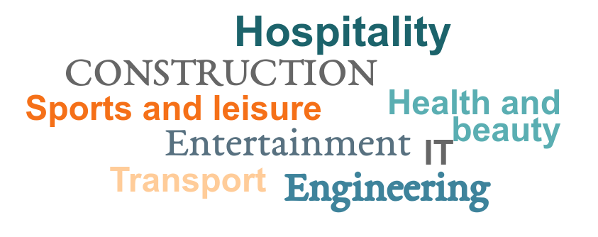

Target: 89% of young people will demonstrate increased skills.

Achieved: 79% of young people reported an increase in their skills.

- Based on a sample of participants, evidence suggests that the programme has not met its outcome for young people reporting an increase in skill.

- Young people we spoke with said that Development Awards had allowed them to gain new skills in a range of areas, depending on how they had used the Award. Some young people developed sector specific skills through a course. Others said that they had gained more general skills around planning for and managing a business, which often came through wider support from Prince’s Trust Scotland staff.

- Young people said that the Award helped them to gain new skills in a few different ways. Those using the Award for a course said that they had been able to develop sector specific skills through training and education. Others used the Award for equipment, which also helped them develop skills. A few young people who used the Award to help them access employment (transport costs/clothing) said that they had learned a lot of new skills by being in the working environment. They felt that these were useful, transferable skills that would benefit them throughout their careers. One young person who is visually impaired noted that working in an office environment helped her gain confidence in her skills, particularly using a screen reader and working with spreadsheets.

“Being in the office environment I’m learning skills that are applicable across a wide range of environments. Eventually I’m hoping to go into youth work.”
Young person

- For example, one young person used the Award to purchase a laptop, with the intention of setting up a website for his landscaping business. He has now developed useful IT skills including web design and using spreadsheets.

- From our survey, 82% of stakeholders reported that Development Awards helped improve young people’s skills. Stakeholders said that as well as developing sector specific skills through training courses, they had noticed improved social and communication skills amongst young people. These included maintaining eye contact, speaking with new people, speaking in public and working courteously in a customer facing role. Stakeholders also reported that young people took more of an interest in their own skills development after receiving an Award.

“Often two or more clients attend the same course which gives them the opportunity to prepare together, improve social and communication skills, and respect for others who may need that little bit extra support.”
Stakeholder

Outcome 3: Young people’s behaviours and aspirations change positively

Target: 84% of young people report increased aspirations.

Achieved: 86% of young people report increased aspirations.

Target: 70% of young people report positive changes in behaviour.

Achieved: 76% of young people report positive changes in behaviour.

- Most of the young people we spoke with said that they felt more positive about their future, and some had set goals and ambitions for business development.

“Yes, definitely, it’s nice to actually see a future.”
Young person

- Some of the young people we spoke with said that they felt more motivated to succeed after they had received a Development Award. However others said that they were already highly motivated, and the Award helped fuel this motivation and propel them into action.

“Yes – it’s made me feel much more positive about the opportunities available to me.”
Young person

Case study
One young person we spoke with said that they felt more able to achieve in their business because of the support they had received through Development Awards and further support from Prince’s Trust Scotland.

“I feel able to achieve something with my business.”

This young person received a £500 Development Award. He then went on to start a business with a £5,000 loan through the ‘Will it Work’ scheme. He is currently still working a part-time job whilst he builds up his client base.

He noted that as well as the financial support in the form of grants and loans, he found the general support from staff at Prince’s Trust Scotland to be valuable, particularly in building his confidence and helping him to develop a business plan.

“It’s an excellent thing for young people to start their own business. And it’s not just about the money it’s the after-support as well.”

He now feels much more positive and motivated to succeed in his business because of the support that was kickstarted with the Development Award.

“Definitely, it’s made me much more positive about my life and the future.”

Target: 70% of other stakeholders report perceived positive changes in behaviour.

Achieved: 88% of stakeholders responding to the survey said that they had noticed an increase in young people’s behaviours and aspirations since they received their Development Award. Sixty-seven per cent of stakeholders felt that young people’s aspirations had increased ‘a lot’.

- Most stakeholders completing the survey felt that Development Awards helped young people change their behaviour in positive way, making them more focused and motivated to set and achieve goals.

- They felt that the access to a training course, and the subsequent achievement of qualifications gave young people motivation, and the confidence that they could achieve their goals, resulting in an overall change in behaviour.

- Stakeholders reported seeing changes such as improved punctuality, attendance, engagement and a sense of pride in themselves and their activities.

“They are determined to make positive changes to help move them forward into employment.”
Stakeholder

“I have noticed changes and improvements in people we work with since receiving their Development Award as they become more active, turning up earlier, more motivated and show more interest in learning. They ask for notes to read at home and for me that is a big step as they want to be prepared.”
Stakeholder

“Young people can often struggle to find employment but being able to achieve work related qualifications they can start to believe that they are capable of achieving their goals.”
Stakeholder

“Yes, Development Award courses help young people achieve manageable goals that in turn give them a structure and step by step guide on how to achieve the things they want in life.”
Stakeholder

“As young people take up employment opportunities they tend to mature also and this can have a positive impact on their behaviour.”
Stakeholder

- One stakeholder who had conducted a survey with school pupils receiving Awards found that over 80% of pupils said they had increased aspiration and felt more positive about their personal goals since receiving a Development Award.

- One stakeholder noted that the young people they work with are usually focused on achieving a goal, as this is what prompts them to apply for an Award.

“Most are very focused on achieving their goals and this is an area discussed with the assessor during their meeting to complete the assessment.”
Stakeholder

Outcome 4: Young people’s wellbeing improves

Target: 80% of young people will make positive comments about wellbeing against one of the relevant SHANARRI indicators.

Achieved: 84% of young people reported an improvement in their wellbeing.

- Young people we spoke with said that the Award helped improve their wellbeing, predominantly by improving their mental health. Some young people also said that it helped them to feel more responsible, as they had been given an amount of money to use, and to feel like they were achieving when they had completed a course.

“I now have responsibility over my finances … and am able to save. I also feel more confident in new situations.”
Young person

- One young person said that he felt more respected as he now had a website for his business. The website has given his business a platform, from which he feels he will be more able to achieve success.

Case study
One young person used the Award to fund a course in makeup artistry. The Award enabled her to improve her skills and abilities in something she was very interested in. She explained that she was disabled and prior to becoming unwell, makeup was “like a hobby”, but when she was unwell, it was one of the only things that made her happy. Because of this she thought it would be a good idea to try to improve her skills in this area and possibly gain a qualification in this field.

“When I was ill – it brought me joy.”

She had always loved learning, but her illness made her feel that she would no longer be able to participate in learning opportunities. Receiving the Award changed her attitude and enabled her to return to a learning environment and gain a qualification in something that she really enjoys.

She explained that over the years since becoming unwell she had become quite socially isolated from the outside world and spent most of her time with her family. Receiving the award enabled her to have contact with new people outwith her family and to make new friends.

“It took me a while to get out of the mind frame of – my life is over, and the Award, definitely changed this.”

She now feels much more motivated to go on and do more things since receiving her award.

Target: 80% of partners will make positive comments about wellbeing against one of the relevant SHANARRI indicators.

Achieved: 82% of stakeholders made positive comments about wellbeing against at least one of the relevant SHANARRI indicators.

- Overall, stakeholders felt that receiving a Development Award helped improve young people’s wellbeing in terms of health, achievements, respect, responsibility and inclusion.

“Yes, after taking part in the course that they have attained with their Development Award, many young people appear to be happier and healthier!”
Stakeholder

- The chart below shows the perceived improvements in young people’s health and wellbeing, as reported by stakeholders completing our survey.

- Stakeholders reported that Development Awards gave young people access to training, further education or employment and that this itself improved their health and wellbeing.
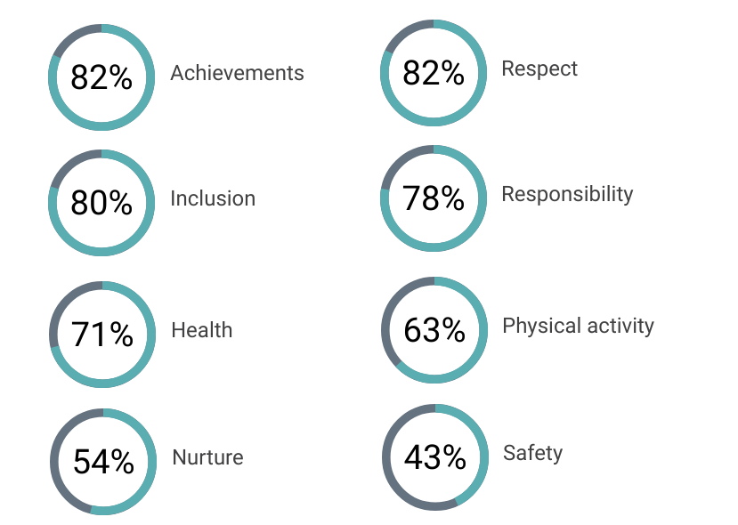

“Being able to work has a massive impact on young peoples' health and wellbeing.” Stakeholder

“Being supported into employment tends to have a significant impact on young people's mental health.”
Stakeholder

- A few stakeholders mentioned that young people’s mental health improved, and this led to improvement in their sense of self-worth. Stakeholders also noted that receiving a Development Award gave young people a sense of responsibility and encouraged them to respect themselves and others.

“Many who have mental health problems start to improve.”
Stakeholder

“Yes, after taking part in the course that they have attained with their Development Award, many young people appear to be happier and healthier!”
Stakeholder

“Yes, personal appearance, dress sense, and personal hygiene as they know they are mixing with others and have to take responsibility. Don't wear hats in the premises, as they would not do this at work. As they prepare their behaviour changes. They show more respect for the opportunities provided to them by the Development Award.”
Stakeholder

“They have developed what I refer to as the 6 C's - confidence, communications, commitment, customer service, customer care and courtesy plus a significant degree of competence in the projects they are involved in.”
Stakeholder

- A few stakeholders commented on young people’s physical health, and felt that Development Awards encouraged young people to make healthy changes to their lifestyle.

“There has been a noticeable difference in their appearance as well as lifestyle such as eating, drinking habits.”
Stakeholder

“When young people are engaged on the course and start to feel good about their achievements, they are invited to join the gym and are given a free pass, at one of our centres. They are now ready to travel and take the initiative to keep fit and healthy, and are always mentioning keeping fit and healthy on their Interests for their C.V.”
Stakeholder

Outcome 6: Young people participate in activity which improves their learning, employability and employment options

- Data in this section is taken from the Prince’s Trust Scotland reporting scorecard, which records progress towards outcomes for participants on a quarterly basis. The table below summarises the targets and achievements in relation to this outcome.

- The data, based on a small sample of participants, suggests that Prince’s Trust Scotland has achieved and exceeded its overall target for 848 young people to progress into a positive destination. In a similar pattern to year one, very few young people progressed into volunteering, but more than anticipated have progressed into education or training. This year the programme has not met its target for young people progressing into employment.

Progression to positive destinations
Destination | Achieved | Annual target | Achieved  % | Overall target
Employment | 345 | 467 | 30% | 44%
Further education or training | 346 | 276 | 30% | 26%
Volunteering | 23 | 106 | 2% | 10%
Total positive destinations | 920 | 848 | 79% | 80%

- In addition to the data collected above, Prince’s Trust ran a text survey which yielded 183 responses. Data from the text survey indicates that overall, Prince’s Trust met and exceeded its targets for young people progressing to positive destinations. This data shows that young people are progressing to employment and further education or training, and that more young people are progressing to volunteering.

Progression to positive destinations (data from text survey)
Destination | Achieved | Overall target
Employment | 62% | 44%
Further education or training | 30% | 26%
Volunteering | 4% | 10%
Total positive destinations | 83% | 80%
- We would note that the sample sizes for both data sets are too small to be representative of all participants. This has resulted in a wide variance between the two sets of results. We would advise caution when interpreting this data and would use it only as an indication of progress towards the outcomes.

- Young people we spoke with said that the Award had helped them to progress into employment/self-employment or higher education. For some young people this was through funding for a course, course equipment clothes for an interview or for transport to get to a job they had already secured.

“It got me out into the work place.”
Young person

- For some young people the Award removed a small but significant barrier to this progression. For example, one young person used her Award (£320) to buy materials required for her college course. Without the materials she would not have been able to fulfil the course requirements. She is now able to complete the course and plans to continue to university to study computer based art and design and eventually to start her own business.

- Another young person was supported to apply for a Development Award through a CashBack partner organisation. His Award was used to fund CSCS card. Having the CSCS card has been a useful addition to his CV and he now feels in a better position to apply for work.

“I got a certificate which in turn made it easier for me to apply for and get jobs – made me stronger than other people applying.”
Young person

“I managed to get a job in Boots and I am going to be starting college this year, to study Sports Fitness and maybe to become a PE teacher in the future.”
Young person

- And a few young people used the Award to fund travel expenses so they could travel to and from a job that they had already secured. This was a small amount of money over a short period of time (until their first pay cheque) but it made the difference between the young person being able to take up employment or not.

- One young person said that the Development Award had helped him shape his business in a new way. He used the Award to buy specialist equipment that allows him to automate a previously manual process in his design business. The equipment is light and portable, which has allowed him to increase the reach of his work. Recently he has been to Devon to appear in a television programme showcasing his design work.

“It’s completely changed the direction of my business…it’s become a lot more comfortable to do my business…and I’ve been able to take on a lot more opportunities.”
Young person

- One young person said that without the Award she would have taken a similar path towards business development, but that she would not have progressed as much or as quickly as she has now. The Award allowed her to purchase specialist equipment for her fashion design business. Having specialist equipment has allowed her to develop her business in the direction she wants, and made her feel that her business is legitimate and on a par with others in the industry.

- Stakeholders responding to the survey felt that the Awards were a useful and practical step into further education, training and employment.

“Yes, getting the Development Award has allowed them to progress into employment or education which has a very positive outcome on their confidence.”
Stakeholder

“It is a fantastic programme and gives young people an opportunity to reach a positive destination.”
Stakeholder

Outcome 7: Young people participate in positive activity

Target: 80% of young people will participate in positive activity.
Annual target: 848 young people will participate in positive activity.

Achieved: 99% of young people participated in a positive activity through the Development Award.
Achieved: 1151 young people participated in a positive activity through the Development Award.

- Young people have used Development Awards to help them access, participate in and stay engaged in a range of positive activities. These included training courses, further and higher education courses and work placements.

- All of the young people we spoke with felt that the Award had directly and indirectly helped them access positive activity through employment, business development, training or education.

Case study
One young person said that the Development Award had helped him reach an important turning point in his life. This young person said that he had started taking “legal highs” when he was about 16 and quickly became addicted. His life was chaotic and he had to move out of home because of his behaviour.

Whilst living in a hostel, his key worker encouraged him to apply for a Development Award so he could buy clothes that would be appropriate for attending a job interview. During this time, he was also supported by a mentor at Prince’s Trust Scotland.

He found the application process simple and said that he received his Award within a few weeks of applying. In addition, he appreciated the caring and non-judgemental attitude of the staff at Prince’s Trust Scotland.

Receiving the Award helped him to turn his life around. He felt it gave him more structure in his life, enabled him to build confidence, skills and gain qualifications.

“So it’s like a lifeline. It gives people that are struggling a chance. It gave me a lifeline to work that I wouldn’t have had.”

He is now living back at home and is no longer taking drugs. He successfully found work with a national company and is now working full-time.

Without the Development Award and subsequent employment he thinks he would probably still be using drugs and may not have survived.

Target: 80% of young people are new to the activity.
Annual target: 848 young people are new to the activity.

Achieved: 99% of young people were new to the activity.
Achieved: 1151 of young people were new to the activity.

- The Prince’s Trust Scotland defines new to the activity as young people that had not received a Development Award before. Young people are allowed to apply for multiple Awards, up to the value of £500, and some young people within year two had applied for more than one award. For example, a young person may apply for an award to help fund a training course. Upon completing the course they may need support to help them travel to a work placement, or to take the next step into employment. Development Awards can continue to support the young person provided that the total Award amount does not exceed £500.

Conclusions and Recommendations

Conclusions

  - The programme has reached more than its intended target number of young people, and has remained within its allocated budget. Most Awards recipients were from Glasgow and Ayrshire. The ongoing partnership with Ayrshire schools supported an increase in awards across all three Ayrshire authorities. The programme reached more young men than young women, however it is clear that staff are keen to reach a wider range of young people to ensure that it aligns with the national picture of young people meeting the eligibility criteria.

  - Despite the national restructure of the organisation, new approach to delivery and management and ongoing challenges of the new national monitoring system, the Development Awards Programme has been able to gather enough data to track young people.

  - Overall, the programme has made good progress towards most of its outcomes. Young people spoke positively about their experiences of receiving Development Awards and the positive impact that the Award had facilitated their life. In particular, young people felt that that the Award helped them build skills for employability, develop their business and increase their confidence.

  - Stakeholders said that they felt the Awards supported young people to access employment through training courses, education or practical tools for work. They felt that the Awards removed barriers for young people, allowing them to progress into positive destinations and achieve their goals.

Summary of CashBack outcomes and progress for year two, Phase 4
Outcome 1: Young people build their capacity and confidence | The programme has met and exceeded its targets for this outcome. Both stakeholders and young people felt strongly that the Award helped increase young people’s confidence and capacity, and that it helped them to do new things.
Outcome 2: Young people develop their physical and personal skills | The programme has made good progress towards this outcome. The programme has met and exceeded its targets for young people gaining accreditation. Although it has not met its target for young people reporting an increase in skills, young people and stakeholders we spoke with were clear that Development Awards supported young people to develop a range of skills, particularly around communication and social skills.
Outcome 3: Young people’s behaviours and aspirations change positively | The programme has made good progress towards this outcome, meeting and exceeding all targets. Young people said that the Award made them feel positive and motivated to succeed. Stakeholders said they had noticed improvements in young people’s behaviour, levels of maturity and motivation to succeed.
Outcome 4: Young people’s wellbeing improves | Information from young people and stakeholders shows that the programme has made good progress towards this outcome and has met and exceeded its targets. In particular, there was good evidence to show that young people had improved wellbeing, sense of responsibility and sense of achievement.
Outcome 6: Young people participate in activity which improves their learning, employability and employment options | Data from the scorecard and text survey indicates that the programme has made good progress towards this outcome, meeting and exceeding targets for young people to progress into employment, education and training. Fewer than expected moved into volunteering.
Outcome 7: Young people participate in positive activity | The programme has demonstrated that it is achieving this outcome, with young people using the Award to access and engage in a range of positive activities, and to make positive changes to their lives.

Recommendations

  - With the success of the Ayrshire schools programme, that the Trust may wish to consider expanding this to other regions. This approach may be particularly useful to encourage Award applications amongst target groups, or in areas with low uptake.

  - Going forward the team may wish to consider the best, and most accurate methods for collecting outcomes focused data from young people. We would also recommend that the Trust builds in longer term monitoring of young people to better understand their post-Award journey. It may also be useful to check that data is consistently recorded across all systems.

Prince’s Trust Scotland, Development Awards Toolkit, 2012
As above
This data was obtained by Prince’s Trust Scotland from the national monitoring database.
This data was obtained by Prince’s Trust Scotland from the national monitoring database.
^{, 6} These targets were measured using data from the survey of young people, which was conducted with a sample of 125 award recipients. Data provided was an extrapolated figure, based on the sample. As the sample size was not large enough to be representative, we have reported the achievements as a percentage, rather than a numerical figure.
This is based on data from the Prince’s Trust Scotland reporting scorecard which records that 517 young people achieved a qualification or accreditation.
This is based on data from the Prince’s Trust Scotland reporting scorecard.
This is based on data from the Prince’s Trust Scotland reporting scorecard.
This is based on data from the Prince’s Trust Scotland reporting scorecard.
This is based on data from the Prince’s Trust Scotland reporting scorecard.
This is based on data from the Prince’s Trust Scotland reporting scorecard.
This is based on data from the Prince’s Trust Scotland reporting scorecard.

