Prince’s Trust Development Awards Programme

Evaluation of Phase 4 of CashBack supported activity

Year One

July 2018

Research Scotland
Suite 42, Spiersbridge House
Spiersbridge Business Park
Glasgow, G46 8NG
0141 428 3972
nadia.hyder@researchscotland.org

Contents

Executive Summary

- Introduction 1

- Participation in 2018/19 7

- Outcomes 12

- Partnership Work 27

- Conclusions and Recommendations 32

Executive Summary

About this report

About this report

This report is an evaluation of Prince’s Trust’s Development Awards during the first year of Phase 4 CashBack funding. It covers delivery from April 2017 to March 2018 and provides an overview of outcomes achieved and partnership work during year one.

Methodology

Evaluation fieldwork in year one involved telephone interviews with seven programme partners, a discussion with the Programme Manager, analysis of a stakeholder survey and analysis of monitoring data collected by Prince’s Trust staff.

Outputs and outcomes achieved

In year one, the programme delivered 955 Development Awards across 28 local authorities in Scotland. Almost half of the award recipients (47%) were from the 20% most deprived areas in Scotland.

The average value of awards was £240. Two thirds of awards (66%) were delivered to young men, with a third (34%) to young women. Young people predominantly used the award for course fees, equipment clothing and/or travel costs.

The award has helped young people to gain confidence, capacity and communication skills, with young people reporting that they felt able to do new things since receiving an award. Using Development Awards, young people achieved positive destinations in education and training, and achieved recognised qualifications. Stakeholders reported that having the award, and achieving positive outcomes helped young people to increase their aspirations, and to feel more motivated about their future.

Development Awards have supported young people to progress into employment, education and training. Receiving an award also helped to improve young people’s sense of wellbeing, particularly around their sense of responsibility, achievement and their mental health.

Key successes and challenges

Monitoring and evaluation has changed this year, due to a new national monitoring system implemented by the Prince’s Trust. The team has also taken a proactive approach to gathering feedback from young people, which has resulted in a much higher response rate than in previous years.

Partnership working has continued to be successful, with referral partners speaking positively about the benefits and outcomes of Development Awards. This year has seen the development of a successful new partnership with schools in Ayrshire, which has helped the programme to reach disadvantaged young people.

Programme staff are still working on increasing the diversity of award recipients. Going forward they will continue to reach out to relevant referral organisations, particularly those that that work with young women and minority ethnic communities.

Introduction

About this report

  - The Prince’s Trust commissioned Research Scotland to evaluate the impact of Phase 4 of its CashBack funded Development Awards Programme. This report covers programme delivery during 2017/18, the first year of Phase 4 of CashBack delivery. A further two reports will be delivered covering delivery during 2018/19 and 2019/20.

  - This report will:

- explore the reach of Development Award activity;
- consider developments and progress; and
- explore the impact of the Development Award programme.

The Prince’s Trust

  - The Prince’s Trust is a UK wide charity which works with disadvantaged young people aged 13 to 30, to build their confidence, increase their motivation and improve their employability. It achieves these goals by providing practical and financial support to help young people develop key workplace skills such as confidence and motivation. It targets its support at 13 to 30 year olds who have struggled at school, have been in care, are long-term unemployed, have criminal convictions or are at risk of offending.

  - The Prince’s Trust in Scotland delivers a range of education, training and development, as well as employment and enterprise programmes. Beginning as a small grants programme, the Development Awards programme was one of the founding elements of the Prince’s Trust. The programme was introduced in its current form in 1999, initially as a pilot which was reviewed and expanded across the UK.

Development Awards

  - Development Awards offer cash awards up to £500, and support for young people aged 13-24 who are struggling to access education, work or training due to a lack of funds. The programme often works with young people that are unemployed, leaving care, in trouble with the police or with no qualifications.

  - The Development Awards are targeted at:

“...young people who are ready for work or education but cannot access education, employment or training because of a financial barrier that prevents them from having the resources or skills they need.”

  - The programme specifically aims to:

“Remove financial barriers that prevent young people entering education, employment or training and help them into these outcomes.”

  - The Prince’s Trust has a clear target group for the Development Awards programme. To be eligible for an award a young person must be:

- aged 13 to 24;
- living in an area of deprivation;
- unemployed, not in education or training;
- excluded or at risk of exclusion from school; or
- at risk of being involved in antisocial behaviour, offending or re-offending.

  - Across three years of delivery in Phase 4, the programme aims to engage 3,431 young people across all 32 local authorities in Scotland. This will be delivered as:
  - Year 1 – 950 young people;
  - Year 2 – 1,140 young people; and
  - Year 3 – 1,341 young people.

CashBack for Communities

  - The Prince’s Trust has been allocated £1,070,000 of Phase 4 CashBack funding to deliver the programme during 2017/18, 2018/19 and 2019/20.

  - Funding was allocated over three years as follows:
  - Year 1 2017/18 - £297,000
  - Year 2 2018/19 - £353,000
  - Year 3 2019/20 - £420,000.

  - Over the three year funding period, 88 per cent of CashBack funding has been allocated towards Awards for young people. The remaining 12 per cent is allocated towards management, marketing and evaluation of the programme.

  - In year one, the programme has spent a total of £267,000, with £230,000 spent on Development Awards for young people. This is £30,000 less than anticipated. The underspend is likely to be because more awards were delivered at a low value. Development Awards can be up to £500. The budget allowed for an average award value of £275, however in year one the average award value was £240.

Evaluation method

  - In April 2018 we met with the Development Award Programme Manager to agree an evaluation plan. We developed an evaluation logic model, outlining outcomes, indicators, targets and responsibilities for data collection. This helped to ensure that evidence was gathered in relation to all outcomes and targets. We also developed discussion guides and surveys to use with young people and partners.

  - During the first year of delivery, our evaluation work involved:

- analysis of 11 completed surveys from partners;
- seven telephone interviews with partners;
- a case study on partnership work;
- a discussion with programme staff; and
- analysis of programme data collected by Prince’s Trust.

  - Most partners completing a survey were from organisations which support young people to use their Development Awards to progress into positive destination. A few were from organisations that refer young people to Development Awards and one identified as a mentor that supports young people with Development Award applications. Some people fell into more than one category i.e. they refer young people to Development Awards and support them to use the award to progress into a positive destination.

  - Staff from the Prince’s Trust issued, collected responses and analysed responses to the survey that we designed for young people. Staff only contacted young people that were identified as over the age of 16. Most young people completed the survey by phone. Very few (30) young people completed the survey online. The Programme Manager reported that staff had a better response when conducting the survey over the telephone. A total of 444 young people were contacted and in total there were 196 responses. In addition, Prince’s Trust staff issued an edited, online version of the survey through schools, and this received 226 responses.

  - Data reported by Prince’s Trust in the reporting scorecard was based on the 196 survey responses and extrapolated to report against CashBack targets. This is a good sample size. However, as we do not know if the sample was broad enough to be representative, we have reported the achievements as a percentage, rather than a numerical figure.

  - This survey represents a good sized sample, but it was not necessarily representative of all award recipients. As such, we have not used the figures directly in this report. Instead, we have used a percentage, to indicate the extent to which the outcome has been achieved.

Agreed targets and intended outcomes

  - CashBack funding is granted on the understanding that the programme will work towards agreed outcomes and outputs.

  - The Prince’s Trust has agreed to deliver the following CashBack outcomes, and will measure progress towards these outcomes through set targets.

CashBack outcomes and targets for Phase 4
Outcome 1: Young people build their capacity and confidence
- 84% of participants will increase their confidence/capacity
- 80% of young people will report they are able to do new things
- 80% of other stakeholders report increases in confidence and ability to do new things
Outcome 2: Young people develop their physical and personal skills
- 40% of young people will gain accreditation for learning and skills development
- 89% of young people will demonstrate increased skills
- 56% of young people will achieve a positive outcome in education or training
- 36 young people are awarded with a ‘Will it Work?’ grant and 8 young people will start a business.
  - In year one 6 young people awarded with ‘Will it Work?’, 1 young person starting a business
Outcome 3: Young people’s behaviours and aspirations change positively
- 84% of young people report increased aspirations
- 70% of young people report positive changes in behaviour
- 70% of other stakeholders report perceived positive changes in behaviour
Outcome 4: Young people’s wellbeing improves
- 80% of young people will make positive comments about wellbeing against one of the relevant SHANARRI indicators
- 80% of partners will make positive comments about wellbeing against one of the relevant SHANARRI indicators.
Outcome 6: Young people participate in activity which improves their learning, employability and employment options
- 80% of young people will achieve positive destinations
- 44% of young people will move into employment
- 26% of young people will progress to further education or training
- 10% of young people will be involved in volunteering
Outcome 7: Young people participate in positive activity
- 80% of young people will participate in positive activity
- 80% of young people are new to the activity

  - The Development Award programme and its eligibility criteria has remained largely the same in Phase 4 as it was in previous years. The maximum award amount remains at £500. As there was an underspend in the previous Phase, the Programme Manager hopes that in years two and three of Phase 4, the programme will be able to offer more awards at a high amount.
  - During Phase 4, the programme will be delivering a small number of ‘Will it Work?’ grants. ‘Will it Work?’ is a grant scheme delivered primarily through the Prince’s Trust Enterprise programme. Young people can apply to receive a grant of up to £250 to fund a business idea. The Prince’s Trust conducts a follow-up review with each young person, six weeks after they are awarded a grant to find out if the business idea has been successful, and if the young person will progress to starting business. The Programme Manager reported that ‘Will it Work?’ is historically quite successful and has a high conversion rate of young people receiving a grant to young people starting a business. The Programme Manager was confident that this would be maintained for the small number of grants delivered through Development Awards.

  - To help provide raise awareness and assess large numbers of young people in an efficient manner, the Programme Executives run Development Award open days. This year they delivered four open days: two in Glasgow, one in Edinburgh and one in Dundee. These locations were selected because Prince’s Trust has premises in these towns to host the open days, and because they can attract large numbers of referrals.

  - During year one, the Prince’s Trust hosted a CashBack Celebration Event in Glasgow. The event was attended by young people, partners and the Cabinet Secretary for Justice. The event provided a useful opportunity for Development Award staff to build relationships with partners, and also provided a networking opportunity for partners more generally. The event helped to showcase how the Development Awards support young people and highlighted the progress that four young people had made, using Development Awards to start their own businesses.

Monitoring and evaluation

  - In February 2018, the Prince’s Trust moved to a new monitoring system. Due to challenges migrating information across systems, not all data relating to Development Awards has been available in this monitoring period. Where possible, Development Award staff kept a manual record of data relating to outputs, however it was not possible to record all information manually.

  - Data from the Prince’s Trust text survey, which records young people’s progress onto positive destinations was not available. The Programme Manager has contacted the central evaluation team and requested this data, but it has not yet been provided. Staff anticipate that these issues will be resolved imminently and will not affect monitoring and evaluation going forward.

  - This year, the Development Awards team has had support from the wider Prince’s Trust support team, to help issue surveys to young people. This support has allowed the programme to reach significantly more young people than in previous years, as the survey was issued both online, and over the telephone. Staff conducting the survey with young people gathered mainly quantitative information, relating to outputs and targets. Research Scotland will conduct qualitative interviews with young people in year two, to gather more information on young people’s stories and experiences.

- Participation in 2018/19

Introduction

- This section will outline programme participation in year one of CashBack funded activity. It is based on data provided by the Prince’s Trust.

Overall activity
- In year one, the programme has delivered 955 Development Awards, achieving five more than the target of 950. The average award value was £240.

- Most Development Awards were used for course fees (68%), or a mixture of course fees, clothing, equipment and travel. The chart below outlines how awards were used, as categorised by the Prince’s Trust. This data is based on 945 of the awards delivered in year one.
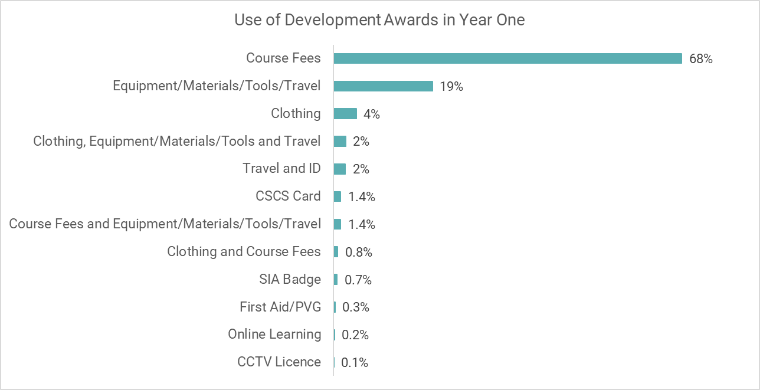

Gender
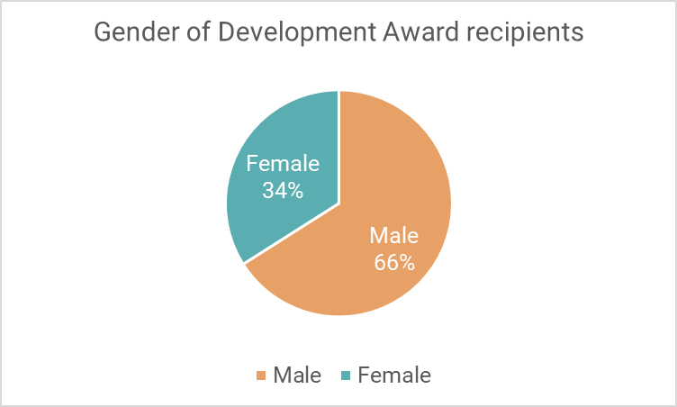
- Of the 955 Development Award recipients, around two thirds were male (629) and one third (326) were female.

- Programme staff have been working to engage more young women. Staff have approached organisations working with women who might benefit from a Development Award, such as AMINA and Women’s Aid. Staff have also approached organisations that have dedicated female programmes , however the volume of referrals has been lower than anticipated.

- The Programme Manager said that the programme is taking steps to address the gender imbalance. It is useful to note that a higher proportion of young men are unemployed and not in education or training. The most recent ONS statistics report that, UK-wide, an estimated 60% of unemployed young people are male, and 40% are female. Similarly, in Scotland, significantly more men receive criminal convictions and custodial sentences than women. The programme still has some work to do, to increase female participation, however the gender divide of Development Award recipients is close to that of the target demographic.

Age
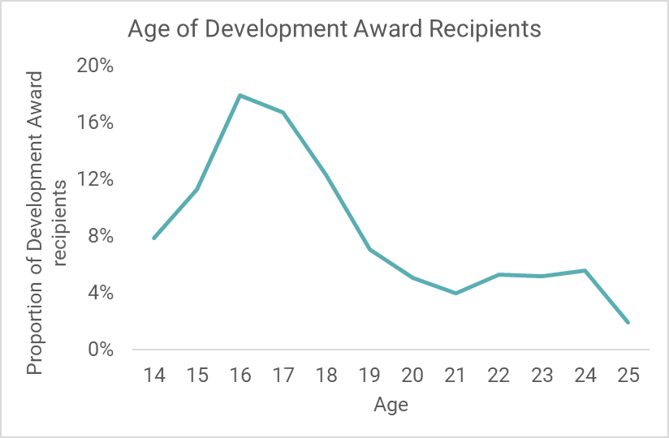
- Information on age of Development Award recipients was available for 933 young people. Most award recipients were aged between 15 and 18.

Disability
- Due to the challenges migrating and obtaining information from the new monitoring system, no data on how many young people identified as disabled was available.

- The Programme Manager said that Development Awards would like to work with more young people that are disabled. This year, Programme Executives approached a leading disability membership organisation, and held a stall at one of the organisation’s open day events. However, the response has not been as high as anticipated. The Programme Executives will continue to engage with organisations that support disabled young people and encourage uptake of awards where possible.

Sexual orientation and identity

- The Development Award programme does not routinely record information on young people’s sexual orientation. However, the Programme Manager said that anecdotally, it was understood that the programme was supporting young people that identify as LGBTQI. The Programme Manager noted that one of key success stories of the year had been around a young transgender person who used the award to help her get a job.

Ethnicity
- Due to the challenges migrating and obtaining information from the new monitoring system, data on ethnicity of Development Award recipients was not available.

- This year Programme Executives have tried to engage organisations that work with minority ethnic young people. They have also worked with partner programmes within the Prince’s Trust that work with minority ethnic young people.

Disadvantage

- Of 849 valid postcodes, 345 (41%) were in 15% most deprived areas in Scotland and 399 (47%) were in 20% most deprived areas in Scotland. The Programme Manager felt that the high proportion of young people from areas of deprivation was due to partnership work with schools and organisations in Ayrshire and Glasgow, as these partners tend to work with young people from the most deprived areas.

- Stakeholders we spoke with said that they referred young people who had a wide range of challenges. Referral partners worked with young people that required support because they were care experienced, had a history of anti-social behaviour or criminal convictions, had issues around substance use or had mental health issues.

Geographic spread

- Information on local authority area was available for 853 award recipients. During year one, the programme supported young people from 28 local authorities across Scotland. Most award recipients were from Glasgow and Ayrshire. The programme was able to deliver large numbers of awards in Glasgow, through established referral routes and partnerships. This year the programme has worked closely with schools in North, East and South Ayrshire, resulting in a high number of awards delivered in these areas.

- The chart below shows the spread of awards delivered across local authorities. Most awards were delivered in the central belt. This year has seen a significant increase in awards delivered in Ayrshire, due to a new partnership developed in the area.

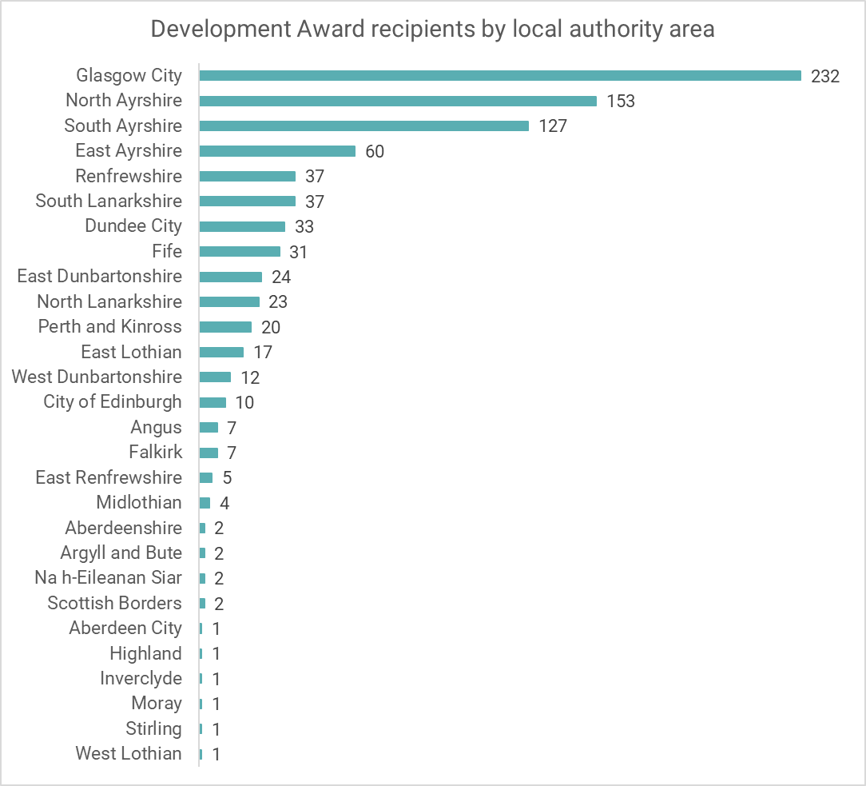

- Outcomes

Introduction

- This chapter explores how the Development Awards programme has progressed in relation to its intended outcomes. The information in this chapter is based on:

- surveys with 196 young people;
- surveys with 11 stakeholders;
- interviews with 7 stakeholders;
- an interview with the Programme Manager; and
- data collected by the Prince’s Trust relating to outputs and outcomes.

Outcome 1: Young people build their capacity and confidence

Target: 84% of participants will increase their confidence/capacity.

Achieved: 79% of young people reported an increase in confidence or capacity.

Target: 80% of young people will report they are able to do new things.

Achieved: 90% of young people reported that they are able to do new things.

- The programme has made good progress towards young people building confidence and capacity. The programme has met and exceeded its target for young people reporting that they are able to do new things. Although the programme has not met its target for young people reporting an increase in their confidence or capacity, there is good evidence from stakeholders working with young people that confidence and capacity does increase after receiving a Development Award.

- In addition, a survey conducted with 226 young people in Ayrshire schools found that 73% of them felt ‘a little’ or ‘a lot’ more confident since receiving a Development Award. And 92% reported that they felt able to do more things, after receiving the award.

- In year one, we have predominantly focused on gathering feedback from stakeholders. In year two we will conduct telephone interviews with young people to gather more qualitative information on their experiences. This will provide further evidence towards progress around this outcome.

Target: 80% of other stakeholders report increases in confidence and ability to do new things.

Achieved: 100% of stakeholders responding to the survey said that they had noticed an increase in confidence amongst young people since they received their Development Award. 91% of stakeholders felt that confidence had increased ‘a lot’.

- Almost all stakeholders we engaged felt that Development Awards helped improve young people’s confidence. For some young people, stakeholders felt that simply receiving the award helped them feel more confident. And many stakeholders commented that, for the young people they support, receiving a Development Award might be the first time that the young person has accomplished something on their own.

“Young people that would not usually be able to take up opportunities due to financial hardship often struggle to ask for help. When this is offered and they realise the opportunity can still be open to them and there is help they can access it boosts their confidence a great deal.”
“Oh my goodness, yes, because they can actually achieve something on their own. Sometimes it’s the first thing they’ve ever achieved.”
Stakeholders

- Many stakeholders commented on young people’s improvement in confidence, and how this affected their communications skills. They felt that young people were more confident in speaking to people, both in person and over the telephone. Some stakeholders reported that the increase in confidence was seen across a number of areas, for example more confidence around course assessments or job interviews.

“After a Development Award they have more confidence and a drive to succeed in whatever their choice of career is.”
Stakeholder
- A few stakeholders commented that their increased confidence was apparent in the way that they presented themselves, especially at job interviews.
“Increase in confidence can be seen when they are able to use the award towards clothing before entering work placements or when they have a job interview. With the ability to look as professional as possible a new level of maturity is clear in later reviews and I believe without the award it would have been difficult to achieve this.”
Stakeholder

- All stakeholders responding to the survey said that they felt young people were able to do new things since they received their Development Award. 91% of stakeholders felt that their ability to do new things had increased ‘a lot’.

- Primarily, stakeholders felt that the Development Award helped young people to access work or courses that they would not have been able to access due to a financial barrier. It helped unlock the opportunity for young people to do new things. One of the key things they felt young people were able to do was to look for and apply for jobs independently.

- Some stakeholders felt that the things new people were able to do were closely linked to the new skills that they had acquired through the award funding. For example, young people using the award for a course in health and beauty, gained relevant knowledge and skills in this area of work. Stakeholders reported that it was important for young people to gain practical or technical skills that were sector specific.

“Young people always want to try new things. And Development Awards help us to facilitate these.”
Stakeholder

- They reported that the new skills, and often qualifications, allowed young people to apply for industry specific jobs. This gave them a stronger sense of confidence and sense of worth, as they felt equally as qualified for the role as other candidates.

“It gave them the opportunity to have new experiences and build on their existing skills which in turn gives them confidence. When they are confident about what they are doing there are so many other improvements as a knock on effect.”
Stakeholder

- Stakeholders felt that young people’s existing skills were enhanced through the Development Award, and that it offered them the opportunity to develop new skills, and therefore new abilities. Some stakeholders discussed how the award supported young people to gain industry specific skills and experience, through technical training and qualifications. Other stakeholders commented on how young people were more able to engage with people around them, and they felt that demonstrated improved confidence and capacity.

Outcome 2: Young people develop their physical and personal skills

Target: 40% of young people will gain accreditation for learning and skills development.
Annual target: 380 young people will gain accreditation for learning and skills development.

Achieved: 52% of young people receiving a Development Award gained accreditation.
Achieved: 496 young people receiving a Development Award gained accreditation.

- Prince’s Trust data shows that over half of young people (52%) receiving a Development Award were able to gain accreditation for their learning. This demonstrates that of the 68% of young people using the award for course fees, most are completing the course and achieving accreditation for their learning.

- Most young people achieved accreditation at SCQF level 2 – level 5. A small number of young people achieved qualifications at SCQF level 8 and some young people gained non-SCQF qualifications.

- Data on how participants used their Development Award indicates that awards were used for a range of accredited courses, across a number of different industries. These sectors included: construction, health and beauty, sports and leisure, entertainment, transport, engineering and IT.

- Stakeholders we engaged felt that young people gaining qualifications was an important step in their journey towards employability. Accredited courses helped young people enhance their skill set and add to their CV, making them more attractive to employers.

- Many stakeholders reported that successfully completing a course and receiving accreditation gave young people a confidence boost, as well as making them more competitive in the job market. Some stakeholders noted that this might be this first time that the young person had ever completed a course and received a certificate, so the impact on confidence and self-belief was significant.

“One of my young people secured her First Aid certificate via Development Awards and her confidence increased tenfold, she had a lot more belief in herself and has since been very active in moving forward to better her prospects.”
“Some of them are quite low in confidence when they come to us, so this gives them a chance to achieve something…some of these certificates are the first thing they’ve achieved.”
Stakeholders

- Stakeholders also reported that the knowledge young people gained through accredited courses gave them a better insight into the industry. This knowledge helped them decide if it was the right option for them, and gave them more confidence to speak about the industry when they went for job interviews.

- A few stakeholders reported that after receiving the Development Award, young people took more responsibility and utilised their skills better, requiring less support from key workers to contact employers.
“They are proactive in doing so and need little [sic] help from myself than before…they seem happier due to having more control.”
Stakeholder

Target: 89% of young people will demonstrate increased skills.

Achieved: 86% of young people reported an increase in their skills.

- In addition, a survey conducted with 223 young people in Ayrshire schools found that 94% of them reported that they had increased their skills since receiving a Development Award.

- In year one, we have predominantly focused on gathering feedback from stakeholders. In year two we will conduct telephone interviews with young people to gather more qualitative information on their experiences. This will provide further evidence towards progress around this outcome.

- Stakeholders completing the survey commented positively on the improvements they had noticed in young people’s skills. All of the stakeholders responding to the survey felt that young people’s physical or personal skills had improved. Primarily, they noticed an improvement in communication skills and social skills. Stakeholders reported that skills improved as confidence increased, particularly around things like making phone calls, enquiring about job opportunities, and speaking to new people. A few stakeholders reported that the process of applying for a Development Award taught young people how to find out information for themselves, and as a result they seemed less dependent on support from others.

- Some stakeholders said that the activity funded by the award helped young people to improve their skills, often around team work, listening and developing a positive work ethic.

- Stakeholders reported different skills being developed, depended on how the award was used. Young people using the award to fund a training course, reportedly improved skills around knowledge and communication, because they felt they knew more about their chosen industry. Young people using the award for interview clothes or work placement clothes, improved skills around self-awareness and more general personal skills. Stakeholders felt that this was because they felt more comfortable and confident overall, and that this allowed them space to concentrate on developing their personal skills.

“The personal skills affected are confidence, teamwork, self-development and self-awareness. When the young person receives the funding towards their appearance, it allows them to feel comfortable and focus on the personal skills listed.”

“This could be as simple as actually attending interviews or developing work skills while on work placements. Work Placement skills have included: Customer service, admin skills, construction skills and networking skills.”
Stakeholders

- A few stakeholders felt that however the award was used, it would help young people improve their personal skills, particularly wider skills around career management and planning for the future.

Target: 56% of young people will achieve a positive outcome in education or training.

Achieved: We estimate that 78% of young people achieved a positive outcome in education or training. This is an estimation based on data recorded by the Prince’s Trust on how many young people used the award for course fees and how many young people achieved a qualification or accreditation.

- Data recorded by the Prince’s Trust indicates that at least 68% of young people used the Development Award for course fees, with some using it for additional support, such as travel or equipment.

Target: 6 young people are awarded with a ‘Will it Work?’ grant and 1 young person will start a business.

Achieved: The programme has successfully met and exceeded this target with six young people awarded a grant and all six young people starting a business.

Outcome 3: Young people’s behaviours and aspirations change positively

Target: 84% of young people report increased aspirations.

Achieved: 90% of young people report increased aspirations.

Target: 70% of young people report positive changes in behaviour.

Achieved: 90% of young people report positive changes in behaviour.

- In addition, a survey conducted with 225 young people in Ayrshire schools found that 84% of young reported that their ambitions and behaviours had changed in a positive way, since receiving a Development Award. And 82% said that they felt more positive about the future, since receiving a Development Award.

- In year one, we have predominantly focused on gathering feedback from stakeholders. In year two we will conduct telephone interviews with young people to gather more qualitative information on their experiences. This will provide further evidence towards progress around this outcome.

Target: 70% of other stakeholders report perceived positive changes in behaviour.

Achieved: 100% of stakeholders responding to the survey said that they had noticed an increase in young people’s behaviours and aspirations since they received their Development Award. 73% of stakeholders felt that this had increased ‘a lot’. 100% of stakeholder felt that young people were more interested in achieving their goals since they received a Development Award.

- Stakeholders reported that the Development Award had helped improve young people’s behaviours in a range of ways. Some stakeholders noticed improvements around behaviour in a work environment, with young people behaving safely and more appropriately.

- Stakeholders also felt that young people had become more responsible, through the work they were doing that was funded by the Development Awards. A few stakeholders reported young people taking more initiative, having better attendance or being more punctual. They felt this might be because young people felt that the Award was helping them to accomplish new things and make progress towards their career.

- Some stakeholders reported improvements in the way that young people behaved around other people, such as young people becoming more aware, respectful and tolerant of people around them. One stakeholder said that employers had responded positively to young people that had received a Development Award, and had noticed the difference in their behaviour.

“The young people have become more tolerant of each other during the group work session with some even making new friendships. Another way in which they have developed is they have realised that they are responsible for their own futures and are now more willing to work hard and be pushed out their comfort zones.”
“Employers feedback that young people are mature, confident and curious.”
Stakeholders

- One stakeholder said that she had noticed a reduction in criminal convictions and criminal activity amongst some young people, after they received their award and began a training course. She felt that this was because the training provided a routine and a productive activity to occupy their time. And she noted that without the Development Award, this opportunity might not have been available.

- Changes in aspiration were mentioned by almost all stakeholders. They felt that the Development Award supported young people to feel more positive about their future, and feel more motivated to accomplish their goals.

- Some stakeholders said that going through the process of applying for the award and being successful, helped improve young people’s aspiration, and gave them a sense of self-belief. One stakeholder said that the young people she works with would expect to go into low paid, entry-level jobs, but that the Development Award allowed the young person to apply for jobs at a higher level or to start their own business.

“It raises their job goals…They’re allowing themselves to apply for certain jobs…it broadens their idea of what is achievable.”
Stakeholder

- After using the award, stakeholders said that young people demonstrated a better outlook, behaving more positively and confidently.

- Often this was after they had completed a training course or work placement, that the Development Award had supported them to undertake. One stakeholder reported that once they had successfully completed a training programme, young people were motivated by the sense of achievement to do even more. Another stakeholder reported that, upon completing a training course, one young person used his own savings to undertake further training so he could apply for a more lucrative job in the oil and gas industry.

“The young people have a brighter outlook on life thinking about the possibilities that await them if they put their mind to it rather than focusing on the obstacles that could be in their way.”
Stakeholder

“On completion of training the young people are more focused on their goals as they get a sense that they are achieving and taking positive steps forward.”
“They also build a determination to succeed as we see often during the preparation, training/Placement stage, as achievement seems to bring out a better understanding of work ethics required to succeed.”
“Definitely, once they’ve done their training, they start pushing themselves to get to a higher level.”
“They are more determined to make things happen after going on training.”
Stakeholders

- For young people using the award for clothing, the increase in aspiration was closely aligned to how they felt in the working environment and feeling that they belonged in the professional working space.

“The main behaviour that changes is that the worry of appearance is removed…This then results in increased confidence and a professional mind-set.”
Stakeholder
Outcome 4: Young people’s wellbeing improves

Target: 80% of young people will make positive comments about wellbeing against one of the relevant SHANARRI indicators.

Achieved: 86% of young people reported an improvement in their wellbeing.

- In year one, we have predominantly focused on gathering feedback from stakeholders. In year two we will conduct telephone interviews with young people to gather more qualitative information on their experiences. This will provide further evidence towards progress around this outcome.

Target: 80% of partners will make positive comments about wellbeing against one of the relevant SHANARRI indicators.

Achieved: 100% of stakeholders made positive comments about wellbeing against at least one of the relevant SHANARRI indicators.

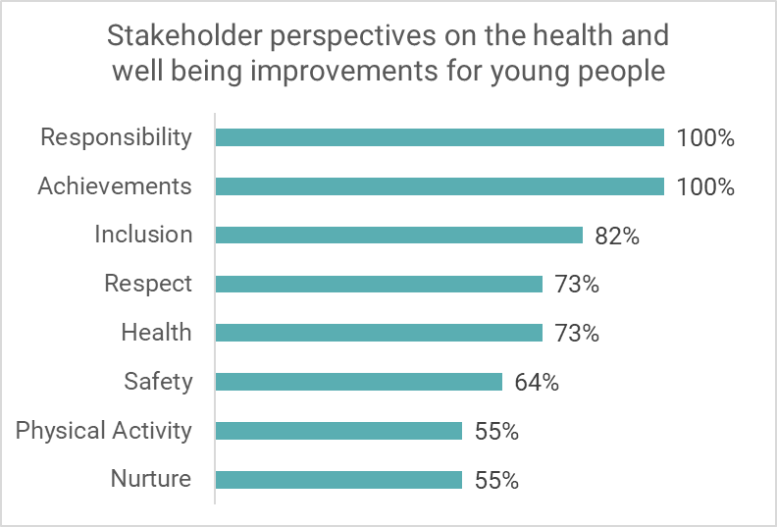
- Overall, stakeholders felt that Development Awards had a positive impact on young people’s health and wellbeing. The chart below shows how stakeholders responded to the survey. All stakeholders responding to the survey reported noticing improvements in young people’s sense of responsibility, their level of maturity, and their sense of achievement.

- Some stakeholders felt that the Development Award helped young people to feel more included, particularly when they went on a work placement or a training course, as it allowed them to feel that they were on an equal footing with other young people. This was particularly apparent for young people from very disadvantaged homes, or who had been looked after in care – and the Development Award helped them feel that they deserved the same opportunities as others, and were capable of achieving as much as other young people.
“When they go on training or work placements, people don’t know that they’ve been in care, so they feel ‘normal’, and included in the community.”
Stakeholder

- Stakeholders also commented that they felt young people seemed less anxious, and more hopeful about themselves and about the future. A few stakeholders felt that young people had become more realistic and that this helped them to make better, more positive decisions.

“The young people have a brighter outlook on life thinking about the possibilities that await them if they put their mind to it rather than focusing on the obstacles that could be in their way.”

“Overall the young people have come on leaps and bounds since receiving their Development Award. They have become responsible citizens within their community, effective learners and using this to better themselves. This has had a positive effect on the young’s people confidence and self-worth.”
Stakeholders

- A number of stakeholders commented on improvements to young people’s mental health. They felt that at first this was this was due being successful in receiving the award, and latterly due to improved confidence and self-worth in how they used the award. For example, one stakeholder said that using the award to dress appropriately for a job interview or work placement helped young people to feel more confident, more responsible, and ultimately more professional.

“It is clear the young people improve in regards to mental health as they receive a massive boost from receiving the award.”

“I would say mostly in regards to their emotional wellbeing as when they are completing training they feel they are achieving and progressing with their career plan. I believe when they can see progressions they are making it has a ripple effect in how it makes them feel and in turn effects their behaviours.”
Stakeholders

- A few stakeholders linked increased sense of achievement, with an increase in self-respect. As young people accomplished more, they gained more confidence in their abilities and more respect for themselves.

- One stakeholder felt that the programme contributed towards a sense of safety for some young people, such as those living in supported accommodation or in hostels, as it supported them on their journey towards earning money and improving their living situation.

Outcome 6: Young people participate in activity which improves their learning, employability and employment options

- Data in this section is taken from the Prince’s Trust reporting scorecard, which records progress towards outcomes for participants on a quarterly basis. The table below summarises the targets and achievements in relation to this outcome.

- The Prince’s Trust has achieved and exceeded its overall target for 760 young people to progress into a positive destination. Although very few young people have progressed into volunteering, more than anticipated have progressed into employment, education or training.
Progression to positive destinations
Destination | Achieved | Annual target | Achieved% | Overall target
Employment | 457 | 418 | 48% | 44%
Further education or training | 340 | 247 | 36% | 26%
Volunteering | 4 | 95 | 0.4% | 10%
Total positive destinations | 801 | 760 | 84% | 80%

- The Programme Manager recognised that the award was not being used to progress into volunteering opportunities. The programme is addressing this, by raising awareness with partners of how the award could be used to support volunteering opportunities, for example, to purchase clothing or equipment required for volunteering outdoors. The Programme Executives will also be targeting organisations that deliver volunteering opportunities to young people, to try to boost the number of young people progressing to volunteering.

- Stakeholders felt strongly that Development Awards supported young people’s progression into positive destinations. For many young people, the award allowed them to progress to a training course, to undertake a work placement or to start a business. Some stakeholders commented that although the award amounts were often relatively small, the difference they made was significant.

- One young person wanted to start her own mobile hairdressing business but was struggling with the start-up costs, as her car needed to be serviced. She used the Development Award to purchase the products she needed, allowing her to use her own money to get her car serviced.

“It has allowed her to start up . . . getting this bit of help allowed her to hit the ground running.”
Stakeholder

- One young person used the Development Award for a provisional driver’s licence and a laptop as he was about to start university. This young person was autistic and had a challenging family background. The laptop and licence have enabled him to get the best out of his time at university, and have given him the freedom to study independently.

“He is doing fantastic now. He was anxious working in groups. . . . if he hadn’t been given the means to study on his own outwith his house, he would never have done this. It has really made a big difference.”
Stakeholder

Outcome 7: Young people participate in positive activity

Target: 80% of young people will participate in positive activity.
Annual target: 600 young people will participate in positive activity.

Achieved: 97% of young people participated in a positive activity through the Development Award..
Achieved: 923 young people participated in a positive activity through the Development Award..

- Young people have used Development Awards to help them access, participate in and stay engaged in a range of positive activities. These included training courses, further and higher education courses and work placements.

- In year one, we have predominantly focused on gathering feedback from stakeholders. In year two we will conduct telephone interviews with young people to gather more qualitative information on their experiences. This will provide further evidence towards progress around this outcome.

- Stakeholders we engaged with felt that Development Awards had a crucial role in helping young people participate in positive activity. Most young people used their award to directly or indirectly engage in positive activity.

- For example, young people used the award directly by funding training courses. Stakeholders reported that attending, engaging with and completing the course was a positive activity, which young people would not have had the opportunity to do had it not been for the Development Award.

- Indirectly, young people used the awards to overcome a barrier to positive activity, such as travel costs or clothes for job interviews and training programmes. Again, stakeholders felt that young people would not have been able to engage in these positive activities without the support of the Development Award.

Target: 80% of young people are new to the activity.
Annual target: 600 young people are new to the activity.

Achieved: 93% of young people were new to the activity.
Achieved: 886 of young people were new to the activity.

- The Prince’s Trust defines new to the activity as young people that had not received a Development Award before. Young people are allowed to apply for multiple awards, up to the value of £500, and some young people within year one had applied for more than one award. For example, a young person may apply for an award to help fund a training course. Upon completing the course they may need support to help them travel to a work placement, or to take the next step into employment. Development Awards can continue to support the young person provided that the total award amount does not exceed £500.

Case study example (Adapted from Prince’s Trust)

One young person was supported through multiple Development Awards to achieve his goal of studying Dentistry at University. The young person had arrived in Scotland and was unable to return home due to the civil war. He struggled to gain employment as his qualifications were not recognised in Scotland, and he had no prior work experience.

His first Development Award supported him gain the relevant qualifications and begin work as a door supervisor. This gave him the experience, confidence and skills he needed to apply for other employment.

“I liked that I was able to apply for more than one award to help me on my journey. The first award helped me gain a stable footing and foundation to grow.”

He then received a second Development Award, which supported him to go to college and achieve the Highers he needed to apply for a place at University. He was successful in is university application and is now progressing well with his dentistry degree.

“The second award allowed me to take that stability and have a real chance at achieving my goals in life. The ability to apply for awards at different stages in my journey is very helpful.”

He is grateful for the support he received from Development Awards, and now feel very hopeful for the future.

“I want to make the most, of not only the financial help and stability that was given by The Prince’s Trust, but also the bright ray of light of caring and kindness that has been shown to me by the staff that has helped me get to where I am now.”

- Partnership Work

Introduction

  - This chapter explores views on partnership working, including what has worked well and areas for improvement. This chapter is based on seven interviews that we conducted with stakeholders, a discussion with the Programme Manager and 11 stakeholder surveys. Partners engaged this year were predominantly referral partners and people from organisations that support young people to use their Development Award.

What worked well

  - Existing partners appeared to have a good understanding and awareness of the programme and what it can offer. Some partners said that they return to Development Awards year after year, because the awards support the work that they do with young people around training and employability.

“The funding is brilliant. It fits really nicely in terms of what we’re doing, which is upskilling young people.”
Stakeholder

  - They also felt that the awards provide a straightforward way to unlock opportunities for young people, and for young people to identify their interests – giving them a better idea of what a job would entail and if they want to pursue employment in a particular industry.

“The Development Award enables young people to go for opportunities they might not have previously. For example, one young person wanted to go to college, but she told a worker to do the course she had to have all the hairdressing equipment. She had not applied as she knew she did not have the money to do this. Her worker spoke to her about the Development Awards, she then applied, got a place and the funding to pay for the equipment she needed.”
Stakeholder

  - Partners spoke highly of the programme and programme staff. They felt that the Awards give young people the best possible chances in the world of work.

“The Development Awards allows us to match the client to vacancy opportunities and ensure they are skilled-up before interview, thus promoting positive outcomes and routes to progression. Without the opportunity of the Development Awards our clients would not have progressed as well as they have.”
“We couldn’t do it without the Prince’s Trust.”
“It’s helping them maximise their chances of getting a job.”
Stakeholders

  - The wider support from staff was highly valued, and helped ensure that referral partners and young people knew what to expect from the programme.

“She’s honest all the way through the process, young people know that it isn’t guaranteed that they will get the award, and she is rally clear about that from the beginning. It gives them realistic expectations.”
“The support that we get is good. We have good relationships and it’s a pretty smooth process.”
Stakeholders

Applying for Development Award
Stakeholders spoke positively about the process of applying for a Development Award. Overall, they felt that the process of applying was fast, easy to understand and straightforward.

A few stakeholders said that they appreciated the flexibility that the Programme Executives offered them. They said it was helpful that staff could meet young people at the Prince’s Trust, at their own premises and also at events hosted by the Prince’s Trust, where they could be assessed for awards.

Some stakeholders worked closely with young people to apply for and utilise the award. Others felt that doing the application themselves was an opportunity for young people to learn something new and to take ownership of the process. Those who took this approach felt it was a valuable experience and motivated them to make best use of the award and the opportunities available to them.

“The application process makes them take responsibility and take ownership of the Award."

  - Where young people were using the award for clothing or equipment, stakeholders appreciated that the awards allowed them to buy good quality products, as this helped young people to feel equal to their peers when they were in the work place.

  - One partner, that supports young people to use their Development Award noted that the award helped the young people to continue contact with the organisation and maintain their placement. They felt that this was because the award had funded a structured training course, which had given the young person motivation and incentive to maintain engagement.

  - More widely, one stakeholder reported that young people completing training courses (funded by a Development Award) become role models amongst their friends – who then enquired about how they could achieve the same outcomes. This stakeholder felt that the Development Award facilitated young people to develop themselves and put back into their communities, rather than continuing old patterns of behaviour.

New partnerships

This year the programme has developed a new partnership with schools in North, South and East Ayrshire. The Programme Manager felt that this partnership had worked very well. Awards delivered in these local authorities has increased significantly, from 184 awards last year to 340 awards this year.

The partnership works between Development Awards, individual schools and Developing the Young Workforce (DYW) – building on an existing partnership between schools and DYW.

The partnership supported young people who had been identified by their schools as at risk of exclusion or at risk of not achieving. Development Awards were used to fund appropriate courses for these young people, and DYW which covered the cost of any equipment required.

Where the partnership has been particularly successful, it was felt to be because there were partners in individual schools that had bought into the idea, and were actively supporting young people to access the award. The Programme Manager felt that this partnership had been successful, as it provides positive outcomes for young people and fulfilled the aims of all three partners involved.

  - The programme has worked closely with other CashBack partners. This year, the Prince’s Trust ran a two-day training programme, which allowed eleven members of staff from eight different CashBack funded organisations to become fully trained Development Award assessors. The organisations included:

- Action for Children;
- Wise Group;
- Bridges Project;
- National Autistic Society;
- Venture Trust;
- Impact Arts;
- Basketball Scotland; and
- Barnardo’s.

  - This has allowed for a more streamlined approach to providing Development Awards to young people involved in other CashBack activities.

“It makes it a smoother, easier process for the young people.”
Programme Manager

  - Programme staff have worked to develop new partnerships, particularly with organisations that support young women and minority ethnic young people. In total, staff have developed relationships with five new partner organisations that have provided regular streams of referrals.

Areas for improvement

  - The Programme Manager reported that not all potential partners were keen to engage, despite staff reaching out and offering onsite support. The Programme Manager will continue to encourage the Programme Executives to be active in the community and to encourage communication with potential partners as much as possible.

  - Most long term referral partners we spoke to had been using the Development Awards for the same purpose each year. For example, one stakeholder was a training provider, and had only ever used the award to fund additional training courses for young people (in addition to their own provision). Another stakeholder had only ever used the award to fund clothing for young people going on work placements or interviews. In some cases, partners had been going through the same process with the Development Awards for some years, and were not aware, or could not recall, that awards could be used in a range of ways to support young people. Similarly, some stakeholders were not sure what the maximum award amount was, or if young people were eligible to apply for more than one award if their needs changed.

  - One stakeholder said that it would be useful to extend the age range for CashBack Development Awards up to the age of 30, as this would benefit care experienced young people. The Programme Manager noted that Prince’s Trust works with young people up to the age of 30, however CashBack funded Awards are only delivered to young people up to 24.

  - A small number of stakeholders commented on the time it took to process a Development Award. For some the process was simple and quick. Prince’s Trust reports that the Awards can take up to eight weeks to be processed, but that most are processed within five or six weeks. In some cases, Prince’s Trust has also expedited the process time, where a young person has applied at short notice. One stakeholder reported that they had been working with the programme for many years, but that recently the processing time seemed to have increased, and they felt that they were having to follow up with staff to ensure that awards were being processed in time for young people to use them. The Programme Manager noted that at certain times of the year the processing time may take longer, but that Awards are usually processed within eight weeks.

- Conclusions and Recommendations

Introduction

  - This chapter provides an overview of progress in year one of CashBack funding. It summarises the programme reach, outcomes achieved and next steps.

  - The programme has reached more than its intended target number of young people, and has remained within its allocated budget. Most awards recipients were from Glasgow and Ayrshire. A new partnership with Ayrshire schools supported an increase in awards across all three Ayrshire authorities. The programme reached more young men than young women. Programme staff are continuing to work to address the gender imbalance as much as possible, to ensure that it aligns with the national picture of young people meeting the eligibility criteria.

  - Overall, the programme has made good progress towards most of its outcomes. Stakeholders spoke highly of the programme, its impact on young people and of programme staff. In particular, stakeholders reported strong outcomes around changes in confidence, behaviour and aspirations of young people. The table below summarises the outcomes achieved during year one.

Summary of CashBack outcomes and progress for year one, Phase 4
Outcome 1: Young people build their capacity and confidence | The programme has made good progress towards this outcome, although it fell slightly short of one target. Stakeholders felt strongly that the award helped increase young people’s confidence and capacity. Most young reported that they felt more confident, and almost all said that they felt able to do new things since receiving an award.
Outcome 2: Young people develop their physical and personal skills | The programme has made good progress towards this outcome. Most young people reported an increase in their skills. The programme has met and exceeded its targets for young people gaining accreditation and young people achieving positive outcomes in education or training. Stakeholders spoke positively about the skills young people had developed, particularly around communication and proactive job searching.
Outcome 3: Young people’s behaviours and aspirations change positively | The programme has made very good progress towards this outcome, meeting and exceeding all targets. Stakeholders said they had noticed significant changes in young people’s behaviour, levels of maturity and motivation to succeed.
Outcome 4: Young people’s wellbeing improves | Information from young people and stakeholders shows that the programme has made good progress towards this outcome and has met and exceeded its targets. Stakeholders felt that young people developed an increased sense of responsibility and achievement, and that receiving an award had a positive impact on mental health.
Outcome 6: Young people participate in activity which improves their learning, employability and employment options | The programme has made good progress towards this outcome, meeting and exceeding targets for young people to progress into employment, education and training. It still has some work to do around supporting young people into volunteering.
Outcome 7: Young people participate in positive activity | The programme has demonstrated that it is achieving this outcome, with young people using the award to access and engage in a range of positive activities.

  - Despite challenges caused by moving to a new national monitoring system, the Development Awards Programme has tracked young people and their progress adequately. Going forward, it will be beneficial for staff to have access to more information, particularly around protected characteristics. This will help ensure that the programme is reaching a broad demographic of young people.

  - A key success of evaluation this year has been the new approach to gathering feedback from young people. Having dedicated staff to issue the survey online and by telephone has allowed the programme to reach significantly more young people than in previous years. This has provided more meaningful data, from a wider pool of award recipients.

Next steps

  - Going forward the Programme Manager would like to host more CashBack celebration events. This years event was considered a success, and provided a good opportunity to meet with partners and develop relationships.

  - The partnership with schools in Ayrshire has been successful. The Development Awards team could consider developing similar partnerships in other local authorities with areas of deprivation, to increase participation in areas where few awards have been delivered.

  - Over the next two years of Phase 4, the programme will focus on engaging more young women and developing sustainable partnerships. Programme staff reported that they will strive to engage more organisations that work with young women and minority ethnic communities.

  - The programme hopes to train more individuals as assessors, allowing for more a more efficient referral pathway. The programme also plans to host more open day events across Glasgow, Edinburgh and Dundee to help raise awareness and assess young people for Development Awards.

  - The programme also hopes to increase the number of award recipients moving into volunteering. The delivery team will be developing a strategy to approach organisations that deliver volunteering opportunities for young people, in order to address the shortfall.

  - Our evaluation work over the next two years will involve:

Year 2
  - 30 telephone interviews with young people;
  - two case studies on young people;
  - staff interviews/discussion group; and
  - data analysis.

Year 3
  - staff interviews/discussion group;
  - data analysis; and
  - a case study.

Prince’s Trust, Development Awards Toolkit, 2012
As above
25 young people received two Development Awards. Each Award is counted as a single participation.
https://www.ons.gov.uk/employmentandlabourmarket/peoplenotinwork/unemployment/bulletins/youngpeoplenotineducationemploymentortrainingneet/march2018#total-young-people-who-were-neet
http://www.gov.scot/Topics/People/Equality/Equalities/DataGrid/Gender/GenCrimeJust
This data was provided by Prince’s Trust at a point when data on all 955 award recipients was not available.
This data was provided by Prince’s Trust at a point when data on all 955 award recipients was not available.
^{, 9} These targets were measured using data from the survey of young people, which was conducted with a sample of award recipients. Data provided was an extrapolated figure, based on the sample. As we cannot ascertain if the sample was representative, we have reported the achievements as a percentage, rather than a numerical figure.
This target was measured using data from the survey of young people, which was conducted with a sample of award recipients. Data provided was an extrapolated figure, based on the sample. As we cannot ascertain if the sample was representative, we have reported the achievements as a percentage, rather than a numerical figure.
This is based on data from the Prince’s Trust reporting scorecard which records that 496 young people achieved a qualification or accreditation.
This target was measured using data from the survey of young people, which was conducted with a sample of award recipients. Data provided was an extrapolated figure, based on the sample. As we cannot ascertain if the sample was representative, we have reported the achievements as a percentage, rather than a numerical figure.
This is based on data from the Prince’s Trust indicating that at least 638 young people used the award for course fees, and that 496 young people achieved a qualification or accreditation.
This is based on Prince’s Trust data on award categories for 945 young people.
^{, 16} This target was measured using data from the survey of young people, which was conducted with a sample of award recipients. Data provided was an extrapolated figure, based on the sample. As we cannot ascertain if the sample was representative, we have reported the achievements as a percentage, rather than a numerical figure.
This target was measured using data from the survey of young people, which was conducted with a sample of award recipients. Data provided was an extrapolated figure, based on the sample. As we cannot ascertain if the sample was representative, we have reported the achievements as a percentage, rather than a numerical figure.
This is based on data from the Prince’s Trust reporting scorecard.
This is based on data from the Prince’s Trust reporting scorecard.
This is based on data from the Prince’s Trust reporting scorecard.
This is based on data from the Prince’s Trust reporting scorecard.
This is based on data from the Prince’s Trust reporting scorecard.

