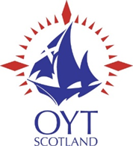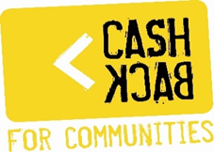

Ocean Youth Trust Scotland – CashBack for Communities
Changing Tack with CashBack
Year 1 – End of Year Report 2020/2021

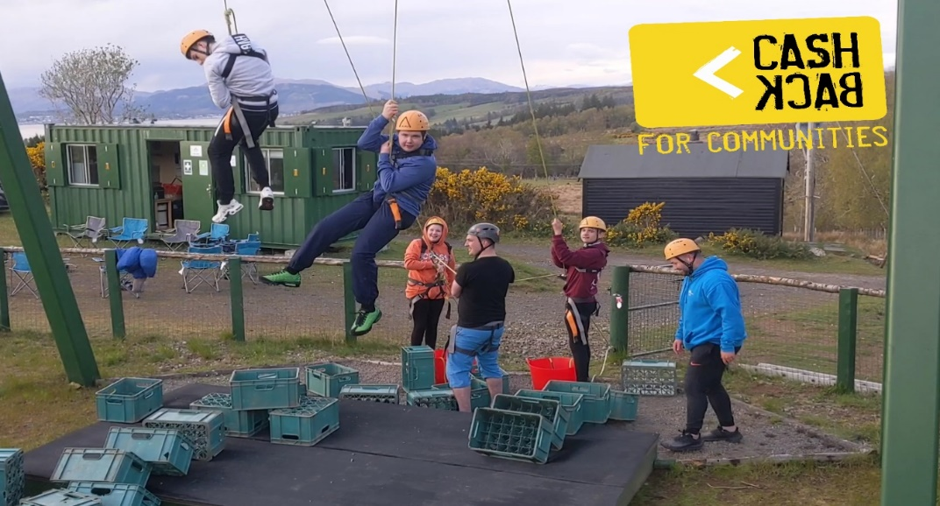

Victoria House, 5 East Blackhall Street, Greenock, PA15 1HD
T: 01475 722 722
E: office@oytscotland.org.uk
W: www.oytscotland.org.uk

Scottish Charity No. SC029531

Contents

Overview 3
Summary of Programme Delivery 4
Budget Implications as a result of Covid-19 6
Outcomes 7-14
Communities we worked with 14
Organisational Development 14-15
Social Media impact 15

Plans and Priorities for Year 2
Outdoor Activities and Potential Ministerial Visits 16-17
Case Study: the GK Experience 18

OVERVIEW
Change Tack With CashBack draws on more than two decades of expertise delivering Ocean Youth Trust (OYT) Scotland’s unique brand of youth work at sea.
2020/21 should have brought to fruition the first year of a pioneering three-year project, aimed at delivering youth work at sea to more than 29 young people from twelve local authorities across Scotland. These young people were to consist primarily of those deemed most at risk of entering the judicial system or engaging in antisocial behaviour, with the intention of steering them on to more positive destinations.
However, in March 2020, the world was hit by the global coronavirus pandemic, the impact of which was particularly devastating for the delivery of our youth work at sea. Two national lockdowns, travel restrictions and strict social distancing measures meant delivering youth work in the close confines of a sail training boat was simply not feasible or permitted within the Government or Sail UK restrictions. Since March 2020, the Trust has remained unable to deliver our traditional form of youth work on the waves and the three training boats have been in dry dock.
The Scottish Government’s Lockdown Lowdown Report showed that almost two fifths (39%) of young people questioned (39%) stated that they felt Moderately or Extremely concerned about their own mental wellbeing as a result of coronavirus. Mirroring this, Tim Frew, CEO, YouthLink Scotland, stated:
“Many young people are anxious about what life is like now and what it will be like post lockdown, and the impact of social isolation on their mental health and wellbeing. Youth workers will continue to find innovative ways to support young people through this uncertain time in their lives. It is not just the actions as a society we take now that will be crucial, young people deserve a commitment to the continuity of the services that support them post COVID-19.”
The ethos of OYT Scotland is to teach young people to thrive and adapt in the face of challenge and adversity. Therefore, as a Trust we adapted our youth work model in the throes of the pandemic in order that we could continue delivering life-changing youth work to the young people who have arguably never needed it more.
Once restrictions allowed, we designed and implemented a new and bespoke land-based youth development programme. Led by our Youth Development Worker (YDW) and our new CashBack ‘Toolkit’ of on-shore workshops and activities, we embarked on a new enhanced programme that included working with other outdoor providers across the country where we could support groups to participate in activities that promote wellbeing and work towards all CashBack outcomes.
For the first time in the Trust’s history, we have provided land-based youth work, successfully adapting our unique and proven model of delivering youth work at sea and applying it to activities on shore. Despite a national lockdown for more than half the year, we managed to support four groups, including disadvantaged 29 young people.
We are extremely proud to be a Scottish Government CashBack for Communities partner, committed to making a real difference to the lives of deserving young people across Scotland.

Our Belief
We believe that all young people regardless of circumstance or ability should have the opportunity to realise their true potential in order for them to live healthy, fulfilling lives and make a positive contribution to their community.
Our Mission
We exist to inspire young people through the challenge of youth work on the waves. Residential voyages aboard our fleet of sail training vessels provide a uniquely powerful and extremely effective environment for the personal development of young people from a diverse range of backgrounds throughout Scotland.
Our Voyages
The unpredictable environment aboard our vessels presents real physical, mental and emotional challenges. It is a genuinely life-changing experience with unique learning opportunities.
SUMMARY OF PROGRAMME DELIVERY
As a result of the Covid-19 pandemic and the restrictions imposed by the national lockdown, the Trust was severely hindered in delivering our youth work programme. The management committee took the difficult but unavoidable decision to cancel the youth work sailing programme for 2020, rescheduling all youth voyages until July 2021 in line with Government advice.
In Q1 and Q2, the progress on achieving the agreed CashBack outcomes was significantly impacted by the government restrictions forbidding any OYT Scotland voyage or group work from taking place. This continued to have devastating effect on OYT Scotland as we entered Q3.
In response, the Trust redesigned and redeveloped our entire CashBack delivery programme to focus on what we could realistically deliver to help improve outcomes for young people using our unique expertise. We devised a pioneering land-based youth work development programme that incorporated a series of dynamic and interactive outdoor activity sessions for identified groups, to be delivered as part of the Cashback for Communities programme. Group activities were to include archery, tubing, orienteering, crate climbing and kayaking. The Youth Development Worker undertook significant work to ensure this newly created land-based youth work met the agreed CashBack outcomes.
The new enhanced programme planned to deliver 18 outdoor sessions throughout Q3 and Q4. We successfully delivered our first two group sessions in Q3, with a group of 10 young people from the GK Experience enjoying two workshops involving white water tubing, an Easter egg hunt and a group BBQ; and St Pauls Youth Forum who benefited from an outdoor BBQ and two workshops from the CashBack toolkit.
To reflect the change in programme delivery, we updated the outcomes template with revised targets. Regrettably, we were forced to postpone two sessions due to a further imposed lockdown and tightening of government restrictions in Q4. We worked with partner organisations to reschedule these sessions to take place in Spring 2021, and subsequently successfully delivered 15 activity sessions in April and May 2021, albeit this being Q1 of Year 2.
Staff training and development have remained a key focus for OYT Scotland. Our Youth Development Worker has now completed four sessions of the ‘Iheart’ Resilience and Wellbeing Webinar course, which aims to equip practitioners with the skills needed to promote personal and professional wellbeing. This will be used to develop the OYT Scotland CashBack program further as we endeavour to deliver wellbeing workshops later in the year as part of the Cashback Programme.
St Pauls Youth Forum
The reach of the programme to date is 23. A postcode analysis shows that the majority (85%) of participants live in deciles 1 and 2 in the Scottish Index of Multiple Deprivation (SIMD), representing the most deprived 20% of datazones in Scotland. The area of Blackhill and Hogganfield, situated in the East of Glasgow, where many participants of St Paul’s Youth Forum live, is reported in the Understanding Glasgow database as follows:
“A high percentage of young people are not in education, employment or training and a high percentage of the adult population claim unemployment and disability benefits.”

The report declares that the area has a higher proportion of young people than Glasgow as a whole. Amongst those young people, 11% are from a black and ethnic minority. More than a third (34%) of 16–19-year-olds from this area are not in employment, education or training; which is +22% higher than Glasgow overall.
Hospitalisations due to assault are +114% higher in this area than in Glasgow overall. The offenders per 1,000 of the population aged 8-18 is 11 (26.6%). Statistics show that 31% of young people living in this area live in poverty, while 43% are in lone parent households and 14% of households with children are deemed to be overcrowded.
This gives us a good insight into the challenges faced by young people living in the Blackhill and Hogganfield area, in addition to the ways in which OYT Scotland, through the CashBack for Communities programme, can support young people in their development. An interesting observation where OYT Scotland can have an impact through the land and sea-based activities is that only 56% of under sixteens in this area live in proximity to green space, which is 30% lower than Glasgow overall.
A similar analysis will be carried out, where information is available, on other partner areas as part of the case study research.
BUDGET IMPLICATIONS AS A RESULT OF COVID 19
The inability to deliver our youth work at sea had inevitable financial implications in terms of the budget awarded to the Trust.
The vessel running costs were less than normal and consisted of the basic standing charges incurred for the period. Staff costs incurred were based on the actual cost of the Youth Development Worker.
There were no costs incurred for a share of the wages for the Skipper, 1st Mate or Development worker as they were respectively furloughed under the Government’s Job Retention Scheme in Q1 and Q2. Additionally, there were no costs incurred for travel or certification.
A revised phased budget was submitted for 2020/21 when it became apparent that youth work could not commence until Q3, the variations in spend relating to the dynamic outdoor activities and related travel costs.
Many of the vessel costs will continue to be incurred whether we run voyages or not. However, there was a saving of £10,406 compared with our original budget for vessel costs (reduced harbour fees, fuel, food and cleaning supplies, chandlery and repairs). Staff costs will also be less than originally budgeted by £12,410, as there are no vessel staff costs incurred.
Additional costs arose from the outdoor activities and while there was no travel to/from the vessel, there was travel to/from activities. The dynamic outdoor sessions cost the Trust £2,605 which was not part of our original plan. However, this was more than offset by the reduction in other costs. We have added management and external evaluation cost at the prescribed 10% and 5% respectively. All variances are shown on the table below.
In Phase 5 Year 1 OYT Scotland was awarded £54,908. We supported 29 young people, at a cost to the Trust of £1,893 per person, as shown in the table below.

Local Authority | Group | No. of Young People | Spend
Glasgow North East | St Pauls Youth Forum | 10 | £18,933.80
Glasgow | theGKexperience | 10 | £18,933.80
East Lothian | Musselburgh Grammar | Postponed
Fife | Glenwood High School | Postponed
Perth | REACH | 9 | £17,040.41
Various | Action for Children | Postponed
Inverclyde | Port Glasgow High School | Postponed
TOTAL SPEND |  |  | £54,908

PROGRESS ON OUTCOMES
Our External Evaluators, Catch the Light, have developed a comprehensive evaluation framework and have worked on compiling case studies and data from feedback and reports from participants.
This is a proven evaluation process and one used for previous CashBack programmes delivered by Ocean Youth Trust Scotland. Unfortunately, the target participant numbers for CashBack Phase 5 have, to date, inevitably not been achieved due to pandemic restrictions and the impact of Covid19. Target numbers going forward are therefore being reviewed.
Based on data gathered to date, our evaluators have proposed, regardless of revised participant numbers for the remainder of Phase 5, that they expect the enhanced programme will in fact result in increased percentages for a number of the outcomes.

Due to our enhanced programme, we have increased the percentages of some of the outcome targets as we are confident that this new programme will have a more positive and significant effect on participants. Originally, we planned to work with 224 young people. While this number has been reduced 152, we have focused on giving young people a more intense and progressive experience through our land-based development program.
Outcome 1: Young people build their confidence and resilience, benefit from support networks and reduce risk taking behaviour.
OYT Scotland created a ‘Cashback Toolkit’ which includes workshops covering an assortment of important youth issues. This toolkit includes 12 workshops focusing on issue-based youth topics including resilience and the reduction of risk-taking behaviours in addition to mental health and self-care, dealing with conflict, and internet safety.
The workshops were designed to be both engaging and educational, covering topics that relate specifically to the agreed CashBack outcomes.
In Q3 we successfully delivered our first ‘Introduction to Ocean Youth Trust Scotland’ workshop from The CashBack Toolkit. This was delivered to 12 young people from Saint Pauls Youth Forum in Glasgow’s North East. The session, which incorporated a BBQ, provided an invaluable opportunity to meet with a group of young people and show them the OYT Scotland programme and start the process of building positive relationships.
Crucially, this event also enabled us to begin the baseline evaluation process using a digital evaluation tool made with Evaluators, Catch the Light. This baseline data will be instrumental for measuring the impact of how the OYT Scotland youth work programme achieves all CashBack outcomes and will be reported on as we progress. Early observations have shown that the young people we have worked with to date are reporting an increase in confidence and willingness to try new things.
“I want to use this to get more confident as I struggle with talking to people.”
Young person, St Pauls Youth Forum

Young people from St Pauls Youth Forum enjoying Archery
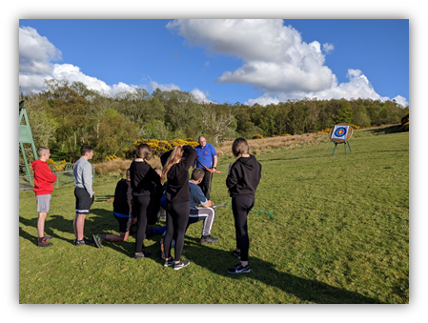

Outcome 2: Young people develop their personal and physical skills.
A significant piece of work that was undertaken by the Youth Development Worker in Q1 was the redevelopment of the Trust’s logbooks to make them more engaging, fun, understandable and accessible for the young people with whom we work. These changes were intended to help reduce barriers young people have historically faced in completing the log books and to ensure that young people who engage with the programme will be upskilled on completion. Most importantly, the log books are an effective way for the young people to measure the skills they have acquired throughout the programme and to record their experiences and learnings as they develop.
In redesigning our youth work programme to overcome the barriers presented by the pandemic, our outdoor activity sessions were intended to promote physical and mental wellbeing. A partnership was established with Pinkston Watersports Centre and other outdoor providers who offer a range of fun and engaging outdoor activities, including tubing and kayaking in addittion to providing meeting-room facilities. Bringing young people together for the first time both to meet each other and the Youth Development Worker and to participate in these physical activities will engage our groups in working towards achieving Outcome 1.
In Q3, our land-based development programme saw 10 young people from the CashBack group theGKexpierence take part in one such activity at Pinkston Watersports, namely white-water tubing. Young people participated in the fun yet physically demanding activity alongside our Youth Development Worker. The group also enjoyed a BBQ and some games. This was a unique opportunity for these young people to start building positive relationships with each other and with our Youth Development Worker.
“Our first session at the Pinkston Watersports Centre provided the almost perfect setting for the group to get to know each other and participate in a challenging activity! The cold weather didn't hamper the excitement of the team and the day served as a great introduction to our partnership between theGKexperience and the Ocean Youth Trust Scotland.”
Senior youth worker, theGKexperience

Prior to the activity, our Youth Development Worker delivered a presentation outlining what the session would entail and the benefits it could provide, to which the group responded with both positivity and great interest, displaying an encouraging level of enthusiasm. They asked a plethora of questions about the programme and what to expect.
Early observations show that participants are responding with enthusiasm to the opportunity to partake in physical activity and develop their interpersonal skills. Indeed, following the session, one of the group leaders pointed out that one of the young people who regularly displayed challenging behaviours had seemed particularly engaged and had evidently learned a new skill about which they felt proud.
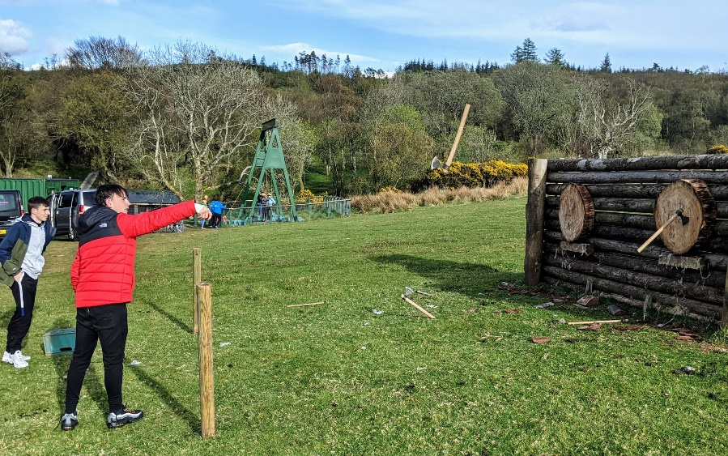
Young people from theGKexperience enjoying axe-throwing
Outcome 3: Young people’s health and wellbeing improves.
We know that young people have been disproportionally affected by the pandemic and that supporting them is a key priority for the First Minister as set out in the recent Programme for Government.
The newly designed OYT Scotland Cashback Toolkit incorporates specific health and well-being workshops. We increased the focus on mental health due to the findings that emerged from the ‘LockdownLowdown’ report from Young Scot and Scottish Youth Parliament. This report found that 77% of young people are worried about their mental health and wellbeing as a result of the pandemic. These health and well-being workshops are explicitly linked to SHANNARI indicators and include some of the following topics:
- Smoking
- Substance Misuse
- Knife Crime
- Mental Health and Self Care
- Sexual Health
- Managing Conflict and Emotions

Through attending vital partnership and training events hosted by Youthlink Scotland we worked with the Scottish Centre for Conflict Resolution to create a session on manging conflict and emotions to support young people to both manage and take better care of their own emotional wellbeing.
“Ocean Youth Trust have been able to adapt it’s programmes to ensure that the young people face minimal disruption in their planned voyages. By working outside with the small group of vulnerable young people, Barry McLaughlin, the Youth Development Worker, has been able to build relationships, enable the young people to take part in exciting activities, with Archery and Axe throwing being a firm favourite.”
Group Leader, St Pauls Youth Forum

Outcome 4: Young people participate in activity which improves their learning, employability and employment options (positive destinations).
The young people identified and supported by the Cashback Phase 5 programme often leave school with no qualifications.
Participants are able to attain up to eleven external qualifications during the programme, namely SQA National Qualification Core Skills Units at Level 3, including: Listening, Reading, Speaking, Writing, Measuring, Calculation, Using Graphical information, Problem Solving, and Working with Others. As they progress through the programme, the young people gain qualifications and thus increase their employability skills, subsequently working towards achieving Outcomes 5-6.
An example of the young people improving their learning and employability was when the OYT Scotland youth forum was supported in hosting an Instagram takeover as part of our digital engagement. This required the young people to use written skills, creativity, imagination, digital engagement and develop skills in social media management. The young people had to understand the audience they were targeting via different social media channels, and adapt the tone, language and content of posts to fit that audience, just as they might have to adapt their language or behaviour for different situations in life.
“The valuable skills, lessons and knowledge we gained from our time has really benefited us as young leaders and has allowed us to progress in other things.”
Young person from St Pauls Youth Forum
In conjunction with working towards this outcome, OYT Scotland has continued to keep up to date with requirements from the SQA with regards to internal assessment and evidence gathering. We redeveloped our Assessment Checklists, marking schemes and internal verification paperwork in accordance with the changes made to our Logbook.
We were due to receive a Quality Assurance visit from an External Verifier for the ‘Problem Solving’ and ‘Working with Others’ Units, however due to Covid-19 this was postponed until a voyage has been completed.
“Our group are very excited that after a year of disappointments that OYT Scotland is able to provide the young people with life long memories enabling change and development.”
Neil Young, Youth Team Leader, St Pauls Youth Forum

Outcome 5: Young people contribute positively to their communities.
In Q1 we worked to support the OYT Scotland Youth Forum, a group of young people that was established to provide a voice for the views, interests and preferences of young people and to ensure OYT Scotland remains relevant to those it seeks to support.
As part of the forum, young people are upskilled and take part in decision-making processes within the organisation. We are currently working with a group of six young people from various parts of the country and of various different backgrounds.
This group is a vital part of the Cashback Programme process. Three of the young people have taken part in previous CashBack voyages, as both participants and volunteers, so have valuable insight and experience of what the programme can do to support young people. Covid-19 restrictions meant digital engagement was the only way in which to work with this group. Throughout Q1, the OYT Scotland Youth Development Worker worked with this group to enhance the contribution they make to their communities, by engaging in voluntary work.
The Youth Forum was supported on digital platforms including Zoom and Instagram and tasked with organising social media posts and events. This included hosting a takeover of the OYT Scotland Instagram account for seven days. During this takeover the Youth Forum was able to celebrate and tell others the story of their respective OYT Scotland journeys based on their own experiences. Through this process the group was able to learn how to manage a charity’s social media campaign, while using their digital, written and creative skills.
The young leaders had this to say on their final post of the Instagram Takeover:
“We want to use this platform to show just how important it is that we are able to still sail and volunteer next year and that young adults are able to have the same experience as what we have all had! But also to all volunteers, staff and donors involved in the Trust to whom our journey from when going as a young adult wouldn’t be possible and I’m sure we speak for every young person who has been on a voyage and benefited from their own personal journeys!”
Young Leader

“We have all experienced just how much of a positive and inspiring impact our time with OYT Scotland has had on each of us and we feel very strongly that the Trust truly is life changing and we are proud to be the products of it all. Especially in these unprecedented times, it has made us all realise just how important it is that we keep volunteering and donating, whether it be money or time so that we are able to give young people like us the chance to really benefit and make a change”
Young Leader

Our focus on shore-based youth work will enrich the entire CashBack programme and the overall OYT Scotland experience, ahead of young people going to sea next year. The focus on team building, relationships and engagement in year one means that the young people with whom we have worked will be better prepared for our voyages and for life in general. As a result, the CashBack programme will have a more profound impact on these young people in the long term.
Throughout the delivery of our land-based sessions, we continue to use the digital evaluation tool with our evaluation partners Catch the Light.
Outcome 6: Young people are diverted from criminal behaviour or involvement with the criminal justice system.
Throughout Q1 the six organisations with whom we worked consisted of young people with a background of offending or antisocial behaviour, thus meeting the specific cashback criteria. Working with such groups ensures we are working with those for whom the programme will have the greatest impact.
OYT Scotland liaised with school staff, group leaders and youth workers to gather information on specific socio and economic issues faced by each respective group. Our Youth Development Worker worked with these organisations and schools to create a bespoke programme for each group, and we are now more confident that our results, whether delivered on land or sea, will have a greater impact on Outcome 6.
“Given their circumstances this could be life-changing”
Youth Worker, theGKexperience, when discussing a young participant

We know from the information gathered from participants of St Paul’s Youth Forum that almost a third (30%) declared that they, their family or community are affected by crime. Almost two-fifths (38%) claimed that on occasions they have been involved in antisocial behaviour. 15% said that they have done something that could be considered as being against the law. Our target for Outcome 6 is to work with young people for whom 25% are affected by or have experienced these situations respectively.
Therefore, if this trend persists for the groups we work with in year two, then we will exceed our targets for Outcome 6. We do however anticipate expect the percentages to decrease towards the target of 25% once all groups are accounted for.
COMMUNITIES WE WILL WORK WITH IN YEAR 2
In total we signed up seven organisations to the CashBack for Communities program. While unable to deliver youth work due to restrictions, we used this year to build sustainable relationships with these partners and plan for the delivery of shore-based development work to take place when allowed to do so. The schools and organisations were: – need something for each to say how their members/young people meet the criteria (E.g. postcode, criminal/antisocial behaviour)
- Saint Pauls Youth Forum
- Glenwood High School
- Musselburgh Grammar
- TheGKexperience
- Port Glasgow High School
- Action for Children
- REACH: REACH signed up to the programme in Q4. Although their session had to be postponed until the Spring break, (our Youth Development Worker successfully delivered a session in April where nine young people enjoyed workshops in Bushcraft and Archery)

One triumph of this year is we have committed to finding the right young people who will benefit the most from the OYT Scotland CashBack experience and best meet the funding criteria.
Our partners remain determined to take part in the programme from April 2021 and we have begun work with a further group, REACH, which supports some of the most vulnerable young people throughout Perthshire.
ORGANISATIONAL DEVELOPMENT
In response to the extraordinary circumstances presented by the global pandemic, on order to protect our financial position and ensure organisational sustainability we prioritised carrying forward 2020 existing bookings to 2021.
All staff except key management staff were put on the Government's Job Retention Scheme. While all staff are now back at work or part-furloughed, whether our youth work voyages at sea will be able to recommence in Autumn 2021 remains questionable. This has inevitably impacted our ability to deliver our CashBack programme as planned.
In March 2020 (the week before the initial lockdown commenced) we held our annual training seminar for staff and volunteers at Stirling Court Hotel. Twenty-two volunteers took part in Cashback for Communities training which aimed to upskill them in a number of key areas under the heading ‘Putting YOU into YOUTH WORK’. The training was delivered in partnership with Catch the Light and focused on equipping our volunteers with the necessary skills and knowledge to work with young people who display distressed behaviour. It covered the history of the Cashback Programme and its importance to OYT Scotland and young people across Scotland.
We also hosted two training events during the seminar where 18 volunteers were trained in delivering the OYT Scotland logbook.
In February 2021 we again hosted our annual seminar, this time on the digital platform Hop In. The event was a huge success with over 60 participants who took part in a number of workshops which were aimed at upskilling our volunteers. These sessions covered a number of topics including safeguarding and supporting young people with ASN. The sessions were delivered by a mix of staff, volunteers and guest speakers.
As part of the seminar, our Youth Development Worker along with a partner organisation Catch the Light hosted a training session ‘Putting you into Youthwork’ which focused on training 22 volunteers on youth engagement strategies and how best to support young people taking part in our CashBack voyages. The training was well received and we plan to deliver another two sessions throughout the year.

MEDIA / SOCIAL MEDIA IMPACT
On the commencement of Phase 5, local MSP and OYT Scotland Ambassador Stuart MacMillan publicised to his constituents via his website that OYT Scotland would again be a CashBack partner.
Local Youth Group Awarded CashBack Funding – Stuart McMillan MSP (wordpress.com)
In Q1, the OYT Scotland Youth Forum were supported in hosting an Instagram takeover to highlight the work of the Trust. The young people used Instagram as it was a platform they were most comfortable and familiar with. They aimed to engage with other young people who had never been on an OYT Scotland voyage. This takeover was well received and content was shared widely on both Instagram and on Facebook, reaching more than 3,000 followers.
Throughout the year we shared photos across our social media channels from previous Cashback voyages, raising the profile of the Trust’s work with Cashback groups and its impact. Many photos were shared with quotes from young people, highlighting the impact the voyage has had on them.

PLANS AND PRIORITIES FOR 2021/22: CHANGING TACK
OUTDOOR ACTIVITIES AND POTENTIAL MINISTERIAL VISITS
Given the inability to deliver our CashBack programme as initially planned, the Trust took the opportunity to focus on organisational development through restructuring and training.
We were forced to restructure the office team to create a leaner team, with a number of redundancies made as a result, including a Skipper and our Development Officer.
It is likely the Trust will have to reduce the number of groups it works with in 2022, leading to a reduction in our overall programme for years 1 and 2. However, we are exploring creative options that might include using the boats out of season if restrictions allow.
We are investigating the possibility of adjusting the CashBack programme schedule and altering the sailing timetable to identify possible gaps that would enable us to work with more young people. We expect to work with at least six groups in 2021 and the full twelve groups in 2022 but, should restrictions allow, we hope to be able to expand on that. This will take time but we hope that in the coming months a semblance of clarity will emerge.
In Year 2, Q1-2, the newly appointed Scottish Minister for Justice and Veterans, Keith Brown, has been invited to attend an activity session with a group of young people in Greenock.

We continue to work towards providing residential voyages from 02 August 2021, government restrictions depending.
Having seen the initial positive reactions and outcomes from our land-based youthwork, the Trust endeavours to continue a shore and sea-based youth work programme indefinitely. With the enhanced programme, we expect even greater outcomes, albeit with potentially fewer people than planned in Year two.
In order to comply with ongoing government restrictions, in the absence of permission to deliver residential voyages aboard our boats, the Trust has committed delivering a series of 3-4 days in lieu of the one week spent on board. This would involve young people joining the boat in the morning and departing late afternoon, with different start and end locations, e.g. Greenock and Largs. Each young person would bring a packed lunch to minimise interaction below deck. Incorporating one-night camping on shore is also a possibility. The next government guidance will be announced on 21 June 2021 at which time the situation will become clearer.
It is expected that our traditional youth work programme will have resumed in Year 3, however we will of course be delivering our new enhanced programme, incorporating land-based youth work. It is proposed that the underspend from Year 1 as a result of not being able to sail at all, be repurposed into Year 3 to cover the inevitable extra costs of delivering an enhanced land-based programme.

CASE STUDIES
TheGKexperience
theGKexperience is a Youth Work Charity founded on the belief that young people deserve the same opportunities in order to enable them to reach their full potential, an ethos that complements that of OYT Scotland. Youth workers and young leaders work together to support young people facing challenges in their everyday lives.
Historically, the areas with which the organisation is connected include Possilpark, Milton and Castlemilk - all areas of Glasgow within the most deprived 20% of data zones [SIMD 1&2] in Scotland. There are 10 young people in the group, aged 11-15, with an equal split of males and females. Unfortunately, efforts to commence activities were stifled by the pandemic, as the worker explained:
“The impact of Covid has obviously had a massive impact on the structure of the programme. Whilst it was upsetting the original programme changed the plan to amend the approach that allowed us to meet the group monthly and build them up for a voyage at the end of the year would have really worked for the young people we work with. Unfortunately, as we know because of the increased restrictions this didn’t happened and we’ve only manged one meeting and have a second one planned for the 6th April. So we’ve only had one physical session with Barry, the OYT Scotland youth worker.”

The young people taking part fit the CashBack criteria and were able to sample what they can expect in year two. The focus now is on making sure that preparations for the sail programme can commence as soon as is practicably possible. Meanwhile, the outcomes will be pursued through the land based programme, including delivery of the SQA units, or other suitable awards programmes.

SUMMARY
It’s been a hugely challenging 18 months for Ocean Youth Trust Scotland. As the only floating outdoor education residential centre in Scotland, and the only centre to deliver youth work of this nature – at sea and in confined spaces - we have been particularly adversely affected by the restrictions in place due to the pandemic. We were unable to sail from March 2020 until late July 2021. However, our creativity and flexibility meant that we continue to support the young people of Scotland through our shore-based youth work.
We have responded positively and with diversification, of which not only we are proud, but which has been lauded by the public and by the Scottish Government.
On the approach taken by OYT Scotland in the face of the pandemic, the challenges it has presented and our subsequent flexibility to youth work delivery, Justice Secretary Keith Brown commented:
“It is vital that we offer young people an alternative to a life of crime. OYT Scotland is a fantastic example of a project that builds confidence, resilience, teamwork and social skills that will be immensely useful on and off the water.
“Covid has affected us all and it is incredibly heartening that as we recover from the pandemic an organisation like OYT Scotland is using our CashBack for Communities programme, funded through the proceeds of crime, to get back to doing such valuable work.
“The benefits will be felt not just by the young people that take part in these exciting activities but also by our wider communities.”

Through commitment, adaptability, creativity and diversification, OYT Scotland has continued to support young people throughout the pandemic, albeit having had to adapt the way in which we deliver our youth work, showing that OYT Scotland is not only committed to improving the wellbeing of Scotland’s young people but an organisation with resilience and sustainability. Further, having seen the initial impact on the intended outcomes from this diversified shore-based and sea-based youth work programme, which has already shown such positive results, it is the organisation’s intention to adopt this model going forward - for the first time in the Trust’s history.

Understanding Glasgow (2021) https://www.understandingglasgow.com/profiles/children_and_young_peoples_profiles/1_ne_sector/10_blackhill_and_hogganfield

