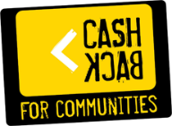

**Evaluation of basketball**scotland**’s Phase 4 CashBack for Communities-funded School of Basketball programme**

**Year 2 report**

**basketball**scotland

June 2019

CONTENTS

**Chapter Page**

Executive Summary **Error! Bookmark not defined.**

1. Introduction and context 1

2. Approach and methodology 4

3. Overview of the delivery of basketballscotland’s Phase 4 programme 8

4. Programme impact 14

5. Conclusions and recommendations 29

Appendices:

Appendix 1: List of outcomes and indicators

Appendix 2: Participant profile

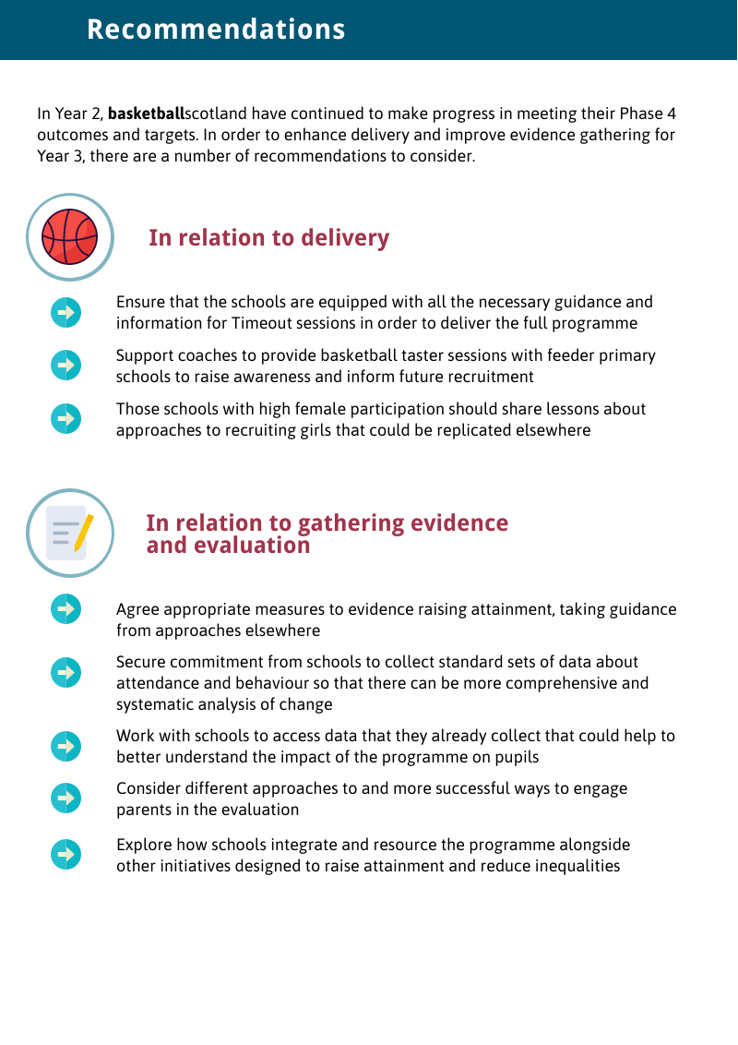

1. Introduction and context

Sport and Young People in Scotland

1. The potential for sport to drive positive social impact has gained increasing policy focus and informed policy frameworks at a national level. For young people in particular, sport can assist their long-term development, raise aspirations and be a source of hope across different demographics. There are many examples of sport being used to promote positive social and community outcomes, including health improvement topics such as smoking cessation and active living, tackling crime and anti-social behaviour and programmes designed to enhance skills for learning, life and work.
2. Structured sporting programmes where young people are guided through physically, social and emotionally challenging experiences allow the young people to develop new skills and generates a sense of personal achievement.
3. The Scottish Government’s Active Scotland Outcomes Framework[1] describes Scotland’s ambition for sport and physical activity as a means to contribute towards the delivery of National Outcomes. Active Scotland Outcomes build on an understanding of the social impact of sport, including raising educational attainment, improving wellbeing, and increasing resilience and confidence among individuals and communities through sport and physical activity.

Raising attainment

1. Poverty is a key factor in tackling attainment and in closing the poverty-related attainment gap. The Scottish Government is committed to building a country that has low levels of poverty and inequality, genuine equality of opportunity, better life chances, and support for all those who need it. There is a multifaceted approach to achieve this which includes establishing an independent Poverty and Inequality Commission, introducing a Fairer Scotland Action Plan, committing funding to tackle poverty and inequality and introducing the Child Poverty (Scotland) Act 2017.
2. There are several policies in place to close the persistent attainment gap. The Scottish Attainment Challenge aims to improve activity in literacy, numeracy and health and wellbeing in targeted areas in Scotland with key measures to evidence progress in reducing the gap. To achieve these measures, the Scottish Government created the Attainment Scotland Fund (ASF), with £750 million committed spend until April 2021, on initiatives focused on local authorities (‘challenge authorities’[2]) with the highest concentration of deprivation. It also creates additional funding, Pupil Equity Funding (PEF)[3], allocated directly to schools, targeted at closing the poverty related attainment gap. PEF is spent at the discretion of the head teachers who must develop a clear rationale for use of the funding to target and raise the attainment of children affected by poverty.

CashBack for Communities programme

1. Since 2008, CashBack for Communities has received funding to invest in community initiatives to improve the quality of life for young people across Scotland. Phase 4 of CashBack, like other Scottish Government initiatives, has placed a strong focus on addressing inequality in Scotland, in raising attainment, ambition and aspirations for disadvantaged young people living in areas of deprivation.
2. The programme has placed a focus on the positive impact of Sport for Change and the **basketball**scotland programme is funded under this theme.

basketballscotland’s CashBack for Communities programme

1. As part of its programme, **basketball**scotland is receiving up to £493,000 to deliver Schools of Basketball working with 800 young people aged 11-14. The selected pupils are living in areas of high deprivation, have been excluded from school, or are at risk of exclusion and/or risk of being involved in antisocial behaviour.
2. The School of Basketball programme includes a minimum of two basketball sessions during the school week, to develop participants’ basketball skills as well as social skills including confidence, communication and respect. The programme is delivered by a coach who helps all pupils to enjoy curricular and extra-curricular basketball, as well as facilitate a connection to their local basketball community.
3. In Year 1, 156 young people across six schools in Scotland took part in the programme. In Year 2, the programme successfully expanded to 17 schools across Scotland, including two Additional Support Needs (ASN) schools, working with a total of 553 young people.
4. Blake Stevenson is commissioned to evaluate **basketball**scotland’s Phase 4 programme, and this report provides the findings from Year 2 (2018-19).
5. Approach and methodology

Evaluation aims

1. In designing the Phase 4 programme, **basketball**scotland identified outcomes and targets, drawn from the CashBack logic model (listed in Appendix 1), which its programme could deliver over the three-year funding period. Like other CashBack partners, monitoring and evaluating its delivery and progress amongst participants and schools is a key requirement. This allows achievements to be captured and reflect on lessons learned and this is also supported by Performance Advisors in Inspiring Scotland.
2. Blake Stevenson’s role is to independently evaluate the progress of the programme in delivering the funded outcomes and to add value to the self-evaluation activity. This is done by consulting with a broader range of participants and stakeholders about the delivery and impact of the programme and considering other evidence that will show the effectiveness of the programme.

Methodology

1. Building on the mixed methods approach used in the first year of the evaluation, our activities in Year 2 included further primary research with participants, parents/carers, school staff and coaches as well as analysing data collected by **basketball**scotland. Figure 2.1 provides a summary of the evaluation activities undertaken by the Blake Stevenson team in Year 2.

Figure 2.1: Evaluation activities undertaken

Desk-based activity

1. In Year 1, Blake Stevenson used questions from the Health Behaviour in School Aged Children (HBSC) survey to develop a wellbeing survey for participants that was administered by **basketball**scotland. This survey was distributed again in Year 2, and we analysed these results alongside **basketball**scotland’s surveys of participants and coaches, which are focused on key outcomes including confidence, behaviour and educational attainment.
2. Our desk-based activity also included analysing data submitted by schools to **basketball**scotland about the behaviour and attendance of School of Basketball participants and we also reviewed data reported by **basketball**scotland related to their outcomes and indicators.

Fieldwork

1. We undertook a range of fieldwork activities to understand how the programme has impacted on participants and schools, and how the programme has evolved and developed in schools delivering their second year of the programme. We placed an emphasis on interviewing programme participants to analyse whether the positive impacts of the programme found in our Year 1 report have continued and translated in the programme’s expansion to 17 participant schools. In Year 2, we visited four schools: Tynecastle High School, Rosshall Academy, Inverness High school and Baldragon Academy.
2. We also conducted a survey of school leads to gather insight into the wider impact the programme has had on educational attainment, changes in participants’ skills and confidence, and the effectiveness of CashBack funding. We received responses from 14 of the 17 schools - a response rate of 82%.

Analysis

1. All survey results from participants, coaches, and School of Basketball leads were analysed using Snap Survey software and MS Excel and we carried out a thematic analysis of all research data. As part of this, our team held a deliberative analysis workshop to examine and discuss the themes that emerged from the data in response to the evaluation aims.

Evaluation challenges

1. The evaluation issues we faced in Year 2 are largely the same as in Year 1. The schools visited were accommodating in completing surveys and providing access to participant interviewees when requested. However, in some cases, we experienced difficulties in securing interviews with head teachers, PE staff and other school staff involved with the programme. We scheduled our evaluation activity towards the end of the school year to allow time for the new schools to establish the programme and for evidence of impact to emerge, but this was a busy period for school staff and this limited their ability to take part. In Year 3, fieldwork will be spread throughout the academic year.
2. Consultation with parents continued to be a significant challenge in Year 2. School staff noted that some parents do not engage with the programme itself, so we understand that they would also be unlikely to engage with independent evaluators. To improve parent engagement in Year 3 may require a co-ordinated effort from schools, Blake Stevenson and **basketball**scotland. We will discuss with **basketball**scotland a more structured approach to engaging parents for Year 3, such as attendance at parents’ evenings at schools, as well as considering some form of incentive to encourage parental involvement.
3. **basketball**scotland asked schools taking part in the programme to provide data about participants’ attendance and behaviour to help understand the impact of the programme. Ten schools provided this data, which is a more complete dataset than was available in Year 1, but if more of the schools provide this data there will be a comprehensive dataset that offers reliable evidence of the programme’s impact.
4. Due to unforeseen and unavoidable circumstances, the data provided by two schools was incomplete. Wester Hailes Education Centre established a School of Basketball programme, but was forced to pause delivery when the school’s sport facilities were damaged by fire in March 2019. Similarly, Braeview Academy experienced a fire which restricted the School of Basketball activity delivered this year. This means that, although young people from these schools are included in the numbers, their involvement in the programme has been limited and **basketball**scotland and the schools have been restricted in their ability to collect data about the impact of the programme on the young people involved.

The report

1. This report provides details of the Schools of Basketball programme delivered in Year 2 of Phase 4 (2018-19) and presents evidence of its impact, based on data collected by **basketball**scotland and the information collected through our fieldwork activities.
2. The remainder of the report is structured in line with the evaluation reporting requirements of the CashBack for Communities programme and is set out as follows:

* Chapter 3 provides an overview of the delivery of the School of Basketball programme in Year 2;
* Chapter 4 discusses the impact of the programme so far, broken down by the CashBack for Communities outcomes; and
* Chapter 5 presents conclusions and recommendations.

1. Overview of the delivery of basketballscotland’s Phase 4 programme

Introduction

1. The Phase 4 **basketball**scotland programme received an award of up to £493,000 to fund the delivery of a restructured and intensive Schools of Basketball programme. This funding has been invested in a team of four Regional Development Officers, as well as a coach and equipment for each School of Basketball.
2. In this chapter we discuss the delivery of the programme in Year 2, under the following headings: geographical coverage, delivery model, recruitment of participants, delivery and organisation, funding, and profile of participants.

**Geographical coverage**

1. In Year 2, the programme was extended from six schools to 17 schools, including two ASN schools, across Scotland.
2. While most schools are still located in the central belt, **basketball**scotland has been successful in Year 2 in introducing the School of Basketball further north, with schools in Inverness and Aberdeen beginning the programme.
3. Figure 3.1 displays the location of the 17 schools.

Figure 3.1: Participating schools

**Recruitment of participants**

1. Across the three years of Phase 4, the Schools of Basketball programme aims to work with 800 young people aged 11-14, who are:

* living in areas of deprivation;
* being excluded or at risk of exclusion from school, and/or
* at risk of being involved in antisocial behaviour, offending or re-offending.

1. Similar to our findings in the Year 1 evaluation report, the approach to the recruitment of participants differed across the schools involved. Some leveraged links with primary schools and transition teachers to identify pupils who met the criteria and had an interest in sport. Other schools handpicked pupils based on their SIMD decile, participation in PE, and whether they believed the programme would be of benefit. Some schools offered the programme to all S1 pupils who showed an interest. As a result, it appears that not all schools have taken account of the target group for the programme when recruiting participants. One school that began the programme in 2018-19, for example, acknowledged that they had limited time to take a systematic and targeted approach to recruitment this year, but they are currently consulting with primary schools to select pupils who more closely match the programme’s target audience in 2019-20.
2. The Year 1 evaluation recommended that the programme allocate resources to provide basketball activity for P7s in the feeder primary schools to increase interest and drive engagement when pupils reach secondary school. Where resources allow, a few of the schools visited during our Year 2 evaluation activities, have started holding promotional days at primary schools, with coaches and current participants demonstrating basketball drills and delivering workshops to build interest and to help coaches better-understand the young people and who to target for the programme next year.

Delivery and organisation

1. In each School of Basketball, the programme is delivered by basketball coaches, supported by a member of school staff identified as the school lead. The coach ensures that the participants receive high quality and specialised basketball coaching, while the school lead co-ordinates the recruitment of participants, liaises with senior school staff over aspects like timetabling, assists the coach to deliver basketball sessions, and helps to manage any behavioural issues.
2. The school leads often give up their own time to support the School of Basketball. While some are given time allocation within their timetable, in many cases teachers give up free periods, lunchtimes and time before and after school to support the programme. This dedication of the school staff is an important aspect of the effective delivery of the programme.
3. In the Year 1 evaluation report, we discussed the School of Basketball curriculum based on the NBA’s Rookie programme. The ‘Timeout’ sessions are designed to improve pupils’ personal, social and life skills and these are delivered in the classroom or on the side of the court.
4. Compared to Year 1, there has been reduced delivery of “Timeout” sessions in the schools consulted. Only one school reported that they were delivering structured classroom sessions with a focused topic each week. This school also noted that although they were doing their best to deliver Timeout sessions, they needed more guidance and materials from **basketball**scotland as to the structure and content of the sessions. All other schools consulted were not running any classroom sessions and were simply having informal on court chats during basketball sessions - for example, about expected behaviours, and skills such as teamwork and communication.

Views of the programme support and delivery

1. School staff provided positive feedback on the delivery of the programme by **basketball**scotland in Year 2. Nearly all schools surveyed (13, 93%) agreed or strongly agreed that the programme has been delivered to a high standard this year through experienced coaches working flexibly in collaboration with school staff.
2. The majority of schools were satisfied with the support provided by **basketball**scotland, with 11 schools (79%) agreeing or strongly agreeing that **basketball**scotland has been in regular correspondence with school staff. Where schools felt there was scope for improvement was the kit and materials supplied by **basketball**scotland. Fifty per cent of schools surveyed agreed that the kits and materials were of high quality, but a complaint from five of the 16 schools is that they have not received kits this year.
3. Whilst the schools surveyed (13, 93%) agreed or strongly agreed that the programme fits within their school timetable, during the visits many teachers reported the challenges of negotiating a timeslot for the School of Basketball with lack of space and competing extra-curricular activities offered at their school.

**Funding**

1. CashBack funding is critical to the delivery of the School of Basketball programme. Most schools surveyed (12, 86%) reported that they have not accessed any other sources of funding to enhance their School of Basketball. Two schools stated that they were able to use their Pupil Equity Fund money to augment the CashBack funding.
2. Every school surveyed (100%) stated that they would not be able to continue to facilitate a School of Basketball if CashBack funding was no longer available. Schools commonly reported that the cost of a basketball coach as the biggest expense, and could not be covered by their already stretched PE budgets.

**Participant profile**

1. We provide key profile statistics from the School of Basketball participants in Figure 3.2. A more detailed breakdown is included in Appendix 2.

**Figure 3.2: Schools of Basketball participant profile (Year 1 n=148, Year 2 n=553)[4]**

1. In Year 1, the majority of participants were male (68%) and 27% were female[5]. There has been improvement in the gender ratio of participants in Year 2, with overall female participation increasing to 41%, but still with great variation across the schools.

**Table 3.1 Number of male and female participants in each school[6]**

|  |  |  |
| --- | --- | --- |
| **School** | **Female** | **Male** |
| Ardrossan Academy | 4 (15%) | 23 (85%) |
| Baldragon Academy | 2 (15%) | 11 (85%) |
| Clydebank Academy | 14 (38%) | 23 (62%) |
| Craigie High School | 8 (40%) | 12 (60%) |
| Cumbernauld Academy | 19 (83%) | 4 (17%) |
| Gracemount High School | 13 (48%) | 14 (52%) |
| Harris Academy | 5 (28%) | 13 (72%) |
| Inverness High School | 48 (66%) | 25 (34%) |
| Larbert High School | 9 (17%) | 44 (83%) |
| Lochend Community High School | 10 (34%) | 19 (66%) |
| Lochside Academy | 5 (28%) | 13 (72%) |
| Rosshall Academy | 9 (36%) | 16 (64%) |
| St Andrew’s RC Secondary School | 25 (47%) | 28 (53%) |
| Tynecastle High School | 18 (40%) | 27 (60%) |
| Wester Hailes Education Centre | 34 (42%) | 47 (58%) |
| Woodlands School | 2 (20%) | 8 (80%) |
| **TOTAL** | **225 (41%)** | **327 (59%)** |

1. In terms of areas of deprivation, whilst there were participants living in areas across all SIMD quintiles, over half of the young people (53%) had an address in an area classed as the 20% most deprived in Scotland, an increase on Year 1 (40%), and 75% were located in communities within the 40% most deprived.
2. Programme impact

Introduction

1. This chapter discusses the impact the School of Basketball programme in Year 2. The chapter is structured around each of the outcomes outlined in the CashBack for Communities Grant Offer Letter, with evidence provided against the associated indicators under each heading. The outcomes and indicators are listed in Appendix 1.
2. The analysis is based on a range of evidence collected by **basketball**scotland and Blake Stevenson during Year 2 of the evaluation. This includes data gathered through surveys of players, coaches and teachers, and qualitative information gathered through visits to the Schools of Basketball at Tynecastle High School, Rosshall Academy, Inverness High school, and Baldragon Academy.
3. As noted in Chapter 2, the data related to some of the outcomes in Year 2 has been impacted due to the events at WHEC and Braeview High School. As these schools could no longer deliver basketball sessions, this has affected the dataset collected by **basketball**scotland.
4. As a result, although 553 young people took part in the programme in Year 2 in total, the data relating to the targets is based on 417 participants rather than 553.

Outcome 1: Building capacity and confidence

1. Taking part in the School of Basketball programme has had a positive effect on participants’ confidence, as shown by the indicators in Figure 4.1.

**Figure 4.1: Building capacity and confidence[7]**

1. A close up of a logo

   Description automatically generatedCoaches and school staff both observed an increase in participants’ confidence. Coaches noted that the pupils are “all more confident than I realised”, with some taking on the role of assistant coach for younger pupils. Ninety-three per cent of schools surveyed also reported that the programme has helped to develop confidence. Some schools staff noted that the programme allows participants to develop skills in their own time without the pressures of a normal PE environment.
2. The increased confidence is also allowing participants to step into leadership roles. Some pupils have become ambassadors for the School of Basketball during recruitment and promotional visits to primary schools, and were able to lead P7 pupils through basketball drills and games. One school reported that a participant, who began the programme facing significant challenges in social situations, had developed such confidence that he was happy to promote the School of Basketball in primary schools, and is now “more vocal than he has ever been”.
3. Coaches also stated that the programme has greatly helped participants with their communication skills, to speak out and contribute more during discussions. Rather than responding with a one worded answer, participants are now able to join in with game strategy discussions and self-reflection sessions. Pupils confirmed that they have gained a “massive confidence boost” and that the programme has helped them to become “more 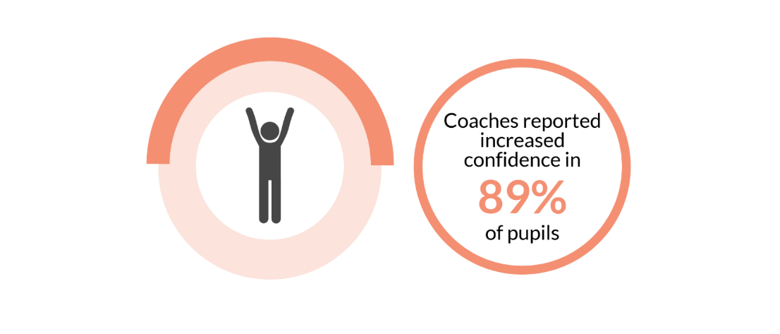extroverted” and “speak up more”.
4. The overall increase in confidence amongst participants has led to many pupils joining basketball clubs outside of schools. Most schools consulted reported that their School of Basketball coach is linked with their local club, and were successful in feeding participants into their club, including an increased number of girls who have never played for a club before. This had even led to some participants playing in their national Under 16s team.

Outcome 2: Developing physical and personal skills

1. Figure 4.2 highlights that the School of Basketball programme has helped young people to develop their physical and personal skills.

Figure 4.2: Developing physical and personal skills

Physical skills

1. The programme has had a positive impact on participants’ physical skills.
2. In the schools survey by Blake Stevenson, there was unanimous agreement (100%) that the School of Basketball programme has helped participants to improve their basketball skills. Some schools attributed this improvement to the quality of the coaching and the regular opportunity to play the sport.
3. A close up of a logo

   Description automatically generatedSeveral participants stated that they have learned core ball skills such as dribbling, shooting and bouncing. Ninety-six per cent of young people said their basketball skills had improved and 75% reported that their fitness has increased because the sessions provide them with more opportunities of being active during the day. Some young people who have previously played basketball stated that they have learned advanced skills such as shooting from distance, layups, and new tactics to use during games. One participant stated that he had improved his hand-eye co-ordination, which had helped him in other subjects like art.

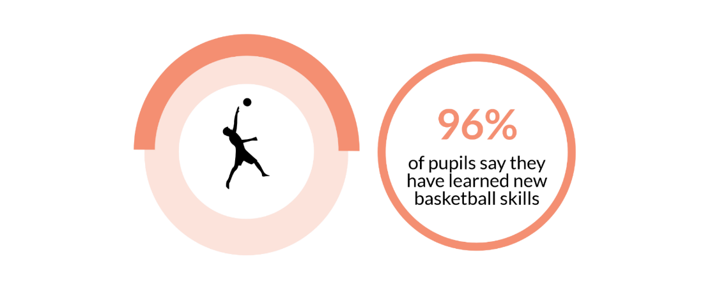Personal skills

1. The School of Basketball has continued its success in helping participants develop a range of personal skills. Ninety-three per cent of schools reported that participants had gained skills for learning, life and work including teamwork, communication, leadership, organisation and time management. Many young people stated that they had learned problem solving skills, particularly during games. They stated that rather than becoming frustrated or angry when they lost the ball, they have been able to develop strategies to work with their team mates to get the ball back. The programme has also helped participants increase their social awareness and empathy. One participant stated that he has learned how to help his team mates when he sees that they are frustrated and struggling during a game.
2. The School of Basketball programme offers participants the chance to gain accreditation for some of the learning they achieve from the programme. **basketball**scotland engaged with Scottish Sports Futures and Youth Scotland to deliver The Dynamic Youth Award at SCQF Level 3 to participants in School of Basketball. The Dynamic Youth Award is a nationally recognised award, which allows young people to develop life, learning and work skills, and recognises their contributions and achievements.
3. Confirmation of the qualification is received over the summer, so the most recent data available for participants who have achieved the award is from Year 1, when 122 participants were accredited with the report in summer 2018[8]. This was in excess of **basketball**scotland’s target of 108.
4. In Year 2, the 17 schools delivered the Award to 417 pupils. On the assumption that all 417 participants receive a two- or three-star award of between two and seven SCQF credits, this will be an equivalent to a cumulative achievement of between 834 and 2,919 SCQF credits. If all these participants achieve the award, this will surpass **basketball**scotland’s target of 324.
5. In addition, 25 participants have achieved the Make It Happen award. This is a six-hour course with practical and classroom elements that introduces coaching and officiating skills. It is targeted at people aged 14 and over, which explains why a relatively small number of School of Basketball participants have completed this course.

Outcome 3: Changing behaviours and aspirations

1. Figure 4.3 shows that participants have demonstrated increased aspirations and improved behaviour as a result of taking part in the School of Basketball.

Figure 4.3: Changing behaviours and aspirations

Behaviour

1. Teachers, participants and coaches were in general agreement that participation in the programme has resulted in positive behavioural changes amongst young people. Ten schools (71%) agreed or strongly agreed that involvement in the program has improved pupils’ behaviour in school, and 79% of pupils reported improvements in this respect. Many coaches have focused on fostering manners during basketball sessions, including requiring all participants to say “hi”, give a high-five or a handshake when they first come into their session. One teacher stated that this has translated into the classroom, as their pupils have started saying greeting him at the beginning of classes, and showing him “the most respect I’ve ever had”.

1. Most coaches stated that they have not had any significant behavioural issues during their programme sessions. PE staff confirmed that although some pupils were known to have a challenging reputation in other classes and around the school, their behaviour within the programme environment is completely different, and that they are always motivated during basketball. One young person stated that they are “always eager to learn everything” during basketball sessions so that they can use their new knowledge during games.
2. A common view from the Year 1 evaluation, which remains unchanged among stakeholders, is that the programme is an incentive for improved behaviour because participants are aware that they would be unable to take part if they do not behave well in other classes. Many schools have used the programme as an incentive for pupils with behavioural issues. This has generally been a successful strategy. As many of the young people interviewed explained, they believe it is important to show respect and behave well during classes, because they “don’t want to get kicked out” of the School of Basketball.
3. Some teachers and coaches who were interviewed felt that the programme provides an outlet for participant to let out energy and exuberance, allowing them to be calmer and well-behaved in other classes. Many participants agreed, stating that basketball sessions provides them “time to relax” and that they have “more concentration in other classes” as they have let our energy during basketball.
4. However, many DHTs reported in the school survey that their schools currently do not have any tools in place to measure and quantify whether the programme has had any impact on the behaviour and engagement of pupils in other classes.
5. Similarly to Year 1 findings, many coaches commented on the importance of their role as an adult in the school whom young people can speak to informally about issues they are experiencing. Some coaches stated that most of their participants do not have much trust in teachers and adults, but they are able to build good rapport and put a lot of trust in their basketball coaches. They believe that it is easier for them as coaches to have informal chats with participants around their behaviour and expectations, and how this translates off the court into acceptable behaviour in the classroom.

Aspirations

1. The programme has also led to increased aspirations among participants, including, ambitions related to fitness and sport, especially basketball.
2. Schools were in general agreement that participants’ attention spans have increased, and that they are showing more commitment and more focus during basketball compared to when they first started. Two young people stated during interviews that their dream is to play in a professional league and the NBA.
3. School staff recognised the advantages of the programme in helping young people experience success in sport, and how this can translate into academic areas and increase their aspirations to succeed in other subjects.
4. School of Basketball was described by a member of staff as “uplifting” for young people who struggle academically, as it provides a different avenue for achievement. One example was provided of a participant who struggled in classes and had a low level of literacy. He has excelled in the School of Basketball and gained a lot of confidence from this success and receiving recognition from peers.
5. Coaches and teachers commonly noted that the **basketball**scotland kits provided as part of the programme have been a huge benefit to participants. They explained that most of their participants either do not own high quality sporting gear, or have never had a sports kit before. The participants are “delighted” with the **basketball**scotland branded kits as it allows them to feel like they are “part of something”.

Outcome 4: Improving wellbeing

1. The School of Basketball programme has met its wellbeing outcomes for participants, as summarised in Figure 4.4.

Figure 4.4: Improving wellbeing

1. 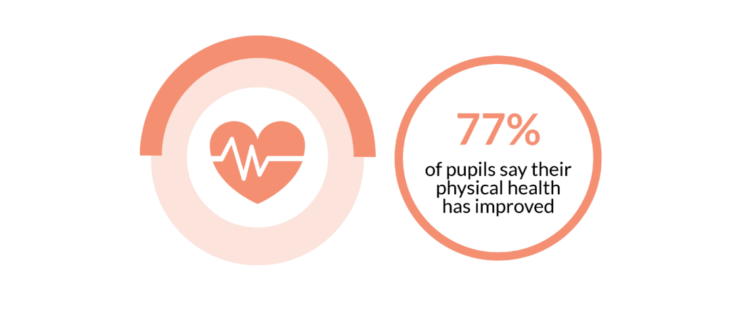All but one school (13, 93%) agreed or strongly agreed that the programme has led to improved health and wellbeing amongst participants. Some DHTs stated that many of their pupils are inactive outside of school, with weekly PE classes as their only form of exercise. They identified that the programme provides participants with at least another hour of exercise per week and has also allowed them to increase their fitness and embrace a “sporting ethos”.
2. Many young people stated that they have improved their eating habits and learned “how to be healthy and take care of myself”, giving examples of swapping crisps for sandwiches and baguettes at lunchtime. Some coaches also reported that the increased physical activity and healthy habits have also increased participants’ self-esteem and that they are gaining a “more positive view of themselves”.

Outcome 5: Increasing school attendance and attainment

1. A close up of a logo

   Description automatically generatedSimilar to our findings in the Year 1 evaluation report, it remains difficult to accurately measure the programme’s impact on attainment given the lack of access to formal assessment data for pupils at this stage of secondary school. However, there is some evidence gathered through interviews with PE teachers and participants that the programme has led to improved behaviour among participants and increased engagement in other classes.
2. 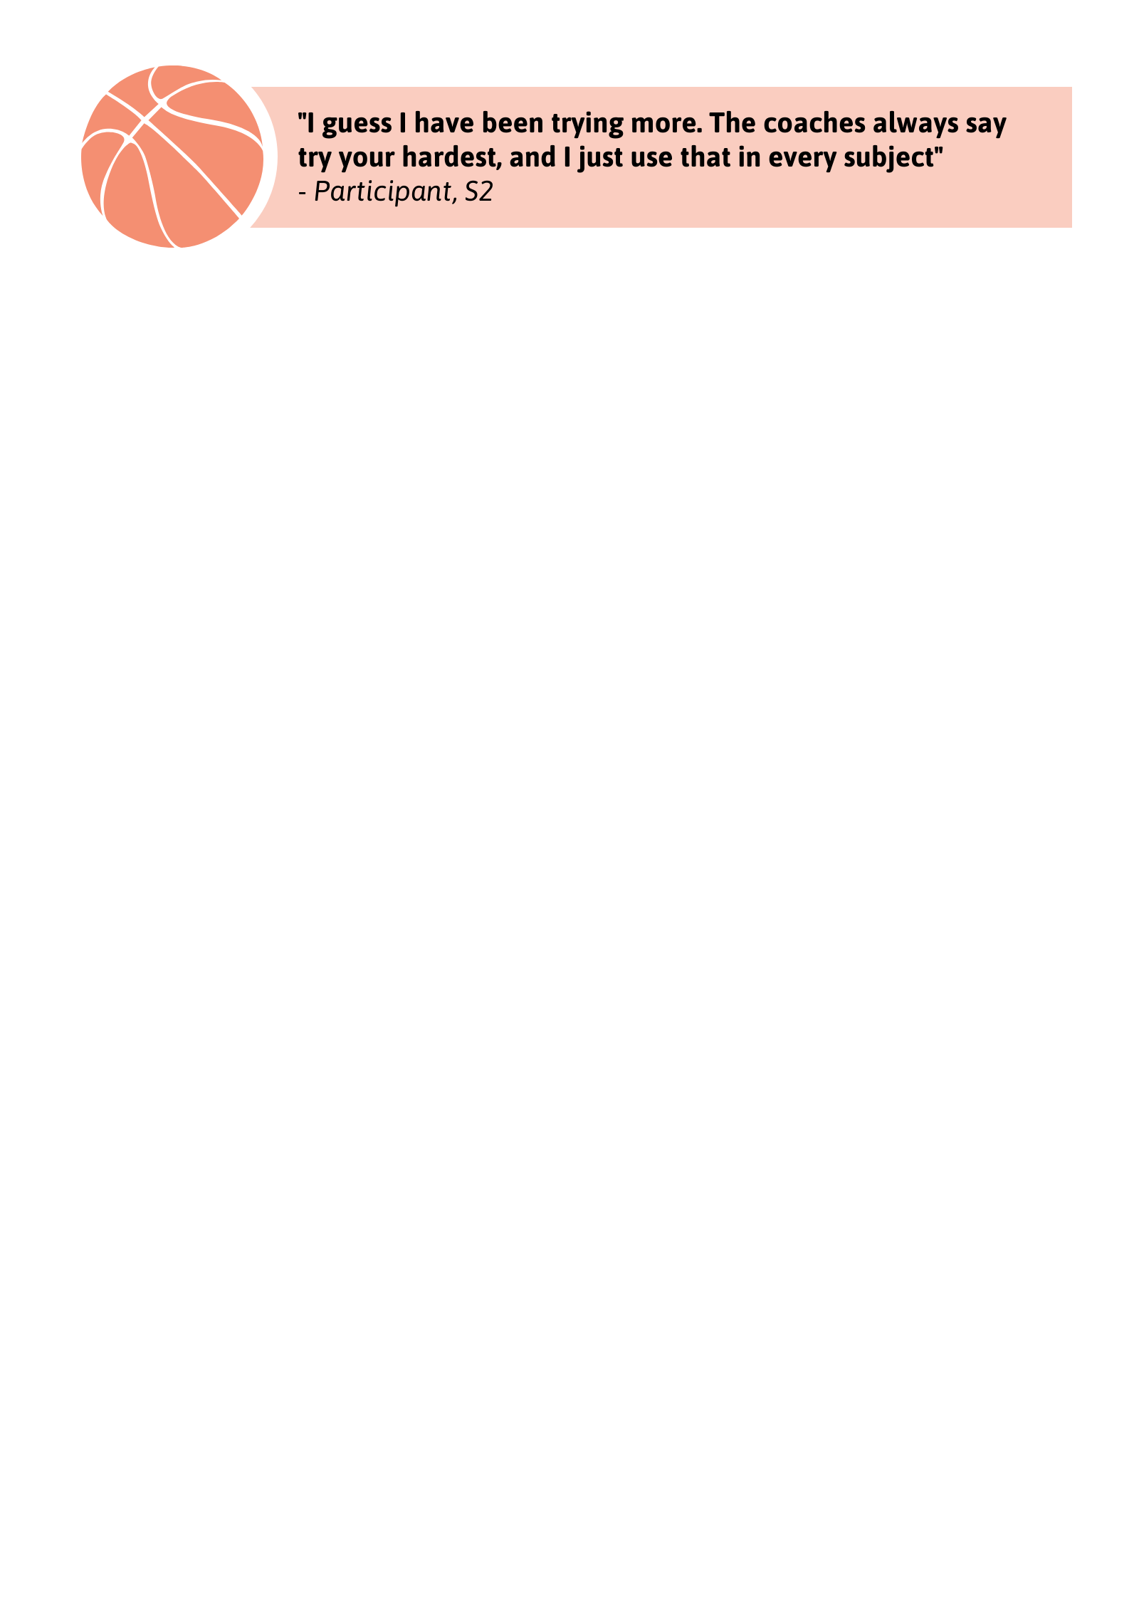Where staff felt able to comment, some said that the programme has led to a “marked improvement” in pupils’ focus and that they are “more switched on, brighter and more responsive” during classes. Several participants echoed this during their interviews saying that the programme had helped with their focus and concentration in classes, as well as giving them more motivation to improve their grades.
3. In comparison to the Year 1 evaluation findings, where some teachers noted that the programme can help with other areas of the curriculum, our Year 2 survey results found that there was less evidence of the programme assisting in aspects of pupil education such as literacy and numeracy. Three schools (21%) stated that there is no evidence that the programme has had any impact on numeracy, literacy and social education curriculum. Most young people interviewed stated that they did not think participating in the programme has helped them to improve their literacy or numeracy skills. This could be because the School of Basketball programme is very new in some schools and the focus has been on the physical skills rather than the classroom-based elements.
4. **basketball**scotland’s measurement of attainment against indicators is based on behavioural merits in Year 2 and, using this measure, the programme has not met its target for young people to improve attainment at school. On this basis, 46% of young people improved attainment at school, against a target of 60%.
5. Qualitative evidence gathered during interviews and the school survey showed general consensus among teachers, coaches and pupils that the programme has led to improved attendance. In response to the school survey, most schools (11, 79%) agreed or strongly agreed that the programme has helped to improve attendance at school, with some schools reporting that the programme has helped to specifically remediate non-attendance for participants who had attendance issues in primary school.
6. During interviews, several participants considered the programme as an incentive for them to attend school, with one pupil explaining that he enjoys coming to school on the days he has basketball sessions as “it makes it more fun because you know you’ll be able to play basketball”.
7. However, SEEMiS data provided by nine schools shows that school attendance has decreased among a large proportion of School of Basketball participants at those schools. While attendance rates improved for 39% of individuals, they deteriorated for 52% and stayed the same for 9%. Using this data, in Year 2, the programme has not met its target of 80% for young people improving attendance at school.
8. As shown in Table 4.1, when we analysed the data on average school attendance from the nine schools that provided it, we found increases in average attendance among the School of Basketball participants between terms one and two in five schools. In particular, the 89.5% average attendance among S1 participants in term two at Harris Academy was notably higher than the term one average of 75.3%.

**Table 4.1: Average school attendance at Schools of Basketball**

|  |  |  |  |
| --- | --- | --- | --- |
| **School** | **Year group(s)** | **Average attendance of SoB participants (% - Term 1)** | **Average attendance of SoB participants (% - Term 2)** |
| Cumbernauld | S1 | 94.3 | 90.8 |
| Harris | S1 | 75.3 | 89.5 |
| Larbert | S1 & S2 | 92.4 | 90.4 |
| Lochend | S1 | 94.9 | 92.9 |
| Lochside | S1 | 96.9 | 90.9 |
| Rosshall | S1 | 64.4 | 75.1 |
| St Andrew's | S1 & S2 | 94.9 | 95.2 |
| Tynecastle | S1 | 94.0 | 90.0 |
| Tynecastle | S2 | 83.8 | 85.4 |
| WHEC | S1 & S2 | 90.6 | 96.1 |

Figure 4.5: Increasing school attendance and attainment

Outcome 6: Improving learning and employability options

1. Figure 4.6 shows that the programme has met both targets related to improving learning and employability options.

**Figure 4.6: Improving learning and employability options**

1. Schools remained overwhelmingly positive about the impact of the programme on participants’ skills for learning, life and work. All but one (13, 93%) of the schools surveyed agreed or strongly agreed that the programme has helped improve participants’ personal skills, including teamwork, communication, leadership, organisation and time management.
2. A close up of a logo

   Description automatically generatedParticipants most commonly reported improvement in their communication skills and their ability to work with other people.
3. The programme has also had a positive impact in encouraging participants to take up volunteering activities. In our Year 1 evaluation, there was insufficient data to measure volunteering involvement. In our Year 2 participants’ survey, 31% of S2 participants had engaged in some form of volunteering activity. Although this is below the target of 40%, it reflects the S2s’ increasing involvement in basketball-related volunteering - for example, tabling games and coaching primary school pupils. Some other volunteering activities mentioned by the participants included helping coaches at tennis club, netball club, and youth club.

Outcome 7: Increasing participation in positive activity

1. 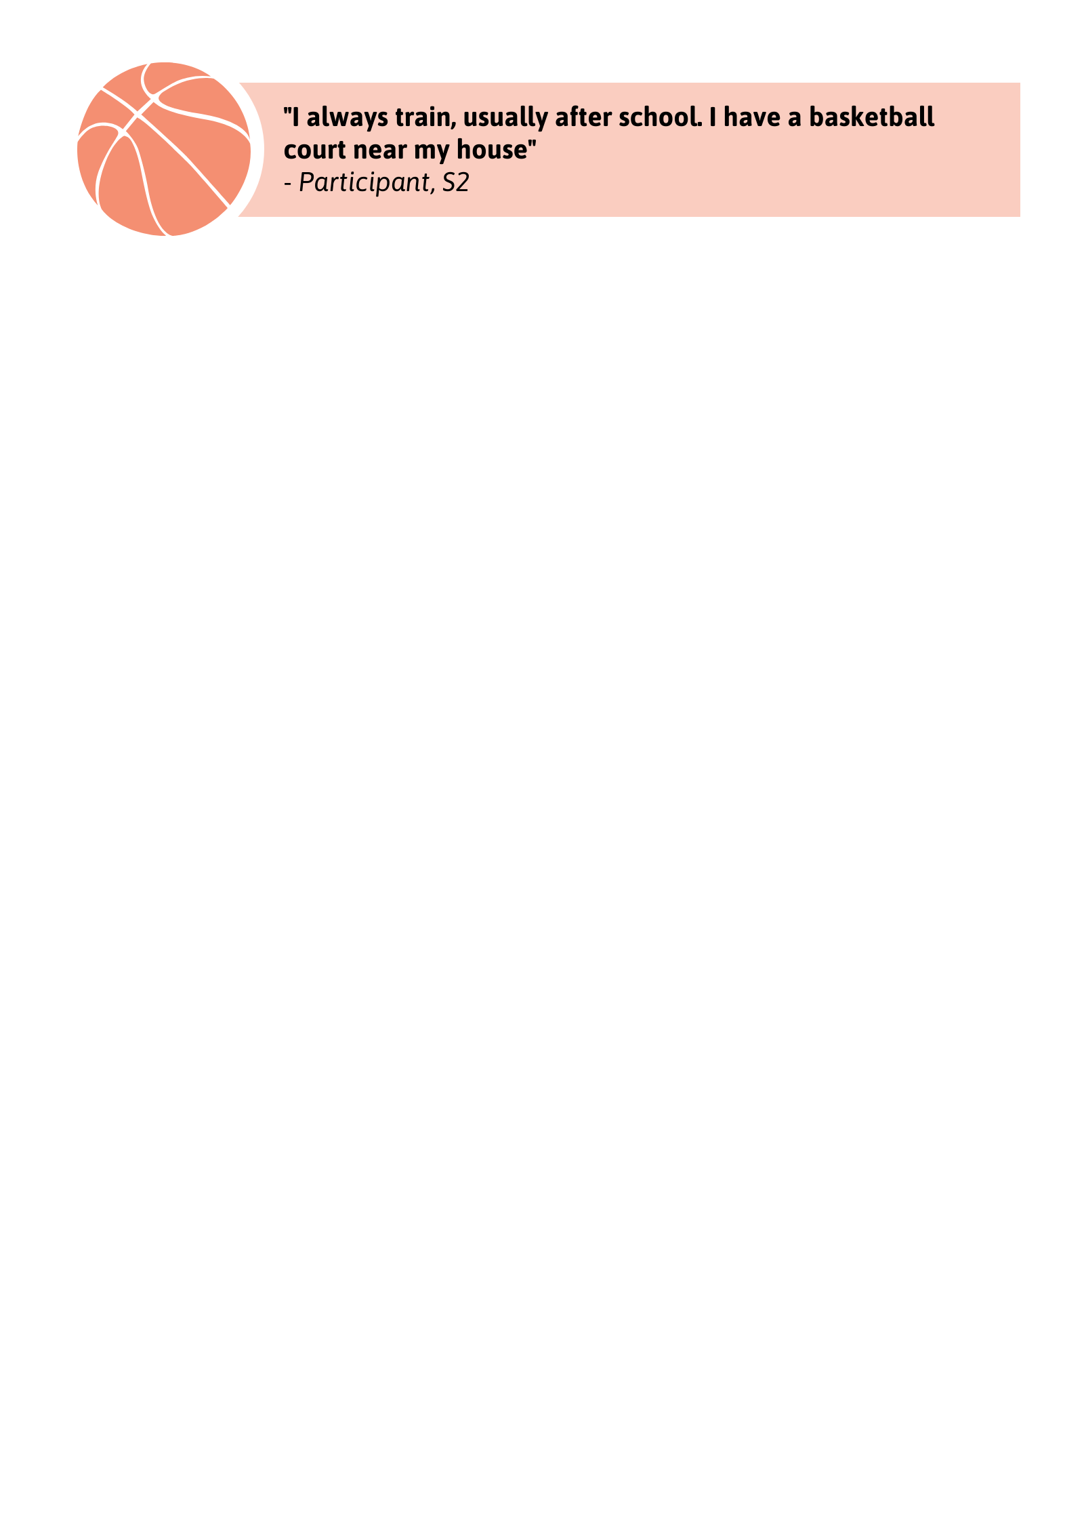Year 2 of the programme has seen an expansion from six schools to 17, surpassing the programme’s target of 16 for this year. This means that there are more young people involved in playing basketball - some of these pupils were new to the sport and now taking part in a positive activity.
2. As shown in Figure 4.7, in Year 2 the School of Basketball programme exceeded its target percentage for participation in new activity. It has achieved its target of 100% participation in positive activity, and far exceeded its target of 54 young people (10%) being new to the activity.

**Figure 4.7: Increasing participation in positive activity**

1. Feedback from participants and teachers shows that participants are more involved in basketball, with many joining local clubs, as well as other sports and activities inside and outside school.
2. Teachers and coaches at two schools reported that they had also set up basketball teams for older age groups in order to allow continuity of basketball for when participants move up the school. The teacher felt the School of Basketball has been important in encouraging more pupils to play the sport, with a few participants going on to play for teams in the Scottish Cup and one pupil playing in a national league Under 16s team.

Case studies

1. Using the data gathered through surveys of players, and qualitative information gathered during our visits to the four Schools of Basketball, we have created case studies of participants in the programme. We have selected young people from different backgrounds whose behaviour, attitude or health and wellbeing have improved as a result of participating in the programme.
2. For Year 2 of the programme, we have completed three case studies.

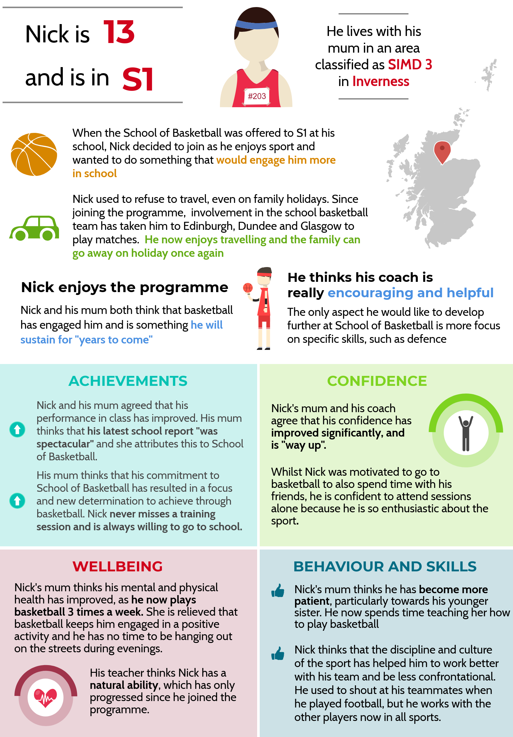Case Study 1 – Nick

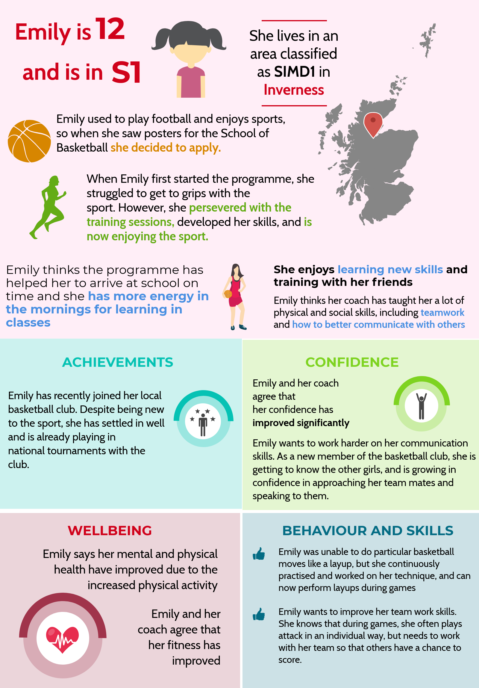Case Study 2 - Emily

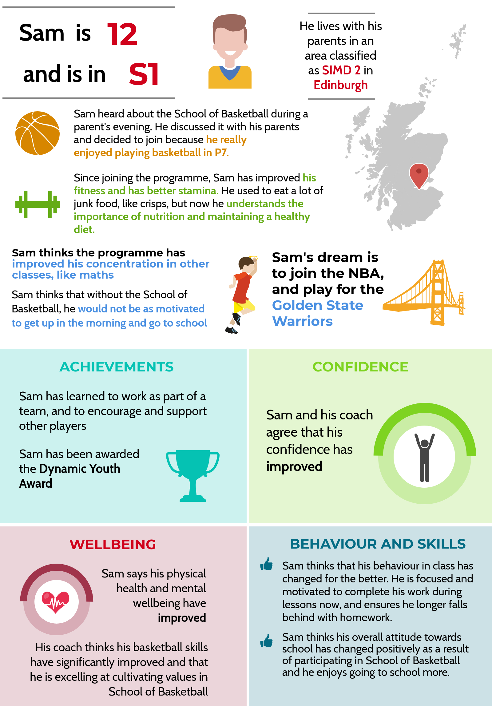**Case Study 3 – Sam**

1. Conclusions and recommendations

Summary of Year 2 activities

1. The School of Basketball programme has continued to achieve significant positive outcomes in Year 2. The programme has successfully expanded from six schools in Year 1 to 17 schools in Year 2, surpassing its initial target of 16 schools. Despite the significant effort required and barriers faced in the task of nearly tripling the number of participating schools in that timeframe, the programme has still been able to successfully meet most of its targets and outcomes.
2. All schools consulted during this evaluation reported positive benefits as a result of engaging in the programme, and all stakeholders provided highly-favourable feedback. Participants widely reported increases in their overall wellbeing, including improvements in their fitness and improved concentration and focus during other classes. The quantitative evidence collected through surveys alongside interviews conducted during this evaluation paint a positive image of the impact the programme has had on participants’ skills, confidence and aspirations. Participants are demonstrating:

* more confidence, both inside and outside of the programme environment;
* more awareness of their own health and wellbeing needs, particularly in relation to diet and exercise;
* better communication and teamwork skills;
* improved technical basketball skills and athleticism;
* better focus and concentration in class;
* improved overall physical fitness;
* increased interest in basketball and aspirations to join local basketball clubs.

1. A key recommendation in the Year 1 report was for **basketball**scotland to consider ways to encourage more female participation in the programme. There has been success in addressing this recommendation, with Year 2 female participation increasing to 40% across the programme, compared to 27% in Year 1.
2. From the information about participants, it does appear that not all schools are targeting the groups of pupils that the programme is designed for, 53% of participants are from areas of deprivation but it is not clear if the other pupils are selected because they are at risk of exclusion or anti-social behaviour or if the schools are applying any criteria for participation. This is understandable given the notable expansion of the programme in Year 2, but it is important that **basketball**scotland works with schools to remind them of the pupils that should be part of the programme to ensure that more targeted recruitment takes place in Year 3.
3. Our Year 1 evaluation report also recommended that **basketball**scotland work with schools to ensure commitment to evaluation activities and to agree the types of data required. In Year 2, there was an improvement in response rates to evaluation surveys, which is very positive given the expanded number of schools in the programme. However, collection of data remains inconsistent across schools. We received SEEMiS data for key indicators including attendance, demerits and referrals from only half of the schools involved. As such it was difficult to quantitatively assess the impact the programme has had on attendance and behaviours.
4. **basketball**scotland has made a real effort to provide support to coaches and staff establishing new Schools of Basketball in Year 2. Schools commented positively that communication with **basketball**scotland is prompt and effortless. However, a common issue in Year 2 was that many schools have yet to receive their School of Basketball kits and many schools had not received the Timeout session materials.

Recommendations and areas for consideration

Delivery

**Recommendation 1:** The number of schools involved in the programme has increased significantly in the past year. **basketball**scotland should consider how it can ensure it equips all schools with the necessary guidance and information for ‘Timeout’ sessions in order to deliver the full programme.

**Recommendation 2**: Some schools have successfully introduced and established feeder basketball programmes in primary schools. **basketball**scotland should consider adopting an approach that supports coaches to provide basketball taster sessions with feeder primaries as a way of sparking interest and to achieve better and more targeted recruitment.

**Recommendation 3:** Rates of female participation vary greatly among schools, and it could be beneficial for schools with high rates to share lessons with **basketball**scotland and other schools about approaches to recruiting girls to the programme.

Evaluation and evidence gathering

**Recommendation 4:** Measuring attainment is challenging and proxy measures like change in behaviour, attendance or engagement can be used. One measure in isolation is not necessarily a robust indication of change and **basketball**scotland should agree with Inspiring Scotland appropriate measures of change to evidence raising attainment (informed by evidence used in other CashBack funded projects).

**Recommendation 5: basketball**scotland should secure commitment from schools to collect a standard set of data for participants to measure attendance and behaviour. This could be reinforced by guidance materials for data collection at the start of each school year which would lead to consistent and complete data sets which would enable more accurate reporting, as well as more detailed year to year comparative analysis of the programme’s impact.

**Recommendation 6: basketball**scotland should explore with schools what impact data they already collect about their pupils, and whether this could be shared with **basketball**scotland to further support understanding of the impact of the School of Basketball programme.

**Recommendation 7: basketball**scotland, along with Blake Stevenson, should consider ways to plan and obtain better buy-in from parents and carers, for example through incentives and targeted parents’ evenings. Increased engagement in evaluation activities would allow **basketball**scotland to gain a better view of how the programme is impacting participants outside of the school environment.

**Recommendation 8:** In Year 3, a focus for our evaluation should be on exploring how schools integrate and resource the School of Basketball alongside other initiatives designed to raise attainment and reduce inequalities.

Appendix 1: outcomes and targets



APPENDIX 2 - PARTICIPANT PROFILE

Details about the profile of School of Basketball participants are included below.

Gender

The majority of participants were male (327, 59%). Two hundred and twenty-five (41%) were female and 1 participant preferred not to disclose their gender.

**Figure A2.1: Gender (n=553)**

Country of birth

Two hundred and thirty (42%) participants were born in Scotland. Thirty-four (6%) were born outside the UK, in countries including Poland, Italy, Spain, Nigeria, Africa, Bangladesh, Congo, France, Ghana, India, Latvia, Nepal, Somalia, Syria and Vietnam. There was no data available for 281 participants.

**Figure A2.2: Country of birth (n=553)**

Ethnicity

One hundred and seventy-one participants (31%) described their ethnicity as white. A total of 34 participants (6%) were from BME backgrounds. There was no data available for 348 participants.

**Figure A2.3: Ethnicity (n=553)**

Disability

Twenty-eight participants (5%) described themselves as having a disability, such as a learning disability or physical impairment. There was no data available for nine participants.

**Figure A2.4: Disability (n=553)**

Deprivation

Over half of the participants (293, 53%) lived in postcodes within SIMD decile 1 or 2, the 20% most deprived areas in Scotland. There was no data available for 20 participants.

**Figure A2.5: SIMD decile (n=553) (1 = most deprived, 10 = least deprived)**

Caring responsibility

Twenty-nine participants (5%) reported that they have caring responsibilities, for example looking after someone at home who has a disability or long-term health condition. There was no data available for 288 participants.

**Figure A2.6: Caring responsibility (n=553)**

1. <https://www2.gov.scot/About/Performance/scotPerforms/partnerstories/Outcomes-Framework>
2. Glasgow, Dundee, Inverclyde, West Dunbartonshire, North Ayrshire, Clackmannanshire, North Lanarkshire, East Ayrshire and Renfrewshire.
3. The amount of PEF funding allocated to individual schools is determined by the proportion of the school roll eligible for free school meals.
4. The Year 1 figures provided here differ slightly from the data provided in our Year 1 report. This is because we have used the total number of all participants as the basis for calculating these figures in Year 2, including those who did not provide data. We took this approach because many participants did not provide data related to their ethnicity, and excluding these individuals would have presented a potentially misleading impression of the proportion of participants from BME backgrounds. This is in contrast to Year 1, when the denominator we used to calculate the percentages included only those participants who had provided the data.
5. 5% preferred not to say.
6. 1 participant preferred not to disclose their gender
7. The actual percentages are based on a survey of 417 pupils.
8. Confirmation of these awards was made too late for inclusion in the evaluation report for Year 1.