Action for Children
Positive Choices Plus

Evaluation of Phase 4 of CashBack supported activity

Year Two

June 2019

Research Scotland
Suite 42, Spiersbridge House
1 Spiersbridge Way
Glasgow, G46 8NG
0141 428 3972
nadia.hyder@researchscotland.org

Contents

1. Introduction 1
2. Participation in 2018/19 6
3. Outcomes 10
4. Programme development 38
5. Conclusions 50

Appendix 1 – Table of targets and indicative performance

Introduction

About this report

  - Action for Children commissioned us (Research Scotland) to evaluate the impact of Positive Choices Plus, its Phase 4 CashBack funded programme. This report covers programme delivery during 2018/19, the second year of Phase 4 CashBack. A final report will be produced covering over all delivery of Phase 4.

  - This report will:

- explore the reach of Action for Children activity;
- consider developments and progress; and
- explore the impact of Action for Children’s programme.

Action for Children

  - Action for Children is a national children’s charity committed to making a real difference to vulnerable children, young people and their families – particularly in areas such as safety, health, relationships and achievements. Through its activities it actively works to tackle important issues such as child neglect and abuse. It delivers 650 services across the UK and works directly with over 300,000 children, young people, parents and carers.

Programme delivery

  - Over three years of CashBack funded delivery, from 2017 to 2020, the Positive Choices Plus programme aims to work with 225 young people aged 14 to 24. The programme will work across five local authority areas: Glasgow, Edinburgh, North Lanarkshire, South Lanarkshire and West Dunbartonshire.

  - It aims to support young people that experience disadvantage because they are:

- living in areas of deprivation;
- unemployed and not in education or training;
- excluded or at risk of exclusion from school; and
- at risk of being involved in anti-social behaviour or the criminal justice system.

  - Positive Choices Plus was developed through learning from Action for Children’s Phase 3 CashBack funded programme (Positive Choices) but takes a more flexible approach to delivery, and is targeted towards young people at stage one or two of the employability pipeline. The programme runs generic courses that support young people to progress into their chosen pathway, rather than delivering industry specific courses and accreditation.

  - The programme offers participants a period of 1:1 support from staff, particularly in the early stages of the programme. This support helps young people to stabilise their lives before beginning the more structured course involving group work. Staff help young people with basic life skills, aimed at ensuring they are prepared and able to undertake a structured course. This support has involved: setting up bank accounts, travel planning, accompanying young people to appointments, wake up calls and engagement with parents and families. Staff felt that this wider support was often necessary before young people could realistically engage in a programme.

“We provide them with whatever support they need at the time…that’s the reality of the baggage that young people come with. If we don’t do all of that, then they won’t engage.”
Action for Children staff

  - Each young person can work with Action for Children staff for up to nine months, following a broad structure of:

- four-week pre-course support;
- four to eight-week course focused on identified needs; and
- up to 26 weeks of post-course support.

  - The programme offers a range of support and activities, including opportunities to gain accreditation and work experience. It is designed to offer a wide range of support at different levels, which can be tailored to meet individual needs. Whilst on the focused course, young people are eligible for a training allowance of £55 per week, and travel expenses.

  - The activities are focused on improving young people’s personal skills, core skills and readiness to enter the world of work. The support is offered as a mix of 1:1 and group work and can range from in-house support with literacy and numeracy to work placements with employers. The programme also supports young people to create and develop CVs, prepare for interviews and apply for jobs and apprenticeships.

  - The programme was initially planned to be delivered in five groups of 15 young people, with one group in each of the five local authority areas. The course would last for eight weeks, with delivery running for three days per week. During year one it became clear that this number of participants was difficult to achieve over one delivery period, and that large groups did not facilitate the type of support that the young people needed. The programme was altered to run as a four-week course, with delivery over five days per week, and with around eight participants per group. This approach has continued during year two.
  - The programme’s outputs and outcomes were measured through a dedicated outcomes database, an outcome star, a survey with young people and a survey with stakeholders.

CashBack for Communities

  - Action for Children has been allocated £576,617 of Phase 4 CashBack funding to deliver the Positive Choices Plus programme during 2017/18, 2018/19 and 2019/20.

  - Funding was allocated over three years as follows:
  - Year 1 2017/18 - £195,924
  - Year 2 2018/19 - £198,594
  - Year 3 2019/20 - £182,099.

  - CashBack funding is granted on the understanding that the programme will work towards agreed outcomes and outputs.

  - In year two, the programme was delivered within its budget of £198,594.

Evaluation method

  - This year, our evaluation work involved:

- analysis of 75 completed surveys from young people;
- analysis of 36 completed surveys from stakeholders;
- 4 focus groups with 25 young people;
- 5 telephone interviews with stakeholders;
- 20 telephone interviews with young people;
- two individual case studies;
- a discussion with programme staff; and
- analysis of programme data collected by Action for Children.

  - Of the 36 stakeholders that completed the survey, 20 were referral partners, nine were parents, and six respondents were from other support organisations such as social work or Skills Development Scotland.

  - Where possible, we have reported progress against targets as a numerical figure. Some outcomes have been measured through the survey, which was conducted with a sample of participants. Targets relating to these outcomes are reported as a percentage. A full table of all targets and indicative performance is included as Appendix 1.

  - In year two, Action for Children staff worked closely with young people and achieved a high response rate of end of project surveys (75 of 88 participants). This figure allows us to be 95% confident that the full population response would be within 5% of the sample.

Agreed targets and intended outcomes

  - Action for Children has agreed to deliver the following CashBack outcomes, and will measure progress towards these outcomes through set targets.

CashBack outcomes and targets for Phase 4
Outcome 1: Young people build their capacity and confidence
- At least 191 (85% of the agreed overall target of 225 participants) participants will increase their confidence/capacity
- 191 (85%) young people will report they are able to do new things
- 75% of other stakeholders report increasing confidence
- 191 (85%) young people go on to do new things after their initial CashBack involvement
Outcome 2: Young people develop their physical and personal skills
- At least 214 (95%) participants will increase personal skills, achieving accredited learning
- At least 191 (85%) participants will report an increase in their skills
- 75% of other stakeholders report increased skills in young people
Outcome 3: Young people’s behaviours and aspirations change positively
- At least 180 (80%) participants will report increased aspirations
- 75% of other stakeholders report increased aspirations
- At least 180 (80%) participants will positively change behaviours
- 75% of stakeholders report perceived positive changes in behaviour
Outcome 4: Young people’s wellbeing improves
- At least 180 (80%) participants will improve wellbeing.
- 75% of other stakeholders will make positive comments about wellbeing against one of the relevant SHANARRI indicators
Outcome 6: Young people participate in activity which improves their learning, employability and employment options
- At least 169 (75%) participants will achieve positive destinations
- 101 (45%) young people will progress to training
- 23 (10%) young people will access learning (including staying on at school)
- At least 34 (15%) of young people will gain employment (due to provision being targeted at stage one of the SSP)
- 11 (5%) young people volunteering following completion of programme
Outcome 7: Young people participate in positive activity
- At least 214 (95%) participants will participate in positive activity
- 169 (75%) young people are new to the activity (had never done that type of activity before)
- At least 214 (95%) participants will complete a work star
- 169 (75%) young people participating in/completing personal development/community-based challenge
- 113 (50%) of young people participating in/completing Workplace Core Skills/accredited learning

  - This evaluation uses a wide range of evidence. Some figures may be different from those reported in quarterly reports or scorecards. Throughout this report we have measured progress against percentage targets, as a percentage of the number of young people that participated. When reporting on outcomes about young people’s experiences, we have only used data that has come directly from young people i.e. surveys completed by young people. Although this does not gather the views of every participant, we feel it provides a good indication of progress.

Participation in 2018/19

Introduction

- This section will discuss programme participation in year two of CashBack funded activity. It is based on data recorded in the Action for Children outcome database.

Overall participation
- Action for Children aims to work with 225 young people through the Positive Choices Plus programme. This would be 150 over the first two years of delivery, working with, on average 75 young people per year.

- In year two the programme worked with 88 young people. Action for Children is on track to make up the shortfall in participants reached in year one. Over the first two years of delivery, the programme has reached 147 of the intended 150 participants.

Target group
- The programme aimed to engage young people that were furthest away from the job market – at Stage 1 or 2 of the employability pipeline. All young people involved in the programme during year two met this criteria.

Disadvantage
- Analysis of participant postcodes found that almost half (49%) of participants came from the 20% most deprived areas of Scotland. The programme worked with young people from a range of challenging backgrounds, who experienced disadvantage for a variety of reasons. The following table outlines the proportion of participants across datazones.

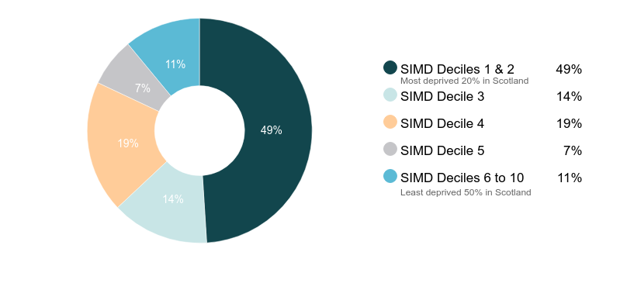

- Information from the Action for Children outcomes database shows that some young people dealt with significant life events and challenges during their engagement with the programme.

- The range of challenges varied, and included:
- use of alcohol and drugs;
- being care experienced;
- significant challenges with mental health;
- challenging and chaotic home circumstances;
- offending behaviour; and
- significant challenges with literacy and numeracy.

- Staff reported that many young people presented with challenges around literacy and numeracy. Staff supported young people to develop these skills so that they could confidently progress to work-based activities such as CV building and job applications.

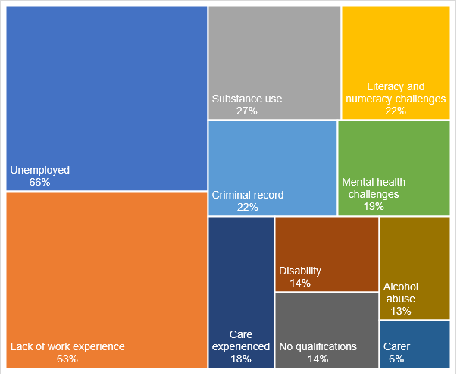
- The chart below shows the range of challenges faced by programme participants.

- A small proportion of participants identified as homeless, a lone parent or minority ethnic (3%). And a small number of individuals identified as asylum seekers or refugees (2%).

Geographical spread
- During year two the programme worked with young people across its five target local authority areas - Glasgow, Edinburgh, West Dunbartonshire, North Lanarkshire and South Lanarkshire.

Gender
- Of the 88 participants, 70 were male and 18 were female.

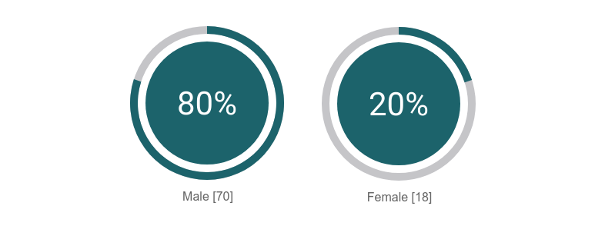

- The programme still supports more young men than young women and the proportion has not changed significantly from year one (19%). Action for Children staff said that they felt the programme was working towards achieving a better balance of male and female participants during Phase 4. The data shows an increase from 14% female participation across Phase 3, to 19% in the first two years of Phase 4.

Age
- Data relating to age at the beginning of the programme was available for 82 of the 88 participants. The programme engaged with young people aged 15 to 23. Most participants were aged between 15 and 17.
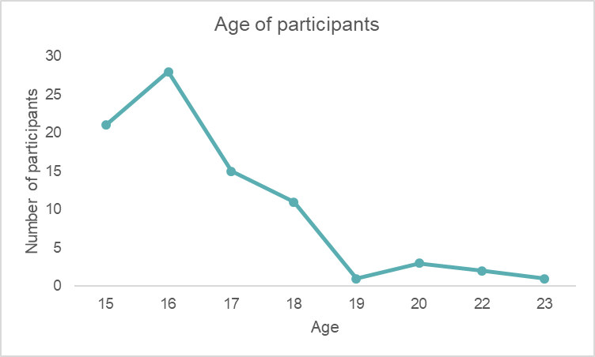

Referrals
- Positive Choices Plus received referrals from a range of partners. This year referrals have predominantly come from social work services – Children and Families teams or Criminal Justice teams. Previously, Action for Children has received referrals from Job Centres or Skills Development Scotland. Referrals are now being received for young people that choose not to engage with Job Centres, but who have involvement with social work services.

- During year two, Action for Children has continued to raise awareness of the programme with partner organisations working with young women, minority ethnic people and LGBTQ young people. However, it remains challenging to encourage referrals.

- In addition to receiving referrals, staff actively reach out to young people that might benefit from the programme. Staff have conducted outreach in the delivery areas by walking around the area, making themselves known to young people and making themselves known to relevant local organisations.

Outcomes

Introduction

- This chapter explores how Action for Children has progressed in relation to its intended outcomes.

- This year, Action for Children engaged with 88 young people, reaching and exceeding its target number of young people (75). Throughout this chapter we have reported on outcomes using the overall target, and where relevant, the annual numerical target.

Outcome 1: Young people build their capacity and confidence

Target: At least 85% of participants will increase their confidence/capacity.

Achievement: 99% of young people responding to the survey said that they felt more confident in themselves and their ability, since they had started working with Action for Children. And 100% of survey respondents felt more confident about their future.

Achievement: 100% of young people responding to the survey said that they felt more confident about starting employment, training or education since they started working with Action for Children.

- Most of the young people we spoke with said that they felt they had gained confidence by attending Positive Choices Plus.

- Young people said that they felt more confident about working with other people, working in groups and applying for jobs. They also felt more confident about applying for jobs, developing a CV and attending an interview.

“The course has made me more confident.”
Young person

“I feel I am more confident about speaking with others and working as a team to complete the tasks that we’re are asked to do.”
Young person

“I am more confident working in groups and with new people.”
Young person

- One young person said that before he attended the programme he did not know what he wanted to do and thought that he would never get a job, now he feels a lot more confident in himself and thinks that getting a job is achievable.

- One young person said that the programme helped her to become more confident in her parenting skills and she now feels more confident about her relationship with her daughter.

Target: 85% of young people will report they are able to do new things.

Target: 85% of young people go on to do new things after their initial CashBack involvement.

Achievement: 99% of young people responding to the survey said that they felt able to do new things, and 92% said that they had done new things since they started the programme.

- Survey respondents felt that they were more able to:

- work confidently in groups;
- travel independently;
- create CVs; and
- search and apply for jobs.

- Some young people said that they felt more able to speak in a group, or to speak with new people. They also noted that they felt they knew how to behave in different environments and different circumstances.

- Young people also mentioned that they felt more able to maintain a healthy routine, attend interviews, use computers and work with tools, through the course activities.

“I feel like I am more confident in interviews and to find jobs that are more suitable.”
Young person

“I have been able to travel a bit easier on buses and unfamiliar areas. I was able to meet new people to help build my confidence and go places I once wasn't confident enough to go to.
Young person

- Most (94%) of the stakeholders completing our survey reported that they had noticed young people were more able to do new things since they started the programme.

- Stakeholders reported improvement across a range of areas. These included:

- group work;
- participating in family life;
- communication; and
- employability related activities (CV, interview prep, job searching).

- Stakeholders also reported improvements in young peoples’ attitudes towards trying new things. Some said that young people were now more open to trying new things. This was further evidenced by reports of young people undertaking independent travel and route planning.

“The young person I referred was quite subdued and put up a lot of barriers. Since completion of the course she seems more keen to participate in other activities.”
Stakeholder

Target: 75% of other stakeholders report increasing confidence.

Achievement: All (100%) of the stakeholders responding to the survey said that they had noticed an increase in confidence amongst young people since they started working with Action for Children. Over half (60%) of stakeholders felt that confidence had increased ‘a lot’.

- Stakeholders we spoke with and those completing the survey said that they had noticed significant improvements in young people’s confidence.

- Stakeholders reported that changes in confidence were often associated with improved communication skills, and increased engagement in activities.

“[Young person] has showed more confidence and maturity since being on the programme.”
Stakeholder

“She has become more confident in standing up for herself when dealing with authoritative people.”
Stakeholder

“[Young person] is more confident speaking to employers and meeting new people.”
Stakeholder

- Many stakeholders commented that attending a course regularly, and attending for the full duration of the course was a significant increase in capacity for the young people they work with.

“Action for Children does wonders for their self esteem. It lets them feel that they’re not stupid. And for these kids, attending a course for three days a week is a big step.”
Stakeholder

“The attendance thing, it might not seem like a big thing, but for these young people, it is.”
Stakeholder

- Many stakeholders reported noticing changes in body language and behaviour which they attributed to increased confidence and capacity. These included young people making more eye contact, speaking out in group settings, taking care of their physical appearance or taking down their hoods. They felt that although these changes may seem small, they represented significant changes for the young person. And they felt that the increased confidence had a direct impact on improving communication and social interaction.

“Her eyes glow now. She’s got more pride in herself. She’s got a purpose. She looks at you when she talks to you. And she doesn’t bite your head off!”
Stakeholder

“She was so down and she’s so confident now. It takes my breath away.”
Stakeholder

“[Young person] feels more confident working within a group and meeting new people.”
Stakeholder

“I have noticed a big change in my candidate since she started this provision. She came into her 1 to 1 with head up and no hat on. She had loads of eye contact and smiled throughout her appointment.”
Stakeholder

Outcome 2: Young people develop their physical and personal skills

Target: At least 95% of participants will increase personal skills, achieving accredited learning.
Annual target: 71 participants will increase personal skills, achieving accredited learning.

Achievement: Data from the Action for Children reporting scorecard indicates that 82% (72) of young people have achieved accredited learning through the programme. The programme supported young people to achieve 133 SCQF qualifications at SCQF level 3, including the Wellbeing Award. In addition, 74 non-SCQF qualifications were achieved, such as Fire Reach participation certificates.

Target: At least 85% of participants will report an increase in their skills.
Annual target: At least 64 participants will report an increase in their skills.

Achievement: Data from the reporting scorecard indicates that across the board, 80 (91%) participants reported an increase in their skills. Data from outcome stars indicates that participants increased their skills across all areas, but particularly employability related skills such as job searching and workplace related social skills.

- Young people completing a work star were asked to comment on any changes to their job specific skills, job search skills, basic skills and social skills. The areas where most young people reported an increase were around employability skills, reflecting comments made by young people completing the survey. Fewer participants reported an increase in their basic skills.

- The chart below provides an overview of how participants felt their skills had changed at the end of the programme. This data was collected through outcome stars completed with participants at the beginning and end of their engagement with the programme.

- The small decrease is likely to be caused by young people starting off with an overestimated baseline. Although young people might improve their skills in real terms, they may become more aware of their strengths and weaknesses and report a more realistic estimation of skills at the end of their engagement. This results in, what appears to be, a reported decrease in skills. We would note that the young people we spoke with said that the programme had helped them to improve their skills.

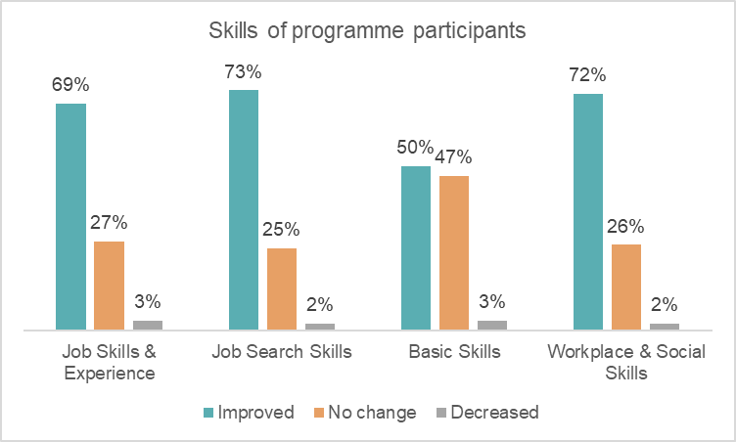
- Young people also reported improvements in:

- communication skills;
- literacy skills; and
- teamwork skills.

“They helped me read and write which is what I wanted.”
Young person
“I work better with people and I am more confident in myself and talking during group discussions.”
Young person

- This was often linked to greater confidence i.e. feeling confident enough to interact with others and taking part in group activities. A few young people said that attending the programme, particularly the group work and activities, took them out of their comfort zone. Prior to taking part in the programme they would not have spoken to people they did not know, and would not have been able to take part in an interview or focus group.
“They gave me qualifications, which I didn’t have before.”
Young person

“It took me out of my comfort zone.”
Young person

“I wouldn’t really talk to people before. It helped with that, and with social skills.”
Young person

- Many of the young people we spoke with said that coming to the programme helped give them a good routine, and that without the programme they would most likely have been in bed all day or playing video games.

- A few young people said that their course involved young people coming together from a wide area. They liked this, as it gave them the opportunity to meet new people, and they liked the mix of people with different backgrounds.

- A few young people said that the course content focusing on personal development helped them to better understand the skills and qualities that they already had. This gave them more confidence in themselves and helped motivate them to set and achieve goals.

Target: 75% of other stakeholders report skills increasing.

Achievement: 86% of stakeholders completing the survey felt that young people had shown an improvement in their skills since they started working with Action for Children.

- Stakeholders responding to the survey said that young people developed a range of personal skills. These were most often around listening, communication and confidence.

- Stakeholders also reported that young people were demonstrating more responsibility and motivation through their actions and the ways in which they were choosing to spend their time.

- For example, one stakeholder reported that the young person they had referred to Positive Choices Plus had started spending more time at home with family, and significantly less time drinking alcohol. Another noted that the young person had become more outgoing, spending less time alone at home, and more time socialising with friends.
“The majority of young people I have referred within a couple of months present as more confident, with self esteem and as a result, improved social skills.”
Stakeholder

“The young people are more talkative and are now confidently initiating conversations.”
Stakeholder

- A few stakeholders reported that young people had been supported to develop their physical skills, by joining physical activity programmes.

- They also reported that young people had developed practical skills, such as cooking and housework.

- Some stakeholders commented that they felt these changes occurred because Positive Choices Plus gave young people structure and routine, which had previously been lacking.
“They got used to having structure in their lives which hopefully will continue.”
Stakeholder

Outcome 3: Young people’s behaviours and aspirations change positively

Target: At least 80% of participants will report increased aspirations.

Achievement: Overall, young people responding to the survey reported positive changes in their levels of aspiration. The survey asked a series of questions relating to behaviour and aspiration, and responses were positive for all areas covered. The survey found that:

- 100% reported feeling better about their future, and having goals to work towards;
- 100% reported feeling more motivated to improve their situation, with most reporting that they felt ‘a lot’ more motivated; and
- 100% reported feeling more positive about themselves, their lives and their future.

Target: At least 80% of participants will positively change behaviours.

Achievement: Overall, young people reported that they had made positive changes to their behaviour since starting the programme. Most young people felt that the changes were ‘a little’ rather than ‘a lot.’ The survey found that:

- 96% reported feeling that they could cope better and overcome problems; and
- 82% reported feeling better about their relationships with family, friends and support workers.

- Overall, young people reported feeling much more positive about their future. Most had short term goals that they were working towards, and some had longer term ambitions that they wanted to achieve. Many young people said that their behaviour had changed significantly since attending the programme.

- Young people were predominantly positive about their futures and felt motivated to set and achieve goals. Many reported that they felt better able to manage their behaviour and reactions, particularly in terms of anger management. For example, some young people said that prior to attending the programme they found it difficult to manage their anger and would often react badly to situations that did not go as planned. Now they felt more calm, and able to respond with a positive attitude.
“I am able to deal with situations I couldn’t deal with before.”
Young person

“I found the course very helpful and it gave me hope for the future.”
Young person

“Before I started Action for Children I felt I couldn't achieve a big goal but I have been shown that everyone can succeed if you put in the effort.”
Young person

- Young people we interviewed or met in focus groups had mixed views about the future. These young people were in the middle of the programme and had not received the full programme of support. Some said that they had clear ideas of what they want to do before coming on the programme and that these ideas had not changed, although they felt supported and motivated to achieve their goals. A few young people said that they were not sure what they wanted to do in the future, and they still were not sure. However, when asked, they also said that they knew they could speak with their Action for Children worker about training or employment options, and they felt that their Action for Children worker would support them.

- Some of the young people we spoke with felt very positive about their future since completing the programme. They felt that they knew what they wanted to achieve and how to go about making this happen e.g. going to college, gaining the appropriate qualifications.

“Yes, I think it did make me more positive about my future. It opened up my eyes to opportunities that I didn’t know where there.”
Young person
- Some young people commented that they had made significant changes to their behaviour since attending Positive Choices Plus. There was often a clear pattern of behaviour amongst boys who reported that they had not enjoyed school, had truanted or stopped attending entirely and then had been increasingly engaged in anti-social or criminal activity. These young people said that coming to Action for Children had helped them a lot, and had helped turn their lives around, particularly in terms of maturity and responsibility.
“I’ve got high hopes for myself.”
Young person

“I can actually see a future now.”
Young person

“I was just being a delinquent….I can see myself going to college and getting an apprenticeship and getting a job.”
Young person

- Whilst some young people had more motivation and ambition, some noted that they were not ready to move on and achieve their goals unsupported. For example, one young person said that he had started a work placement on a building site but did not enjoy it and was unable to complete it. He is now at college studying painting and decorating, which he is enjoying very much.

“I thought it was what I wanted to do… It was just overwhelming, I wasn’t ready for it.”
Young person

Case study

Background
Michael is 16 and started working with Action for Children in September 2018. During his time with Action for Children he has worked with Positive Choices Plus and then moved onto Youthbuild. He was referred in by a school guidance teacher and his social worker.

Before he started working with AfC he was not attending school and didn’t feel that he had much direction in his life. Immediately prior to joining the programme he was on the cusp of being securely accommodated.
“I wasnae working, going out for days, smoking green and going on benders.”

Support
Michael enjoyed his time working with Action for Children. He got on well his support worker and the other young people participating in the programme. He felt that some of the activities and topics were similar to school, in terms of support with literacy and numeracy. However, he was glad that he gained the qualifications, as he now has additional qualifications for his CV.

“There was a lot of help there for me, I was never left on my own.”

Although there were some aspects of the course that he did not enjoy, Michael felt supported enough to continue attending. For example, as part of the course, participants took part in outdoor volunteering in a local woodland. Michael did not enjoy this experience, however he attended every session, on time, as he was working towards a longer term goal of employment. And he found that attending the programme helped him to change his habits and behaviours in other areas of his life, such as helping him to reduce and cease his cannabis use.

“It was one of the most up and down experiences of my life.”
“I’ve changed my life around, and I’ve stopped smoking green for two months now.”

Impact
Michael feels that since attending the programme, he has turned his life around. He feels that his attitude has changed a lot. Although he notes that he is still quite opinionated.

“When I went to Action for Children they taught me how to have a better perspective on how to deal with matters…I learned a wee bit of respect for other people...Now, if someone asks me to do something with them, I will.”

Through the programme, he feels that he learned how to work with other people, and how to respect people. The main thing that he feels he has achieved through his involvement with Action for Children, is his job.

Within a few weeks of completing Positive Choice Plus and beginning Youthbuild he was able to secure a work placement in construction. He enjoyed the placement and found that being busy keeps him away from antisocial activities.
“It keeps me out of trouble.”
“I wasnae doing anything with my life…now, seven months down the line, I’m in my first year of training and I’ll be starting an apprenticeship.”

Without the course, he doesn’t feel that he would have changed his life, and feels that his situation might not have improved, and that it may even have become worse.

“I wouldn’t be where I am now, today. I probably would have been doing what I was doing, or in a secure unit, or at worst, Polmont. So I’m really glad I changed my life.”

Michael successfully completed his work placement, which has now been extended into a paid placement for a further 6 months. He is now making long term plans, and hopes to take up an apprenticeship programme and become a qualified electrician.

“In four years, I’ll be a fully qualified electrician.”

Michael says that he would recommend the course to other young people, provided that they are ready for it and willing to make a change. He felt that the programme came to him at the right point in his life, when his life could have gone down a very different path. He noted that the programme was not always easy, but that for him it was worthwhile.
“I’d say, dae it. It could either be the best or worst experience of your life.”

Target: 75% of other stakeholders report increased aspirations among young people.

Achievement: 97% of stakeholders completing the survey reported that young people showed increased aspirations since they started on the programme.

- Stakeholders reported that young people they worked with demonstrated more motivation. Some stakeholders commented that simply attending regularly and completing the course demonstrated the young people’s increased motivation, as many had struggled to attend school and had never completed a course like this before.

“[Young person] completed core skills qualification - this is the first qualification he has achieved and has given him a real confidence boost.”
Stakeholder

Definitely, they are more open about thinking about training and college as they now see the benefits of planning for the future.
Stakeholder

“[Young person] had never completed any courses before, this is the first course that he has completed and is very motivated to move on to the next course and find employment.”
Stakeholder

- Other stakeholders commented that young people who had been reluctant consider their future options were markedly more motivated not only to discuss their options, but to seek out opportunities, once they had completed Positive Choices Plus.

- Stakeholders reported that some young people had started talking about their ambitions and had ideas about the ways in which they wanted to move forward. And that generally, young people were more vocal about their future aspirations.
“Some of my young people have struggled to achieve and progress in the more formal environment of statutory secondary education but have flourished at AFC.”
Stakeholder

“Definitely, they are more open about thinking about training and college as they now see the benefits of planning for the future.”
Stakeholder

“[Young person] has an increased desire to work. He has also been talking more about his move on plan from foster care which he previously avoided.”
Stakeholder

- Some stakeholders noted that as well as being more vocal about their aspirations, young people were actively planning for their futures and looking for ways to achieve their goals. In particular, some young people were hoping access education or training to improve their skills and allow them to pursue their chosen career path.
“I have noticed the difference is that the young person is now seeking ways to achieve her aim in life not just talking about what she wanted to do.”
Stakeholder

“She is looking at going back to college to complete her accountancy HNC. She is also receiving support to apply for an apprenticeship with direct line.”
Stakeholder

- Stakeholders also commented on how taking part in the programme helped young people look at themselves differently, and set higher expectations of themselves. A few stakeholders commented that this change occurred because the programme helped young people develop them self-confidence, self-belief and hope.
“They’re starting to think that they’re not losers, and that they do have a future.”
Stakeholder

Target: 75% of partners report perceived positive changes in behaviour.

Achievement: 86% of stakeholders completing the survey said that they had noticed a positive change in young people’s behaviour since they started the programme.

- Stakeholders reported that they had noticed a range of positive changes in behaviour amongst young people attending Positive Choices Plus. These included:

- improved maturity and responsibility;
- improved punctuality;
- being noticeably calmer and more relaxed;
- increased engagement in discussions; and
- reduced anti-social behaviour and offending.
“My client now contacts me rather than me instigating all contact.”
Stakeholder

“[Young person’s] offending has significantly reduced since participating in the programme.”
Stakeholder

“I am of an opinion that my relationship with this young person has improved since she has been involved with staff from Action for Children…This young person has achieved the skill of respecting herself and others that will give her an excellent foundation for this new found attitude to life.”
Stakeholder

“I have witnessed young people who appeared to have little chance of completing court orders mainly because they believed their lives would follow the same paths as their parents or friends. This path being crime, prison and being reliant on government benefits. However, once they begin engaging with Action for Children learning new skills, experiencing employment placements and in some cases obtaining paid work the changes can be remarkable.”
Stakeholder

“He has not been in trouble since attending the course, which is a change of behaviour and he has been attending which he didn't do at school. He is now very relaxed and not uptight.”
Stakeholder

- For example, one stakeholder reported that the young person she referred to Action for Children had problems with his use of alcohol and did not always attend routine appointments. Since joining Positive Choices Plus, the young person attends all of his appointments. Action for Children workers have supported him to attend substance use support meetings, which he has also attends regularly. Since completing the initial activity period of Positive Choices Plus he has actively maintained contact with his Action for Children support worker and attends fortnightly progress meetings. This stakeholder said that this level of proactive engagement would not have been expected prior to his engagement with the programme.

- Another stakeholder reported that a young person who had consistently been late for social work appointments had started taking an earlier bus to get his work placement. Since completing the programme this young persons attitude had changed from complete disregard for set appointment times, to wanting to be early rather than risk being late.

- Again, whilst stakeholders reported very positive and sometimes very significant changes in behaviour, some also noted that young people continued to face challenges in their personal lives that may prevent them for achieving their goals.

“Some of the participants have shown a more positive outlook and are aware of what is acceptable when attending meetings and interviews. However, some of the participants given their chaotic lifestyles will require further intervention to enable then to become more employable.”
Stakeholder

Outcome 4: Young people’s wellbeing improves

Target: At least 80% of participants will improve wellbeing.

Achievement: All young people (100%) responding to the survey reported improvements in wellbeing in at least one of the SHANARRI indicators explored.

- Young people responding to the survey were asked if they had experienced any changes in their wellbeing, in relation to the following SHANARRI indicators: active, achieving, responsible, respected, included.
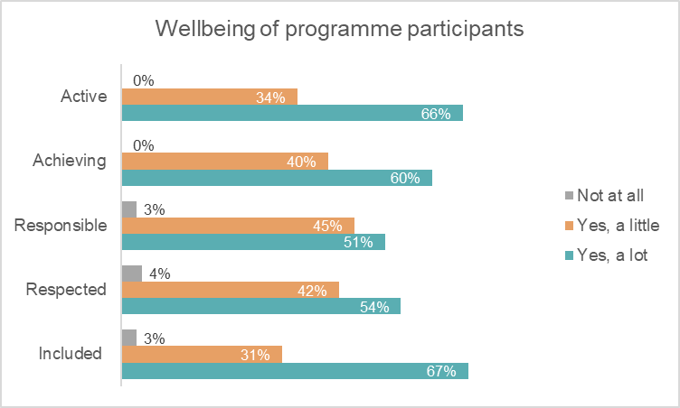

- Most participants said that their wellbeing had improved ‘a little’ or ‘a lot’ across all areas. Young people experienced the most change around feeling included, and active, which is a similar response to participants in year one.

- Yong people were not always forthcoming in speaking about specific changes to their health and wellbeing. However, as discussed under Outcome 3, many young people said that they felt more positive about themselves and their future aspirations. Some of these young people commented that they had not enjoyed school and that it had predominantly been a negative experience. However, since attending Positive Choices Plus, they felt that they would be able to achieve something with their lives.
“I feel that Action for Children have helped me through a lot with this course and outside the course they have helped me help myself.”
Young person

- And a few young people mentioned that the programme had helped improve their mental health. One young person said that the programme had helped her to deal with anxiety and depression. She had been stressed (due to a range of complex personal circumstances) and found it difficult to put on weight. Since taking part in the programme she has returned to a healthy weight.
“It helped me with my mental health by seeing people and talking to different people every day.”
Young person

“The programme helped my mental and physical wellbeing.”
Young person

- One young person mentioned that the programme helped reduce isolation. Before attending the programme she was spending most of their time alone, or caring for her partner. The programme helped her to meet new people and improve her confidence.
“I was isolated from age 14, caring for my partner…they made me feel so welcome…It brought me out of myself.”
Young person

- One young person said that since attending the programme she felt more responsible, and was actively trying to make a better life for herself and her daughter.

- They survey also asked young people if they felt supported, and if they felt involved in their community.

- 100% of young people said that they felt supported, with 79% saying that they felt supported ‘a lot’. Similarly, all of the young people we spoke with said that they felt well supported by staff. In particular some young people commented on the way that staff had supported them with literacy, numeracy, managing relationships and searching for employment.

- Young people that had completed the initial four-week course also said that they felt well supported by staff. They said that they received a phone call from staff at least once a week to check in and that they felt they could approach their worker for any additional support if they needed it. A few young people said that this aftercare was important, and made them feel that staff cared about them as an individual.

“They made me feel comfortable.”
Young person

“The workers – they went above and beyond.”
Young person

“Everyone got the right amount of support including me.”
Young person

- 75% of young people completing the survey also said that they felt more involved in their community. Young people we spoke with in focus groups said they felt a little involved, simply by living there, but some said that they did not want to be involved in their local community as they felt it was not a good environment and there was nothing positive to get involved with.

Target: 75% of other stakeholders will make positive comments about wellbeing against one of the relevant SHANARRI indicators.

Achievement: Overall, stakeholders reported improvements in young people’s wellbeing across all areas. Stakeholders completing the survey were asked if they had noticed any improvements in young peoples’ health and wellbeing, relating to their feelings around the SHANARRI indicators. Stakeholders had noticed an improvement across all of the indicators. The areas where most stakeholders reported improvements were achieving (91%), responsible (89%), included (89%) and respected (88%).
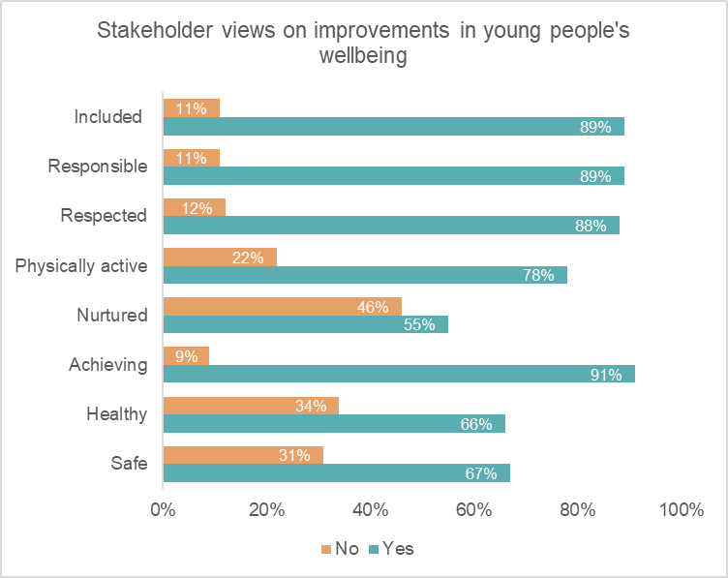

- Stakeholders reported a range of improvements in health and wellbeing including:

- improved mental health and confidence;
- improved diet;
- increased exercise and physical activity;
- establishing a routine; and
- reduced alcohol intake.

“Prior to attending the programme, this young person was quite socially isolated amongst young people his age, having moved recently to a new area and due to his offending behaviour. He has been able to engage with other group members and formed appropriate relationships with them. This has increased his self confidence and improved his mental health.”
Stakeholder

“Their mental health appears to have improved greatly.”
Stakeholder

Outcome 6: Young people participate in activity which improves their learning, employability and employment options

- Of the 88 young people that began the programme in 2018/19, 84 completed it. Four young people chose not to continue with the programme or became unreachable during the course of the programme.

- Data for progression of participants was available for 81 participants. Some participants were still engaged in the programme and were receiving ongoing support. Data in this section is taken from the Action for Children outcomes database. The table below summarises the targets and achievements in relation to this outcome.
Note – the annual target figure adds up to 56
Progression to positive destinations
Destination | Actual | Annual target | % achieved (of total participants) | Overall target | Performance against target
Training | 41 | 34 | 51% | 45% | +6%
Employment | 17 | 12 | 21% | 15% | +6%
Education/return to school | 6 | 8 | 7% | 10% | -3%
Volunteering | 4 | 4 | 5% | 5% | =
Total positive destinations | 68 | 56 | 84% | 75% | +9%
No progression | 13 | - | % | - | -

- Progression in year two has been positive. Action for Children has met and exceeded most targets, particularly for young people moving into training and employment.

- It is useful to note that although the data refers to young people that had finished the course, many were still receiving ongoing support, therefore these figures are likely to increase. We would also note that although the programme has not met its target for young people moving into education, this may be because more young people moved onto training programmes or into employment. In addition, most young people we spoke with said that they joined the programme specifically because they wanted to find employment, and many said that they had negative experiences at school or college and were not interested in returning to a formal education environment.

- Young people said that they felt the programme had shown them the range of opportunities available, and the range of things that they could be capable of achieving. They felt that this helped them decide what to do next.

“It opened my eyes to a range of different things.”
Young person

- Young people commented that the programme helped them to prepare for whatever they were moving on to do. They also mentioned that attending the programme required them to get up in the morning and get themselves to the course venue on time. Some felt that this was a good practice to establish before they started working for an employer.

“It’s getting you ready for the working world.”
Young person

- We met with young people (in focus groups) whilst they were still on the programme. All of the young people we met with were taking steps towards achieving a positive destination. Most had entered the programme because they thought it would help them get a job. Some said that they were planning on pursuing an apprenticeship, others said they wanted to go straight into employment. Only a few of the young people we met in focus groups said that they wanted to pursue further education.

- One young person we spoke with (after he had completed the course) said that the programme had helped him achieve his long term goal of becoming a joiner. This young person had not enjoyed school and had been waiting for the earliest opportunity to leave. After he left school, he contacted AfC directly because he had a friend who was doing a course there and his friend persuaded him to contact them. Through the programme he has been able to obtain a CSCS card and is now about to start his “dream job” as a joiner. In the long term he hopes to move to Australia to work as a fully served joiner.

Case Study

Background
Fiona is 22 years old and took part in Positive Choices Plus during 2018. She left school at age 14 due to personal challenges and lacked qualifications. While Fiona has taken part in a number of other training courses since, she has found that there is not much provision for young people her age. She is a care experienced young person and staff from the residential unit she was living in referred her to Positive Choices Plus.

Fiona wanted to be involved in the programme to pursue a career in bartending. At the time of applying for Positive Choices Plus, she had been applying for jobs and going to interviews. She was unsuccessful in securing employment because of her lack of skills and experience. Fiona decided that the programme would help her to gain the experience and build skills she needed, to improve her job prospects.

“I couldn’t get anywhere, I had no qualifications or experience.”

The programme
Fiona started Positive Choices Plus working with programme staff to identify what she wanted to learn. In particular, Fiona struggled with reading and writing. The training phase of the programme gave her the opportunity to gain SQA qualifications, including a Level 3 Wellbeing Award. She gained Food Hygiene, Manual Handling and Customer Service certification. Fiona was supported by staff to complete the paper-based elements of qualifications. She also developed a CV during the programme.

Fiona progressed onto a hospitality course as part of the programme, allowing her to gain a wide range of skills through practical training. This included barista training with the Matthew Algie Coffee School, mixology training and a chocolatier course. She went on a tour of the Tennant’s Brewery with other participants, and they cooked lunch in the professional kitchen.

“It was the best day of my life.”

Impact
Fiona said that she faces mental health issues, and Positive Choices Plus helped to build up her confidence and self-esteem. Before taking part in the programme she described herself and quiet and shy and spent most of her time at home. Now she enjoys being social, busy and active. Due to the non-judgemental and trusting relationships she developed with programme staff, Fiona said that her mental wellbeing has improved.

“It has improved so much in such a short space of time, it’s amazing. It really changed my life.”

Positive Choices Plus helped Fiona to develop her personal skills, including communicating and working with people she did not know. She met lots of people while on the programme, some of whom she did and did not get on with, but learned to work well with everyone.

“I met some really good people.”

Getting the opportunity to gain new skills and experience related to the career she aspires to, had a positive impact on Fiona. She said that the hospitality course she studied covered everything she wanted to know and helped confirm that she wanted a job in the industry.

“It was absolutely brilliant, a great taster. This is what I want to do.”

Fiona believes that the knowledge she gained through the programme helped her to secure her ideal job. She is now bartending at a busy venue in Glasgow. Courses such as Drugs and Alcohol Awareness and food hygiene certification have been useful for Fiona in her role.

“The programme showed me that you can do what you want as long as you put the effort in.”

Successes
Fiona felt that the most beneficial aspect of the programme was the programme staff. The staff supported her through her coursework, which she said she struggled with at times. They helped her to identify and send out her CV to potential employers, which resulted in several interviews. Having a support system gave Fiona belief in her own abilities. She is still in contact with the programme staff who make time to ensure that she is still doing well.

“They were absolutely amazing. I was supported every step of the way.”

The chance to gain qualifications was really important to Fiona, because she left school at an early age. For a similar reason, the work experience element of the programme was particularly positive. While Fiona understands the value of the classroom-based training she undertook, she particularly enjoyed getting the chance to learn new practical skills.

“I didn’t have enough experience, but now I do.”

Fiona felt that Positive Choices Plus was more flexible than other programmes she had taken part in. It was personalised rather than generic which she found beneficial. She appreciated that the programme staff tailored the learning to each individual.
“I learned what I wanted to. It was all centred on me.”

The future
Fiona is happy in her current job and has continued to develop her skills and experience. She is confident that she will be a positive asset to any future employer and is keen to progress within the hospitality industry.

“It has opened the doors for other opportunities.”

Fiona previously volunteered for a mental health charity but stopped because she felt that she wasn’t dealing well enough with her own personal issues to be a good role model for other young people. However, because her mental wellbeing has improved significantly, she is currently considering getting involved again.

“The programme is helping people to be what they want to be.”

- Stakeholders commented that the course activity and ongoing support was well designed to help young people succeed in the job market. In particular, a few stakeholders appreciated that the programme supported young people to gain sector specific qualifications that helped young people stand out amongst other candidates.
“They gain qualifications that are meaningful, like the CSCS card and Health and Safety certificate, so they can go onto sites. With those qualifications, they’re an employers delight.”
Stakeholder

- A few stakeholders commented that this change came about because staff were able to demonstrate to young people the range of realistic options available to them, in a way that they had never been shown before.

“They’ve [AfC] changed their lives for the better, by guiding them. They give them the opportunity to see that there is a bigger world out there and they can be a part of it.”
Stakeholder

- As well as the tangible outcomes of young people progressing into positive destinations, some stakeholders reported that young people’s attitudes had changed, and that they were moving closer to positive destinations, even if they had not yet achieved them. They noted that young people were showing more interest and motivation around employability, careers and long term goals, which, prior to Positive Choice Plus, they had not even wanted to discuss.

“Most of the young people I work with have little or no aspiration. it's great therefore, to see them learn new skills and work with others. Thereafter, this often leads to them talking about apprenticeships, paid work and obtaining the things most people take for granted. These examples include aspirations with regards to independent living, purchasing a car or settling down with a partner.”
Stakeholder

“[Young person] has an increased desire to work. He has also been talking more about his move on plan from foster care which he previously avoided.”
Stakeholder

- One stakeholder reported that a young person they worked with had previously dropped out of college after difficult life circumstances and bad experiences at college. After working with Action for Children the young person was keen to return to college to finish her course and achieve a qualification.

“She is planning ahead and looking to go back to college which was off the table before she started working with AFC.”
Stakeholder

- One stakeholder responding to the survey said that the young person they had referred had stopped attending school, was struggling to adhere to parental guidance and was subject to a court order. Since attending Positive Choices Plus, he is now working with a scaffolding company, has his own bank account and has started contributing to the household budget.

“I can think of a few examples, however, one that comes to mind is a young man I came upon recently. He was in overalls, hard hat and working on one of the Edinburgh University buildings. He was working productively with middle aged men as part of a work team. When I first met him, he was in danger of entering the prison system, using drugs and struggling to get out his bed to attend lunch time appointments. Having spoken to him it is evident that he is fit physically able, mentally healthy and respects not only his work colleagues, but his family and those professionals that previously assisted him. To be honest a transformation I would not have thought possible.”
Stakeholder

Outcome 7: Young people participate in positive activity

- Data in this section is taken from the Action for Children reporting scorecard, which records progress towards outcomes on a quarterly basis, and from focus group discussions with young people.

Target: 95% of participants will participate in positive activity.
Annual target: 71 participants will participate in positive activity.

Achievement: The programme engaged 88 young people in year two. Of these 88, 84 young people (95%) completed the programme and 74 attended fully.

- Action for Children defined positive activity as engagement in the four to eight week semi-structured course. Data from the Action for Children outcomes database indicates that four young people did not continue with the programme as they chose to disengage and became unreachable. Although not all young people engaged fully with the course, staff were able to provide a range of opportunities for young people to engage in some form of positive activity, beyond the semi-structured course, particularly for those who required more individual support.

- Young people said that they enjoyed the course. They were happy to attend the programme and felt it was a very good option for them. Young people said that they had fun attending the group sessions and enjoyed meeting new people and learning from the activities, particularly the employability activities and practical activities.

“I have enjoyed the course and taking part in group activities.”
Young person

“I enjoyed doing new stuff and meeting new people that I wouldn't have met if it wasn't for Action for Children.”
Young person

“I liked the programme, it was good to be able to do something every day.”
Young person

- Young people said that they particularly enjoyed the practical activities and taster sessions e.g. Fire Rescue programme and training day with the army.

- Stakeholders all felt that the programme provided opportunities for positive activity. As discussed earlier in this report, engaging with staff and attending the programme was considered positive activity for many of the young people.

Target: 75% of young people are new to the activity.
Annual target: 56 young people are new to the activity.

Achievement: The programme engaged 88 young people in total. Of these 88, 75 young people (85%) were new to the activity and had never done a programme like it before. Some of the young people had been referred from similar programmes, as they were not quite ready to progress to further training or employment.

Target: 95% of participants will complete a work star.
Annual target: 71 participants will complete a work star.

Achievement: The programme engaged 88 young people in total. All young people (100%) taking part in the programme completed a work star.

Target: 75% of young people participating in/completing personal development or community based challenge.
Annual target: 56 young people participate in/complete personal development or community based challenge.

Achievement: The programme engaged 88 young people in total. Of these 88, 72 young people (82%) completed a personal development or community based challenge.

- Young people took part in a range of voluntary activities in their local community. These included a woodland project, participating in a community clear up and volunteering at food banks.

Target: 50% of young people participating in/completing Workplace Core Skills/accredited learning.
Annual target: 38 young people participate in/complete Workplace Core Skills/accredited learning.

Achievement: The programme engaged 88 young people in total. Of these 88, 72 young people (82%) took part in or completed the SQA Workplace Core Skills course, or other accredited learning. This course supports young people to develop transferable skills for the workplace. The course was designed to assess young people’s skills in the workplace. The core skills covered in the course are: communication, numeracy, ICT, problem solving and working with others. In addition, 55 young people completed a Wellbeing Award.

- Staff felt that the key outcomes for young people were:
- attendance;
- teamwork;
- confidence; and
- personal development.

- They said that young people were attending regularly and that they had noticed punctuality improving. Along with stakeholders, they noted that attending all the sessions and completing the course was an important outcome for them. They also noted that young people worked well in groups, even with people that they did not know. Staff said that they had prepared to manage difficult group dynamics, however young people got on well and there was never any animosity within the groups. Staff also noted that they noticed young people becoming more conscientious, and thinking about themselves and other people more sensitively.

- For example, the community projects have helped young people to think about how they can contribute to the community and make a difference for others. Staff said that they were impressed with young people’s considerate and conscientious behaviour and attitudes on community projects, which demonstrated that they were really thinking about the people that they would be helping.

Programme development

Introduction

  - This chapter explores how the programme has developed and views on what has worked well and areas for development.

Programme development

  - Action for Children staff reported that this year, the programme had changed its delivery model slightly. The programme is delivered by three members of staff. Previously, all three staff members had responsibility for generating referrals, delivering the programme, and managing throughcare of participants.

  - In year two, the responsibilities have shifted. Two staff members are focusing on delivery of the programme and supporting young people whilst they are attending programme activities. And one staff member has responsibility for generating referrals and managing throughcare of young people as they move on.

  - Staff have also had further training on the outcomes star that they use to measure outcomes for young people. The baseline measurement is now conducted one week into engagement, rather than on the first day. One week into engagement, staff found that they receive more open and honest responses from young people, as they have had time to build up rapport.

What worked well

- This section outlines areas that young people, stakeholders and Action for Children staff felt worked well.

- Stakeholders overall felt that the programme worked very well and reported that the young people they worked with had enjoyed and benefited from the programme. The key success factors were identified as the delivery staff, content and the level of the programme.

“[Young person] really enjoyed the programme and has benefited from having structure and routine in his life. The project workers have been very supportive of him and given encouragement and guidance when required.”
Stakeholder

“[Young person] was given lots of support and encouragement throughout the programme and has benefited greatly from this. He is feeling much more hopeful about the future and is keen to continue working with staff to progress further.”
Stakeholder

“The support they give them is really invaluable and it does make a difference.”
Stakeholder

Staff approach
- Young people commented very positively on the staff approach. They felt that staff were open, friendly and easy to get on with. Young people frequently reported that staff spoke to them as adults, which they valued highly.
“Honestly – great. They’re not like teachers, they were funny, polite and we had great banter. They treat everyone like an adult.”
Young person

“They give you a chance. They actually speak to you and try to sort it out.”
Young person

“All staff were nice, chatty and helpful, they and the course was very helpful.”
Young person

- Participants felt that staff genuinely cared about them and wanted to help them. Many young people said that they felt they “could have a laugh” with the staff, and they liked the relaxed approach, which felt very different from the school environment they had been used to.
“The staff were great. They work round us – that was the biggest thing.”
Young person

“The staff were brilliant. I have not a bad word to say about them….They went beyond their job – we need more people like that.”
Young person

“I’ve been chucked out of every course I’ve ever been on, except this one. Here you can actually express yourself.”
Young person

- Staff and stakeholders commented on the proactive approach of staff and the intensive advocacy and support that they provide. Staff go to young people’s homes to engage them and ensure that they attend not only the programme, but also any other important appointments that they have.

“Her confidence wasn’t great and initially she wasn’t sure about going. But the staff met her beforehand and with their support, she started to open up.”
Stakeholder

“They do everything to show that they do care about you and if you come along and work with them, your life will change.”
Stakeholder

“They build a kind of relationship. I don’t know what they do, or how they do it, but they do it. And they do it well.”
Stakeholder

- Stakeholders frequently commented on the accessibility of staff to young people. They appreciated that staff made themselves available to young people, and more importantly that they persevered with young people who were reluctant to engage.

“That’s what I like about them the most, that they don’t give up, they keep with them.”
Stakeholder

“To be honest with you, I think they’re the best for young people. My client group, they don’t want to engage, they don’t go to school. These guys are really patient with them – they’re the best at what they do.”
Stakeholder

- One stakeholder also appreciated that all of the staff team were aware of each individual young person. This meant that young people could work with any staff member, if their allocated support worker was unavailable.

- Some stakeholders commented that they keep referring young people to Action for Children, because they know and trust the approach of staff within the service. Others were new to the service, but were happy with the outcomes achieved for young people and said that they would work with Action for Children again.

“The programme is fantastic and the staff do a great job engaging and motivating the young people.”
Stakeholder

“If I’m able to get them into Action for Children, I know they’re in with a good chance.”
Stakeholder

“They care, but they’re still professional. They’re there, they’re totally committed.”
Stakeholder

“I really trust the people that work there. I have a lot of respect for them, that’s why I keep referring young people to them.”
Stakeholder

- Stakeholders and young people commented on the non-judgemental approach of staff. Stakeholders liked that Action for Children workers took the time to listen to young people and to focus on the individual young people. Importantly they appreciated that staff were not dismissive of what young people identified as their needs, and were happy to focus on those areas first, before moving onto more employability focused work.

- Young people and stakeholders commented on the diversity of staff. Stakeholders in particular noted that Action for Children had a diverse range of staff (in terms of age and gender) who could relate to young people in different ways.

Programme content and level
- Young people generally enjoyed the course content. Most thought it was interesting and useful. For many young people, the setting and atmosphere worked well, as they felt it was not too classroom-based.

- In terms of content, a number of young women said that they found the suicide prevention topic very useful. And some young men said that they liked the fire rescue programme and army training experiences. A few young people commented that the course content helped them to realise the skills and qualities that they had, and made them feel more positive about their ability to succeed.

“I struggle to learn from writing. Learning from doing is better.”
Young person

- A small number of young people said that some of the course content relating to literacy and numeracy was not appropriate for them, as they had completed National 4 exams at school.

- Stakeholders appreciated that the programme, although employability focused, supported young people to develop the important personal skills that they needed – such as budgeting, social skills and relationships.

- Some stakeholders said that they appreciated the level at which this programme was designed i.e. pre-employability pipeline. Most stakeholders we spoke with were aware of other Action for Children programmes (as well as programmes run by other organisations) and they appreciated that Action for Children had a range of programmes pitched at different stages of the employability pipeline.

“This programme worked well for the clients we referred, and the staff made everyone feel welcome and at ease throughout the programme. It was pitched at the right level as some of the clients had very erratic lifestyles and still got something from the programme.”
Stakeholder

- Stakeholders also noted that this programme offered a lot of support for young people to develop life skills and personal skills. They said that many of the young people had significant challenges in their life and that this was one of the few employability programmes available that took account of all their life influences. One stakeholder said that she did not know of other programmes that offered this type of support.
“When I looked at this, it talked about developing life skills, managing budgets, developing relationships…and there are not a lot of courses that I know that would address specific needs like that, whilst on the course.”
Stakeholder

“I work hard to improve the lives of the young people I work with and it's heartening for me to work with a service who share my own commitment and passion.”
Stakeholder

- A few stakeholders who work in social work services said that Positive Choices Plus gave young people time and support that social workers were no longer able to provide due to high case loads.

“Often it feels like they are filling in the gaps that we can no longer do.”
Stakeholder

Safety and trust
- A few stakeholders we spoke with mentioned that they felt they could entrust young people to Action for Children, and knew that they would be cared for appropriately.
“I know that they [young people] will be looked after.”
Stakeholder

“They will go over and above. They never close the door. They never say no…I like that they really do go the extra mile for any young person. I refer to them regularly because I’ve never been let down.”
Stakeholder

- They noted that Action for Children staff made themselves available to young people in a way that other services could not, and this helped them build trust with young people. One stakeholder, who was a social worker, noted that young people were more comfortable with Action for Children because it was not a statutory organisation.

- A few stakeholders commented that for young people with challenging home lives, the Action for Children support workers were often the only adults they had contact with that provided a consistent, nurturing influence.
“They’ve been at the end of the phone when no one else was.”
Stakeholder

“The support they give them is really invaluable and it does make a difference.”
Stakeholder

- Young people echoed this feeling, and said that they felt they could trust staff and share personal information with them. One young person said that he appreciated being given opportunities to take responsibility and earn trust, for example
“I could tell them anything and it is totally confidential.”
Young person

“I could trust them and they were never too strict.”
Young person

“They give you the responsibility that you should be given. Some of us have been in trouble with the police and stuff, and [during construction skills sessions] they let you walk about with hammers and tools…it shows that they care and that they trust us.”
Young person

“Most people in my life turned their back on me, but they want to actually try to help.”
Young person

Managing young people’s complexities
- Staff reported that since most referrals this year have come from social work services, the young people in the programme tend to have chaotic home lives and high levels of need. For these young people, employability is still a goal, but realistically, there are many barriers to overcome before they can begin actively working towards employment.

- Young people displayed a range of challenges including: substance use and addiction, mental health issues, low literacy and numeracy and learning difficulties. Stakeholders also commented that many of the young people they referred to the programme had experienced neglect, lack of boundaries, and that many came from non-working households or had parents with mental health or substance misuse problems. These young people presented to the service with little or no resilience or coping mechanisms.

- Working around these issues was challenging, particularly because some young people were reluctant to acknowledge or address these issues. Staff reported that for these young people, regular attendance and engagement in activities was an achievement. Often the first step was to help them establish a routine and staff said that they were wary of overloading them with too much, too quickly.

“We don’t want to scare them off by putting too much on them at once.”
Action for Children staff

- Stakeholders felt that one of the key strengths of the programme was its ability to acknowledge and address young people’s complexities, many of which arose from adverse childhood experiences.
“I can only put on a plaster. Action for Children can spend time to heal the wounds.”
Stakeholder

“My client group are predominantly made up of young people who have suffered significant trauma and because of this have great difficulty developing trusting relationships. They also have criminal records and little or no academic qualifications.
Therefore, getting these young people who suffer from low confidence and self-esteem into training or employment is an extremely difficult task. Most training providers lose patience with them which only adds to the negatives views they have of themselves. AfC on the other hand do a tremendous job at sticking with these young people. I can think of at least three ex-clients who are now in full time employment or were when I last had contact with them. Which, is great for them, their family and friends.”
Stakeholder

- Young people also reported that they felt Action for Children staff understood them in a way that other agencies, particularly school, had not. They felt that the staff took the time to understand them and their aspirations, and encouraged them to achieve their goals.

Partnership working
- Staff reported that partnerships with social work teams have worked well this year. Social work staff have recognised the benefits of the programme. In particular, the fact that few other organisations were willing or able to engage the young people on their case load with the highest level of need.
“Other organisations don’t want to work with these young people. They’re harder to work with.”
Action for Children staff

“They’re just dead decent people who understand the client group they’re dealing with. If Action for Children wasn’t there I’d be pulling my hair out because there’s nobody doing the same job. They’re the best thing that’s out there.”
Stakeholder

“I think sometimes other agencies are scared of our client group…Action for Children knows how to manage them in a non threatening way. With other agencies, they just get scolded.”
Stakeholder

- Stakeholders we spoke with said that they enjoyed working with Action for Children. Those that had been working with the organisation for a long time said that they continued to refer young people because the services and staff were consistently of a high quality.

- All of the stakeholders we spoke with felt that staff were easy to work with, good at maintaining communication and easily accessible. Some noted that the regular flow of communication allowed them to work in close partnership to meet the (sometimes changeable) needs of young people.
“They’re very good at communicating and networking with other agencies, and that helps young people know that we’re all working together.”
Stakeholder

“I can phone them anytime.”
Stakeholder

- One stakeholder noted that Action for Children was able to recommend if a young person would be suitable for their course or not, and that she trusted their recommendations and judgements.

What could be improved

- This section outlines areas that young people, stakeholders and Action for Children staff felt were challenging, or could be improved.

Generating referrals
- Staff noted that reaching people and getting them involved in the programme in the first instance was difficult. Staff have spent a significant amount of time working on referral routes and seeking our referral partners. They noted that the market for services supporting young people is quite full, which adds to the challenge.

- Staff felt that in some cases, organisations were reluctant to refer young people as they did not want to ‘share’ young people between services, particularly if the organisation feels that it already provides a similar service.

- Action for Children staff were keen not to compete with services that were already established within a local area. Where possible they focused on localities without this type of support and provision. However, in some localities, young people expressed little demand for services. On speaking with local agencies, staff found that in some localities, young people were very reluctant to use services and partners, as such, the local services had found it very difficult to engage them and were not able to make many referrals.

- They noted that the time taken up trying to obtain referrals limits the time available to support young people with throughcare, that is, to progress after the initial four week course (throughcare).

“Getting referrals is the hardest thing.”
Action for Children staff

- Staff said that although they have been proactive in reaching out to a range of organisations, there has been very little return, particularly from the targeted groups such as organisations working with young women or LGBTQI young people.

Programme duration
- During year one, Action for Children staff responded to feedback from participants and changed the course from three days per week over six to eight weeks, to five days per week over four weeks. This model better reflects a working week and encourages development of routine and structure. However, one stakeholder commented that the expectation of attendance five days a week during the initial support period might be too much of a commitment for some young people. They suggested that this portion of delivery could run over a longer period of time, but with fewer days per week (as per the previous model of delivery).

- A few other stakeholders reported that they think young people would benefit from a longer period of intensive support.
“I think this programme is so beneficial to young people however it would be really good if it was longer.”
Stakeholder

- However a few stakeholders also recognised that the programme offered a period of 26 weeks follow up and they felt that this was also an important element of the offering. One stakeholder noted that with Action for Children she felt that her clients received “genuine follow up” via weekly calls. During the follow up period, staff can also offer 1:1 sessions and visits to work placements, if needed.

“The follow up for 26 weeks is very important.”
Stakeholder

Diversity and reach
- A few young people and stakeholders commented on the age range of young people eligible for the course. A few young people said that they were frustrated that they were unable to progress directly on from this course to Youthbuild (an Action for Children construction course) as they were under 16 when they completed Positive Choices Plus. This left them with a gap in activity between completing the course and progressing to their ideal training programme. A few stakeholders felt that the service would be valuable to their clients beyond the upper age limit of 24.

- Staff also noted that the diversity of young people that the programme can reach is limited to the diversity of young people in the services that are referring them. Staff said that they continue to contact a wide range of services across the programme locations, however establishing new referral routes remains a challenge.

Ongoing support and work placements
- A small number of young people told us that they did not find the programme as useful as they had expected it to be. For these young people, their work placement had not gone as expected or did not give them the type of experience they had hoped for. In particular, some young people wanted more hands-on activity and practical experience, from both the programme and the work placement. And two young people said that they did not feel they received enough ongoing support after the initial engagement period, although they were aware that they could contact Action for Children if they wanted to.

“The placements could be better.”
Young person

- One young person had a very negative experience on their work placement, where they felt unsupported and badly treated by the employer. He felt that more care should have been taken before selecting employers for work placements, and that there could have been better monitoring of his placements. Although this young person reported his challenges to Action for Children, he did not feel that action was taken to improve the situation.

“I should have been moved to another site, and things would have been different.”
Young person

Conclusions

Introduction

  - This chapter provides an overview of progress in year two of CashBack funding. It summarises the programme reach, outcomes achieved, key successes and recommendations going forward.

  - In year two, Action for Children has made very good progress towards its targets and intended outcomes. It has reached and exceeded most of its targets and has shown significant progress towards delivering positive outcomes for young people.

Programme reach

  - The programme reached 88 young people, exceeding the annual target of 75 young people, and helping to make up the shortfall in participation during year one.

  - The programme has continued to work with young people who have a range of different life challenges and disadvantages. Most young people on the programme were from the 20% most disadvantaged areas in Scotland. Young people also reported having a range of risk factors, including lack of work experience, single-parenting, substance misuse and mental health issues, indicating that they were distant from the job market and employment options.

  - The proportion of males and females engaging in the programme has not changed significantly since year one. There are still more young men than young women participating in the programme. The high proportion of referrals of young men may be linked to the organisation’s established reputation for delivering construction programmes, and the demographics of the young people that are supported by social work services.

Progress towards intended outcomes

  - The programme has demonstrated good progress towards all of the intended outcomes. In particular, around young people’s confidence, behaviours, aspirations and progression towards employability.

  - Most young people progressed into positive destinations. The programme met and exceeded its targets for young people progressing into employment, training and volunteering. It is useful to note that some young people will be receiving ongoing support, as part of the extended support offered by the programme. These young people’s destinations may not have been recorded during the year two delivery period that ran from April 2018 to March 2019. The programme targets young people who are disadvantaged and have significant challenges in their lives. We would anticipate that these young people would require ongoing support, beyond the initial delivery period, in order to progress to a positive destination.

  - The table below provides an overview of progress towards each outcome.

Summary of CashBack outcomes and progress for year two, Phase 4
Outcome 1  Young people build their capacity and confidence | The programme met and exceeded all of its targets relating to this outcome. Young people and stakeholders reported significant increases in capacity and confidence.
Outcome 2  Young people develop their physical and personal skills | The programme met and exceeded its numerical target with 72 participants achieving accredited learning. Overall stakeholder reported improvement in communication and personal skills. Young people reported increased in employability related skills.
Outcome 3  Young people’s behaviours and aspirations change positively | The programme met and exceeded all of its targets relating to this outcome. Young people and stakeholders reported significant improvements in behaviour and aspiration, particularly around self-belief and motivation to seek employment.
Outcome 4  Young people’s wellbeing improves | The programme met all of its targets relating to this outcome. Young people reported feeling well supported by the programme, and feeling that they were able to achieve. They also felt better able to manage their emotions and reported improvements in mental wellbeing. Stakeholders reported that they felt young people were achieving, becoming more responsible and were being included.
Outcome 6  Young people participate in activity which improves their learning, employability and employment options | The programme met and exceeded its targets for young people progressing to positive destinations – specifically into employment, training and volunteering. It fell slightly short of its target for young people moving into education, possibly because more young people entered training and employment. Young people felt that the programme taught them valuable employability skills and would support them to achieve their goals.
Outcome 7  Young people participate in positive activity | The programme met its numerical targets relating to this outcome. Young people reported that they felt the activity was worthwhile, useful and enjoyable. Stakeholders reported that they felt the programme was a good option, and noted that for some young people, engaging with staff and completing the programme was a significant achievement.

  - There is good evidence to show that the programme is supporting young people to build their confidence and skills, which has helped young people move closer to or into the job market. The programme has supported significantly disadvantaged young people with multiple challenges to develop self-belief and to begin working towards a positive future.

  - Staff felt that the key outcomes for young people were around attendance, learning to work as a team, personal development, confidence and independence.

  - One of the key success factors has been the staff approach, which has helped encourage engagement and ongoing participation in the programme.

  - In year two, staff successfully implemented a new model for delivering outcomes stars, which has worked well. Staff also worked hard to support the evaluation by encouraging completion of the evaluation survey from stakeholders and young people.

Next steps

  - A small number of young people reported that their work placements were not what they had expected. Although the team has established procedures in place, further measures may help ensure that young people are fully aware of the throughcare support that is available to them, and that they feel confident to report any challenges as soon as they arise. Similarly, continued communication with work placement deliverers may help to ensure that expectations are well managed, for both young people and employers.

  - As discussed in the previous year’s evaluation, Action for Children may wish to take action around the gender imbalance of the programme, particularly as the programme is designed to be generic and non-industry specific.

  - Young people reported that they enjoyed the more practical aspects of the programme, and it may be beneficial to consider how to incorporate more of this type of activity into the programme.

This data comes from Action for Children’s outcomes database.

