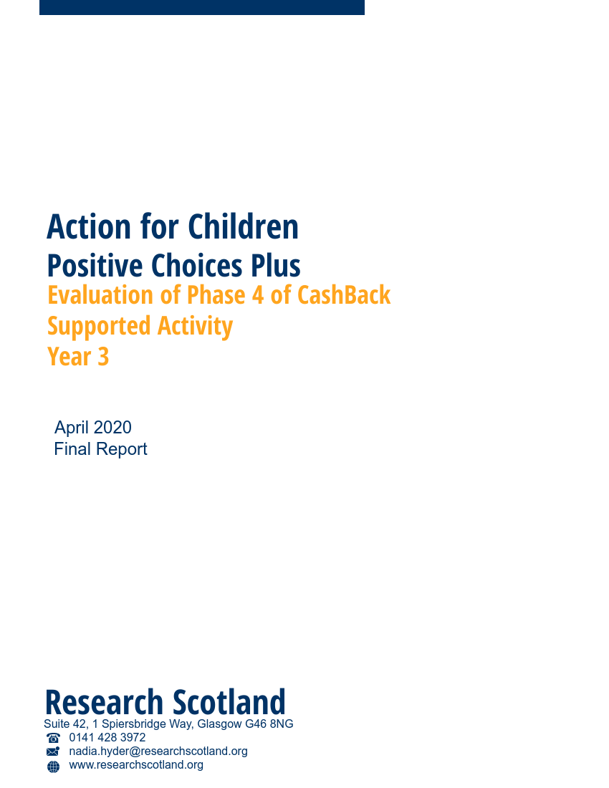

Contents

1. Introduction 1
2. Participation in Phase 4 5
3. Outcomes 9
4. Programme development 29
5. Conclusions 38

- Introduction

About this report

  - Action for Children commissioned us (Research Scotland) to evaluate the impact of Positive Choices Plus, its Phase 4 CashBack funded programme. This report covers programme delivery during Phase 4. It brings together information gathered across the three years of programme delivery.

  - This report will:

- explore the reach of Action for Children activity;
- consider developments and progress; and
- explore the impact of Action for Children’s programme.

Action for Children

  - Action for Children is a national children’s charity committed to making a real difference to vulnerable children, young people and their families – particularly in areas such as safety, health, relationships and achievements. Through its activities it actively works to tackle important issues such as child neglect and abuse. It delivers 650 services across the UK and works directly with over 300,000 children, young people, parents and carers.

Programme delivery

  - Over three years of CashBack funded delivery, from 2017 to 2020, the Positive Choices Plus programme aimed to work with 225 young people aged 14 to 24. The programme worked across five local authority areas: Glasgow, Edinburgh, North Lanarkshire, South Lanarkshire and West Dunbartonshire.

  - It aimed to support young people experiencing disadvantage because they:

- lived in areas of deprivation;
- were unemployed and not in education or training;
- were excluded or at risk of exclusion from school; and
- were at risk of being involved in anti-social behaviour or the criminal justice system.

  - Positive Choices Plus was developed through learning from Action for Children’s Phase 3 CashBack funded programme (Positive Choices) but took a more flexible approach to delivery, and was targeted towards young people at stage one or two of the employability pipeline. The programme ran generic courses that supported young people to progress into their chosen pathway, rather than delivering industry specific courses and accreditation.

  - The programme offered participants a period of 1:1 support from staff, particularly in the early stages of the programme. This support helped young people to stabilise their lives before beginning the more structured course involving group work. Staff helped young people with basic life skills, aimed at ensuring they were prepared and able to undertake a structured course. This support involved: setting up bank accounts, travel planning, accompanying young people to appointments, wake up calls and engagement with parents and families. Staff felt that this wider support was necessary before young people could realistically engage in a formal programme.

“We provide them with whatever support they need at the time…that’s the reality of the baggage that young people come with. If we don’t do all of that, then they won’t engage.”
Action for Children staff

  - Each young person worked with Action for Children staff for up to nine months, following a broad structure of:

- four-week pre-course support;
- four to eight-week course focused on identified needs; and
- up to 26 weeks of post-course support.

  - The programme offered a range of support and activities, including opportunities to gain accreditation and work experience. It was designed to offer a wide range of support at different levels, which can be tailored to meet individual needs. Whilst on the focused course, young people were eligible for a training allowance of £55 per week, and travel expenses.

  - The activities were focused on improving young people’s personal skills, core skills and readiness to enter the world of work. The support was offered as a mix of 1:1 and group work and can range from in-house support with literacy and numeracy to work placements with employers. The programme also supported young people to create and develop CVs, prepare for interviews and apply for jobs and apprenticeships.

  - The programme was initially planned to be delivered in five groups of 15 young people, with one group in each of the five local authority areas. The course would last for eight weeks, with delivery running for three days per week. During year one it became clear that this number of participants was difficult to achieve over one delivery period, and that large groups did not facilitate the type of support that the young people needed. The programme was altered to run as a four-week course, with delivery over five days per week, and with around eight participants per group. This approach was more successful and continued for the remainder of Phase 4.

  - The programme’s outputs and outcomes were measured through a dedicated outcomes database, an outcome star, a survey with young people and a survey with stakeholders.

CashBack for Communities

  - Action for Children was allocated £576,617 of Phase 4 CashBack funding to deliver the Positive Choices Plus programme during 2017/18, 2018/19 and 2019/20.

  - Funding was allocated over three years as follows:

  - Year 1 2017/18 - £195,924
  - Year 2 2018/19 - £198,594
  - Year 3 2019/20 - £182,099.

  - CashBack funding is granted on the understanding that the programme will work towards agreed outcomes and outputs.

  - The programme in Phase 4 was delivered within budget at £576, 058.

Evaluation method

  - Over three years of delivery, our evaluation work involved:

- analysis of 187 completed surveys from young people;
- analysis of 64 completed surveys from stakeholders;
- six focus groups with young people;
- 20 telephone interviews with young people;
- nine telephone interviews with partners;
- discussions with the staff team and practice team leader; and
- analysis of programme data collected by Action for Children.

  - Throughout this report we have measured progress against numerical and percentage targets. We note that our calculations are a percentage of the number of young people that participated (228). When reporting on outcomes about young people’s experiences, we have only used data that has come directly from young people i.e. discussions with young people, surveys completed by young people. Although this does not gather the views of every participant, we feel it provides a good indication of progress.

  - The practice team leader worked closely with staff and young people to achieve a good response for end of project surveys achieving an overall response rate of 82%. This figure allows us to be 99% confident that the full population response would be within 5% of the sample.

Agreed targets and intended outcomes

  - Action for Children agreed to deliver the following CashBack outcomes, and to measure progress towards these outcomes through set targets. Numerical and percentage targets were set based on the assumption that the programme would engage 225 participants.

CashBack outcomes and targets for Phase 4
Outcome 1: Young people build their capacity and confidence
- At least 191 (85%) participants will increase their confidence/capacity
- 191 (85%) young people will report they are able to do new things
- 75% of other stakeholders report increasing confidence
- 191 (85%) young people go on to do new things after their initial CashBack involvement
Outcome 2: Young people develop their physical and personal skills
- At least 214 (95%) participants will increase personal skills, achieving accredited learning
- At least 191 (85%) participants will report an increase in their skills
- 75% of other stakeholders report increased skills in young people
Outcome 3: Young people’s behaviours and aspirations change positively
- At least 180 (80%) participants will report increased aspirations
- 75% of other stakeholders report increased aspirations
- At least 180 (80%) participants will positively change behaviours
- 75% of stakeholders report perceived positive changes in behaviour
Outcome 4: Young people’s wellbeing improves
- At least 180 (80%) participants will improve wellbeing.
- 75% of other stakeholders will make positive comments about wellbeing against one of the relevant SHANARRI indicators
Outcome 6: Young people participate in activity which improves their learning, employability and employment options
- At least 169 (75%) participants will achieve positive destinations
- 101 (45%) young people will progress to training
- 23 (10%) young people will access learning (including staying on at school)
- At least 34 (15%) of young people will gain employment (due to provision being targeted at stage one of the SSP)
- 11 (5%) young people volunteering following completion of programme
Outcome 7: Young people participate in positive activity
- At least 214 (95%) participants will participate in positive activity
- 169 (75%) young people are new to the activity (had never done that type of activity before)
- At least 214 (95%) participants will complete a work star
- 169 (75%) young people participating in/completing personal development/community-based challenge
- 113 (50%) of young people participating in/completing Workplace Core Skills/accredited learning
- Participation in Phase 4

Introduction

- This section will discuss programme participation during Phase 4. It is based on data recorded in the Action for Children outcome database.

Overall participation
- In total, Action for Children worked with 228 young people over the three years of delivery, exceeding the overall target to work with 225 young people. Delivery was split as follows:

- Year 1 – 59
- Year 2 – 88
- Year 3 – 81.

Target group
- The programme aimed to engage young people that were furthest away from the job market – at Stage 1 or 2 of the employability pipeline. All young people involved in the programme met this criteria.

Disadvantage
- The programme worked with young people from a range of challenging backgrounds, who experienced disadvantage for a variety of reasons. Analysis of participant postcodes found that most participants (58%) came from the 20% most deprived areas of Scotland. The following chart outlines the proportion of participants across datazones.
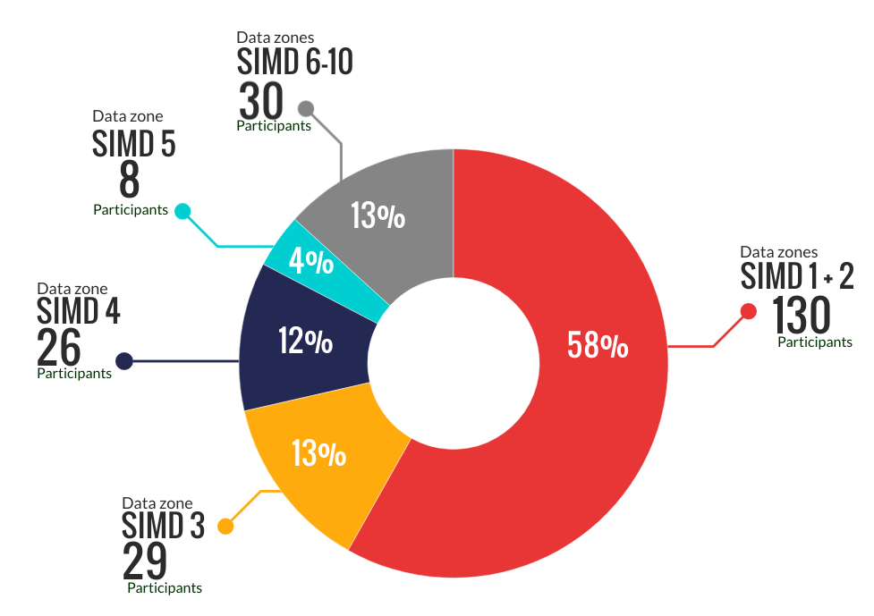
- Information from the Action for Children outcomes database shows that some young people dealt with significant life events and challenges during their engagement with the programme.

- The range of challenges varied, and included:

      - use of alcohol and drugs;
- being care experienced;
- significant challenges with mental health;
- challenging and chaotic home circumstances;
- offending behaviour; and
- significant challenges with literacy and numeracy.

- Staff reported that many young people presented with challenges around literacy and numeracy. Staff supported young people to develop these skills so that they could confidently progress to work-based activities such as CV building and job applications.

- A small proportion of participants identified as homeless (6%), a lone parent (5%) or minority ethnic (3%). And a small number of individuals identified as asylum seekers or refugees (2%). The table below shows some of the challenges faced by young people working with the programme.

Challenges faced by young people | Number | Percentage
Lack of work experience | 165 | 73%
Unemployed | 140 | 62%
Substance abuse | 60 | 27%
Mental health | 53 | 24%
Literacy and numeracy | 51 | 23%
No qualifications | 50 | 22%
Criminal record | 42 | 19%
Alcohol abuse | 29 | 13%
Disability | 30 | 13%
Care experienced | 30 | 13%
Family caring responsibility | 16 | 7%
Homeless | 14 | 6%
Lone parent | 11 | 5%
Ethnic minority | 6 | 3%
Refugee/asylum seeker | 3 | 1%

Geographical spread
- During year two the programme worked with young people across its five target local authority areas - Glasgow, Edinburgh, West Dunbartonshire, North Lanarkshire and South Lanarkshire.
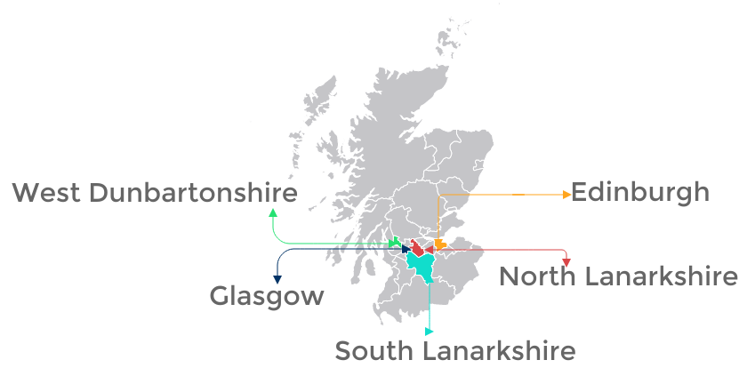

Gender
- Of the 228 participants, 182 were male (80%) and 46 (20%) were female.

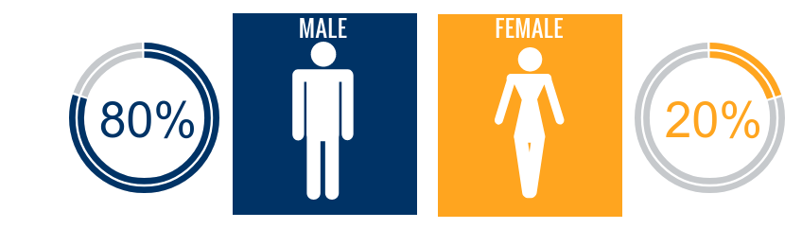

- The proportion of male and female participants in the programme has been steady at 80:20. Action for Children staff said that they felt the programme was working towards achieving a better balance of male and female participants during Phase 4. The data shows an increase from 14% female participation across Phase 3, to 20% in Phase 4.

Age
- The programme engaged with young people aged 14 - 25. Most participants were aged between 15 and 18 when they joined the programme. The chart below shows the spread of participants across age groups.

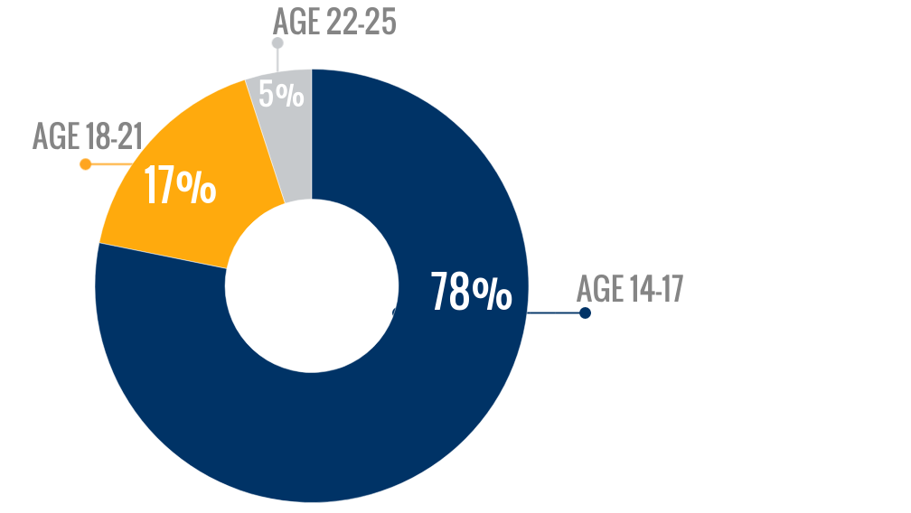

Referrals
- Positive Choices Plus received referrals from a range of partners including social work services (Children and Families teams or Criminal Justice teams), Job Centres, Skills Development Scotland, schools and other Action for Children programmes.

- In addition to receiving referrals, staff actively reached out to young people that might benefit from the programme. In year two particularly, staff conducted outreach in delivery areas where fewer referrals had been received, by walking around the area, making themselves known to young people and making themselves known to relevant local organisations.

- Outcomes

Introduction

- This chapter explores how Action for Children has progressed in relation to its intended outcomes over the three year period. This chapter is based on information collected by Action for Children staff through outcome stars, outcomes focused surveys, regular monitoring and our fieldwork in years one and two.

- During Phase 4, Action for Children engaged 228 young people, reaching and exceeding its target number of young people (225).

Outcome 1: Young people build their capacity and confidence

Target: At least 191(85%) of 225 participants will increase their confidence/capacity.

Achievement: 213 (93%) of 228 young people said that they felt more confident in themselves and their ability, since they had started working with Action for Children.

In addition:

161 (70%) of 228 young people felt more confident about their future.

160 (70%) of 228 young people said that they felt more confident about starting employment, training or education since they started working with Action for Children.

Target: 191 (85%) of 225 young people will report they are able to do new things.

Target: 191 (85%) of 225 young people go on to do new things after their initial CashBack involvement.

Achievement: 212 (93%) of 228 young people responding to the survey said that they felt able to do new things, and 191 (84%) said that they had done new things since they started the programme.

- Young people said that they were more able to:

- work confidently in groups;
- travel independently;
- create CVs; and
- search and apply for jobs.

“I have started looking for jobs more confidently.” Young person

“I feel able to go to job interviews and know what to do and say better than I have in the past.” Young person

“I have more confidence for interviews” Young person

- Some young people said that they felt more able to speak in a group, or to speak with new people. They also noted that they felt they knew how to behave in different environments and different circumstances.

“I feel more confident working in groups.” Young person

“I have more confidence about working with new people and interacting with people.” Young person

- Young people also mentioned that they felt more able to maintain a healthy routine, attend interviews, use computers and work with tools, through the course activities.

- And those who had completed the programme and moved into positive destinations reported that they continued to gain confidence as they progressed.

“I feel more confident since I started Positive Choices and became employed.” Young person

- Almost all of the stakeholders (95%) completing the survey reported that they had noticed young people were more able to do new things since they started the programme.

“I would say that the young people are more confident to talk to new people, they are more confident to try new things and they seem to gain maturity to help them have the confidence to move on from school.” Stakeholder

- Stakeholders reported improvement across a range of areas. These included:

- group work;
- participating in family life;
- communication; and
- employability related activities (CV, interview prep, job searching).

- Stakeholders also reported improvements in young peoples’ attitudes towards trying new things. Some said that young people were now more open to trying new things. This was further evidenced by reports of young people undertaking independent travel and route planning.

“They are getting outside more and much more confident when travelling.” Stakeholder

Target: 75% of other stakeholders report increasing confidence.

Achievement: All (100%) of the stakeholders responding to the survey said that they had noticed an increase in confidence amongst young people since they started working with Action for Children. Over half (64%) of stakeholders felt that confidence had increased ‘a lot’.

- Stakeholders said that they had noticed significant improvements in young people’s confidence.

- Stakeholders reported that changes in confidence were often associated with improved communication skills, social sills and increased engagement in activities.

“All of the pupils who have been referred to Action for Children have gained a lot of confidence and experience from the program.” Stakeholder

“I have noticed a huge difference in confidence with [young person] on and since the course.” Stakeholder

“This young person was extremely isolated and very vulnerable at the time of referral. I have witnessed an increase in confidence and they have shown willingness to engage with peers and professionals.” Stakeholder

- Many stakeholders commented that attending a course regularly, and attending for the full duration of the course was a significant increase in capacity for the young people they work with.

- And some stakeholders provided specific examples where young people had demonstrated improved confidence by speaking with new people and doing things outwith their comfort zone.

“[Young person] has had the confidence to attend a few interviews since attending the course.” Stakeholder

“His confidence has improved - especially around talking to people.” Stakeholder

Outcome 2: Young people develop their physical and personal skills

Target: At least 214 (95%) of 225 participants will increase personal skills, achieving accredited learning.

Achievement: 219 (96%) young people achieved non-SCQF qualifications, such as Fire Reach participation certificates. 208 (91%) of 228 young people achieved accredited learning through the programme. The programme supported young people to achieve 313 SCQF qualifications at SCQF level 3, including the Wellbeing Award.

Target: At least 191 (85%) of 225 participants will report an increase in their skills.

Achievement: 201 (88%) of 228 participants reported an increase in their skills.

- Young people reported improvements in their skills across a range of areas including:

- communication skills;
- literacy skills;
- personal safety;
- personal development;
- health and wellbeing;
- money and budgeting; and
- teamwork skills.

“We were learning sexual health and how to protect yourself and others, we learned to work in a team better, we learned about where to go if you want to find employment.” Young person

“I have learned to complete my qualifications and have more social skills.” Young person

“I learned about first aid.” Young person

- Young people sometimes linked the increase in skills to their increased confidence. A few young people said that attending the programme, particularly the group work and activities, took them out of their comfort zone. Prior to taking part in the programme they would not have spoken to people they did not know, and would not have been able to take part in an interview or focus group.

“I wouldn’t really talk to people before. It helped with that, and with social skills.” Young person

- Some young people specifically mentioned the support that they had received to improve their literacy skills. Given that many of the young people were not attending school or had been school refusers for extended periods of time, this was an important skills to develop in order to become employable.

“I have had a lot of support with my literacy.” Young person

“I’m starting to read more and think about English.” Young person

- Many of the young people we spoke with said that coming to the programme helped give them a good routine, and that without the programme they would most likely have been in bed all day or playing video games.

- A few young people said that their course involved young people coming together from a wide area. They liked this, as it gave them the opportunity to meet new people, and they liked the mix of people with different backgrounds.

- A few young people said that the course content focusing on personal development helped them to better understand the skills and qualities that they already had. This gave them more confidence in themselves and helped motivate them to set and achieve goals. One young person commented that they were working on developing their “initiative” – becoming more independent and responsible.

- A few young people commented on industry specific employability support that they had received. The programme was designed to be generic, however where a young person demonstrated an interest in a particular industry, staff supported them to access information and training courses, and develop the relevant skills.

“I understand a lot more things about construction overall.” Young person

- Data from completed work stars indicates that young people developed their workplace related skills. Three quarters of participants reported improvements in job search skills and employment related skills and experience. And most reported improvements in one of the four skill sets.

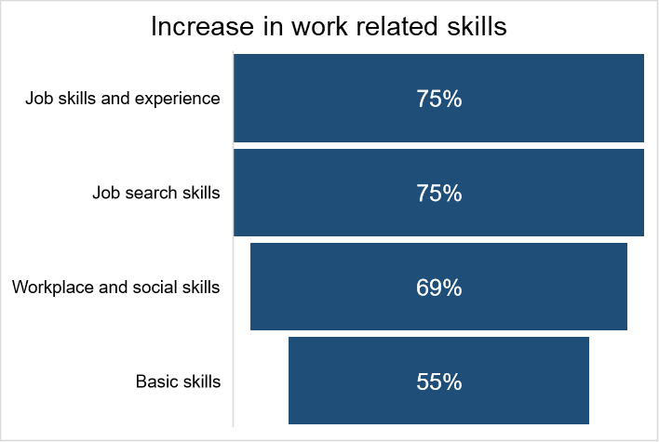

Target: 75% of other stakeholders report skills increasing.

Achievement: 81% of stakeholders felt that young people had shown an improvement in their skills since they started working with Action for Children.

- Stakeholders said that young people developed a range of personal skills. These were most often around listening, communication and confidence. \in particular, some stakeholder reiterated young people’s comments on becoming more confident and able to take initiative.

“Social Skills have become a lot better.” Stakeholder

“I definitely see a real improvement in the young people's communication skills and in their independent thinking.” Stakeholder

- Stakeholders also reported that young people were demonstrating more responsibility and motivation through their actions and the ways in which they were choosing to spend their time.

- A few stakeholders reported that young people had been supported to develop their physical skills, by joining physical activity programmes. They also reported that young people had developed practical skills, such as cooking and housework.

- Some stakeholders commented that they felt these changes occurred because Positive Choices Plus gave young people structure and routine, which had previously been lacking.

“They got used to having structure in their lives which hopefully will continue.”
Stakeholder

Outcome 3: Young people’s behaviours and aspirations change positively

Target: At least 180 (80%) of 225 participants will report increased aspirations.

Achievement: 215 (94%) of 228 participants reported increased aspiration

- 99% reported feeling better about their future, and having goals to work towards
- 98% reported feeling more positive about themselves, their lives and their future
- 70% reported feeling more motivated to improve their situation

Target: At least 180 (80%) of 225 participants will positively change behaviours.

Achievement: 206 (90%) of 228 participants reported positive changes in their behaviour.

- 67% reported feeling that they could cope better and overcome problems
- 61% reported feeling better about their relationships with family, friends and support workers

- Overall, young people reported feeling much more positive about their future. Most had short term goals that they were working towards, and some had longer term ambitions that they wanted to achieve. Many young people said that their behaviour had changed significantly since attending the programme.

“Before I started Action for Children I felt I couldn't achieve a big goal but I have been shown that everyone can succeed if you put in the effort.” Young person

- Some young people reported that they felt better able to manage their behaviour and reactions, particularly in terms of anger management. For example, some young people said that prior to attending the programme they found it difficult to manage their anger and would often react badly to situations that did not go as planned. Now they felt more calm, and able to respond with a positive attitude.

“I don't get into trouble because I want to focus on my career.” Young person

- Some of the young people we spoke with felt very positive about their future since completing the programme. They felt that they knew what they wanted to achieve and how to go about making this happen e.g. going to college, gaining the appropriate qualifications.

- There was often a clear pattern of behaviour amongst boys who reported that they had not enjoyed school, had truanted or stopped attending entirely and then had been increasingly engaged in anti-social or criminal activity. These young people said that coming to Action for Children had helped them a lot, and had helped turn their lives around, particularly in terms of maturity and responsibility.

“I was just being a delinquent….I can see myself going to college and getting an apprenticeship and getting a job.” Young person

Case study – Jack

*Name has been changed for anonymity

Jack began working with Action for Children in 2018 when he was 15. He was referred by Social Services and his social worker has supported him and worked with Action for Children throughout.

He had recently returned to Scotland from overseas and was having difficulties resettling back into school and the way of life here. He is also dyslexic and smoked cannabis regularly. He started offending and became one of the most prolific young offenders in his locality, with charges for house breaking, bike theft and assault. Due to his offending behaviour he was at risk of being transferred to secure accommodation.

He has engaged with four Action for Children programmes throughout 2018 and 2019. Initially he struggled with commitment and attendance as he was continuing to offend and had to attend court appearances. With support from the Action for Children team and his social worker, his behaviour and commitment improved.
Eventually he was able to do work experience with a scaffolding company. Whilst on work experience, he was arrested, but maintained communication with Action for Children staff and was able to return and successfully complete his work experience.

Having demonstrated a change in attitude and commitment, Jack was interviewed and accepted onto Youthbuild. He did well on the course. His attendance and attitude were better, and he got on well with the team and the group. He successfully passed all the exams, obtaining all his construction certificates.

When he completed the course, staff were not sure how ready he was for the world of work. They supported him to develop a CV and spoke with several agencies about contract work. During this time, he had court appearances, and he was issued with a 12-month CPO, which potentially made finding him work more difficult. However, Jack was more focused and determined to succeed.

Staff were able to secure a two-week work trial with company in the construction industry. During the work trial he had a court appearance and meetings with social work, but he communicated with the employer. He explained that his CPO required him to attend weekly meetings and the employer was supportive and prepared to work around this. He did well on his trial and was subsequently taken on in a paid position at the end of 2019.

The location of the work site required Jack to get up at 5.30am and take a bus. However Jack remains unfazed and undeterred. Action for Children staff visited him on site and he is on track to earning an apprenticeship.

Over the course of two years, staff have seen a significant improvement in Jack’s attitude and motivation to change his life. In partnership with his social worker, his employer, his family and with Jack himself, Action for Children will continue to support him.

Target: 75% of other stakeholders report increased aspirations among young people.

Achievement: 97% of stakeholders completing the survey reported that young people showed increased aspirations since they started on the programme, with 66% feeling that this had increased ‘a lot’.

- Stakeholders reported that young people demonstrated significant improvements in motivation and aspirations after engaging with Positive Choices Plus.

- Stakeholders felt that young people who previously showed no intentions of engaging with services or gaining employment showed a distinct change in mindset. Not only did they begin planning for their future, stakeholders said that young people also began to set goals and apply themselves to achieve them.

“Before he started the course he wasn't bothered. Now he wants to get to the goal of an apprenticeship or a job.” Stakeholder

“He now wants to go onto Youthbuild and get a job. He used to say he would end up in jail.” Stakeholder

- Stakeholders noted that often these young people had never sustained engagement with support services before. The outcomes, of sustained engagement, improved mindset and positive destinations were a significant achievement.

“[Young person] has never managed to engage consistently in anything in school...It’s been an incredible change in his commitment since starting positive choices.” Stakeholder

“Seems to be more motivated. Never had any goals before this programme. Offering to do gardening and helping out at home…This is great for me and I don't need to nag him anymore. he seems willing to help.” Stakeholder

- Stakeholders noted that the change in motivation was linked to change in how the young people perceived themselves. They noted that Action for Children helped young people believe that they were both worthy of a positive, proactive existence and capable of achieving one.

“Most of the young people I have referred have no motive or structure in their lives and didn't go to school, no bed times, meal times. The programme when it works at its best give them these things and belief that they can obtain meaningful employment.” Stakeholder

“[They have] improved insight with regards to who they are and who they potentially could be.” Stakeholder

Target: 75% of partners report perceived positive changes in behaviour.

Achievement: 83% of stakeholders completing the survey said that they had noticed a positive change in young people’s behaviour since they started the programme.

- Stakeholders reported that they had noticed a range of positive changes in behaviour amongst young people attending Positive Choices Plus. These included:

- improved maturity and responsibility;
- improved punctuality;
- being noticeably calmer and more relaxed;
- increased engagement in discussions; and
- reduced anti-social behaviour and offending.

- Stakeholders also commented that young people had a broader view of the world and of themselves. They were more willing to listen to suggestions and engage in an open discussion about the future.

“He is more open minded and willing to explore different options.” Stakeholder

“The young person is very keen to move forward and engage with the next employability programme.”
Stakeholder
“Seems more able to set goals and more open to different suggestions.” Stakeholder

- Again, whilst stakeholders reported very positive and sometimes very significant changes in behaviour, some also noted that young people continued to face challenges in their personal lives that may prevent them for achieving their goals.

“Some of the participants have shown a more positive outlook and are aware of what is acceptable when attending meetings and interviews. However, some of the participants given their chaotic lifestyles will require further intervention to enable then to become more employable.” Stakeholder

“[Young person’s] physical and personal presentation has improved slightly. He appears to take more interest in how he is presenting himself. It is difficult to gauge change in [young person] at this time as he is being emotionally challenged by the various life events which can impact on his mood level with regularity.” Stakeholder

Outcome 4: Young people’s wellbeing improves

Target: At least 180 (80%) of 225 of participants will improve wellbeing.

Achievement: 200 (88%) of 228 participants reported improvements in wellbeing in at least one of the SHANARRI indicators explored.

- Young people were asked if they had experienced any changes in their wellbeing, in relation to the following SHANARRI indicators: active, achieving, responsible, respected, included.

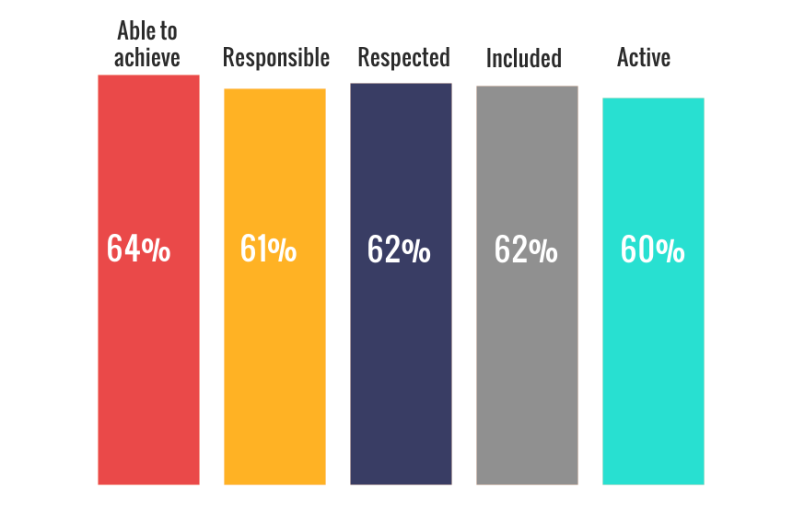
- Most participants said that their wellbeing had improved in some way across all areas. Young people experienced the most change around feeling able to achieve, feeling included and feeling respected.

- Young people repeatedly reported that they felt well supported by staff. In particular some young people commented on the way that staff had supported them with literacy, numeracy, managing relationships and searching for employment.

- Some young people noted that they felt better within themselves, with improvements relating to mental health – particularly anxiety and depression. And a small number of young people said that the programme had helped them to feel more active, or to improve their physical health.

- One young person said that the programme had helped her to deal with anxiety and depression. She had been stressed (due to a range of complex personal circumstances) and found it difficult to put on weight. Since taking part in the programme she has returned to a healthy weight.

“I feel that Action for Children have helped me through a lot with this course and outside the course they have helped me help myself.”
Young person

“I feel active as I walk to programme and look at college courses.” Young person

- One young person said that since attending the programme she felt more responsible, and was actively trying to make a better life for herself and her daughter.

- Sixty-one per cent of young people also said that they felt more involved in their community. Young people we spoke with in focus groups said they felt a little involved, simply by living there, but some said that they did not want to be involved in their local community as they felt it was not a good environment and there was nothing positive to get involved with.

Target: 75% of other stakeholders will make positive comments about wellbeing against one of the relevant SHANARRI indicators.

Achievement: 100% of stakeholders reported that there had been improvements in young people’s health and wellbeing across at least one of the SHANARRI indicators.

- Similar to young people, most stakeholder reported improvements around inclusion and achievements. Stakeholders also reported and commented on young people becoming more responsible.

Stakeholder’s views on improvements in young people’s wellbeing [n=64]

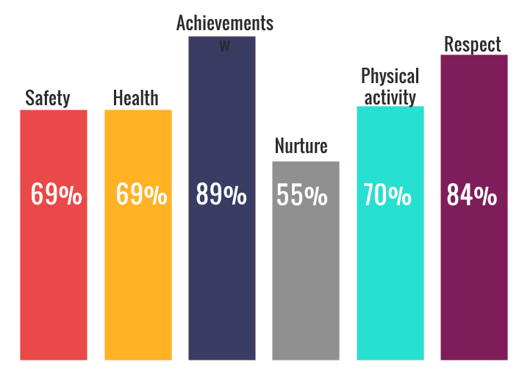
- Stakeholders reported a range of improvements in health and wellbeing including:

- improved mental health and confidence;
- improved diet;
- increased exercise and physical activity;
- establishing a routine; and
- reduced alcohol intake.

- Again, stakeholders often attributed wider outcomes in health and wellbeing to young people’s improved confidence and self-esteem. Stakeholders who were parents noted that young people were keeping a better routine.

“His increase in confidence has made him a much happier lad.” Stakeholder

“More outgoing, not as depressed as before the course.” Stakeholder

“Yes he has a lot more focus. Still has his moments but he really enjoys the course … and he has been much calmer lately.” Stakeholder

“More football and out on the bike - drinking more water which he never done.” Stakeholder

“I have definitely seen an improvement in the mental health of children who have worked with Action for Children, especially around their self-worth.” Stakeholder

- A few stakeholders commented specifically on the way in which young people had become more responsible. This was often through better life choices and being accountable for the way they spent their time. One parent noted that their child was not staying out late anymore, and this gave them peace of mind.

“Back on a better routine, going to bed earlier and not sleeping all day.” Stakeholder
He's more grown up and starting to take responsibility for his actions. Stakeholder
“He is easier to talk to. He has a better routine now. He has a goal which he never had before.” Stakeholder
“[Young person] has been tending more to his personal presentation recently and displays more confidence in conversation.” Stakeholder

Stakeholders reported that the programme helped young people to develop better relationships, particularly with family members. They felt that this contributed to a better home environment for the whole family, and in turn, had a positive impact on young people’s behaviour outside of the home.

“Never spoke to family friends before but now has more dialogue with them now which is great to see.” Stakeholder
“Yes more mature in his way of thinking. Him and his brother used to fight but get on much better now.” Stakeholder

- A few stakeholders commented on the improvement in young people’s wellbeing that came from having trusting relationships with adults. They said that working with Action for Children helped young people to start regaining trust with professionals. Young people were then able to access support networks and move away from negative influences and associates. Stakeholders noted the importance of the therapeutic relationship between staff and young people, and the transformative effect it had on outcomes for individuals.

“This young person has shown strength and courage when communicating with professionals. She has accepted that previously she engaged in risk taking behaviours but by disclosing this to adults she has indicated she needs help with this.” Stakeholder
“They begin to engage positively with adults and most importantly develop trusting relationships. Whereas, many were previously abused by adults in their lives.” Stakeholder

Outcome 6: Young people participate in activity which improves their learning, employability and employment options

- Of the 228 young people that began the programme 213 (93%) completed it. Fifteen young people chose not to continue with the programme or became unreachable during the course of the programme.

- As the programme finished delivery in December 2019, data for progression was available for all participants. Some participants were still engaging with staff and were receiving ongoing support. The table below summarises the targets and achievements in relation to this outcome.

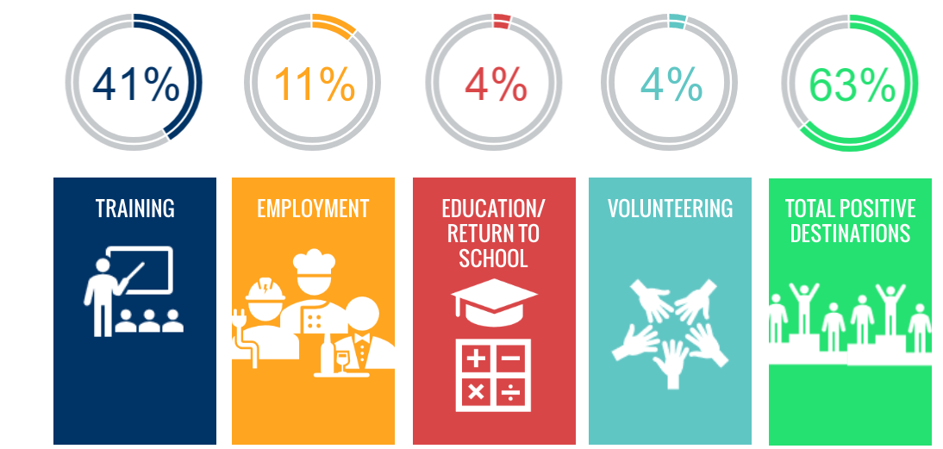

Progression to positive destinations
Destination | Actual | Target | % achieved (of 228 participants) | Overall target | Performance against target
Training | 94 | 101 | 41% | 45% | -4%
Employment | 26 | 34 | 11% | 15% | -4%
Education/return to school | 10 | 23 | 4% | 10% | -6%
Volunteering | 9 | 11 | 4% | 5% | -1%
Total positive destinations | 143 | 169 | 63% | 75% | -12%
No progression | 85 | - | 37% | - | -

- Almost two thirds of participants moved into a positive destination, with most going on to further training. One in ten participants moved into employment, and a small proportion went on to education or volunteering.

- Action for Children has not met its targets for progression to positive destinations. Over a third of participants did not progress to any positive destination. It is useful to note that the young people engaged with the programme had a range of challenging life circumstances. Staff worked very closely with young people during and beyond the programme delivery period. Where possible, the reasons for lack of progression were noted. These included:

- Unsafe or unstable housing
- Maternity
- Being the victim of an assault
- Picking up charges and criminal convictions
- Going to prison.

- A number of young people were noted to have been referred to CAMHS and needing a lot of support with their mental health, including significant issues with substance use. And a number of young people disengaged from the service and became uncontactable despite persistent efforts from staff. One young person was dismissed from the programme after stealing a wallet from a staff member.

- Young people said that they felt the programme had shown them the range of opportunities available, and the range of things that they could be capable of achieving. They felt that this helped them decide what to do next.

“It opened my eyes to a range of different things.” Young person

- Stakeholders commented that the course activity and ongoing support was well designed to help young people succeed in the job market. In particular, a few stakeholders appreciated that the programme supported young people to gain sector specific qualifications that helped young people stand out amongst other candidates.

“They gain qualifications that are meaningful, like the CSCS card and Health and Safety certificate, so they can go onto sites. With those qualifications, they’re an employers delight.” Stakeholder

- As well as the tangible outcomes of young people progressing into positive destinations, some stakeholders reported that young people’s attitudes had changed, and that they were moving closer to positive destinations, even if they had not yet achieved them. They noted that young people were showing more interest and motivation around employability, careers and long term goals, which, prior to Positive Choice Plus, they had not even wanted to discuss.

“Absolutely brilliant thing for young people, school was not for him. he would never be able to get a job without this. It’s a great step for people like him.” Stakeholder

“I'm really grateful for this, if he wasn't on this programme he would be sitting about - I'm really proud of him.” Stakeholder

- Although Action for Children did not meet the numerical targets set for this outcome, we would note that there is evidence to show that young people moved closer to employment. Staff spent time addressing core issues with young people and changing their mind set towards learning and working. They noted that this type of work takes time and that it may take years before a young person takes a step into a sustained positive destination. Staff also noted that they were very careful not to push young people into education, training or employment programmes before they were ready. And due to the reality of many young people’s lives, they may not have been ready or capable of sustaining a placement directly after completing Positive Choices Plus.

Outcome 7: Young people participate in positive activity

- Data in this section is taken from the Action for Children reporting scorecard, which records progress towards outcomes on a quarterly basis, and from focus group discussions with young people.

Target: 214 (95%) of 225 participants will participate in positive activity.

Achievement: 213 (93%) of 228 young people completed the programme.

- Action for Children defined positive activity as engagement in the four to eight week semi-structured course. Data from the Action for Children outcomes database indicates that fifteen young people did not continue with the programme as they chose to disengage and became unreachable. Although not all young people engaged fully with the course, staff were able to provide a range of opportunities for young people to engage in some form of positive activity, beyond the semi-structured course, particularly for those who required more individual support.

- Young people said that they enjoyed the course. They were happy to attend the programme and felt it was a very good option for them. Young people said that they had fun attending the group sessions and enjoyed meeting new people and learning from the activities, particularly the employability activities and practical activities.

- Similarly, stakeholders reported that young people enjoyed the programme and continued to attend throughout the duration because they wanted to.

“Great place, great people and great opportunity.” Young person

“It is one of the only programmes that I can say that we have had a 100% positive feedback rate from our pupils and many younger pupils request to be referred on a regular basis.” Stakeholder

Target: 169 (75%) of young people are new to the activity.

Achievement: The programme engaged 228 young people in total. Of these all, (100%) and had never done a programme like it before. Some of the young people had been referred from similar programmes, as they were not quite ready to progress to further training or employment.

Target: 113 (95%) of participants will complete a work star.

Achievement: The programme engaged 228 young people in total and 224 young people (98%) completed a work star.

- Staff conducted the work star with young people once at an early stage in their journey, and again towards the end of their engagement. Staff noted that in a small number of cases young people joined the programme but did not complete it, or did not engage in post programme support, and so did not complete the work star.

Target: 75% of young people participating in/completing personal development or community based challenge.

Achievement: 107 (47%) of 228 participated in or completed personal development or community based challenge.

- Young people took part in a range of voluntary activities in their local community. These included a woodland project, participating in a community clear up and volunteering at food banks.

- The team was unable to offer community based challenges for the final blocks of the programme. In some areas, it was logistically challenging to deliver these challenges and some activities required specialist tools which were difficult to procure. There were also fewer staff members available to deliver the challenges as the individuals moved on to other roles. At one stage a programme was delivered by a single staff member, when ordinarily there would have been three staff members. In lieu of the required staff and practical resources, staff focused on delivering the core outcomes for young people, around confidence, employability and wellbeing.

Target: 113 (50%) of 225 of young people participating in/completing Workplace Core Skills/accredited learning.

Achievement: The programme engaged 228 young people in total. Of these 152 young people (67%) took part in or completed the SQA Workplace Core Skills course, or other accredited learning, such as the Wellbeing Award. This course supports young people to develop transferable skills for the workplace. The course was designed to assess young people’s skills in the workplace. The core skills covered in the course are: communication, numeracy, ICT, problem solving and working with others.

- Staff felt that the key outcomes for young people were:

- attendance;
- teamwork;
- confidence; and
- personal development.

- They said that young people were attending regularly and that they had noticed punctuality improving. Along with stakeholders, they noted that attending all the sessions and completing the course was an important outcome for them. They also noted that young people worked well in groups, even with people that they did not know. Staff said that they had prepared to manage difficult group dynamics, however young people got on well and there was never any animosity within the groups. Staff also noted that they noticed young people becoming more conscientious, and thinking about themselves and other people more sensitively.

- For example, the community projects have helped young people to think about how they can contribute to the community and make a difference for others. Staff said that they were impressed with young people’s considerate and conscientious behaviour and attitudes on community projects, which demonstrated that they were really thinking about the people that they would be helping.

- Stakeholders also noted that attending Positive Choices Plus was a positive activity for young people. They commented that young people enjoyed attending, sustained their engagement and benefited greatly.

- A few stakeholders commented that engaging with Positive Choices Plus was the gateway for young people to engage with other services, resulting in more support and better outcomes.

“Nearly all of the referred individuals have demonstrated more willingness to engage with other services not just Action for Children.” Stakeholder

- Programme development

Introduction

  - This chapter explores how the programme has developed and views on what has worked well and areas for development.

Programme development

  - Over the course of the programme the delivery model changed slightly. In year two, staff responsibilities shifted so that two staff members would focus on delivery and one would focus on generating referrals and managing throughcare. This model worked more effectively than all staff members being responsible for delivery, referrals and throughcare.

  - Staff also received further training on the outcomes star used to measure outcomes for young people. The baseline measurement is conducted one week into engagement, rather than on the first day. One week into engagement, staff found that they received more open and honest responses from young people, as they had time to build rapport.

What worked well

- This section outlines areas that young people, stakeholders and Action for Children staff felt worked well.

- Stakeholders overall felt that the programme worked very well and reported that the young people they worked with had enjoyed and benefited from the programme. The key success factors were identified as the delivery staff, the content and the level of the programme, and the outcomes achieved for young people.

“The young people I refer belong to chaotic, disadvantaged backgrounds. They have few positive role models in their lives and often despite their self they project lack of confidence. I strongly believe this programme is one of the few that genuinely helps young people to unlock their potential.” Stakeholder

“The support they give them is really invaluable and it does make a difference.” Stakeholder

Staff approach
- Young people consistently commented very positively on the staff approach. They felt that staff were open, friendly and easy to get on with. Young people frequently reported that staff spoke to them as adults, which they valued highly.

“Honestly – great. They’re not like teachers, they were funny, polite and we had great banter. They treat everyone like an adult.” Young person

“They give you a chance. They actually speak to you and try to sort it out.” Young person

- Participants felt that staff genuinely cared about them and wanted to help them. Many young people said that they felt they “could have a laugh” with the staff, and they liked the relaxed approach, which felt very different from the school environment they had been used to.

“The staff were great. They work round us – that was the biggest thing.” Young person

“I’ve been chucked out of every course I’ve ever been on, except this one. Here you can actually express yourself.” Young person

- Staff and stakeholders commented on the proactive approach of staff and the intensive advocacy and support that they provide. Staff go to young people’s homes to engage them and ensure that they attend not only the programme, but also any other important appointments that they have.

“In terms of the support provided by Action for Children as a whole, this has been invaluable for the young person, particularly now they have returned to reside with their mother where there are concerns.” Stakeholder

“They build a kind of relationship. I don’t know what they do, or how they do it, but they do it. And they do it well.” Stakeholder

- Stakeholders frequently commented on the accessibility of staff to young people. They appreciated that staff made themselves available to young people, and more importantly that they persevered with young people who were reluctant to engage.

“That’s what I like about them the most, that they don’t give up, they keep with them.” Stakeholder

“To be honest with you, I think they’re the best for young people. My client group, they don’t want to engage, they don’t go to school. These guys are really patient with them – they’re the best at what they do.” Stakeholder

- Some stakeholders commented that they keep referring young people to Action for Children, because they know and trust the approach of staff within the service. Others were new to the service, but were happy with the outcomes achieved for young people and said that they would work with Action for Children again.

“We see Action for Children as one of our most valued partners. So many of our pupils ask to be referred to Youth Build and we see a massive benefit to the pupils who go on the course.” Stakeholder

“They care, but they’re still professional. They’re there, they’re totally committed.” Stakeholder

“I really trust the people that work there. I have a lot of respect for them, that’s why I keep referring young people to them.” Stakeholder

- Stakeholders and young people commented on the non-judgemental approach of staff. Stakeholders liked that Action for Children workers took the time to listen to young people and to focus on the individual young people. Importantly they appreciated that staff were not dismissive of what young people identified as their needs, and were happy to focus on those areas first, before moving onto more employability focused work.

- Young people and stakeholders commented on the diversity of staff. Stakeholders in particular noted that Action for Children had a diverse range of staff (in terms of age and gender) who could relate to young people in different ways.

Programme content and level
- Young people generally enjoyed the course content. Most thought it was interesting and useful. For many young people, the setting and atmosphere worked well, as they felt it was not too classroom-based.

- In terms of content, a number of young women said that they found the sexual health and suicide preventions topic very useful. And some young men said that they liked the fire rescue programme and army training experiences. A few young people commented that the course content helped them to realise the skills and qualities that they had, and made them feel more positive about their ability to succeed.

“I struggle to learn from writing. Learning from doing is better.” Young person

- Stakeholders appreciated that the programme, although employability focused, supported young people to develop the important personal skills that they needed – such as budgeting, social skills and relationships.

- Some stakeholders said that they appreciated the level at which this programme was designed i.e. pre-employability pipeline. Most stakeholders we spoke with were aware of other Action for Children programmes (as well as programmes run by other organisations) and they appreciated that Action for Children had a range of programmes pitched at different stages of the employability pipeline.

- Stakeholders also noted that this programme offered a lot of support for young people to develop life skills and personal skills. They said that many of the young people had significant challenges in their life and that this was one of the few employability programmes available that took account of all their life influences.

“When I looked at this, it talked about developing life skills, managing budgets, developing relationships…and there are not a lot of courses that I know that would address specific needs like that, whilst on the course.” Stakeholder

- A few stakeholders who work in social work services said that Positive Choices Plus gave young people time and support that social workers were no longer able to provide due to high case loads.

“Often it feels like they are filling in the gaps that we can no longer do.” Stakeholder

Safety and trust
- Stakeholders we spoke with mentioned that they felt they could trust Action for Children to support young people appropriately.

“They will go over and above. They never close the door. They never say no…I like that they really do go the extra mile for any young person. I refer to them regularly because I’ve never been let down.” Stakeholder

- They noted that Action for Children staff made themselves available to young people in a way that other services could not, and this helped them build trust with the young people. One stakeholder, noted that young people may be more comfortable with Action for Children because it was not a statutory organisation.

- A few stakeholders commented that for young people with challenging home lives, the Action for Children support workers were often the only adults they had contact with that provided a consistent, nurturing influence.

“The support they give them is really invaluable and it does make a difference.” Stakeholder

- Young people echoed this feeling and said that they felt they could trust staff and share personal information with them. One young person said that he appreciated being given opportunities to take responsibility and earn trust.

“I could trust them and they were never too strict.” Young person
“They give you the responsibility that you should be given. Some of us have been in trouble with the police and stuff, and [during construction skills sessions] they let you walk about with hammers and tools…it shows that they care and that they trust us.”
Young person

“Most people in my life turned their back on me, but they want to actually try to help.” Young person

Managing young people’s complexities
- Staff reported that since most referrals have come from social work services, the young people in the programme tend to have chaotic home lives and high levels of need. For these young people, employability is still a goal, but realistically, there are many barriers to overcome before they can begin actively working towards employment.

- Young people displayed a range of challenges including: substance use and addiction, mental health issues, single parenthood, very low literacy and numeracy and learning difficulties. Throughout the programme staff noted that a significant amount of time was spent supporting young people with basic literacy and numeracy.

- Stakeholders also commented that many of the young people they referred to the programme had experienced neglect, lack of boundaries, and that many came from non-working households or had parents with mental health or substance misuse problems. These young people presented to the service with little or no resilience or coping mechanisms.

- Working around these issues was challenging, particularly because some young people were initially reluctant to acknowledge or address these issues. Staff reported that for these young people, regular attendance and engagement in activities was an achievement. Often the first step was to help them establish a routine and staff said that they were wary of overloading them with too much, too quickly.

- Stakeholders felt that one of the key strengths of the programme was its ability to acknowledge and address young people’s complexities, many of which arose from adverse childhood experiences.

“I can only put on a plaster. Action for Children can spend time to heal the wounds.” Stakeholder

- Young people also reported that they felt Action for Children staff understood them in a way that other agencies, particularly school, had not. They felt that the staff took the time to understand them and their aspirations, and encouraged them to achieve their goals.

Partnership working
- Staff reported that partnerships with social work teams have worked well and social work staff recognised the benefits of the programme. In particular, they noted that few other organisations were willing or able to engage these young people, as they had the highest level of need.

“Other organisations don’t want to work with these young people. They’re harder to work with.” Action for Children staff

“I think sometimes other agencies are scared of our client group…Action for Children knows how to manage them in a non threatening way. With other agencies, they just get scolded.” Stakeholder

- Staff noted that they were able to work in close partnership with Skills Development Scotland and job centres. In some areas, staff sat in these offices and engaged with young people as they passed through for other appointments. During this Phase staff also developed a good relationship with an organisation supporting refugees, minority ethnic people and people on the fringes of society. These were target groups that the programmes wished to support and had previously struggled to reach.

- Stakeholders we spoke with said that they enjoyed working with Action for Children. Those that had been working with the organisation for a long time said that they continued to refer young people because the services and staff were consistently of a high quality.

- All of the stakeholders we spoke with felt that staff were easy to work with, good at maintaining communication and easily accessible. Some noted that the regular flow of communication allowed them to work in close partnership to meet the (sometimes changeable) needs of young people.

“They’re very good at communicating and networking with other agencies, and that helps young people know that we’re all working together.” Stakeholder

- Action for Children staff and stakeholders felt that they had excelled at achieving outcomes for young people. Staff felt that the key successes were around giving young people opportunities they would not normally have had and providing a broad learning experience. As part of the programme in years one and two, they also delivered mind set training, through an external provider. They felt that this worked very well to change young people’s behaviours.

What could be improved

- This section outlines areas that young people, stakeholders and Action for Children staff felt were challenging, or could be improved.

Generating referrals
- Staff noted that reaching people and getting them involved in the programme in the first instance was difficult. Staff have spent a significant amount of time working on referral routes and seeking out referral partners. They noted that the market for services supporting young people is quite full, which adds to the challenge.

- Staff felt that in some cases, organisations were reluctant to refer young people as they did not want to ‘share’ young people between services, particularly if the organisation feels that it already provides a similar service.

- Action for Children staff were keen not to compete with services that were already established within a local area. Where possible they focused on localities without this type of support and provision. However throughout the programme, in some localities, young people expressed little demand for services. On speaking with local agencies, staff found that in some localities, young people were very reluctant to use services and partners, as such, the local services had found it very difficult to engage them and were not able to make many referrals.

- And in one locality, staff noted that there were issues with territorialism, which prevented young people from attending the programme.

- Staff noted that planning around referrals had been an important learning point in Phase 4. Particularly for this client group, the referral partners needed a lot of advance notice before a programme was to begin.

- The original plan was ambitious and required partners to be responsive and for there to be a high demand in each area at the time when they were running the programme. Staff learned that they needed to make use of economies of scale where possible – and this was challenging when working across five local authorities, some of which were geographically large.

- Staff said that although they were proactive in reaching out to a range of organisations, there was very little return, particularly from the targeted groups such as organisations working with young women or LGBTQI young people. Marketing and promotion was specifically designed to attract different groups of people, and to show that the programme is keen to work with underrepresented groups. However, the return on the output was very unpredictable.

- Staff also noted that when one person moves on, either in their own organisation or in a partner organisation, their network goes with them and a lot of institutional knowledge lost. The Positive Choices Plus team had a lot of turnover across the three years of delivery and for the final four months the team ran one staff member short.

“It was quite a high ambition with a small core team working across five different local authority areas.” Action for Children staff

“Given the challenges, the team has worked really well and have developed loads of networks.” Action for Children staff

Programme duration
- There were mixed opinions regarding the duration and intensity of the programme. During year one, Action for Children staff responded to feedback from participants and changed the course from three days per week over six to eight weeks, to five days per week over four weeks. This model better reflects a working week and encourages development of routine and structure. However, a few stakeholders commented that the expectation of attendance five days a week during the initial support period might be too much of a commitment for some young people. They suggested that this portion of delivery could run over a longer period of time, but with fewer days per week (as per the previous model of delivery).

“It’s a great programme and I think young people would benefit from it maybe being less days a week and over a longer period of time.” Stakeholder

- However a few stakeholders also recognised that the programme offered a period of 26 weeks follow up and they felt that this was also an important element of the offering.

Diversity and reach
- A few young people and stakeholders commented on the age range of young people eligible for the course. A few young people said that they were frustrated that they were unable to progress directly on from this course to Youthbuild (an Action for Children construction course) as they were under 16 when they completed Positive Choices Plus. This left them with a gap in activity between completing the course and progressing to their ideal training programme. A few stakeholders felt that the service would be valuable to their clients beyond the upper age limit of 24.

- Staff also noted that the diversity of young people that the programme can reach is limited to the diversity of young people in the services that are referring them. Staff worked extensively to reach minority groups and people who would benefit from the programme but were unlikely to engage with statutory services. In year three the programme developed a good relationship with a community organisation supporting these groups and was able to generate new referrals.

Ongoing support and work placements
- Staff reported that one of the challenges they had in sustaining engagement and positive destinations was the time gap between young people finishing the structured course programme and moving into a positive destination. There was not always an appropriate project/training course/education programme for them to move onto. Where there was a significant delay, there was a risk that young people lost momentum or motivation. Where possible, staff tried to minimise this gap or to find positive activity for young people to engage with in this time.

- A small number of young people told us that they did not find the programme as useful as they had expected it to be. For these young people, their work placement had not gone as expected or did not give them the type of experience they had hoped for. In particular, some young people wanted more hands-on activity and practical experience, from both the programme and the work placement.

- Conclusions

Introduction

  - This chapter provides an overview of progress over Phase 4 of CashBack funding. It summarises the programme reach, outcomes achieved and key factors to consider going forward.

  - Overall, the programme has made good progress towards its targets and intended outcomes. Evidence from monitoring information, young people, stakeholders and staff indicated that the programme has been successful. It is clear that young people benefited from the programme and were supported to move towards employment.

Programme reach

  - Over three years of delivery, the programme reached 228 young people, exceeding its target of 225 young people.

  - The programme has continued to work with young people who have a range of different life challenges and disadvantages. Most young people on the programme were from the 20% most disadvantaged areas in Scotland. Young people also reported having a range of risk factors, including lack of work experience, single-parenting, substance misuse and mental health issues, indicating that they were distant from the job market and employment options.

  - The proportion of males and females engaging in the programme has remained steady during the course of the programme. There are still more young men than young women participating in the programme. The high proportion of referrals of young men may be linked to the organisation’s established reputation for delivering construction programmes, and the demographics of the young people that are supported by social work services.

Progress towards intended outcomes

  - The programme has demonstrated good progress towards all of its intended outcomes. In particular there was strong evidence to demonstrate increased confidence, behaviour change and improved wellbeing.

Young people build their capacity and confidence
  - The programme met and exceeded all of its targets relating to this outcome. Young people and stakeholders reported significant increases in capacity and confidence, which were often the catalyst for improvements in other areas. Young people reported and demonstrated that they had increased capacity and were able to do new things, which improved their lives and increased their level of employability.

Young people develop their physical and personal skills
  - The programme met and exceeded its target for participants developing skills. Young people reported increased skills in a range of areas, particularly around communication and literacy skills, as well as specific employability related skills. Stakeholders also reported improvement in communication and personal skills.

  - The programme did not achieve its target for 214 young people to achieve accredited qualifications, falling short by just 6. However, 219 young people achieved non-accredited qualifications, and overall, young people on the programme accumulated 313 SCQF qualifications at Level 3. Given that many of the young people struggled with literacy and numeracy, this is a good achievement.

Young people’s behaviours and aspirations change positively
  - The programme met and exceeded all targets relating to this outcome. Young people and stakeholders reported significant improvements in behaviour and aspiration. Young people reported and demonstrated that they were more motivated and were aiming for better outcomes for themselves. Young people who previously would not have discussed future prospects or set goals engaged in these discussions. Those who were able to also took positive steps towards achieving their goals. And some young people demonstrated radical shifts in mind set, often linked to a change in their self-esteem and recognition of their potential.

Young people’s wellbeing improves
  - The programme met and exceeded its targets relating to this outcome. Young people reported feeling safe, supported and able to achieve. They also felt better able to manage their emotions and reported improvements in mental wellbeing. A smaller proportion of young people reported improvements in physical health as well. Similarly, stakeholders reported that they felt young people were achieving well and could see that young people were maturing into more responsible young adults.

Young people participate in activity which improves their learning, employability and employment options
  - The programme did not meet its targets for young people progressing to positive destinations. However young people and staff reported that good progress was being made towards becoming more employable. Young people felt that the programme taught them valuable employability skills and would support them to achieve their goals.

  - As noted in the report, many of the young people engaging with the programme were the furthest from employability and had numerous recurring challenges in their personal lives.

  - Although the numerical targets were not fully achieved, it is clear that Action for Children succeeded in moving young people closer to employment. Often this required staff to address fundamental and limiting factors in young people’s lives such as childhood trauma or unstable living conditions.

  - Despite the challenges, many young people demonstrated a distinct change in attitude towards learning and employment, which is the first step towards progression into a sustained positive destination.

Young people participate in positive activity
  - The programme met its numerical targets relating to this outcome. Young people and stakeholders repeatedly reported that they felt the programme was worthwhile and beneficial. Young people enjoyed attending and demonstrated this by continuing to attend and completing the programme.

Next steps

  - One of the key success factors as identified by young people and stakeholders was the staff approach. The way in which they listened to, supported and encouraged young people was a key factor in achieving positive outcomes for individuals. Similarly, one of the challenges for the programme was staff turnover. Going forward we would recommend that Action for Children considers how best to retain the highly skilled staff who are vital to the success of the programme, or to minimise the impact of staff turnover.

  - Although the programme was designed to work with those farthest from employment, young people on the programme had a range of significant, challenging and limiting factors which affected their ability to engage and progress. Given these challenges, the programme has delivered well. Going forward we would recommend that any targets are carefully set to fully reflect the reality of what can be achieved with this target group over a limited period of time.

  - Action for Children staff noted that they had taken into account some of the lessons learned when planning the programme for Phase 5. The delivery locations have been carefully selected to meet a known demand and the work within schools will help the programme reach the target group effectively.

Action for Children gathered feedback from 187 of the 228 participants.
This data was retrieved from the Action for Children outcomes database. Postcodes were available for 223 of the 228 participants.
This information was available for 225 participants.
Based on data from 224 completed work stars.
This data comes from Action for Children’s outcomes database.

