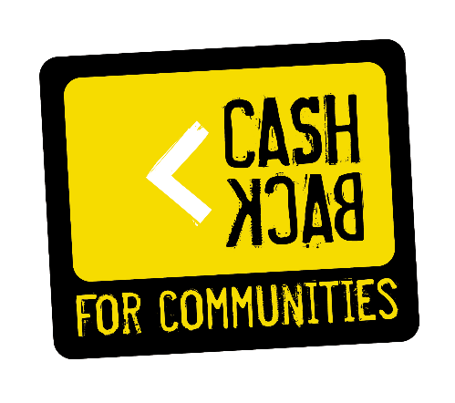
CashBack for Communities Annual Report

Improve Health
Promote Equality
Encourage Learning
Tackle Poverty

“A football club will be formed for the maintenance of dinner tables for the children and the unemployed”
Brother Walfrid, November 6th, 1887

“Celtic FC Foundation, Football for Good”
Celtic FC Foundation is a registered Scottish Incorporate Charitable Organisation (number SC024648) with its registered office at Celtic Park, Glasgow, G40 3RE

Index

Summary………………………………………..……………………………………… Page 3 - 4
Project Aims…………………………………………………………………………… Page 5
Staff and delivery………………………………………………………………… Page 5
Referral agencies…………………………………………………………………. Page 6
External agencies………………………………………………………………… Page 6
Partnership work at its best……………………………………………… Page 7 - 8
Great working relationships with referral sources……. Page 9
CashBack Family Working Together………………………………. Page 9
Case studies………………………………………………………………………….. Page 10 - 12
CashBack Gateway to Employment giving………………….. Page 12
Celebration Events……………………………………………………………… Page 13 - 14
Communications……………………………………………………..…………… Page 15
CashBack for Communities Award Nomination………….. Page 15 - 16
Targets & outcomes…………………………..………………………………… Page 17 - 19
Financial summary………………..…………………………………………… Page 19
Ongoing learning…..………………..…………………………………………… Page 20
Future Plans…………………………………………………………………………. Page 20
Learnings from external evaluation……………..……………… Appendix 1

Summary

Celtic FC Foundation are very proud to have successfully completed CashBack Gateway to Employment Phase four year one, engaging with 76 young people in Glasgow and beyond, supporting them to make positive changes to their lives on a daily basis using a variety of delivery in a supportive and encouraging environment within Celtic Park.

Phase four, year one Gateway to Employment Project has gained a great reputation for supporting young people in our communities to change their lives. By attending training at Celtic Park, using the Club’s brand as an engagement tool, young people, who may not have previously sustained in training have engaged via word of mouth and through external referral sources. The project has become increasingly more popular through its success, which will provide a strong foundation for CashBack for Communities phase four, year two. We are delighted to be involved in this amazing process to tackle inequalities and make a difference using criminal activity proceedings in a way that will support our communities and make a positive impact on young lives.

CashBack Gateway to Employment has delivered 6 Cohorts over the last year within Celtic Park focussing on engaging with young people at risk of offending or re-offending and/or those living in the most deprived areas and in need of advice and guidance to progress into positive destinations. Delivering a wide range of life skills, personal development, employability and physical activity our aim was to assist those most in need of support and second chances to change their lives and progress into positive destinations such as Volunteering, Training, Education and/or Employment. In addition to this, a key focus for young people we support is encouraging them to maintain a good structure in their lives, give them the experience of being in a positive and supportive environment, set goals to work towards and achieve and ultimately make positive steps towards a better future for themselves - this has been proven in numerous case studies and projects throughout the last year.

Delivering here at Celtic Park allows young people to benefit from Celtic FC Foundation’s ethos to HELP: Improve Health, Promote Equality, Encourage Learning and Tackle Poverty. Present and past first team players have supported our projects immensely with some giving up their time to meet the group, share their stories, giving perfect examples of persevering in life, and be part of their Celebration Events to encourage them to continue progressing in the right direction. Participants also benefited from having access to the Player’s Club Gym for their physical activity, the stadium for fitness classes and Barrowfield Training ground for a range of sports.

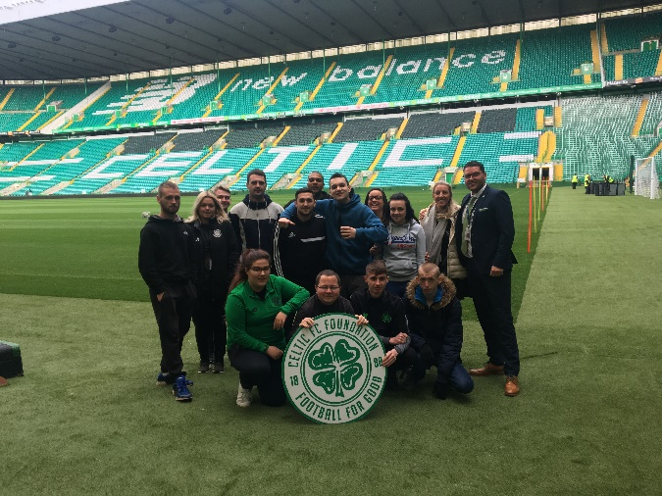
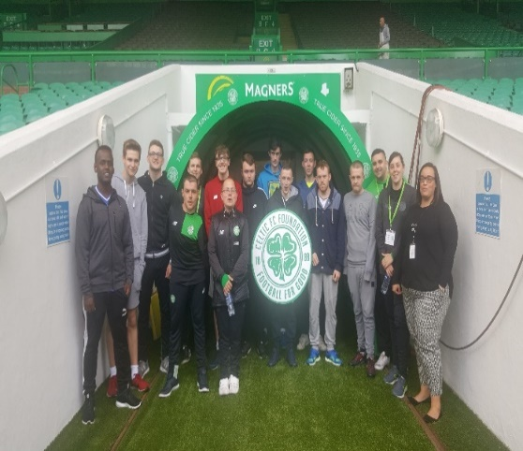
Our CashBack groups celebrating their success……

Celtic is more than a Football Club

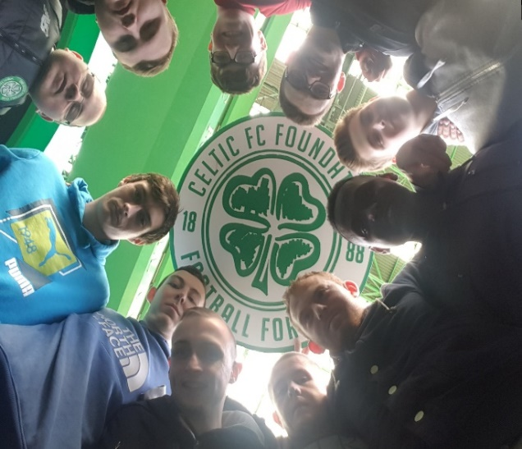
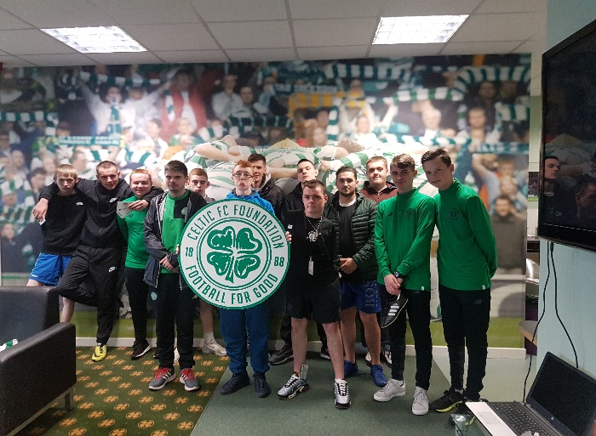

Project aims

Based on the support young people require to assist them in moving forward with their lives we focussed on the following to deliver a bespoke, unique and exciting programme of delivery which included:

- Increasing self-esteem, confidence and motivation
- Increasing physical fitness through fitness tests and physical activity
- Personal development
- Action Planning & Goal Setting
- Nutrition and Health & Wellbeing, promoting good mental health
- Engagement with external agencies to maximise opportunities and learning experiences
- Delivery on life skills to assist making better life choices (preventing re-offending)
- Volunteering opportunities to learn new skills in a work environment
- Employability Skills (CV, Applications, Interview Prep, Job Searching etc)
- Increased knowledge of career interests and entry routes to progress into positive destinations: Volunteering, Education, Training and/or Employment

Staff and delivery

Participants benefited from working alongside various people with a wide range of knowledge and experience to enhance their learning experience here at Celtic Park:

- Celtic FC Foundation Employability staff delivered training and provided one to one advice and guidance including aftercare support
- Celtic FC Foundation Community Coaches delivered physical activity and health and wellbeing
- Guest speakers have included Bertie Auld, Danny McGrain, Tony Roper, Tony Hamilton and numerous members of staff to inspire young people in their journey at Celtic Park
- External Agencies present opportunities to the participants to maximise their chances of progressing into positive destinations
- Liaising with local provision, they deliver educational topics to the projects to increase learning and experience

Referral agencies

Throughout the last year our referral sources have increased by consistently networking and ensuring that our Project information is circulated to providers and case managers.

- Through care Support Officers (Polmont Young Offenders and Scottish Prison Services)
- The Wise Group – New Routes and SHINE Woman’s Mentoring Project
- Community Safety Services
- Skills Development Scotland
- Job Centre Plus DWP
- Jobs & Business Glasgow
- Venture Trust
- Quarriers
- Tomorrow’s People
- NHS Occupational Therapists, GP’s and Community Psychiatric Nursing Team
- Local Housing Associations
- Glasgow City Council, North Lanarkshire Council, South Lanarkshire Council and Renfrewshire Council Social Work Services
- Glasgow City Council, North Lanarkshire Council, South Lanarkshire Council and Renfrewshire Council Educational Services/Care Leavers Education Services

External agencies

We understand how important it is to network, work with and liaise with external agencies and provision to maximise our participant’s chances of progressing, learning and building a better future for themselves and by doing so it gives our young people knowledge on a wide range of subjects.

- Scottish Sport Futures – Conflict Resolution ETC (CashBack family)
- Princes Trust – Personal Development Awards (CashBack Family)
- SFA – Coach Education (CashBack Family)
- Scottish Fire & Rescue Services – Fireskills Employability Programme
- Glasgow North East Food Bank – Volunteering for Food Bank/Work Experience
- Glasgow Council on Alcohol – Drug & Alcohol Awareness
- NHS – Smoking Cessations
- SCVO – Community Jobs Scotland
- Police Scotland – Equality & Diversity and Social Media Awareness
- Emirates Arena – Tour of Velodrome and free pass to experience fitness centre
- Colleges, Training Providers and employers keen to engage with the group to present potential opportunities for participants

Partnership work at its best
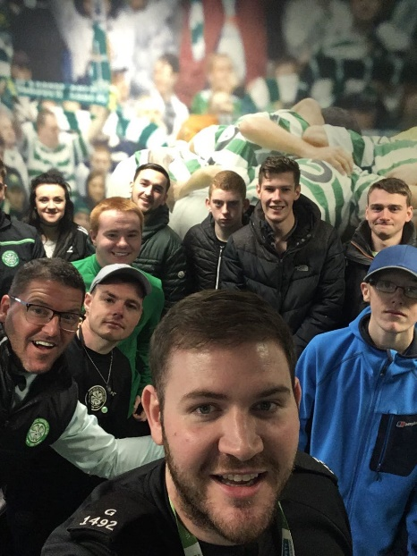

A perfect example of partnership working between organisations to maximise our young people’s experience has been that of Celtic FC Foundation’s Gateway to Employment Project and Police Scotland which has been a great success for our participants.

Police Scotland have delivered a verity of workshops to CashBack Gateway to Employment Projects throughout Phase Four, Year One. These information sessions have included topics such as Equality and Diversity, Social Media Awareness and Hate Crime.

The information sessions that Police Scotland deliver have a number of aims, firstly to upskill young people and give young people the opportunity to gain knowledge in a verity of topics that are current and relevant to the young people’s lives that Celtic FC Foundation are engaging with on CashBack Gateway to Employment Projects .

Secondly the aim of these information sessions are to allow young people the opportunity to engage with Police Scotland in order to breakdown any barriers young people may have in regard to Police Scotland. Young people often report negative views in respects to Police Scotland, this often has been created through pervious experiences, hearsay or via social media influences. These information sessions make available honest interactions providing young people with the chance to express their views openly and fairly through discussion. It also provides participants with the chance of creating a positive relationship with Police Scotland. By allowing young people attending the projects to have a more positive view of Police Scotland, whilst empowering young people to use the information gathered to make positive changes, not only to their own lives, but those of their families and local community.

By working in Partnership with Police Scotland on Celtic FC Foundations’ CashBack Gateway to Employment Projects, stronger connections within the local community between young people and Police Scotland have been generated. As well as the group being challenged and it being a great learning experience, the difference in the groups before and after these information sessions is clear to see in terms of energy, motivation and great team spirit. These traits can all of be transferred into their journey beyond CashBack Gateway to Employment. With this partnership working it is evident to see the support Stephen Canale, and his colleagues at Police Scotland have for Celtic FC Foundations’ CashBack Gateway to Employment Projects.

“The Celtic Foundation is one of a number of partner agencies, officers from Greater Glasgow’s Safer Communities Department work with. The project provides an opportunity for officers to deliver on a number of key issues which can affect young people, including hate crime and internet safety. It is another platform for officers to engage with often, hard to reach groups, breaking down barriers and attitudes and providing those in attendance with a positive engagement with the police.”

Stephen Canale – Police Scotland

Great working relationships with referral sources

Throughout the past year as well as previous years Celtic FC Foundation have built up excellent working relationships with referrers across the city of Glasgow and beyond with organisations working with vulnerable young people in need of support and guidance aged 16-24 years.

As well as networking and arranging meetings with support workers, case managers and organisations engaging with young people, we have also attended numerous events to highlight the work we do.

Year One of Phase Four has seen an increase in the areas we are receiving referrals from which suggests the impact of our networking is having a positive influence within other areas such as North and South Lanarkshire, Renfrewshire and Glasgow.

We pride ourselves in constructive client conferencing between ourselves and agencies/referrers when a young person has committed to CashBack Gateway to Employment to ensure case managers/social workers/through care support officers are up to date with their client’s progress. This approach has often proved to maximise the young person’s progress working with multiple agencies and getting an all-round support network resulting in better results for the individual.

Other examples of why working closely with our referrers has helped our participants is when other professionals have to be involved to support that young person’s needs i.e: Drug & Alcohol Support Workers, Social Workers, Occupational Therapists, Housing Officers etc. The projects flexibility in terms of being delivered two days per week allows them to build up a good structure on the project meanwhile having the flexibility to attend other appointments/arrangements etc.

CashBack family working together

Working together with fellow CashBack for Communities projects has been to the great advantage of our participants who have benefitted from this delivery in various ways. It gave many young people the opportunity to build on their skills, personal development and experience.

From taking part in Scottish Sports Future’s Conflict Resolution Training (ETC), Development Awards with Princes Trust allowing participants to gain a qualification maximising their chances of securing employment:
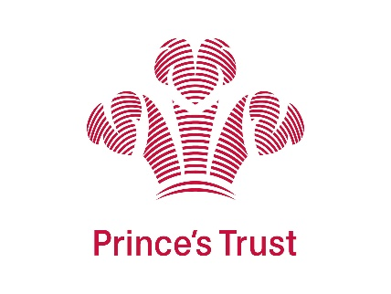

Case studies

Case Study 1: Thomas McGarvey

Thomas was referred to Celtic FC Foundation CashBack Gateway to Employment through Community Safety Glasgow. Thomas had found himself engaging in anti-social behaviour resulting him being awarded community service. During this time with Community Safety Glasgow Thomas was looking to change his life style, work towards something more positive and get away from the negativity he had previously been involved in. Thomas was referred into cohort 2 of phase 4.

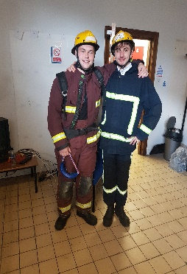
During Thomas’s time with Celtic FC Foundation on the CashBack Gateway to Employment project Thomas had opportunities to get involved in a verity of activities such as Fire Skill’s Training, personal development workshops, and physical activity sessions. When Thomas started attending the CashBack Gateway to Employment project he struggled to get into a routine and structure. Thomas would also struggle with anxiety and this would often result in Thomas walking away from tasks and taking a step back from engaging and was reluctant to talk about how he was feeling.

Through the weeks Thomas grew in confidence and found his feet. He was more engaging and would at times take a lead role by encouraging and influencing his peers. Thomas really found his inspiration for leadership while on the Fire Skills Training. This training allowed Thomas to gain new skills as well as develop further his current skill base in areas such as communication, leadership and partnership working. Thomas achieved his SQF Level 5 Fire Skills Training, alongside this Thomas also completed the Health and Safety in the work place and Manual Handling Training. Thomas was motivated and had set clear goals for himself.

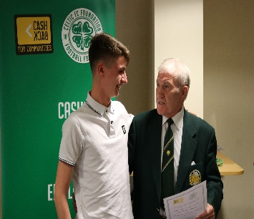
Before completing Celtic FC Foundation on the CashBack Gateway to Employment Project Thomas had an opportunity to take part in a recruitment day with SCVO, Community Jobs Scotland. Thomas was selected for 2 interviews during this recruitment day. With the skills and knowledge that Thomas had gained during the project he was able to confidently undertake the interviews with the knowledge and self-assurance that he felt he did not have prior to starting the CashBack Gateway to Employment Project. Unfortunately, Thomas was not successful however he was able to use this experience as a learning curve that he was then able to put to good use when he was selected for interview a couple of weeks later with Celtic FC Foundation for the role or Trainee Community Coach. Thomas was successful with this interview and was offered a Trainee Community Coach position with Celtic FC Foundation through SCVO, Community Jobs Scotland.
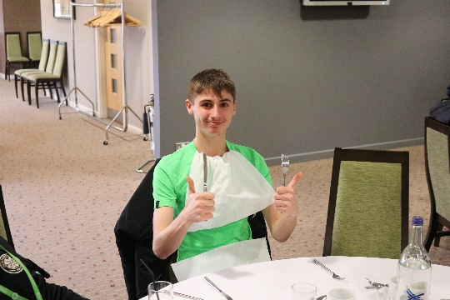
Since being offered this position Thomas has further developed his skills and knowledge. He is an inspiration to other young people who Thomas now helps support at Celtic FC Foundation. Thomas has gone on to support young people through CashBack Projects amongst some many other projects at Celtic FC Foundation. Thomas has completed further training and qualifications while gaining experience of working with a vast verity of people with in the local community.

Please find below a link to a video interview with Thomas McGarvey.

https://www.dropbox.com/s/jc61lzm15i4nz13/Case%20Study%20with%20Tommy.mp4?dl=0

Case Study 2: Nicolle McArdle

Nicolle was referred to Celtic FC Foundation CashBack Gateway to Employment though Skills Development Scotland. Prior to starting the project Nicolle had engaged in several training provisions however Nicolle could not find something that she enjoyed and something that she had a passion for. Nicolle is a lover of football and with her being an avid Celtic fan, this opportunity was a win, win situation for Nicolle when she found out about the project. Nicolle was referred into Cohort 3 phase 4.
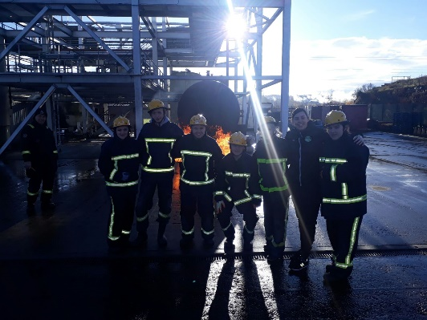
When Nicolle began her journey with Celtic FC Foundation on the CashBack Gateway to Employment project she was unsure of her goals and did not know what she wanted to do at the end of the 10-week project. Through the 10 weeks on the project Nicolle was involved in a verity of activity sessions including personal development and skills-based learning. Nicolle always presented herself confidently and would lead a group comfortably. Nicolle would however struggle was with her confidence in her own abilities, this would often restrict Nicolle when applying for opportunities. This was something that Nicolle was keen to change. Nicolle had amazing commitment and drive when she was interested in a topic such as Celtic Football Club. Over the 10 weeks with the support of the staff at Celtic FC Foundation this encouraged Nicolle and helped Nicolle identify her strengths allowing her grow in confidence in her own abilities.

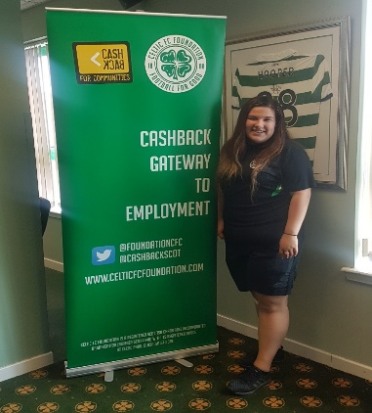
Before completing the CashBack Gateway to Employment Project Nicolle had an opportunity to take part in a recruitment day with SCVO, Community Jobs Scotland. Nicolle was successful in applying for a position with Celtic FC Foundation for the role of Trainee Community Coach. Nicolle was delighted to be offered this position as she had a love of football and a passion for the club and Celtic FC Foundation. Nicolle felt that this was the best outcome she could have wished for, working within a place that she has grown up loving and to be able to be part of a team that has supported her to achieve her goals and aspirations that she did not know she had at the start of her journey.

Since completing the Celtic FC Foundation CashBack Gateway to Employment project Nicolle has helped support a verity of projects. This has given Nicolle an opportunity to home in on what aspects of the Trainee Community Coaching role she enjoys. Nicolle has also gained further training in which has seen Nicolle develop in her confidence and her leadership skills even further. This has given Nicolle a desire to complete her Football badges and focus on her next step in her journey.

Please find below a link to a video interview with Nicolle McArdle.

https://www.com/s/icxop1xxxnfuyyn/Nicole%20InterviewSmaller.mp4?dl=0.dropbox

CashBack Gateway to Employment giving back

Giving back to the community is a priority for Celtic FC Foundation as it provides assistance to those who face daily challenges within our key priority areas; Health, Equality, Learning and Poverty (HELP). This can be seen in this quote by Brother Walfrid, November 6th, 1887:

“A football club will be formed for the maintenance of dinner tables for the children and the unemployed”

With Brother Walfrid’s quote in mind alongside the drive from Celtic FC Foundation to support others there is be no better way than getting young people valuable experience whilst having the chance to help others working in partnership with the Glasgow North East Foodbank.

Throughout each 10 week CashBack Gateway to Employment Project young people are given the chance to volunteer with the Glasgow North East Foodbank. At Celtic FC Foundation we believe that young people can learn a great deal from an opportunity such as this. Not only does it provide young people with a prospect to develop new skills and build on existing experience and knowledge it also allows young people to have the chance to give something back to the community and make a difference to the people around them. Young people find volunteering at Glasgow North East Foodbank both challenging and rewarding which often results in young people feeling motivated. This is an experience that is often invaluable to CashBack Gateway to Employment participants as it can provide experience of a working environment whilst giving the young people the opportunity to work as part of a team learning and gaining knowledge. This knowledge can not only go on to help benefit the participants direct but can also have a positive impact on the wider community including family and friends.

Celebration events

At the end of each of our 6 CashBack Gateway to Employment Projects, participants have celebrated their successes and progressions by attending their Celebration Event, held in the Jock Stein Lounge within Celtic Park, creating a warm environment and sense of achievement to all involved.

Our celebration events are an opportunity to congratulate each young person, who on commencing the Project started out on their own journey and allow them to reflect on their progression and achievements whilst on the CashBack Gateway to Employment Project.

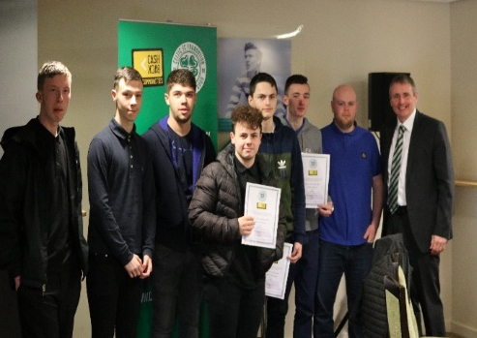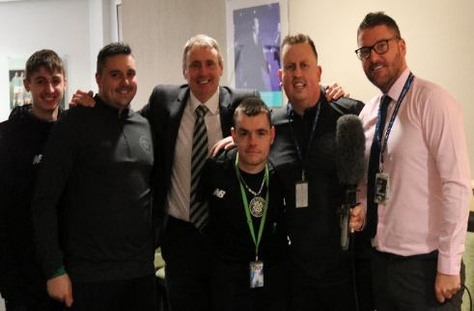
Celtic FC Foundation Staff and Tom Boyd (Centre)
CashBack Participants with Tom Boyd (Right)

The successes of our CashBack funded projects have been proved time and time again and this event gives young people the opportunity to be proud of themselves, which is often a feeling some may never have experienced previously and it allows them to share their achievement with family, project staff, funders and referrers/external agencies who all play a part in encouraging them to raise their ambitions and make positive changes to their lives.

For some young people starting the project their aim may be to change their offending behaviour to prevent being imprisoned whilst for others it may be to progress into employment and start on a new positive pathway. Because of the variety of goals and journeys that are taken, our celebration events
can be an achievement of different things for different young people. The event gives participants a chance to tell their stories. When our young people have moved into a positive destinations such as training, education or employment, employers, colleges and training organisations have been overwhelmingly supportive in allowing the young person time to attend their event, often showing their support by attending also.

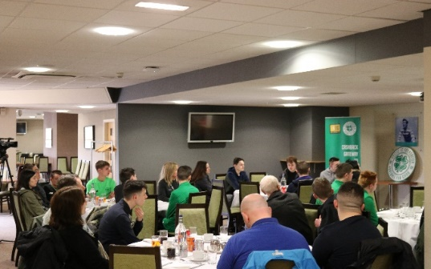
CashBack Gateway to Employment Celebration Event

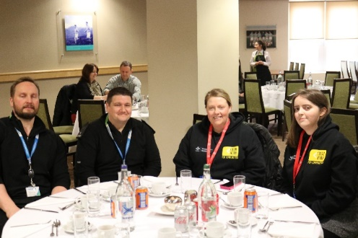
Police Scotland (Left) and Prince’s Trust (Right)

Communications

On 2nd of May 2017 we celebrated the launch of CashBack for Communities Phase 4. By using social media to celebrate the successes of the fantastic funded Projects, supporting Scotland’s most disadvantaged young people to reach their full potential in life, develop new skills, improving confidence and become responsible individuals.

Phase 4 Year One has had a strong focus on helping to tackle Scotland’s inequalities – raising the attainment, ambition and aspirations of those young people across Scotland who are disadvantaged by:

- Living in areas of deprivation
- Not in education, training and/or employment
- At risk of being involved in anti-social behaviour, offending/re-offending

The CashBack family successfully managed to trend on Twitter and Facebook promoting a wide variety of Launches, activities and achievements with #CB4C and #Tacklinginequalities to the excitement of everyone involved.

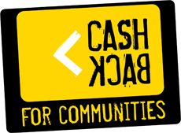

Award nomination

The completion of CashBack Gateway to Employment Phase Four Year One seen the Project listed as 2018 finalists for SPFL Trust Community Project of the Year alongside Aberdeen, Dunfermline Athletic and Heart of Midlothian.

The Scottish Professional Football League Trust is an independent, registered charity that works in partnership with all 42 SPFL Clubs to develop community activities across Scotland. Through the power of football with an aim to make a difference by empowering clubs to create opportunities at the heart of their communities that bring people together and change lives for the better.

To be nominated for this award is a great acknowledgement for Celtic FC Foundation CashBack Gateway to Employment Project and all the participants throughout Phase Four, Year One as well as past projects. This nomination recognises the Celtic FC Foundation’s efforts in supporting young people in our communities to change their lives by attending training at Celtic Park, using the CashBack for Communities funding.

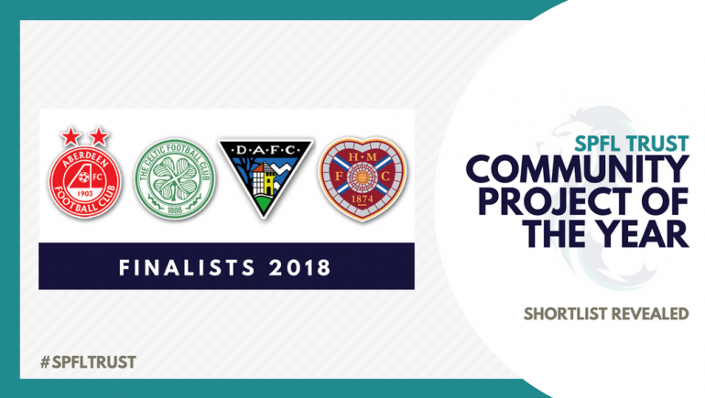

Please find links below to information regarding this award nomination:

https://twitter.com/SPFLTrust/status/986537318306799617

http://spfltrust.org.uk/spfl-trust-reveals-community-project-of-the-year-shortlist/

Targets and outcomes

Outcome 1: Young people build their capacity and confidence |  | Target | Actual | Variance
Young people report their confidence increasing |  | 61 | 76 | +15
Young people feel able to do new things |  | 61 | 76 | +15
Other stakeholders report increasing confidence in young people |  | 85% | 25% | - 60%
Young people go on to do new things after their initial CashBack involvement |  | 61 | 74 | +14
Outcome 2: Young people develop their physical and personal skills |  | Target | Actual | Variance
Young people gain accreditation for learning and skills development |  | 61 | 53 | -8
Young people report their skills are increasing |  | 61 | 76 | +15
Other stakeholders report skills increasing in young people |  | 85% | 25% | - 60%
Outcome 3: Young people’s behaviours and aspirations change positively |  | Target | Actual | Variance
Young people report increased aspirations |  | 61 | 75 | +14
Other stakeholders report increased aspirations in young people |  | 85% | 25% | - 60%
Young people report positive changes in their behaviour |  | 61 | 75 | +14
Other stakeholders’ report positive changes in YP behaviour |  | 85% | 25% | - 60%
Outcome 4: Young people’s wellbeing improves |  | Target | Actual | Variance
Young people report increases in feelings against SHANARRI indicators |  | 61 | 75 | +14
Other stakeholders make positive comments about wellbeing against one of the relevant SHANARRI indicators |  | 85% | 23% | - 60%
Outcome 6: Young people participate in activity which improves their learning, employability and employment options (positive destinations) |  | Target | Actual | Variance
Number of young people progressing to positive destinations |  | 61 | 58 | -3
Employment |  | 28 | 29 | +1
Training |  | 14 | 18 | +4
Education - college |  | 0 | 5 | 5
Education - other |  | 0 | 3 | +3
Volunteering |  | 10 | 3 | -7
Outcome 7: Young people participate in positive activity |  | Target | Actual | Variance
Participate in positive activity |  | 72 | 76 | +4
New to this type of activity |  | 72 | 76 | +4
Outcome 8: Young people are diverted from criminal behaviour or involvement with the criminal justice system |  | Target | Actual | Variance
Young person reports that their own participation in antisocial and/or criminal behaviour has reduced |  | 61 | 71 | +10

Accredited Training
Fire skills SCQF Level 4 | 15
Non- Accredited Training
Manual Handling | 49
Health and Safety in the workplace | 49
Age | Male | Female
16 | 6 | 0
17 | 11 | 3
18 | 7 | 1
19 | 9 | 0
20 | 9 | 0
21 | 6 | 0
22 | 4 | 0
23 | 7 | 0
24 | 11 | 2
Total | 70 | 6

SIMD Breakdown | Young people
0 to 20% | 57
0 to 30% | 62
0 to 40 % | 66
0 to 50% | 70
50 to 100% | 5
(75 out of 76 included in SIMD Breakdown) One participant did not have a fix address so no postcode details have been obtained for this young person however they did attached the CashBack Gateway to Employment project.

Local Authority | CashBack expenditure | Young people
Glasgow | £91,588 | 59
North Lanarkshire | £10,434 | 7
Renfrewshire | £8,115 | 5
South Lanarkshire | £3,478 | 2
West Dunbartonshire | £1,159 | 1
East Dunbartonshire | £1,159 | 2
Total | £115,933 | 76

Financial summary

 | Actual | Target | Variance
Project Activity
Project Co-ordinator | £28,103 | £28,103 | £0
Coaching Staff/Delivery | £36,758 | £36,758 | £0
Workshop/Training | £2,184 | £2,184 | £0
Equipment | £1,965 | £1,965 | £0
Recruitment | £954 | £954 | £0
Design/Print/Promotional Materials | £2,060 | £2,060 | £0
Facility Hire | £9,090 | £9,090 | £0
Celebration Event Catering | £954 | £954 | £0
Catering for participants | £9,540 | £9,540 | £0
Monitoring & Evaluation | £7,825 | £7,825 | £0
Total Project Activity | £99,433 | £99,433 | £0
Other Project Costs
Management and Marketing | £11,000 | £11,000 | £0
External Evaluation | £5,500 | £5,500 | £0
Total Other Project Costs | £16,500 | £16,500 | £0
Total Expenditure | £115,933 | £115,933 | £0
Matched Funding | £60,241 | £60,241 | £0

Ongoing learning

Key areas that both ourselves and our external evaluator have identified for ongoing focus are:

Improvements in gathering evidence of outcomes
We have identified that we do not have robust evidence for each outcome indicator. While we are confident in our evidence of hard outcomes (positive destinations) we have recognised the need to improve our evidence of the softer outcomes. This will help to tell the story of change for young people involved in the Programme. We have already developed some new processes (a personal action plan and journal) which will ensure that young people record their journey toward outcomes.

Sustainability of outcomes
Providing and maintaining evidence of long term outcomes continues to be a challenge in some cases. Although we maintain contact with many participants there are a number who do not, despite ongoing efforts. Although this can be symptomatic of the groups that we are dealing with we will endeavour to try new methods using technology, as an example, as well as building strong ongoing relationships with the individual and support organisations that they may be engaging with, eg Social services/criminal justice etc.

Please see appendix 1 attached for external evaluation findings.

Future plans: year 2018/2019

We are extremely excited to be launching Phase Four Year Two CashBack for Communities Gateway to Employment and network with the CashBack family providers.

Phase Four Year Two will allow us to continue engaging with young people and focus on supporting them to raise their aspirations to make a better future them for themselves.

Celtic FC Foundation are looking forward to engaging with new provision and creating new delivery to maximise participants chances of progressing into positive destinations.

Part of Phase Four Year Two Celtic FC Foundation will be piloting a bespoke female only CashBack Gateway to Employment Project. The aim and objective of this project is to empower female participants giving them an opportunity to engage in personal development by way of taking part in a combination of sessions that will involve inspirational speaking, relaxation, goal setting, teambuilding, and physical activity sessions amongst many more. The delivery of these sessions will be provided by Staff at Celtic FC Foundation along with organisations that have expertise within the field of work. These sessions will provide the female participants with a safe space to identify and explore issues whilst learning and gaining new skills maximise participant’s chances of progressing into positive destinations.

We will continue to focus on HELP:

Improve Health
Promote Equality
Encourage Learning
Tackle Poverty

We will encourage our young people to reach their full potential in life by helping them learn new skills, boost their confidence and become responsible individuals.

We aim to ensure our young people get the best learning experience and delivery that will incorporate life skills, personal development, employability and physical activity. As well as our participants developing we know the importance for ourselves in learning and improving our delivery to best ensure we reach our key objectives, alongside the outcomes for those we support. We demonstrate this by developing new partnerships with external organisations, getting feedback from all those involved in our programmes and analysing our strengths and more importantly our areas for improvement through statistical analysis, both ourselves and through our external auditors.

Celtic Park will continue to be our learning base with Barrowfield Training Ground being utilised for physical activity as well as the stadium player’s gym.

The next two years will be an exciting opportunity to work in partnership with other CashBack family providers to educate the participants and utilise all the amazing training and opportunities that can be provided.

Having successfully completed Phase Four Year One we understand our client group and what support is required, discussing individual action plans and goals for each individual to work towards and we have learned what delivery works through experience. We are really keen to build on this and continue excellent working relationships with external agencies who have been very supportive of our projects.

We are proud to be a part of the CashBack family, having the ability to give young people in our community second chances and inspire them to raise their aspirations within a world class stadium.

Young People are our future

Appendix 1 – External Evaluation Learnings

Learning from the Programme
This chapter highlights the key learning points from the project. The ‘key strengths’ section highlights the factors which contribute to the achievement of outcomes. The challenges section identifies some weaknesses in delivery in year 1 includes recommendations where appropriate.

Key strengths
Targeting
Celtic FC Foundation has been very successful in targeting recruitment on young people from the 3 CashBack priority groups.
- Living in areas of deprivation (as measured by the SIMD 20% most deprived data zones)
- At risk of being involved in anti-social behaviour, offending or re-offending
- Unemployed, not in education or training

Celtic FC Foundation has achieved this through developing relationships with projects/agencies that work with the target client group. The Gateway to Employment model has become recognised by referral agencies working with ex-offenders and those at risk.

Celtic FC Foundation has also worked to extend the network of referral partners, to recruit more young people from outside Glasgow and more young women.

The high profile of the Programme and the extensive outreach work means that the Celtic FC Foundation has exceeded its target numbers for the Programme in year 1.

The profile and performance of the Programme has also resulted in a very high number of self-referrals (self-referral is the biggest single source of referrals).

The Celtic Football Club brand continues to be a powerful hook for engaging with young people in employability support.

Strong delivery partnerships
Celtic FC Foundation has been successful in developing the number and range of experiences and learning opportunities available to participants through its relationships with other organisations.

Staff
Interviews with participants and stakeholders consistently mention the staff as one of the ‘success factors’ of the Programme.

Stakeholders comment on the energy, dedication and motivation of the delivery staff.

Many of the participants have been on other training/employability programmes, and highlight a key strength in the Celtic FC Foundation model ‘the way they speak to you’.

Participants mention ‘feeling respected’, being treated ‘as equals’, ‘not being talked down to’, ‘treating everyone the same way, no matter what your background’.

These comments highlight the fact that ‘how it is delivered’ rather than ‘what is delivered’ makes a difference for participants.

Celtic FC Foundation as an employer /Use of role models
Celtic FC Foundation has made good use of the community Jobs Scotland Programme to provide employment training opportunities for participants within the Celtic FC Foundation organisation. Young people from the Programme have moved into jobs as Community Coaches, developing their own skills and getting valuable work experience.

However, participants also identified that the Community Coaches act as role models which helps to motivate them to succeed.
“When I see them in their Celtic kit, I know that they were just like me a wee while ago. They were on this programme too. I know that if they can do it, so can I”

Challenges
Disconnect between the Programme targets (positive for destinations) and the barriers/readiness of many participants.
We have already commented on the strength of the targeting on the CashBack target group and strong profile of the Gateway to Employment Programme with agencies that work with the most disengaged client group.

While this profile is a strength of the Programme, it has resulted in challenges for a Programme which seeks to achieve a positive destination for 85% of participants:
- The programme has become a recognised destination for young people who have complex issues and barriers – some are referred within days of leaving prison, some have outstanding charges and unspent convictions, some have issues relating to addictions, mental health, homelessness, etc.
- The number and complexity of barriers means that many of the participants in year 1 were not ready to move toward employment.
- 20 participants (26%) did not achieve a positive outcome:
  - of these 13 (17%) had not sustained their participation in the Programme.
The expectation of 85% positive destinations is a very ambitious target and is perhaps unrealistic for the profile of participants in year 1. Celtic FC Foundation may need to review the referral criteria to ensure that participants are ‘ready’ to address employability issues in their lives.
Recommendation:
Celtic FC Foundation should review the positioning of Gateway to Employment in the pathway to employment, and review the referral criteria to ensure ‘fit’ between the profile of the participants and the objectives of the Programmme.

Staff changes
There have been recent changes in the team structure which have augmented the management and delivery resources for the Programme.

However, the team has also lost a member of staff after a period of illness – this has affected the collection and reporting of monitoring and evaluation data for Year 1.

Monitoring and evaluation
There have been weaknesses in year 1 in the collection of self-evaluation data.

As an employability project, with an aim and track record in moving participants into positive destinations, the achievement of this outcome (and recording of this achievement) has been a priority for the Programme.

However, gathering robust data on destinations is challenging – participants attend on a voluntary basis and can leave at any time throughout the programme. It is especially challenging to gather data on outcomes which participants who achieve after the end of the Programme. While some participants stay in contact with the Programme, others do not and there is no mechanism to ensure that they report destinations back to the project.

There has been a lower priority in gathering evidence of other outcomes, and an assumption that if a young person has participated in the programme, then they have achieved the softer outcomes.

The systems for collecting evidence of outcomes were not used systematically in year 1, but as a result of changes in the staff team, Celtic FC Foundation has already started to make improvements to the new processes for collecting evidence from each participant (a personal action plan and journal) which will ensure that young people record their journey toward outcomes.

Recommendation
For year 2, there needs to be a review of the evaluation processes.

New staff should have an induction to ensure that they understand the CashBack outcome framework and reporting system:
- To clarify understanding of the CashBack indicators
- To review the measures for each indicator (what evidence they will collect to demonstrate the achievement of the indicators)
- To review the tools for gathering evidence
- To review the tools for recording data
- To clarify understanding of the reporting system and responsibility for reporting.

Data on destinations needs to be more robust:
- Where participants progress in to employment, identify the employer and job role
- Where participants progress into training, identify the training provider/type/duration of programme
- Where participants progress into learning/education, record the course and level of course
Where destinations cannot be verified, it should be noted that destinations are not verified.

Referral forms should also be improved to provide more accurate profile information on participants.

Aftercare and tracking of outcomes
Although a key strength of the Programme is one-to-one support which can continue beyond the end of the programme for participants, in year 1 there is no formal follow-up programme for participants or tracking of outcomes.

While there is no formal target to report on sustained outcomes, the description of the project in the Grant Offer letter from Scottish Government references ‘ support [to] young people in sustaining their positive destination by providing one-to-one support and tracking service, ensuring that any potential issues are addressed and relevant support is put in place.’

Although there are recognised challenges in carrying out follow-up and tracking (young
people change phones numbers/refuse to respond etc) Celtic FC Foundation should develop a protocol for follow up of all participants and tracking of outcomes.

Where young people progress into other training programmes (for example street League) or job training opportunities through Community Jobs Scotland, Celtic FC Foundation might wish to consider an information sharing protocol with other training providers (with agreement of young people), to streamline follow-up and tracking.
Also, where young people have a support worker/key worker, Celtic FC Foundation should seek an agreement over tracking and information sharing.

Recommendation
While it is recognised that after-care and tracking are difficult, due to the nature of the client group, Celtic FC Foundation should develop a clearer offer to participants (and the agencies who refer and support participants) in relation to after-care and tracking.

Celtic FC Foundation could also explore ‘data sharing’ protocols with other agencies (agree who is responsible for tracking post completion of the programme and agree to share tracking data).

