2016:17 CashBack for Communities Youth Work Fund
  - YouthLink Scotland
Aberdeen Be Friend A Child: “We hadn’t met each other before but we got together to visit the Cairngorms. It was fantastic! The focus groups were also very informative and I think we came up with some amazing ideas for the organisation too. We have all become good friends!”
Summary

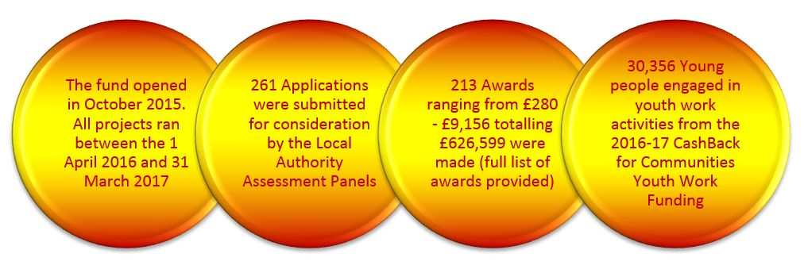

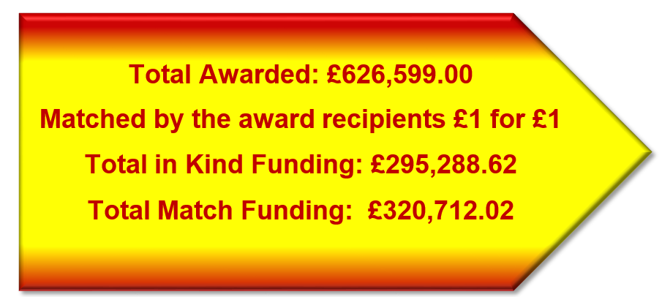

YouthLink Scotland continues to administer the CashBack for Communities Youth Work Fund open grant programme.in order to resource community based youth work organisations so that they can provide a range of diversionary activities for local young people which builds their capacity and increases their opportunities to develop interests and skills in an enjoyable, fulfilling and supported way in line with the SHANARRI indicators.

The CashBack for Communities Youth Work Fund supports projects which meet the following criteria:

- Target young people aged 10 – 19 years
- Offer free youth work activities for young people to increase the opportunities they have to develop their interests and skills in an enjoyable, fulfilling and supported way
- Focus resources in areas where there is a demonstrated need, taking account of local priorities
- Fill gaps in provision for young people or add value/build on existing provision
- Support young people who are currently involved or at risk of becoming involved in violence, alcohol, drugs and/or anti-social behaviour
- Promote equalities and be open and accessible to young people
- Support and encourage the involvement of local young people in the development, management and running of the project
- Demonstrate sustainability (whether in attracting other resources or in leaving a legacy)

YouthLink Scotland administers the open grants programme by;
- managing an application and assessment process,
- monitoring the delivery of the activities,
- actively promoting the projects supported,
- conducting an evaluation of the programme
- producing a comprehensive report for Scottish Government

Cumulative Summary of CashBack for Communities Youth Work Fund Awards

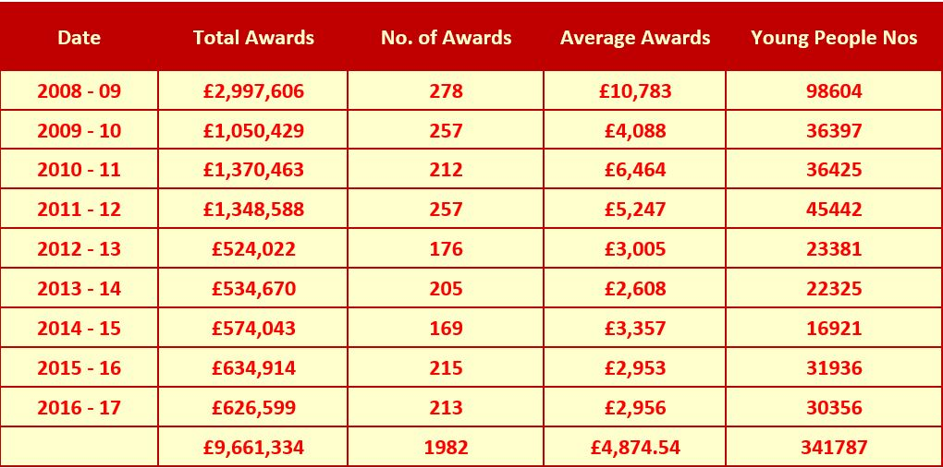

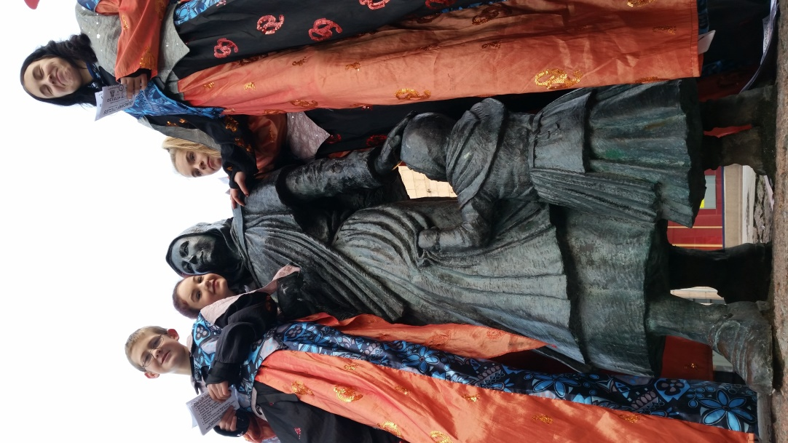

Modo Circus Peterhead
Finance

- Grant Programme Finances

EXPENDITURE | Annual Budget | Actual
Annual Grant Fund to be distributed to the Youth Work Sector | £600,000.00 | £626,599.00

Organisation Name | Local Authority Beneficiaries | Award Amount | Total Young people
Fersands and Fountain Community Project | Aberdeen City | £3,917.00 | 50
Transition Extreme Sports Ltd. | Aberdeen City | £4,316.00 | 60
Denis Law Legacy Trust | Aberdeen City | £3,525.00 | 1388
St Andrew Community | Aberdeen City | £2,000.00 | 68
Aberdeen YMCA | Aberdeen City | £4,000.00 | 68
Printfield Community Project | Aberdeen City | £3,660.00 | 51
CLD Aberdeenshire Council | Aberdeenshire | £5,142.00 | 47
Modo - Circus with Purpose | Aberdeenshire | £4,950.00 | 200
Modo - Circus with Purpose | Aberdeenshire | £4,930.00 | 162
Modo - Circus with Purpose | Aberdeenshire | £8,980.00 | 86
Westhill Community Church | Aberdeenshire | £4,998.00 | 230
Befriend A Child - Award Returned | Aberdeenshire | £4,458.00 | 0
Tayside Council on Alcohol | Angus | £3,744.00 | 9
Brechin Youth Project (The Attic) | Angus | £4,100.00 | 137
The Pitstop Youth Project | Angus | £3,894.00 | 56
Mid Argyll Youth Forum | Argyll and Bute | £1,358.00 | 55
Islay & Jura Community Enterprises Limited | Argyll and Bute | £1,950.00 | 175
Bute Youth Forum | Argyll and Bute | £1,303.00 | 183
Project 81 Youth and Community Enterprises Ltd | Argyll and Bute | £4,293.00 | 173
Argyll and Bute Youth Forum | Argyll and Bute | £3,450.00 | 121
Dunedin Canmore Housing | City of Edinburgh | £2,894.00 | 17
Wester Hailes Youth Agency | City of Edinburgh | £3,672.00 | 105
The Yard Adventure Centre | City of Edinburgh | £3,000.00 | 50
Edinburgh City Youth Cafe | City of Edinburgh | £3,807.00 | 28
The Junction - Young people, health and wellbeing | City of Edinburgh | £1,490.00 | 10
The Ripple Project | City of Edinburgh | £3,510.00 | 46
Citadel Youth Centre | City of Edinburgh | £1,951.00 | 15
Pilmeny Development Project | City of Edinburgh | £3,191.00 | 37
Muirhouse Millennium Centre | City of Edinburgh | £4,082.00 | 16
Edinburgh Young Carers Project | City of Edinburgh | £2,036.00 | 19
The BIG Project | City of Edinburgh | £4,406.00 | 62
St Teresa's Youth Club | City of Edinburgh | £3,335.00 | 76
The Broomhouse Centre | City of Edinburgh | £1,000.00 | 58
Friends of the Award in Edinburgh and the Lothians | City of Edinburgh | £2,445.00 | 14
Deaf Action | City of Edinburgh | £2,700.00 | 47
Granton Youth Centre | City of Edinburgh | £3,000.00 | 81
Hawkhill Community Association | Clackmannanshire | £4,066.00 | 22
PLAY ALLOA | Clackmannanshire | £5,318.00 | 81
LGBT Youth Scotland | Dumfries and Galloway | £640.00 | 16
Dumfries YMCA | Dumfries and Galloway | £900.00 | 17
Oasis Events Team | Dumfries and Galloway | £8,200.00 | 10400
Commnity Learning and Development Service - Wigtown Area | Dumfries and Galloway | £4,936.00 | 35
Dumfries and Galloway Council - CLD Nithsdale | Dumfries and Galloway | £5,060.00 | 350
Youth Alive Dumfries and Galloway | Dumfries and Galloway | £2,209.00 | 22
Yusuf Youth Initiative | Dundee City | £3,000.00 | 55
RockSolid Youth Project | Dundee City | £2,000.00 | 20
LGBT Youth Scotland - Allsorts | Dundee City | £4,070.00 | 56
Hot Chocolate Trust | Dundee City | £3,500.00 | 146
The zone initaitive limited | East Ayrshire | £1,500.00 | 78
yipworld | East Ayrshire | £2,775.00 | 11
Vibrant Council, East Ayrshire Council | East Ayrshire | £4,775.00 | 183
Vibrant Communities, East Ayrshire Council | East Ayrshire | £1,741.00 | 112
Barnardo's | East Ayrshire | £3,500.00 | 115
Twechar Youth Group | East Dunbartonshire | £2,040.00 | 78
Bearsden Muslim Association | East Dunbartonshire | £3,000.00 | 74
LGBT Youth Scotland | East Dunbartonshire | £2,700.00 | 10
Milngavie Youth Centre | East Dunbartonshire | £3,154.00 | 37
North Berwick Youth Project | East Lothian | £3,840.00 | 115
Tranent Youth and Community Facility | East Lothian | £4,290.00 | 117
Pennypit Community Development Trust | East Lothian | £3,080.00 | 115
St Luke's High School | East Renfrewshire | £280.00 | 13
St Luke's High School | East Renfrewshire | £480.00 | 11
Barrhead High School | East Renfrewshire | £1,740.00 | 15
St Luke's High School | East Renfrewshire | £1,900.00 | 21
East Renfrewshire Council - Young Person's Services | East Renfrewshire | £4,185.00 | 27
Falkirk Council | Falkirk | £3,215.00 | 8
LGBT Youth Scotland - FK1NCLUDE | Falkirk | £2,000.00 | 44
Barnardo’s | Falkirk | £1,500.00 | 18
Powerstation Whitecross | Falkirk | £2,500.00 | 12
Falkirk council | Falkirk | £3,000.00 | 114
Falkirk Football Community Foundation | Falkirk | £4,706.00 | 67
The Savoy Youth Clubs | Fife | £4,161.00 | 63
Glenrothes Detached Youth Work | Fife | £3,753.00 | 40
Cupar Youth Cafe | Fife | £4,690.00 | 41
LGBT Youth Scotland - Flavours of Fife | Fife | £2,000.00 | 26
KIRKCALDY YMCA | Fife | £3,911.00 | 246
Gallatown Gala and Community Group | Fife | £2,228.00 | 50
Fife Council | Fife | £1,620.00 | 20
Fife Council, Kirkcaldy CLD | Fife | £2,479.00 | 127
Fife Council, Community Learning & Development | Fife | £2,912.00 | 31
Youth 1st (SCIO) | Fife | £1,748.00 | 316
Kirkcaldy YMCA | Fife | £3,295.00 | 100
Raith Rovers Community Foundation | Fife | £2,610.00 | 24
Kirkcaldy YMCA | Fife | £2,998.00 | 43
Fife Council | Fife | £4,000.00 | 31
Cupar Youth Cafe/Fife Council CLD | Fife | £2,715.00 | 194
Gallatown Gala and Community Group | Fife | £2,770.00 | 31
Fife council | Fife | £4,754.00 | 40
Toll Centre | Fife | £2,094.00 | 0
Duke of Edinburgh's Award Scotland | Glasgow North East | £3,000.00 | 16
Tollcross YMCA | Glasgow North East | £3,014.00 | 48
Helenslea Hall Management Committee (The Urban Fox Programme) | Glasgow North East | £2,520.00 | 24
Tron Marys Church Community Programme | Glasgow North East | £3,180.00 | 8
Fuse Youth cafe | Glasgow North East | £2,680.00 | 48
Parkhead Youth Project | Glasgow North East | £3,000.00 | 89
Scripture Union Scotland | Glasgow North East | £1,590.00 | 9
Royston Youth Action | Glasgow North East | £1,250.00 | 68
Lambhill Stables | Glasgow North West | £2,101.00 | 605
Cadder Housing Association | Glasgow North West | £2,475.00 | 53
A&M Scotland | Glasgow North West | £3,625.00 | 270
Community Central Hall | Glasgow North West | £3,080.00 | 20
Temple/Shafton Youth Project | Glasgow North West | £6,723.00 | 287
Govan Youth Information Project | Glasgow South | £2,100.00 | 40
Crossroads Youth and Community Association | Glasgow South | £2,000.00 | 11
South West Arts and Music Project ( SWAMP ) | Glasgow South | £4,440.00 | 53
Gorbals Youth Run Drop in Cafe (Gorbals Youth Cafe) | Glasgow South | £1,120.00 | 12
Youth Community Support Agency (YCSA) | Glasgow South | £6,000.00 | 70
Gorbals Youth Run Drop in Cafe (Gorbals Youth Cafe) | Glasgow South | £2,640.00 | 36
Bethany Christian Trust | Glasgow South | £3,276.00 | 35
Youth Highland | Highland | £4,100.00 | 47
LGBT Youth Scotland - Pillar | Highland | £2,936.00 | 28
Duirinish Youth Club | Highland | £1,928.00 | 30
Tain and District Youth Cafe YMCA | Highland | £3,840.00 | 92
High Life Highland | Highland | £3,136.00 | 26
High Life Highland | Highland | £3,728.00 | 66
High Life Highland | Highland | £1,161.00 | 17
Broadford Youth Club | Highland | £1,500.00 | 123
The Place | Highland | £5,974.00 | 66
Inverclyde Council Community Learning and Development/Youth Work Services | Inverclyde | £2,500.00 | 8
RIG Arts Ltd. | Inverclyde | £4,630.00 | 24
Community learning and Development | Inverclyde | £6,346.00 | 272
Midlothian Council, Education Communities and Economy, Lifelong Learning and Employability | Midlothian | £2,298.00 | 18
Midlothian Youth Platform | Midlothian | £700.00 | 110
Bill Russell Woodburn Youth Project | Midlothian | £1,150.00 | 21
Midlothian Council | Midlothian | £1,763.00 | 31
Loanhead Community Learning Association (The Kabin) | Midlothian | £1,760.00 | 18
Feel Good Fridays | Midlothian | £1,050.00 | 51
Midlothian Council | Midlothian | £1,320.00 | 19
Elgin Youth Development Group | Moray | £2,370.00 | 139
Forres Area Youth Zone | Moray | £2,790.00 | 89
The Loft Youth Project | Moray | £4,377.00 | 148
Engagement Team (West) | Moray | £675.00 | 44
Garnock Valley Youth Forum | North Ayrshire | £2,692.00 | 27
Redburn Management Committee | North Ayrshire | £3,150.00 | 239
North Ayrshire YouthBank | North Ayrshire | £595.00 | 9
Three Towns Youth Forum | North Ayrshire | £2,500.00 | 195
Broomlands-Bourtreehill Baptist Church (Noonday) | North Ayrshire | £2,500.00 | 55
Barnardos | North Ayrshire | £1,050.00 | 44
YOUTH UNDER CONSTRUCTION (part of BRIDGE CHURCH COMMUNITY ACTION PROJECT) | North Ayrshire | £4,000.00 | 40
Caldercruix Youth & Community Development Project | North Lanarkshire | £1,882.00 | 13
Focus Youth Project | North Lanarkshire | £3,906.00 | 53
The Safety Zone | North Lanarkshire | £3,716.00 | 65
Cumbernauld YMCA-YWCA | North Lanarkshire | £1,240.00 | 26
Utheo Ltd | North Lanarkshire | £1,900.00 | 46
North Lanarkshire Council - Wishaw/Shotts CLD Locality Team (Youth Work) | North Lanarkshire | £3,720.00 | 12
Getting Better Together Ltd | North Lanarkshire | £2,418.00 | 75
Hope United | North Lanarkshire | £3,000.00 | 167
Glenboig Neighbourhood House | North Lanarkshire | £2,296.00 | 32
MADE4U IN ML2 | North Lanarkshire | £1,500.00 | 14
Parent Action for Safe Play | North Lanarkshire | £2,634.00 | 8
Reeltime Music | North Lanarkshire | £2,384.00 | 60
Orkney Youth Cafe | Orkney Islands | £2,018.00 | 80
Orkney Islands Council Community Learning | Orkney Islands | £1,860.00 | 188
Papdale Halls Youth Group | Orkney Islands | £456.00 | 0
Orkney Youth Cafe | Orkney Islands | £4,442.00 | 160
Logos Centre | Perth and Kinross | £1,380.00 | 53
PKAVS Young Adult Carers (YAC) Service | Perth and Kinross | £2,300.00 | 6
LGBT Youth Scotland - GLOW | Perth and Kinross | £2,860.00 | 27
Barnardo's Hopscotch P&K | Perth and Kinross | £2,550.00 | 8
Tayside Council on Alcohol | Perth and Kinross | £4,110.00 | 26
PKAVS Young Carers Service | Perth and Kinross | £1,960.00 | 16
Strathmore Centre for Youth Development | Perth and Kinross | £1,750.00 | 26
Create Paisley | Renfrewshire | £6,901.00 | 35
Paisley YMCA | Renfrewshire | £4,347.00 | 68
16th Paisley Boys Brigade | Renfrewshire | £1,400.00 | 22
Loud n Proud | Renfrewshire | £4,200.00 | 50
Renfrewshire Youth Voice | Renfrewshire | £800.00 | 130
Tweeddale Youth Action | Scottish Borders | £3,917.00 | 135
Rowland's Selkirk | Scottish Borders | £1,850.00 | 80
Earlston Youth Catchment | Scottish Borders | £1,250.00 | 192
Eildon West Youth Hub | Scottish Borders | £2,038.00 | 111
Escape Youth Services | Scottish Borders | £4,420.00 | 46
Shetland Islands Council | Shetland Islands | £3,983.00 | 34
OPEN Peer Education Project, Voluntary Action Shetland | Shetland Islands | £4,270.00 | 664
Scalloway Youth Centre Management Committee | Shetland Islands | £2,078.00 | 10
Adventure Centre for Education | South Ayrshire | £900.00 | 15
The Ayr Ark | South Ayrshire | £1,500.00 | 132
Unity Enterprise- South Ayrshire Carers Centre | South Ayrshire | £1,532.00 | 12
South Ayrshire Council/ South Ayrshire Youth Forum | South Ayrshire | £2,214.00 | 3400
South Ayrshire Council | South Ayrshire | £2,096.00 | 71
LGBT Youth Scotland | South Ayrshire | £2,980.00 | 14
Community Safety | South Ayrshire | £2,880.00 | 5
Larkhall Universal Connections | South Lanarkshire | £2,758.00 | 61
DofE Support Team | South Lanarkshire | £350.00 | 21
Cambuslang UC Entertainment Group | South Lanarkshire | £1,760.00 | 20
Cambuslang Universal Connections Girls Group | South Lanarkshire | £700.00 | 32
Youth Scotland | South Lanarkshire | £4,360.00 | 54
Fernhill Hyper Cyber | South Lanarkshire | £2,007.00 | 43
Springhall Youth Project | South Lanarkshire | £1,767.00 | 89
Biggar Youth Project | South Lanarkshire | £1,960.00 | 37
Burnhill Youth Project | South Lanarkshire | £1,767.00 | 72
Hamilton Information Project for Youth | South Lanarkshire | £1,717.00 | 25
East Kilbride Universal Connections | South Lanarkshire | £2,573.00 | 81
Whitehill Universal Connections | South Lanarkshire | £1,129.00 | 24
Sportworx Home & Away | South Lanarkshire | £2,070.00 | 45
Larkfield Youth Project | South Lanarkshire | £2,208.00 | 124
Eddlewood Youth Project | South Lanarkshire | £1,400.00 | 39
Regenfx Youth Trust | South Lanarkshire | £4,536.00 | 208
Callander Youth Project Trust | Stirling | £4,318.00 | 14
LGBT Youth Scotland - Triangle | Stirling | £2,000.00 | 18
Green Aspirations Scotland CIC | Stirling | £1,080.00 | 35
Stirling Council Youth Services | Stirling | £4,070.00 | 187
Haldane Youth Services | West Dunbartonshire | £1,710.00 | 61
West Dunbartonshire Youth Alliance | West Dunbartonshire | £8,124.00 | 194
YWCA Scotland - The Young Women's Movement | West Lothian | £4,155.00 | 76
West Lothian Youth Action Project | West Lothian | £9,156.00 | 122
Linlithgow Young Peoples Project | West Lothian | £5,328.00 | 32
West Lothian Youth Action Poject | West Lothian | £6,724.00 | 164
Lewis and Harris Youth Clubs Association | Western Isles | £3,812.00 | 16
Action for Children | Western Isles | £1,345.00 | 46
Barra Youth Cafe | Western Isles | £1,824.00 | 14
Pointers Youth Committee | Western Isles | £3,695.00 | 79

- Management & Administration Finances

EXPENDITURE | Actual
Grant Application, Assessment & Reporting Administration Costs | 59.900.00
Assessment Panel Costs | 6,550.00
Funding Surgery Costs (approximately 6 events per year) | 600.00
IT Development (Provided by YouthLink Scotland In Kind) | 0
YLS Staff Travel & Subsistence (Provided by YouthLink Scotland in Kind) | 0
Management and Marketing | 11,180.00
External Evaluation | 3,500.00
VAT on Programme Administration Costs | 16,346.00
Total Expenditure | 98,076.00

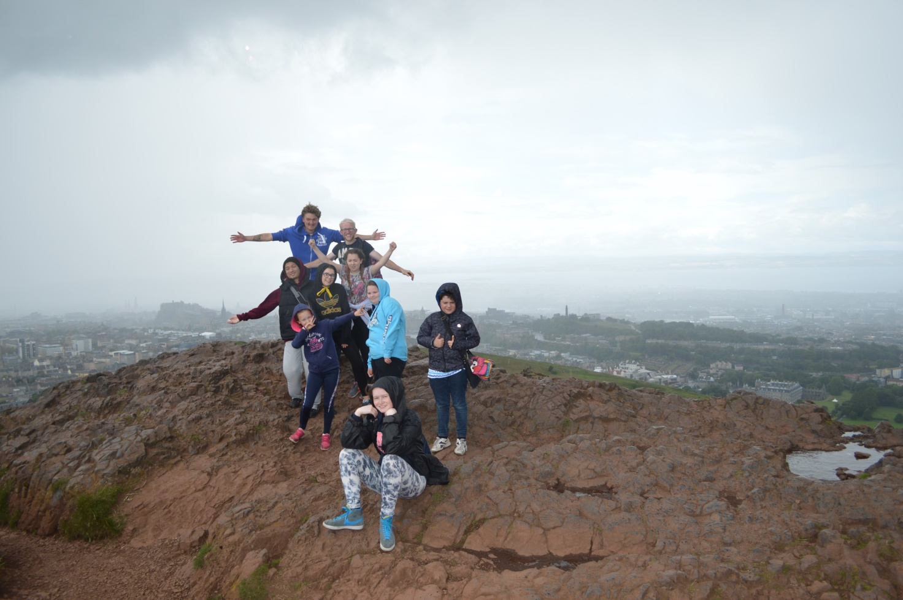

Deaf Action Edinburgh

Outcomes

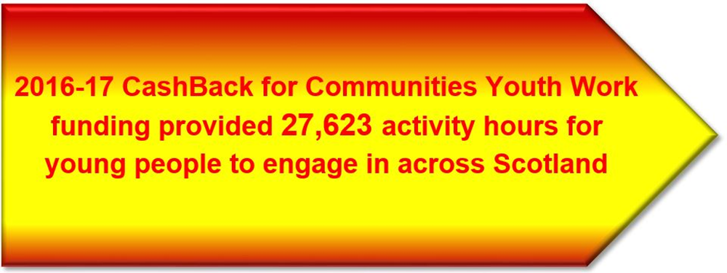

The youth work projects awarded a grant through the CashBack for Communities Youth Work Fund will contribute to the achievement of one or more of the following outcomes for the young people involved.

- Increased participation in positive community-based activity
- Increased participation by difficult to engage and equalities groups
- Increased opportunities to try new things
- Increased opportunities to develop interests and skills
- Increased involvement in structured pro-social and healthy activities
- Young people have places to go where they feel safe and comfortable
- Greater confidence and self-esteem among young people
- More young people have achieved accreditation for their learning

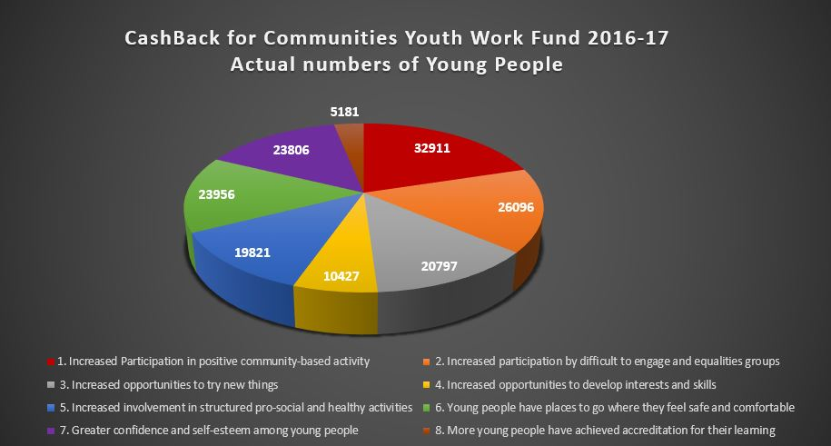

All projects in receipt of £5,000 or more are required to submit a Case Study on completion of their project. We only had thirteen projects who received awards of over £5,000

Two example Case Studies have been appended for your information

Outcomes Achieved

The projects were evaluated against the CashBack Outcomes as they relate to the Functions of Youth Work

Youth Work Functions | CashBack Outcomes
Work with Young People and Others | Young people have places to go where they feel safe and comfortable
 | Increased participation in positive community-based activity
Facilitate the personal, social and educational development of young people | Increased opportunities to try new things
 | Increased opportunities to develop interests and skills
Promote inclusion, equity and young people’s interests and wellbeing | Increased participation by difficult to engage and equalities groups
 | Increased involvement in structured pro-social and healthy activities
 | Greater confidence and self-esteem among young people

A. Work with Young People and Others
CB1. Young people have places to go where they feel safe and comfortable

One of the documented success factors of youth work is the need for young people to be assured of their physical and emotional safety. Robertson (http://infed.org/archives/e-texts/robertson_clubs.htm) described youth clubs as a place where young people can gain real power and ownership as well as a place to excel, explore their true characters and have fun. Youth workers and young people in our case studies identified the importance of open access, coupled with the freedom for participants to choose their own levels of engagement:

“I think firstly for us it’s the free admission…And it’s a drop-in centre so you can come and go as you please. We don’t make young people stay, they’re not committed to doing something, everything is optional.” (The Attic, Youth Worker)

“This is definitely a safe place for young people. They can come in here and have a laugh with staff and other young people. For the hour and a half, they’re in here they don’t have to worry about anything outside.” (Temple Shafton Youth Project, Youth Worker)

“The loneliness I felt was extremely stressful and this affected my mental health. When dealing with issues of gender identity there are dangers around as you look to connect to the outside world. You’re subjected to name calling and physical abuse. As you look for connections it leads to using the internet and social media which isn’t the best thing and you can very easily be exposed to dangerous situations. Now I feel liberated, empowered and happy. ‘Allsorts’ offers a safe place for young LGBT people, a place where I can be myself without judgements being made.” (LGBT Dundee, Young Person)

“The Vogrie Project gave me new skills and motivation to move on to other things in rural skills work. I didn’t know I would like it as much as I did [because of negative experiences in school]. The staff were amazing and accommodating and very down to earth. They made sure you got the most out of what you were doing, and made learning outdoors fun.” (Vogrie Project, Young Person)

CB2. Increased participation in positive community-based activity

Effective youth work practice moves young people along a continuum of participation from what Hart’s ladder of participation defines as tokenistic, towards gaining more power and control over the democratic decision-making and becoming active citizens.

One example of this came from Inverclyde, where such engagement has led to this young person being offered a place at Dundee University to study politics.

“I have been coming to I-Zone for about 4 years…When I started here I was quiet, shy, and not sure of myself. The staff have pushed and supported me to do things I didn’t know I was capable of. They gave me consistent feedback about how well I was doing and guidance to help improve myself. I am really interested in politics and that is something I would never have thought. But by giving me the opportunity and supporting me to get involved in various groups I want to have a career in politics. I am part of the Youth Council that makes sure young people in Inverclyde have a voice in decision making.” (I-Zone, Young Person)

B. Facilitate the personal, social and educational development of young people
CB3. Increased opportunities to try new things
CB4. Increased opportunities to develop interests and skills

Case study evidence consequently confirms that the improvements youth work makes to young people’s creativity, self-awareness and curiosity drive their capacity to try new activities and develop new interests and skills. Indications are that where the youth work process deliberately emphasises one or more of the abilities as with creative methods in Regen:fx, this is reflected in higher levels of improvement.

“Acting is something I’ve never done before. It’s made me think more creatively.”
“This opportunity has let me try scriptwriting and this has made me more creative.”
“Acting in ‘The Street’ has improved my confidence and creativity, as I get to see the real results of the things I make up.” (Young Person Regen:fx)

C. Promote inclusion, equity and young people’s interests and wellbeing
CB5. Increased participation by difficult to engage and equalities groups
CB6. Increased involvement in structured pro-social and healthy activities
CB7. Greater confidence and self-esteem among young people

TSYP is a long-established hub in the heart of an urban area of Glasgow in the worst 10% decile on the Scottish Index of Multiple Deprivation. It demonstrates that to develop the self-regulation young people need to have good sociability, workers fill gaps where positive adult relationships are missing from young people’s lives. Over time, workers direct young people towards becoming more connected to their peers and wider community, as this young person commented:

“I have been coming here since I was 4. I wouldn’t say I had a bad childhood but I did have really bad anger issues. I would never have thought I’d ever be a youth leader, I didn’t think I had the temperament for it. I would kick off at everything, but [one worker] would constantly take me aside and talk to me. He was interested in me, he listened to what I had to say, he took risks by giving me responsibility. And now because of what he done I turned my life around. Now I am living my dream and draw on my experience to help and support the young ones who come here.” (Temple Shafton Youth Project, Young Person)

The Vogrie Project in Midlothian has a referral system, where young people at risk of exclusion or truancy from school or not in work or education; are referred to them. This young person explained why youth work’s approach of being more respectful of and interested in individual participants makes way for developing a sense of integrity where they can leave an old version of themselves behind and become a more authentic version of who they want to be in future:

“I hated school and always got into trouble. Eventually I was kicked out. My life was like totally a mess. I would just sit about playing on my computer. When I came here I was nervous because I didn’t know anyone. [The worker] helped me through this. He introduced me to everyone and made me feel easier. The difference here is the adults respect you, you can have a joke with them, not like teachers that just talk down to you and treat you like sh***. The workers will listen to you and help you do stuff you’re interested in. They also push to try new and different things. I am interested in sport so through [the youth worker] I am planning to help coach an under 12’s football team and hope to go to college to get a sports coaching qualification. Since coming here I am not the wee sh*** I used to be and my behaviour has improved. I am now more optimistic about the future.” (Vogrie Project, Young Person)

In conclusion, there is compelling evidence that the CashBack for Communities Youth Work funded projects are making an indispensable contribution to achieving the CashBack for Communities outcomes.

Equalities information

Equalities information is captured within the end of project report submitted by each grant recipient on completion of the funded activity. All data from these reports has been uploaded to the Scottish Government database.

“I am surprised how long I’ve stayed. I can be myself and my autism doesn’t make me feel any different. I’ve been surprised by the range of things that I’ve been able to try or be involved in. I’ve enjoyed somethings more than others but I’ve learned a lot.”
Young Person from Create Paisley

“The song writing project helped me to be strong and hopeful that one day all my dreams will come true that I just have to be strong.”
Young Person from Youth Community Support Agency

External evaluations/Lessons Learnt

YouthLink Scotland engaged the services of Catch the Light to conduct an evaluation of the programme over the three-year term of the funding. Taking advantage of the three year funding commitment the main purpose of the forthcoming review is to build up longer-term evidence of progress and develop a deeper understanding of the impact the funding has in adding to and consolidating excellent youth work practice.

Catch the Light identified six projects to be evaluated, the projects/organisations selected were: Midlothian Council CLD (Midlothian), Regen:fx Youth Trust (South Lanarkshire), Brechin Youth Project (Angus), LGBT Youth Scotland (Stirling), 1 Youth Zone (Inverclyde) and Temple Shafton Youth Project (Glasgow NW).

The full evaluation report is now available and has been submitted separately however the report
reiterates an acknowledgement among recipients that CashBack for Communities funding is a lifeline in times of austerity, it supports local organisations to offer youth work opportunities that would otherwise not happen.

Youth organisations are unfalteringly grateful for being able to employ workers for extra hours, open the doors for slightly longer and subsequently sustain transformative opportunities and experiences that are not accessible to young people in mainstream institutions.

The case studies give an insight to youth work professionals with a range of knowledge, skills and experience on how to support young people’s successful transitions into adult life. This report therefore calls attention to the benefits youth work brings to giving democratic power and control to our young people, as follows:

Communications

Building on the success of the ‘CashBack Selfie Campaign’ YouthLink has developed that further and ran a CashBack Postcard Campaign this year highlighting the work of projects across Scotland that have benefited from CashBack funding.

The idea behind the campaign was to show the reach and benefit of CashBack money by creating a postcard map of Scotland. We asked young people involved in local projects to take a picture of themselves with the local project or a landmark in the background and for them to sum up their experience in 25-50 words.

An exhibition of the postcards was held on Scottish Parliament in February 2017, bringing together groups of young people from across Scotland who then met with their local MSP’s and were able to share their experiences of the CashBack funded programmes.

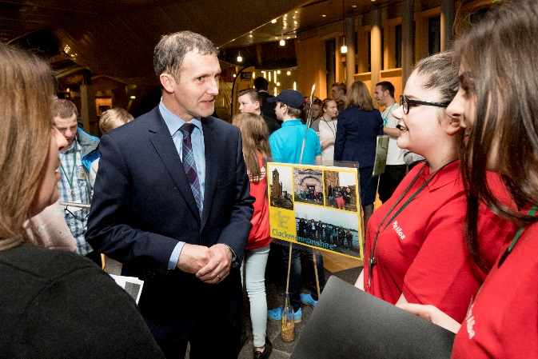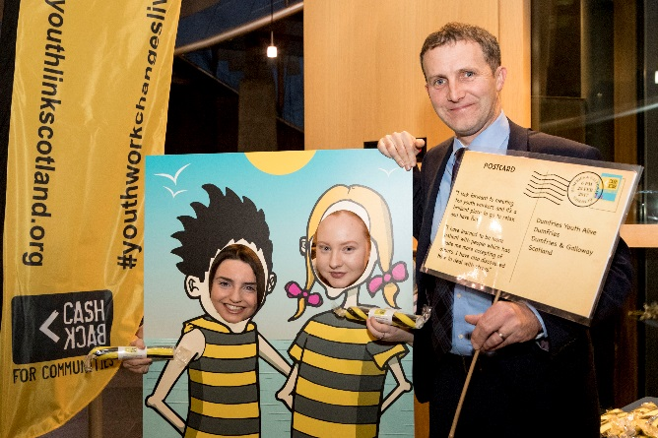

Future

YouthLink Scotland has successfully secured funding for CashBack Phase 4 and will continue to administer that grants programme for a further three years supporting the delivery of targeted youth work activity programmes which provide diversionary youth work activities for young people aged 10 to 24 who face one or more forms of disadvantage as listed below:

- Living in areas of deprivation (priority will be given to projects working in communities within the top 20% SIMD)
- Being unemployed, not in education or training;
- Being excluded, or at risk of exclusion from school;
- Being at risk of being involved in antisocial behaviour, offending/re-offending

Appendix: Case Study Example 1

Cashback for Communities Case Study
Youth Work Fund 2016-17

Name of Group | Youth Highland
Local Authority Area | Highland
Value of Award | £4100
Completed By | Clair Nichols – Chief Officer

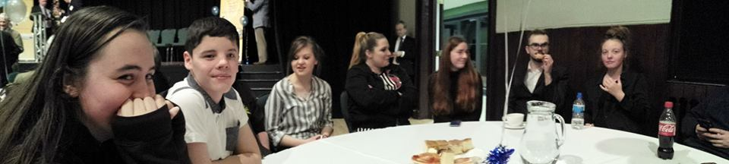

Awards Night: Mind Your Head Project win Highly Commended at Lord Lieutenant’s Award 2017

Case Study Pro-forma for use with the Project Staff

Getting Started

How did the activity get started?

Why did you/the group get involved?

Who was involved in the design, the delivery and any reviews of activities?

Were other projects or organisations involved in the design and/or delivery?

Youth Highland young people were involved in SMHAFF last year and felt it would be more appropriate to have a ‘youth SMNAFF’ which would address young people’s issues and concerns around mental health.
- We got involved because Youth Highland has a strong peer education group who were happy to guide me as a youth worker and arts leader towards themes and styles which would appeal to other young people on the project.
- Youth Highland, arts workers, peer leaders and young people were involved in the design, delivery and reviews of activities.
- The project was delivered in partnership with Women’s Aid, Refugee families, Connecting young carers and Crocus Bereavement project.

If someone from your area asked you what this project is about what brief description would you give?
Mind Your Head is an exhibition of art made by six groups of young people focussing on coping mechanisms, mental strength, knowing your rights and your place in the World.
The groups were a bereavement group, women’s aid mentors, refugee families, young carers, Maryburgh youth group and Youth highland young people / peer educators.

Outcomes proposed at outset
- Increased Participation in positive community-based activity
- Increased participation by difficult to engage and equalities groups
- Increased opportunities to try new things
- Increased opportunities to develop interests and skills

Outcomes at this point; have these been met?

Completely? Partially? Not met?

Reasons?

What are the key learning points?
- Completely
- These outcomes were met because more than 30 young people created art for the exhibition around the themes of helping each other, coping mechanisms, their place (and others) in the World. And we put on an exhibition called ‘Mind Your Head’.
- Having understanding for other people, one piece of work was called ‘Sonder – the realisation that each random person is living a life as vivid and complex as your own’.

Process

What has been done?

Has the activity gone to plan?

Was there anything that didn’t go to plan & if so what did you think of that?

- Ideas explored, critiqued and recreated by young people for young people and 4 or 5 choices created for the groups.
- These were presented to the groups as taster sessions who then ran with their favourite or came up with their own idea.
- Whilst working on pieces we chatted and explored issues relevant to the young people and mental strength and health.
- Because we had built into the sessions ‘adaptability’ plans could change according to needs.

Impact

What was the learning from the project?

What came out of the project that was not in the original aim and objectives?

If you didn’t do this activity or project what would participants be doing?

What did taking part mean to them? Have you recorded that? If so, can you share the evidence?

If you started again tomorrow how would you keep the same or change?
- Young people found each other to be diverse yet with similar sympathies for each other – the overarching theme was ‘to help others’.
- Some art made by the refugee group was used by a local refugee charity as their charity Christmas card designs.
- Youth Highland has been asked to work with other refugee groups because the work was valued and seen to make a difference.
- One young leader acted as a peer educator but also stepped up as a lead artist with his ‘dream jars’.
- If I started the project again I would do it the same way – co producing issue / art based youth work is amazing!
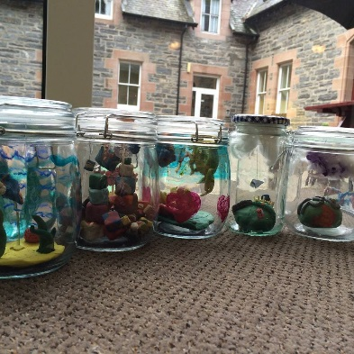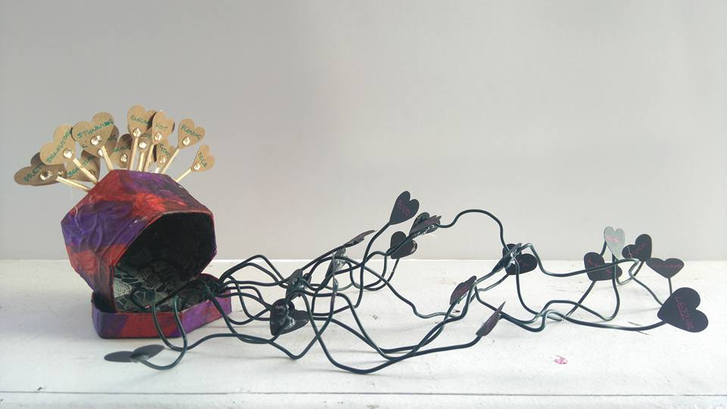
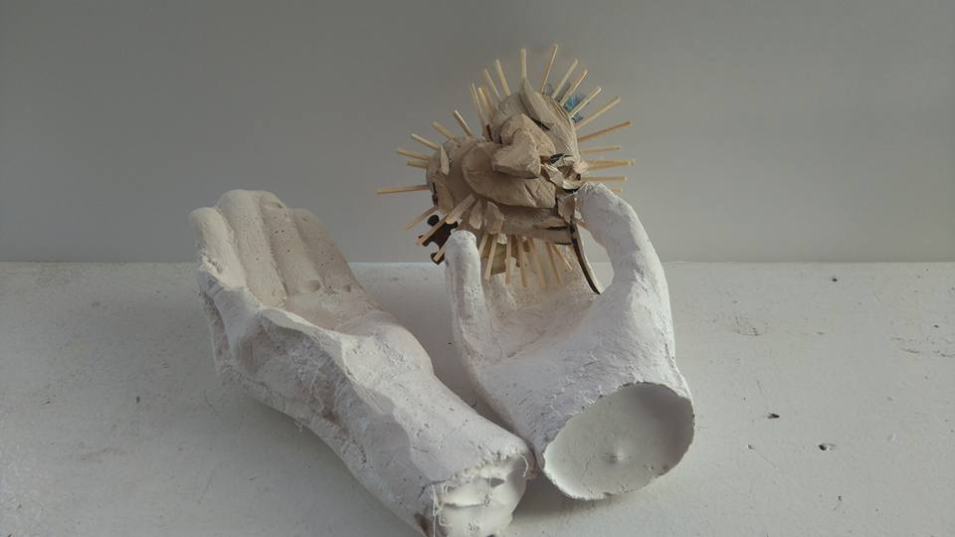

Case Study Pro-forma for Use with Young People

Getting Started
- How did you hear about Mind Your Head?
- Why did you get involved?
- What did you think the project would involve?
- I was involved with Youth Highland and Jacquie the arts worker told me about it.
- I got involved because mental health is a part of my life and is important for me to spread awareness. I also love creating things.
- I knew that it involved creating artwork to represent mental health.

On the Project
- What have you done?
- What do you think of that?
- What do you intend to do on this project?
- What will you do after this project?
- What have you gained? Skills, qualifications, awards, networks, friends
- I was involved in running workshops helping young people create artwork.
- I really enjoyed it as I got to help others doing what I love and spreading awareness.
- I intended to create a gallery of artwork to spread awareness of mental health. After I will continue to support Mind Your Head and work with Youth Highland.
- I have gained workshopping skills, we got a Lord Lieutenant’s Award for the project and also I gained friends through this project.

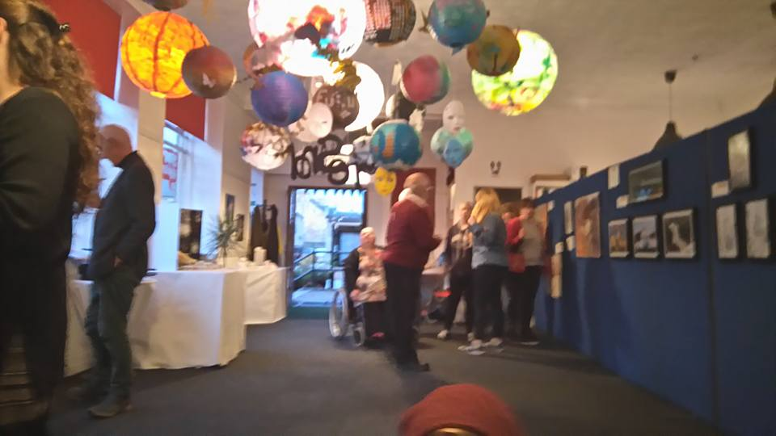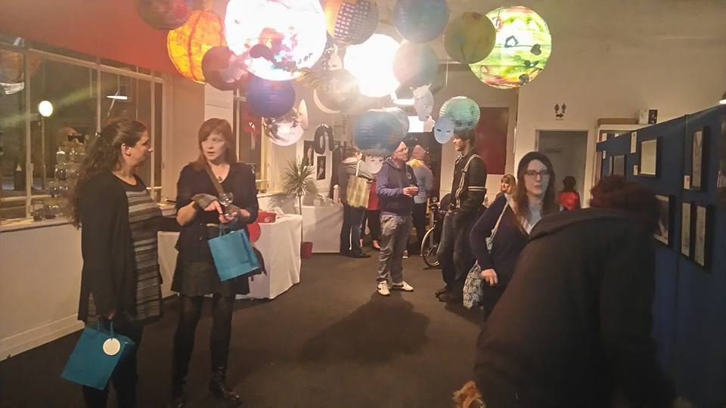

Impact
- If you didn’t do this activity or project what would you be doing?
- What has taking part meant to you?
- Why do you/ did you continue to take part?
- I would still be working with Youth highland but not feel part of a great project.
- It was an honour to take part as a mental health issue has affected my family and I want to spread awareness.
- I continue to take part as I enjoy the project and I learn new things and make new friends.

Wider Context
- Are other people you know involved in this project?
- If someone from your area asked you what this project is about what brief description would you give?
Yes. A few of my friends have been involved with the project because mental health has affected their family.
It is a selection of artwork created by young people affected by mental health that reflects what they feel in some way or another.

Overview
- What surprised you most about being involved?
- What would you change if you started the project again tomorrow?
- Finally, if someone asked you to comment on your experiences what would you say about YOUR experience?
I was surprised at how creative everyone is, even if they say they are not.
Everyone has great ideas.
I don’t think I would change anything as everyone has their own experiences so just provide the supplies and the young people would create their own work.
I had a fantastic experience. I got to be involved in a serious issue but having fun at the same time!
We made the young people happy creating artwork that they can be proud of!

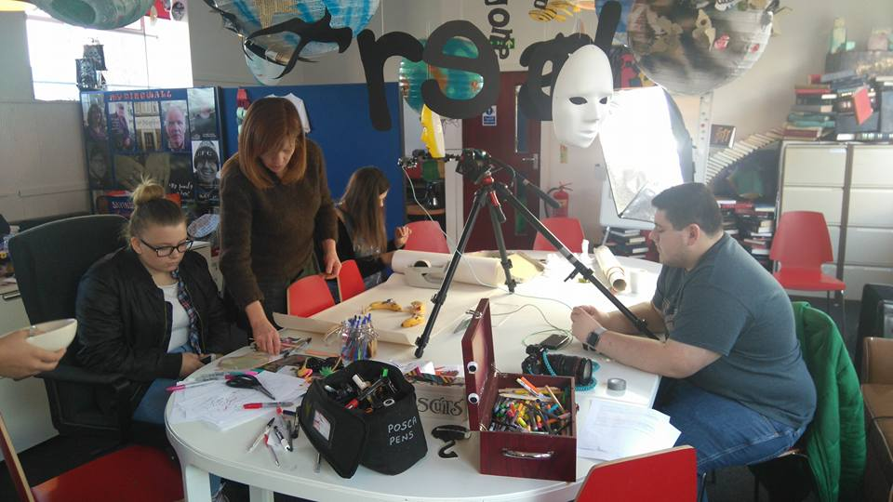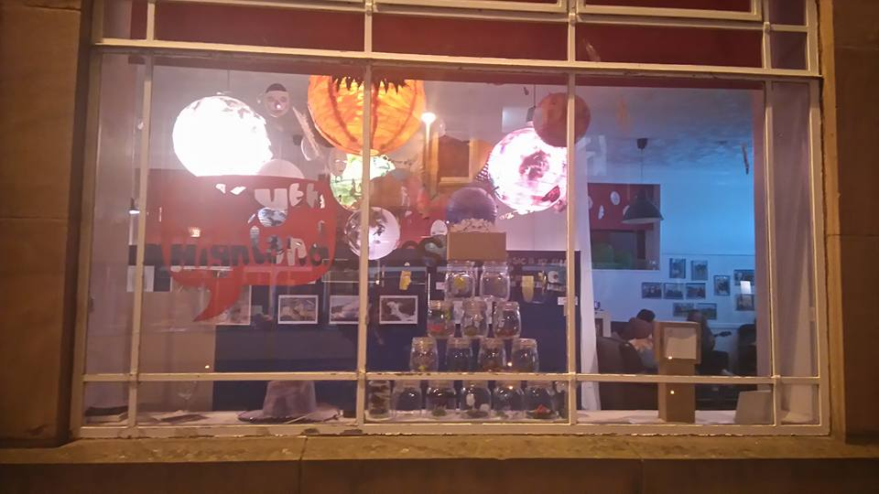

Appendix: Case Study Example 2

Cashback for Communities Case Study
Youth Work Fund 2016-17

Name of Group | Create Paisley
Local Authority Area | Renfrewshire
Value of Award | £6,901.00
Completed By | Maria Suarez

Case Study Pro-forma for use with the Project Staff

Getting Started

How did the activity get started?

Why did you/the group get involved?

Who was involved in the design, the delivery and any reviews of activities?

Were other projects or organisations involved in the design and/or delivery?
- CREATE's Youth Forum was set up as a result of young people expressing a desire to be involved as “actors ­not­ objects” in their wider communities.
- Young people have been involved at every stage of the development of this proposal. Young people's voice influenced the creation of CREATE and since then every activity, programme, and project has been a direct response to the ideas put forth by young people. CREATE continues to actively seek involvement from young people on our board who represent the voices of young people engaging with CREATE at events and activities.
- The young people shaped the design of the youth forum, the activities and topics that would be covered. Create staff were responsible for delivering this programme with support from crew volunteers. As well, the young people were offered to deliver partially or completely CREATE’s Youth Forum sessions.
- No other projects or organisations were involved in the design of this programme. Eventually we invited other organisations/groups to come along to deliver sessions like ‘Rainbow Turtle’, ‘PACE’ or the ‘Paisley 2021 Bid Team’ CREATE’s Youth Forum organised visits to other activities happening in the community by request from the young people like participating in Common Threads event, the Renfrewshire Youth Assembly or a Youth Arts Consultation organised by the ‘Paisley 2021 Bid Team’.

If someone from your area asked you what this project is about what brief description would you give?
CREATE’s Youth Forum is a space for young people designed by young people. It is created to offer a safe space to have a voice in the wider community, to express themselves, to talk freely and listen to other young people. It is a space to meet other young people with the same interests, share ideas and work in a common project together.
We have this video that summarise the year and the work that CREATE’s Youth Forum does: https://drive.google.com/file/d/0B47d6rxSLAZqVWIzSjloRmhxNVU/view?usp=sharing

Outcomes proposed at outset
1. Increased Participation in positive community ­based activity
1.1 There are more young people accessing the youth work opportunities on offer
1.2 New members join the group

3. Increased opportunities to try new things
3.1 The youth work programme contains a variety of new opportunities for group members
3.2 Young people are supported to take on leadership roles within the group

5. Increased involvement in structured pro­social and healthy activities
5.1 Young people engage in the programme opportunities
5.2 All available learning opportunities are utilised by young people

7. Greater confidence and self-esteem among young people
7.1 Young people are willing try new things
7.2 Young people take on leadership roles within the group

Outcomes at this point; have these been met?

Completely? Partially? Not met?

Reasons?

What are the key learning points?
- Completely
- The young people who attended the Youth Forum are an example of each of the outcomes above. For example:
They were able to try new things and identify through these skills they wanted to learn. This lead to us organising skilled volunteers to come or young people from other groups to come and deliver a session for them (i.e.: young participants from PACE coming to deliver a ‘Declaiming Poetry’ workshop so they could read pieces they had been writing for a wider event the Youth Forum took part). As well sometimes the young people participating on the forum lead sessions with support from CREATE staff members.
- We can summarise the key learning points in 3 areas:
  - Learning to learn: they were able to identify what they wanted to learn and how they wanted to learn activities: by workshops, by practical sessions, by experience panel, etc. One of the main needs for learning was learn how to design a
  - Organise and coordinate activities: they took the lead in organising a fortnightly CREATE event. The event is the Create Cafe Nights: a jam and arts session at a local cafe. They decided the topic and different activities that would happen during the night, host the event welcoming audience and introducing performers and took pictures at the event. As well they implement from idea to final product an APP to showcase safe events for young people happening in Renfrewshire (we have the help from computer software engineer who volunteer to develop the code)
  - Identify and research in the community: in order to improve the above explained event they were able to implement a creative evaluation, following the placemaking methods, to enquire the young people.

Process

What has been done?

Has the activity gone to plan?

Was there anything that didn’t go to plan & if so what did you think of that?
- We have been offering either a weekly or more often, when the Create Cafe Nights or external activities were going on, youth forum sessions. On this time the young people had accomplished the following things:
  - Develop an APP, ‘Discover Paisley’ from the idea to the final product (with the code being made by a CREATE crew volunteer)
  - Organise and coordinate a fortnightly event: Create Cafe Nights
  - Take part in Common Threads by making creative writing pieces that were showcased during the event.
  - Take part in the group of young people who planned the Renfrewshire Youth Assembly and attend the event as Youth Forum. We prepared 2 activities for the attendees of the Youth Assembly about stereotypes: one about matching the picture with the short sentence about someone, the other about filling some paper with the sentence: “ I am______ and people tell me that________”. To encourage reflection and discussion on prejudices.
  - Take part of a focus group in Create Paisley to improve Create Paisley work.
  - Be part of a consultation session by the Tackling Poverty Team to develop a film about the work they had done.
  - Develop a consultation for other young people using the placemaking methods
- The Youth Forum sessions went usually as planned. Sometimes we have to cancel some sessions because of the participants not being able to attend last minute.
- The mentoring services to young people we offered were irregular and unfinished sometimes due to the lack of staff time, volunteers and that some young people moved away. I think the main contingency was that we thought we will be able to train volunteers and they will be delivering the services as there was not enough time for a staff member to take on the mentoring. It’s remarkable that we had a lot of interest from volunteers to mentor young people but the way we conceive the mentoring, 6 sessions just related to a personal project instead of a year round of general support, was different to the expectations of the potential volunteers. As well the young people expressed a lot of interest on being mentees. We concluded that mentoring services are a need and a possible outcome for the future but with staff time to organise and prepare crew volunteers to become mentors the meetings would be more regular and one to one as we have to do a lot of group mentoring sessions at this project.

Impact

What was the learning from the project?

What came out of the project that was not in the original aim and objectives?

If you didn’t do this activity or project what would participants be doing?

What did taking part mean to them? Have you recorded that? If so, can you share the evidence?

If you started again tomorrow how would you keep the same or change?
- The young people were able to take the lead and be responsible of the delivery of different events and trainings. They were able to see their full potential and overcome situations that made them feel uncomfortable or not skilled enough to do. Create Paisley as well recognised that with a really little support the young people can be as efficient as adults in the development of these different tasks. As organisation we were aware of the young people skills and make them go out of their comfort zone but always with the staff or volunteers around to help if they need it what made them being more open to take risks and try new things. We learned that an open guidance giving enough support for the young people to believe in themselves was enough to offer high quality events and workshops.
- As we are a youth arts charity we finally had the opportunity to implement a lot of artistic projects (like APP design or creative writing) that maybe were not the aim of the project at the beginning. We were as well able to contribute in levels that weren’t expected to the development of the Create Cafe.
- We evaluate every session at the end. We used different creative evaluation methods, some were quantitative (i.e.: make with your body a number to rate a question from 1 to 10), in which ones we asked them about 3 aspects of the session:
  - Learning: 5(median). Sometimes they feel they didn’t learn that much as it was more about sharing our ideas.
  - Personal work: 7. Sometimes they felt like they didn’t contribute so much or they work less than other participants
  - Fun: 8. They almost always agreed in how much they enjoyed all the sessions.
The qualitative evaluation methods (i.e.: with a chair in the middle of the room one person goes to the chair and say a statement, the rest of the people have to get closer if they agree or far if they disagree/ describe today’s session using a cake) gave us some interesting feedback about their feelings and opinions:
  - “Cakes with jam: because they have surprisingly a lot of things inside and we got a lot of things done” (S, 13)
  - “Caramel shortbread because is nice and tasty and if you have a bad day it cheers you up and she had a better day because of the youth forum” (M, 13)
  - “It was good to having opinions listened to” (A, 17)
  - “The best of the session were all the ideas we could share” (Z, 14)
  - “I felt motivated and passionate during the session” (K, 17)
  - “After this session I feel awaken and realise a lot about how some people is threatened and from now I will be more aware of other persons needs and ways to be” (G, 14)
  - “It was good getting our points across” (N, 16)
  - “We spoke about important issues still having fun” (G, 14)
  - “It was good to get to know what we think of each other’s, the stereotypes we had” (S, 13)
  - “I enjoyed how we got everything done” (G, 14)
  - “I learned a lot today” (G, 14)

I want to remark that in one case when we were proposing a quantitative evaluation: they have to put up to 3 stars (being 3 good and 1 bad) in each part (learning, personal work and fun) of the workshop. They misunderstood the activity and decided to write in the stars what was fun, what they learn… it was an interesting exercise on communication and maybe the need from the young people to express themselves over the simple act of rating: they decided to highlight WHY they had fun instead of HOW MUCH fun they had.
- If I started again tomorrow, I will keep the decision making on the young people but maybe giving them more information. With an informed decision making process the young people could choose activities that won’t need the support of Create Paisley to continue with the work we do during the sessions. Maybe being more aware of how breakdown the bigger tasks in small and easier to do tasks. I think I will try to be more realistic as well with the staff time and make ambitious but realistic goals.

Case Study Pro-forma for Use with Young People (R, 16)

Getting Started
- How did you hear about [insert the activity, project, group]?
- Why did you get involved?
- What did you think the project would involve?
- I heard about the forum through CREATE. I had been involved with 20|20 and going to Create Cafe Nights.
- I really liked the people and wanted to know more. It was about things I was interested in. It was something out of school.
- I knew it was about improving Paisley and the local community. It meant I could be involved and find out other local groups.

On the Project
- What have you done?
- What do you think of that?
- What do you intend to do on this project?
- What will you do after this project?
- What have you gained? Skills, qualifications, awards, networks, friends
- Youth Action: looking at improving Paisley.
Create Placemaking: making an enjoyable safe space for Create Cafe Nights.
APP: really interesting. Harder than I thought looking at design, layout details, etc.
Common threads: writing something about the fashion industry.
- I think I am doing well. I’ve enjoyed them all and learned something from each of them.
- I wanted to have my voice heard and improve Paisley
- Continue with Create Paisley and Create Cafe Nights.
- I gained lots of new skills, used different software in groups. Mostly I gained friends and confidence and personal independence travelling by my own.
Impact
- If you didn’t do this activity or project what would you be doing?
- What has taking part meant to you?
- Why do you/ did you continue to take part?
- If it wasn’t for Create Paisley, I probably wouldn't be doing anything
- It’s meant I’ve gained new friends and skills. A place I can be myself. From starting Create Paisley I’ve grown and become more independent. I have more confidence talking to strange people. Interests in other things.
- I continue because I feel confident and safe and learn new stuff and new people and develop on skills I have.
Wider Context
- Are other people you know involved in this project?
- If someone from your area asked you what this project is about what brief description would you give?
- All the people at the Youth Forum have mostly been friends I have met at other Create Paisley group. I didn’t know any of them before that.
- It’s a fun way of meeting new friends, getting interested in new stuff, being able to develop on your own is around your local community to be involved/part of.

Overview
- What surprised you most about being involved?
- What would you change if you started the project again tomorrow?
- Finally, if someone asked you to comment on your experiences what would you say about YOUR experience?
- I am surprised how long I’ve stayed. I can be myself and my autism doesn’t make me feel any different. I’ve been surprised by the range of things that I’ve been able to try or be involved in. I’ve enjoyed something more than others but I’ve learned a lot.
- It would be great if the project had its own building but nothing about the project.
- It’s been an absolute delight being part of Create Youth Forum. The best.

Project returned the funds and did not deliver the project
Project returned the funds and did not deliver the project
Project returned the funds and did not deliver the project

